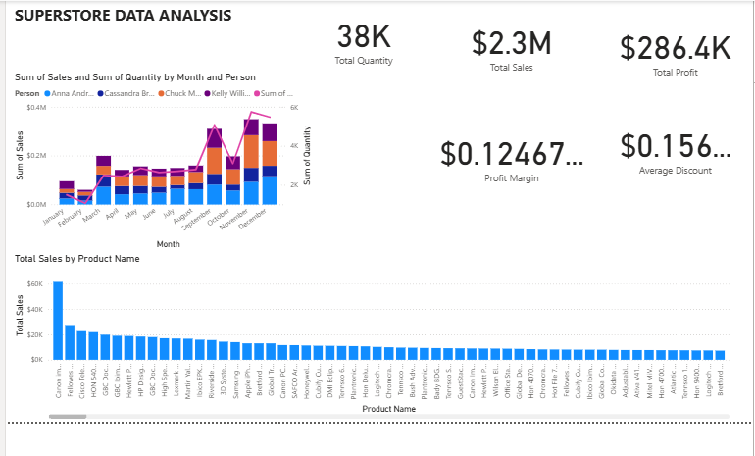
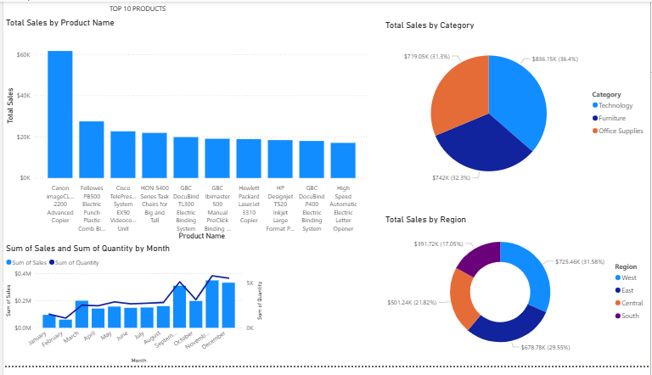

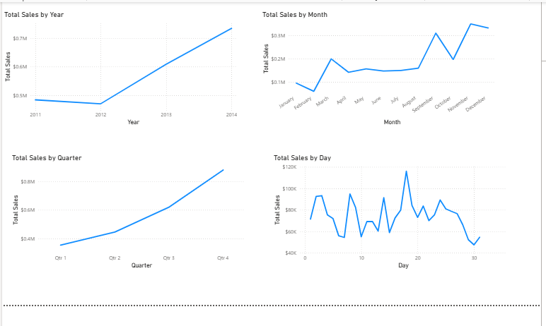
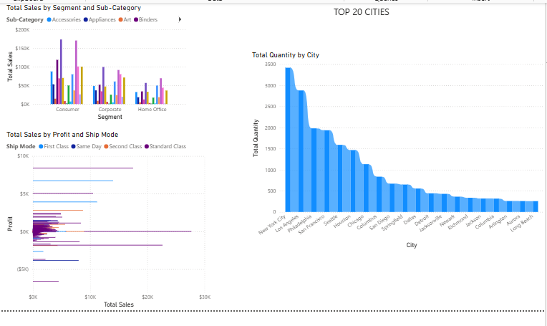

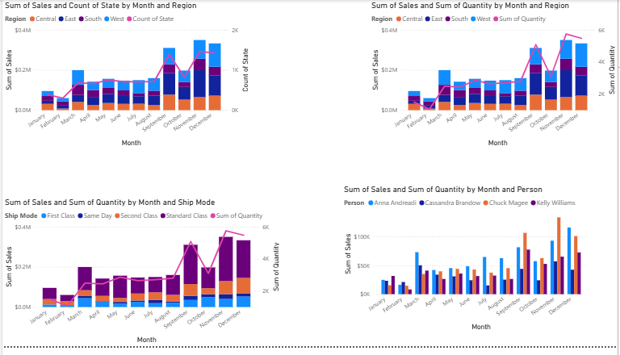

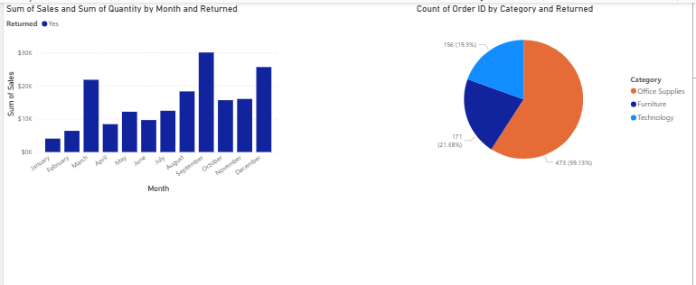

BASED ON THIS DATA IT IS CLEAR THAT:
This detailed report provides an analysis of the provided Superstore data visualizations, covering key performance indicators, sales trends, product performance, and regional breakdowns.

Key Performance Indicators (KPIs)
The dashboard's summary statistics highlight the overall performance of the superstore:
• Total Quantity: 38K
• Total Sales: $2.3M
• Total Profit: $286.4K
• Profit Margin: $0.12467}$ (or about $12.47\%
• Average Discount: $0.156}$ (or about $15.6\%

Sales Trends Over Time
Sales and quantity exhibit significant seasonality and growth, both annually and monthly.

Annual and Quarterly Trends
- Total Sales by Year shows a clear and consistent upward trend from 2011 to 2014, with sales growing from approximately $0.5M in 2011 to over $0.7M in 2014.
- Total Sales by Quarter mirrors the yearly growth, showing a steady increase in sales from Quarter 1 (Qtr 1) to Quarter 4 (Qtr 4) each year, reaching over $0.8M in Qtr 4.

Monthly Trends (Overall)
Monthly sales and quantity follow a pronounced pattern:
- Sales are relatively low from January to August, fluctuating between approximately $0.05M and $0.2M.
- There is a significant spike in both sales and quantity in the latter part of the year, starting around September and peaking in November and December, which are consistently the highest-performing months.

Daily Sales Trends
- Total Sales by Day shows high variability throughout the month, with some days (around the 20th and late in the month) reaching high sales of over $100K, and other days seeing dips to under $50K.

Performance by Category, Product, and Geography

Sales by Category
Sales are distributed across the three main categories as follows:
- Technology: $836.15K{36.4\%}
- Furniture: $742K{32.3\%}
- Office Supplies: $719.05K{31.3\%}
Technology is the top-selling category by total sales.

Top Products
The chart displaying Total Sales by Product Name (Top 10 Products) shows a highly concentrated product performance:
- Canon Advanced Copier is the clear top-selling product, generating sales significantly higher than the next product.
- The top-selling products generally fall into categories like Copiers, Machines, Binders, and Phones (e.g., Canon, Fellowes, Cisco, HON 5400, GBC).

Geographic Performance
- Total Sales by Region indicates the West region as the highest contributor to sales at $725.46K{31.58%}.
  - West: $725.46K (31.58%)
  - East: $678.78K (29.55%)
  - Central: $501.24K (21.82%)
  - South: $391.72K (17.05%)
- Total Quantity by City (Top 20 Cities) shows that New York City and Los Angeles have the highest total quantity sold by a considerable margin.

Deep Dive into Monthly Trends

Regional Monthly Performance
The general seasonal pattern (low Jan-Aug, high Sep-Dec) holds true for all regions, but with differences in magnitude:
- West and East regions generally contribute the most to the overall sales and quantity throughout the year, especially during the peak months of November and December.
- The high December sales are notable, especially in the West region.

Sales Rep Performance
The chart tracking Sum of Sales and Sum of Quantity by Month and Person (Anna Andreadi, Cassandra Brandow, Chuck Magee, Kelly Williams) shows:
- Kelly Williams consistently has the highest sales contribution, particularly during the peak months of October, November, and December, often leading the team in quantity and sales.
- Anna Andreadi has the lowest sales contribution overall.

Ship Mode Impact
Sales and quantity are highest for the Standard Class ship mode, which also follows the pronounced September-to-December sales spike.

Returns Analysis
- Sum of Sales and Sum of Quantity by Month and Returned (Yes) indicates that returned sales (for items marked as 'Returned: Yes') are also highest in October and December.
- Count of Order ID by Category and Returned shows that the largest number of returned orders is in the Office Supplies category (473} orders,59.13% of returned orders). Furniture (171 orders, 21.38%) and Technology (156 orders, 19.5%) follow.

Segment and Sub-Category Performance
- Total Sales by Segment and Sub-Category shows that the Consumer segment has the highest sales across most sub-categories.
- Within the Consumer segment, Binders and Appliances appear to have the highest total sales.
- Total Sales by Profit and Ship Mode shows a high concentration of both profit and sales in the First Class and Standard Class ship modes. A significant portion of sales, primarily in the Standard Class, results in the highest positive profit. There are also instances of negative profit (loss) across all ship modes, with some of the larger losses associated with the Standard Class, which is expected due to its high volume.

Summary of Key Insights
- Strong Growth: Total sales are on a clear, multi-year upward trend (2011–2014).
- Major Seasonality: Sales and quantity are heavily concentrated in the last four months (September–December), with November and December being the peak.
- Top Performers: Technology is the highest-grossing category, the West is the highest-selling region, and Kelly Williams is the highest-contributing salesperson.
- Returns Focus: The Office Supplies category has the highest volume of returned orders, and returns peak in October and December, aligning with the highest sales months.

