Week 6: Substitution-Permutation Networks (SPN), S-Boxes and Non-Linearity
Topic: Block Cipher Design Using SPN Structures
Required Evidence
The following screenshots document the implementation of a Substitution-Permutation Network, S-Box substitution, permutation operations, and the avalanche effect demonstration.

[ Insert Screen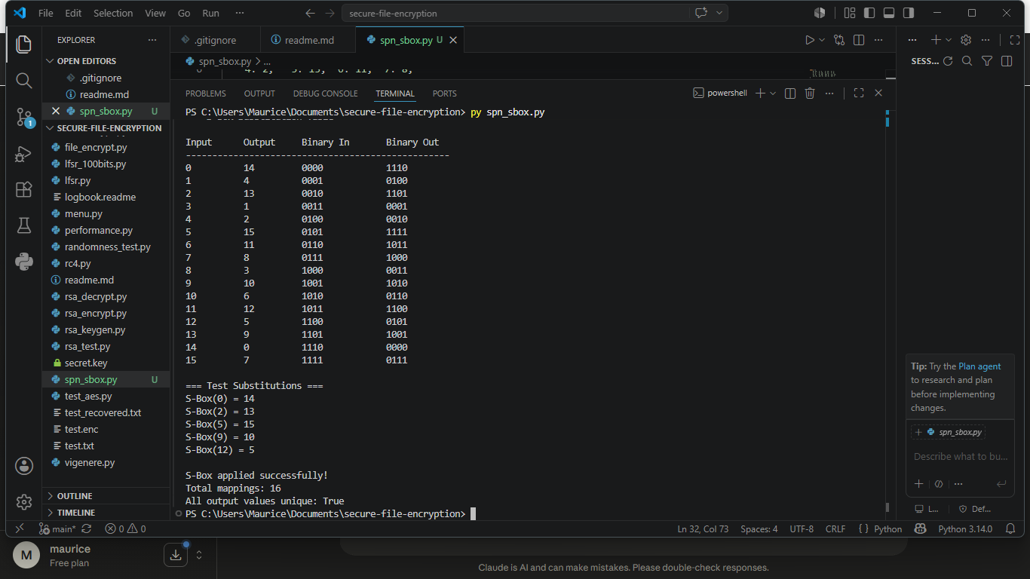shot Here ]
Fig 1: S-Box lookup table implementation — Python script showing the substitution dictionary and print output

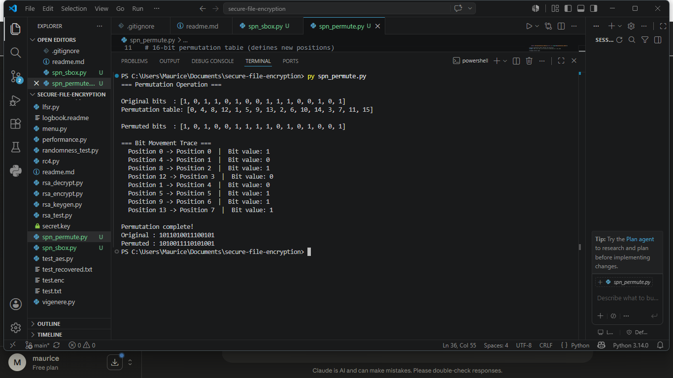
Fig 2: Permutation function — Python script rearranging bit positions and displaying the permuted result

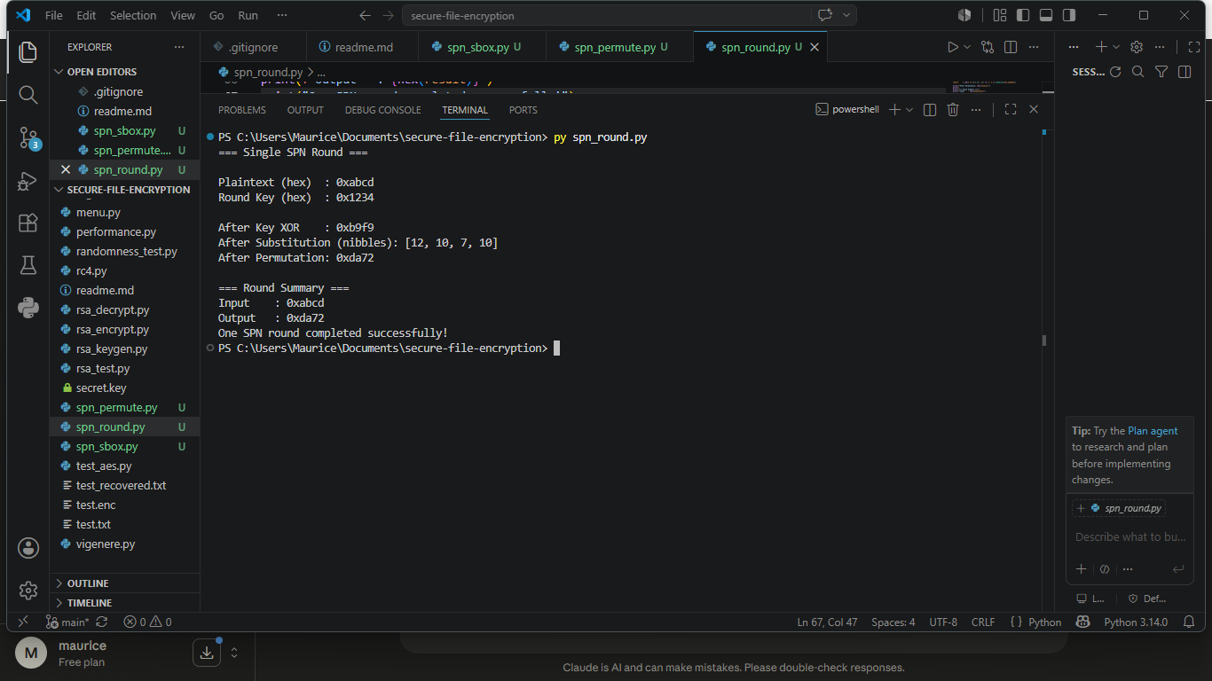
Fig 3: Combined SPN round — Python script applying substitution then permutation in sequence with terminal output

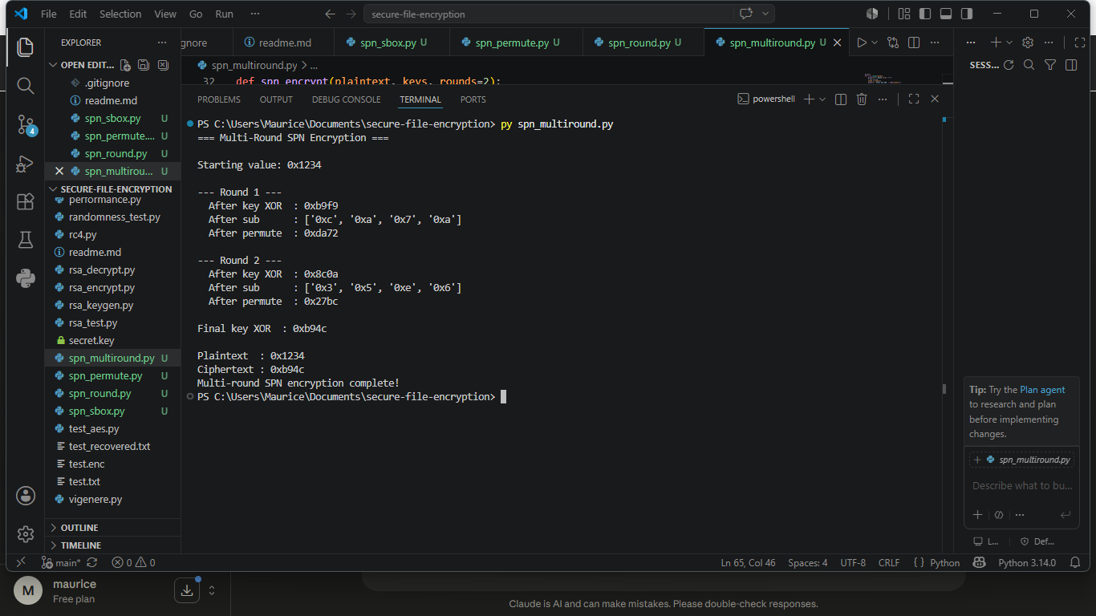
Fig 4: Multi-round SPN with key mixing — XOR key mixing followed by substitution and permutation across two rounds

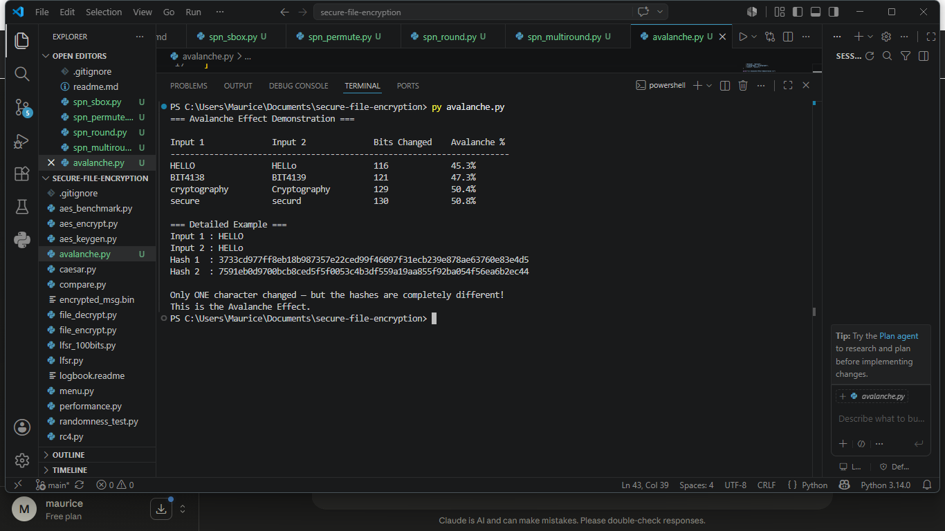
Fig 5: Avalanche effect demonstration — two near-identical plaintexts producing completely different hash outputs

Student Reflection (max 50 words)
Implementing the SPN showed why both substitution and permutation are necessary together. Substitution alone creates confusion but permutation spreads changes across the block, creating diffusion. Together they make the cipher exponentially harder to break.

Creative Addition / Innovation This Week
Automated Avalanche Effect Measurer
Built a script that flips one bit in a plaintext, runs it through the SPN, and counts how many output bits changed — calculating an avalanche percentage score. A good SPN should change approximately 50% of output bits for any single input bit change.
S-Box Security Evaluator
Created a tool that checks an S-Box for repeated output values and calculates a basic non-linearity score, helping identify whether a given S-Box design meets minimum cryptographic security requirements — an original extension beyond the practical task.

Weekly Summary (max 50 words)
Week 6 produced a working Substitution-Permutation Network with S-Box substitution, permutation, key mixing, and multi-round operation. An avalanche effect measurer and S-Box security evaluator were added as creative extensions demonstrating cipher design analysis.

Week 7: Block Cipher Cryptanalysis
Topic: Algebraic Attacks, Differential Cryptanalysis and Linear Cryptanalysis
Required Evidence
Screenshots document the implementation of a differential cryptanalysis simulation, frequency analysis tool, statistical bias calculator, and avalanche effect testing framework in Python.

[ Insert Screenshot Here ]
Fig 1: XOR-based algebraic attack simulation — Python script demonstrating key recovery from plaintext-ciphertext pairs

[ Insert Screenshot Here ]
Fig 2: Differential cryptanalysis simulation — two similar plaintexts encrypted and their ciphertext differences computed

[ Insert Screenshot Here ]
Fig 3: Frequency analysis tool — character frequency counter applied to ciphertext showing statistical bias

[ Insert Screenshot Here ]
Fig 4: Avalanche effect tester — single bit change in input producing large ciphertext difference, shown as percentage

[ Insert Screenshot Here ]
Fig 5: Attack comparison report — terminal output comparing brute force, algebraic, differential, and linear attacks

Student Reflection (max 50 words)
Simulating differential cryptanalysis made it clear why strong S-Boxes are non-negotiable. A weak S-Box allows differences to propagate predictably through rounds, giving attackers a statistical foothold. AES survives because its S-Box design eliminates exploitable patterns.

Creative Addition / Innovation This Week
Mini Cryptanalysis Toolkit
Built an automated toolkit combining frequency analysis, difference calculation, and statistical bias measurement into a single script that accepts any ciphertext and produces a formatted security assessment report — an original tool going beyond the practical task requirements.
Visual Bit Difference Mapper
Created a script that takes two ciphertexts and prints a bit-by-bit comparison map, visually highlighting which positions changed. This makes the avalanche effect tangible and measurable rather than just theoretical, demonstrating real cipher evaluation technique.

Weekly Summary (max 50 words)
Week 7 produced a cryptanalysis simulation toolkit covering XOR algebraic attacks, differential analysis, frequency analysis, and avalanche testing. A mini cryptanalysis toolkit and visual bit difference mapper were built as creative additions demonstrating professional cipher evaluation skills.

Week 8: PKI, Diffie-Hellman and Asymmetric Cryptography
Topic: Public Key Infrastructure, Digital Certificates and Diffie-Hellman Key Exchange
Required Evidence
Screenshots document the Diffie-Hellman key exchange implementation, OpenSSL certificate inspection, digital certificate browser analysis, and PKI component identification exercise.

[ Insert Screenshot Here ]
Fig 1: Diffie-Hellman key exchange — Python script showing Alice and Bob computing the same shared secret

[ Insert Screenshot Here ]
Fig 2: User-input Diffie-Hellman program — CLI accepting custom p, g, and private keys then computing shared secret

[ Insert Screenshot Here ]
Fig 3: OpenSSL certificate inspection — terminal showing openssl x509 command output with issuer, subject, and expiry

[ Insert Screenshot Here ]
Fig 4: Browser certificate analysis — secure website certificate viewed in browser showing CA, expiry, and public key algorithm

[ Insert Screenshot Here ]
Fig 5: PKI component identification — completed class activity showing roles of CA, RA, digital certificate, and end user

Student Reflection (max 50 words)
Implementing Diffie-Hellman highlighted how two parties can create a shared secret without ever transmitting it directly. The security depends entirely on the discrete logarithm problem being computationally infeasible to reverse, which is why large prime numbers are essential.

Creative Addition / Innovation This Week
Man-in-the-Middle Attack Simulation
Built a three-party simulation where an attacker intercepts Alice and Bob's public keys and substitutes their own, demonstrating exactly why Diffie-Hellman without authentication is vulnerable to MITM attacks — a practical security awareness extension not required by the task.
Diffie-Hellman Parameter Security Checker
Created a script that evaluates whether given p and g values meet minimum security requirements, checking prime size, generator validity, and warning if parameters are too small for real-world use — demonstrating cryptographic parameter selection awareness.

Weekly Summary (max 50 words)
Week 8 implemented Diffie-Hellman key exchange with user-defined parameters and performed OpenSSL certificate inspection. A MITM attack simulation and DH parameter security checker were built as creative additions demonstrating real-world PKI and key exchange security awareness.

