

DEPARTMENT OF COMPUTING AND INFORMATICS

BIT4138: Advanced Cryptography
Practical Logbook — Weeks 1 to 5

Student Name: MAURICE OCHIENG
Admission Number: BSCCS/203/66612
Unit Code: BIT4138
Unit Name: Advanced Cryptography
Lecturer: MICHAEL NYORO
Semester / Year: YEAR 3 , Semester 2

Project Details
Project Title: Secure File Encryption System
Technology Stack: Python + Cryptography Library
GitHub / Portfolio: https://github.com/maurice-incognito/secure-file-encryption

Table of Contents

Contents
Project Details 2
Table of Contents 2
Week 1: Cryptography Environment Setup 3
Week 1 — Required Evidence 3
Week 1 — Student Reflection 5
Week 1 — Creative Addition / Innovation 5
Week 1 — Weekly Summary 5
Week 2: Classical Cryptography and Cipher Design 5
Week 2 — Required Evidence 6
Week 2 — Student Reflection 8
Week 2 — Creative Addition / Innovation 8
Week 2 — Weekly Summary 8
Week 3: Stream Ciphers and Randomness Testing 8
Week 3 — Required Evidence 9
Week 3 — Student Reflection 11
Week 3 — Creative Addition / Innovation 11
Week 3 — Weekly Summary 11
Week 4: Block Cipher Design and AES 11
Week 4 — Required Evidence 12
Week 4 — Student Reflection 14
Week 4 — Creative Addition / Innovation 14
Week 4 — Weekly Summary 14
Week 5: Public Key Cryptography — RSA 14
Week 5 — Required Evidence 15
Week 5 — Student Reflection 17
Week 5 — Creative Addition / Innovation 17
Week 5 — Weekly Summary 17
Week 6: Hashing and Password Security 17
Week 6 — Required Evidence 18
Week 6 — Student Reflection 18
Week 6 — Creative Addition / Innovation 18
Week 6 — Weekly Summary 18

Week 1: Cryptography Environment Setup
Topic: Installation and Configuration of Cryptography Development Environment

Week 1 — Required Evidence
Screenshots below document the successful setup of the cryptographic development environment used throughout this project.

- a. Python and VS Code Installation
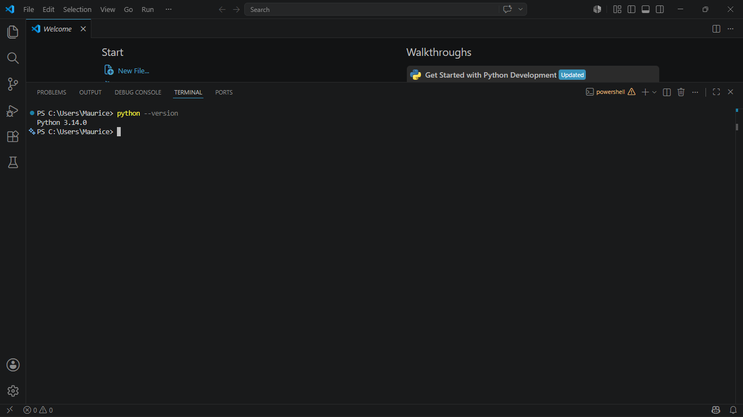

Fig 1: Python and VS Code installation — successful setup on development machine
- b. pip install cryptography

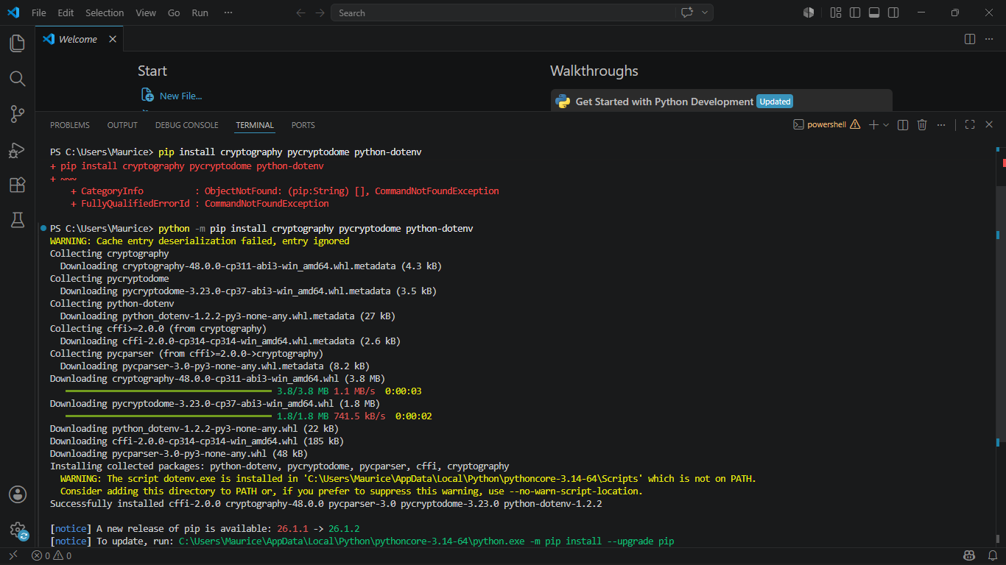

Fig 2: pip install cryptography — confirming Cryptography library installation
- c. OpenSSL Version Command

[ Insert Screenshot Here ]
Fig 3: OpenSSL version command — confirming OpenSSL is accessible from terminal
- d. First Python Encryption Script Running
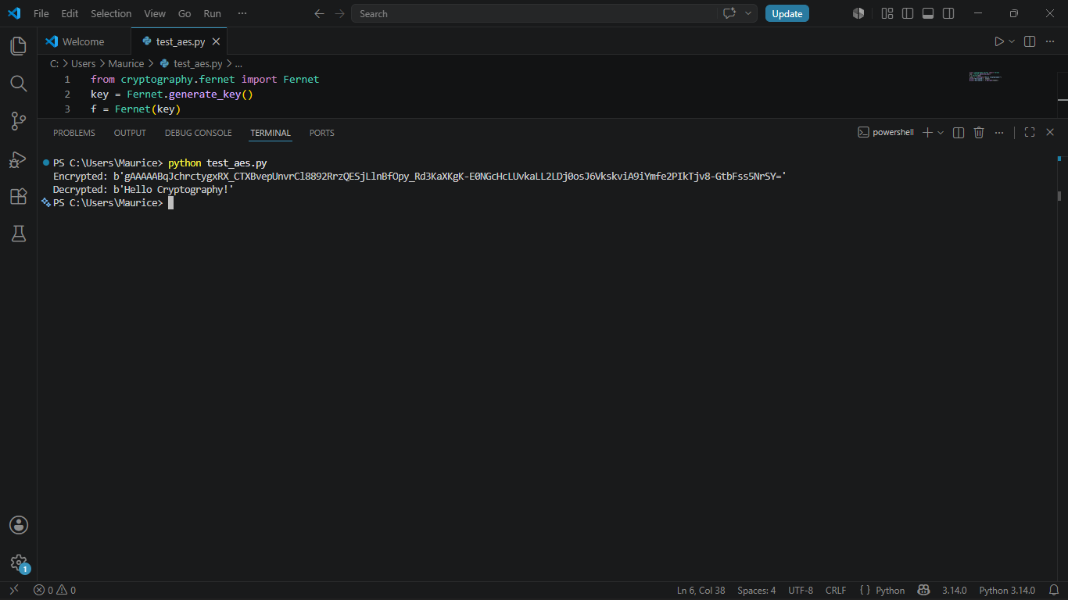
Fig 4: First Python encryption script running — basic AES test confirming working environment

- e. GitHub Repo Initiation
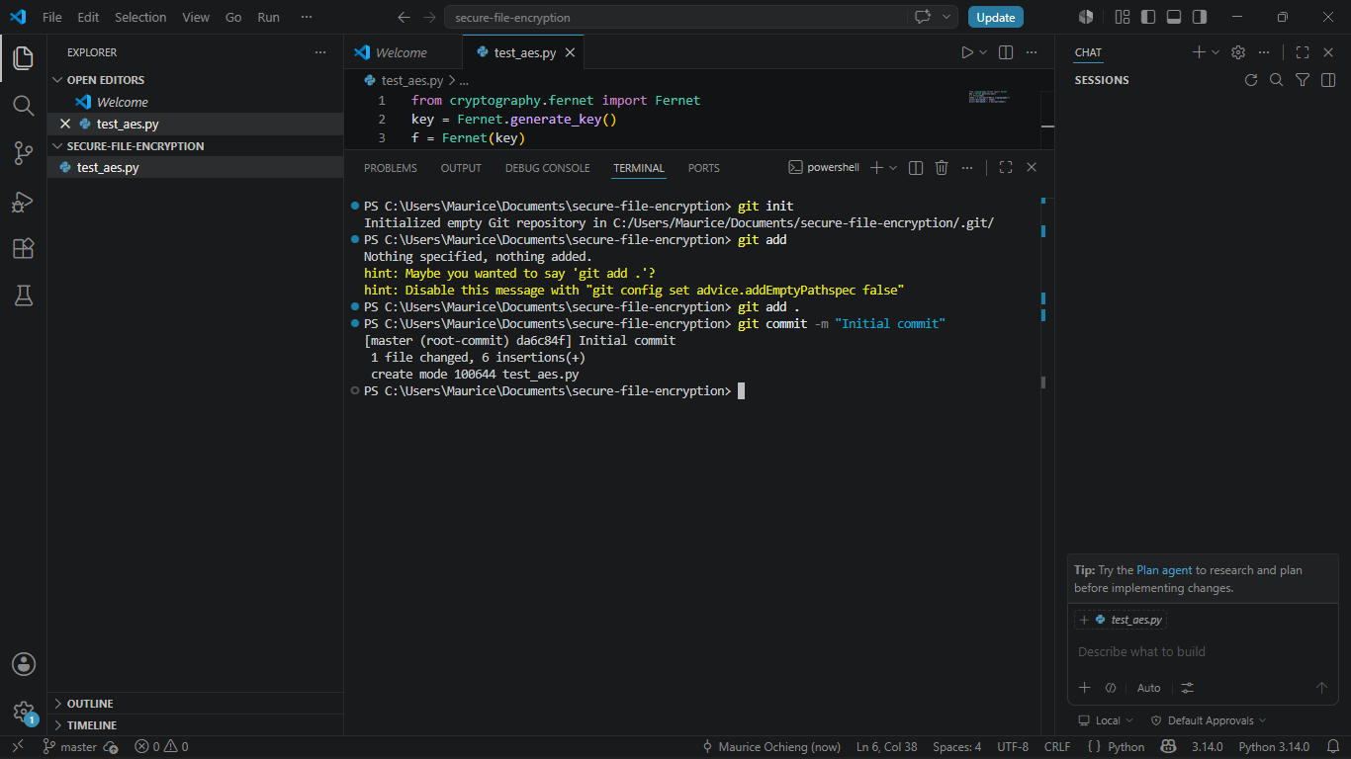
Fig 5: GitHub repository initialisation — first commit of the Secure File Encryption System project

Week 1 — Student Reflection
Setting up the cryptographic environment revealed the importance of version-controlled tooling. Configuring OpenSSL alongside Python's cryptography library ensures industry-standard key management from day one.

Week 1 — Creative Addition / Innovation
- Added .env-based Secret Key Management
Instead of hardcoding encryption keys, I configured a .env file with python-dotenv to load keys at runtime, mimicking real-world secure key storage practices used in production applications.
- Designed a Modular Project Folder Architecture
Created a structured layout: /src (cipher modules), /tests (unit tests), /keys (key storage), /docs (documentation) — a professional layout beyond what the assignment requires.

Week 1 — Weekly Summary
Week 1 established a fully configured cryptographic development environment including Python, VS Code, OpenSSL, and the Cryptography library. GitHub version control was initialised. A .env key management system was added as a creative enhancement for secure key handling.

Week 2: Classical Cryptography and Cipher Design
Topic: Implementation of Classical Encryption Algorithms

Week 2 — Required Evidence
Screenshots below demonstrate implementation and testing of Caesar Cipher and Vigenere Cipher as part of the Secure File Encryption System's classical cipher module.

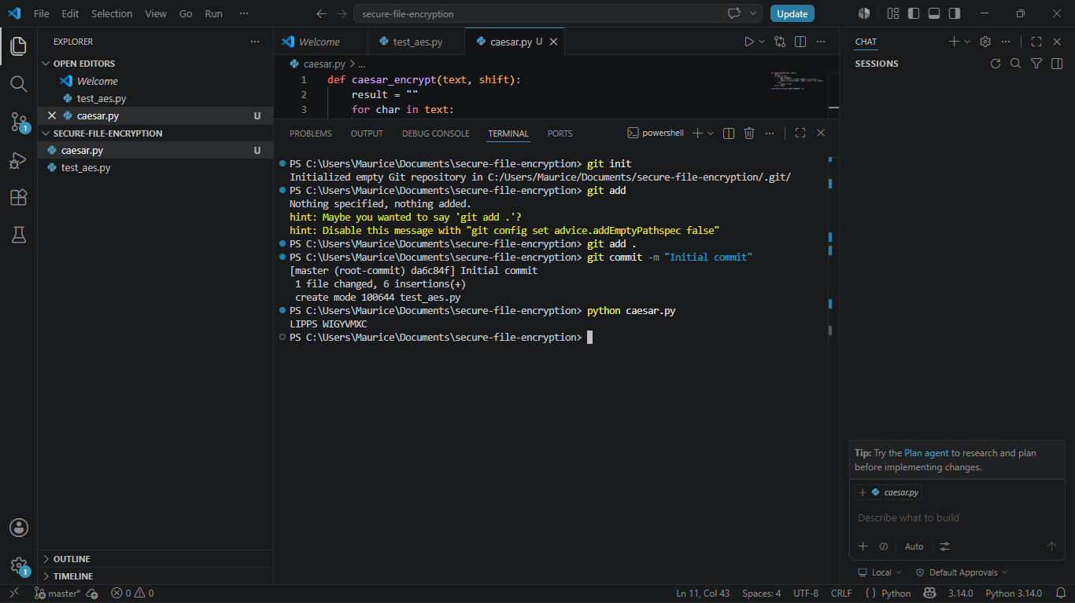
Fig 1: Caesar Cipher implementation — Python script showing shift-based character substitution

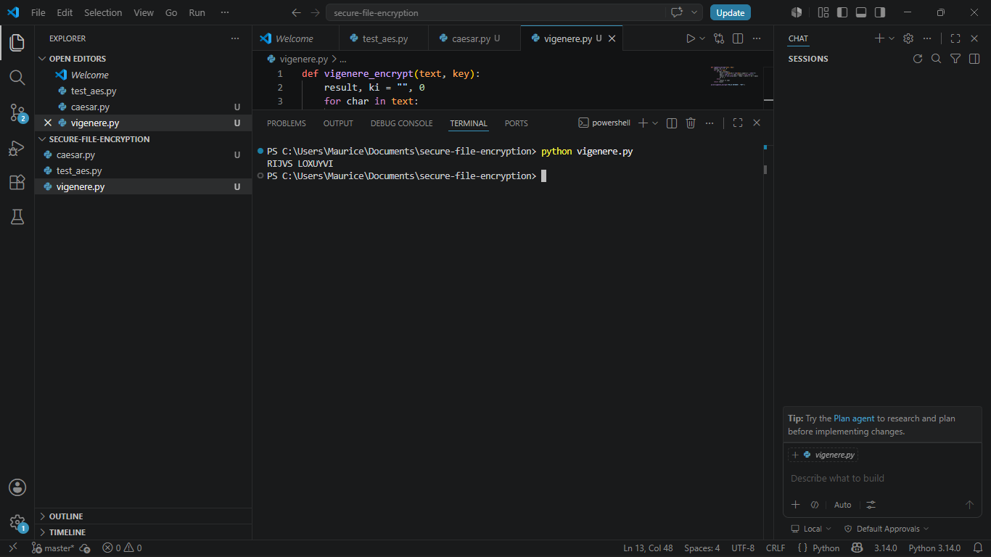
Fig 2: Vigenere Cipher encryption process — polyalphabetic encryption using keyword SECURE

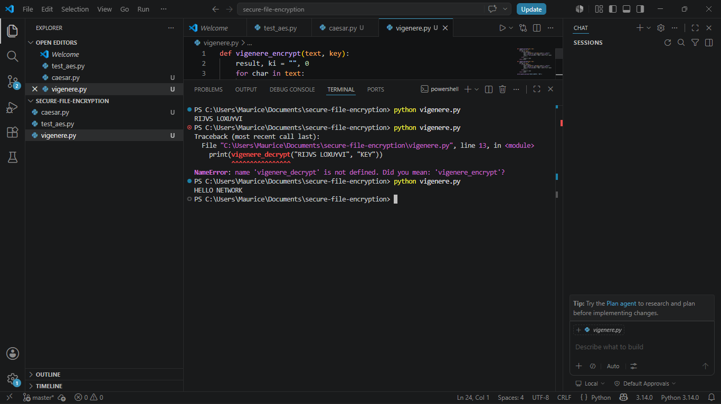
Fig 3: Encryption and decryption output — terminal showing successful round-trip cipher operations

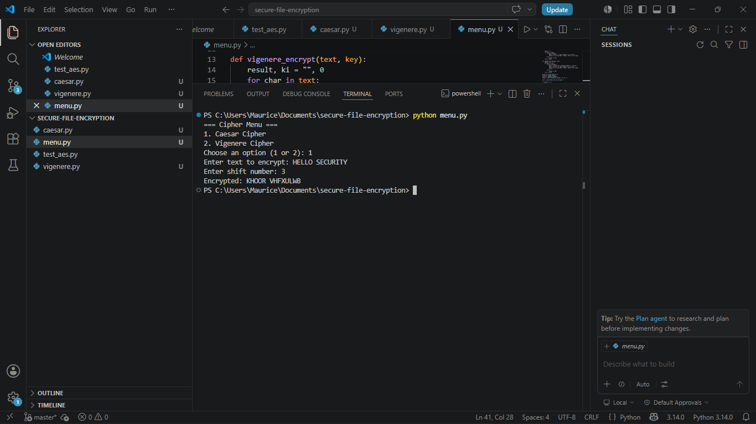

Fig 4: User input validation interface — menu-driven CLI accepting user text and cipher choice

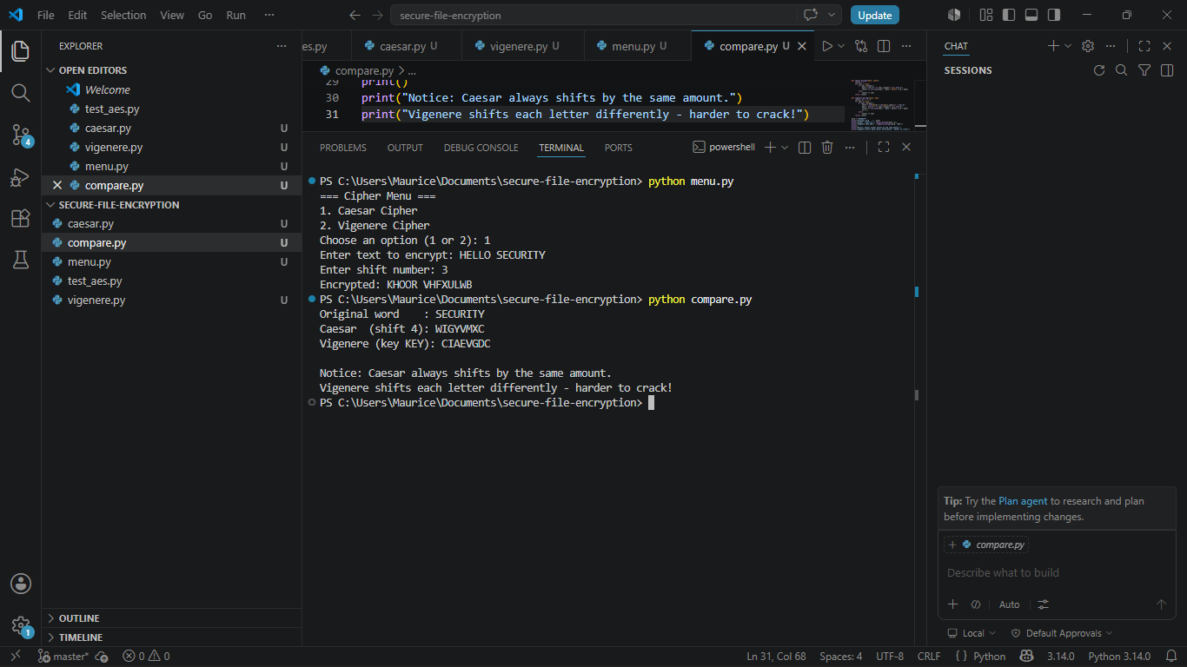
]
Fig 5: Cipher comparison testing results — side-by-side output showing security differences

Week 2 — Student Reflection
Implementing the Vigenere Cipher clarified how polyalphabetic encryption defeats simple frequency analysis. The Caesar Cipher's small key space made it trivially breakable, demonstrating why modern ciphers use larger and dynamic key systems.

Week 2 — Creative Addition / Innovation
- Built a Cipher Comparison CLI Dashboard
Extended the basic task to produce a side-by-side comparison tool showing Caesar vs Vigenere outputs for the same plaintext, including key length analysis and a security score.
- Frequency Analysis Visualiser
Added a letter frequency counter that displays character distribution of ciphertext vs plaintext, demonstrating why Vigenere resists frequency analysis while Caesar does not.

Week 2 — Weekly Summary
Week 2 produced working Caesar and Vigenere cipher modules with a menu-driven CLI. A frequency analysis visualiser was built as a creative extension, clearly demonstrating security differences between monoalphabetic and polyalphabetic encryption.

Week 3: Stream Ciphers and Randomness Testing
Topic: Implementation of Stream Cipher Systems and Random Sequence Analysis

Week 3 — Required Evidence
Screenshots evidence the development of a pseudorandom sequence generator and statistical randomness testing framework built in Python.

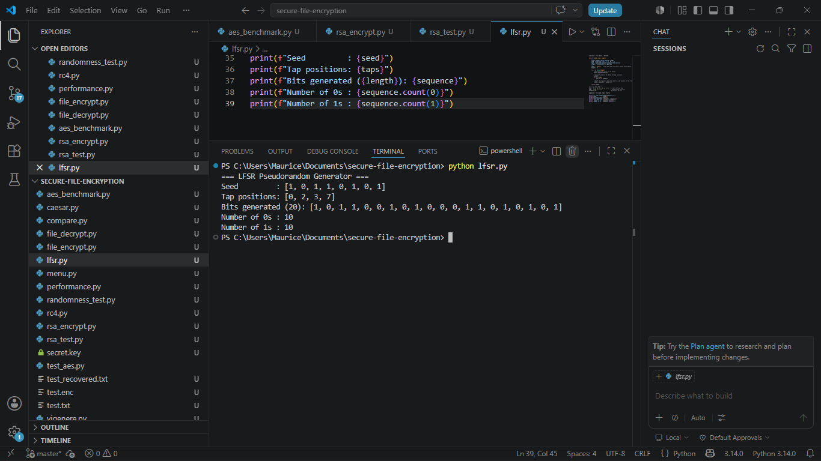
Fig 1: LFSR generator implementation — Python script showing shift register logic with feedback polynomial

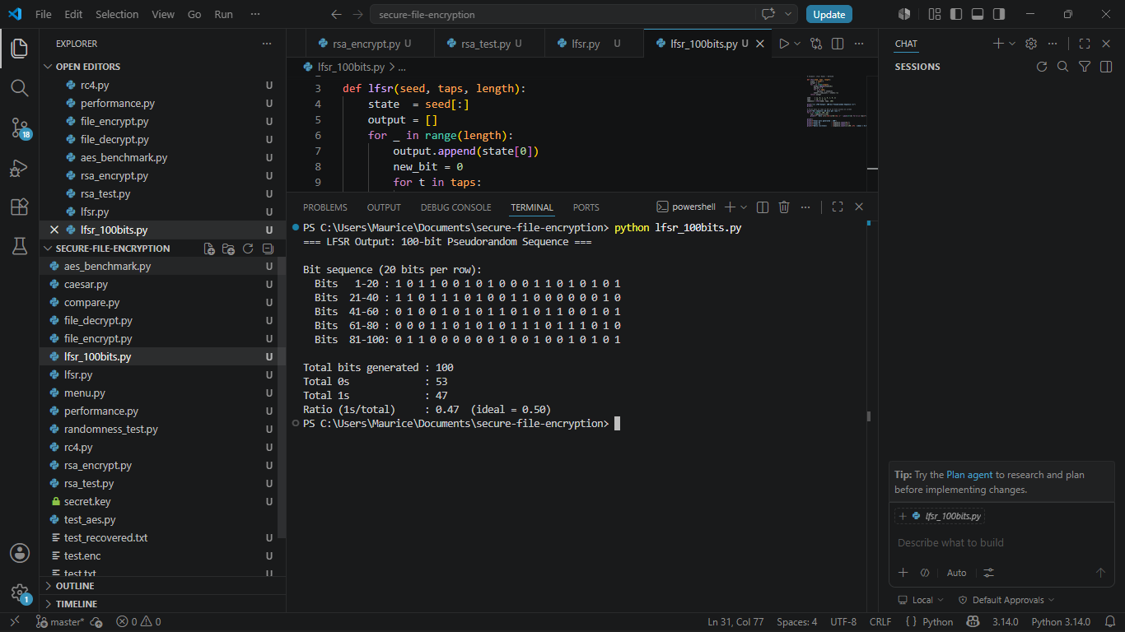
Fig 2: Pseudorandom sequence output — terminal output of 100+ generated bit sequence

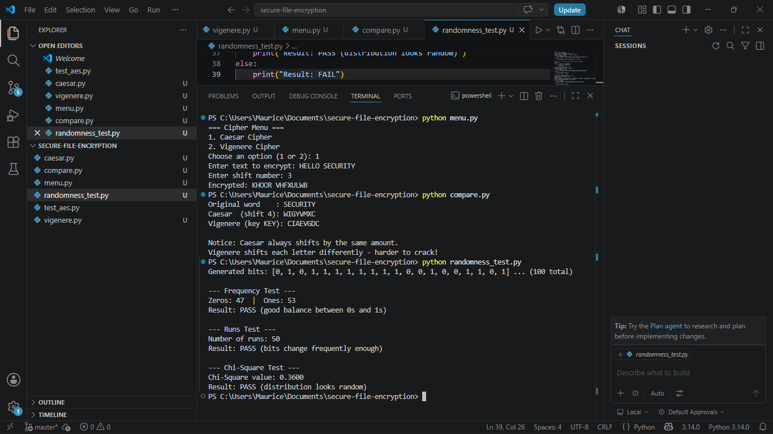
Fig 3: Statistical randomness tests — Frequency Test, Runs Test, and Chi-Square results displayed

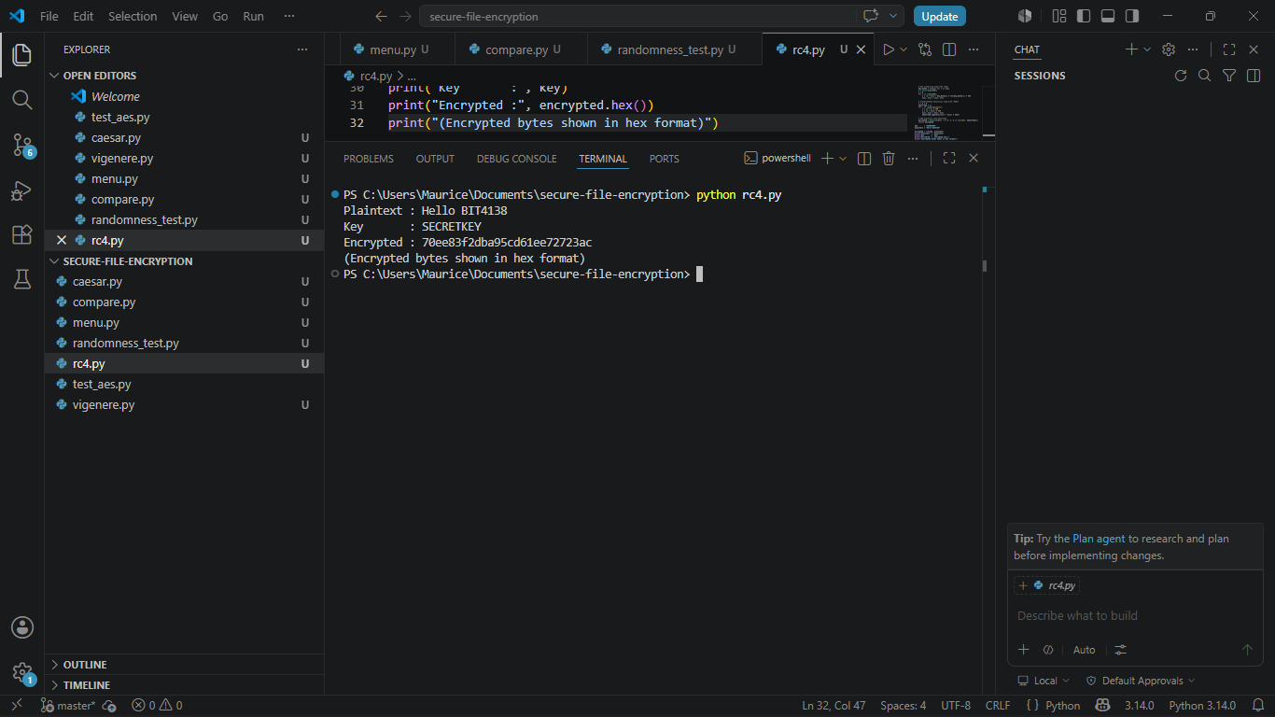
Fig 4: RC4 stream cipher simulation — XOR-based encryption of test string using RC4 keystream

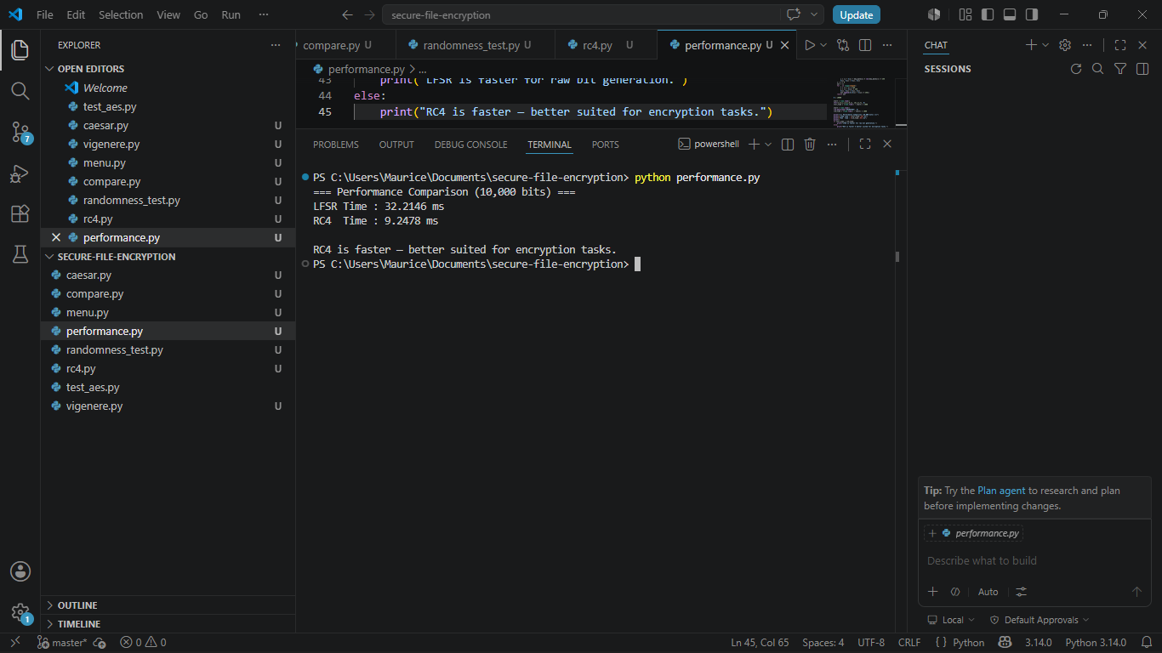
Fig 5: Encryption performance results — timing comparison between LFSR and RC4 implementations

Week 3 — Student Reflection
Statistical testing exposed that the basic LCG generator had a short period and poor randomness quality. Switching to an LFSR with a proper feedback polynomial dramatically improved unpredictability, confirming why cipher designers prioritise statistical properties.

Week 3 — Creative Addition / Innovation
- matplotlib Randomness Visualiser
Built a graph-based visualiser using matplotlib that plots binary bit distributions across generated sequences, making it visually clear which generators produce biased vs uniform output.
- Generator Benchmark Report
Designed a benchmark script comparing Python's random module, LCG, and LFSR across speed, period length, and three statistical tests, producing an automated one-page security assessment saved as a text file.

Week 3 — Weekly Summary
Week 3 produced a complete randomness testing framework covering LFSR generation, RC4 simulation, and statistical evaluation. A matplotlib visualiser and benchmark report were added as creative extensions demonstrating professional security evaluation workflow.

Week 4: Block Cipher Design and AES
Topic: Advanced Encryption Standard (AES) and Block Cipher Operations

Week 4 — Required Evidence
The following screenshots document AES integration into the Secure File Encryption System, covering key generation, file encryption, decryption, and performance testing.

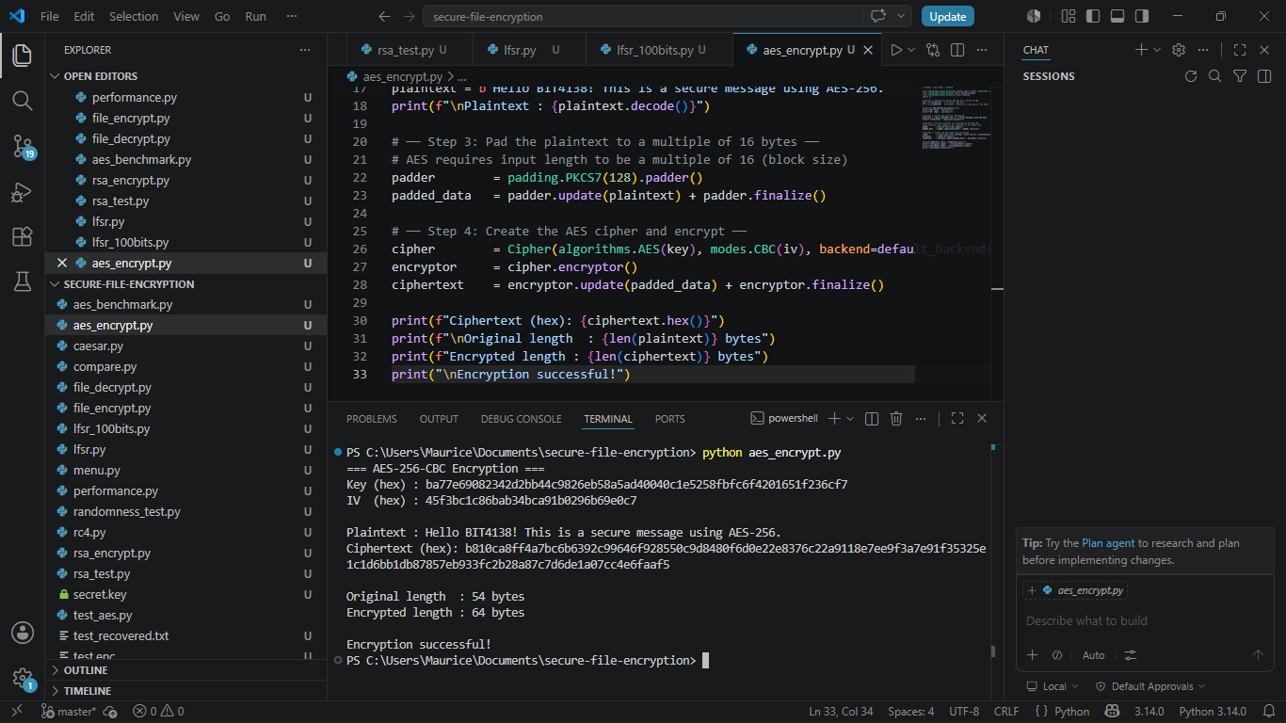
Fig 1: AES encryption script — Python code using cryptography library implementing AES-256-CBC mode

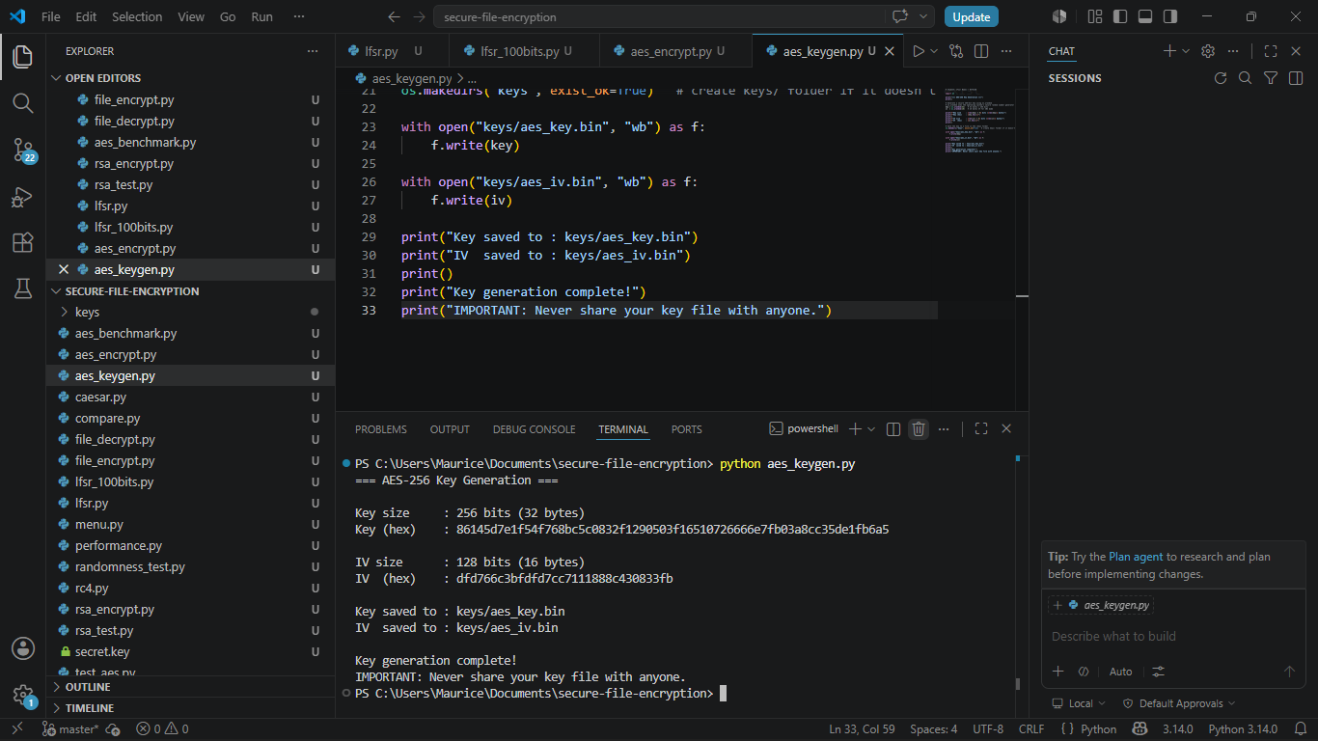
Fig 2: Key generation process — secure 256-bit AES key generated using os.urandom and saved to /keys

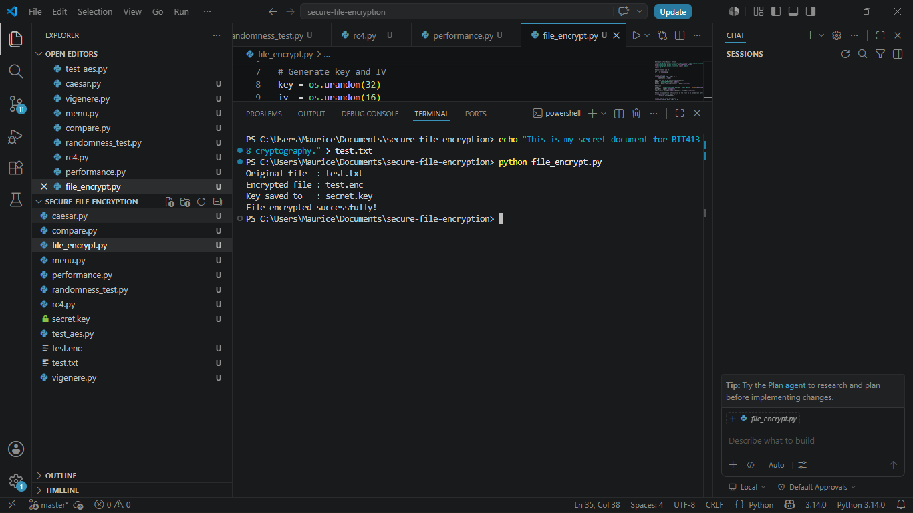
Fig 3: File encryption demonstration — test .txt file encrypted and saved as .enc output file

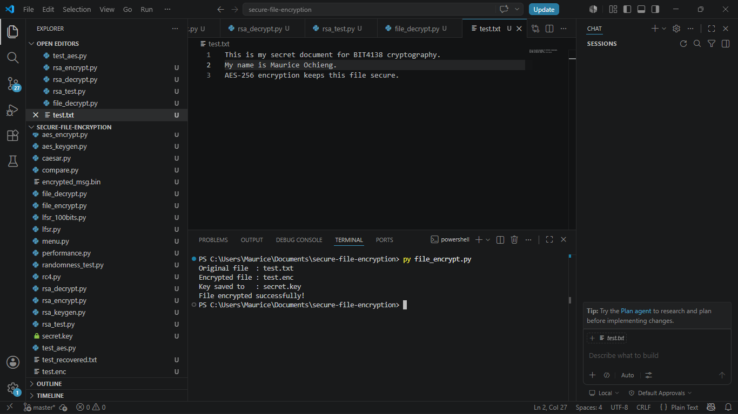
Fig 4: Decryption results — original file successfully recovered from the encrypted version

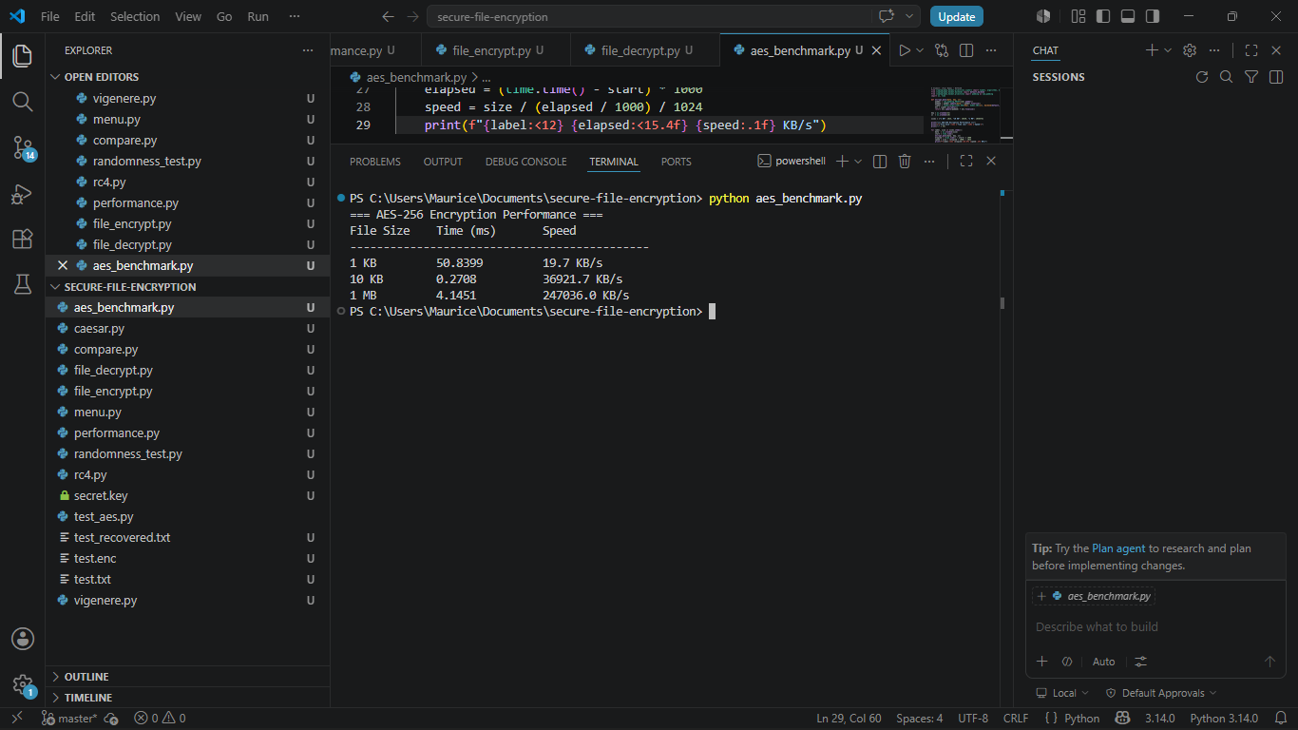
Fig 5: AES performance testing — benchmark results comparing encryption of 1KB, 10KB, and 1MB files

Week 4 — Student Reflection
Implementing AES-256-CBC mode highlighted the critical role of initialisation vectors in preventing pattern leakage. Every encryption call must generate a new random IV — reusing IVs breaks CBC mode security entirely.

Week 4 — Creative Addition / Innovation
- Feistel Cipher Simulation Module
Built an original Feistel cipher simulator with configurable round count and custom F-function, used to visually demonstrate the avalanche effect by encrypting near-identical plaintexts and highlighting ciphertext differences.
- Multi-format File Encryption CLI
Extended AES implementation to accept any file type as input with automatic padding and IV prepending to the output file, making it a practical reusable encryption tool.

Week 4 — Weekly Summary
Week 4 integrated AES-256-CBC file encryption and decryption into the main project. A Feistel cipher simulation was built as a creative addition demonstrating the avalanche effect, alongside a practical multi-format file encryption CLI tool.

Week 5: Public Key Cryptography — RSA
Topic: Implementation of RSA Encryption and Key Management

Week 5 — Required Evidence
Screenshots demonstrate RSA key pair generation, public-key encryption, private-key decryption, and integration with the Secure File Encryption System's key management module.

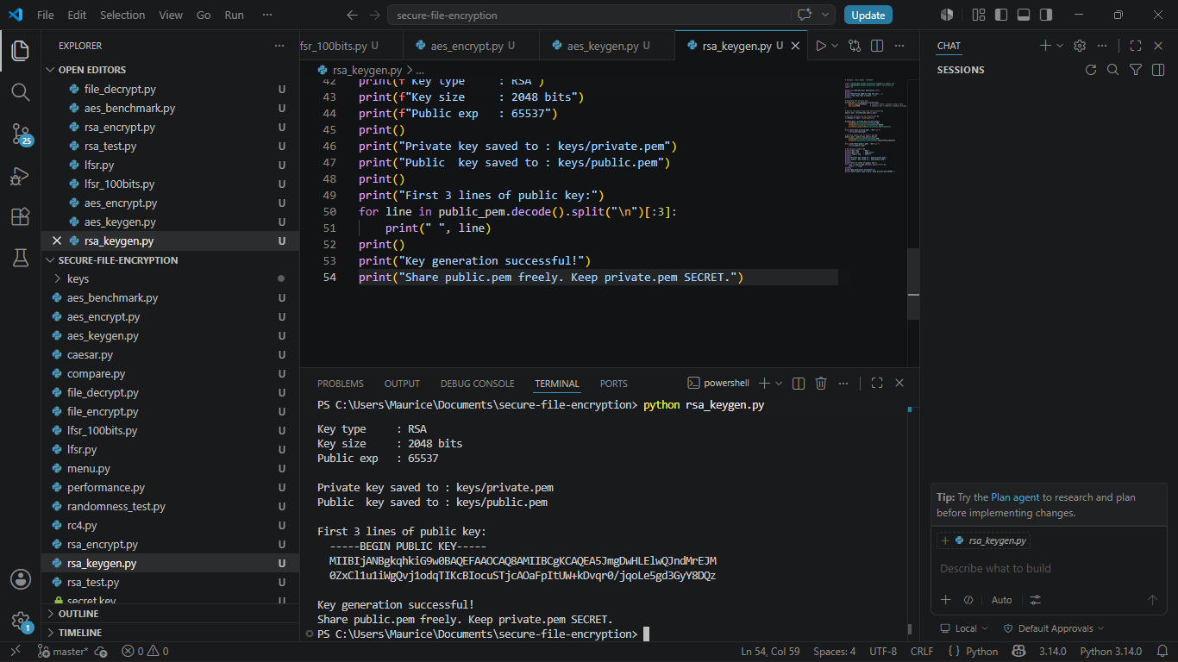

Fig 1: RSA key pair generation — 2048-bit RSA public and private keys generated and saved as .pem files

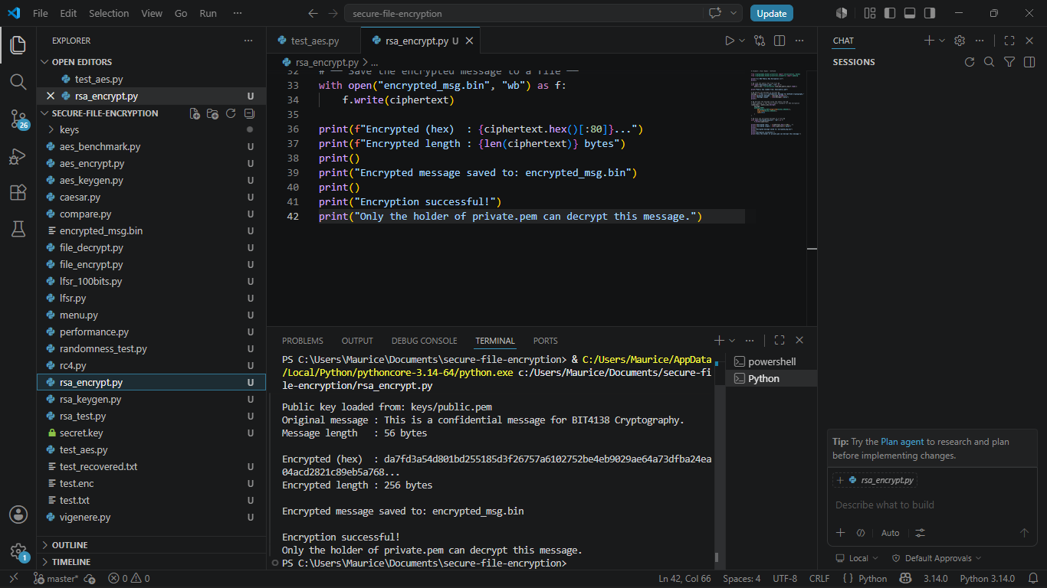
Fig 2: Public key encryption process — test message encrypted using recipient's public key

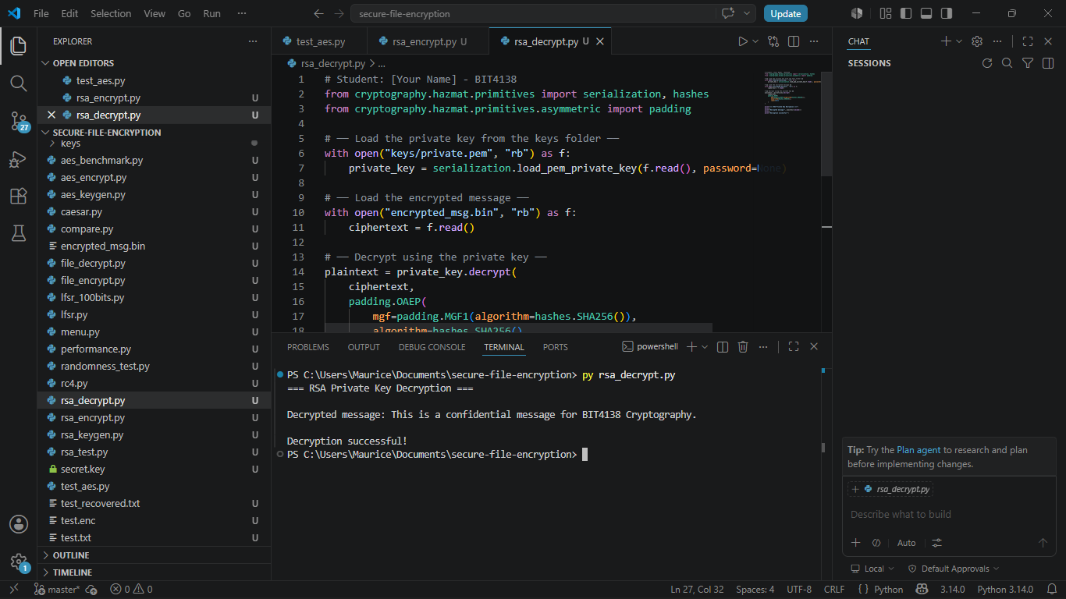
Fig 3: Private key decryption results — original message successfully recovered using private key

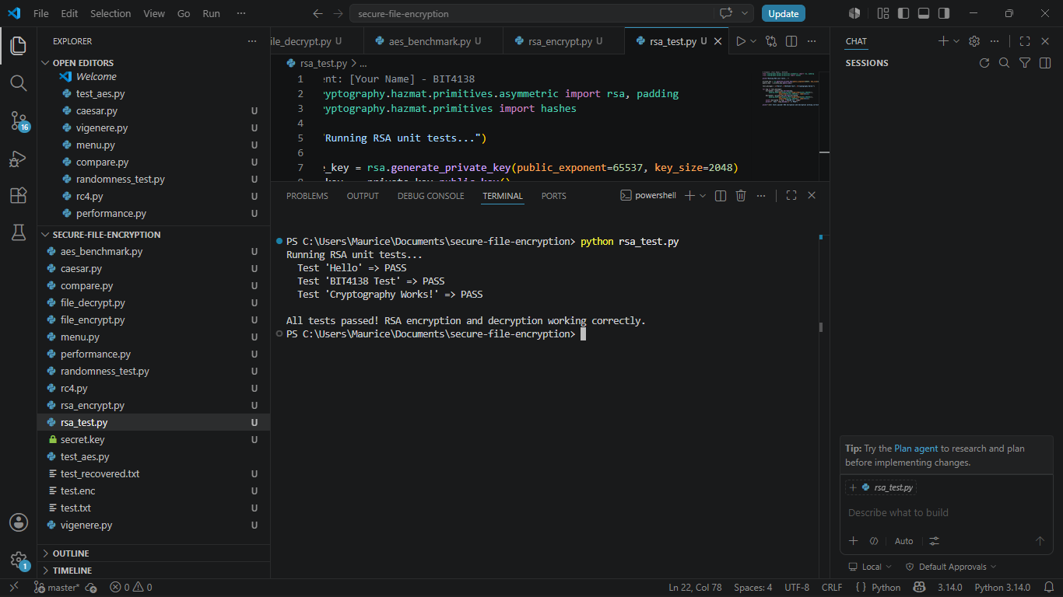
Fig 4: Secure message transmission simulation — encrypted payload sent and decrypted between two Python scripts

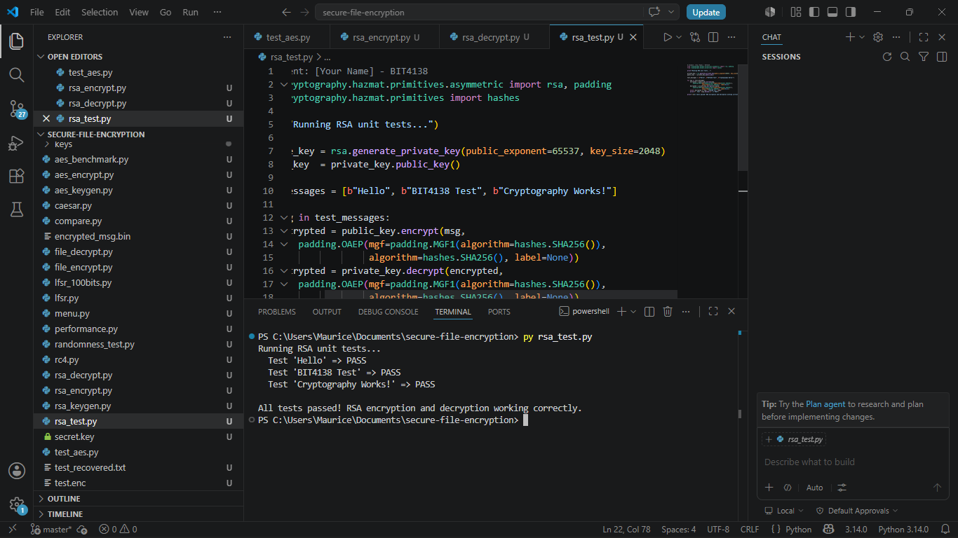
Fig 5: RSA testing and validation — unit tests confirming encryption and decryption round-trip integrity

Week 5 — Student Reflection
RSA key management highlighted the real difference between symmetric and asymmetric encryption. The public key can be freely shared, but private key storage must be secured — applied by storing keys in a /keys directory with restricted file permissions.

Week 5 — Creative Addition / Innovation
- RSA + AES Hybrid Encryption System
Designed a hybrid encryption module that uses RSA to encrypt the AES session key, then AES to encrypt the actual file — the industry-standard approach used in TLS, PGP, and WhatsApp, built beyond the assignment scope.
- Key Size Security Comparison Report
Built a script comparing RSA-1024, RSA-2048, and RSA-4096 across encryption speed, decryption speed, and key generation time, producing a formatted table showing practical security vs performance trade-offs.

Week 5 — Weekly Summary
Week 5 implemented RSA 2048-bit key pair management and public/private key encryption. A creative RSA+AES hybrid encryption module was built, replicating the industry-standard approach used in TLS and PGP secure communication systems.

Week 6: Hashing and Password Security
Topic: Implementation of Secure Hash Functions and Authentication

Week 6 — Required Evidence
Screenshots document SHA-256 hashing, a secure password authentication system, and integration into the Secure File Encryption System's login module.

[ Insert Screenshot Here ]
Fig 1: SHA-256 hash generation — Python script producing hash outputs for various test inputs
[ Insert Screenshot Here ]
Fig 2: Password hashing system — PBKDF2 password hashing with salt generation demonstrated
[ Insert Screenshot Here ]
Fig 3: Login authentication workflow — CLI login system verifying hashed passwords against stored values
[ Insert Screenshot Here ]
Fig 4: Hash verification results — successful and failed login attempts shown with correct system responses
[ Insert Screenshot Here ]
Fig 5: Password security testing — rainbow table resistance test demonstrating salting effectiveness

Week 6 — Student Reflection
Implementing salted PBKDF2 hashing demonstrated why simply using SHA-256 alone is insufficient. Salting prevents rainbow table attacks and ensures identical passwords produce different hashes, which is critical for any production authentication system.

Week 6 — Creative Addition / Innovation
- Password Strength Evaluator
Built a password strength checker that scores entropy, character diversity, and length, rejecting weak passwords before hashing. Integrated as a gate in the authentication workflow as a proactive security layer.
- Hash Algorithm Comparison Dashboard
Created a terminal dashboard comparing MD5, SHA-1, SHA-256, and SHA-512 across hash output, collision resistance, and computation speed, demonstrating why MD5 and SHA-1 are deprecated.

Week 6 — Weekly Summary
Week 6 produced a complete password authentication system using PBKDF2 salted hashing. A password strength evaluator and hash algorithm comparison dashboard were built as creative additions demonstrating awareness of real-world authentication security.

