Reference the screenshot below…

I am trying to build a foreach loop in the $messageHTML to pull the content required for the email message. But, so far I am getting an unpopulated list. I do still have a few elements that are from the tester, so I know that those need to be erased eventually. I am shooting for a similar foreach statement that is in the Order Items subheading.

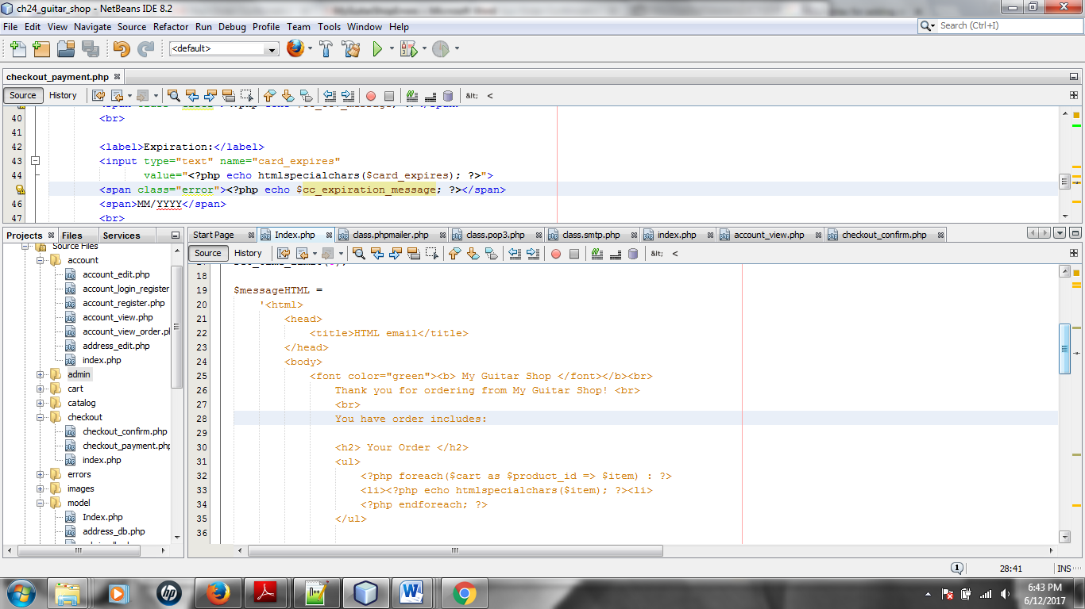

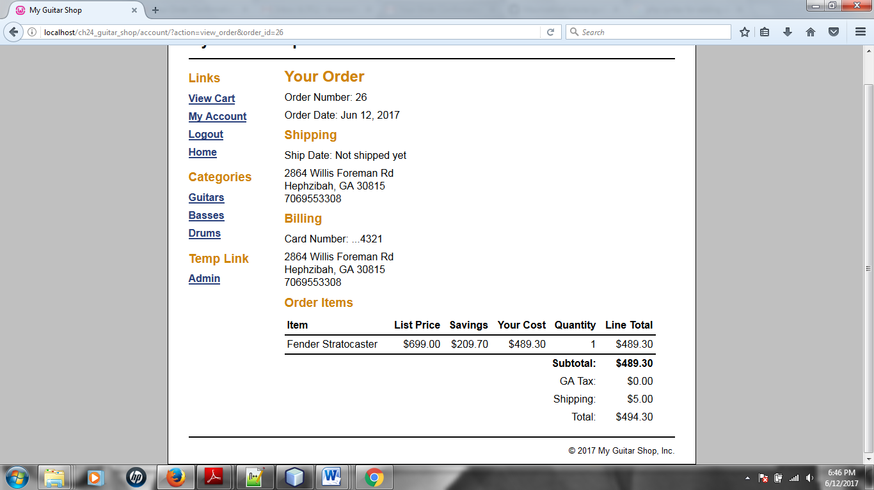

Another suggestion that Lerch made was adding a foreach statement in the blue highlighted area and referencing that in the $messageHTML section from above (Index.php)

Again, I’m struggling with how to code that in the $messageHTML section

