QP
1.
b)
5 day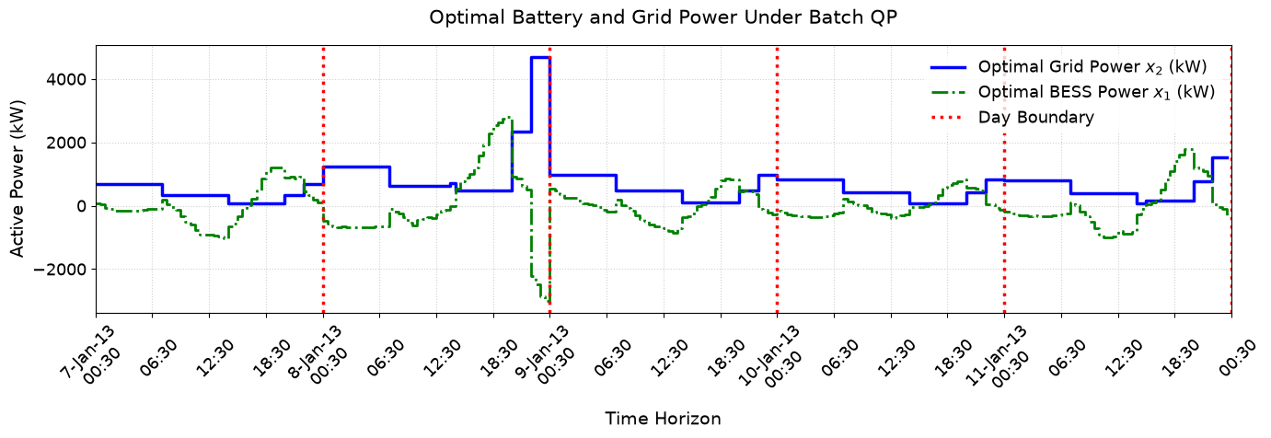
4 day
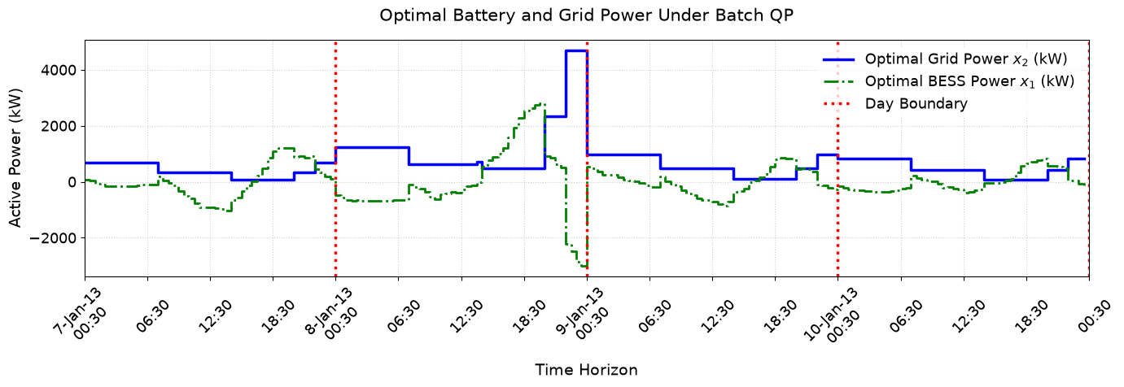
c)
the battery and grid powers must balance the net load at each timestep. The battery charges when the pv gen is higher than the load (indicating excess power). During noon-ish because of the excess power and low load, power is cheap so a little bit of power is also drawn from the grid. During the evening load peak, when power gets very expensive the battery discharges to reduce as much of the power usage during the high tarriff time to generate maximum savings. Typically, the battery charges when power is cheap and discharges when power is expensive. Grid power is utilized when needed (but it is often only needed during low tarriff periods)

2.
a)
5 day
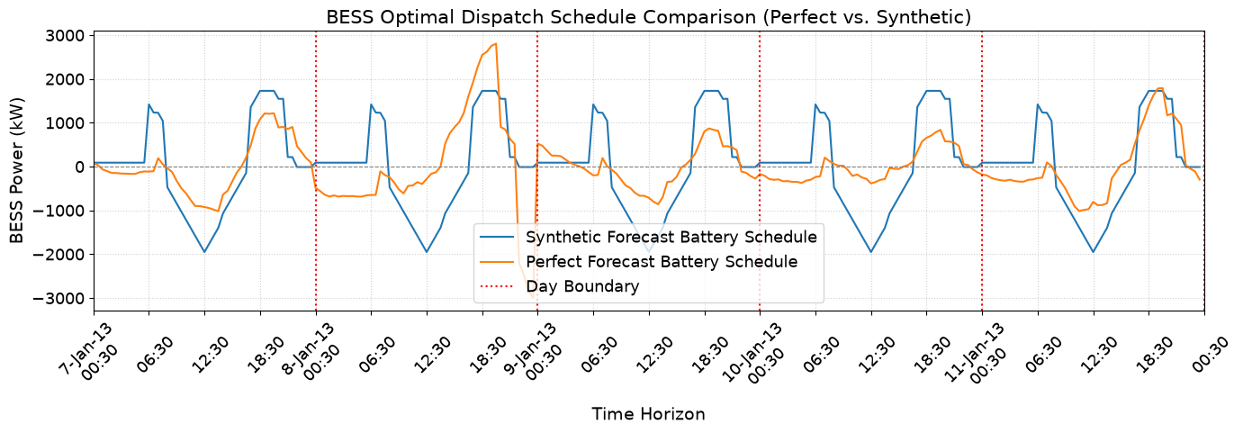
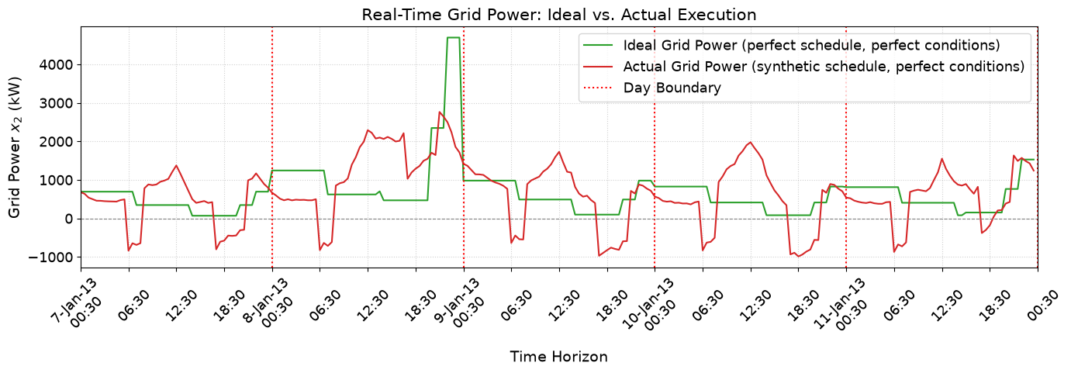
4 day
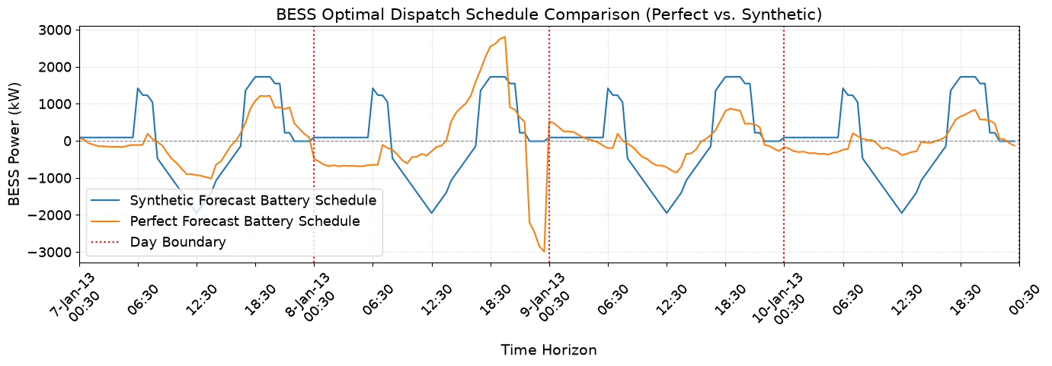
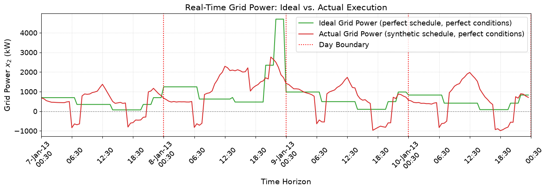

b)
Number of Days Analyzed: 5 days (240 steps)
Schedule Mean Absolute Error (MAE): 697.98 kW
Ideal Electricity Bill (Executing Perfect Forecast Schedule): $4509.70
Actual Electricity Bill (Executing Synthetic Schedule): $6511.32
Financial Loss Incurred due to Forecast Error: $2001.62

Number of Days Analyzed: 4 days (192 steps)
Schedule Mean Absolute Error (MAE): 742.85 kW
Ideal Electricity Bill (Executing Perfect Forecast Schedule): $3732.46
Actual Electricity Bill (Executing Synthetic Schedule): $5281.20
Financial Loss Incurred due to Forecast Error: $1548.75

c)
The actual grid power is significantly higher than the ideal grid power on the evening of the second day of the data. This would increase the electricity bill higher than what is ideal since the price is high during this time, so utilizing a higher amount of electricity than predicted is more significant during this time period.

Also just generally, (im guessing this is due to the perfect data assuming better solar pv performance / better weather) during noon of each day, the synthetic grid power is significantly higher than the ideal grid power use.
I am not fully sure how the payment system for exporting to the grid works in this :/
Also, not fully certain why the synthetic data BESS trajectory is the exact same cycle for each day whereas the perfect data has a significantly different battery charging/discharging structure each day?
I think the battery is charging more off the grid in the middle of the day maybe in order to satisfy the rigid charging schedule, then the battery is exporting power to the grid in the evening when power is expensive.

3.
a) Not sure if this is really still the 5 day electricity bill because I added the thing that supposedly only reads in 4 days of data. I assume that it is the 4 day electricity bill and the title is just wrong since I didn’t update that when I swapped the read function around!!!
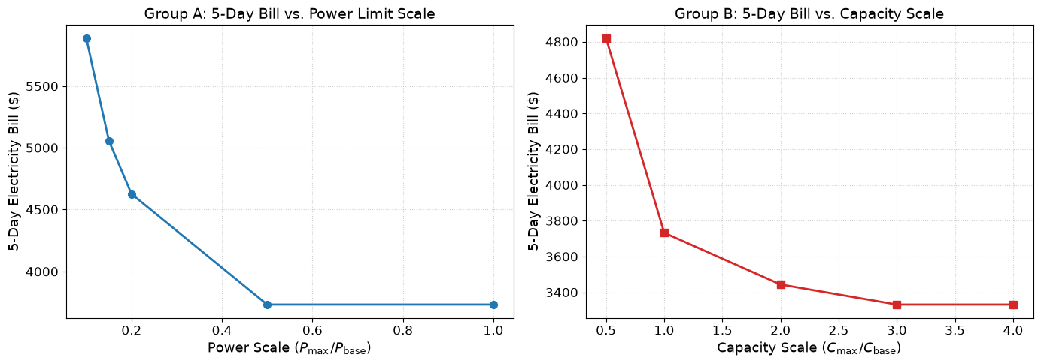

b)
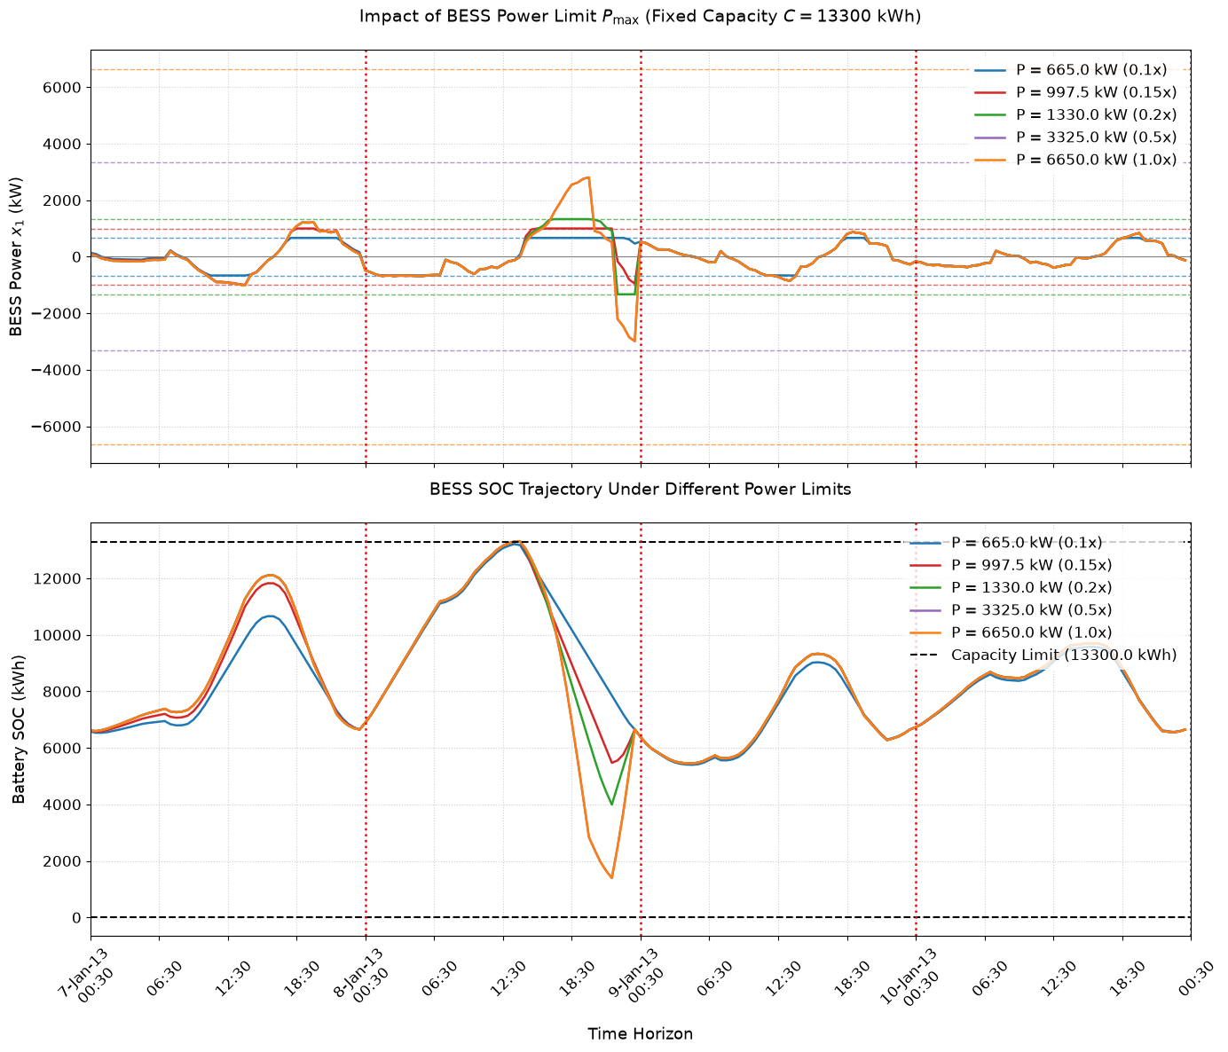
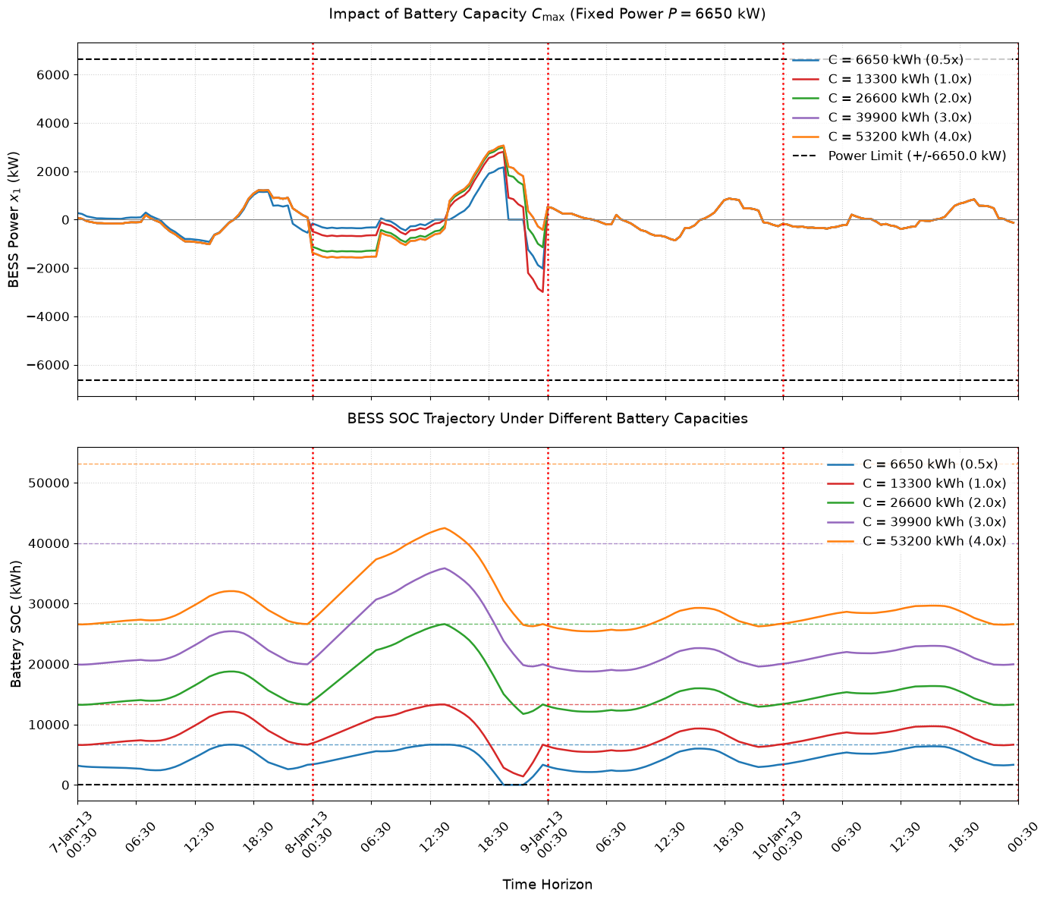

c)
Im not certain I fully understand this question.
I think you can see that for the constant power, changing capacity graphs, the capacity is binding for the capacities including C=26600kWh and below as you can see on the plots that the max capacity is being reached. For the capacities larger than this value, the capacity constraint is not binding.

d)
having a bigger battery (in terms of energy or power) allows for the battery to be utilized in a more versatile way and allows for better savings in many scenarios. However, after a certain point, the battery is too big to allow for the extra capacity to be utilized. This can be seen in the constant power, changing capacity graphs where the biggest capacity batteries don’t fill up completely at any point in the day. This could be because the battery is limited by the power rate and it cant fill up in time. Or it could be because there isn’t actually enough generation to fill up the battery (but I heavily suspect it is something more similar to the first one). It is possible that if you increased both power AND capacity, that the returns might be less diminishing for bigger sizes but since you are only changing one, you see the diminishing effects clearly.

4.
a)
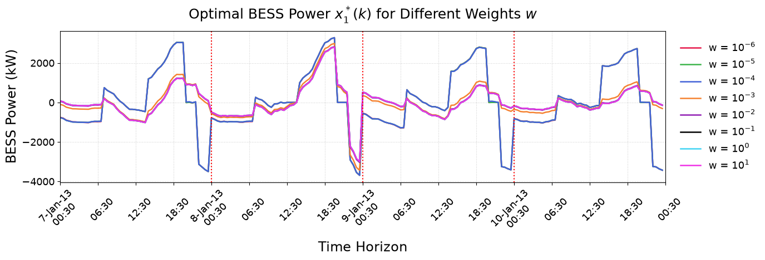
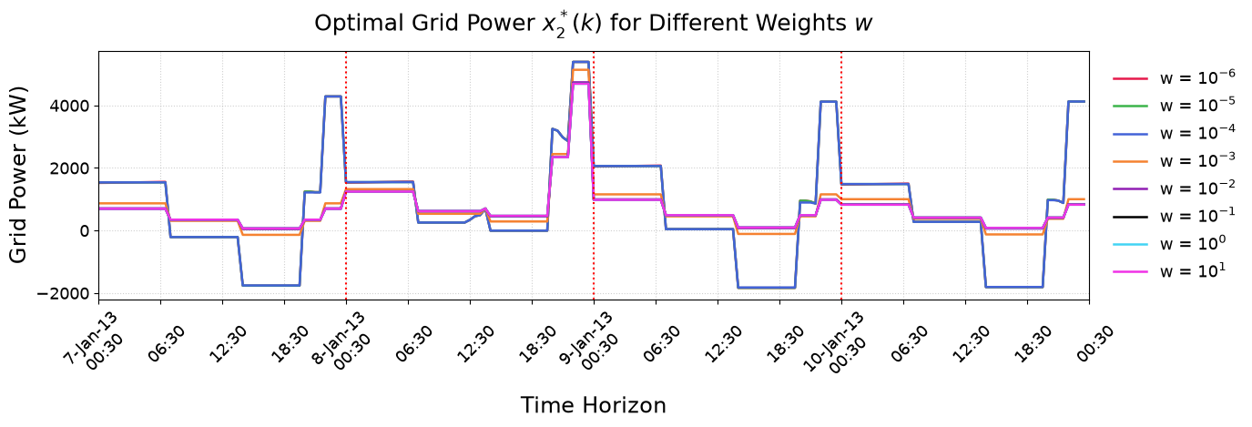

b)
w w_value Total_Savings_$ Grid_Power_StdDev_kW
0 $10^{-6}$ 0.000001 14364.001144 1716.198244
1 $10^{-5}$ 0.000010 14364.007244 1716.187019
2 $10^{-4}$ 0.000100 14331.887595 1713.890050
3 $10^{-3}$ 0.001000 5628.787220 837.979062
4 $10^{-2}$ 0.010000 4421.289988 730.690882
5 $10^{-1}$ 0.100000 4300.540232 720.593855
6 $10^{0}$ 1.000000 4288.465256 719.591482
7 $10^{1}$ 10.000000 4287.257758 719.491319
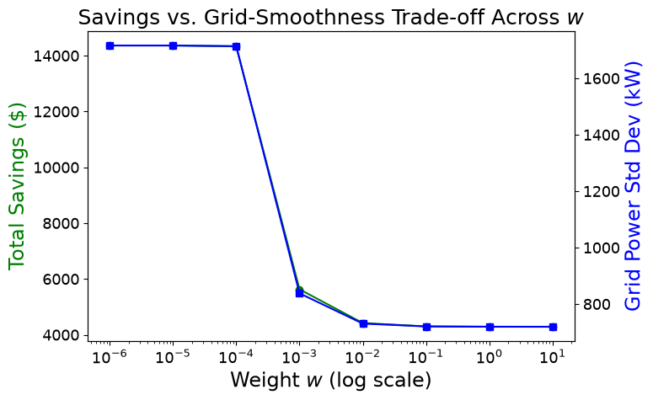

c)
KINDA NOT SURE ABT THIS ONE
I think the linear term is used to optimize the battery charging and discharging in order to minimize the electrical bill. Since it only focuses on minimizing the electrical bill, it tends to utilize large imports and exports in order to buy and sell to the grid at optimal moments, however this is kinda bad for the grid health. A quadratic term is added to attempt to solve this issue. I believe the quadratic term disincentivises trading power with the grid and a scaling term is added (w) so that the optimizing algorithm can be tuned to suit different circumstances (whether the customer needs to be more grid conscious or just purely wants the money/savings)

d)
KINDA NOT SURE ABT THIS ONE EITHER
When w is very small, the savings are relatively large but so is the grid power std dev, and as w gets bigger, both the std dev and the savings reduce drastically. This indicates that as w increases, the savings reduce but the negative impact on the grid also reduces. I SUSPECT THAT THE REASON THAT THE IMPACT OF W IS NOT VERY NOTICABLE AT EITHER EXTREME IS BECAUSE WHEN THE SCALING VALUE IS THAT SMALL/BIG THE QUADRATIC TERM IS EITHER WAY BIGGER OR SMALLER THAN THE LINEAR TERM REGARDLESS OF THE ACTUALL PRICE/POWER FLOW PARAMETERS. For example, if the linear term is 1 and you make w equal 0 (or 0.000001), then the quadratic term would have negligible impact over the overall value. But if you made w 1000000 then the linear term would have negligible impact.

MPC

a)
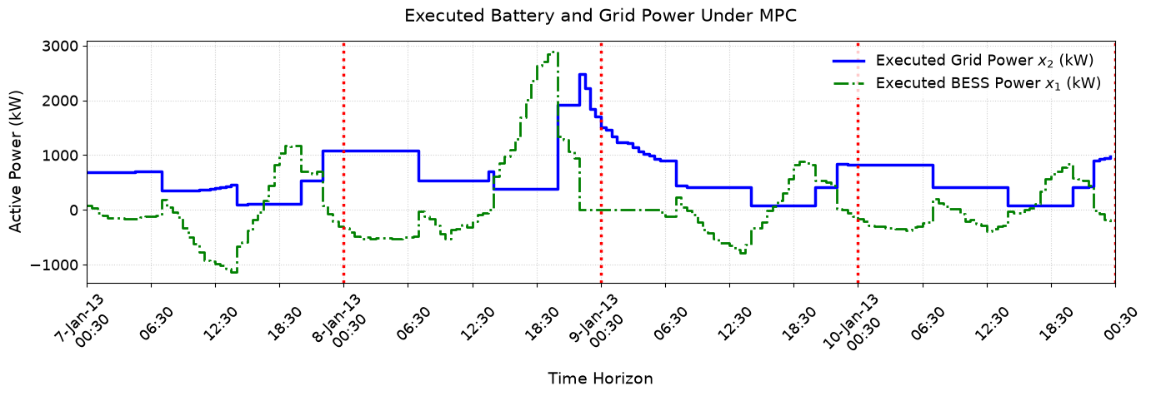
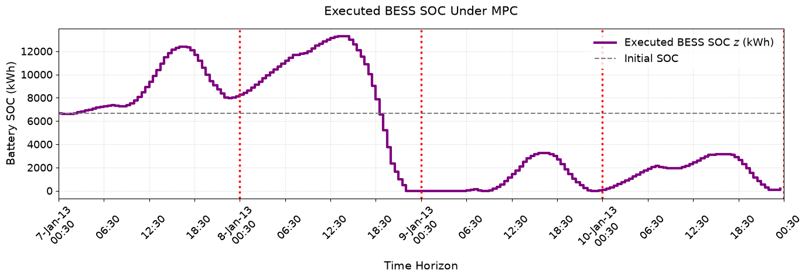
b)
the morning peak shaving is quite hard to see. There is a consistent bit of BESS discharging in the 7-10am range but its often pretty small in these plots. The point of morning peak shaving is to discharge the BESS a little bit in the morning to reduce the morning peak load since solar is not often super active yet and there is a steep increase in load as people wake up to go to work. Due to all the factors mentioned morning power is often a little more expensive than other power so it good for savings to use some BESS energy here.
The midday solar absorption phase is when the BESS charges off of the high solar generation that occurs during the middle of the day. Because of lots of solar pv, voltages in distribution grids can rise leading to problems or curtailment. Using the BESS to absorb this excess grid solar energy and redistribute it later in the day, reduces the duck curve while also providing some savings to the battery owner as they can avoid some of the expensive evening peak prices.
The evening peak clipping phase is when the BESS discharges some or all of the energy it has stored to reduce the steep load increase on the grid while also providing owners savings by reducing their high tariff electricity load.
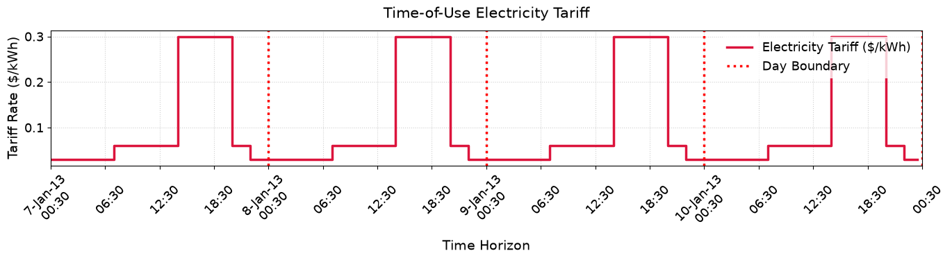
c)
the role of this constraint is to make sure that the controller utilizes the real, measured battery state as the initial/current battery state in the controller. This means that if the controllers model of the batteries performance/SOC is slightly wrong, the value of the SOC in the controller wont be allowed to drift too far from the real, measured value of the real physical BESS. Removing it could mean that if the model of the battery in the controller is slightly wrong, the error in the batteries SOC will be allowed to drift further and further which could cause errors in the system like trying to discharge when the battery is empty or trying to charge when the battery is at capacity.

2.
a)
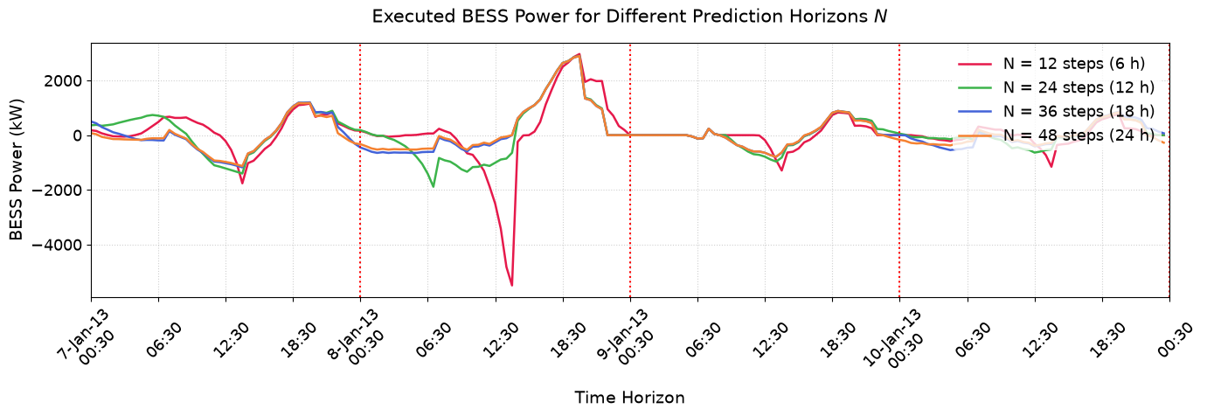
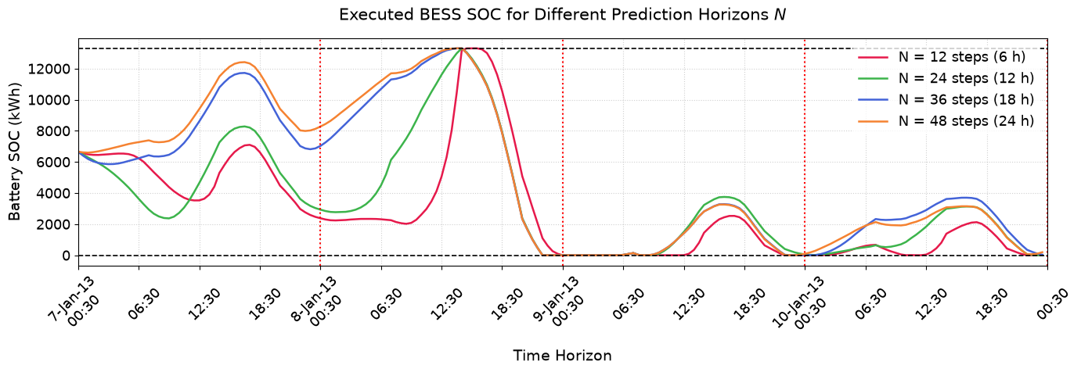
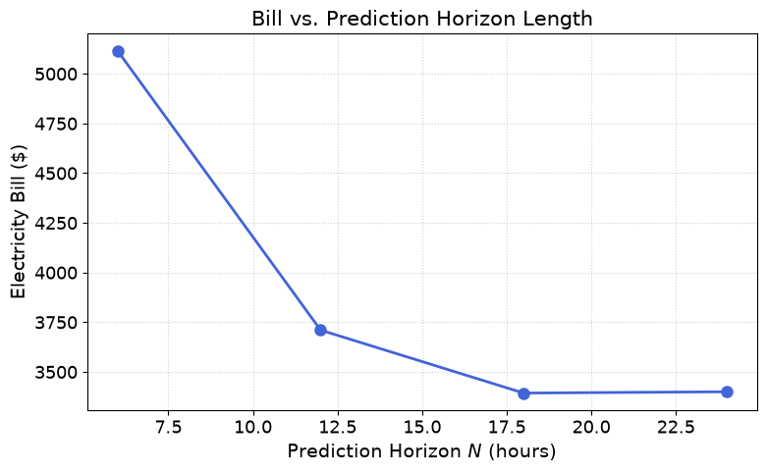
b)
Running MPC with N = 12 steps (6.0 h) ...
MPC QP Completed.
-> Bill: $5115.75
Running MPC with N = 24 steps (12.0 h) ...
MPC QP Completed.
-> Bill: $3710.34
Running MPC with N = 36 steps (18.0 h) ...
MPC QP Completed.
-> Bill: $3393.58
Running MPC with N = 48 steps (24.0 h) ...
MPC QP Completed.
-> Bill: $3400.15

c)
A prediction horizon that is too short means that the controlling system cant see a day with a high predicted load (such as a super hot day or something where everyone has their ac on) a day ahead and so it cant store up SOC for as long beforehand, meaning that the shorter prediction horizon controllers make the bess charge during less ideal conditions than the longer horizon controllers. This is particularly visible in day one and two of the sample data in the plots above.

3.
a)
============================================================
Day-ahead, perfect forecast -- Bill: $3732.46
Day-ahead, synthetic forecast -- Bill: $5281.20
MPC, perfect forecast -- Bill: $3400.15
MPC, synthetic forecast -- Bill: $5252.82
------------------------------------------------------------
Day-ahead financial loss from forecast error: $1548.74
MPC financial loss from forecast error: $1852.66

b)
the day ahead financial loss from forecast error is lower by $303.92

c)
I would say that the price of the bill is what can be used to measure the controllers performance when exposed to forecast error. The higher the bill is, the worse the controller performs with forecast error. The MPC system has lower bills when using both the perfect and erroneous forecast data which I would say means that it is better in both scenarios.
However, if you use the performance with perfect data as a baseline, then you can say that the higher the financial loss due to forecast error is, the less resilient the controller is to errors in the forecast. The MPC controller performs far better than the day ahead controller in the perfect data scenario which sets a lower baseline for the MPC controller. In the synthetic data scenario however, the MPC controller only performs marginally better (approx. $50 or something small), this means that as MPC performs better in the perfect data case, even though the bills are lower in both cases, it could be said that MPC is more sensitive to bad forecast data.

4.
a)
============================================================
GROUP A: Fixed Capacity, Varying Power
============================================================
Power Scale: 0.10x | P_max: 665.0 kW | Bill: $ 5725.70
Power Scale: 0.15x | P_max: 997.5 kW | Bill: $ 4790.04
Power Scale: 0.20x | P_max: 1330.0 kW | Bill: $ 4321.35
Power Scale: 0.50x | P_max: 3325.0 kW | Bill: $ 3400.15
Power Scale: 1.00x | P_max: 6650.0 kW | Bill: $ 3400.15

============================================================
GROUP B: Fixed Power, Varying Capacity
============================================================
Capacity Scale: 0.5x | C_max: 6650 kWh | Bill: $ 4654.77
Capacity Scale: 1.0x | C_max: 13300 kWh | Bill: $ 3400.15
Capacity Scale: 2.0x | C_max: 26600 kWh | Bill: $ 2991.88
Capacity Scale: 3.0x | C_max: 39900 kWh | Bill: $ 3254.30
Capacity Scale: 4.0x | C_max: 53200 kWh | Bill: $ 3348.82
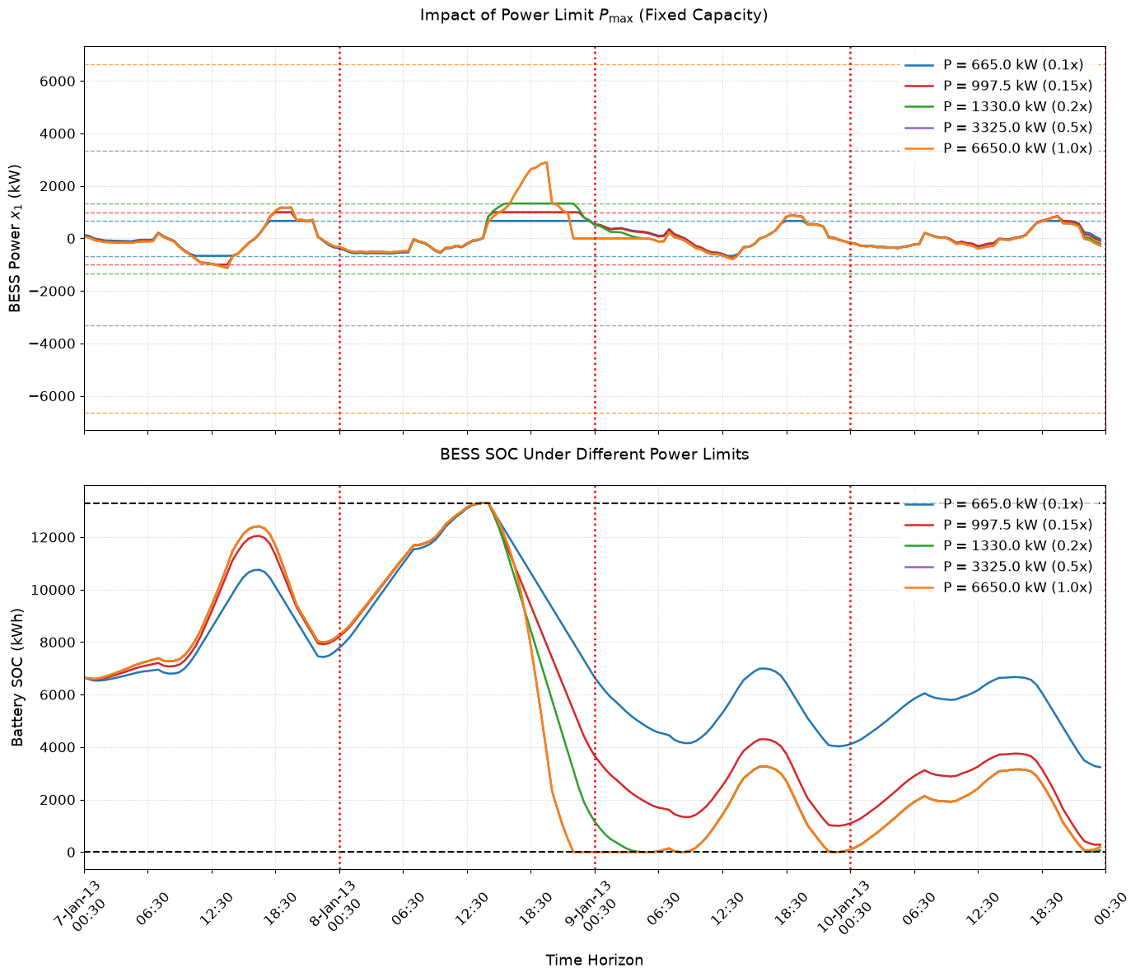
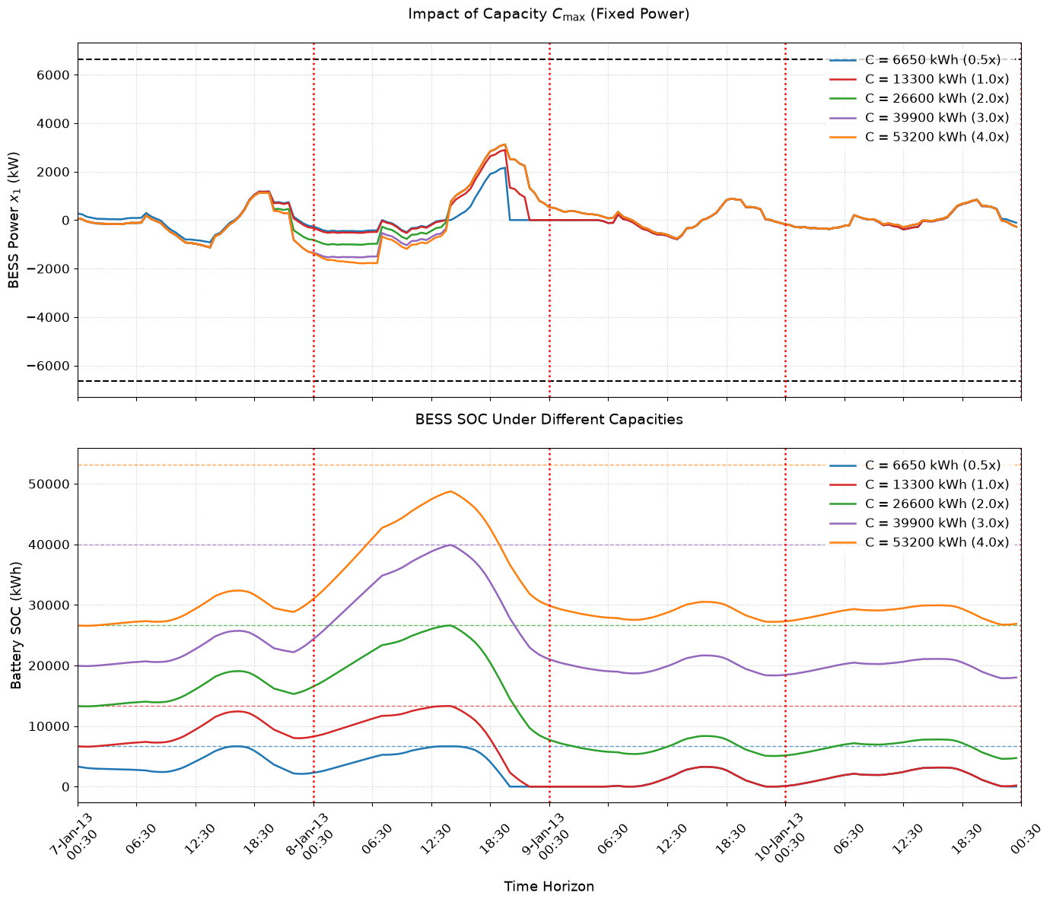
THE ABOVE PLOTS ARE JUST IN CASE ITS NEEDED. THE BELOW PLOT IS THE ONE THE QUESTION ACTUALLY ASKED FOR!!! (I think)
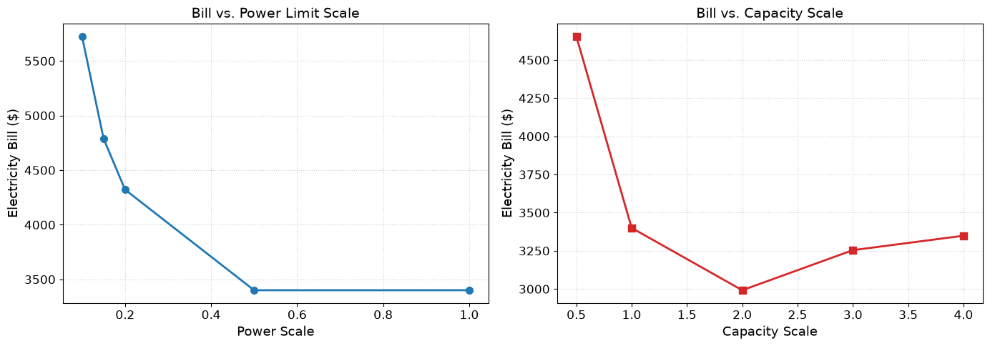
b)
The power limit vs electricity bill plots are very similarly shaped except MPC seems to be at a lower price at each point and the final settled price is lower for MPC too.
The bill vs capacity graphs are fairly different sizes though, with the MPC plot rising back up (getting more expensive) when the capacity gets too big. Even though MPC has this weirdly shaped plot, I think every point on the plot shows MPC to have a lower bill at each capacity value.
Truly not sure why MPC rises up like that. It could be that I did the formula wrong at the start of the MPC section? Because im getting some results that I find weird.

c)
It seems that in the constant capacity graph, the capacity is hit every time. And in the constant power graph the max capacity is reached for every capacity except for C=53200kWh. In the changing power graph, the capacity limit could be impacting the results since the max capacity is already being reached in every case, so having more power could be less useful since you cant actually use it once the capacity is maxxed.

d)
The bill does rise up again as you can see in the plot above. Since the power value of the battery is not increasing, I think that having super big capacity means that the controller will stockpile energy for in case it needs it later causing costs, but then the system cannot discharge the energy fast enough in the high tariff window to recoup the losses from charging. Once the capacity gets too big, the power limit results in a lot of that capacity being essentially useless and if the controller fills that capacity then it will not be able to effectively discharge that energy to generate profits. This could possibly make the controller more sensitive to forecast errors.

5.
a)
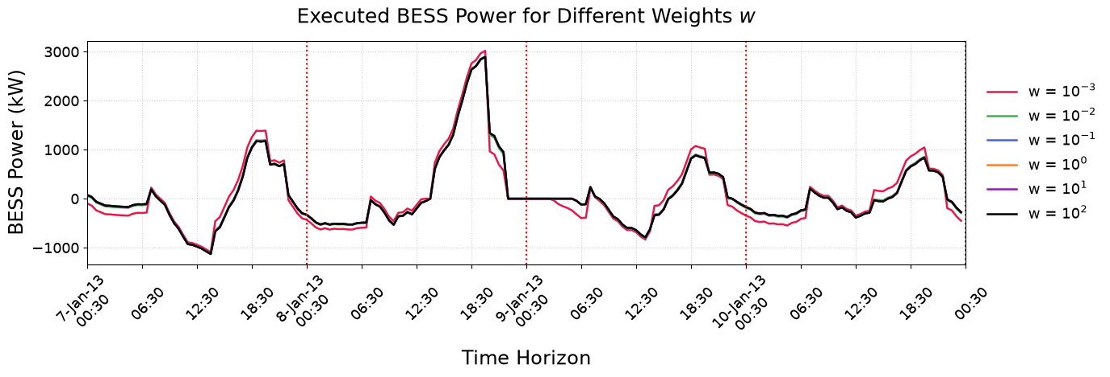
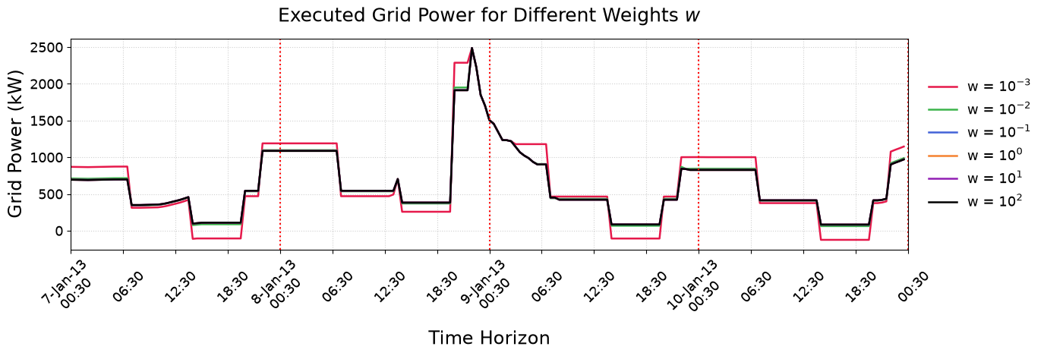
w w_value Savings_$ Grid_Power_StdDev_kW
0 $10^{-3}$ 0.001 5808.551206 557.433118
1 $10^{-2}$ 0.010 4734.981371 454.146485
2 $10^{-1}$ 0.100 4631.196668 445.522159
3 $10^{0}$ 1.000 4620.770056 444.659064
4 $10^{1}$ 10.000 4619.719502 444.574217
5 $10^{2}$ 100.000 4619.622209 444.564542
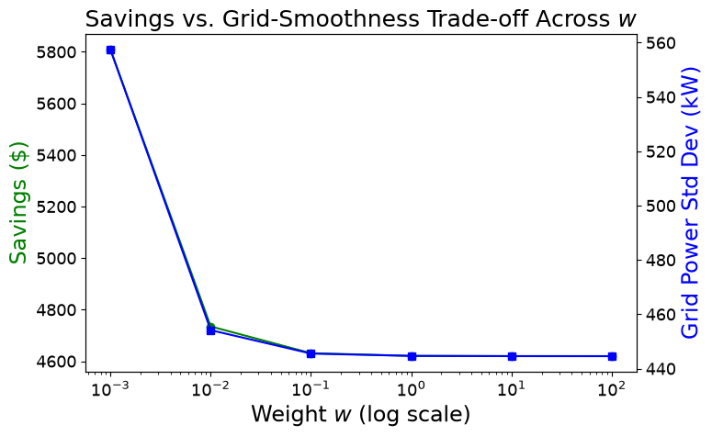

b)
MPC seems more grid focused for the weight values tested we can see that the savings and std dev are pretty low.

c)
For most of the weight values tested, the controller seems to be more grid focused compared to day ahead. the std dev is WAY lower than the day ahead controller that is shown in the plot below. The minimum value of std dev in the day ahead model is approx. 800kW but the max in the MPC controller is approx. 560kW. However, the savings of the day ahead model seem to be much higher for many of the weight values tested. Unlike the day ahead plots shape (which is kinda similar to -tanh(x)) the MPC controller seems to have a shape more similar to 1/e^x or so. Though it could be that we are only seeing part of the plot and that in the MPC controller the plot is shifted in the x (w) direction a little bit.

One very possible reason for the MPC controllers high smoothness is that it is both predicting and adjusting the system as time progresses whereas day ahead predicts a whole day and then cant really adjust it based on real measurements. MPC is also able to better predict the next days challenges (or at least predict them earlier) and start accounting for the possible requirements of the next day faster/better as it operates on a rolling/receding horizon type scheme.

