Architecture Description
Warehouse Robots – Team 3

Software Engineering for Cyber-Physical Systems
2025–2026

Table of Contents
1. Introduction 3
2. Requirements 3
2.1 World–Machine Model 3
2.2 Functional Requirements 3
2.3 Stimulus → Response Specification 4
3. Evolution from Initial Design 4
4. System Overview 5
5. Robot Architecture 6
5.1 State Machine 6
5.2 Hardware Abstraction & Dependency Injection 7
5.3 Navigation 8
5.4 Odometry (Sensor Fusion) 8
5.5 Collision Avoidance 8
6. Server Architecture 9
6.1 Server Update Loop (100 ms) 9
6.2 Component Summary 9
7. Communication Architecture 10
7.1 Task Sequence 10
7.2 MQTT Topics (QoS = 1, JSON) 10
7.3 REST API (FastAPI) 11
7.4 WebSocket (/ws) 11
8. Formal Specifications (TLA+) 12
8.1 Aisle Mutual Exclusion 12
8.2 Robot State Machine 12
8.3 Task Lifecycle 13
9. Key Design Choices 14
10. Conclusion 14

1. Introduction
This document describes the software architecture of the Warehouse Robots system (Team 3). The system coordinates a fleet of autonomous mobile robots that pick items from warehouse shelves and return them to a central base. Three architectural goals guided the design:
- Separation of concerns: robot control, server orchestration, and the web interface are independent layers
- Platform independence: robot logic is decoupled from Webots via abstract interfaces
- Resilience: lease-based locking, offline detection, and priority-based collision avoidance handle partial failures

2. Requirements

2.1 World–Machine Model
The environment and system phenomena are classified according to the World–Machine model:

Category | Phenomena
World (physical env) | Warehouse aisles (one robot at a time), shelves, base location, mobile robots, WiFi network, human operators
Hidden env. phenomena (eh) | Mechanical wear, human presence in aisles, WiFi interference, hardware failures, floor obstacles
Visible env. phenomena (ev) | LiDAR distance readings, wheel encoder ticks, compass yaw, robot network connectivity
Visible system phenomena (sv) | Motor velocity commands, aisle lock grant/release messages, task assignment commands, heartbeat messages, task status updates

2.2 Functional Requirements

# | Requirement | Property
1 | Liveness | Every queued task is eventually picked and delivered
2 | Collision freedom | Robots never collide with each other or obstacles
3 | Aisle exclusivity | At most one robot is present in any aisle at any time
4 | Return to base | Every robot returns to the base after each pick
5 | Operator interface | Operator can manage the queue and monitor robots via web UI
6 | Autonomous recovery | System recovers from connectivity loss without operator intervention
7 | Portability | Deployable on real hardware with minimal code changes

2.3 Stimulus → Response Specification

Stimulus (ev) | Response (sv)
Distance reading < stop threshold | Immediate stop command issued to robot
Robot connectivity → offline | Motion stops; aisle lease expires server-side after 60 s
Robot requests aisle entry | Aisle marked locked; other robots denied access
Operator submits task via web UI | Navigation command issued to nearest available robot
Aisle lease expires (60 s without release) | Lock reclaimed; owning robot notified with granted=false

3. Evolution from Initial Design
Key differences between the initial design (first presentation) and the current implementation:

Initial design | Current implementation | Reason
Shortest-path navigation algorithm | Proportional controller to fixed coordinates | Static layout makes path planning unnecessary
Local mapping as a system phenomenon | Static WarehouseMap with hardcoded coordinates | Fixed geometry; no runtime map needed
Microservices architecture | Single-process FastAPI with modular internal structure | Reduced operational complexity; modules still separate concerns
Strict hexagonal (ports & adapters) | Layered architecture with dependency inversion (DIP) | DIP fully applied; strict port naming not needed at this scale
Explicit safe state on connectivity loss | WAIT_CONNECTION only at startup; lease expires server-side | Mid-task loss handled implicitly via lease timeout
Sensor processing pipeline | Single front-sector LiDAR + compass | Complex fusion not needed in simulation

4. System Overview
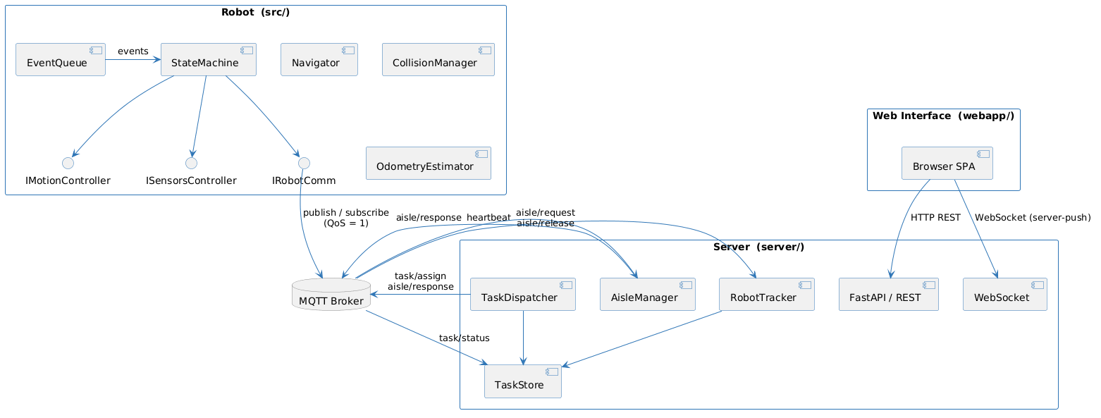
Figure 1 – Three-tier component architecture

Tier | Directory | Responsibility | Protocol
Robot | src/ | State machine, navigation, sensor fusion, collision avoidance | MQTT
Server | server/ | Task dispatch, aisle management, robot registry, API | MQTT + HTTP/WS
Web Interface | webapp/ | Task submission, real-time fleet monitoring | REST + WebSocket

5. Robot Architecture

5.1 State Machine
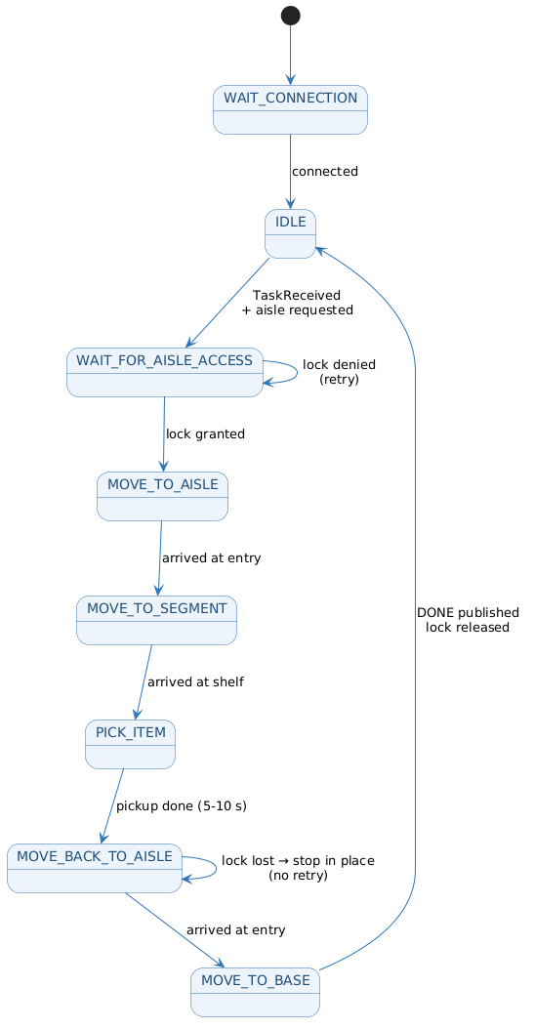
Figure 2 – Robot finite state machine
Each state implements IRobotState: on_enter(robot), on_exit(robot), update(robot, dt) → TransitionID (called every tick), and on_event(robot, event) → None (handles async MQTT events).

State | Behaviour
WAIT_CONNECTION | Connects to MQTT broker; transitions to IDLE on success
IDLE | Stops robot; on TaskReceivedEvent stores task, requests aisle lock, publishes IN_PROGRESS
WAIT_FOR_AISLE_ACCESS | Halts; retries until AisleResponseEvent(granted=true); sets aisle_lock_granted flag
MOVE_TO_AISLE | Navigates to aisle entry point; transitions on arrival
MOVE_TO_SEGMENT | Navigates to shelf location; transitions on arrival
PICK_ITEM | Stops; waits 5–10 s (simulated pickup); transitions to MOVE_BACK_TO_AISLE
MOVE_BACK_TO_AISLE | Returns to entry; if aisle_lock_granted is false → stop in place (does not re-request)
MOVE_TO_BASE | Releases lock, navigates to base, publishes DONE, transitions to IDLE

5.2 Hardware Abstraction & Dependency Injection
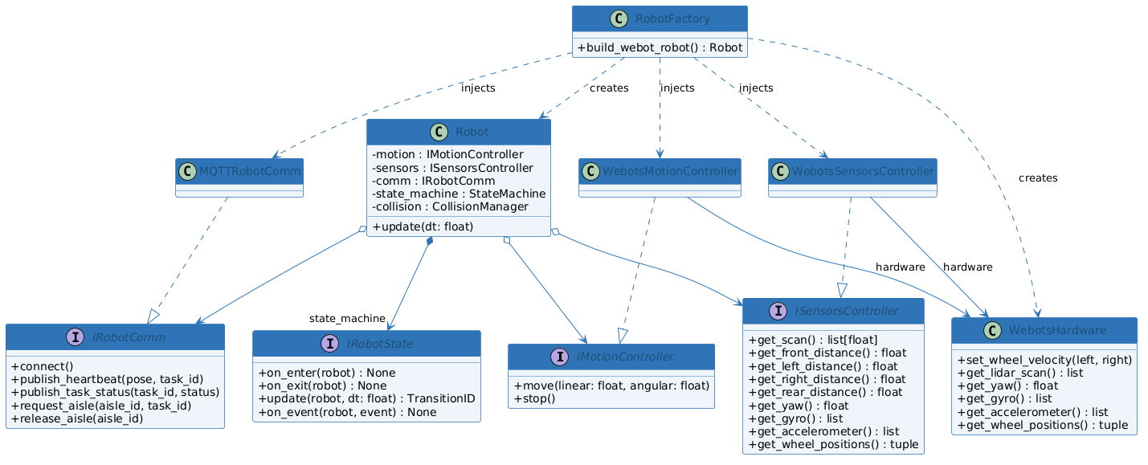
Figure 3 – Interface hierarchy and dependency injection via RobotFactory
The Robot class depends only on interfaces. RobotFactory creates a WebotsHardware instance (the low-level Webots device layer) and passes it to both WebotsMotionController and WebotsSensorsController. These controllers translate abstract interface calls into Webots device API calls. Collision avoidance is applied in each state's update() via robot.collision.apply(), not inside the motion controller.
ISensorsController exposes: get_scan(), get_front_distance(), get_left_distance(), get_right_distance(), get_rear_distance(), get_yaw(), get_gyro(), get_accelerometer(), get_wheel_positions(). Replacing WebotsHardware, WebotsMotionController, and WebotsSensorsController is sufficient for real-hardware deployment.

5.3 Navigation
Proportional controller (no PID); arrival threshold 0.02 m:
angle_error = normalize(atan2(dy, dx) − pose.theta)
angular_vel = clamp(k_angular × angle_error, −max_ω, max_ω)
linear_vel = min(k_linear × distance × cos(angle_error), max_v)
if |angle_error| > 0.8 rad: linear_vel = 0 # rotate-in-place first
Parameters: k_linear = 1.0, k_angular = 2.5, max_linear = 0.20 m/s, max_angular = 1.5 rad/s.

5.4 Odometry (Sensor Fusion)
Wheel encoders provide position; compass overrides yaw to eliminate drift:
if |d_theta| < 1e-6: x += d_center·cos θ; y += d_center·sin θ # straight-line
else: x += r·(sin(θ+dθ) − sin θ); y += r·(cos θ − cos(θ+dθ)) # circular arc
theta = compass_yaw (if available)

5.5 Collision Avoidance
State | Trigger | Effect
SAFE | Path is clear | Full speed
EVADE | Obstacle detected and closing, or critically close | Reduced linear speed; left-turn bias added to navigator output
STOP | Obstacle critically close | Zero velocity; forced evasion window after recovery
The CollisionManager uses front-sector distance readings combined with a closing-rate calculation to distinguish between stationary obstacles and approaching robots. A mandatory evasion window after a hard stop prevents the robot from immediately resuming full speed before the obstacle has cleared.

6. Server Architecture

6.1 Server Update Loop (100 ms)
- Process MQTT events → forward to RobotTracker, AisleManager, TaskStore; WebSocket bridge broadcasts immediately.
- RobotTracker.update() → marks robots OFFLINE if no heartbeat for 4 s.
- AisleManager.update() → expires leases > 60 s; notifies affected robot with granted=false.
- TaskDispatcher.try_dispatch() → assigns next pending task to nearest idle robot.

6.2 Component Summary

Component | Responsibility
TaskDispatcher | FIFO task queue; nearest-idle-robot assignment (Euclidean distance to aisle entry)
AisleManager | Lease-based mutual exclusion (one robot per aisle); 60 s timeout for crash recovery
RobotTracker | Auto-registers robots on first heartbeat; OFFLINE after 4 s silence; OFFLINE state not cleared by heartbeat
TaskStore | Tracks full task lifecycle: PENDING → IN_PROGRESS → DONE / REJECTED
WarehouseMap | Static geometry: 5 aisles × 3 shelves; aisle entry X = 3.0 m; shelf X = 4.5 / 5.5 / 6.5 m

7. Communication Architecture

7.1 Task Sequence
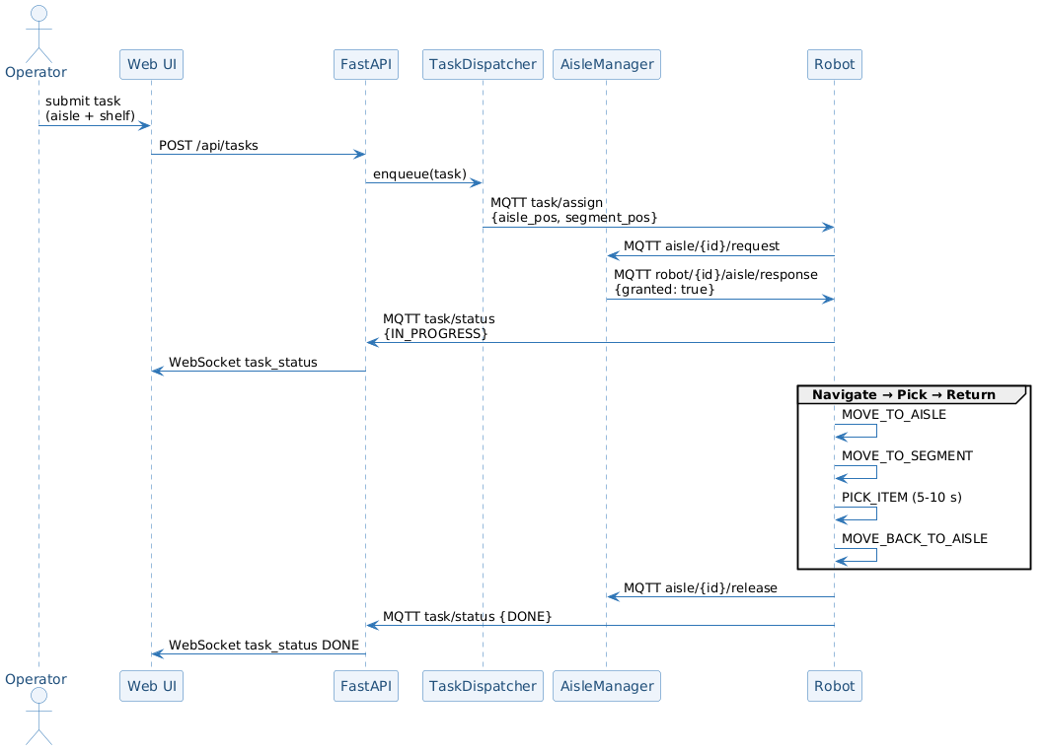
Figure 4 – End-to-end task sequence (Operator → Robot → Done)

7.2 MQTT Topics (QoS = 1, JSON)

Topic | Direction | Key payload fields
robot/{id}/heartbeat | Robot → Server | robot_id, pose {x,y,θ}, task_id
robot/{id}/task/assign | Server → Robot | task_id, aisle_pos, segment_pos
robot/{id}/task/status | Robot → Server | task_id, status, reason
robot/{id}/aisle/response | Server → Robot | aisle_id, granted
aisle/{id}/request | Robot → Server | robot_id, task_id
aisle/{id}/release | Robot → Server | robot_id

7.3 REST API (FastAPI)

Method + Path | Description | Response
POST /api/tasks | Submit new task | 201 TaskSchema
GET /api/tasks | List tasks (filter by status) | 200 TaskSchema[]
DELETE /api/tasks/{id} | Cancel PENDING task | 204 / 409
GET /api/robots | All robots + state | 200 RobotSchema[]
GET /api/aisles | All aisles + lock status | 200 AisleSchema[]

7.4 WebSocket (/ws)
Server-push events to the browser: robot_heartbeat, task_status, aisle_request, aisle_release. Eliminates polling; WebSocketEventBridge converts domain events to JSON and broadcasts to all connected clients.

8. Formal Specifications (TLA+)
Three TLA+ modules capture the key safety and liveness properties.

8.1 Aisle Mutual Exclusion
---- MODULE AisleMutualExclusion ----
EXTENDS Integers, FiniteSets
CONSTANTS Robots, Aisles
VARIABLES aisle_owner, robot_state

NULL == CHOOSE n : n \notin Robots

TypeOK ==
/\ aisle_owner \in [Aisles -> Robots \cup {NULL}]
/\ robot_state \in [Robots -> {"IDLE","WAIT_AISLE","IN_AISLE","RETURNING"}]

(* Safety: at most one robot holds any aisle lock *)
MutualExclusion ==
\A a \in Aisles : Cardinality({r \in Robots : aisle_owner[a] = r}) <= 1

RequestAisle(r, a) ==
/\ robot_state[r] = "WAIT_AISLE" /\ aisle_owner[a] = NULL
/\ aisle_owner' = [aisle_owner EXCEPT ![a] = r]
/\ robot_state' = [robot_state EXCEPT ![r] = "IN_AISLE"]

ReleaseAisle(r, a) ==
/\ aisle_owner[a] = r
/\ aisle_owner' = [aisle_owner EXCEPT ![a] = NULL]
/\ robot_state' = [robot_state EXCEPT ![r] = "RETURNING"]

ExpireLease(a) == (* server reclaims lock after 60 s timeout *)
/\ aisle_owner[a] # NULL
/\ aisle_owner' = [aisle_owner EXCEPT ![a] = NULL]
/\ UNCHANGED robot_state
====

8.2 Robot State Machine
---- MODULE RobotStateMachine ----
VARIABLES state, has_task, aisle_granted

States == {"WAIT_CONNECTION","IDLE","WAIT_FOR_AISLE_ACCESS",
"MOVE_TO_AISLE","MOVE_TO_SEGMENT","PICK_ITEM",
"MOVE_BACK_TO_AISLE","MOVE_TO_BASE"}

Init == /\ state = "WAIT_CONNECTION" /\ has_task = FALSE /\ aisle_granted = FALSE

(* Safety: robot never enters aisle without holding the lock *)
NeverEnterWithoutLock ==
state \in {"MOVE_TO_AISLE","MOVE_TO_SEGMENT",
"PICK_ITEM","MOVE_BACK_TO_AISLE"}
=> aisle_granted = TRUE

(* Liveness: every assigned task eventually completes *)
TaskEventuallyDone == has_task ~> (state = "IDLE" /\ ~has_task)
====

8.3 Task Lifecycle
---- MODULE TaskLifecycle ----
EXTENDS FiniteSets
CONSTANTS Tasks, Robots
NULL == CHOOSE n : n \notin Robots
VARIABLES task_status, task_robot

Init ==
/\ task_status = [t \in Tasks |-> "PENDING"]
/\ task_robot = [t \in Tasks |-> NULL]

Dispatch(t, r) ==
/\ task_status[t] = "PENDING" /\ task_robot[t] = NULL
/\ task_status' = [task_status EXCEPT ![t] = "IN_PROGRESS"]
/\ task_robot' = [task_robot EXCEPT ![t] = r]

(* Safety: a task is assigned to at most one robot *)
SingleAssignment ==
\A t \in Tasks : task_status[t] = "IN_PROGRESS" => task_robot[t] # NULL

(* Safety: DONE and REJECTED are terminal states *)
NoRollback ==
/\ [][task_status[t] = "DONE" => task_status'[t] = "DONE"]_task_status
/\ [][task_status[t] = "REJECTED" => task_status'[t] = "REJECTED"]_task_status
====

9. Key Design Choices

Design Choice | Alternative | Rationale
State machine for robot logic | Monolithic loop | Single responsibility per state; extensible without modifying existing states
Abstract interfaces + factory (DIP) | Direct Webots dependency | Robot core has zero Webots imports; swap two classes for real hardware
MQTT pub-sub (QoS = 1) | Direct TCP / HTTP polling | Scales to N robots; handles WiFi dead spots; wildcard subscriptions
Lease-based aisle locking (60 s) | Full path planning | Simple crash recovery; no extra protocol needed
Priority-based collision avoidance | MQTT negotiation protocol | Deterministic, no extra messages, works without server
Proportional controller (no PID) | PID controller | Sufficient for straight aisles; fewer tuning parameters
Thread-safe EventQueue | Direct callback into FSM | State machine stays single-threaded; only shared structure with MQTT thread
Nearest-idle-robot dispatch | Optimal scheduling | O(n) simplicity; adequate for proof-of-concept; trivially replaceable
Sensor fusion (compass + encoders) | Encoders only | Compass corrects cumulative yaw drift
Vanilla JS SPA (no framework) | React / Angular | No build step; sufficient for monitoring UI scope

10. Conclusion
The Warehouse Robots architecture achieves clean separation across three independent tiers. The robot tier is fully platform-independent — its only Webots coupling is two concrete interface implementations. The server tier coordinates the fleet through lightweight, formally verified mechanisms. The design deliberately favours simplicity over premature optimisation; each algorithmic choice is behind an interface or a single method, making it straightforward to substitute more sophisticated solutions.

