A multi-dimensional solver for the Schrödinger equation based on finite element method
A. Soba∗¹
¹ CNEA, CONICET. Av. Gral Paz 1499, San Martín - Buenos Aires - Argentina

A multi-dimensional finite element solver applied to time-independent Schrödinger equations to study generic problems in quantum mechanics is presented. The solver allows flexible selection of the numerical and physical parameters. It was used to solve problems in one dimension (such as position-dependent mass problems), bi-dimensional problems (a coupled quantum harmonic oscillator) and for tri-dimensional analysis of hydrogen-like atoms. The numerical solutions obtained using the solver are compared with exact analytical solutions provided in several references for the problems selected. The accuracy of these solutions was studied using several elements and interpolation functions, searching for the best numerical approximation for each problem.

KeyWords: Multi-dimensional finite element methods, numerical solutions of Schrödinger equation, quantum computer simulation.

I. INTRODUCTION
This paper presents an extension of previous work in which a general one dimensional solver based on FEM aimed at solving stationary and time-dependent Schrödinger equations were presented⁽¹⁾. Here we extend the method to multidimensional cases, allowing to face complex quantum problems in one, two and three dimension. These equations have analytical solutions in only a few known problems, which are used in books on quantum mechanics to illustrate several points of the theory, i.e. the harmonic oscillator, the hydrogen-like system, or in the case of dynamical problems, spreading of a traveling wave packet in space and time. More complex potentials require the use of more sophisticated methods, such as perturbation theory, variational methods or numeric approximations.
The equation to be solved has the general form (atomic units are used throughout the text):
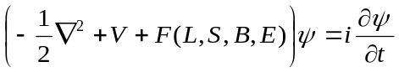 (1)
where V represents the external potential and the function F is a general expression which may contain interactions between external magnetic or electrical fields, spin orbit coupling, etc. This general equation could be solved using several numerical schemes. Examples of the Finite difference approach could be found in references^{(2,3)} where an explicit Numerov method is used in order to reach a general solution of stationary problems and also dynamical ones. This method show good results in the problems treated but required a double explicit integration of the system over the domain, apart of other limitations proper of the numerical tool.

II. NUMERICAL TREATEMENT
A variational or weak FEM approach is used in order of reach a numerical approximation of the time-dependent Schrödinger equation (1). This approach converts the differential problem into an equivalent integral (“weak”) formulation. From this point, in order to find an approximate solution, it is necessary to choose a convenient set of strictly local piecewise polynomials to use in the discrete domain⁽⁴⁾. Applying this approach over each element, the wave function is approximated by a local interpolation function where the unknowns are the local nodal values. In this study we chose fifth/sixth degree polynomials characteristic of Lagrangian elements with five/six nodes as the set of basis functions for the one dimensional case. For the bi-dimensional case, we introduce rectangular elements with two kind of Lagrange interpolation: nine nodes elements (bi quadratic interpolation) and sixteen nodes elements (bi cubic interpolation) ^{(4,5)}. For the tri-dimensional case we used again Lagrangian elements but in this case using a 27 nodes interpolation functions.
In general, a Lagrangian basis function of degree p has unitary value at node p and zero value at all other nodes^{(4,5)}. The projection of every local system into equation (1) generates a simple matrix relation for each element. In order to construct this, it is necessary to integrate over each element. We performed all the integrations using Gaussian quadratures formulas, depending on the elements utilized.
After this, the local matrices are assembled into global matrices in order to build the generalized eigensystem characteristic of these quantum problems. This will have the form:
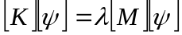 (2) where K (M) is the stiffness (mass) matrix and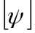/ is the auto-state (auto-energies) of the problem. In the case of FEM a sparse system is obtained.
There are a lot of tools for solving this kind of problem when the matrix M is positive definite⁽⁶⁾ or semi-definite⁽⁷⁾. If the potential term does not have this property, a direct solver taken for example from EisPACK⁽⁸⁾ can be used. This solver provides all the eigenvalues and respective eigenvectors of the system for general matrices K and M.
For some cases, especially when the matrix involve have great size, an iterative method can be more convenient since the point of view of the time of calculus. In those cases we use a preconditioned bi-conjugate gradient solver which gives us a few eigenvalues (usually the small ones) ^{(9,10)}. The finite elements solutions of the infinite coordinates space assumes a cut-off in each coordinate corresponding to each oscillator. Such cut-off radii were selected by requiring that the wave function be at least six orders of magnitude smaller than the value in the origin of coordinates. An advantage in this method, in order to reach a more accurate solution, is that the size of the elements may vary, because it is desirable to use a finer discretization in the region of the origin where the solution is sharply peaked. For this reason a logarithmic scale was selected to build the discretized space finer in the desired region and greater elements in the external regions, where the wave functions have slow decays.
The boundary conditions for all the cases analized are reduced to specifying the value of the solution at infinity. In order to approximate the solution for a discrete space, it is necessary to select a suitable value at this point, depending on the particular problem. In a general description, a Dirichlet essential boundary condition is needed in the extreme domain^{(1,2,3)} .

III. RESULTS
One-dimensional approach: Position-Dependent Mass Schrödinger Equation
The position-dependent mass (PDM) Schrodinger equation has been the object of study from different points of view. There are several analytical approaches^{(12,13,14)} which transform the equation (using the so-called Point Canonical Transformation) and eliminate the mass-dependent factor by using an effective potential. These approaches provide exact solutions for certain potential and position-dependent functionalities of the mass. The new equation is in general solved by using similarities with other known potentials with exact solutions such as the Posh-Teller, Morse, Harmonic oscillators, etc. ^{(14,15)}. More general analytical studies reach quasi-exactly-solvable, position-dependent, effective mass Schrodinger equations and obtain functional forms for their respective Eigen energies and eigen-functions.⁽¹¹⁾ Finally, numerically studies take the unmodified equations and use a discrete approximation using finite element methods (FEMs) or finite difference in order to reach an approximate solution.
In the case of masses which are functions of position, equation (1) takes the form:
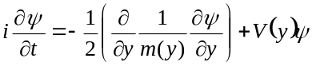 (3)
In order to solve this equation, the conventional approach is to find a Veff choosing the change of variable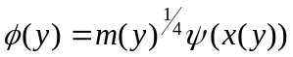,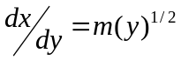. Then, equation (3) takes the form of a traditional Schrödinger equation with a new potential Veff(x) which depends on the mass function and its first and second derivatives with respect to x⁽¹¹⁻¹⁸⁾.
An example with known analytical solutions were used to check the accuracy of the method and the goodness of the elements and interpolation functions chosen. We use the repulsive Coulomb-like potential⁽¹⁴⁾ 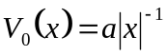 with a>0 and the function 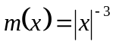. In this case, a one-dimensional scheme over the Schrodinger equation in Cartesian coordinates was used, with five-node Lagrangian elements and a fourth-order Gaussian quadratic integration form. 200 elements with these characteristics divide a domain of 80 atomic units with rigid wall boundary conditions. With this numerical treatment considerable accuracy is obtained. Figure 1 shows the eigenfunctions, solution of the problem, and the respective eigenvalues corresponding to the discrete energy states compared with the analytical solution.

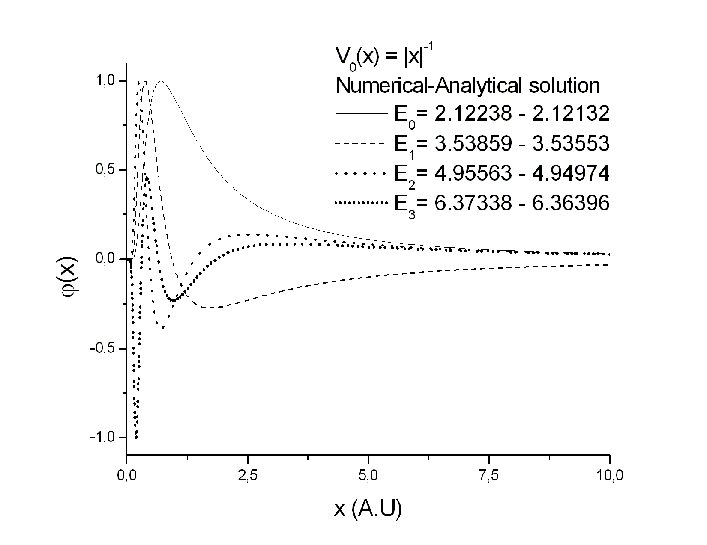
Figure 1: Auto -energies and wave functions of the Coulomb-like potential for the first four eigen values. (Normalized wave function.)
Bi dimensional approach: Coupled harmonic oscillators
The problem of two coupled harmonic oscillators, apart from the relevant academic interest, is the first step in the study of more complex problems, in several fields of physics. In particular, in the quantum mechanics environment, coupled harmonic oscillators are the initial step to analyze vibrational molecular modes, atoms, quantum points and other quantum systems related. In opposition to the classic mechanics case, quantum mechanics oscillators have energies cuantizated and wave functions, which contain, in the quantum mechanics point of view, all the information about the system. Depending on the coupling term, the problem has an exact analytic solution or an approximate one, obtained by perturbation theory or variational methods⁽¹⁸⁾. To test the solver we introduce a general coupling term of the form:
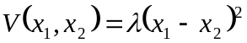 (4)
A simple coordinate and momentum change (as in classic mechanics), constructed by linear combinations of the coordinates and momentum operators, transforms the problem in another one described by two disconnected linear differential equations. Where the auto energies of the new problem characterized by the two quantum numbers n and p take the form⁽¹⁸⁾
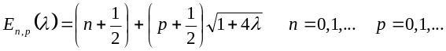 (5)
remarkable situation is that the auto energies do not present degenerate levels except when 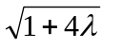is a rational number.
Table 1 is a summary of the analytical solutions and the numerical one obtained with a space discretization of 400 bicubic Lagrange elements (3721 nodes).

Table 1: Analytic and Numeric auto energies of the potential (4)
Selectedn , p | Analytic | Numeric | Relative error
0 , 0 | 1.618034 | 1.61804318728190 | 0.0006E-2
1 , 0 | 2.618034 | 2.61807351498590 | 0.0015 E-2
2 , 0 | 3.618034 | 3.61811313097544 | 0.0022 E-2
0 , 1 | 3.854102 | 3.85414758529879 | 0.0012 E-2
3 , 0 | 4.618034 | 4.61826286641639 | 0.0050 E-2
1 , 1 | 4.854102 | 4.85426150198104 | 0.0033 E-2
4 , 1 | 5.618034 | 5.61890538058997 | 0.0155 E-2
2 , 1 | 5.854102 | 5.85462534002708 | 0.0089 E-2
2 , 2 | 8.090170 | 8.09215096287883 | 0.0245 E-2
0 , 3 | 8.326238 | 8.32659846266902 | 0.0043 E-2
3 , 2 | 9.090170 | 9.09390297680638 | 0.0411 E-2
1 , 3 | 9.326238 | 9.32779526605245 | 0.0167 E-2
4 , 2 | 10.09017 | 10.0947309136404 | 0.0452 E-2
2 , 4 | 12.56231 | 12.5699762393616 | 0.0610 E-2
3 , 4 | 13.56231 | 13.5772999231863 | 0.1105 E-2
4 , 4 | 14.56231 | 14.5955676873372 | 0.2284 E-2

Tri-dimensional approach: Hydrogen-Like Systems
The tri-dimensional Schrödinger equation for the hydrogen like system takes the form:
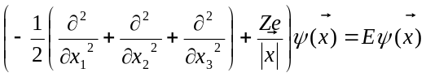 (6)
For solve this equation, we used lagrangian Hexahedrical elements of 27 nodes. We extend the finite element grid over a box of dimension 20x20x20. At the present calculus we used a Grid of ~15600 nodes (~1700 elements). In figure 2 the first’s auto function calculated with their respective auto energies are drawn.
The way of proceed in a tri-dimensional case is basically the same as that discussed in the last sections. Debt to the modular nature of a FEM the extension for more dimensions is straightforward; only require the codification of the new elements that are necessary to discretized the space. An increment in dimension just increase the size of the mesh utilized with the consequent increment in the final generalized eigen system, producing more demanding problems respect to computing time. This makes more difficult the exploration of higher eigenvalues because the enlarging of the region where the eigenfunctions have a non-negligible amplitude and, simultaneously, the increasing in the number of oscillations per unity volume of the domain too. This could be seeing in the lost or precision in the calculus of the auto energies calculated when the main quantum number increase. In order to keep the same precision for the highest part of the spectrum we need to enlarge the domain discretized with the consequent increase of the eigen system, increasing too the calculus time. A good alternative to improve this accuracy, an element of more nodes than 27, i.e. local functions of higher orders, could be another point to explore.
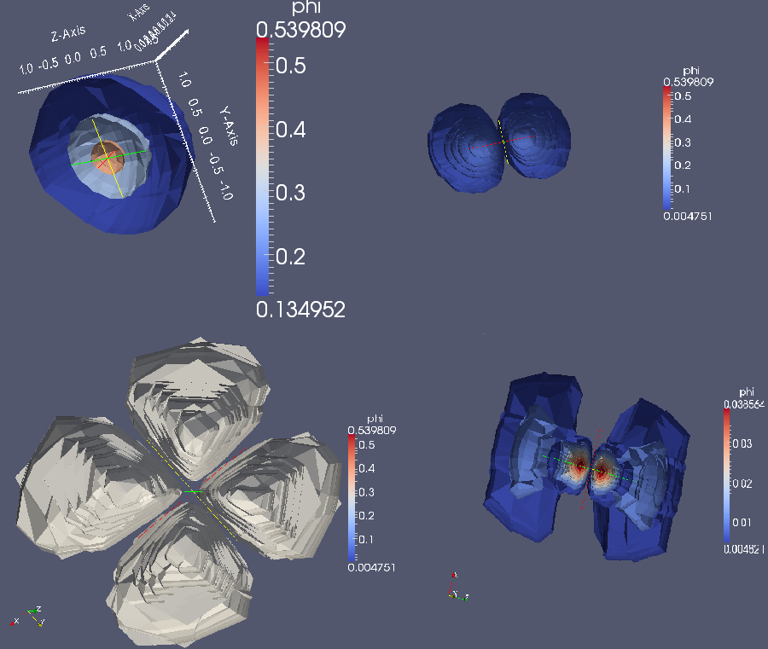
Figure 3 several normalized wave functions of the Hydrogen Atom obtained with the code. Paraview⁽¹⁹⁾ software was used for visualization.

IV. CONCLUSIONS
A finite element based solver dedicated to generic quantum systems in one, two and three simensions were presented. The solver allows the resolution of all kinds of multi- dimensional problems in quantum mechanics related to simple potentials, even with mass as generic functions of position. In order to prove the accuracy of numerical solutions, we compared the results with different known problems with exact analytic solutions and saw good approximations. Based in this behaviour, the solver could be used to study a great variety of problems with no known analytical solution. The solver allows us to analyze the behaviour of the mass-dependent Schrödinger equation with great accuracy with any function of mass. This is very useful to study parametric responses of the solution. Furthermore, it is possible to use the code, with a relevant modification, with perturbed potentials, systems submitted to external fields or non-linear responses.
We test the bi-dimensional behaviour of the solver with a problem of coupled quantum harmonic oscillator for a generic coupled potential using several FE grids. The accuracy of the solution shows an important dependence with the type of elements used to discretized the domain. The results obtained with bicubic Lagrangian elements in a grid of 400 elements were the most precise. The Solutions were compared with exact analytic solutions, and with those obtained across perturbation theory. In both cases, the solver generates a good numerical approximation. It is possible use the code with a great variety of coupled potentials with an irrelevant modification. This code also allows an extension, with minimal modifications, to bi-dimensional systems like the hydrogen like system in cylindrical coordinates or the bidimensional harmonic oscillator with perturbation terms.
The tri-dimensional case shows results with less accuracy that similar to that obtained in the cases of one and two dimensions, because the mesh used for the discretized spatial domain is not as fine as in such cases. More fine meshes would have better results but the computing time will increase much more. In order to reach more accurate values, a parallelized solver is necessary, object of next works

References
1- A. Soba, A Finite Element Method Solver for Time-Dependent and Stationary Schrodinger Equations with a Generic Potential. Commun. Comput. Phys. Vol. 5, 5, pp. 914-927 (2009)
2 - C. A. Moyer, Numerov Extensión of transparetns boundary condition for Schrodinger equation in one dimension, Am. J. Phys, 72 (3) March 2004.
3 - Quiroz Gonzalez J.L.M. Thompson D., Getting started with Numerov’s method, Computers in Phisics 11, 5, 1997.
4 - O.C. Zienkiewicz; R.L. Taylor, El método de los elementos finitos, 4a Edición. McGrall Hill, Barcelona, España (1994).
5 - Klaus-Jürgen Bathe, Finite Element Procedures, Prentice Hall, 1996.
6 - http://www.netlib.org/lapack/
7 - http://www.caam.rice.edu/software/ARPACK/
8 - http://www.netlib.org/eispack/
9 - Ho-Jong Jang, Preconditioned conjugate gradient method for large generalized eigenproblems. Trend in Mathematics, ICMS. Vol 4, 2, 103-109 (2001)
10- R. Aubry, F. Mut, R. Löhner, J. R. Cebral, Deflated preconditioned conjugate gradient solvers for the Pressure–Poisson equation, Journal of Computational Physics 227 (2008) 10196–10208.
11 - S.K.Moayedi, Abraham F. Jalbout, M. Solimannejad, The position-dependent effective mass Schrodinger equation: a quasi-exact solution. J. Molecular Structure (Theochem) 663, 15-18, 2003.
12 - Jiang Yu, Shi-Hai Dong, Exactly solvable potentials for the Schrodinger equation with spatially dependent mass. Physics Letters A 325, 194-198, (2004).
13 - Ling Jiang, Liang-Zhong Yi, Chun-Sheng Jia, Exact solutions of the Schrodinger equation with position-dependent mass for some Hermitian and non-Hermitian potentials. Physics Letters A 345, 279-286, (2005).
14 - A. Ganguly, s. Kuru, J. Negro, L.M. Nieto, A study of the bound states for square potential wells with position-dependent mass. Physics Letters A 360, 228-233, (2006).
15 -A.G.M. Schmidt, Time evolution for harmonic oscillators with position-dependent mass. Phys Scr. 75, 480-483 (2007)
16 - Jiang Yu, Shi-Hai Dong, Guo-Hua Sun, Series solutions of the Schrodinger equation with position-dependent mass for the Morse potential, Physics Letters A 322, 290-297, (2004).
17 - S. Cruz y Cruz, J. Negro, L.M. Nieto, Classical and quantum position-dependent mass harmonic oscillators, Physics Letters A 369, 400-406, (2007)
18- C. Cohen-Tannoudji, B. Diu, F. Laloe, Mecanique quantique (English), Translated from French by Susan Reid Hemley, Nicole Ostrowsky, Dan Ostrowsky, New York, Wiley, 1977.
19- www.paraview.org

 soba@cnea.gov.ar

