Command: Automesh2D_Interface_2010_TEST.exe

The parameters for the mesh generation
If you want to change the parameters for the mesh generation, please edit the ‘control.dat’ file and modify the corresponding items. Otherwise, keep the default data.
The parameters are listed on the first line of the ‘control.dat’ file and the explanation of every item is as following:
First Line: p1 p2 p3 p4 p5 p6 p7 p8 p9 p10
(Default Data: 1 40 40 10 10 4 1 1 1 100)
p1~p5: Please the default data. In most cases, good mesh can be generated using these default data.
p6: 4-quadrilateral mesh 3-triangular mesh
p7: It works only when p6 is set 4. 1-one or a few of triangular elements are allowed to be generated if the total number of nodes on the boundary of a domain is odd or avoiding to generate bad quadrilateral elements on the boundary. 0-no triangular elements should be generated. The program will try to generate all-quadrilateral mesh.
p8: 1-the mesh will be optimized after the generation. 0-no optimization taken
p9: 1 or 2, the algorithm for the node generation on one line. ( 1-the nodes are generated smoothly along the line based on the element size on the two end points of the line. 2-the element size on the midpoint of the line is set the overall mesh size(meshSize) and the nodes are generated based on the element size on the two end points and the midpoint. )
p10: This data is to control the element edge not to be larger p10% than the overall mesh size(meshSize). If you do not care about the element edge size, this item can be set a large value.

Please prepare input file before running!
The input file ‘input.msd’ format
In AUTOMESH-2D, the quadrilateral mesh can be generated by giving one of the following information:
(a) Mesh size and the geometry boundary (Line or Arc).
In this case, the user does not discrete the geometry boundary into boundary nodes. The user can control overall mesh size or the element size on each boundary segment.
(b) The boundary nodes.
In this case, the user has divided the geometry boundary into discrete mesh nodes, which gives the user more flexibility to control the location and distribution of the boundary nodes.
The above information is given as the same format as following:
1. The overall mesh size (meshSize)
2. The point /node number of outer boundary (Can have only one outer boundary)
3. The coordinates, mesh size, type of every point /node on the outer boundary
4. The point /node number of first inner boundary
5. The coordinates, mesh size, type of every point /node on first inner boundary
6. You can define more than one inner boundary
7. The point /node number of first constraint line (add “-“ before the number)
8. The coordinates, mesh size, type of every point /node on first constraint line (from one endpoint to other endpoint)
9. You can define more than one constraint line
10. The node number of first constraint point (i.e. -1)
10. The coordinates and element size of the first constraint point
11. You can define more than one constraint point

Example 1:
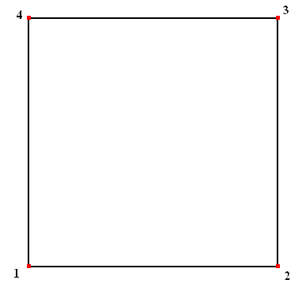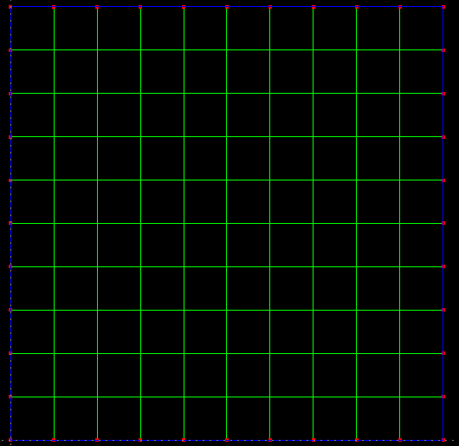
In this example, the user inputs the overall mesh size and the geometry of the domain like this:
10 meshSize //boundary nodes will be generated based on this size
4
1 0.0 0.0 0.0 Line
2 100 0.0 0.0 Line
3 100 100 0.0 Line
4 0.0 100 0.0 Line

Example 2:
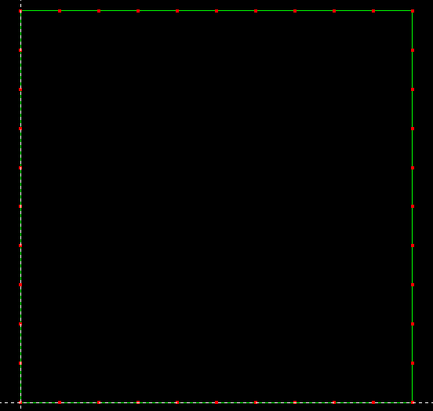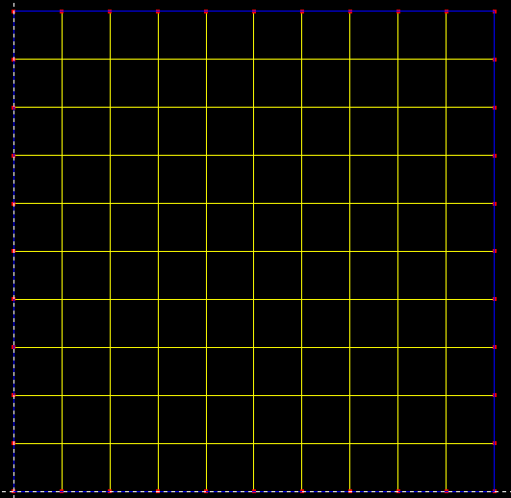
In this example, the user divides the boundary into boundary nodes and inputs the boundary nodes of the domain like this:

1000000 meshSize //This size should be larger than the boundary element size
40
1 0.0 100.0 0.0 Line
2 0.0 90.0 0.0 Line
3 0.0 80.0 0.0 Line
4 0.0 70.0 0.0 Line
5 0.0 60.0 0.0 Line
6 0.0 50.0 0.0 Line
7 0.0 40.0 0.0 Line
8 0.0 30.0 0.0 Line
9 0.0 20.0 0.0 Line
10 0.0 10.0 0.0 Line
11 0.0 0.0 0.0 Line
12 10.0 0.0 0.0 Line
13 20.0 0.0 0.0 Line
14 30.0 0.0 0.0 Line
15 40.0 0.0 0.0 Line
16 50.0 0.0 0.0 Line
17 60.0 0.0 0.0 Line
18 70.0 0.0 0.0 Line
19 80.0 0.0 0.0 Line
20 90.0 0.0 0.0 Line
21 100.0 0.0 0.0 Line
22 100.0 10.0 0.0 Line
23 100.0 20.0 0.0 Line
24 100.0 30.0 0.0 Line
25 100.0 40.0 0.0 Line
26 100.0 50.0 0.0 Line
27 100.0 60.0 0.0 Line
28 100.0 70.0 0.0 Line
29 100.0 80.0 0.0 Line
30 100.0 90.0 0.0 Line
31 100.0 100.0 0.0 Line
32 90.0 100.0 0.0 Line
33 80.0 100.0 0.0 Line
34 70.0 100.0 0.0 Line
35 60.0 100.0 0.0 Line
36 50.0 100.0 0.0 Line
37 40.0 100.0 0.0 Line
38 30.0 100.0 0.0 Line
39 20.0 100.0 0.0 Line
40 10.0 100.0 0.0 Line

Example 3
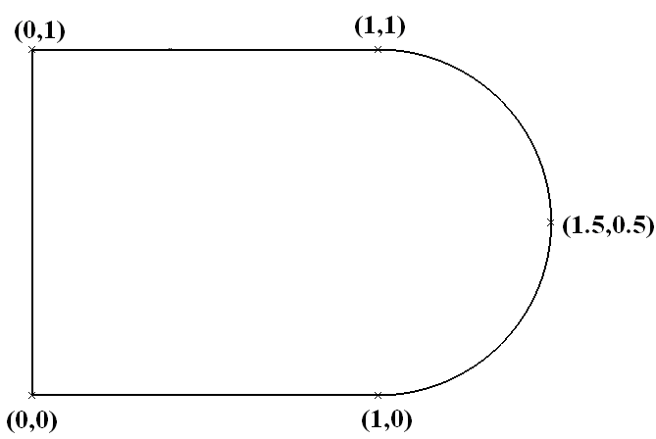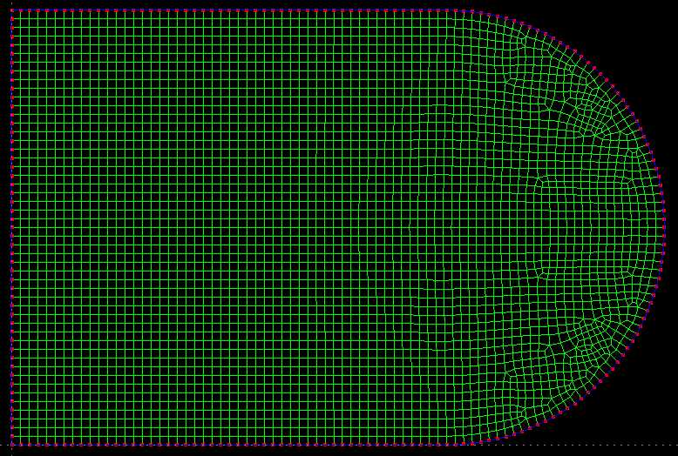
In this example, the boundary is made up of Line and Arc.
0.02 meshSize
5
1 0 0 0 Line // (end point)
2 1 0 0 Line // (end point)
3 1.5 0.5 0 Arc // (point on the arc, not required to be the midpoint)
4 1 1 0 Line // (end point)
5 0 1 0 Line // (end point)
Example 4
In this example, there is a hole in the domain.
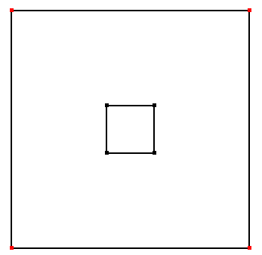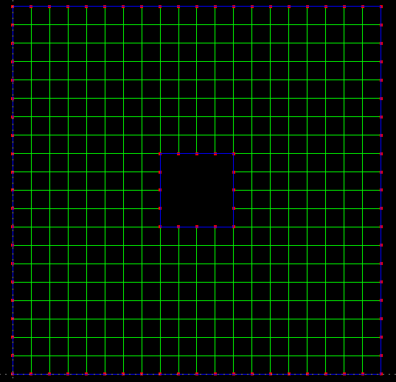
5 meshSize //boundary nodes will be generated based on this size
4
1 0.0 0.0 0.0 Line
2 100 0.0 0.0 Line
3 100 100 0.0 Line
4 0.0 100 0.0 Line
4
1 40 40 0 Line
2 40 60 0 Line
3 60 60 0 Line
4 60 40 0 Line

Example 5
In this example, there is a constraint line.
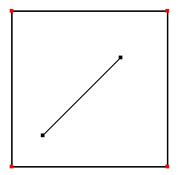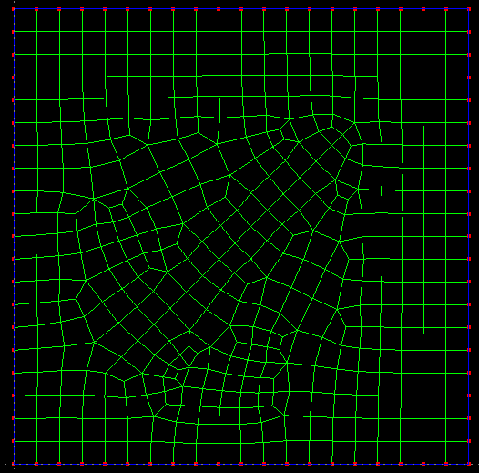
5 meshSize //boundary nodes will be generated based on this size
4
1 0.0 0.0 0.0 Line
2 100 0.0 0.0 Line
3 100 100 0.0 Line
4 0.0 100 0.0 Line
-2
1 20 20 0 Line
2 70 70 0 Line

Example 6
In this example, there is refine/constraint point. In this case, the mesh size on the constraint point must be set.
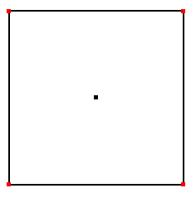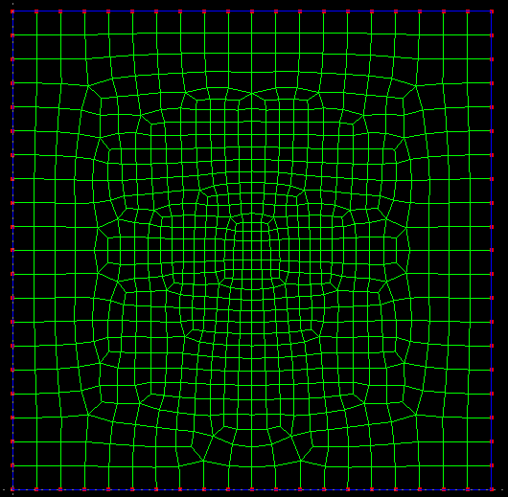
5 meshSize //boundary nodes will be generated based on this size
4
1 0.0 0.0 0.0 Line
2 100 0.0 0.0 Line
3 100 100 0.0 Line
4 0.0 100 0.0 Line
-1
1 50 50 2.0

Example 7
In this example, the mesh size on each point of the boundary is given.
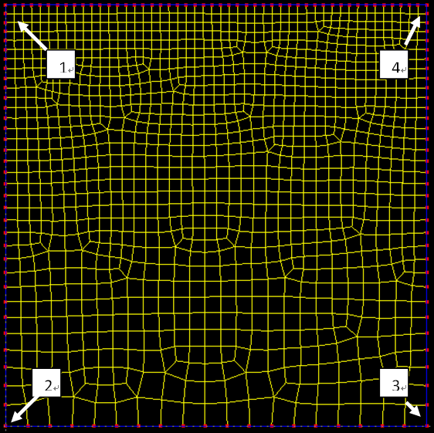
5 meshSize //This size is not used
4
1 0.0 100 2.0 Line
2 0.0 0.0 5.0 Line
3 100 0.0 5.0 Line
4 100 100 2.0 Line

Example 8
In this example, there is a subdomain inside the domain. In this case the boundary of the subdoman is regarded as the constraint boundary.
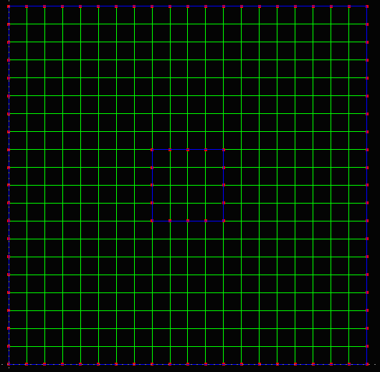
5 meshSize //boundary nodes will be generated based on this size
4
1 0.0 0.0 0.0 Line
2 100 0.0 0.0 Line
3 100 100 0.0 Line
4 0.0 100 0.0 Line
-4
1 40 40 0 Line
2 40 60 0 Line
3 60 60 0 Line
4 60 40 0 Line

If the mesh generation fails, please send the ‘send_to_me.msd’ file to maxinwu@sdu.edu.cn. Thank you!

