Automesh-2D (Multi-Domains) Manual
Example Study
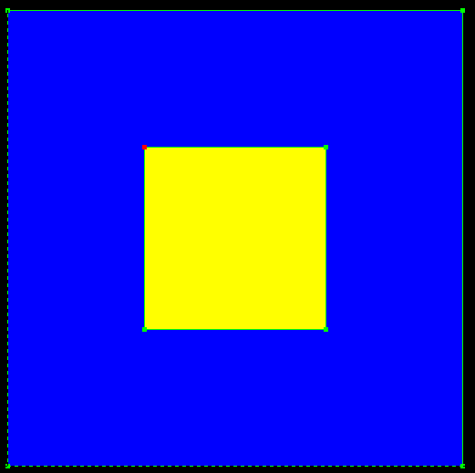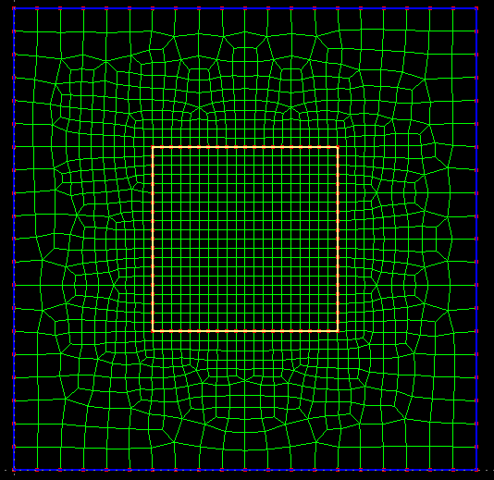
Fig. 1 The geometry with two domains Fig. 2 The mesh
We will show you the usage of the program with an example. In this example, the geometry has two domains (colored with blue and yellow respectively). The generated mesh for the geometry is shown in Fig. 2.

Step 1 Define Points
Define the eight points by typing the coordinates in the textbox on the left dialog or by clicking in the graphics window with the mouse.
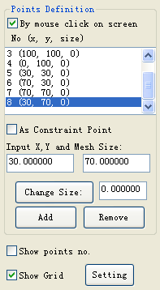
Points list. Select one point to change its Mesh Size or remove it. You can aslo select one point by clicking on it in the graphic window.
Type point coordinates here
You can define constraint points inside the geometry that need apply load on points or refine the mesh at the points.
You need define the element size at the points.
Add: Add one point.
Remove: Remove the point from the list.
Type Mesh Size here and Change it
You can define a point on the grid by the mouse clicking on the point.
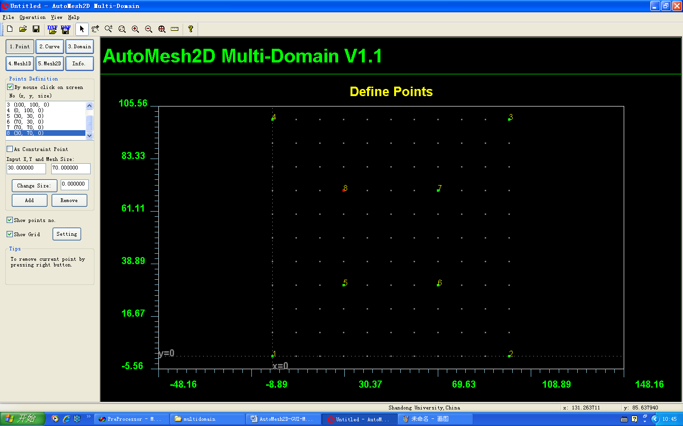

Step 2 Define Lines
Click on the button Curve on the dialog.
Select the points with the mouse to define lines. Press right button after selecting. Eight lines are defined.
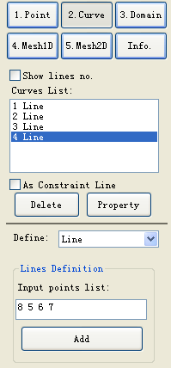
Click here
Curves list. You can select one curve to remove. You can select one curve by clicking on it by mouse in the graphics window.
Add: Add one line. You can select endpoints by mouse in the graphics window, then press RIGHT BUTTON.
You can define constraint lines inside the geometry.
Delete one curve or show its property
You can define all kinds of curve. You can import/export them by DXF.
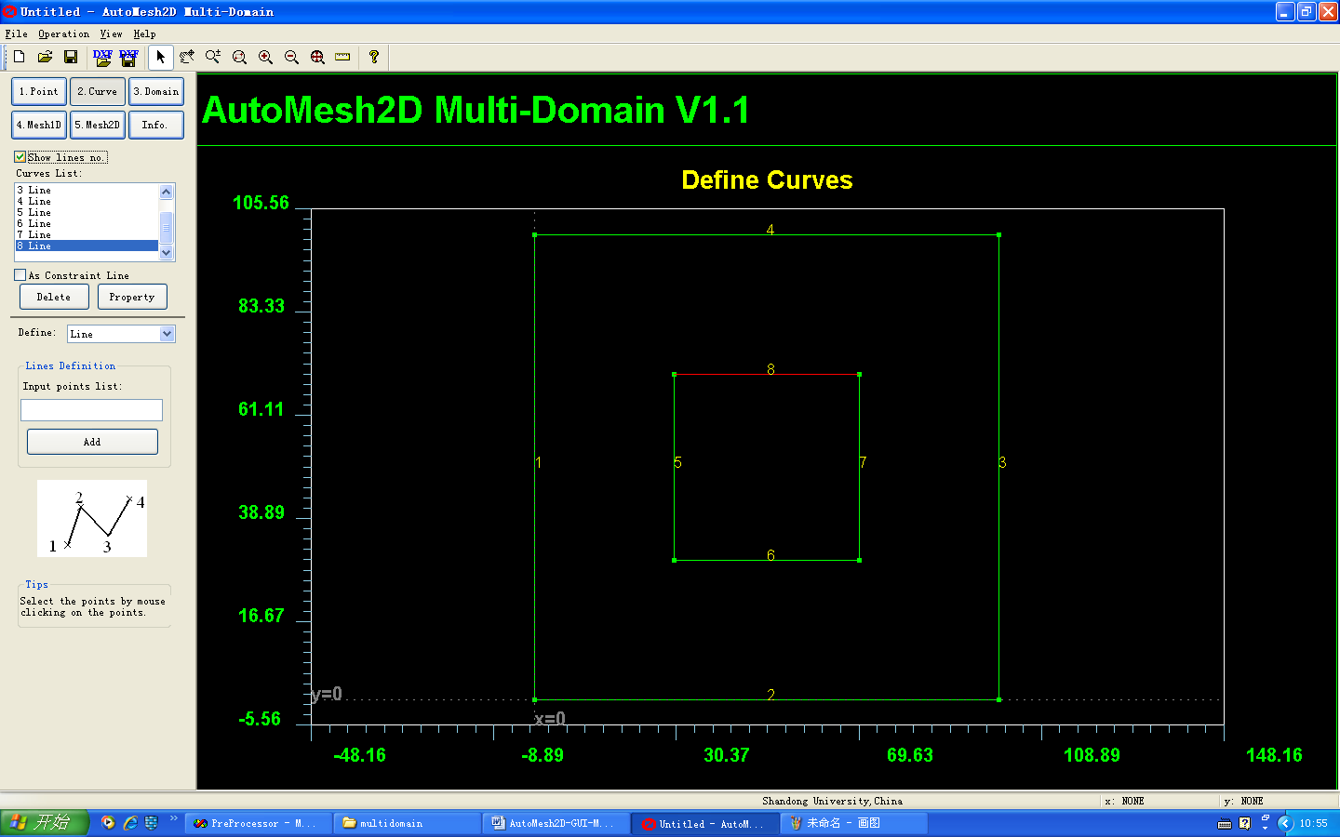

Step 3 Define Domains
Click on the button Domains on the dialog.
We will define two domains. First click on the button Add to add a new domain. Select all the lines with the mouse. After that, press the RIGHT BUTTON and the first domain is defined. Then define the second domain. Click on the button Add to add a new domain. Select four lines of the second domain boundary. After that, press the RIGHT BUTTON and the second domain is defined.
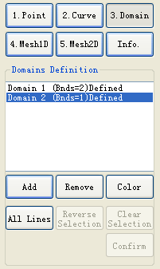
Click here.
Domains list. You can select one domain to Edit its boundaries or remove it.
Add: add one domain. You need define its boundaries. One Domain is defined as a closed area with one outer boundary and with/without inner boundaries.
Remove: remove one domain
You can select boundary lines one by one or by window with the mouse, then press RIGHT BUTTON.
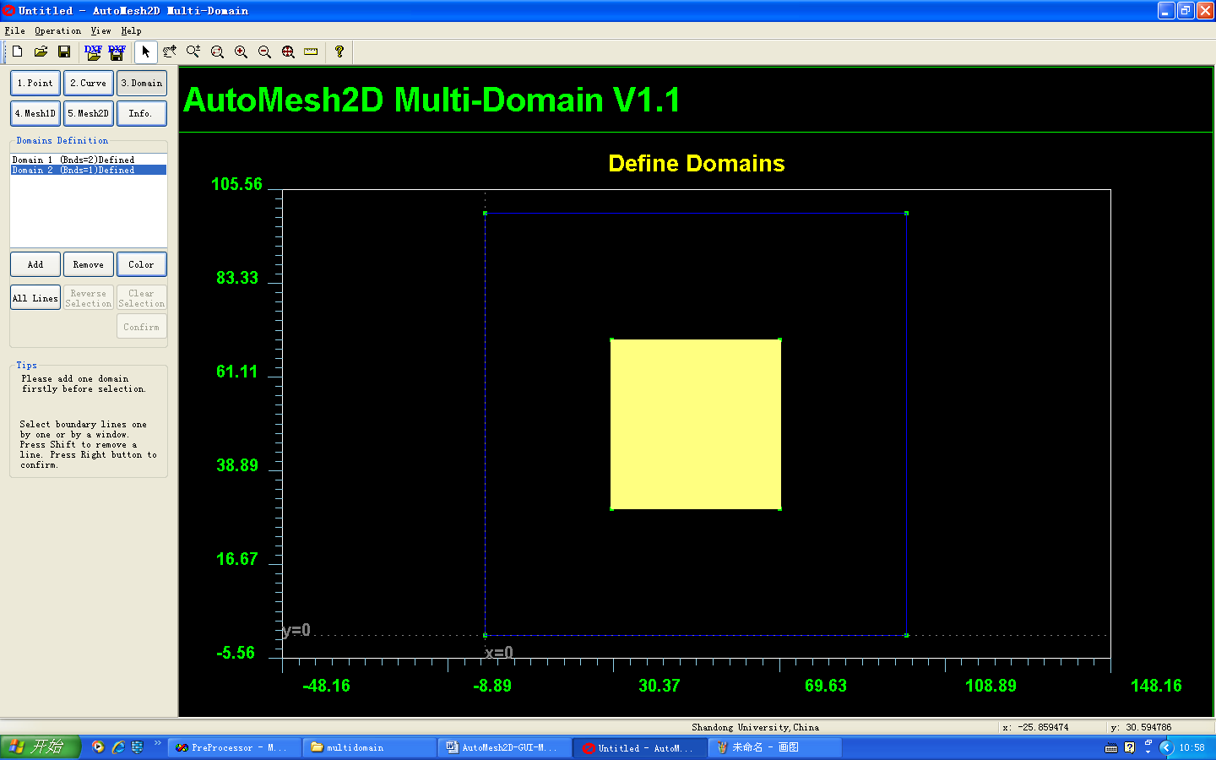

Step 4 Mesh Lines
Click on the button Mesh1D on the dialog.
Input the mesh size or the number of the nodes on every line. (Set mesh size 5 and 2 for external an internal boundary lines respectively.)
Select the lines with the mouse to be meshed. After that, press the RIGHT BUTTON to mesh the selected lines.
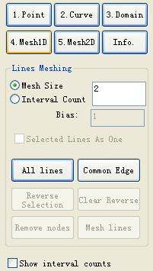
Click here
You can define mesh size or interval count to generate nodes on each selected line.
You can select lines one by one or by window with mouse in the graphics window. Then press RIGHT BUTTON to generate nodes on each selected line.
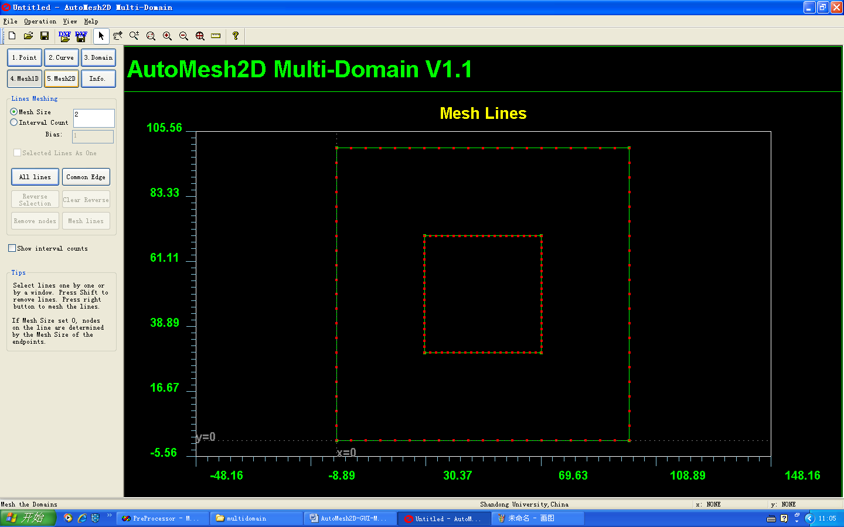
Step 5 Mesh Domains
Click on the button Mesh-2D on the dialog.
Select the domains with the mouse. After that, press the right button.
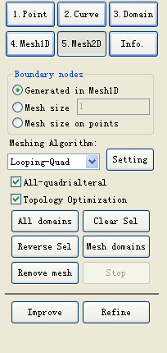
Click here
Mesh generation algorithm.
You can select domains one by one or by window with the mouse in the graphics window, then PRESS RIGHT BUTTON to generate mesh.
You can mesh the boundary lines in Mesh1D.
Or, you can set uniform mesh size.
Or, you can set mesh size on the endpoints of boundary lines
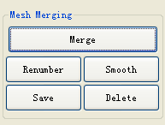
Merge: Merge mesh of all domains into one mesh.
Renumber: Bandwidth Optimization
Smooth: Laplace Smoothing
Save: Save the mesh to the file.
Delete: Delete the merged mesh
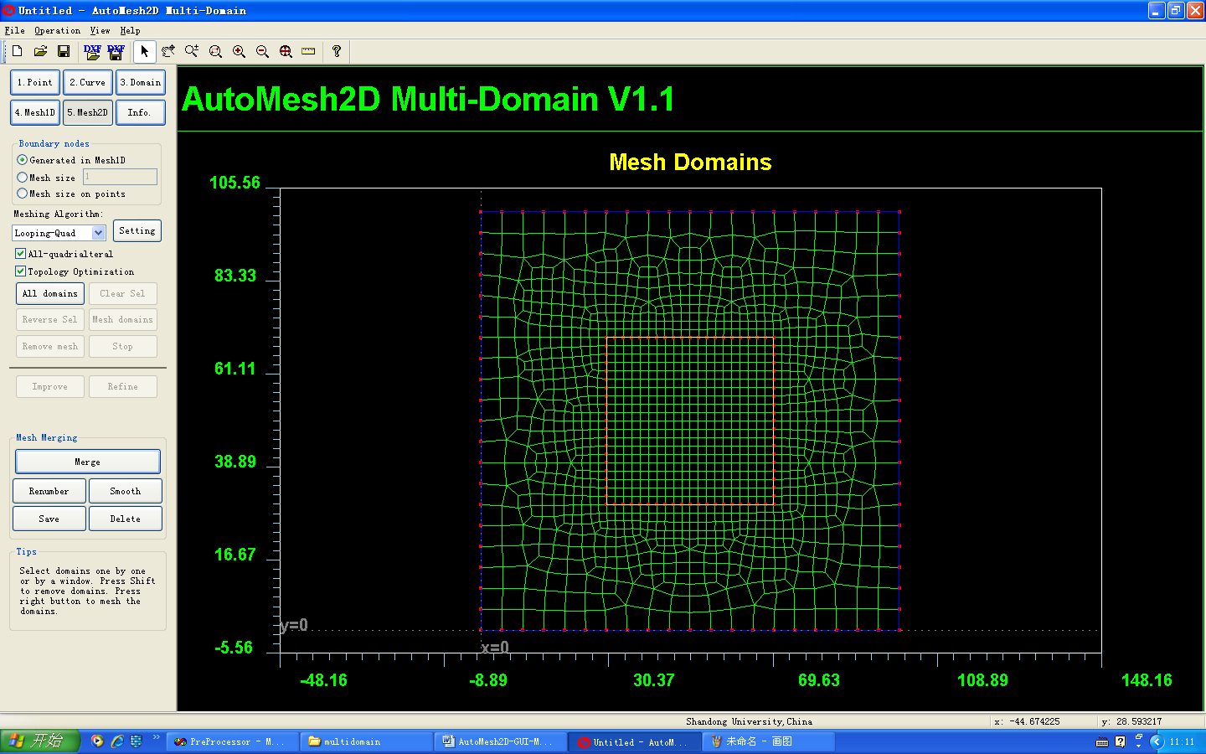
Click on the button Merge to merge all the mesh.
Click on the button Save to write the mesh to a file.

If you have difficulty in using this program or need new function, Please contact me!
If the mesh generation fails, Please send the ‘send_to_me.msd’ file to me: maxinwu@sdu.edu.cn . Thanks!

Please refer this if you publish your paper or thesis:
Ma XW, Zhao GQ, Sun L. AUTOMESH‐2D/3D: robust automatic mesh generator for metal forming simulation. Materials Research Innovations, 2011, 15(s1): s482-s486

