Clase-2_1930302.R

E. Motel

2024-04-29

## Esteban Motel Guzmán   
## 29 / 04 / 2024  
## 1930302  
  
  
# Importar datos ----------------------------------------------------------  
  
### Utilizar función read.csv sirve para importar datos  
  
cr <- read.csv("Cedro.csv", header = TRUE)  
  
  
# Revisión datos ----------------------------------------------------------  
  
mean(cr$diametro); mean(cr$altura)

## [1] 12.52396

## [1] 18.91011

median(cr$diametro); median(cr$altura)

## [1] 12.2489

## [1] 19.0589

sd(cr$diametro); sd(cr$altura)

## [1] 1.71485

## [1] 3.009312

range(cr$diametro); range(cr$altura)

## [1] 9.0283 18.4490

## [1] 10.2723 28.1563

fivenum(cr$diametro); fivenum(cr$altura)

## [1] 9.02830 11.37550 12.24890 13.36935 18.44900

## [1] 10.27230 16.69805 19.05890 20.67880 28.15630

# Representación grafica --------------------------------------------------  
  
boxplot(cr$diametro, main = "Cedro Rojo",   
 col = "darkred",  
 ylab = "Diametro (cm)",  
 ylim = c(10,20))

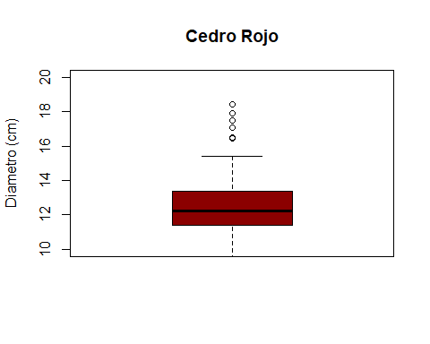

boxplot(cr$altura, main = "Cedro Rojo",   
 col = "yellow",  
 ylab = "Altura (cm)",  
 ylim = c(10,30))

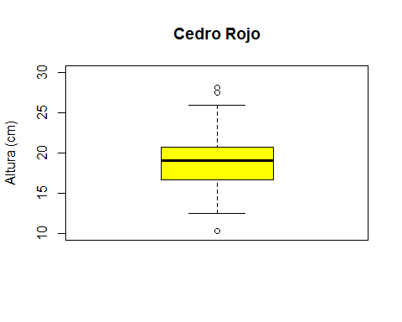

hist(cr$altura, xlab = "Altura (cm)",  
 main = "Cedro rojo",  
 ylab = "Frecuencia",  
 col = "blue")

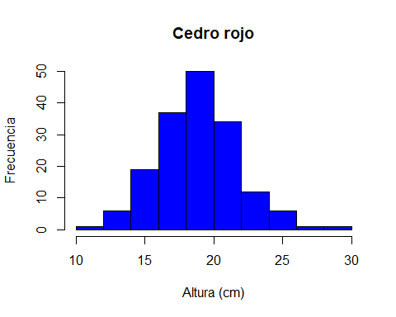

stem(cr$altura)

##   
## The decimal point is at the |  
##   
## 10 | 3  
## 11 |   
## 12 | 46  
## 13 | 2556  
## 14 | 22267889  
## 15 | 01133346688  
## 16 | 01222233444566677899  
## 17 | 112333446677789  
## 18 | 0001334456667777889  
## 19 | 0001112222334555666666777899999  
## 20 | 00111134444567778999  
## 21 | 0122234466678  
## 22 | 00023567  
## 23 | 012578  
## 24 | 06  
## 25 | 01479  
## 26 |   
## 27 | 5  
## 28 | 2