https://conversionxl.com/blog/saas-signup-flows/

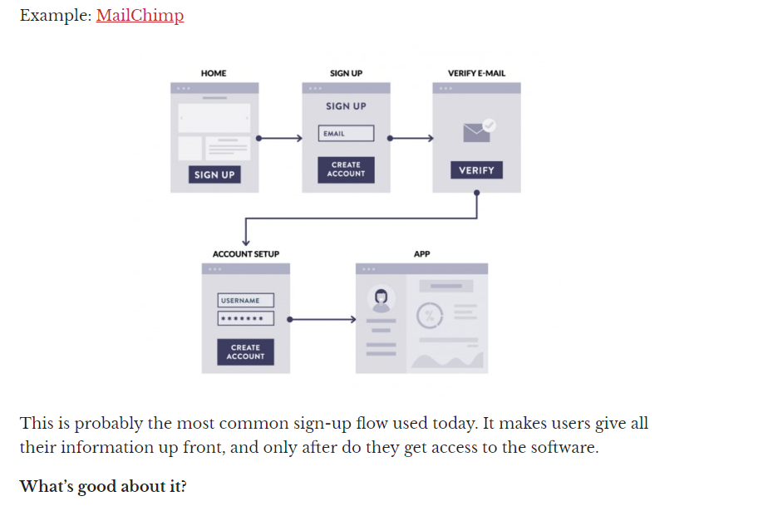

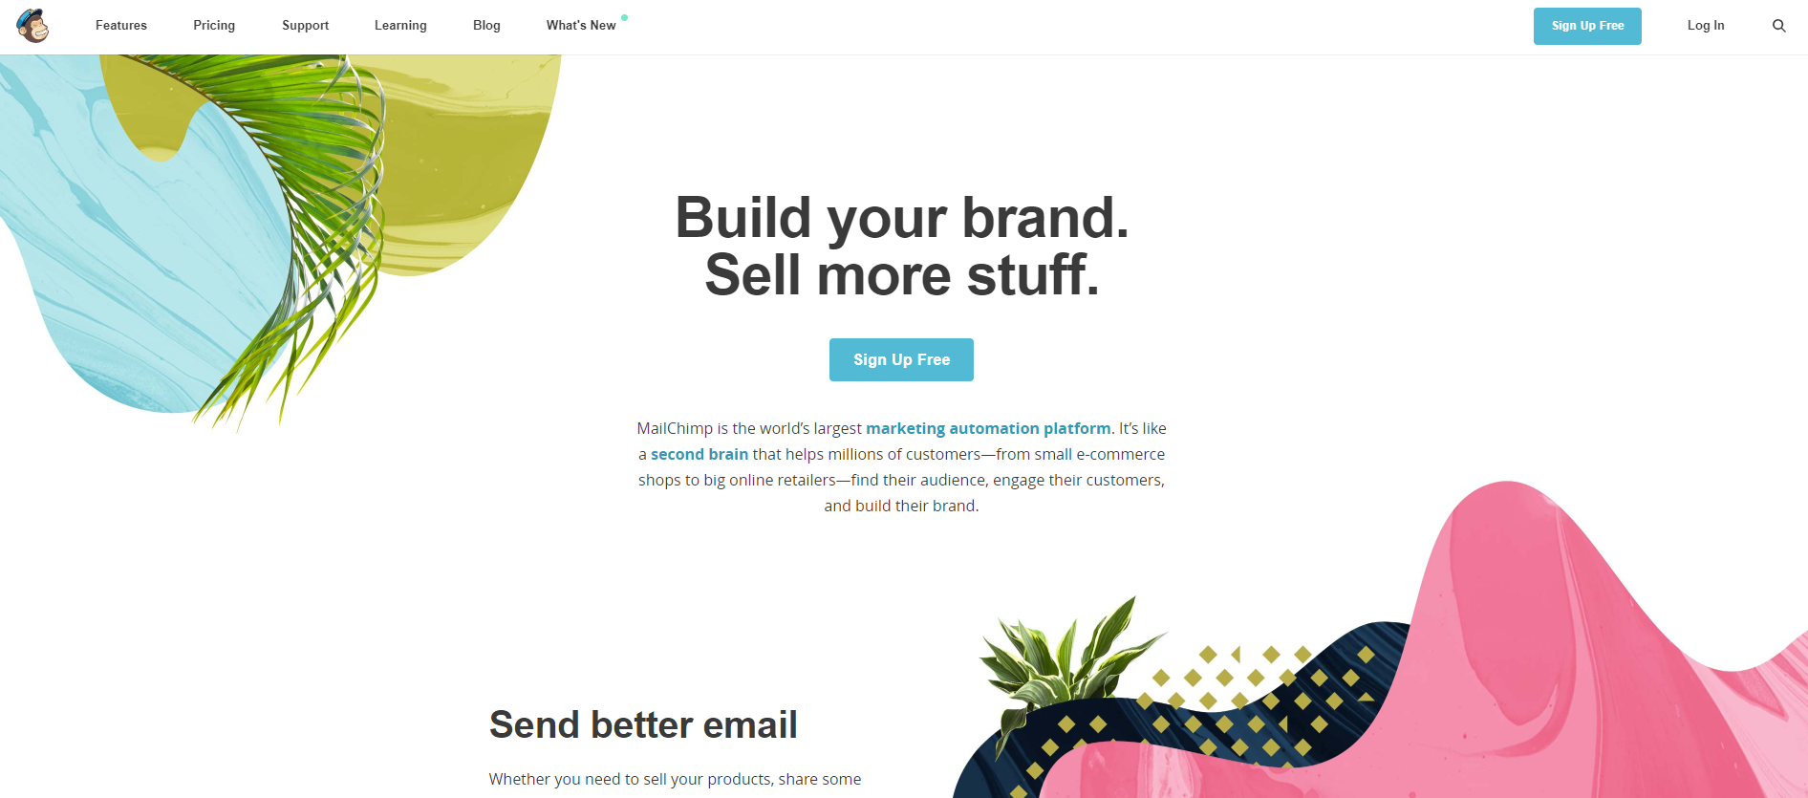

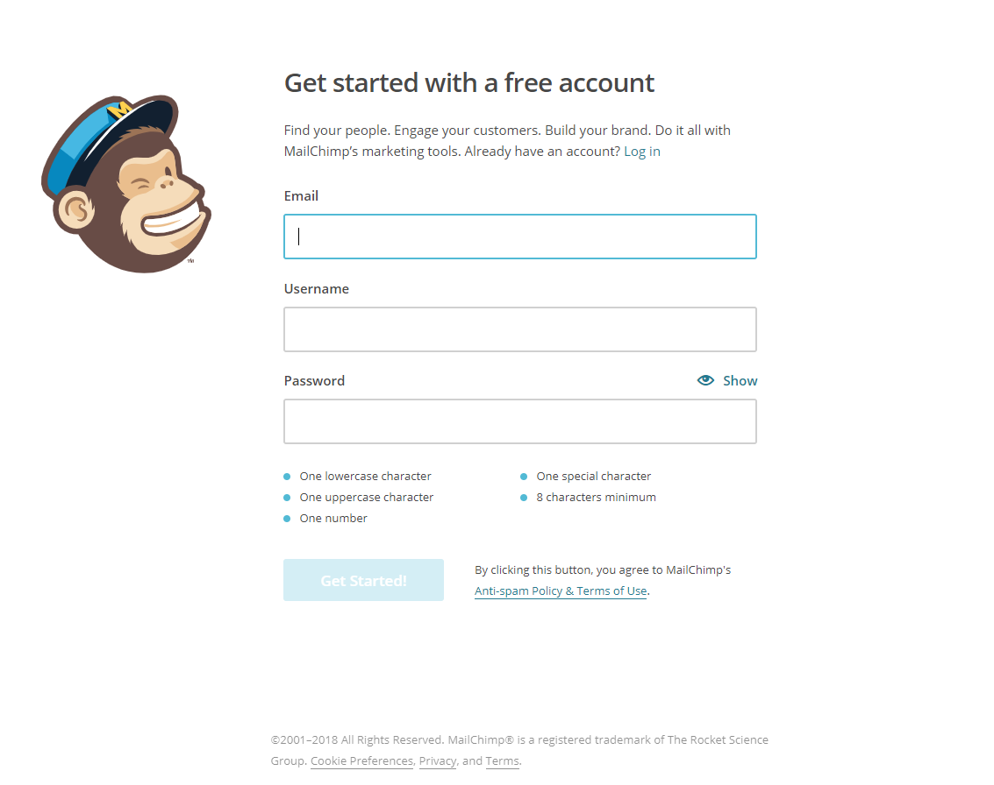

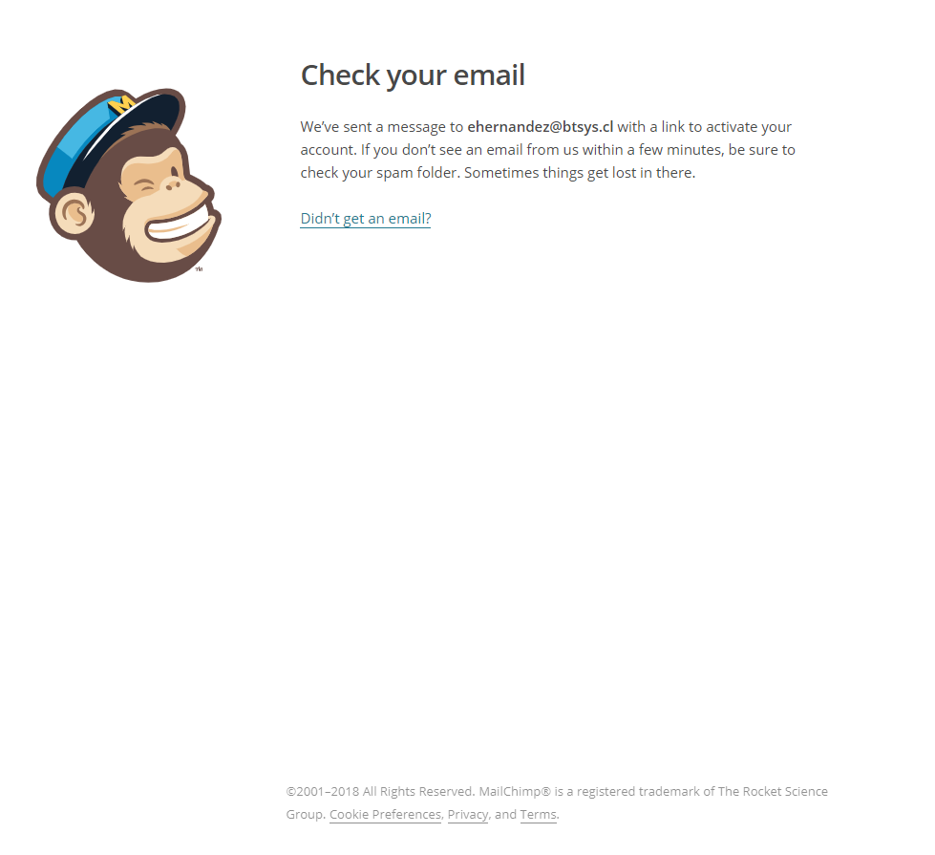

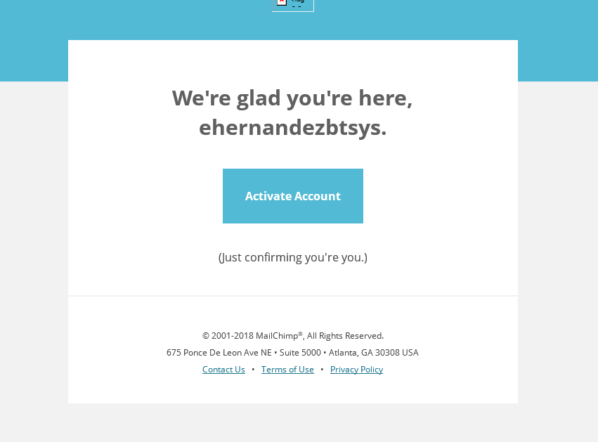

<https://us19.admin.mailchimp.com/signup/confirm?id=90670ef7ae44750396a3c2fb8&referral=&eid=62f7b1de7e922a23728d&kme=Clicked%20Activate%20Account%20Email&kmi=ehernandezbtsys>

<https://us19.admin.mailchimp.com/signup/confirm>?

id=90670ef7ae44750396a3c2fb8

referral=””

eid=62f7b1de7e922a23728d

kme=Clicked%20Activate%20Account%20Email

kmi=ehernandezbtsys

