AMILEARN REPORT

## About

Amilearn is an elearning management platform

## Users

Amilearn has 3 kinds of users

- Admins

- Teachers

- Students

## Tech Stack

Amilearn uses Flask, a Python web framework

It uses Alembic in the form of Flask-migrations for migrations

It uses SQLalchemy for ORM

It uses MySQL as database

## Features

Authentication

Login with email and password

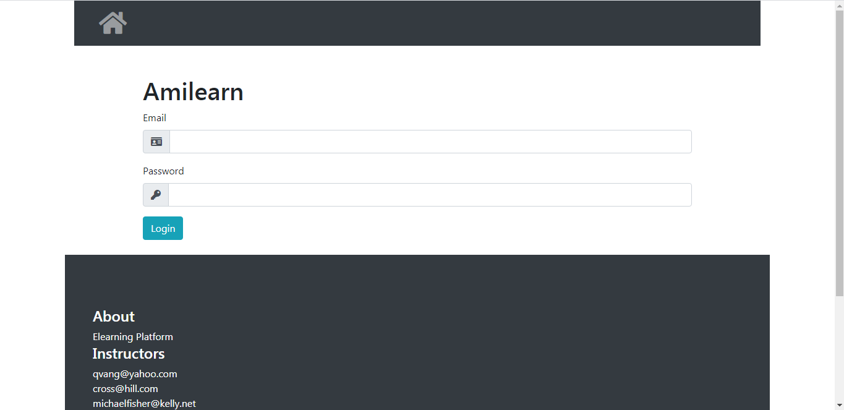

Access restricted as per role

Course Management

Create course

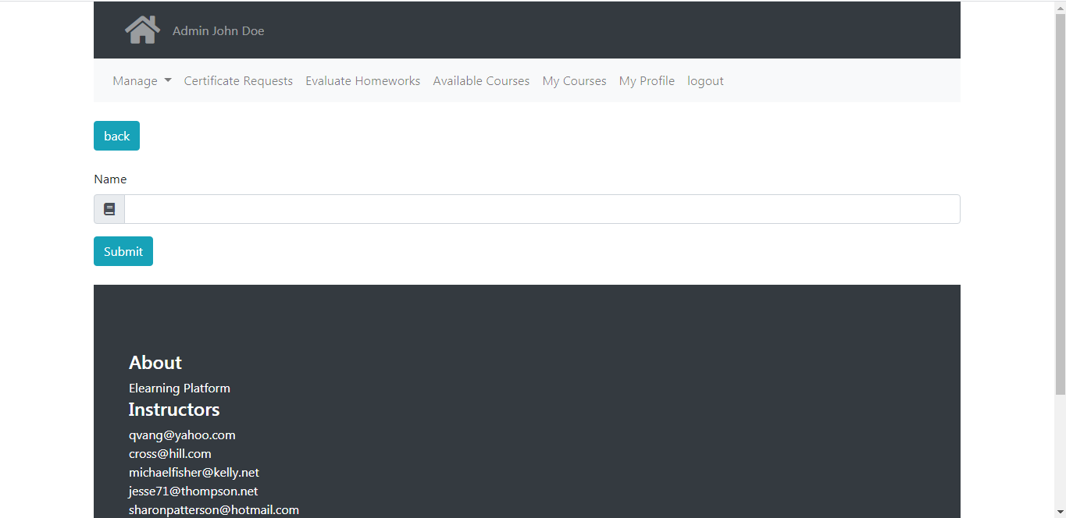

Create section

Create 10 quiz

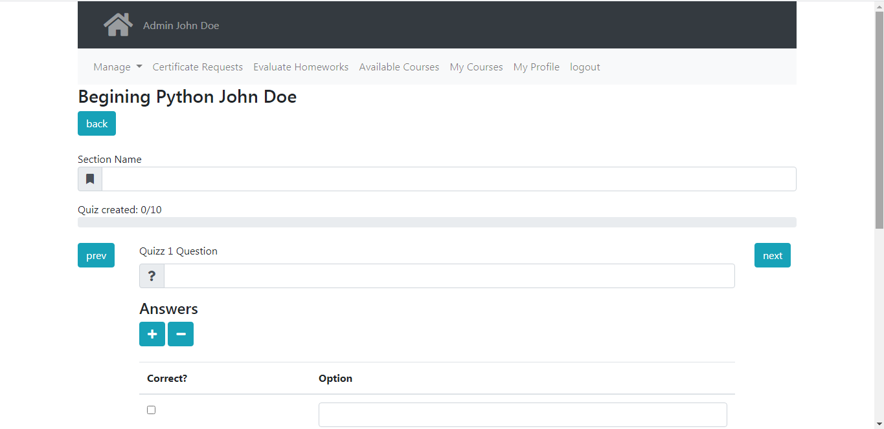

Submit for access

Auto remove if course does not meet display criteria of at least one section with one chapter.

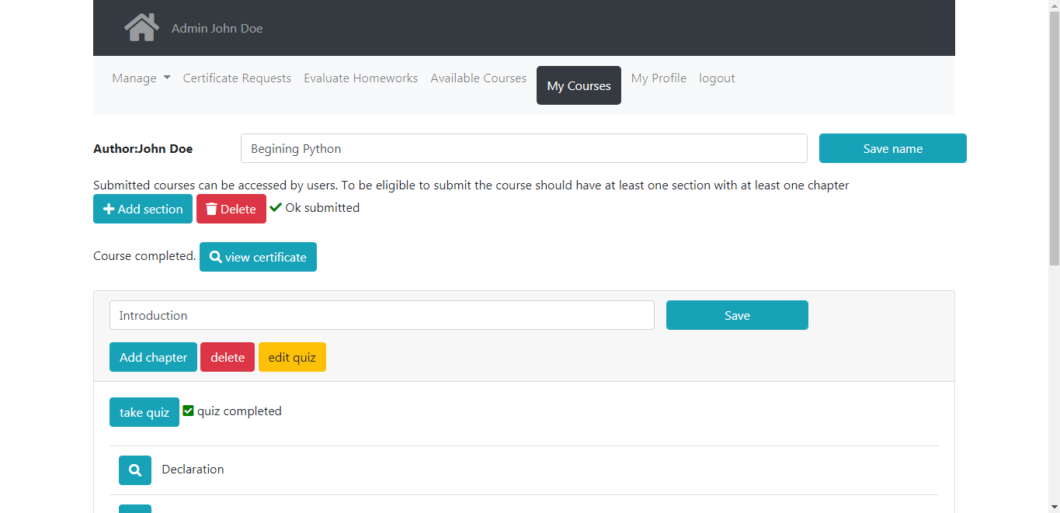

Create chapter

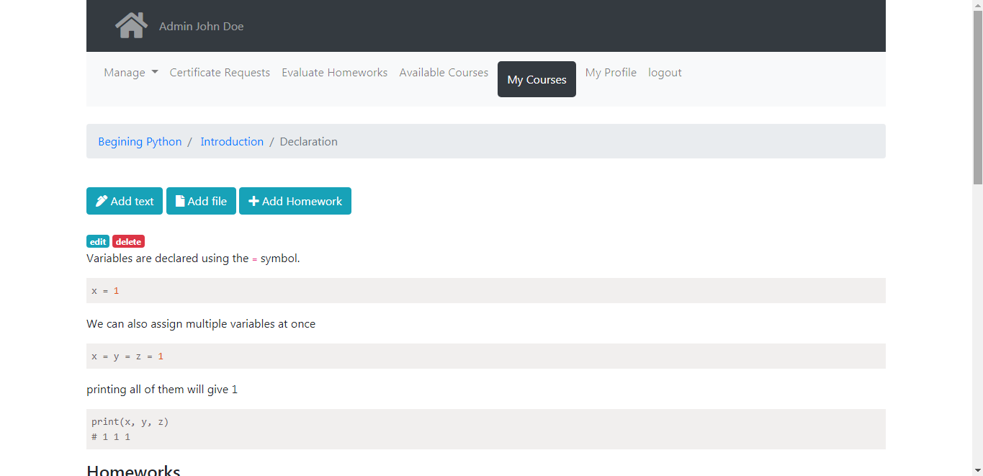

Add text

Add other resources

Course notes in markdown

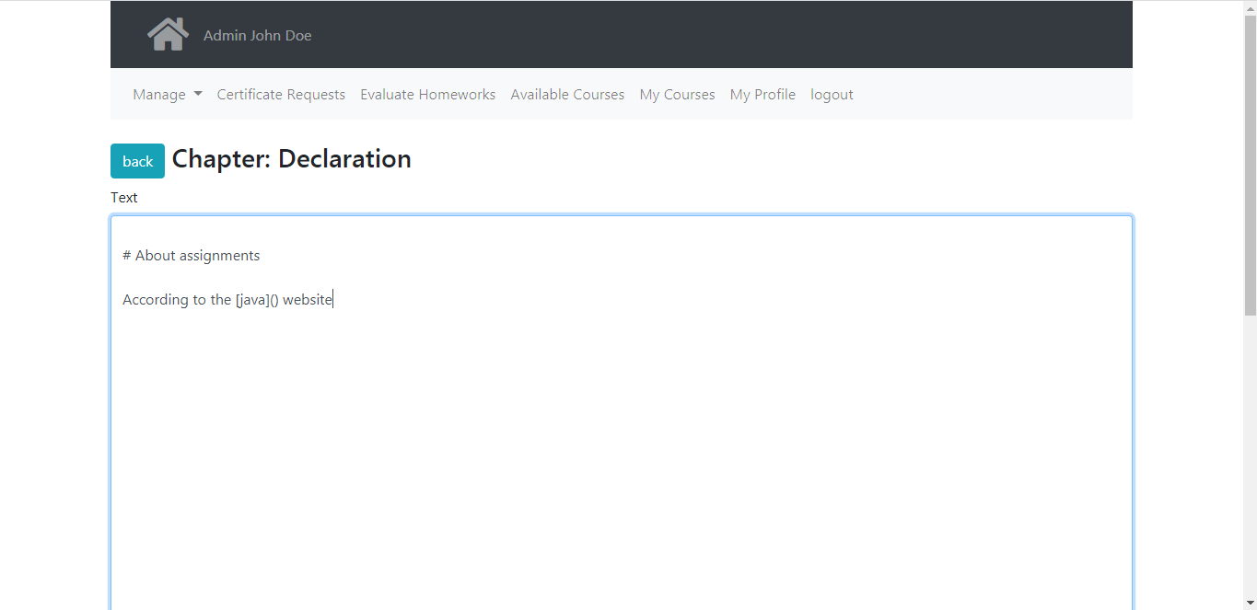

Set homework

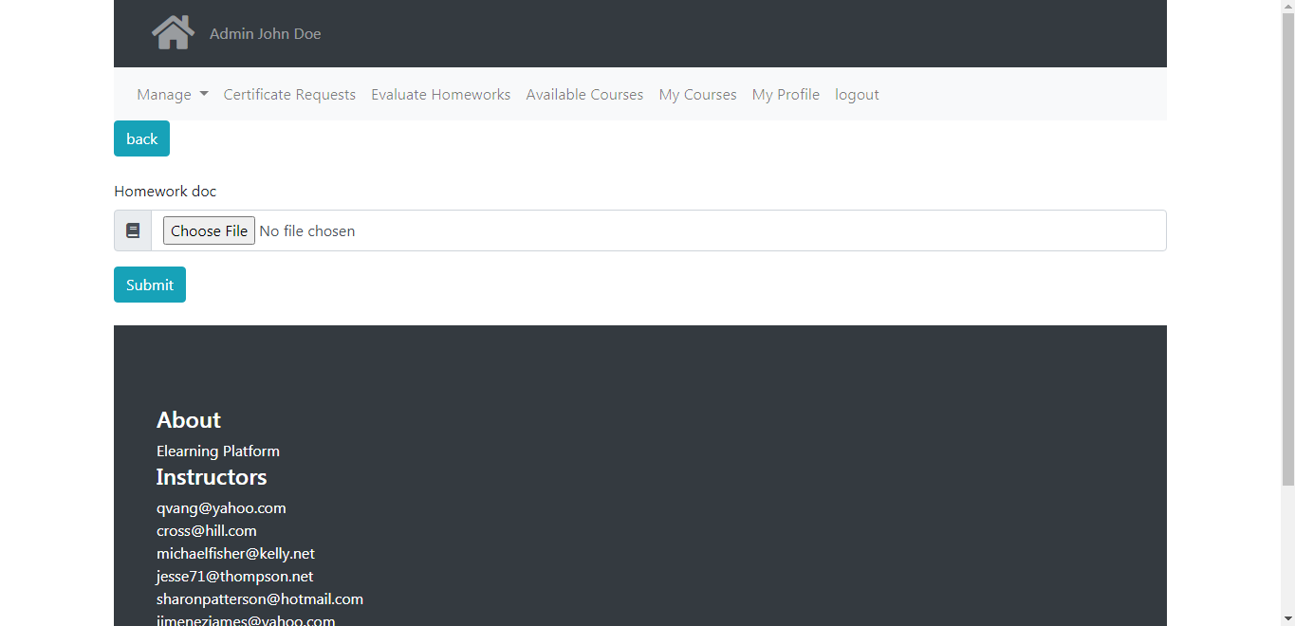

Submit homework

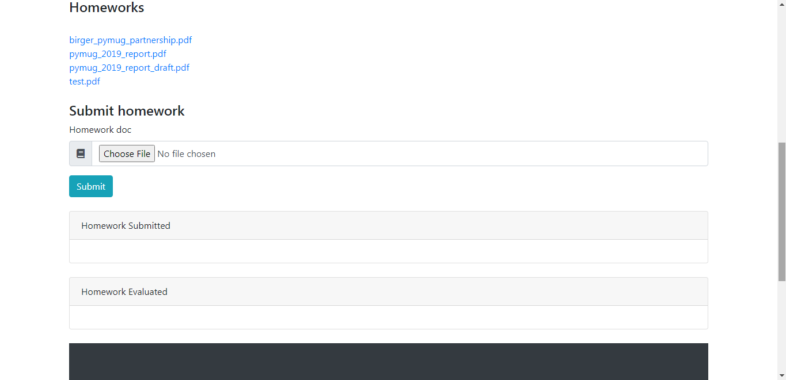

Evaluate homework

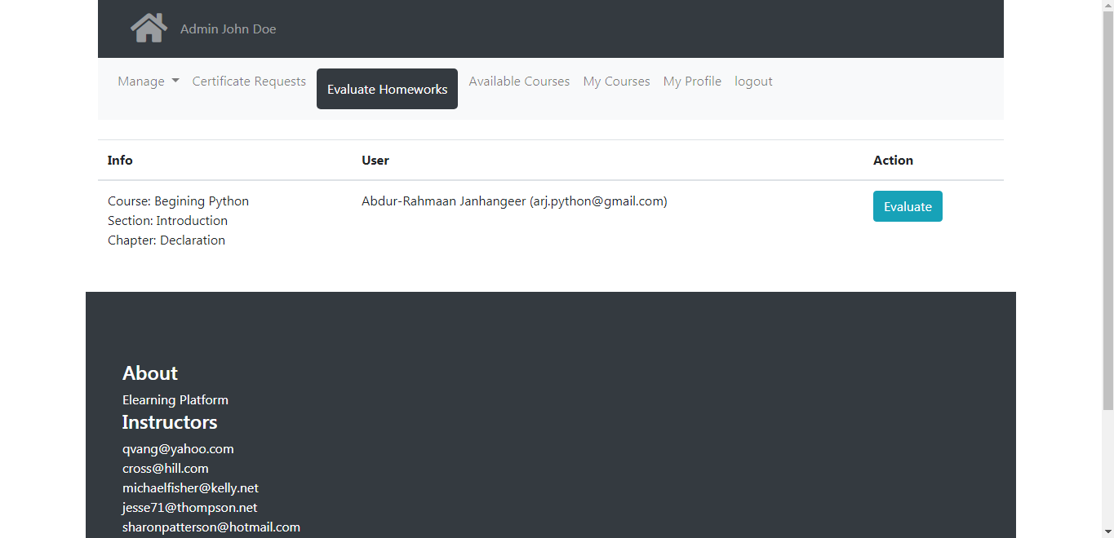

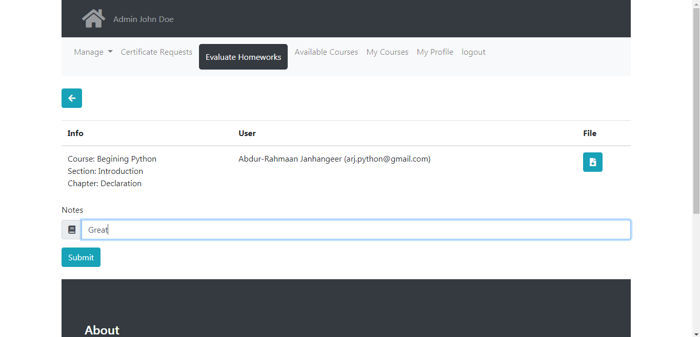

Complete Quiz

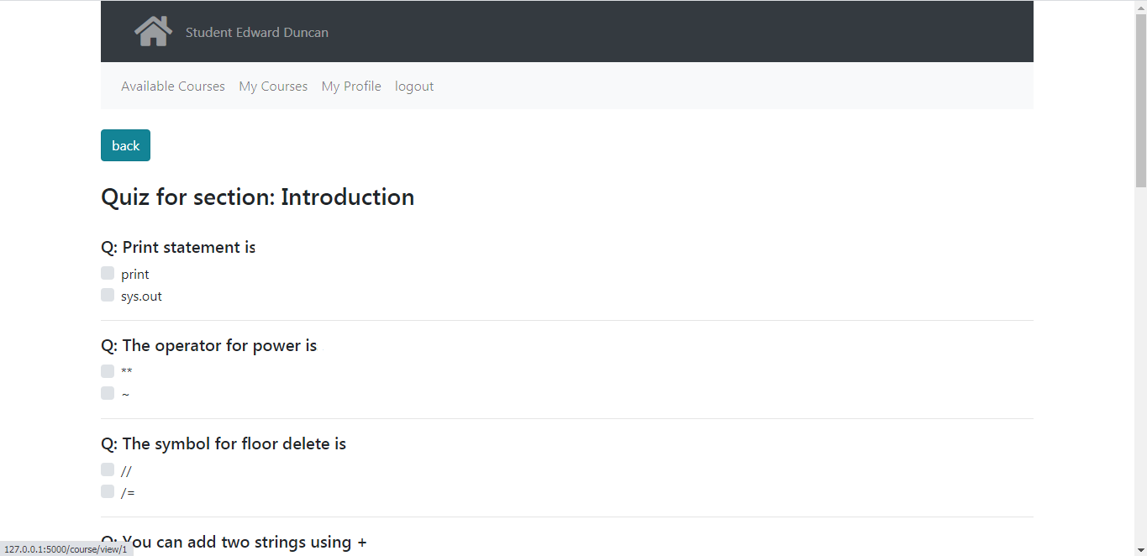

Request certificate

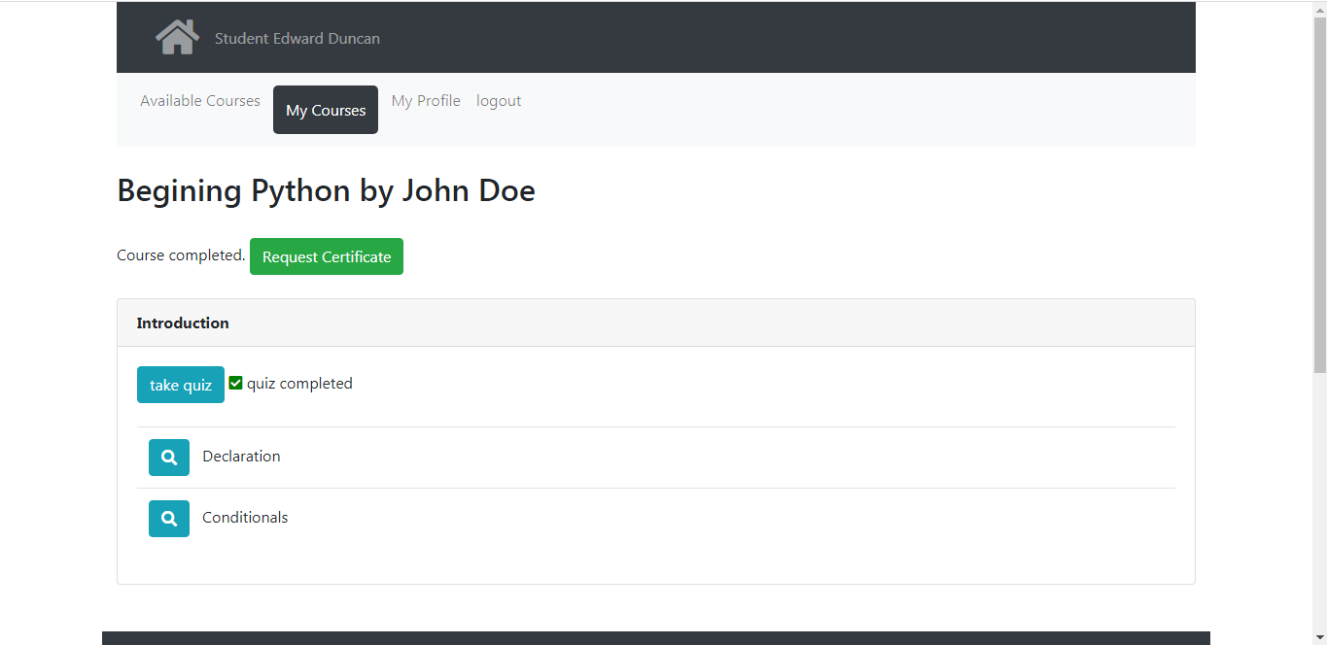

Approve certificate

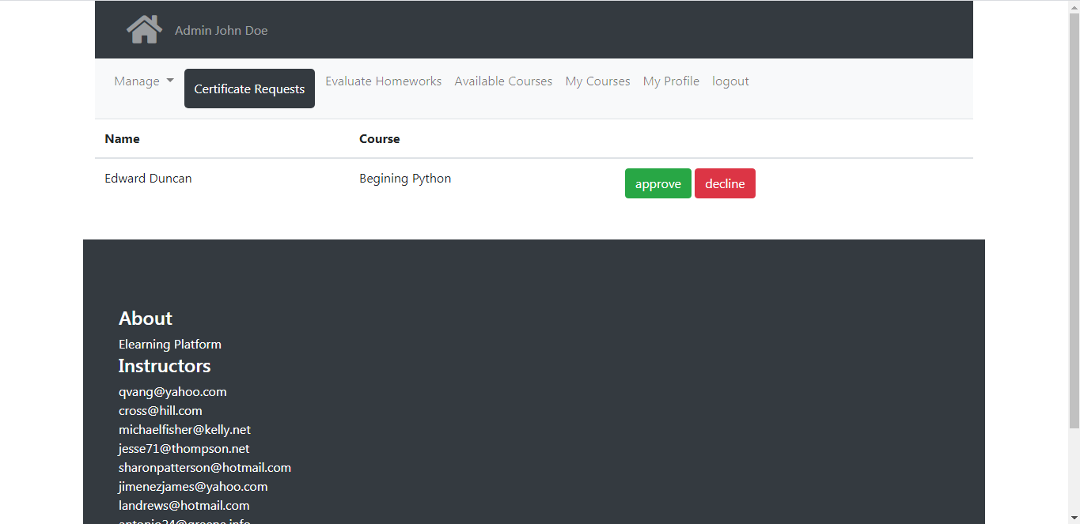

View and download certificate

Admin options

Manage teachers

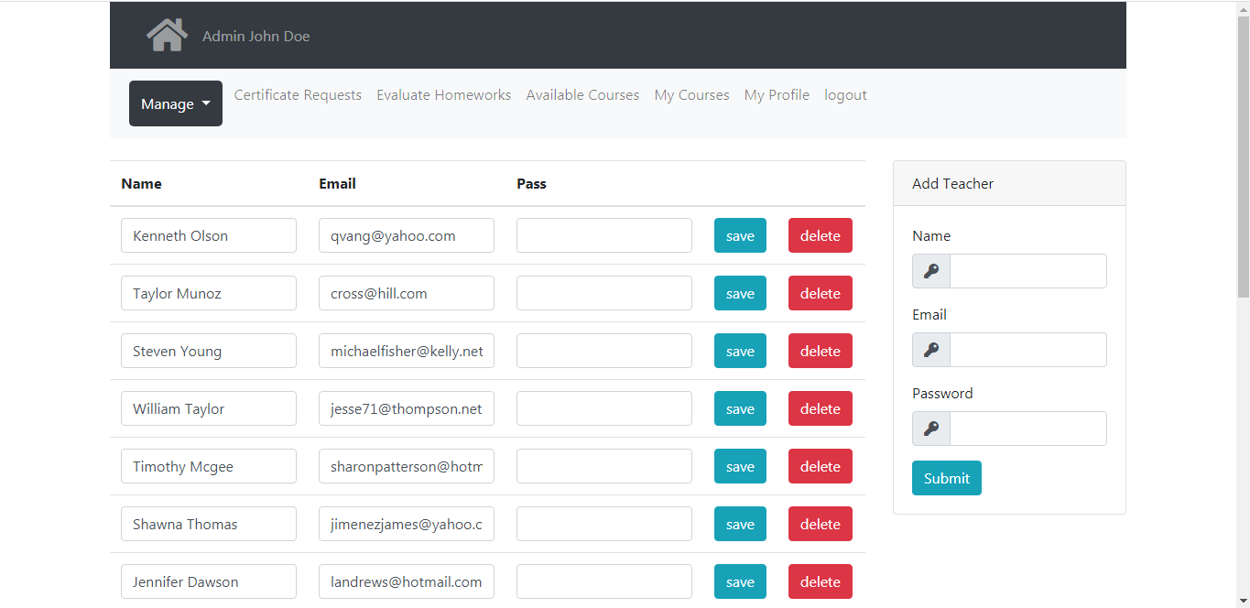

Manage students

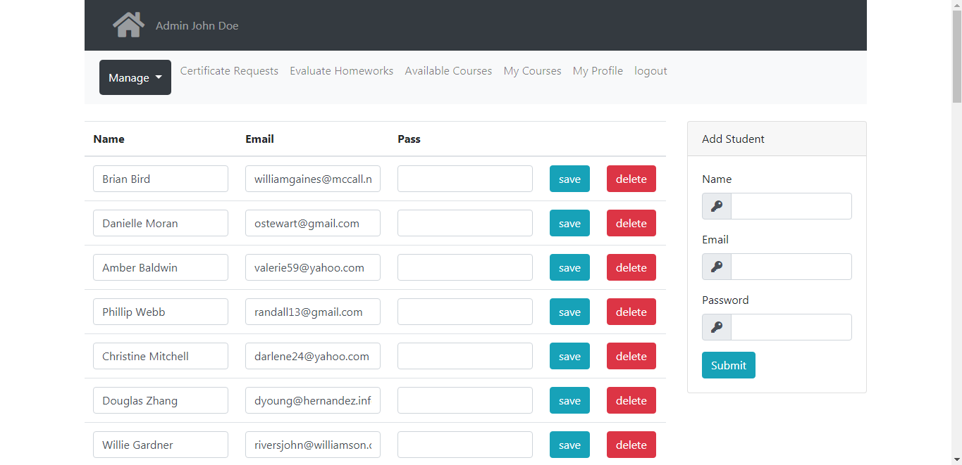

User experience

Besides listed above, users can subscribe and view list of subscribed courses

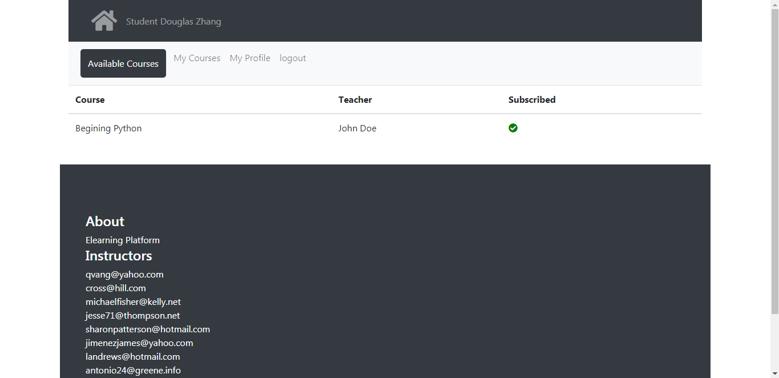

Unsubscribe from courses

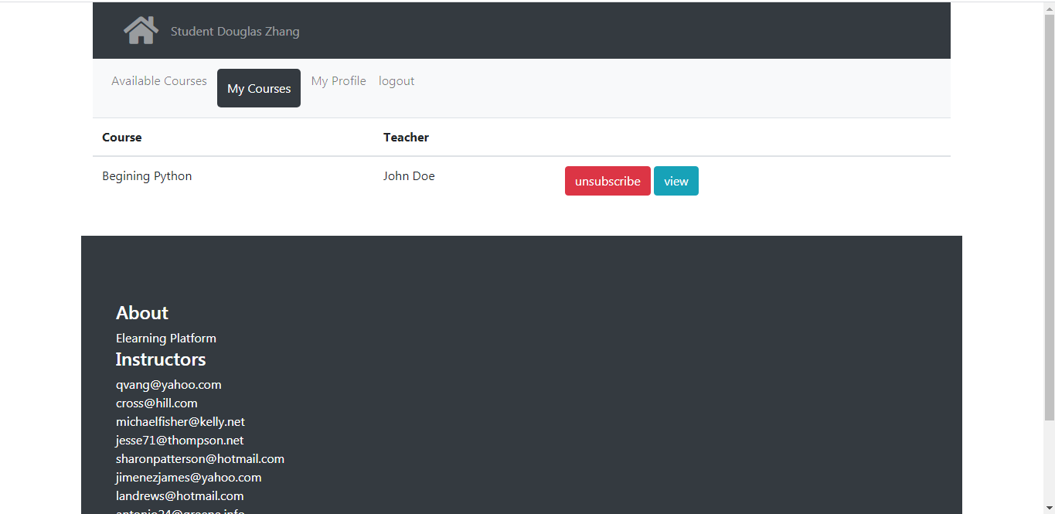

View profile with stats

