This is an example of using a Web MVC application without using any template. Remember, Since the solution is to understand the concepts I just put the code on ProductController.cs. No Layer for Database connection, OK!

What do you need?

1 – Create the database Product as is:

CREATE TABLE [dbo].[Product] (

[ProductID] INT IDENTITY (1, 1) NOT NULL,

[ProductName] VARCHAR (50) NULL,

[price] DECIMAL (18, 2) NULL,

[count] INT NULL,

PRIMARY KEY CLUSTERED ([ProductID] ASC)

);

2- on ProductController.cs, change the connection string as Is:

string connectionString = @"Data Source = (localdb)\MSSQLLocalDB; Initial Catalog = studies; Integrated Security=True";

tip: You can get the string connection as is:

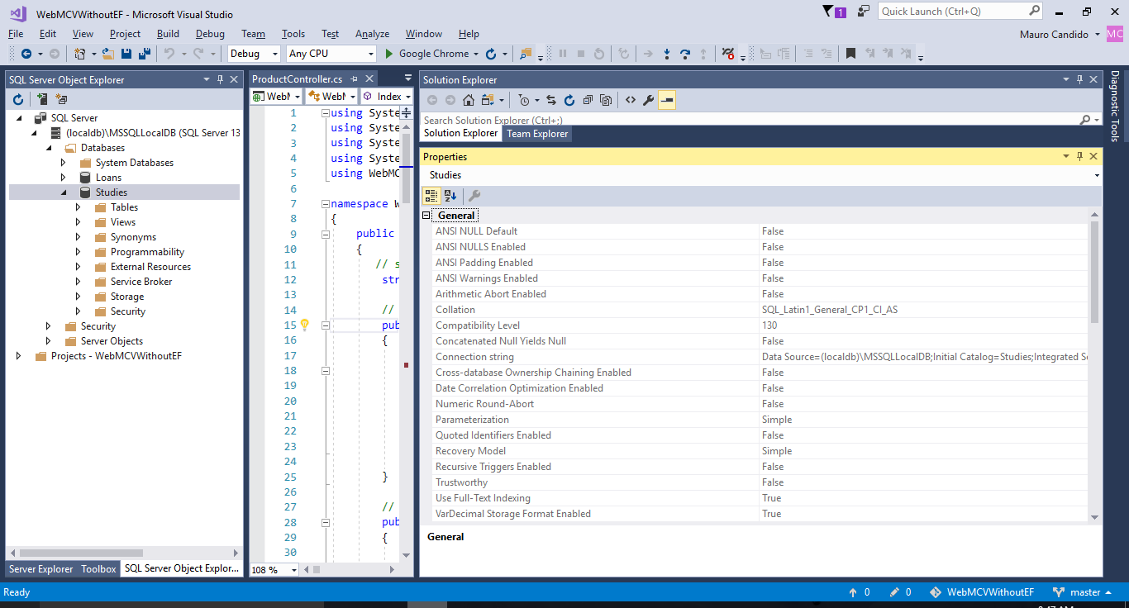

* Open SQL Server Object Explorer and position on the database that you create;
* Right click and them properties;
* Get the Connection String on properties and past on the connection string.