**Appendix A:**

*Input parameter functions for length-, weight-, maturity- and selectivity-at-age*

Weight-at-age is described as function of the weight to length conversion parameters *ω* and *δ* and length-at-age, *La*, such that

*wa* = *ωLa δ* (A.1)

The corresponding *La* was calculated based on the Bertalanffy growth function parameters as:

$L_{a}=L_{∞}(1-e^{-κ\left(a-a_{0}\right)})$, (A.2)

where *L∞* is the asymptotic length, $κ$ is the growth coefficient and *a*0 is the theoretical age at zero length.

The fraction of mature females at age *a* was calculated as:

$φ_{a}=\left\{\begin{aligned}0 for a<a_{mat} \\ 1 for a ≥a_{mat} \end{aligned}\right.$ (A.3)

where $a_{mat}$ is the age-at-maturity assumed to be knife-edge.

.

Selectivity-at-age for the fisheries operating with selectivity *s, $s_{a,s},$*  was calculated as a function of length-at-age, *L*a, using a two parameter logistic model of the form:

$s_{a,s}=\frac{1}{1+e^{-log⁡(19)\left(\frac{L_{a}-L_{{S50}_{s}}}{L_{{S95}_{s}-L_{{S50}_{s}}}}\right)}}$ (A.4)

$L_{{S50}_{s}}$ and $L_{{S95}_{s}}$ are the lengths at which 50% and 95% of the catch is retained, with selectivity *s*, respectively.

*Age-structured dynamics*

The age-structured simulation and estimation models were formulated building on the age-structured simulation-estimation framework employed in previous studies (Thorson and Cope, 2015). Numbers-at-age *a* and year *y, Na,y*,are governed by:

$N_{a,y}=\left\{\begin{aligned}R_{y} for a=0 \\ N_{a-1,y-1}e^{-s_{a,s}-F_{y-1}M} for a>0\end{aligned}\right.$ (A.5)

where *Ry* is recruitment in year *y*, *sa,s* is fishery selectivity at age under selectivity regime *s*, *M* is the instantaneous rate of natural mortality, and *Fy* in year *y*.

Spawning biomass *SBy* is expressed as:

${SB}_{y}=\sum_{a}{w_{a}φ_{a}N_{a,y}}$ (A.6)

where $w_{a}$ is the weight at age, $ψ_{a}$ is the proportion of mature fish in the population.

Stochastic recruitment is introduced as a lognormally distributed random variable with the expected mean derived from the BH-SRR function:

$\ln\left(R_{t}\right)\sim Normal\left(ln\left(\frac{4hR_{0}SB_{y}}{{SB}_{0}\left(1-h\right)+SB_{y}(5h-1)}\right)-0.5σ_{R}^{2}, σ_{R}^{2}\right)$ (A.7)

where *R0* is the unfished average recruitment and $σ_{R}^{2}$ is the variance is recruitment.

To initiate the age structure in the first year of the available catch time series, it is assumed that the stock is in an unfished stated, so that *Na,y=*1 can be approximated by a stochastic age-structured as result of recruitment variation in previous years:

$\ln\left(N_{a,y=1}\right)\sim Normal\left(ln⁡(R_{0}e^{-aM})-0.5σ_{R}^{2}, σ_{R}^{2}\right)$ (A.8)

Catch-at-age *ca,t* (in numbers) was calculated from the Baranov catch equation:

$c_{a,y}=N_{a,y}\frac{s_{a,s}F_{y}}{s_{a}F_{a}+M}\left(1-e^{-s_{a,S}F_{y}-M}\right)$ (A.9)

and total yield $C_{y}$ (in weight) in year *y* the summed product of catch at age and weight at age, such that:

$C_{y}=\sum_{a}{c_{a,y}w_{a}}$ (A.10)

The abundance index *Iy* (CPUE) for year *y* was assumed to be proportional to the exploitable portion of the biomass (*EBy*) and associated with a lognormally distributed observation error $ε_{y}$:

$\log\left(I_{y}\right)\sim Normal\left(\ln\left(q{EB}_{y}\right),σ_{ε}^{2}\right)$ (A.11)

where *q* is the catchability coefficient and *EBy* is a function of selectivity-at-age, such that:

${EB}_{y}=\sum_{a}{N_{a,y}w_{a}s_{a,s}}$. (A.12)

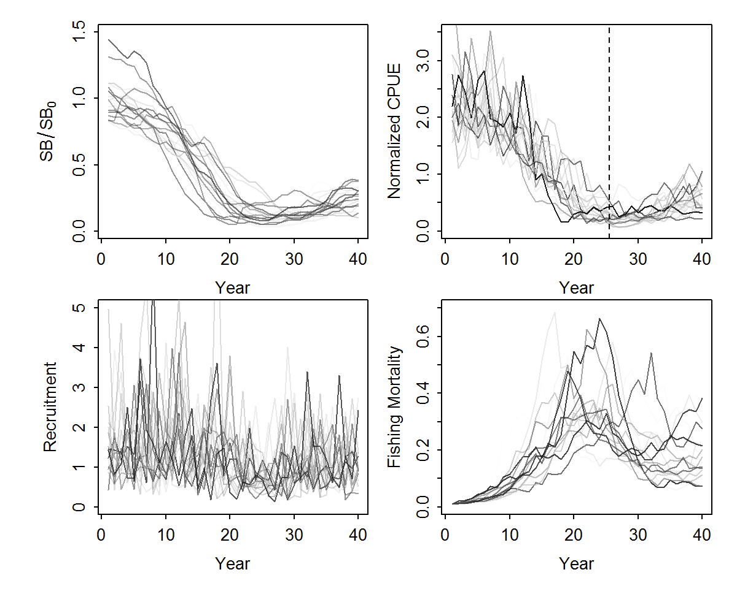

**Fig. A.1. S**imulated trajectories of *SBy*/*SB0*, normalized relative abundance indices (CPUE), recruitment deviates and fishing mortality *F* for the first 20 simulation replicates for the correctly specified model (CSM) scenario.

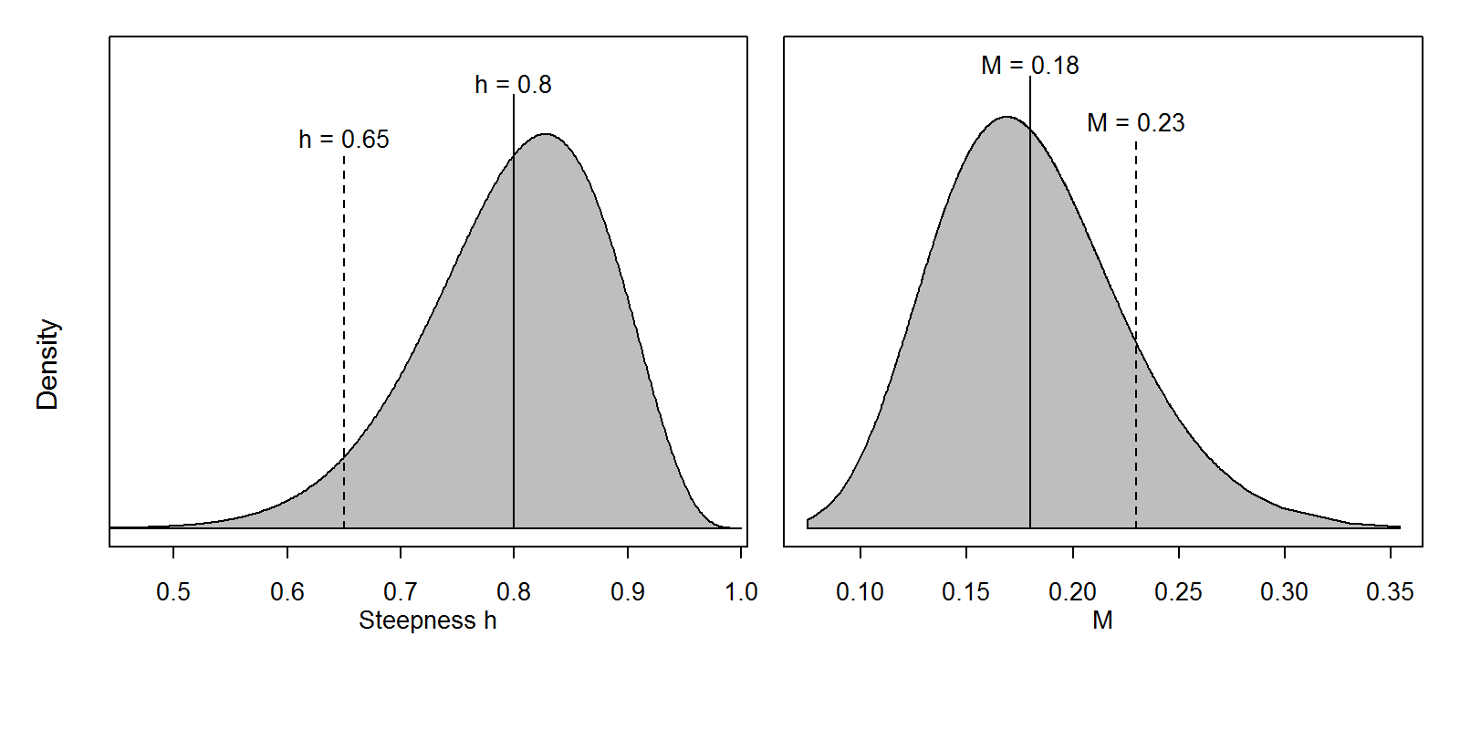

**Fig. A.2.** Illustrating the misspecification in steepness *h* and natural mortality in the operating model (dashed vertical lines) relative to the prior assumptions for the incorrectly specified JABBA-Select estimation model (ISM1).

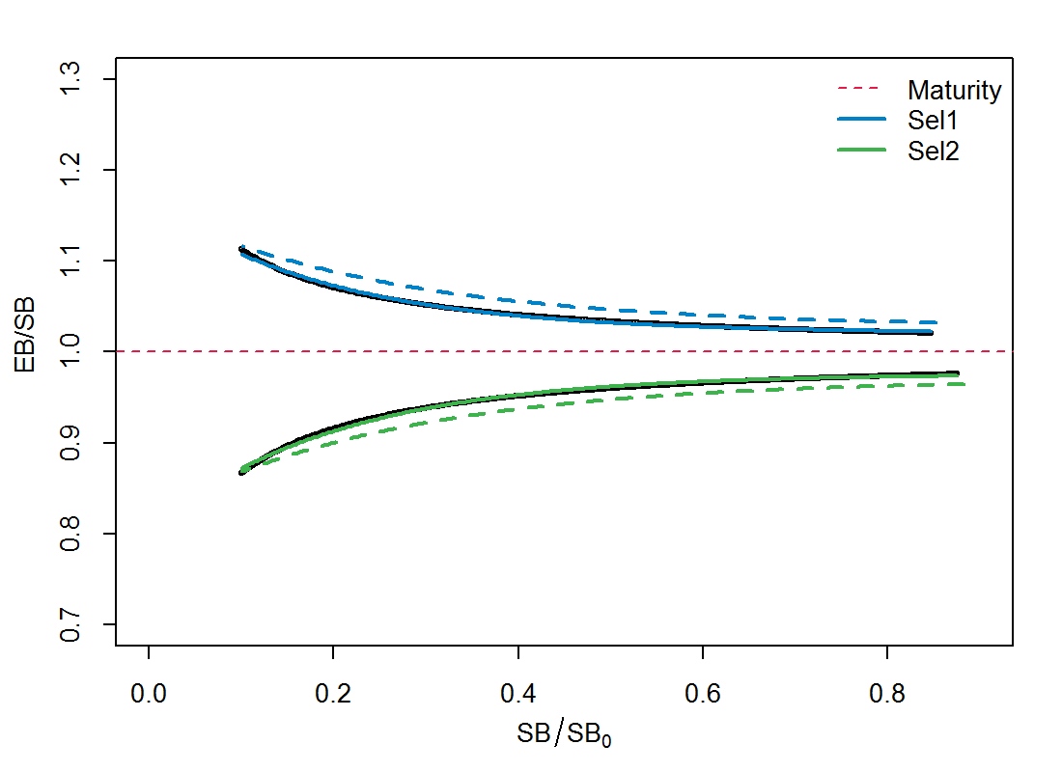

**Fig. A.3.** Illustrating the misspecification in steepness *h* and natural mortality in the operating model (dashed vertical lines) relative to the ASEM-derived selectivity-dependent distortion in the exploitable biomass (*EB*) relative to the spawning biomass (*SB*) over a wide a range of *SB / SB0* iterations (Eq. 12) for the incorrectly specified JABBA-Select estimation model (ISM1). The solid lines indicate the relationship assumed in the JABBA-Select estimation model and the dashed lines denote the misspecified relationship in the ISM3 operating model. The dashed line denotes the

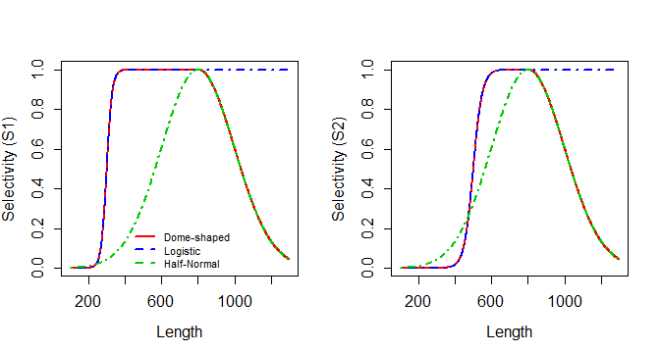

**Fig. A.4.** Misspecified selectivity by using dome-shaped selectivity curves in the operating model and logistic curves the incorrectly specified JABBA-Select estimation model (ISM2). The piece-wise dome-shaped selectivity curve combines a logistic function for the ascending limb with the descending limb described by the mean, CV and minimum of a half-normal distribution

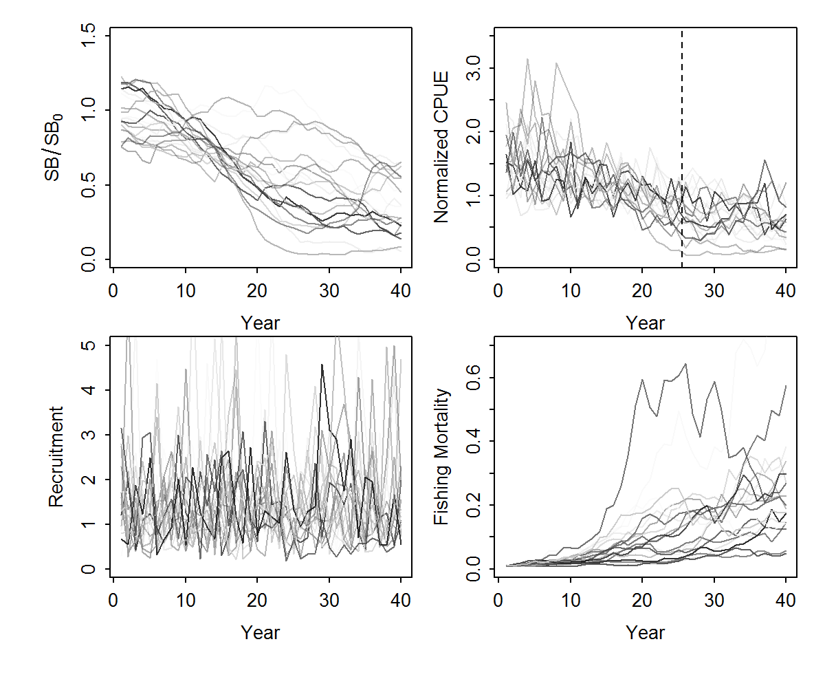

**Fig. A.5. S**imulated “one way trip” trajectories of *SBy*/*SB0*, normalized relative abundance indices (CPUE), recruitment deviates and fishing mortality *F* for the first 20 simulation replicates for the incorrectly specified model scenario IMS4.