Uncertainty in dynamics and populations variables coquina Donax trunculus in Cadiz Golf measure with an integrated model. Implications in management and conservation.

Mardones, M., Delgado, M.,… (Anina, Luis, Miguel?).

# INTRODUCTION

Shellfish fishery is an ancestral activity in most coastal regions worldwide, in part because shellfish remains an open-access source of seafood in many countries [cita]. Despite its popularity and importance, the dynamics of clam harvesting, environmental impacts, and social and economic value for local communities are still poorly known and not well understood [cita], namely because studies on shellfish recreational harvesting are scarce (**Delgado2017?**).

Coquina (Donux trunculus) fishery is one of the most important both socially and economically, in the Gulf of Cadiz over the last three decades . While fisheries for benthic invertebrate resources like this one are generally considered data-poor, this fishery has been subject to monthly periodic monitoring for the past 10 years, placing it in a category with more and better available information. Various scientific studies have been conducted on reproductive aspects, morphology, and life history parameters, contributing to a wealth of information. This data has facilitated scientific advice through population and fishery indicators. However, the lack of knowledge regarding the exploitation status under scientific standards, coupled with the significant variability in life history parameters, complicates advice efforts in management and conservations.

It should be noted that the coquina is exploited in the Doñana National Park, making it an important species. In ecological terms and the ecosystem, therefore, its exploitation must be cautious. On the one hand, it meets socioeconomic expectations and, on the other hand, it generates positive externalities for the ecosystem in which it is found. findsWhich has been a fragile ecosystem and threatened by the growing interest in the use of the coastal edge in this sector

Our aim is to establish the first stock assessment using an integrated model that allows diagnosing the exploitation status based on reference levels. Additionally, we seek to identify and quantify the uncertainty associated with the most controversial aspects within the conceptual model, namely, maturity and growth. It is noteworthy that this resource is exploited in a marine reserve area, which enhances interest not only in its management but also in its conservation.

One of the main sources of uncertainty associated with benthic resource assessment models is considered in aspects such as growth and maturity.

Integrated Stock assessment models, especially in benthic species, are recent, since these resources require special considerations and considerations in terms of their spatial structure, as well as their own dynamics. Examples such as X X X X and XXX have opened the door to this type of evaluation approach for stock resources. invertebrates see tonics

The main sources of uncertainty associated with the valuation of invertebrate resource stock are contained in aspects such as growth and reproduction and recruitment. In this work we will take care of these three aspects, and we will see influence on the main population variables and also the status of exploitation of this resource.

The working group considers that this resource contains these pieces of information collected by monitoring programs over the last 10 years with which population dynamics can be modeled based on scientific rigor and thereby give precise recommendations for management and also in its conservation.

# METHODOLOGY

## Study area

## Data sources

The main source of information for these analyzes comes from population monitoring that has been carried out since 2013 on a periodic and monthly basis. This monitoring includes taking samples with a commercial trail and a population trail which allow obtaining different information components such as example performance densities recruitment size structuresAll I referencedAnd in turnWith other types of variables ICO variables associated with monitoring. This data was standardized and analyzed through a data analysis with which we were able to identify the three patterns and build the templates for the stock valuation. Stock assessment model Scenarios of uncertainty in coquina dynamics

# RESULTS

# DISCUSION

Stock valuation exercise through an integrated model structured in size and with dynamic age. It is configured as the first Inside of population variables and exploitation status of coquina in the Gulf of Cádiz

And versus and varied stock valuation studies of other invertebrate resources have been carried out in the Iberian Peninsula. The greatest number of these have been carried out with a poor data approach, since these resources generally lack pieces of information that vary with which a more sophisticated structural model can be made. In this case and thanks to the monitoring projects funded by the European Union, it was possible to gather and standardize a database of more than 10 years on a monthly basis, which allowed us to model this resource with a monthly dynamic to generate the global advices.

# REFERENCES

# SUPLEMMENTARY INFORMATION

# CREDITS

# Figures and Tables

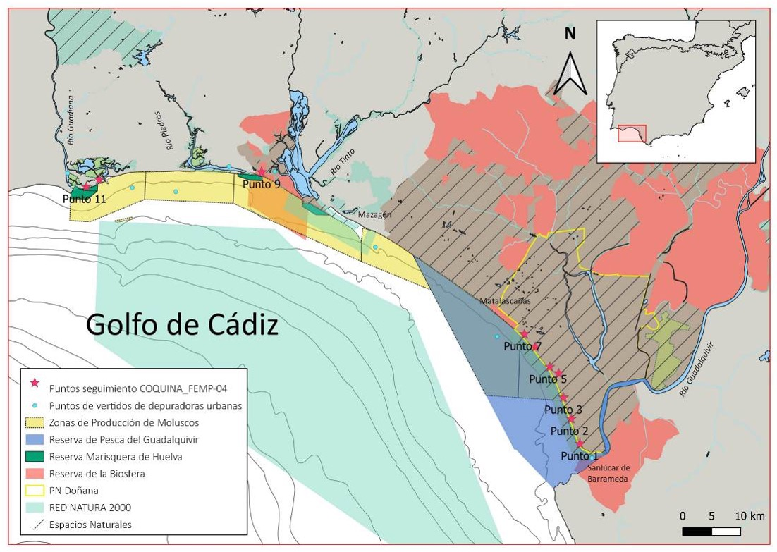

Figure 7.1: Mapa con los puntos de muestreo establecidos en el seguimiento temporal de D. trunculus en el litoral de Huelva llevado a cabo por el IEO.