Searching spatial-temporal changes in intrinsic productivity of Antarctic Krill (Euphausia superba) in a fishery management context

Working Paper to be submitted in a CCAMLR WG 2023

Mardones, M; Watters, G.; Cárdenas, C.

29 May, 2023

# ABSTRACT

One approach for understanding the dynamics of krill populations in the Antarctic Peninsula is through the analysis of empirical data, such as size composition obtained from fishery monitoring. By studying this data over multiple years and considering life history parameters, we can assess the intrinsic productivity of krill and potential changes over time and in different areas. To achieve this, we have employed the Length-Based Spawning Potential Ratio (LBSPR) method. This method allows us to estimate the reproductive potential of the population based on current exploitation levels, as well as its comparison to a virgin condition. By identifying reference points specifically related to reproductive potential, the LBSPR method provides insights about the state of the krill population. Recognizing spatial and temporal changes in the intrinsic productivity of krill, as indicated by their reproductive potential, is crucial for the understanding of the unique characteristics of this species. Moreover, these findings have important implications for management strategies within the context of the Commission for the Conservation of Antarctic Marine Living Resources (CCAMLR). By integrating knowledge of krill dynamics and its reproductive potential, advise can be produced to ensure the sustainable management of krill populations in subarea 48.1.

*Keywords: Krill populations, dynamic population, size compositions, Spawning Potential Ratio (SPR), Management, CCAMLR.*

# 1. INTRODUCTION

The western Antarctic Peninsula ecosystem is a critical region of the Southern Ocean for populations of Antarctic krill (*Euphausia superba*; hereafter krill) serving as a major spawning and recruitment area and as an overwintering hotspot, especially within Bransfield Strait. Over the last 40 years, climate driven changes have resulted in warming waters, declines in seasonal sea ice extent and duration (Stammerjohn, Martinson, Smith, & Iannuzzi, 2008; Stammerjohn, Martinson, Smith, Yuan, et al., 2008), changing trends phytoplankton productivity (Saba et al., 2014; Siegel et al., 2013).

Additionally, changes have impacted the population dynamics of krill, resulting in distribution changes with consequent contraction of the population in the southwest Atlantic Ocean toward the peninsula (A. Atkinson et al., 2009). In addition, changes in the population structure have also verified in krill in recent years (Reiss et al., 2020). The mentioned temporal and spatial changes have implications for the reproductive potential of the species and this, therefore, for intrinsic productivity.

One way to understand and measure changes in intrinsic productivity is through assessing the ratio of krill reproductive potential. There are many length-based assessment methods to understand this changes between years (Canales et al., 2021; Froese et al., 2018; Hordyk et al., 2016; Rudd & Thorson, 2017). On the other hand, one of the advantages of these methods is to use one of the most reliable and abundant sources in the sampling of fishing activities, such as size structures (Canales et al., 2021).

Spatial and temporal changes in the population structure have been a relevant issue within CCAMLR (Commission for the Conservation of Antarctic Marine Living Resources) fisheries management schemes. In this sense, new more localized or reduced spatial scales have been proposed to identify changes in these scales. Despite these proposals to identify krill population dynamics at a finer level, these schemes are not yet operational for decision making (Hill et al., 2016; McBride et al., 2021).

We then propose to identify differences in krill reproductive potential at the finer spatial and temporal scales, propose a specific reference point considering the spatial scale, and ultimately provide recommendations for sustainable management of the krill fishery through intrinsic productivity in Subarea 48.1 on the Antarctic Peninsula in the Southern Ocean.

# 2. METHODOLOGY

## 2.1. Study area

The study area includes subarea 48.1, which is one of the sectors where today the largest amount of krill fishing is concentrated (A. Atkinson et al., 2022; McBride et al., 2021; Santa Cruz et al., 2022). In order to have a finest spatial definition of krill dynamics population, we will analyze the differences between the management strata defined in WG-EMM-2021/05 Rev. (WG-EMM-2021/05 (2021)), namely Brainsfield Strait, Elephant Island, Extra, Joinville Island and South West (hereafter BS, EI, Extra, JOIN and SSIW respectively) (Figure )

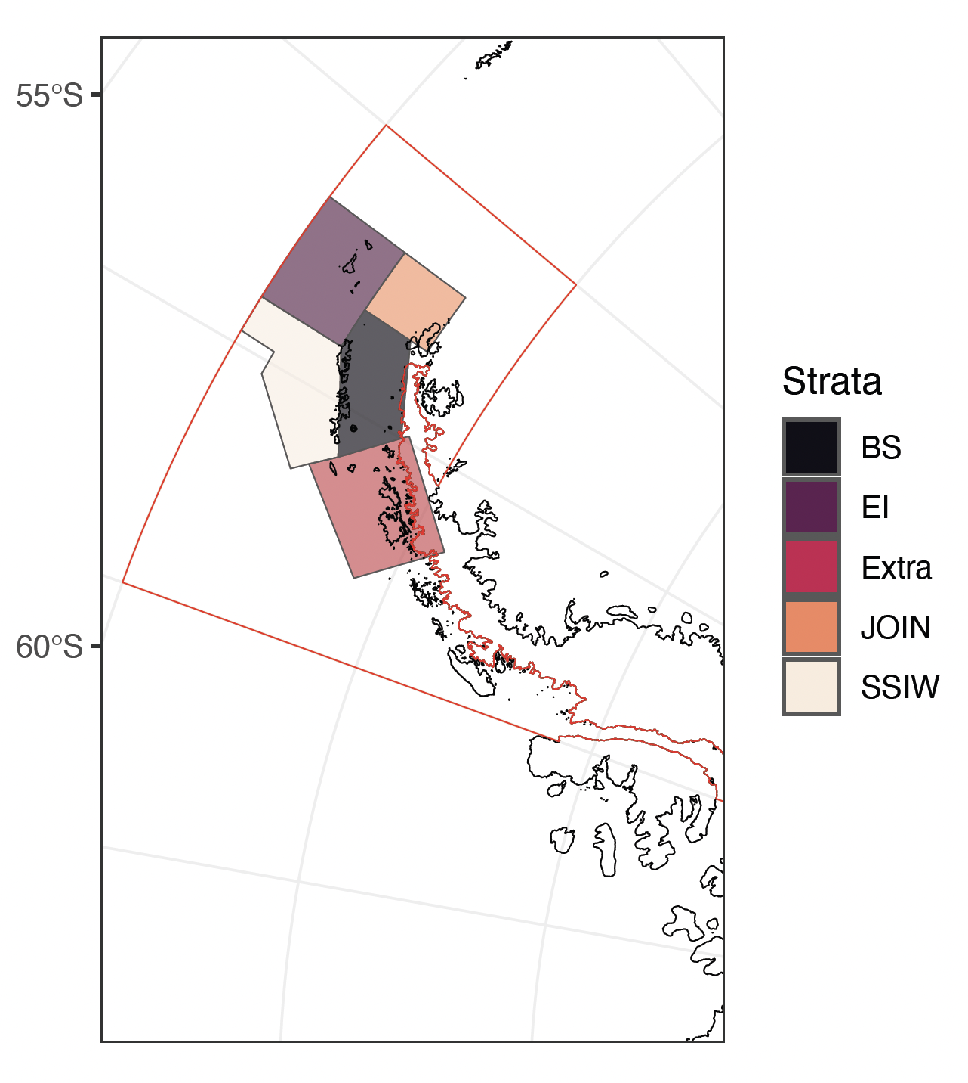

Subarea 48.1 and management strata considered in the spatio-temporal analysis of intrinsic productivity of Krill (BS=Brainsfield Strait, EI= Elephant Island, Extra= Extra, JOIN= Joinville Island, SSWI= South West)

## 2.2. Monitoring Data (SISO Program)

For this analysis, data from the monitoring of the krill fishery were used, which have been systematically collected on board fishing vessels by the CCAMLR SISO (Scheme of International Scientific Observation) program. Krill sizes compositions were obtained from the entire area 48.1, which was combined in each management stratum defined at 2.1 section (Figure ).

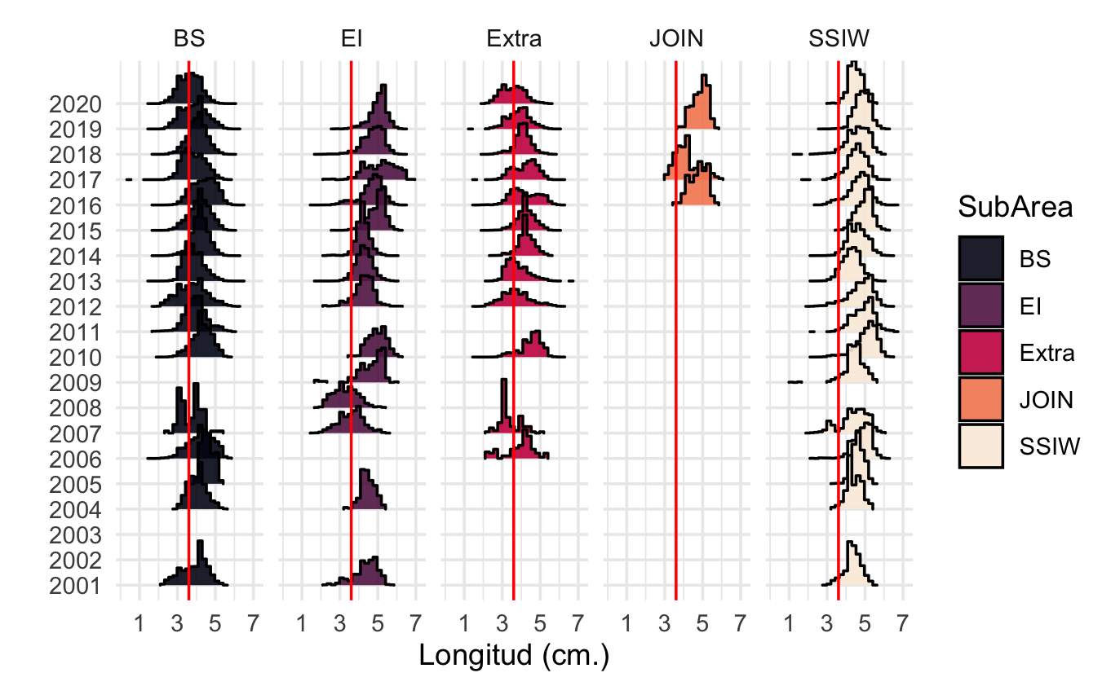

Sizes compositions from SISO program monitoring krill fishery by strata (BS=Brainsfield Strait, EI= Elephant Island, Extra= Extra, JOIN= Joinville Island, SSWI= South West). Red line represent recruit size

The information gaps (years without sizes composition data) are not calculated because there is no autocorrelation between years, but singular estimators over time.

## 2.3. Biological and fishery parameters krill

The model needs specifications related to both biological and fishery parameters according to species evaluated. In a descriptive way, the main parameter sets are described as follows;

**Biology**

* von Bertalanffy asymptotic length Linf
* M/K ratio (natural mortality)divided by von Bertalanffy K coefficient) MK
* Length at 50% maturity (L50)
* Length at 95% maturity (L95)

**Fishery**

* Length at 50% selectivity (SL50)
* Length at 95% selectivity (SL95)
* Biological Reference Point (BRP). F/M ratio (FM) or Spawning Potential Ratio (SPR). If you specify both, the F/M value will be ignored.

**Size Classes**

-Width of the length classes (BinWidth)

These parameters were taken from previous works about krill life history and fishery (Maschette et al., 2020; Thanassekos et al., 2014), which are described (Table ).

## 

## 2.4. Assessment of intrinsic productivity

The intrinsic productivity of krill was evaluated through a method that measures the reproductive potential of commercially exploited marine species known as LBSPR (Length Based Spawining Potential Ratio) and described by Hordyk et al. (2016). The LBSPR method has been developed for data-limited fisheries, where few data are available other than a representative sample of the size structure of the vulnerable portion of the population (i.e., the catch) and an understanding of the life history of the species. The Length-Based Spawning Potential Ratio (LBSPR) method assumes the reproductive characteristics of the species based on the life history parameters, being able to establish management strategies for long-lived species with low reproductive output as well as highly reproductive species with a high growth constant such as krill (Prince & Hordyk, 2018).

LBSPR uses length-composition data and assumptions about biological parameters to make a rapid assessment of stock status relative to unfished levels assuming equilibrium conditions. While LBSPR can use multiple years of length data, status determination is based on one year of data at a time (i.e., estimates of status over multiple years are based on that year’s length composition alone). Mean-length mortality estimators, first developed by Beverton & Holt (1957), assume that fishing mortality directly influences mean length of the catch and therefore in the reproductive potential of the species. Al l this concept about life history and implications in spawning potential ratio was revisited by Jensen (1996).

## 2.5. Model Estimation LBSPR

Recent work has shown that under equilibrium conditions (that is, constant F and no recruitment variability) and assuming the von Bertalanffy growth equation, constant natural mortality for all ages, and logistic or jack-knife selectivity, standardization of the composition of lengths of two populations with the same ratio of natural mortality to growth rate (*M/k*) and the same ratio of mortality by fishing to natural mortality (*F/M*) will be identical (Hordyk et al., 2016). Extension of this model to incorporate length-at-age variability and logistic selectivity confirms that, at equilibrium, the composition of the predicted duration of catch of an exploited population is primarily determined by the ratios of M/k and F/M. The analytical models developed in Hordyk et al. (2014) suggest that with knowledge of the asymptotic von Bertalanffy length and the coefficient of variation in , the ratio of total mortality to the von Bertalanffy growth coefficient (*Z/k*) for a given population can be estimated from a representative sample of the size structure of the catch. If *M/k* (or parameters) is also known, then the results of Hordyk et al. (2016) suggest that it is possible to estimate F/M from the composition of the catch. Often the F/M ratio has been used as a biological reference point when is 1 (Zhou et al., 2012).

The LBSPR model requires the following parameters: an estimate of the M/k ratio, , , and knowledge of maturity by length (maturity ogive), both set parameters know in krill. This model uses data on composition by catch sizes to estimate intrinsic productivity or Spawning Potential Ratio (SPR). This concept was extracted from Goodyear (1993), where the ratio of lifetime average egg production per recruit (EPR) was calculated for fish and non-fish resources. An algorithm route for the calculation of the SPR is the following;

where;

where = , and is egg production at age assumed to be proportional to weight;

on the other hand, the calculation of the reproductive potential is the same as that of those captured without F;

Assuming that egg production is proportional to the size of mature fish, relative fecundity-at-size is given by;

where b is value of the exponent to reflect differente size fecunditity relationship and g is the fraction of recruits to group.

Assuming reasonable estimates of the M/K ratio, (or ), size-at-maturity, the parameters F/M, , and can be estimated from a representative sample of the length structure of the catch by minimizing the following multinomial negative loglikelihood function (NLL):

where and are the observed number and proportion in length class i, respectively, and is the model estimate of the probability in length class i (Hordyk et al., 2016).

Like any assessment method, the LBSPR model relies on a number of simplifying assumptions. In particular, the LBSPR models are both equilibrium based and that the length composition data is representative of the exploited population at steady state (Hordyk et al., 2014, 2016). This methodology was implemented through the package (Hordyk et al., 2014; Hordyk; 2021) and this code and data could be visited in [LBSPRKrill](https://github.com/MauroMardones/LBSPR_Krill).

## 2.6. Biological References Point (PBR) in krill.

A constant challenge for krill has been to provide indicators of stock status that can be compared to predetermined biological reference points. The intrinsic productivity or SPR is commonly used to set the limit and target reference point (Goodyear, 1993; Mace, 2001; Prince et al., 2014). By definition, the SPR is equal to 100% in an unexploited stock, and zero in a non-spawning stock (eg all mature fish have been removed, or all females have been caught). The F40%, that is, the fishing mortality that allows an escape of 40% of the biomass to MSY, is the fishing mortality rate that translates into SPR = 40%, is considered a reference point to many species (Clark, 2002). Suitable SPR biological points can be derived from hypotheses about the steepness of the stock-recruit relationship (Brooks, 2013; Hordyk et al., 2016).

However Prince et al. (2014) provide some considerations in relation to the life strategy of the organisms and the SPR necessary to ensure the sustainability of the fishery. In this work, three types (I, II and III) are identified, which refers to the r and K life strategy. The krill is Type 1 (r-strategy), M/k=~1 (m=0.4, k =0.43) therefore, it requires a higher save of SPR.

On the other hand, the current krill fisheries management schemes established by CCAMLR (2010), Constable et al. (2000) proposes a decision rule scheme based on biomass that ensure the sustainability of this resource in the Southern Ocean. Through a simulation process, a 20-year projection of the krill population is generated, and a probability distribution is established around two decision rules. The first rule is based on the lowest level of exploitation allowed, around 20% of biomass, which could be consider a limit reference point. The second is the target level of the fishery, which indicates the statistical distribution of the biomass at the end of the 20-year projection under a constant catch that allows the average escape of 75% at pre-exploited levels (CCAMLR-2000 Survey). Linking this management scheme to intrinsic productivity of krill, we used two reference points for intrinsic krill productivity, 20% SPR as the limit reference point and 75% as the target to this fishery.

With this references points we can test a challenge for fishing exploitation and sustainability of krill in the Antarctic Peninsula, which is related to overfishing by recruitment. This condition occurs when the adult (reproductive) fraction has been severely reduced due to excessive fishing, jeopardizing the success of recruitment and stock replenishment in order to ensure sustainability (Cubillos, 2005; Hilborn & Walters, 1992) in relation to the previously mentioned PBRs.

The LBSPR package can be used to generate the expected size composition, the SPR, and relative yield for a given set of biological and exploitation pattern parameters. The output of the LBSPRsim function is an object of class LB_obj. This is another LBSPR object, and contains all of the information from the LB_pars object and the output of the LBSPRsim function.

It is important to note that the F/M ratio reported in the LBSPR model refers to the apical F over the adult natural mortality rate. That is, the value for fishing mortality refers to the highest level of F experienced by any single size class (Hordyk et al., 2014). If the selectivity pattern excludes all but the largest individuals from being exploited, it is possible to have a very high F/M ratio in a sustainable fishery (high SPR) and visceverse. Note that only the life history parameters need to be specified for the estimation model. The exploitation parameters will be estimated (Hordyk et al., 2014).

Two objects are required to fit the LBSPR model to length data: life-history parameters (LB_pars) described previously (2.4. section) and size compositions (LB_lengths), which contains the length frequency data. We provide a set of global size data and also by strata, with which we will be able to identify the spatial differences of the potential.

However, it is probably easier to create the LB_lengths object by directly reading in a .csv. A length frequency data of krill set with multiple years (2001-2020) by strata in 48.1 Subarea.

## 2.7. Sensitivity and perfomance analysis.

Ten sensitivity scenarios based on the upper and lower range for the asymptotic length von Bertalanffy (55 to 65 mm) used in the base model (60 mm) were tested to identify the impact of this parameter on the SPR estimation, given that it is the parameters exhibiting the high degree of variability and one of the factors that most determines the estimates. On the other hand, the interdependence between krill and their environment is a well-known and influential factor in population dynamics, ecosystem impacts, and fishery. This interdependence also affects the reproductive potential and consequently, to any management decision that takes into account population parameters of krill. To assess the impact of individual growth variability, three scenarios of the VB k parameter were tested, representing different growth types (low = 0.2, medium = 0.7, and high = 1.2). Figure displays a theoretical growth curve for krill based on three scenarios that were tested using LBSPR.

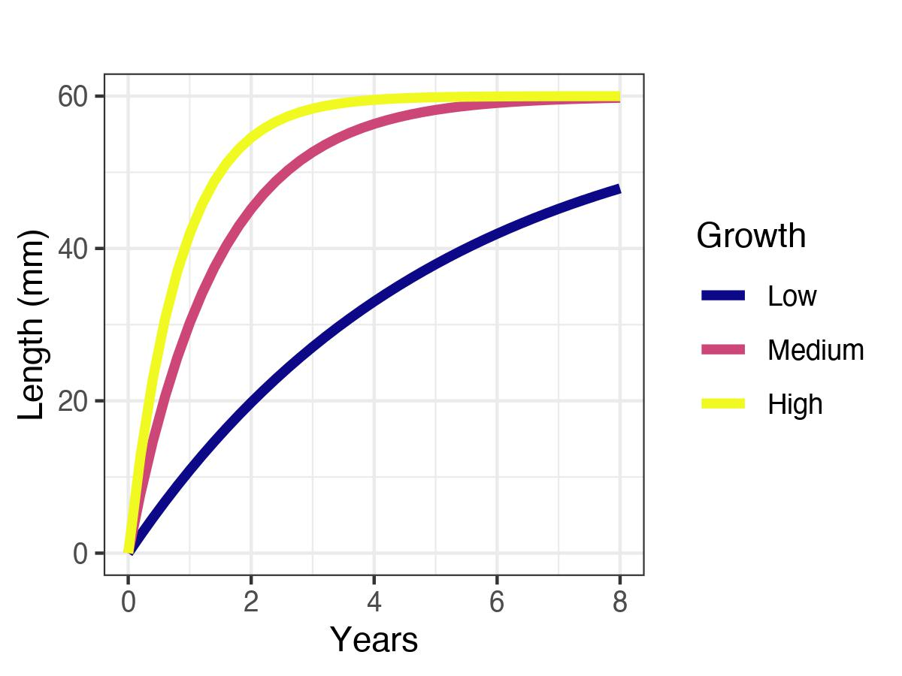

After applying each scenario using each of the parameter setting, the results of scenarios are compared with the results provided by the methods based setting (Table 1), analyzing in this way the efect of underestimation/overestimation of the parameters and *k*.

# 3. RESULTS

## 3.1. Model Perfomance

The results demonstrate good fits of the size structure distribution model for krill across the strata. The model accurately captures the distribution patterns of size classes, indicating its effectiveness in characterizing the population structure. The model successfully captures the variations in size distribution, reflecting the natural variability in krill populations across different strata. These findings suggest that the model can be utilized as a valuable tool for understanding and predicting size structure dynamics in krill populations (Figure ).

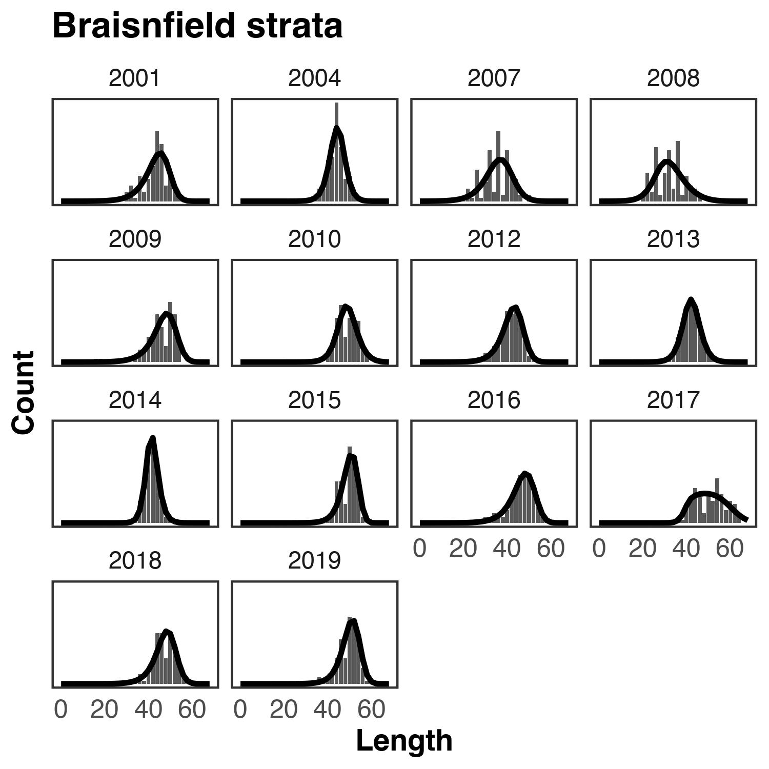

The Joinville strata exhibits the least model fits, supposedly attributed to the limited available size compositions data spanning only three years (Figure ).

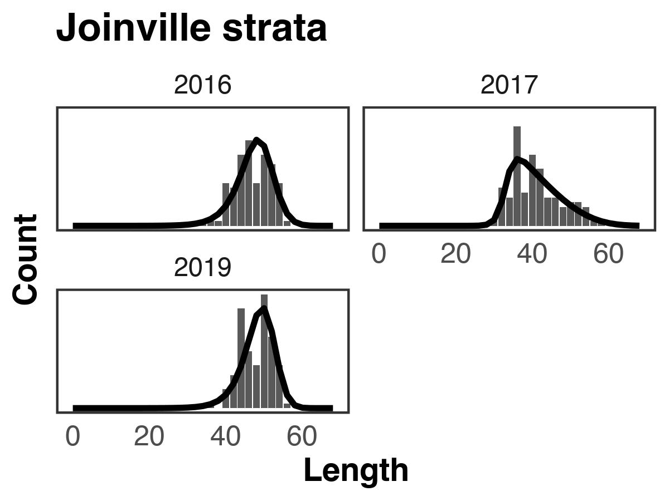

Fit of the model to the data of lengths in Joinville strata

For all the other strata (Extra, EI and SSWI) the model predict sizes compositions in a correct way for all the years (for details see [LBSPRKrill](https://github.com/MauroMardones/LBSPR_Krill)).

The difference between the observed accumulated size compositions for each stratum and compare it with the expected size composition at a target SPR (75% SPR). In the simulation of the structure in its virgin condition (without fishing), the red bars represent each stratum. Additionally, the overlap with the average structures observed during the years of fishery monitoring can be visualized. The SSWI Extra and EI strata exhibit the greatest differences from the simulated structure, possibly due to the significant contribution of juveniles in these strata. Conversely, the BS and JO strata demonstrate the closest resemblance to the simulated structure (Figure ).

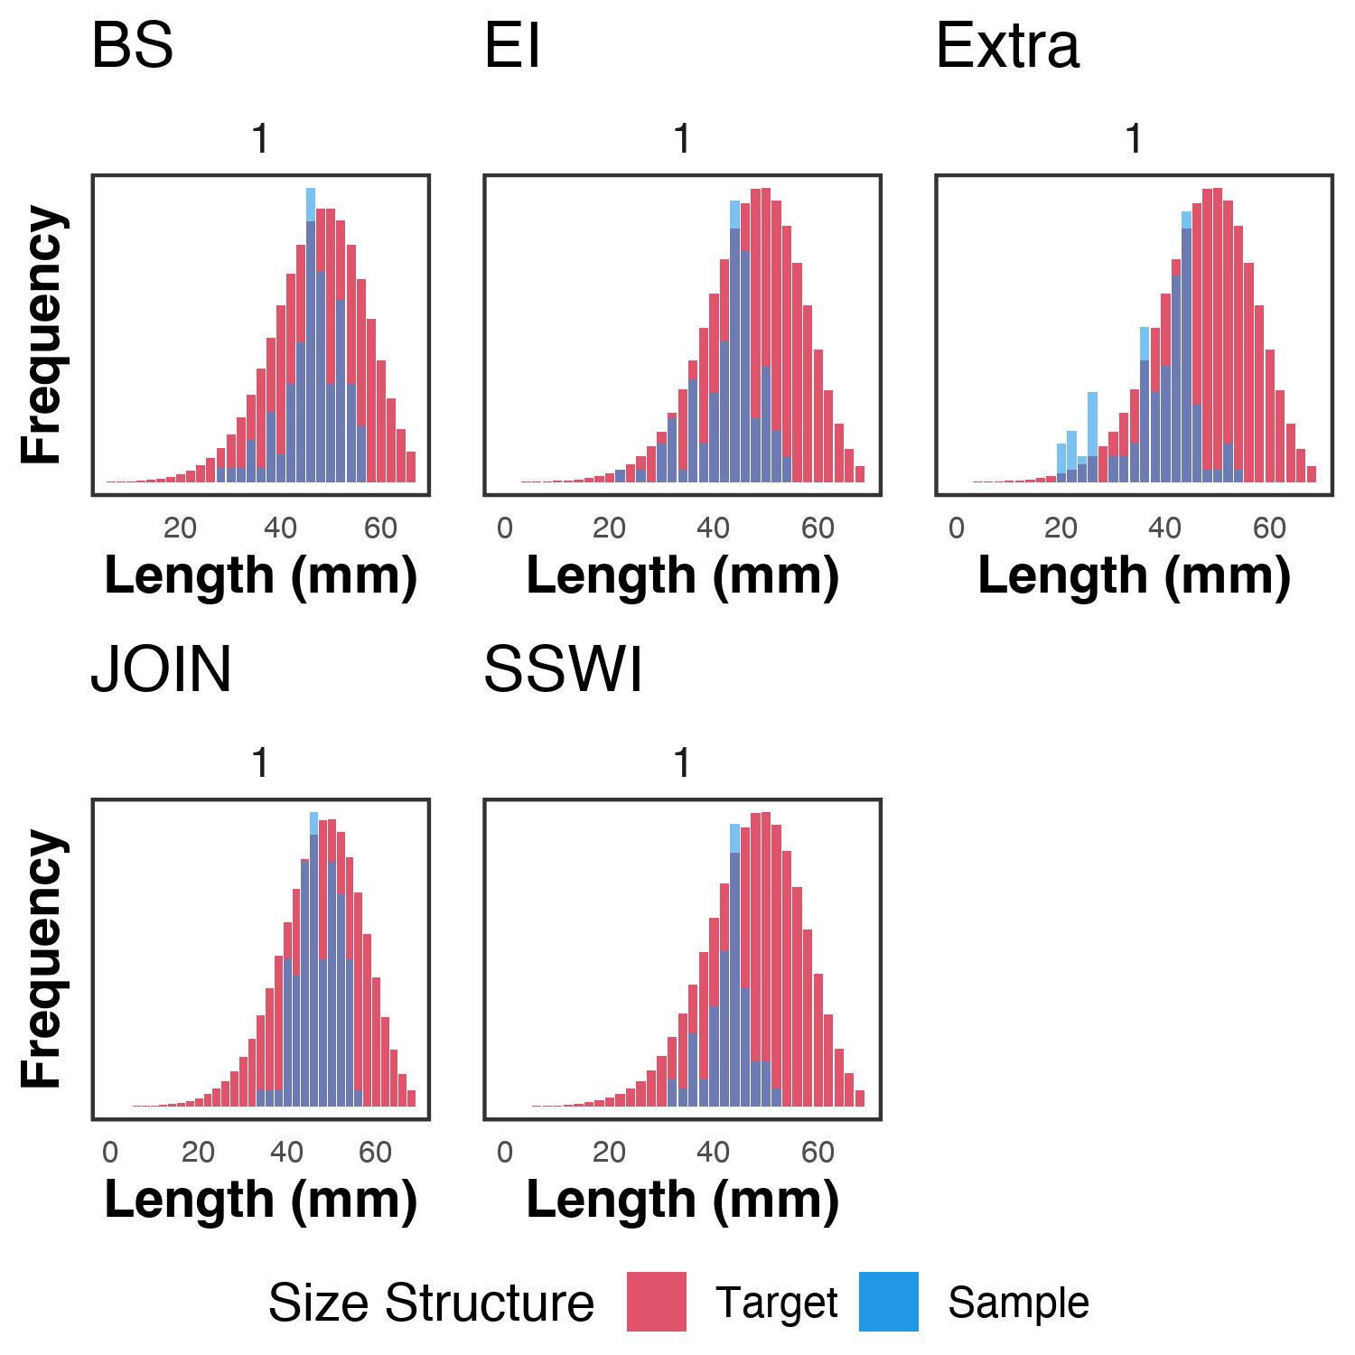

Difference between the observed accumulated size structure for each stratum related SPR objective

Furthermore, ogive maturity curve specific to each stratum and year, as well as the estimated length selectivity curve, are presented in Figure . These curves offer crucial insights into the fishery’s impact on the population and its reproductive status, providing measures of the population’s vulnerability to fishing mortality. Notably, the Braisnfield stratum stands out with a lower proportion of mature individuals, suggesting a higher prevalence of juveniles. It is important to note that the same maturity parameters were applied across all strata.

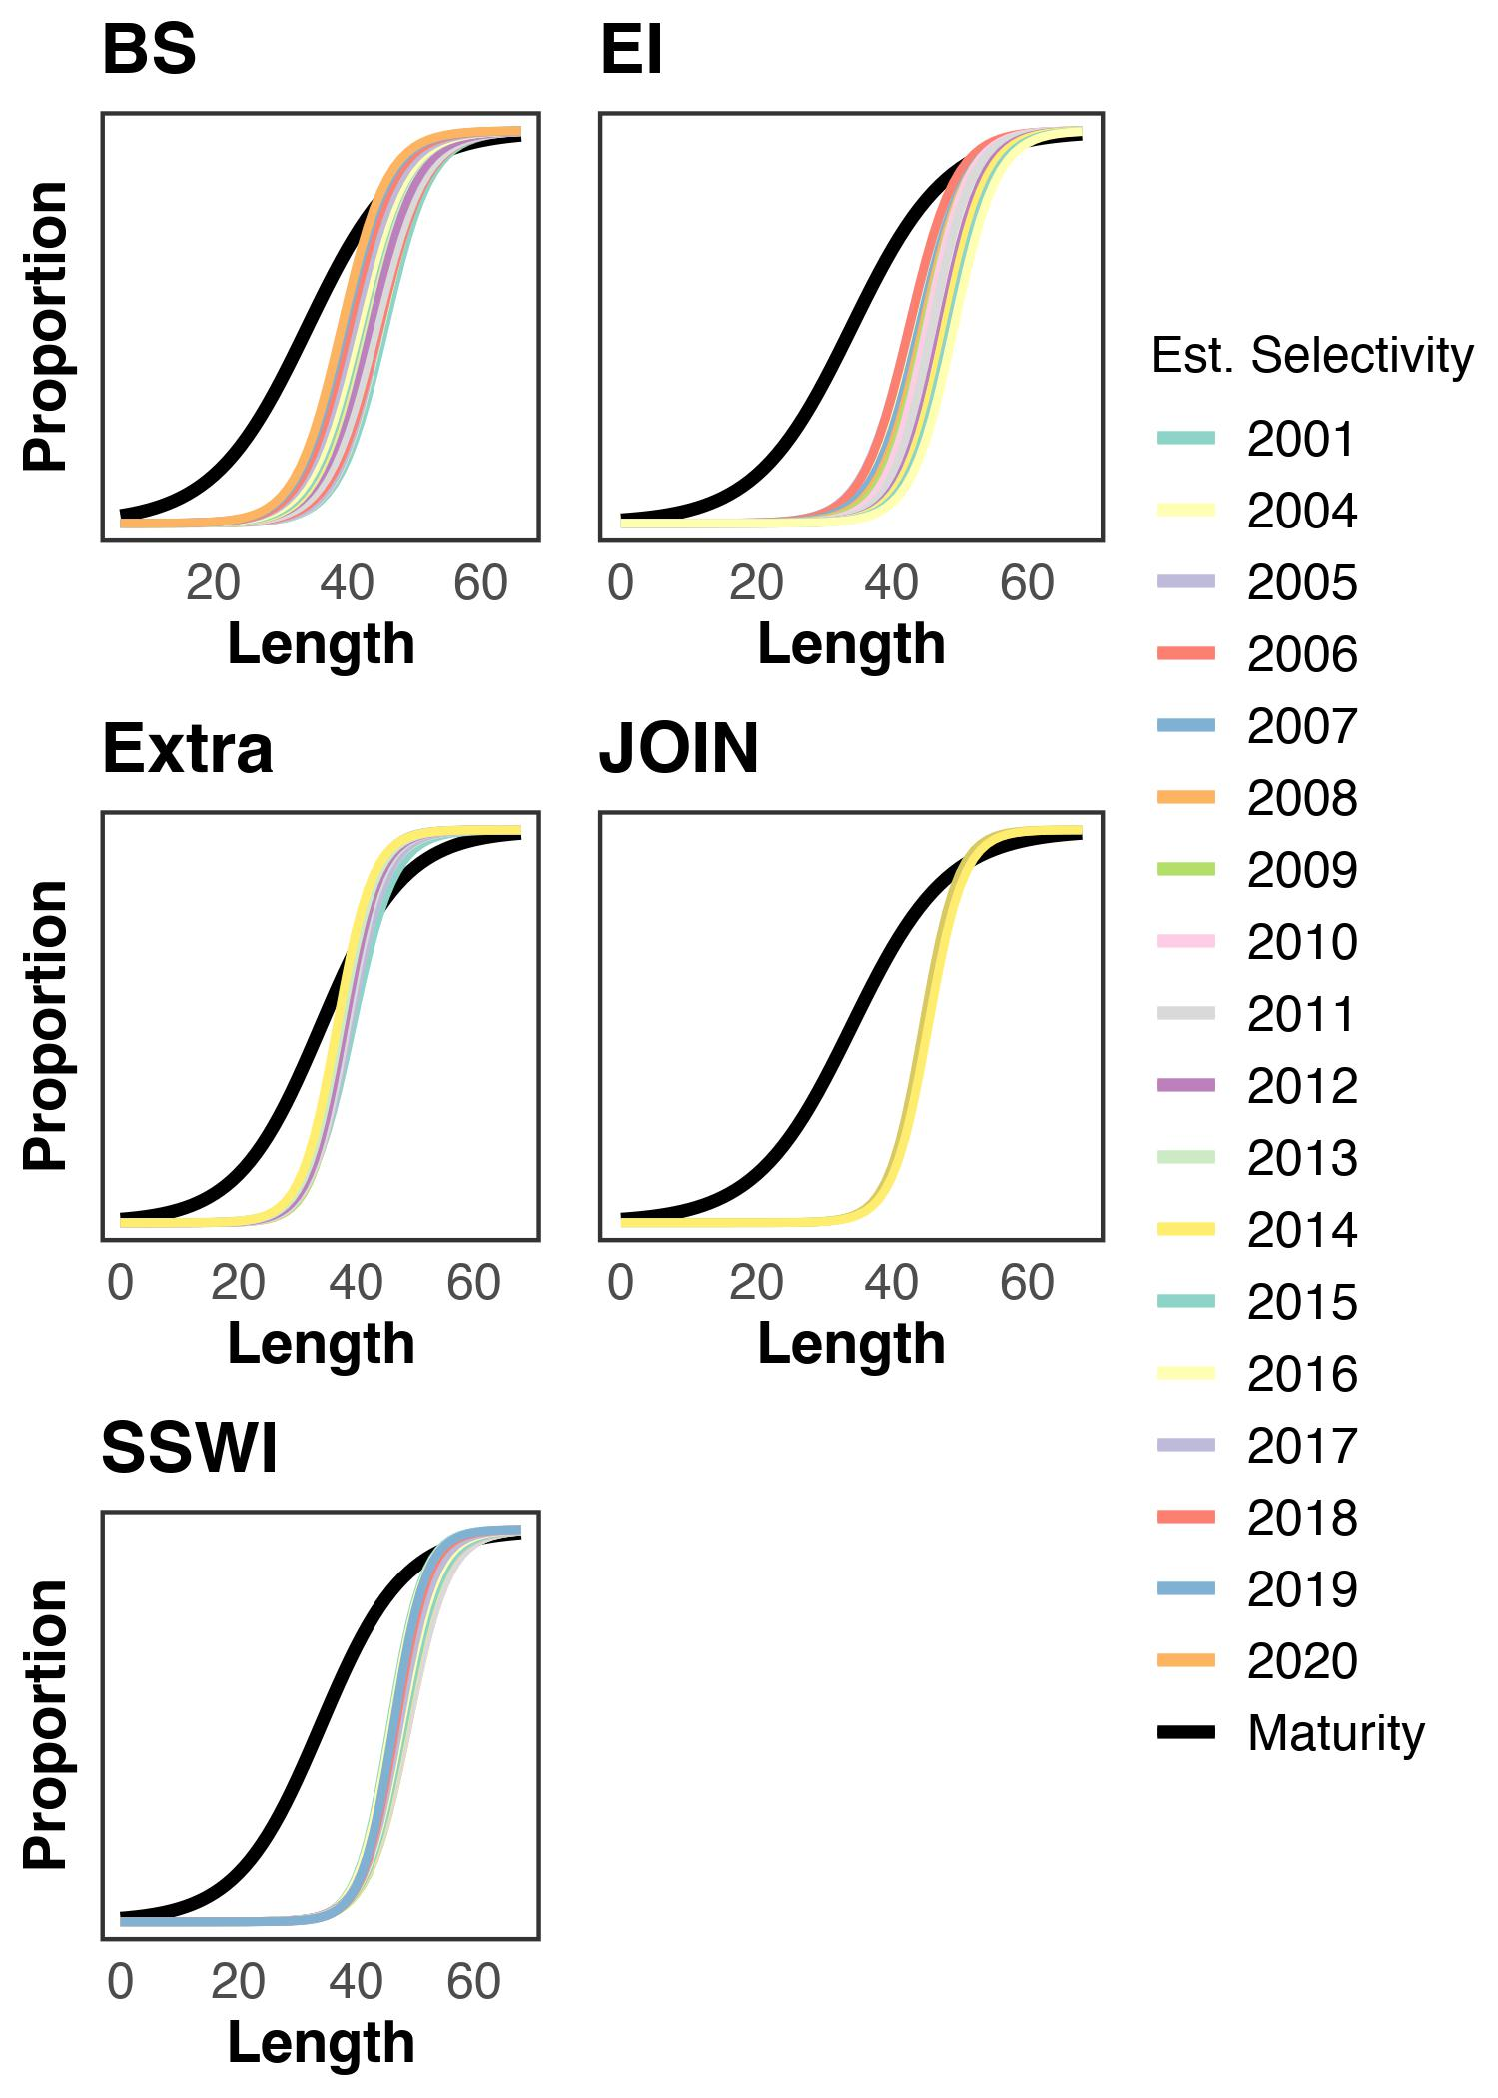

Maturity curves by strata

## 3.2. Comparing producivity between years and Stratas

The analysis of the krill population’s reproductive potential across different years and strata reveals significant differences. Brainsfield and Extra strata exhibit a low reproductive potential below the proposed management target of 75% in the last year, with values of 0.121 and 0.085, respectively, falling even below the limit reference point. This condition arises from the concentration of a substantial number of immature individuals (juveniles) in these strata, which are being exploited by the fishery, thereby hindering their reproductive cycles from completing. On the contrary, the Elephant Island stratum demonstrates higher spawning potential ratio (SPR) levels in recent years, reaching 0.421 in 2019, which aligns closer to the management objective. This discrepancy is attributed to the spatial distribution of krill, as the Elephant Island stratum possesses a larger proportion of adult individuals compared to other strata. Figure provides a visual representation of the SPR trends across years and strata, clearly indicating the references (yellow line = 75% SPR Objective and Red line = 20% Limit SPR).

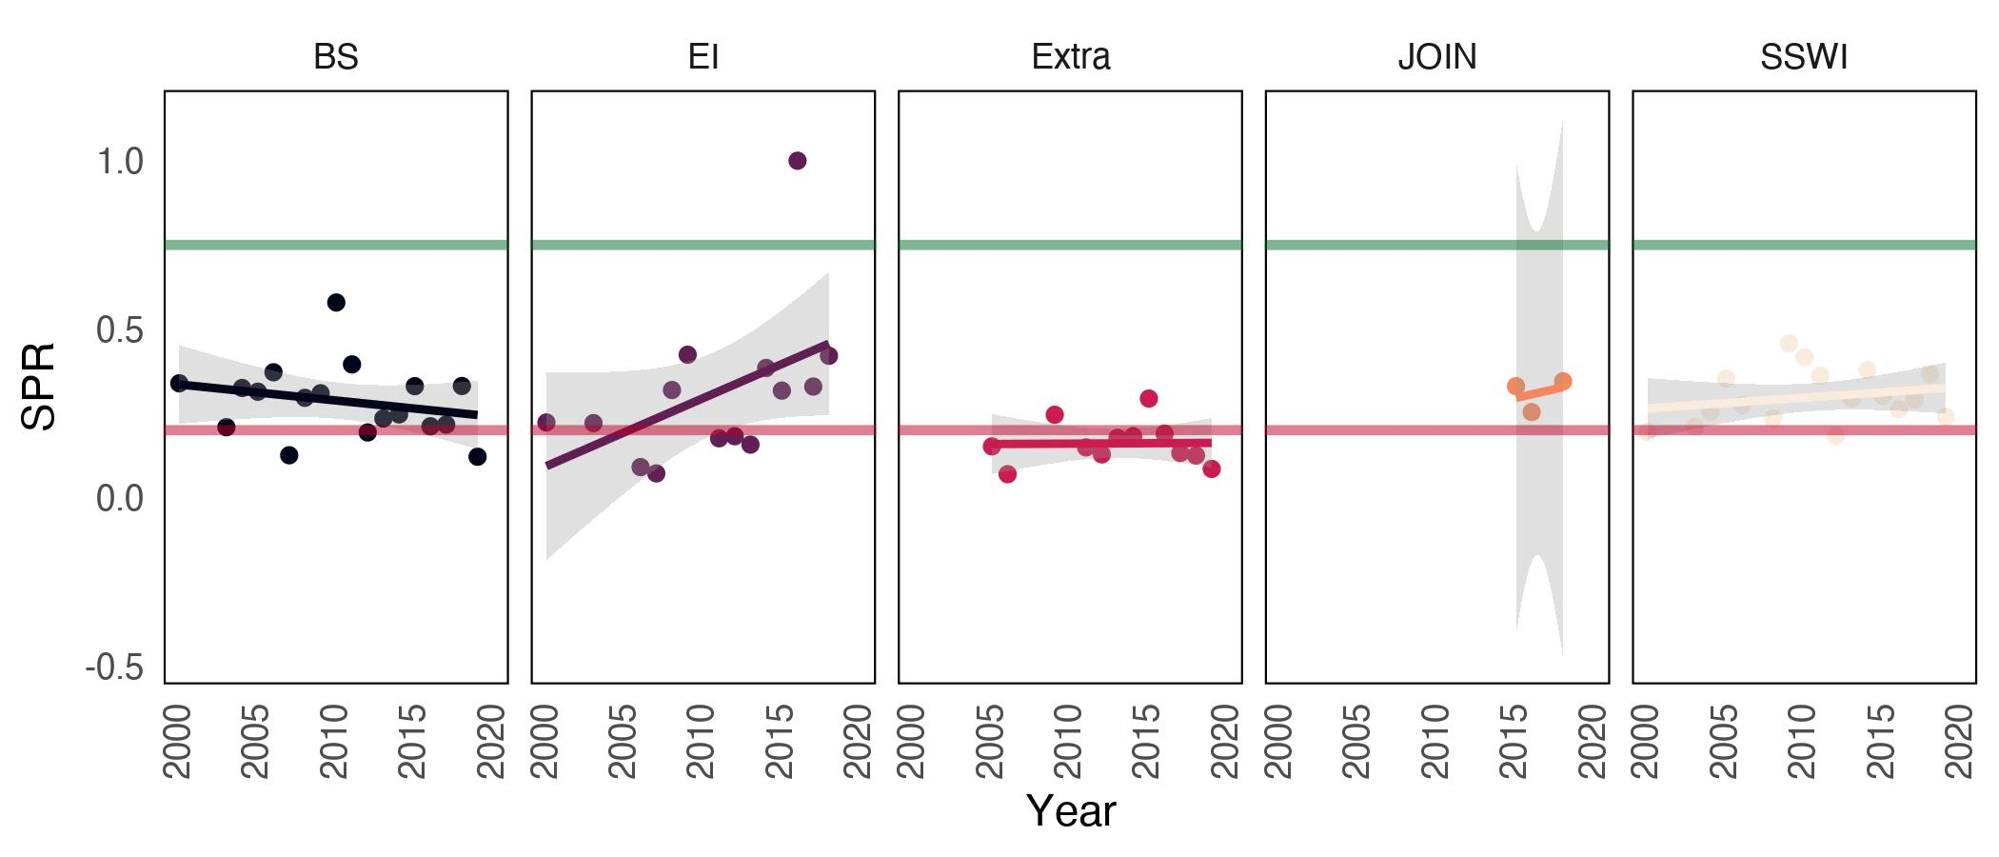

Krill Intrinsic Productivity (SPR) by strata and by year

The Elephant Island stratum has exhibited a higher prevalence of adult fraction in fishing catches, leading to an increase in reproductive potential in recent years. Conversely, the Bransfield and Extra strata experience intense recruitment overfishing, with their reproductive potential falling significantly below the recommended target at 54% and 66.5%, respectively.

All the estimated values of SPR and their associated variance by stratum and by year can be identified in Table .

Estimates SPR by Strata

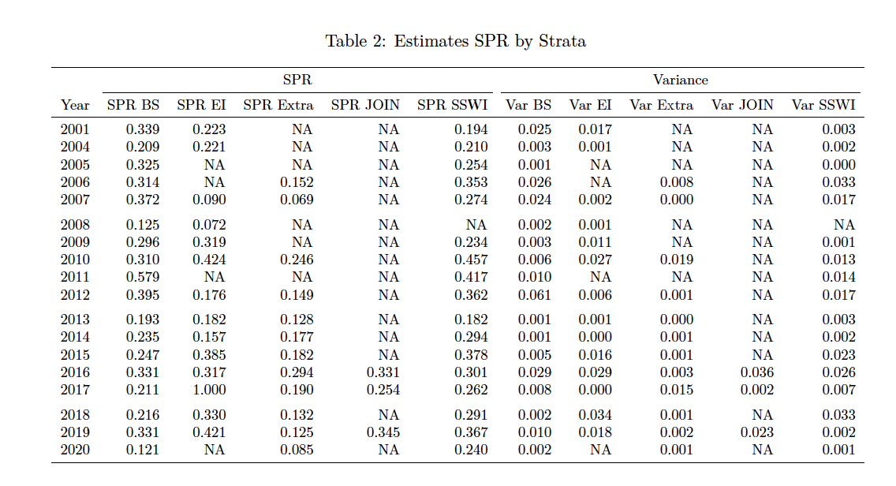

## 3.3. Sensitivity and perfomance analysis

The results of the methods in the reference setting are compared to the obtained under overstimation/underestimation in intrinsic productivity regarding asymptotic length von Bertalanffy parameter in krill. First, it was possible to identify that for all strata, the impact of low ranges under the base model (60 mm) overestimates the level of reproductive potential krill with values between 42% and 32% (Bransfield and Elephant Island strata respectively). Regarding higher settings, the model tends to underestimate the reproductive potential with values between -25% and -30% (Extra and Joinville strata) (Figure , Table ).

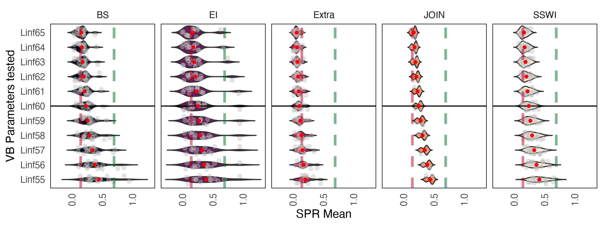

lSensitivity analysis by strata about asymptotic length VB

Estimated by asymptotyc lenght (VB) scenario

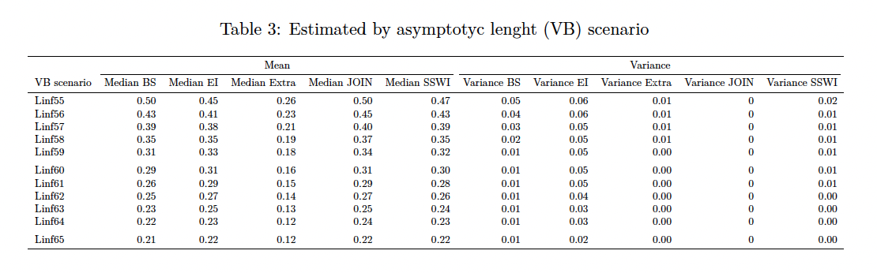

Regarding the three growth levels of the species (high, medium, low) referred to the parameter , it was possible to identify that high and medium growth types result in very low SPR (spawning potential ratio) estimates compared to slow and medium growth. In fact, with high individual growth, the model estimates that SPR levels would be very close to the target management levels (75% SPR) and far from the limit reference level of 20% (Figure , Table ).

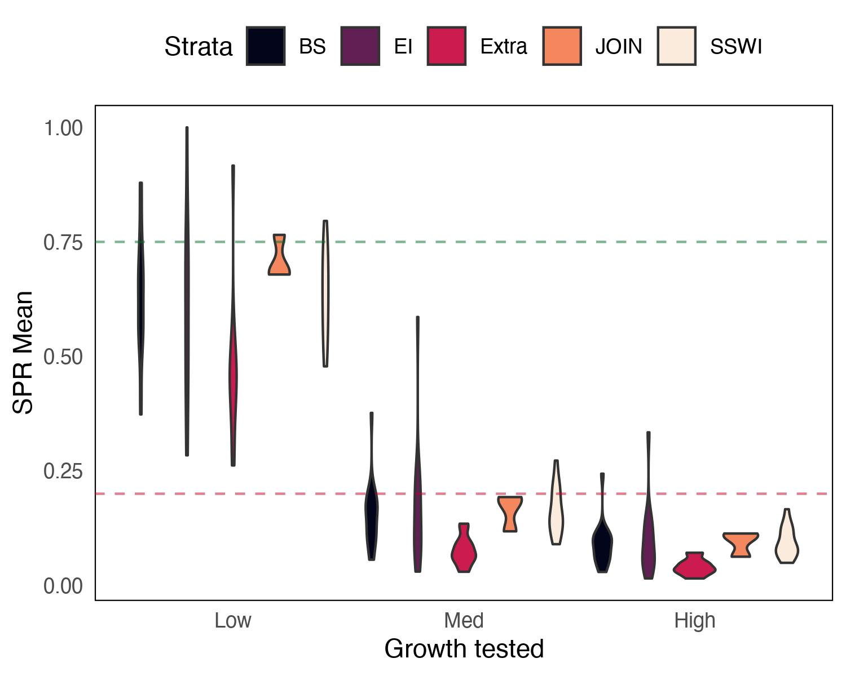

Sensitivity analysis by strata about krill growth type

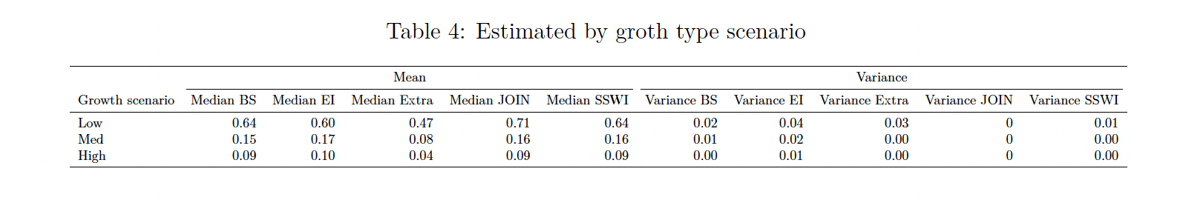

# 4. DISCUSION

## 4.1. Changes in krill population structure

Identifying the population dynamics changes of krill in Subarea 48.1 has been one of the biggest challenges in recent years as temporal-spatial patterns of both concentration and productivity of catches has increased, as well environmental changes are already affecting the ecosystem (Hill et al., 2016; McBride et al., 2021). Krill is a key species in the Antarctic environment and understanding its population dynamics is a basic element to visualize the impacts on the functioning of the food web, conservation of the resource and management of the fishery (Hill et al., 2016). For these reasons, it is key to assess the reproductive potential of the species at fine scales of space and time in subarea 48.1, because this area is where the fishery and resource have been concentrated for the last 20 years (A. Atkinson et al., 2022; Santa Cruz et al., 2022) and the needs for advises for a sustainable management are currently required. In this method we determined the differences between the simulated krill size structures based on their life history parameters (Maschette et al., 2020) and those resulting from the fishery, which allows us to know the difference between the virginal reproductive potential and that currently fishing mortality levels.

Our results identify this changes in spatio-temporal variability of krill in different fishing management strata and, in turn, it was possible to propose Biological Reference Points based on the characteristics of the species, which in turn constitutes a recommendation for the current exploitation strategy carried out by CCMLAR. In this sense, we identify the historical fishing periods based on the reproductive potential and, in turn, an explicit spatial management is proposed based on these results. In recent years, the identification of population dynamics changes in krill within Subarea 48.1 has posed significant challenges. Temporal-spatial patterns of catch concentration and productivity have witnessed a notable increase, while the ecosystem has already begun experiencing the impacts of environmental changes (Hill et al., 2016; McBride et al., 2021). Krill plays a crucial role in the Antarctic environment, and understanding its population dynamics is fundamental for comprehending the effects on the food web, conserving the resource, and managing the fishery (Hill et al., 2016). Given the concentration of fishing activity and resource abundance in Subarea 48.1 over the past two decades (A. Atkinson et al., 2022; Santa Cruz et al., 2022), it is vital to assess the krill intrinsic productivity at fine spatial and temporal scales. This assessment is currently necessary to provide guidance for sustainable management practices. Our research has successfully identified spatio-temporal variability changes in krill across different fishing management strata. Furthermore, based on the krill population features, we have proposed a Biological Reference Points, offering recommendations for the current exploitation strategy conducted by CCAMLR.

Changes in the dynamics and population structure of krill in the Antarctic Peninsula are manifested in various ways, such as distribution, biomass, recruitment, phenology, among others. The main drivers of these changes are associated with the changing behavior of the different environmental variables in the krill habitat (Flores, Franeker, et al., 2012; Flores, Atkinson, et al., 2012; Piñones & Fedorov, 2016; Saba et al., 2014; Veytia et al., 2021; Walsh et al., 2020). Faced with this changing scenario, the intrinsic population productivity, that is, the reproductive potential of the species, has also undergone changes in the last decades (A. Atkinson et al., 2022; McBride et al., 2021; Perry, 2020), both on the temporal scale as well as the spatial one. Similarly, the population structure of krill in the PA has been impacted by this type of environmental forcing (Reiss et al., 2020; Siegel et al., 2013). While we understand that recruitment variability is influenced by environmental factors, including biomass, it is possible to identify the risk of fishing activity on the reproductive condition of the krill population over time and space, in other words, the risk of recruitment overfishing varies across years and strata in Antarctic Peninsula.

## 4.2. Fishery data as population indicators

Krill in the PA have been harvested commercially since about 1970 and constitute the largest fishery in the Southern Ocean. The data on the fishing activity around krill have been systematically collected on board the fishing vessels through the SISO program, with which it has also been possible to identify changes in the population dynamics that have occurred during the last two decades and throughout the area of greater exploitation. The accurate representation of size distribution is crucial for assessing the overall health and productivity of krill populations and for informing effective management strategies in different geographical areas (Thanassekos et al., 2014). Changes in the availability, distribution, and concentration, performance of the resource have been reflected in this kind of data (Canales et al., 2021; Froese et al., 2018; Hordyk et al., 2016). To identify changes in the intrinsic productivity of the krill population, we used one of the most representative pieces of information on the population dynamics of exploited marine resources that exist in this type of fisheries monitoring program, in this case, frequency data of catch size (Chong et al., 2019; Prince & Hordyk, 2018). This type of data is abundant and informative about signals status populations (Canales et al., 2021), and makes it possible to cover a large temporal and spatial scale, in this case, from 1980 to 2020 and throughout subarea 48.1 (Figure .

## 4.3. Spatial and Temporal differences in intrinsic krill productivity

We verified that the reproductive potential of krill has had changes through the years and spaces. These changes were quantitatively measured through reproductive potential using a novel method commonly used in world fisheries that considers the use of life history parameters, such as maturity, growth and growth rate, size structures, and simulations based on invariant parameters. Elephant Island stratum has had an increase in reproductive potential, reaching levels of 56% by the year 2020. This situation has been mainly due to two aspects. The first is that the effect of recruitment, and therefore is a greater proportion of older individuals who are ensuring a reproductive potential for the population. In the opposite case, Extra strata has a zone where juvenile individuals (nursery) (Perry, 2020; Veytia et al., 2021) are more abundant. This situation affects that throughout these 20 years analyzed, the SPR is less compared to the other strata, with an average of 16 throughout the historical series with a 6% at least in 2007. This year is particularly interesting given the high levels of primary productivity concentration in this area that could have had an impact on a high level of recruitment (Saba et al., 2014; Walsh et al., 2020) and consequently, a decrease in reproductive potential at the population level. A large proportion of juvenile individuals is also identified in the Brainsfield strait sector, incorporating in recent years in an important way (Perry, 2020; Reiss et al., 2020), which has had an impact on the fact that the SPR has decreased in the last few years, reaching its lowest level in 2020 with 12%, which is below a limit reference level for this resource.

These results are consistent with other analyzes that identify these spatial changes.. A. Atkinson et al. (2009); A. Atkinson et al. (2008) indicates that the population shows evident symptoms of contraction towards the southwest of the PA. This contraction of the distribution of the population has consequences for other phenomena such as productive yields that are manifested in fishing indicators as shown by Santa Cruz et al. (2022) and Krüger (2019).

One aspect to consider in this analysis was the use of fixed parameters taken from previous studies for the simulations of the krill virginal size structures. In relation to this, we believe it is necessary to obtain of specific life history and maturity parameters by stratum, which would allow us to better define these findings. In any case, we believe that sensitivity analyzes can help fill these existing information gaps.

## 4.4. Sensitivity analysis

This method is sensitive to biological information assumptions. Therefore, an analysis of sensitivity is crucial to understand the importance of growth parameters in a length-based assessment model for krill stocks (Carvalho et al., 2017; Chong et al., 2019; Hordyk et al., 2016; Rudd & Thorson, 2017) like LBSPR (Cousido-Rocha et al., 2022; Hordyk et al., 2016). Indeed, few number of studies have performed parameter sensitivity analyses for these methods with real case studies, among which are Cousido-Rocha et al. (2022) and Hordyk et al. (2016). It helps determine the impact of growth parameters on the model’s output and assesses the sensitivity analysis identifying even conditions of overestimated and underestimated with respect to the reference scenario, detects biases and improves accuracy and reliability (Carvalho et al., 2017; Cousido-Rocha et al., 2022). Ultimately, it enhances understanding of krill stock dynamics and supports effective conservation and management efforts. Sensitivity analyses were 50 scenarios performed with respect to ten scenarios of (ten by strata) and 15 scenarios tested for the different levels of growth and their impact on. All analyses were performed in R version 4.2.1. (R Core Team, 2022).

According to our results, we were able to verify that an individual with a lower growth ( 55), the estimates of SPR increases (Figure ). This was possible to observe through the sensitivity analysis for this parameter in all strata. This situation is repeated in the same way in all the strata, which confirms that the condition is between all them. spaces within SubArea 48.1. Regarding variability in growth krill, our study found that life history as expressed in the parameters was a factor with high influence of SPR estimators. This result supports those in previous studies of length-based analysis about growth type (Cousido-Rocha et al., 2022; Prince & Hordyk, 2018; Rudd & Thorson, 2017), but it is the first time that this type of analysis has been carried out on krill.

## 4.5. Implications for fisheries management in CCAMLR context

Differences spatial and temporal in intrinsic productivity krill can significantly impact long-term conservation and sustainability in the Antarctic Peninsula. This feature directly influences population growth and abundance, which are crucial for maintaining ecosystem balance and species diversity (Hill et al., 2016; McBride et al., 2021). Higher reproductive potential ensures a larger number of offspring, increasing the chances of population recovery after disturbances or by environmental fluctuations (Piñones & Fedorov, 2016; Saba et al., 2014). Reduced reproductive output can lead to decreased food availability for dependent predators, disrupting the trophic cascade and affecting the entire ecosystem (Krüger, 2019). Krill is a key food source for a wide range of species, including penguins, seals, and whales, so fluctuations in reproductive potential can have cascading effects on their populations (McBride et al., 2021). Regarding fishery, the sustainability of commercial krill explotation relies on maintaining a healthy population through sustainable harvesting practices, which can be influenced by variations in reproductive potential. Understanding the changes in intrinsic productivity of krill population in SubArea 48.1 allows better management strategies such as implementation of size and catch limits to protect breeding areas of individuals (e.g. strata) and ensure sustainable catch levels. Climate change impacts on the Antarctic Peninsula, such as rising temperatures and changing sea ice dynamics, can directly affect intrinsic productivity of krill, further influencing long-term sustainability. Maintain a process for monitoring these changes in krill productivity provides valuable insights into the overall health and resilience of the Antarctic Peninsula ecosystem. We believe that this type of analysis can help to identify krill population characteristics and in turn give recommendations for management.

The CCAMLR has implemented a new management strategy for the resources exploited and inhabiting the area, and it is focuses on adopting an ecosystem-based approach, considering the interconnectedness and interdependencies of species and habitats within the ecosystem (CCAMLR, 2021; McBride et al., 2021). The strategy emphasizes a set of principles like; the precautionary principle, taking proactive measures to prevent or mitigate potential adverse impacts on the ecosystem and its components; the use of ecosystem models and indicators to evaluate the health and functioning of the ecosystem and inform management decisions; establishment of marine protected areas (MPAs); safeguard Vulnerable Marine Ecosystems (VME); focuses on improving compliance and enforcement of regulations to prevent illegal, unreported, and unregulated (IUU) fishing activities that can undermine the sustainability of the resources; and the last one, is acknowledges the potential impacts of climate change on the Antarctic ecosystem and considers adaptive management approaches to address these challenges (Chavez_Molina et al., 2023).

In this sense, incorporating the findings regarding the changes in krill intrinsic productivity, as examined in this study, into precautionary and adaptive management strategies for this resource and its fishery is of utmost importance.

# 5. CONCLUSION

* This study show the first analisys about intrinsic productivity of Antarctic krill (*Euphausia superba*) in Antarctic Peninsula, SubArea 48.1 through a quantitative method called LBSPR.
* It was possible to identify differences through temporal and spatial scale within one of the areas with the highest fishing activity on this resource.
* Specifically, we have identified historical fishing periods based on reproductive potential, and we propose an explicit spatial management approach based on these results. These findings contribute to the development of a more informed and sustainable krill fishery management plan.
* We propose reference points associated with the SPR to give management recommendations in the CCAMLR context.
* Considering these differences in an eventual spatially explicit in the new management scheme could be beneficial to ensure sustainability of krill in subarea 48.1 and Antarctic Peninsula.

# 5. SUPLEMENTARY INFORMATION

The methodology and data of this exercise can be found in the following link [LBSPR-Krill](https://github.com/MauroMardones/LBSPR_Krill)

# 6. REFERENCES

Atkinson, A., Hill, S. L., Reiss, C. S., Pakhomov, E. A., Beaugrand, G., Tarling, G. A., Yang, G., Steinberg, D. K., Schmidt, K., Edwards, M., Rombolá, E., & Perry, F. A. (2022). Stepping stones towards Antarctica: Switch to southern spawning grounds explains an abrupt range shift in krill. *Global Change Biology*, *28*(4), 1359–1375. <https://doi.org/10.1111/gcb.16009>

Atkinson, A., Siegel, V., Pakhomov, E. A., Jessopp, M. J., & Loeb, V. (2009). A re-appraisal of the total biomass and annual production of Antarctic krill. *Deep-Sea Research Part I: Oceanographic Research Papers*, *56*(5), 727–740. <https://doi.org/10.1016/j.dsr.2008.12.007>

Atkinson, A., Siegel, V., Pakhomov, E. A., Rothery, P., Loeb, V., Ross, R. M., Quetin, L. B., Schmidt, K., Fretwell, P., Murphy, E. J., Tarling, G. A., & Fleming, A. H. (2008). Oceanic circumpolar habitats of Antarctic krill. *Marine Ecology Progress Series*, *362*(June), 1–23. <https://doi.org/10.3354/meps07498>

Beverton, R., & Holt, S. (1957). *On the Dynamics of Exploited Fish Populations* (p. 540). SPRINGER-SCIENCE+BUSINES S MEDIA , B.V.

Brooks, E. N. (2013). Effects of variable reproductive potential on reference points for fisheries management. *Fisheries Research*, *138*, 152–158. <https://doi.org/10.1016/j.fishres.2012.06.003>

Canales, C. M., Punt, A. E., & Mardones, M. (2021). Can a length-based pseudo-cohort analysis (LBPA) using multiple catch length-frequencies provide insight into population status in data-poor situations? *Fisheries Research*, *234*(October 2020), 105810. <https://doi.org/10.1016/j.fishres.2020.105810>

Carvalho, F., Punt, A. E., Chang, Y. J., Maunder, M. N., & Piner, K. R. (2017). Can diagnostic tests help identify model misspecification in integrated stock assessments? *Fisheries Research*, *192*, 28–40. <https://doi.org/10.1016/j.fishres.2016.09.018>

CCAMLR. (2010). *Conservation Measure 51-01. Precautionary catch limitations on Euphausia superba in Statistical Subareas 48.1, 48.2, 48.3 and 48.4* (Vol. 1, p. 2).

CCAMLR. (2021). *Antarctic krill proportional recruitment indices (2010–2020) in Subareas 48.1–48.3 from the observer data*. CCAMLR.

Chavez_Molina, V., Nocito, E. S., Carr, E., Cavanagh, R. D., Sylvester, Z., Becker, S. L., Dorman, D. D., Wallace, B., White, C., & Brooks, C. M. (2023). Managing for climate resilient fisheries : Applications to the Southern Ocean. *Ocean and Coastal Management*, *239*(February), 106580. <https://doi.org/10.1016/j.ocecoaman.2023.106580>

Chong, L., Mildenberger, T. K., Rudd, M. B., Taylor, M. H., Cope, J. M., Branch, T. A., Wolff, M., & Sta, M. (2019). Performance evaluation of data-limited , length-based stock assessment methods. *ICES Journal of Marine Science*, *77*(1), 97–108. <https://doi.org/10.1093/icesjms/fsz212>

Clark, W. G. (2002). F 35 % Revisited Ten Years Later. *North American Journal of Fisheries Management*, 251–257.

Constable, A. J., Mare, W. K. D., Agnew, D. J., Everson, I., & Miller, D. (2000). *Managing fisheries to conserve the Antarctic marine ecosystem : practical implementation of the Convention on the Conservation of Antarctic Marine Living Resources ( CCAMLR )*. 778–791. <https://doi.org/10.1006/jmsc.2000.0725>

Cousido-Rocha, M., Cerviño, S., Alonso-Fernández, A., Gil, J., Herraiz, I. G., Rincón, M. M., Ramos, F., Rodríguez-Cabello, C., Sampedro, P., Vila, Y., & Pennino, M. G. (2022). Applying length-based assessment methods to fishery resources in the Bay of Biscay and Iberian Coast ecoregion: Stock status and parameter sensitivity. *Fisheries Research*, *248*. <https://doi.org/10.1016/j.fishres.2021.106197>

Cubillos, L. (2005). *Biologia pesquera & evaluación de stock* (U. de Concepción, Ed.; p. 198).

Flores, H., Atkinson, A., Kawaguchi, S., Krafft, B., Milinevsky, G., Nicol, S., Reiss, C., Tarling, G., Werner, R., Bravo Rebolledo, E., Cirelli, V., Cuzin-Roudy, J., Fielding, S., Groeneveld, J., Haraldsson, M., Lombana, A., Marschoff, E., Meyer, B., Pakhomov, E. A., … Werner, T. (2012). Impact of climate change on Antarctic krill. *Marine Ecology Progress Series*, *458*, 1–19. <https://doi.org/10.3354/meps09831>

Flores, H., Franeker, J. van, Siegel, V., Haraldsson, M., Strass, V., Meesters, E., Bathmann, U., & Wolff, W. (2012). The association of Antarctic krill Euphausia superba with the under-ice habitat. *PLoS ONE*, *7*(2). <https://doi.org/10.1371/journal.pone.0031775>

Froese, R., Winker, H., Coro, G., Demirel, N., Tsikliras, A. C., Dimarchopoulou, D., Scarcella, G., Probst, W. N., Dureuil, M., & Pauly, D. (2018). A new approach for estimating stock status from length frequency data. *ICES Journal of Marine Science*, *76*(1), 350–351. <https://doi.org/10.1093/icesjms/fsy139>

Goodyear, C. P. (1993). Spawning stock biomass per recruit in fisheries management: foundation and current use. . *Risk Evaluation and Biological Reference Points for Fisheries Management*, *120*, 67–81.

Hilborn, R., & Walters, C. J. (1992). *Quantitative lisheries stock assessment : choice, dynamics and uncertainty.* SPRINGER-SCIENCE+BUSINES S MEDIA , B.V. <https://doi.org/10.1007/978-1-4615-3598-0>

Hill, S., Atkinson, A., Darby, C., Fielding, S., Krafft, B. A., Godø, O. R., Skaret, G., Trathan, P. N., & Watkins, J. L. (2016). Is current management of the antarctic krill fishery in the atlantic sector of the southern ocean precautionary? *CCAMLR Science*, *23*(December), 31–51.

Hordyk, A. (2021). *LBSPR: Length-based spawning potential ratio*. <https://CRAN.R-project.org/package=LBSPR>

Hordyk, A., Ono, K., Prince, J. D., & Walters, C. J. (2016). A simple length-structured model based on life history ratios and incorporating size-dependent selectivity: application to spawning potential ratios for data-poor stocks. *Canadian Journal of Fisheries and Aquatic Sciences*, *73*(12), 1787–1799. <https://doi.org/10.1139/cjfas-2015-0422>

Hordyk, A., Ono, K., Sainsbury, K., Loneragan, N., & Prince, J. (2014). *Spawning Potential Ratio*. *72*(2015), 204–216.

Jensen, A. L. (1996). Beverton and Holt life history invariants result from optimal trade-off of reproduction and survival. *Canadian Journal of Fisheries and Aquatic Sciences*, *53*(4), 820–822. <https://doi.org/10.1139/f95-233>

Krüger, L. (2019). Spatio-temporal trends of the Krill fisheries in the Western Antarctic Peninsula and Southern Scotia Arc. *Fisheries Management and Ecology*, *26*(4), 327–333. <https://doi.org/10.1111/fme.12363>

Mace, P. M. (2001). A new role for MSY in single-species and ecosystemrapproaches to fisheries stock assessment and management. *Fish and Fisheries*, *2*, 2–32. <https://doi.org/10.1046/j.1467-2979.2001.00033.x>

Maschette, D., Wotherspoon, S., Pavez, C., Ziegler, P., Thanassekos, S., Reid, K., Kawaguchi, S., Welsford, D., & Constable, A. (2020). *Generalised R Yield Model (Grym)*. [https://www.ccamlr.org/en/system/files/meeting{\_}documents/with{\_}cover/sc-39-bg-19.pdf](https://www.ccamlr.org/en/system/files/meeting%7b_%7ddocuments/with%7b_%7dcover/sc-39-bg-19.pdf)

McBride, M., Schram Stokke, O., Renner, A., Krafft, B., Bergstad, O., Biuw, M., Lowther, A., & Stiansen, J. (2021). Antarctic krill Euphausia superba: spatial distribution, abundance, and management of fisheries in a changing climate. *Marine Ecology Progress Series*, *668*, 185–214. <https://doi.org/10.3354/meps13705>

Perry, F. (2020). *Antarctic krill recruitment in the south-west Atlantic sector of the Southern Ocean* (p. 310) [PhD thesis]. UNIVERSITY OF SOUTHAMPTON.

Piñones, A., & Fedorov, A. V. (2016). Projected changes of Antarctic krill habitat by the end of the 21st century. *Geophysical Research Letters*, *43*(16), 8580–8589. <https://doi.org/10.1002/2016GL069656>

Prince, J., & Hordyk, A. (2018). *What to do when you have almost nothing : A simple quantitative prescription for managing extremely data- ­ poor fisheries*. *May*, 1–15. <https://doi.org/10.1111/faf.12335>

Prince, J., Hordyk, A., Valencia, S., Loneragan, N., & Sainsbury, K. (2014). Revisiting the concept of Beverton–Holt life-history invariants with the aim of informing data-poor fisheries assessment. *ICES Journal of Marine Science*, *72*(1959), 1–10. <https://doi.org/10.1093/icesjms/fst176>

R Core Team. (2022). *R: A language and environment for statistical computing*. R Foundation for Statistical Computing. <https://www.R-project.org/>

Reiss, C. S., Hinke, J. T., & Watters, G. M. (2020). Demographic and maturity patterns of Antarctic krill (Euphausia superba) in an overwintering hotspot. *Polar Biology*, *43*(9), 1233–1245. <https://doi.org/10.1007/s00300-020-02704-4>

Rudd, M. B., & Thorson, J. T. (2017). Accounting for variable recruitment and fishing mortality in length-based stock assessments for data-limited fisheries. *Canadian Journal of Fisheries and Aquatic Sciences*, *75*(7), 1019–1035. <https://doi.org/10.1139/cjfas-2017-0143>

Saba, G. K., Fraser, W. R., Saba, V. S., Iannuzzi, R. A., Coleman, K. E., Doney, S. C., Ducklow, H. W., Martinson, D. G., Miles, T. N., Patterson-Fraser, D. L., Stammerjohn, S. E., Steinberg, D. K., & Schofield, O. M. (2014). Winter and spring controls on the summer food web of the coastal West Antarctic Peninsula. *Nature Communications*, *5*. <https://doi.org/10.1038/ncomms5318>

Santa Cruz, F., Krüger, L., & Cárdenas, C. A. (2022). Spatial and temporal catch concentrations for Antarctic krill: Implications for fishing performance and precautionary management in the Southern Ocean. *Ocean & Coastal Management*, *223*(September 2021), 106146. <https://doi.org/10.1016/j.ocecoaman.2022.106146>

Siegel, V., Reiss, C. S., Dietrich, K. S., Haraldsson, M., & Rohardt, G. (2013). Distribution and abundance of Antarctic krill (Euphausia superba) along the Antarctic Peninsula. *Deep-Sea Research Part I: Oceanographic Research Papers*, *77*, 63–74. <https://doi.org/10.1016/j.dsr.2013.02.005>

Stammerjohn, S., Martinson, D. G., Smith, R. C., & Iannuzzi, R. A. (2008). Sea ice in the western Antarctic Peninsula region: Spatio-temporal variability from ecological and climate change perspectives. *Deep-Sea Research Part II: Topical Studies in Oceanography*, *55*(18-19), 2041–2058. <https://doi.org/10.1016/j.dsr2.2008.04.026>

Stammerjohn, S., Martinson, D., Smith, R. C., Yuan, X., & Rind, D. (2008). Trends in Antarctic annual sea ice retreat and advance and their relation to El Niño-Southern Oscillation and Southern Annular Mode variability. *Journal of Geophysical Research: Oceans*, *113*(3), 1–20. <https://doi.org/10.1029/2007jc004269>

Thanassekos, S., Cox, M. J., & Reid, K. (2014). Investigating the effect of recruitment variability on length-based recruitment indices for antarctic krill using an individual-based population dynamics model. *PLoS ONE*, *9*(12), 1–20. <https://doi.org/10.1371/journal.pone.0114378>

Veytia, D., Bestley, S., Kawaguchi, S., Meiners, K. M., Murphy, E. J., Fraser, A. D., Kusahara, K., Kimura, N., & Corney, S. (2021). Overwinter sea-ice characteristics important for Antarctic krill recruitment in the southwest Atlantic. *Ecological Indicators*, *129*(June). <https://doi.org/10.1016/j.ecolind.2021.107934>

Walsh, J., Reiss, C. S., & Watters, G. M. (2020). Flexibility in antarctic krill euphausia superba decouples diet and recruitment from overwinter sea-ice conditions in the northern antarctic peninsula. *Marine Ecology Progress Series*, *642*, 1–19. <https://doi.org/10.3354/meps13325>

WG-EMM-2021/05. (2021). *Results from the WG-ASAM intersessional e-group on Krill biomass estimates from acoustic surveys. WG-EMM-2021/05. WG-ASAM e-group on Krill biomass estimates from acoustic surveys.* (p. 16). Commission for the Conservation of Antarctic Marine Living Resources (CCAMLR).

Zhou, S., Yin, S., Thorson, James. T., Smith, Anthony. D. M., Fuller, M., & Walters, C. J. (2012). Linking fishing mortality reference points to life history traits: an empirical study. *Canadian Journal of Fisheries and Aquatic Sciences*, *69*(8), 1292–1301. <https://doi.org/10.1139/f2012-060>