**Sprint 3 Testing**

In this document, we will be conducting our testing documentation. The main reason for this is that we do not have unit testing in javascript, therefore we did not do our testing by unit testing or mocking. We are mainly doing our testing from the perspective of the user, by operating our widget as a user, trying to make sure everything works, all our features are properly implemented without bugs or issues. Also it is important for us to check and make sure that our APIs are returning the correct data for each functionality and the data is up to date. Each member of our group has done an adequate amount of testing.

**Test 1: Website Dashboard**

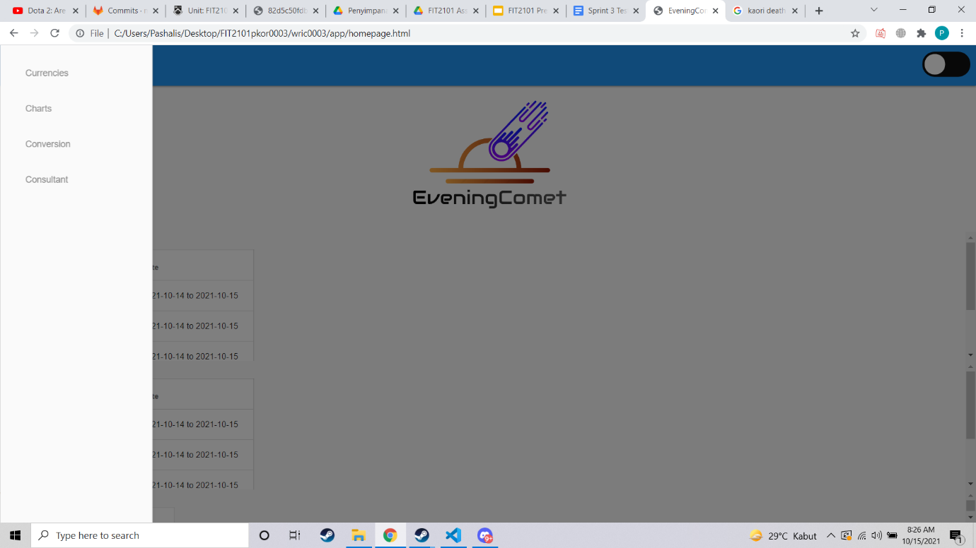

For our first test, we did testing on our website dashboard, we pretended to be a user browsing through the website, and mainly navigating the pages by clicking on the dashboard tabs. While testing, we realised that the pages loaded very quickly in less than a second and navigation overall seemed very simple and quick for the user.

We also tested our home page logo which we created as a home button that takes us back to the homepage, this button works and instantly takes users back to the homepage.

**Tested By: Entire Team**

**Period of testing: Sprint 1**

**Test 2: Dark Mode**

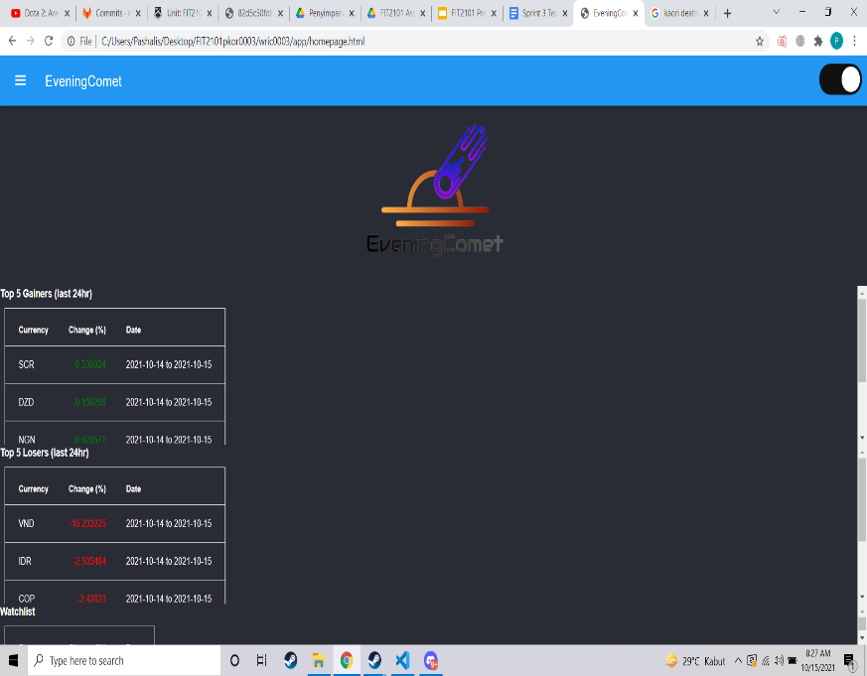

For this test, we were mainly testing the dark mode functionality of our widget, as you can see on the top right, that is a slider button to activate dark mode by clicking on it. We tested this slider for the homepage and all pages, and it successfully changes the pages into the dark mode versions. For our dark mode visuals, we changed the css and javascript as we go, checking to see if everything is readable and the colors transition well into dark mode and making changes as we go.

**Tested By: Entire Team**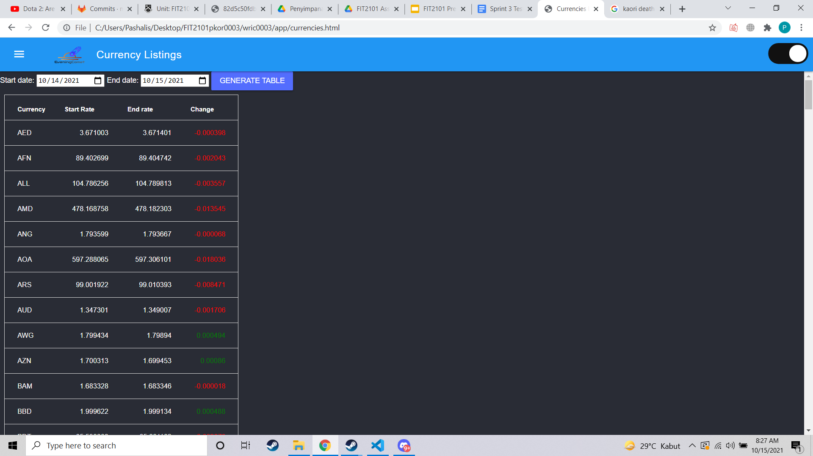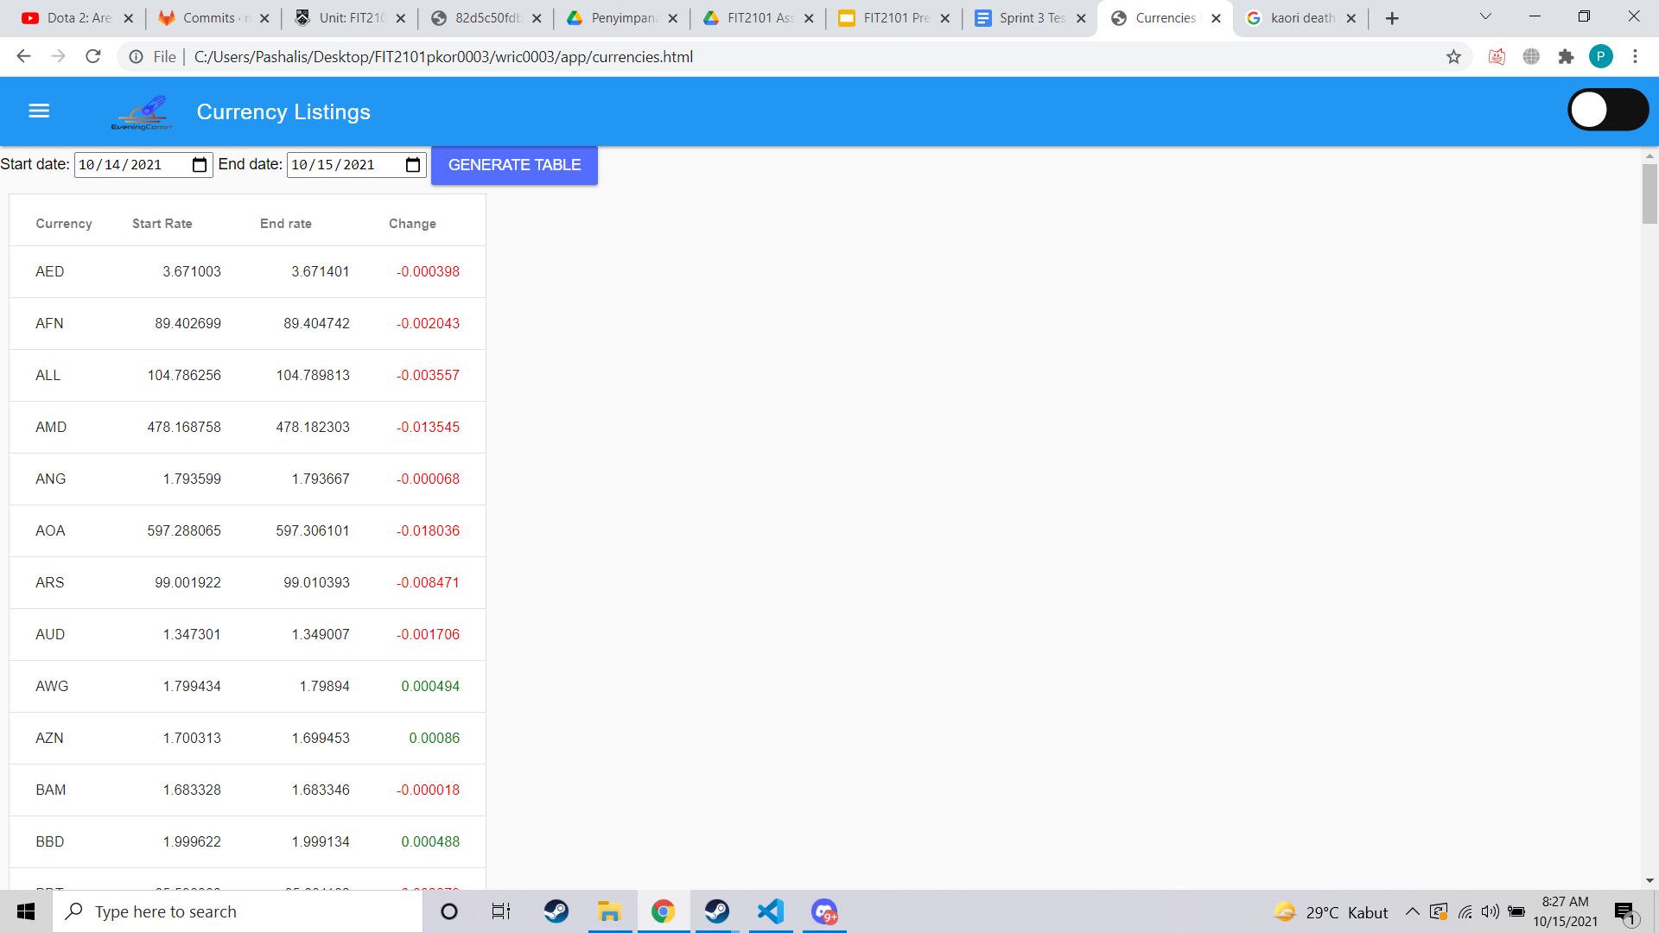

**Period of testing: End of sprint 2 - beginning of sprint 3**

**Test 3: Currencies Page**

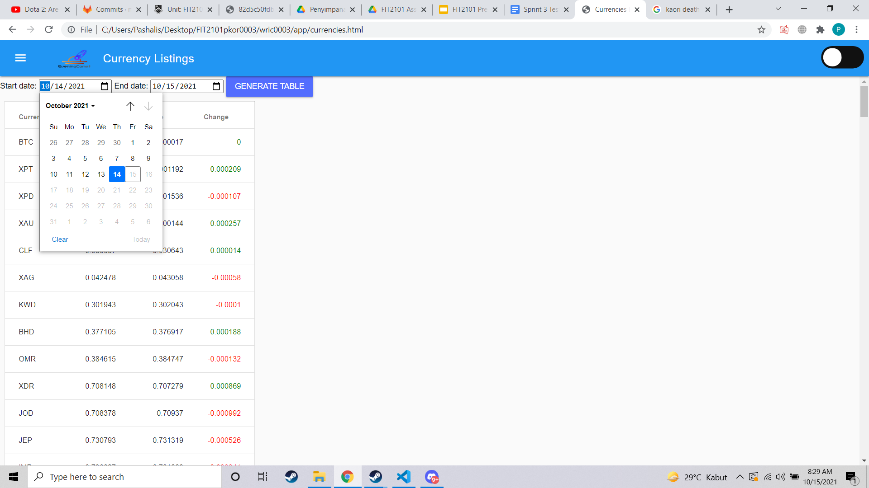

This is our currencies page, which is one of our main features. The test we conducted for this page was mainly regarding 3 things, the start date and end date, the table sort function, and lastly the accuracy of the date.

For the start date and end date, we input multiple different dates to see if they work, for the most part, the start dates and end date search works. We also input invalid dates to make sure it does not work, such as having the start date at a later date than the end date.

For our filter function, we tested it by just going through our table after sorting by alphabetical and rates. Judging by our testing, the tables were sorted properly as we checked through the data after sorting.

The last form of testing was testing the accuracy of our data, to do this we searched multiple valid dates and compared our data with real world data from valid sources such as the world bank. We thoroughly went through our tables to make sure the rates were overall the same as the data provided by the world bank. After testing, we have concluded that our API is sending us trustworthy and accurate data.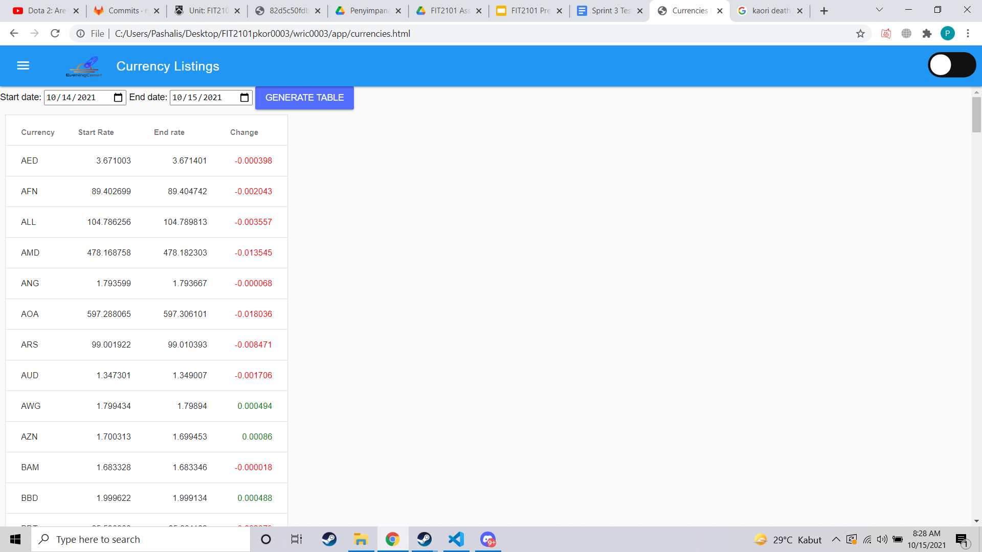

**Above is sorting by alphabetical**

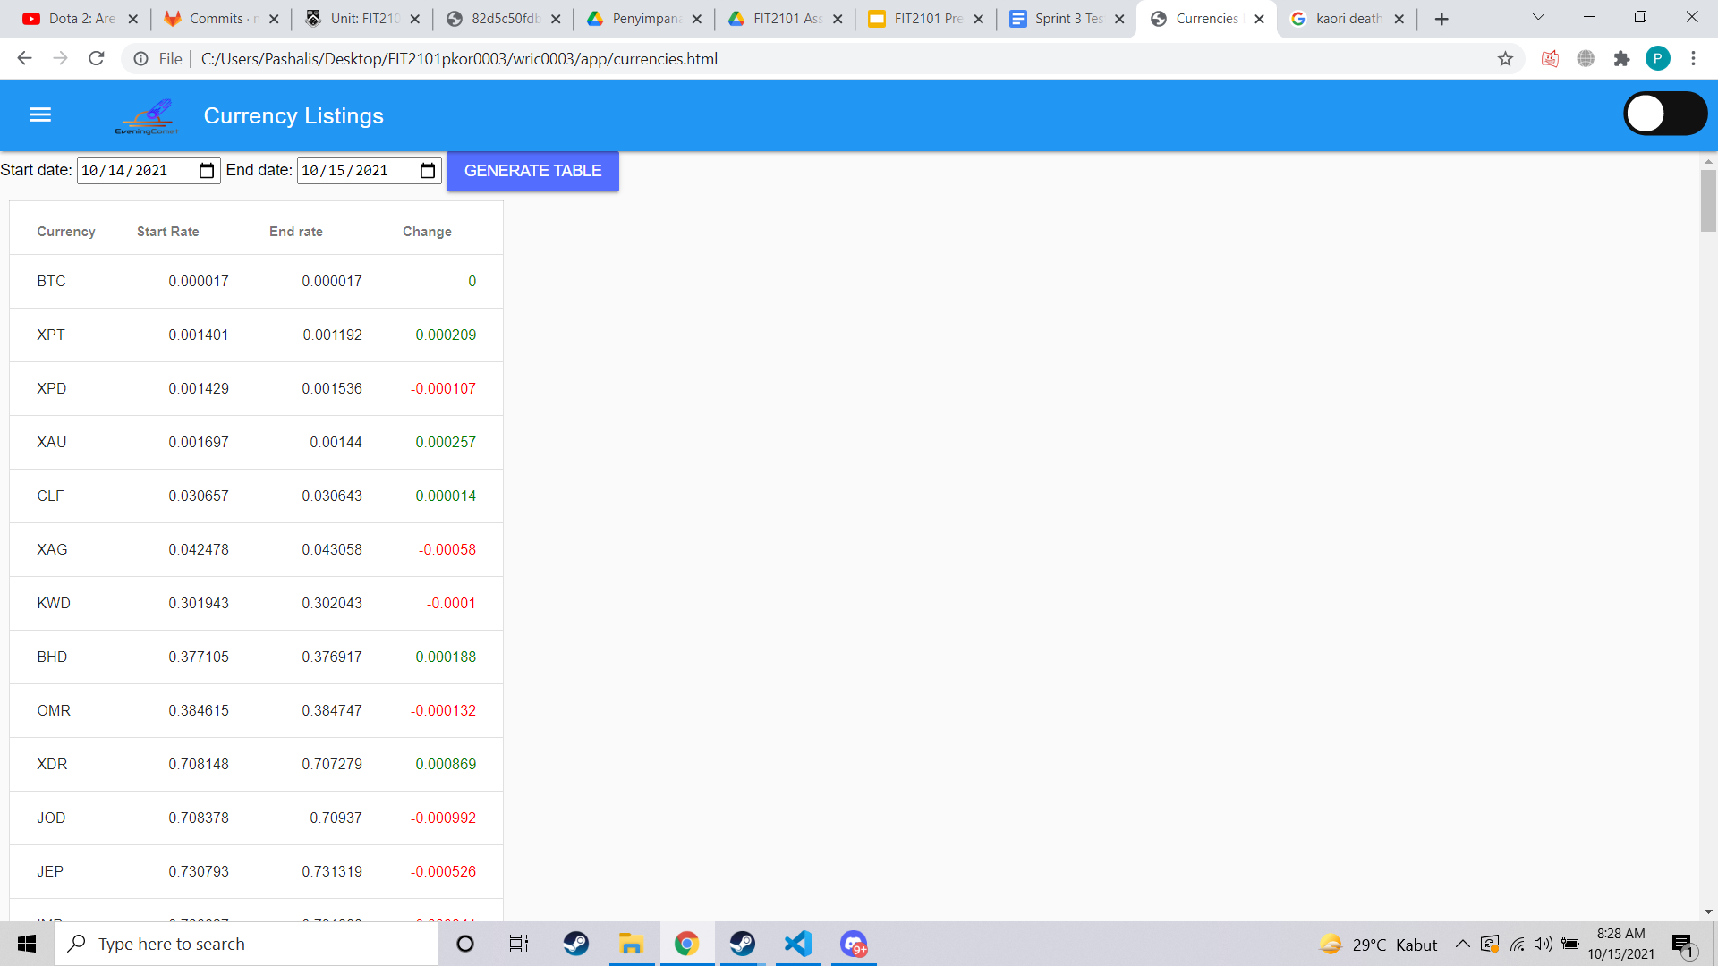

**Above is sorting by numerical**

**Tested By: Brandon and William**

**Testing Period: Sprint 1 - Sprint 3**

**Test 4: Currency Converter**

The fourth main testing we did was for our currency converter, we mainly checked for multiple currencies, and also input invalid data to make sure it will ask the user for a re-input.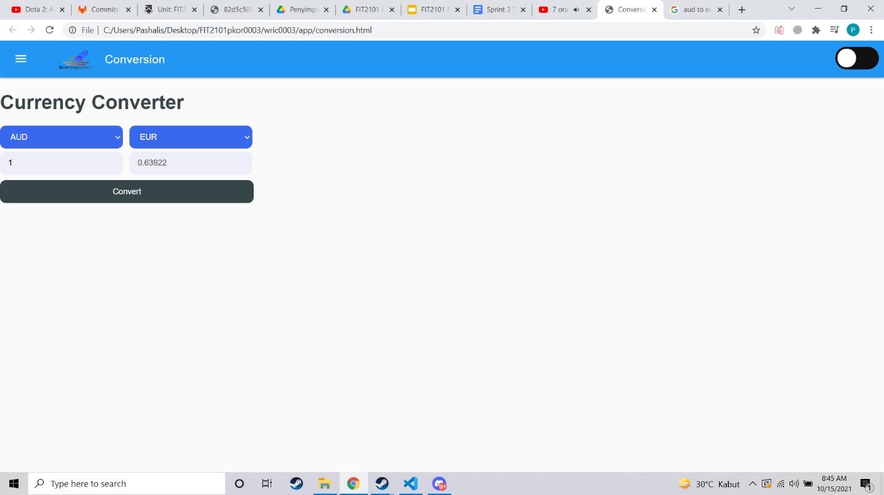

The most important part of the testing however was the accuracy of our data, so we checked multiple conversions on multiple different days to make sure our data is up to date and accurate. After testing and cross checking with external sources, we can conclude that our currency converter works well and converts the currencies correctly.

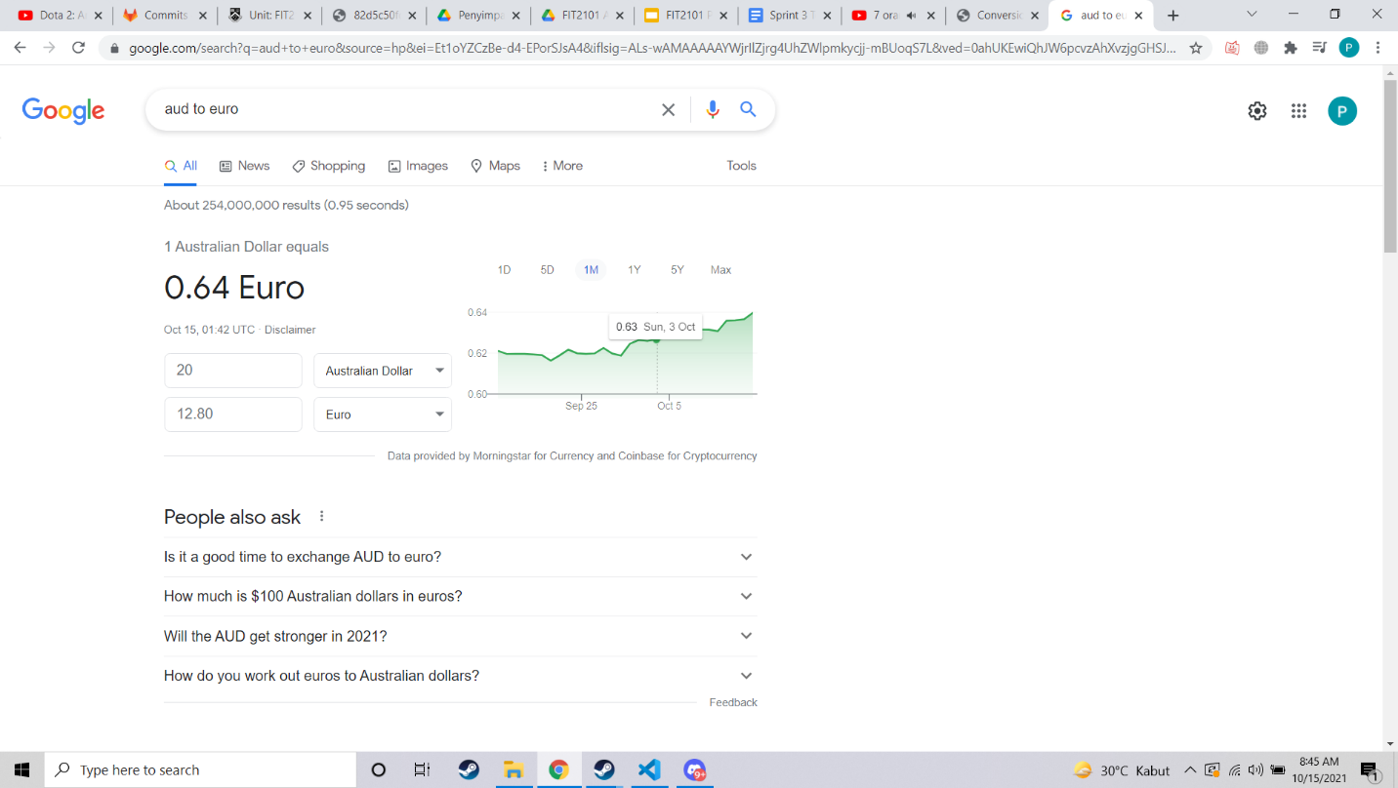

The screenshots here provide proof for the accuracy of our converter.

**Tested by: Pashalis and Brandon**

**Testing period: Sprint 2**

**Test 5: Homepage**Testing was conducted to ensure that the tables of the top 5 gainers and losers visually appear and call the API successfully. 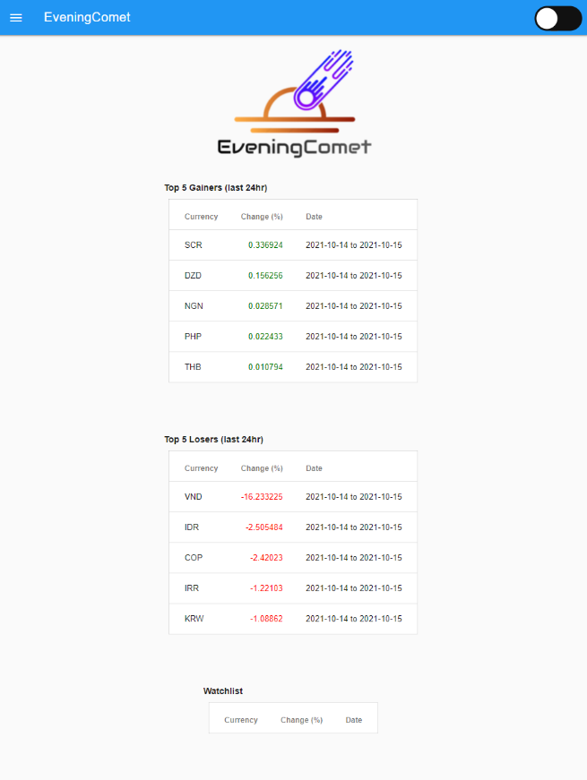

Currencies were added to the watchlist to test and make sure that they appear on the home page when the user returns to the home page.

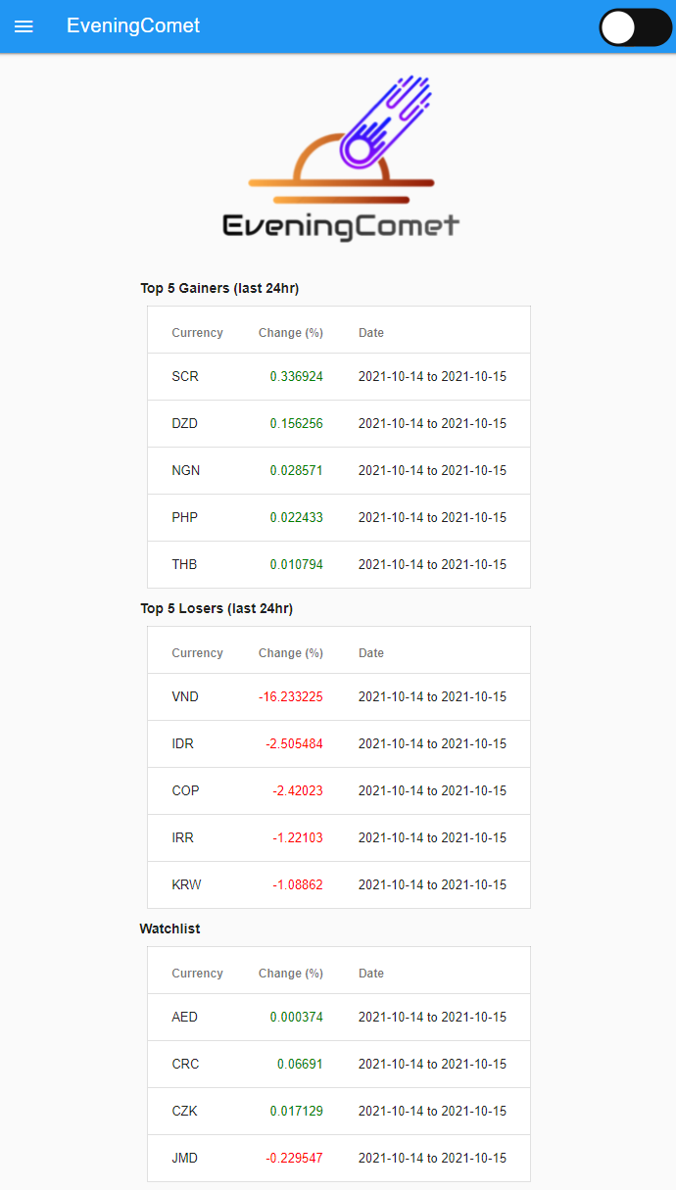

**Tested by: Pashalis and Brandon, Testing period: Sprint 3**

**Test 6: Consultant**

Test whether the upper and lower limit of the budget works

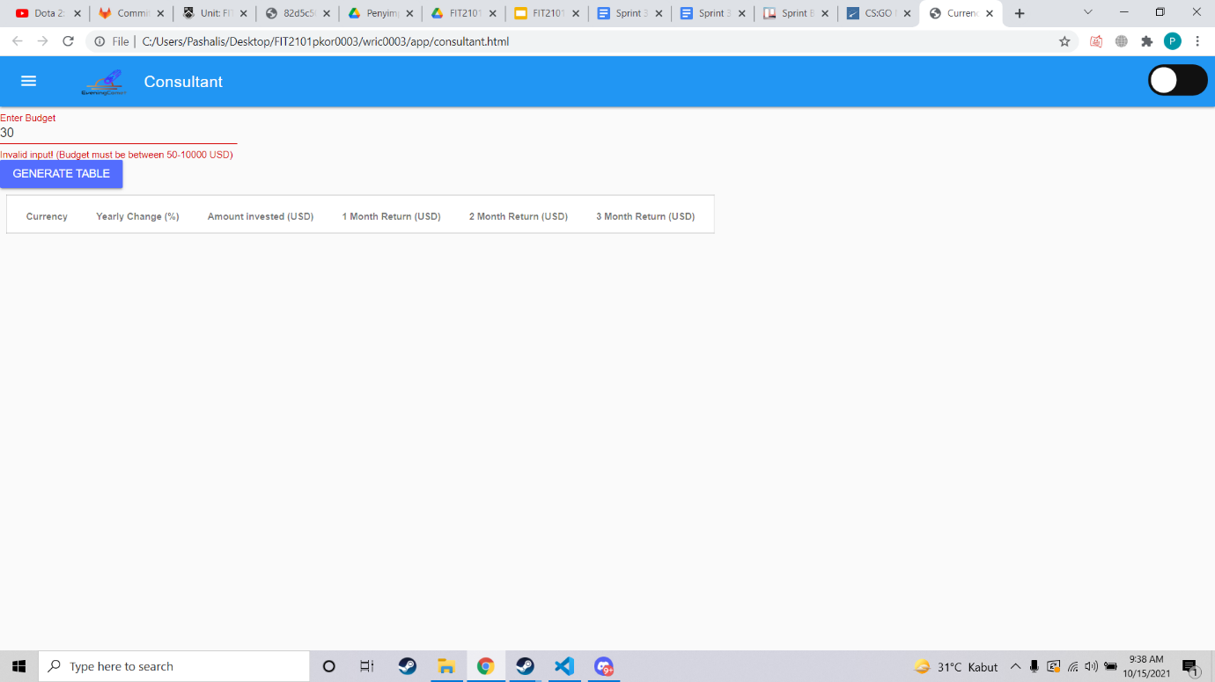

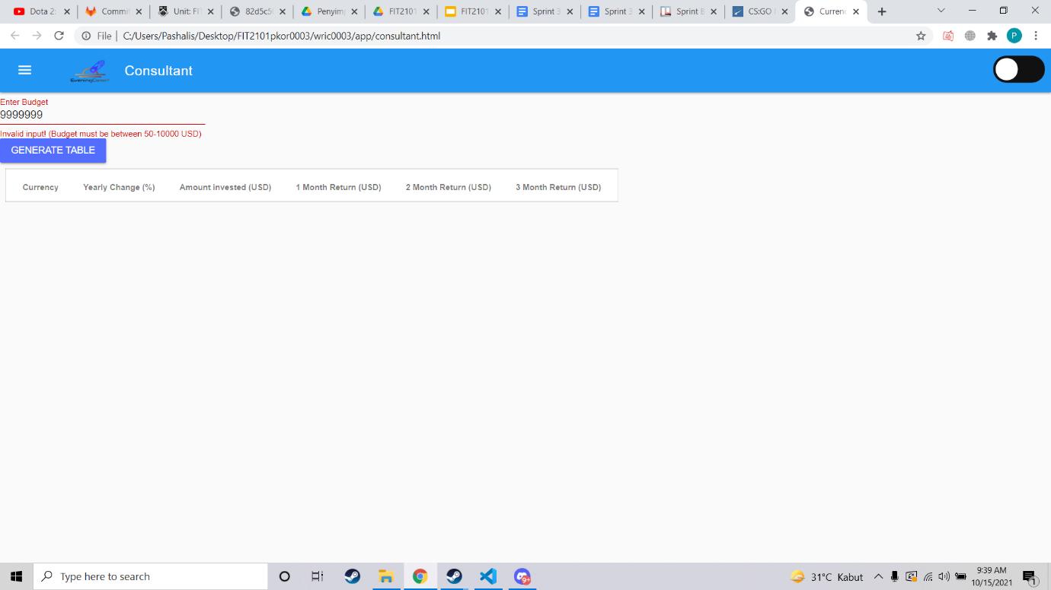

Testing whether the table is properly displaying

Checking whether the values are displayed correctly

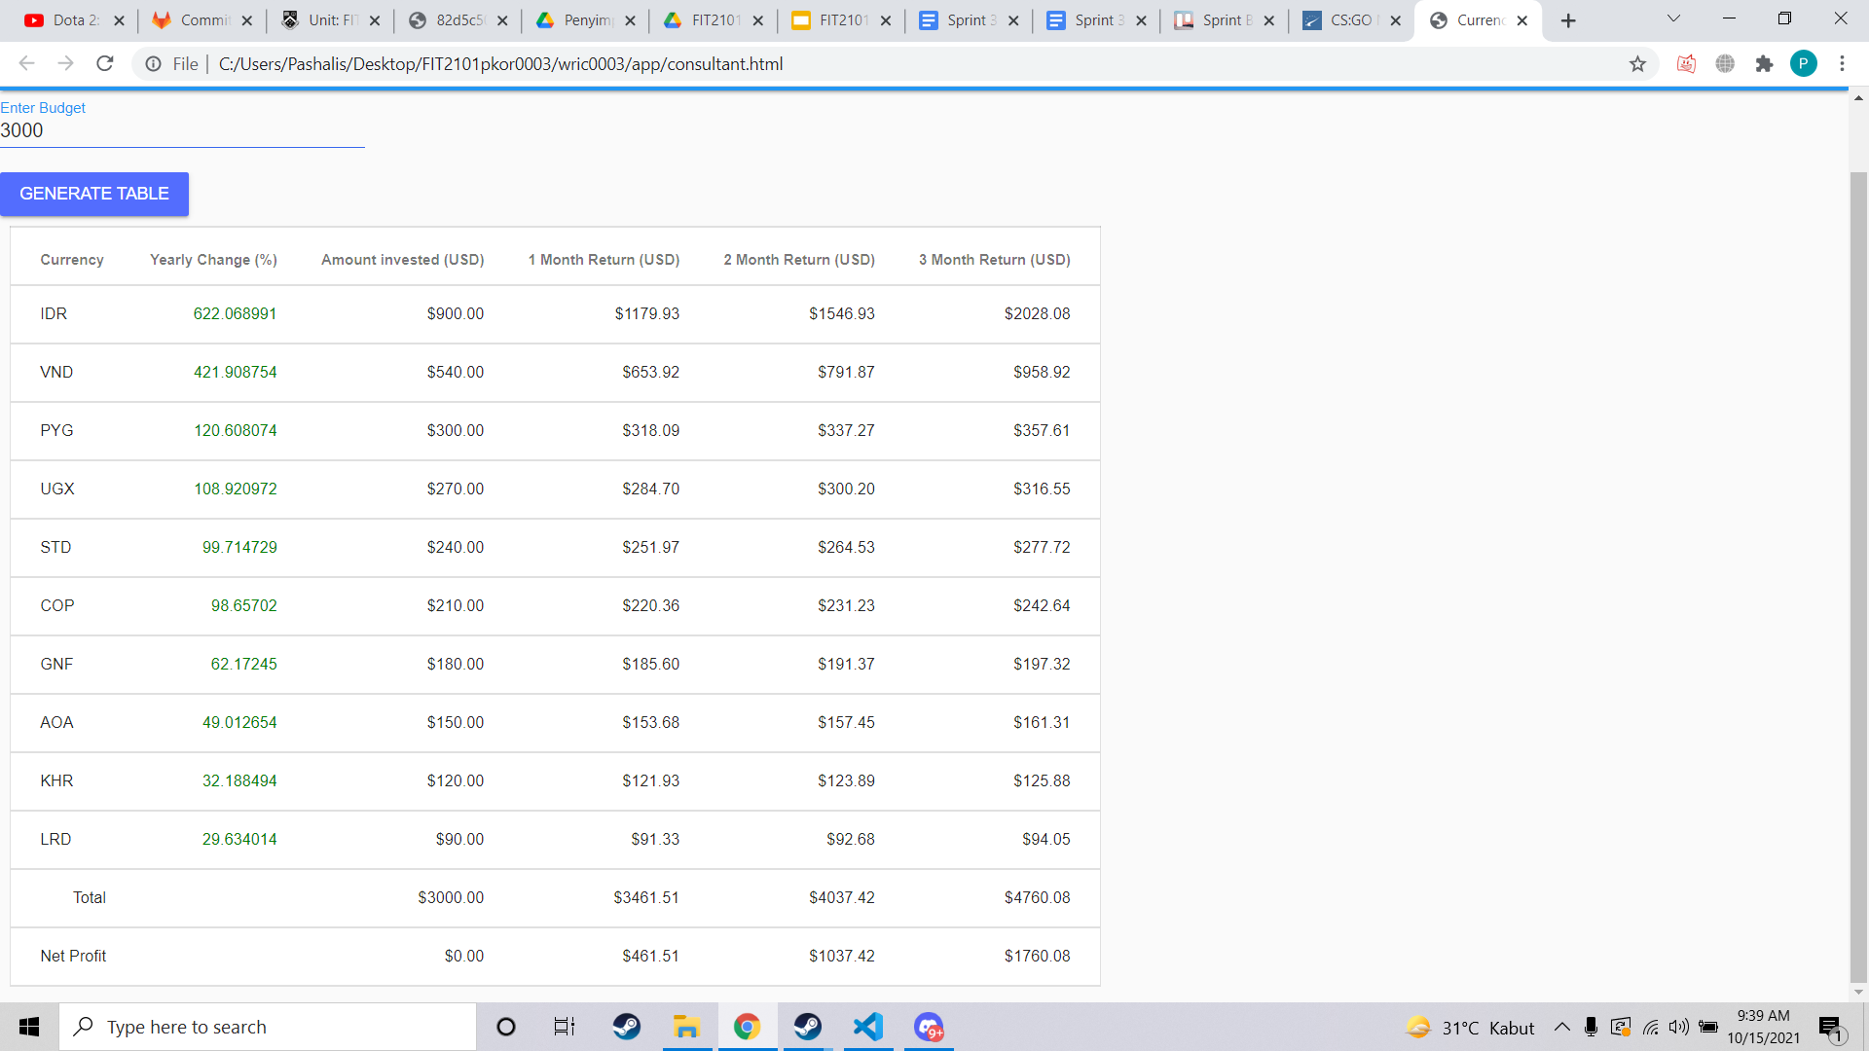

**Tested by: Brandon and William**

**Testing period: Sprint 2**

**Test 7: Charts**

This test checks that the graphs and charts are correctly displayed when selected, and the correct datacard is shown based on the trend of the graph of the currency.

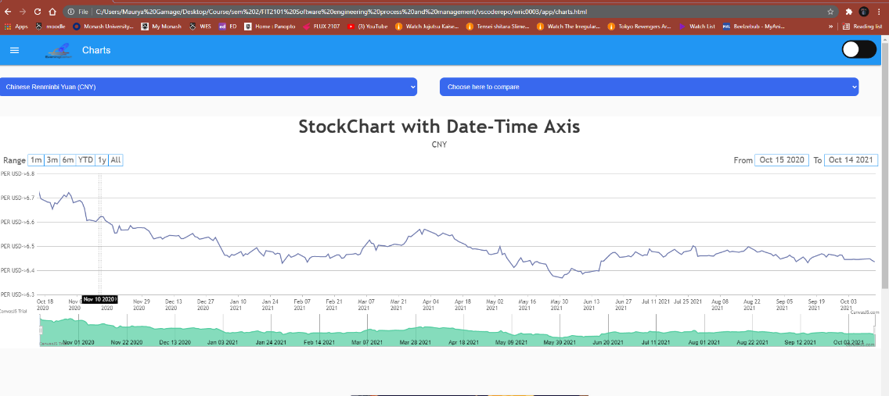

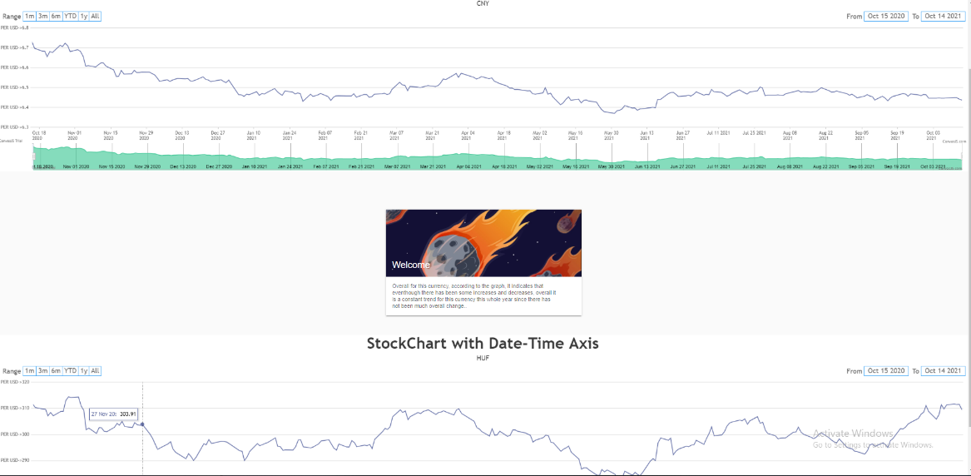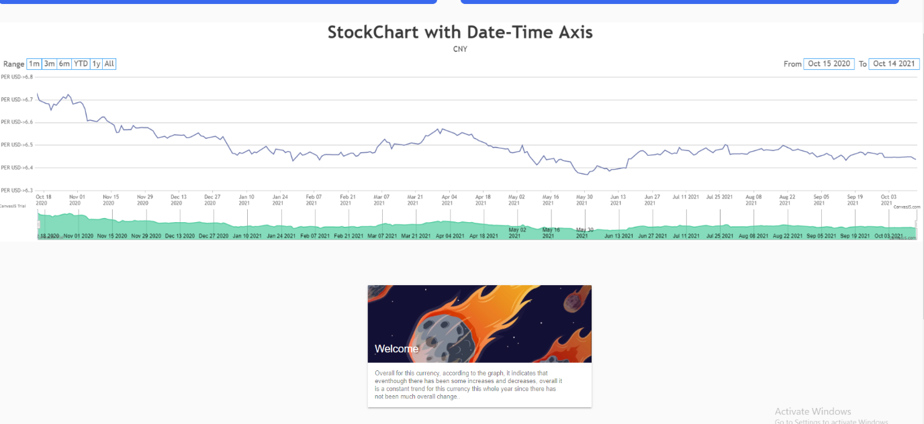

**Tested by: Pashalis and Maurya**

**Testing period: Sprint 3**