Design of an Autonomous On-Orbit Servicing System for Satellite Collision Avoidance in Lower Earth Orbit

By
Maurya Samanta,
UG-4,
Department of Production Engineering,
Jadavpur University

Under the guidance of
Dr. Asim Gopal Barman,
Department of Production Engineering,
Jadavpur University
Acknowledgment
This thesis would not have been successfully completed without the support and guidance of several individuals, to whom I am deeply grateful.
I would like to express my sincere gratitude to my guide and supervisor, Dr. Asim Gopal Barman, whose constant guidance, patience, and invaluable insights played a crucial role in shaping this work. I am especially thankful for the time and attention he consistently provided, always being approachable and willing to clarify even the smallest of doubts.
I am equally grateful to my parents for their unwavering support throughout this journey. Both of them, being academics, have played a significant role in shaping my approach to this work. They have consistently encouraged and respected my efforts, while also providing valuable guidance in refining the structure and presentation of this thesis. Their constant and silent support over the years has been a strong foundation for everything I have achieved.
I would also like to thank my friends, who have patiently listened to my thoughts and discussions regarding this work and provided meaningful inputs. Some of these discussions proved to be particularly valuable, helping me identify and rethink important aspects of the system. I would like to specifically acknowledge Satyaky Jana for his insightful feedback, which helped uncover a critical flaw in the system, and Nabyendu Das, who patiently listened to the conceptual development of this work and provided valuable perspective.
Finally, I would like to express my heartfelt gratitude to my close friend, Hrisheeta Roy, for her constant encouragement and support throughout this journey. Her presence and belief in me have been a source of strength and motivation.

Abstract
With advancement in science and the increasing demand for communication, there has been a rapid increase in the number of satellites deployed in space. Currently, there are approximately 15,000 active satellites, with a vast majority located in Low Earth Orbit (LEO) (~6700–8000 km from Earth’s centre). Over time, many satellites become inactive, contributing to a growing population of space debris. Even small debris, traveling at velocities exceeding 1 km/s, can cause catastrophic damage upon collision with operational satellites.
Thus, the need for autonomous and scalable collision avoidance systems has increased significantly. This paper presents a complete system of multiple On-Orbit Servicing (OOS) vehicles capable of performing Collision Avoidance Manoeuvres (CAM) by identifying high-risk satellites and executing transfer, rendezvous, and docking operations.
The system is evaluated through experiments conducted in a realistic LEO simulation environment, incorporating orbital dynamics, inter-OOS communication constraints such as Earth occlusion, and limited onboard computational capabilities. The results demonstrate the effectiveness of the proposed system in managing collision avoidance operations.
Furthermore, the study shows that multiple OOS agents coordinate through a lightweight communication framework that resolves conflicting service claims that may arise under limited communication visibility, while maintaining fuel-efficient CAM execution within acceptable time constraints. Additionally, the performance of the system is analysed under varying sensing radii of the OOS vehicles.
This work further extends existing approaches that focus on a single OOS servicing multiple satellites, by demonstrating that such systems can be scaled to a multi-agent setting and remain practical for real-world implementation.

Table of Contents
Chapter I 10
1.1 Introduction 10
1.2 Statement of Problem 11
1.3 Need for Study 12
1.4 Objectives and Scope 12
Chapter II 13
2.1 Literature Review 13
2.1.1 Satellite Conjunction Analysis 14
2.1.2 Collision Avoidance Manoeuvres (CAM) 15
2.1.3 On-Orbit Servicing (OOS) 17
2.1.4 Trajectory Planning and Rendezvous 18
2.1.5 Modelling of LEO Environment 19
2.1.6 Research Gap 20
Chapter III 20
3.1 Overview of Proposed System 20
3.2 System Architecture 23
3.2.1 On-Orbit Servicing Agent Model 23
3.2.2 Satellite and Debris Model 24
3.3.3 The Environment Model 24
3.3 Problem Formulation 25
3.5 LEO Environment Modelling 29
3.6 OOS Agent Model 29
3.7 Communication Model 29
3.8 Mission Planning and Decision Framework 29
3.9 Motion and Control Model 29
3.10 System Workflow 29
Chapter IV 29
4.1 Overview of Implementation 29
4.2 Simulation Framework 29
4.3 Algorithmic Design 29
4.3.1 Target Selection Algorithm 29
4.3.2 Communication Protocol 29
4.3.3 Conflict Resolution Strategy 29
4.3.4 Agent Behaviour 29
4.4 Motion and Control Implementation 29
4.5 Scenario Design 29
4.6 Performance Metrics 29
4.7 Validation Strategy 29

Table of Figures
Figure 1 Centralized Ground-Controlled OOS Collision Avoidance 19
Figure 2 Autonomous OOS-Based Collision Avoidance Process Showing Single OOS Vehicle 19
Figure 3 Autonomous OOS based collision avoidance using multiple OOS vehicles 20
Figure 4 Architecture Diagram showing modules inside OOS 22

Table of Tables

Table of Equations
Probability of Collision expression 25
Time of Service expression 26
Optimization Function expression 26

Chapter I

1.1 Introduction
Satellite deployments have increased considerably over the last decade with over 15,000 satellites launched in the last decade (2016-2026), driven primarily by mega-constellations like Starlink. The total count accelerated rapidly from under 200 per year to over 2,500 annually by 2023. The growing density of space environment consisting of active as well dead satellites and debris have significantly heightened the risk of on-orbit collisions which might jeopardise space missions (S. Patnala, 2025).
According to (ESA's Space Debris Office, 2025), as of April, 2026, the Earth orbit is more congested than ever with more than 130 million debris of size larger than 1mm. While only about 44,780 objects are large enough to be actually tracked, they represent a total mass exceeding 15,800 tonnes.
A critical concern is the Kessler Syndrome, a scenario in which collisions between orbiting objects generate debris that triggers further collisions in a cascading effect. This chain reaction can exponentially increase the debris population, posing severe risks to operational satellites and potentially rendering certain orbital regions unusable. (Kessler & Cour-Palais, 1978).
There have been numerous instances of satellite collisions in the past. In March 2021, the Chinese military satellite Yunhai-1 02 was struck by a fragment from a Zenit-2 rocket stage launched in 1996. While the satellite was not completely destroyed and continued to transmit signals, the impact produced at least 37 new pieces of trackable debris (NASA Orbital Debris Quarterly News, 2021). The Russian laser-ranging nanosatellite BLITS was struck by a tiny piece of debris from the 2007 Chinese anti-satellite test (the Fengyun-1C breakup). The impact changed the satellite's orbit and rotation rate, effectively ending its mission early (CelesTrak Event Analysis, 2013).
To solve this problem, various tools to judge and predict conjunction assessment and analyse future risk have been developed. To do this a large amount of data is generally required. This includes detailed understanding of all objects, including operational, non-operational, spent rocket bodies and other debris – items that are manoeuvrable and non-manoeuvrable. (Hall & Alfano). However, after proper detection, measures have to be taken to prevent it.
Currently, standard collision avoidance procedures rely on coordination between satellite operators to designate manoeuvring and non-manoeuvring parties and to determine appropriate avoidance manoeuvres. This process is largely manual and depends heavily on continuous human monitoring, making it increasingly inefficient and non-scalable in the context of rapidly growing satellite populations. Typically, operators first exchange contact information through platforms such as Space-Track.org or the CONFERS database, followed by sharing precise ephemeris data for accurate position prediction. They then negotiate which satellite will perform the manoeuvre—usually based on agility or available fuel—and finally, the designated satellite shares its planned burn parameters for verification to ensure a safe trajectory adjustment.

1.2 Statement of Problem
Despite the growing awareness of collision risks and the development of conjunction assessment systems, several critical limitations remain in current collision avoidance frameworks. The Standard Operating Procedure present currently is tedious and involves serious work on the part of humans (CONFERS, 2021). Operators spend a considerable amount of time and resources designing a CAM. Therefore, this approach is becoming increasingly unsustainable due to the rapid growth in active satellites and space traffic congestion. As mega-constellations continue to expand, there is a critical need for efficient, scalable, and autonomous CAM solutions. (S. Patnala, 2025). This process is time-consuming and resource-intensive, often resulting in delayed responses in time-critical scenarios (Hall & Alfano).
Recent major shift in the thinking of this process has been brought by the putting forward of usage of On-Orbit Servicing vehicles. On-Orbit Serbvicing vehicles(later referred to as “OOS”) are a concept from the late 1960s. The development of the Space Shuttle program, which was executed first with Columbia in 1981, brought huge advancements to the technology of the OOS of spacecraft. Before the Hubble Space Telescope (HST), astronauts had successfully executed several important operations using the Space Shuttle Challenger to the Solar Maximum Satellite (SMM) launched in 1980. They enabled the repair of the attitude control system and replacement of parts of electronic units and a parabolic antenna (Li & Cheng, 2019).
Recent research has explored the potential of On-Orbit Servicing (OOS) vehicles as an alternative approach to collision avoidance, where dedicated servicing spacecraft assist satellites in executing avoidance maneuvers. This paradigm introduces the possibility of shifting collision avoidance responsibilities from individual satellites to specialized agents. However, the application of such approaches in distributed, multi-agent environments under realistic sensing and communication constraints remains insufficiently explored.

1.3 Need for Study
Collision avoidance has traditionally been the responsibility of individual satellites, requiring them to execute maneuvers based on conjunction assessments. However, spacecraft operate under significant constraints, including limited fuel reserves, restricted maneuvering capabilities, and delays in decision-making processes. These limitations reduce the effectiveness and sustainability of current collision avoidance practices (P., S., & Chhabra, 2021).
A shift toward a service-based approach using On-Orbit Servicing (OOS) vehicles offers a promising alternative. By delegating collision avoidance responsibilities to dedicated servicing entities, it becomes possible to support high-value, fuel-limited, or non-maneuverable satellites more efficiently. This approach not only reduces the operational burden on individual satellites but also enhances overall mission sustainability and effectiveness in increasingly congested space environments (S. Patnala, 2025).

1.4 Objectives and Scope
This work explores the use of On-Orbit Servicing (OOS) vehicles for enabling distributed and autonomous satellite collision avoidance. A multi-agent framework is developed in which servicing spacecraft monitor potential conjunction events within a limited sensing radius and coordinate with other agents under constrained communication conditions to execute timely avoidance maneuvers. The proposed system focuses on efficient decision-making and conflict resolution among multiple agents while minimizing fuel consumption and response time. Both single- and multi-satellite scenarios are considered to evaluate the effectiveness and scalability of the approach in increasingly congested orbital environments.
This work extends previous research carried out by S. Patnala and A. Abdin, 2025 and makes the following key contributions:
- Establishes a multi-agent OOS architecture for providing CAM services, optimizing fuel usage and maximizing satellite safety, while enabling servicing of large-scale mega-constellations by multiple OOS agents operating without ground intervention and relying solely on inter-agent communication and edge architecture.
- Conceptualizes and implements a mission architecture along with an inter-communication protocol among OOS agents, including conflict resolution mechanisms to ensure effective multi-agent coordination and decision-making.
- Develops a simulation environment based on realistic Low Earth Orbit conditions, where satellites, debris, and OOS operations are modelled to evaluate the capability of OOS agents to perform both rendezvous and collision avoidance manoeuvres. The environment incorporates factors such as orbital dynamics, Earth-induced communication occlusion, and realistic hardware limitations of individual OOS agents to ensure practical applicability.
- Analyses the relationship between the overall success rate of the multi-agent OOS system and various operational parameters through structured simulation experiments, providing insights into the scalability and real-world feasibility of the proposed framework.
The remainder of this report is structured as follows. Chapter 2 presents the literature review, covering existing work in satellite collision avoidance, space traffic management, and On-Orbit Servicing (OOS). Chapter 3 describes the overall system architecture and methodology, including the multi-agent OOS framework, communication model, sensing constraints, and the conceptual design of the proposed approach. Chapter 4 focuses on the implementation of the system, detailing the simulation environment, algorithmic logic, and the development of various modules such as OOS agents, satellites, and communication mechanisms. Chapter 5 presents the results obtained from different simulation scenarios, along with analysis based on performance metrics such as collision avoidance success rate, fuel consumption, and response time. Finally, Chapter 6 summarizes the key findings of the study, discusses limitations, and outlines possible directions for future work.

Chapter II

2.1 Literature Review
This section reviews existing research work in the areas of Satellite Conjunction Analysis, On-Orbit Servicing (OOS), Collision Avoidance Manoeuvres (CAM), and broader developments in Space Traffic Management. It examines various approaches used to estimate collision risk and predict conjunction probabilities between space objects. Further, it explores trajectory planning techniques for fuel-efficient rendezvous and docking operations, which form a critical component of OOS missions. The review also discusses methods for modelling realistic Low Earth Orbit (LEO) environments, including the presence of multiple satellites, debris, and operational constraints. Finally, this section identifies the existing research gap in the development and evaluation of distributed, multi-agent OOS systems operating under realistic sensing and communication constraints for collision avoidance applications.

2.1.1 Satellite Conjunction Analysis
A satellite conjunction is an event in which two satellites or a satellite and a piece of debris are estimated to pass near each other. The goal of satellite conjunction analysis is to determine whether the risk of collision is high enough to necessitate a collision avoidance manoeuvre (MS, R, & Ferson, 2019). One important concept to note in this is the counterintuitive phenomenon in satellite conjunction analysis, known as probability dilution. Balch et. al. noted that, as uncertainty in the satellite trajectories increases, the epistemic probability of collision eventually decreases. Since trajectory uncertainty is driven by errors in the tracking data, the seemingly absurd implication of probability dilution is that lower quality data reduce the risk of collision.
Balch et. al. attribute this issue to a deeper theoretical problem termed false confidence, wherein probabilistic models assign high confidence to incorrect outcomes under conditions of high uncertainty. The paper argues that this limitation arises from the use of epistemic probability to represent uncertainty, which leads to misleading interpretations of collision risk. As a result, the authors propose the use of alternative approaches such as uncertainty ellipsoids and confidence regions, which provide more reliable and conservative estimates for collision avoidance decision-making. In high-level implementation, it can be conceptually understood as proposing that “at time t, satellite could be anywhere inside this region” instead of “at time t, the satellite is exactly here”.
The work by Ferreira et al. introduces the concept of a satellite safe margin, defined as the minimum possible distance between two space objects considering the uncertainty in their positions. Unlike traditional metrics such as miss distance and probability of collision, this approach directly accounts for positional uncertainty through the use of ellipsoidal representations. The authors propose two computational methods based on the Frank-Wolfe and FISTA algorithms to efficiently compute this margin in both centralized and distributed settings. The proposed approach demonstrates significant improvements in accuracy compared to existing analytical methods, while maintaining computational efficiency. Additionally, it provides a more interpretable and conservative measure of collision risk. However, the method does not fully replace existing probabilistic approaches and is dependent on accurate uncertainty modeling. However, the method does not fully replace existing probabilistic approaches and remains dependent on accurate uncertainty modeling. Furthermore, in cases where uncertainty regions overlap, additional analysis is required to assess the severity of the collision risk.
The probability of collision between space objects is commonly computed using methods developed by F. K. Chan, in 1997 and published by NASA, which estimate collision risk based on the relative position and associated uncertainty of the objects. Chan’s formulation, widely adopted in operational systems, assumes Gaussian uncertainty distributions and computes the probability of collision in the encounter plane. While this method has become a standard in conjunction analysis, it is known to exhibit limitations under high uncertainty conditions, leading to issues such as probability dilution and unreliable risk estimation.

2.1.2 Collision Avoidance Manoeuvres (CAM)
Pavanello et. al. present a comprehensive survey of collision avoidance maneuver (CAM) design methodologies, highlighting the increasing importance of efficient and autonomous maneuver planning due to growing space congestion. CAM design is formulated as an optimization problem aimed at minimizing collision risk while reducing fuel consumption. Existing approaches are broadly categorized into analytical, semi-analytical, and numerical methods, as well as impulsive and low-thrust strategies. Analytical methods offer high computational efficiency but lack flexibility, whereas numerical and heuristic approaches provide greater adaptability at the cost of increased computational complexity (Pavanello & Maria, 2025).
The study identifies a fundamental trade-off between computational speed, optimality, and robustness, with no single method capable of addressing all requirements effectively.
Furthermore, most existing approaches focus on single-satellite decision-making and rely heavily on ground-based human intervention. The increasing frequency of conjunction events, particularly in large constellations, highlights the need for scalable and autonomous CAM solutions capable of operating in real-time onboard spacecraft.
Lee et. al. propose a suboptimal continuous control approach for collision avoidance using generating functions within an optimal control framework. The collision avoidance constraint is incorporated indirectly through a penalty function added to the cost functional, which increases sharply as the spacecraft approaches an obstacle. This transforms the constrained optimization problem into an unconstrained one. The resulting Hamiltonian system is solved using generating functions, yielding a feedback control law without requiring initial guesses or iterative optimization. The method demonstrates effectiveness in both single and multi-obstacle scenarios, producing collision-free trajectories with relatively low fuel consumption. However, the approach is inherently suboptimal due to the indirect representation of constraints and requires manual tuning of penalty parameters. Additionally, it remains limited to single-agent scenarios and does not address scalability or distributed coordination challenges (Lee, Park, & Park, 2016).
The work by Garg et al. presents a direct trajectory optimization approach for solving optimal control problems using a Radau pseudospectral method. The method transforms the continuous trajectory optimization problem into a nonlinear programming problem by discretizing the state and control variables at specific collocation points. This allows complex optimal control problems, including both finite and infinite horizon cases, to be solved efficiently. The approach provides accurate estimation of both the state and costate variables and demonstrates high convergence rates with increasing discretization points. Additionally, the method avoids loss of information by maintaining a consistent mapping between the continuous and discrete systems, making it suitable for trajectory optimization in spacecraft applications (Garg, A., Patterson, Francolin, & Darby, 2009). However, the method assumes smooth system dynamics and requires significant computational effort due to the transformation into a nonlinear optimization problem. Furthermore, it is primarily suited for centralized, single-agent scenarios and does not account for real-time decision-making or distributed coordination, which are critical in large-scale satellite environments.
In contrast, recent work by S. Patnala et al. explores the use of reinforcement learning (RL) for autonomous collision avoidance and on-orbit servicing operations. In this approach, the spacecraft is modelled as an intelligent agent that learns optimal manoeuvre strategies through interaction with a simulated environment. The RL framework enables the system to adapt to dynamic conditions and uncertainties without requiring explicit modelling of all constraints. The agent learns to perform tasks such as rendezvous, collision avoidance, and trajectory correction while optimizing fuel usage and mission efficiency. While RL-based methods offer greater adaptability and autonomy compared to classical optimization techniques, they introduce challenges related to training complexity, convergence stability, and generalization to unseen scenarios. Additionally, most existing approaches focus on single-agent systems and do not fully address the challenges of coordination among multiple agents under communication and sensing constraints.

2.1.3 On-Orbit Servicing (OOS)
On-Orbit Servicing (OOS) has been comprehensively documented in the NASA (2010) report, where it is defined not as a single mission but as a complete mission lifecycle supported by a system-level architecture. In a broad sense, OOS encompasses a range of functionalities including repair, refuelling, relocation, assembly, and upgrades. The core components of an OOS architecture include Guidance, Navigation and Control (GN&C), sensing systems, robotics, autonomy, propulsion, and standardized interfaces. While these individual technologies are largely mature at the component level, the primary challenge lies in their integration into reliable and scalable system-level designs. Furthermore, the transition toward autonomous servicing introduces additional constraints, requiring systems to handle safety-critical scenarios such as abort execution, mode switching, and failure response in real-time operations (NASA, 2010).
A comprehensive overview of the evolution and capabilities of On-orbit service agent is provided by (Lei & Cheng, 2019). A typical OOS system consists of a servicing spacecraft equipped with robotic manipulators, sensing systems, and docking mechanisms, enabling it to approach, capture, and service target satellites. These systems follow a structured operational pipeline involving detection, rendezvous, docking, servicing, and departure. However, the majority of existing OOS systems are designed as centralized, single-agent architectures with pre-planned mission execution. They do not address the challenges of dynamic, large-scale environments involving multiple satellites.
The advancement in the utilization of OOS vehicles for satellite collision avoidance is significantly contributed by the work of S. Patnala and A. Abdin (2025). They proposed a mission architecture in which a servicing spacecraft provides collision avoidance manoeuvre (CAM) support, optimizing fuel consumption while maximizing satellite safety. Furthermore, they introduced a reinforcement learning (RL)-based framework to enable autonomous and dynamic mission planning, allowing the servicing vehicle to perform rendezvous, docking, and collision avoidance operations efficiently. Their framework successfully demonstrates both single-target and multi-target servicing scenarios. However, the multi-target case is handled in a sequential manner using a single servicing vehicle, which limits scalability in highly congested environments such as mega-constellations. The approach relies on a centralized decision-making process and does not consider distributed coordination among multiple servicing agents. Additionally, the experimental setup assumes simplified orbital conditions, including satellites in similar orbital configurations and idealized transfer scenarios. As a result, the framework does not fully capture the complexities of real-world space environments involving heterogeneous orbits, communication constraints, and large-scale multi-agent interactions (S. Patnala, 2025).

2.1.4 Trajectory Planning and Rendezvous
Trajectory planning is a fundamental component of orbital operations, involving the analytical or numerical determination of a feasible path between two points in orbit under constraints such as fuel consumption and time. One of the earliest and most significant contributions to this field was made by Johann Heinrich Lambert in 1761. Lambert’s problem is a classical boundary value problem in analytical mechanics, where the objective is to determine the orbit connecting two spatial positions within a specified time under a central gravitational field (Baloglou, Gill, & Sánchez-Vizuet, 2025)
On the other hand, Hohmann proposed that the minimum-fuel transfer between two coplanar circular orbits is achieved through a two-impulse elliptical transfer that is tangent to both the initial and final orbits. The work by Prussing (1992) provides a simplified analytical proof of the global optimality of the Hohmann transfer for such cases. By analyzing the variation of total velocity impulse with respect to eccentricity, it is shown that the fuel cost increases monotonically with eccentricity, implying that the optimal solution corresponds to the minimum eccentricity transfer, i.e., the Hohmann orbit (Prussing, 1992).
However, practical On-Orbit Servicing (OOS) missions require more than idealized impulsive transfer solutions. Fehse presents a comprehensive framework for autonomous rendezvous and docking, where trajectory planning is performed in multiple stages. An initial coarse orbital transfer is followed by proximity operations using relative motion dynamics, typically modeled through Clohessy–Wiltshire equations, and finally controlled docking using feedback-based guidance laws. This highlights that real-world OOS operations rely on a combination of analytical planning and closed-loop control rather than purely precomputed trajectories (Fehse, 1992).
Similarly, McInnes explores the use of artificial potential field methods for autonomous rendezvous, where continuous low-thrust control is used to guide the spacecraft. In this approach, attractive forces drive the spacecraft toward the target while repulsive forces ensure collision avoidance, enabling real-time trajectory adaptation in dynamic environments. Such methods demonstrate the shift from purely analytical solutions toward control-based and adaptive trajectory generation techniques. (McInnes, 1995).

2.1.5 Modelling of LEO Environment
Digital modelling of the Low Earth Orbit (LEO) environment is essential for evaluating collision avoidance strategies and system-level behaviour under realistic conditions. Existing approaches for modelling orbital object populations can broadly be classified into high-fidelity models and aggregated source–sink models. High-fidelity models simulate individual space objects by propagating their orbits using detailed orbital dynamics and Monte Carlo simulations, providing high physical accuracy at the cost of significant computational complexity. (Miraux, 2025).
In contrast, source–sink models represent the orbital environment at a population level by modelling the flow of objects through creation and removal processes rather than tracking individual trajectories. In this approach, objects are grouped into altitude shells, and their evolution is governed by sources such as launches and collisions, and sinks such as atmospheric decay and post-mission disposal. Miraux (2026) presents a system dynamics-based implementation of this approach, where LEO is discretized into altitude bins and objects are categorized into satellites, rocket bodies, and debris of different sizes, enabling scalable long-term simulation of debris evolution.
Another approach to simulating a realistic physical LEO environment is High Fidelity models wherein the bodies are propagated in real time. This gives us greater physical accuracy to the system and more customizability. A prominent example is NASA’s LEGEND (LEO-to-GEO Environment Debris) model, which propagates the orbits of individual satellites, rocket bodies, and debris objects using detailed orbital dynamics, including perturbation effects. These models simulate collision events, fragmentation using standard breakup models, and long-term debris evolution through Monte Carlo simulations. (LEGEND : 3D/OD Evolutionary Model, n.d.)

2.1.6 Research Gap
Despite significant advancements in collision risk assessment, trajectory planning, and On-Orbit Servicing (OOS), existing approaches remain limited in addressing the operational challenges of large-scale and distributed satellite environments. One of the primary challenges is avoiding collisions between satellites and debris in congested environment in an automated fashion without human or ground intervention.
Recent work by S. Patnala and A. Abdin (2025) introduced a service-based approach to collision avoidance using a single OOS vehicle, demonstrating the feasibility of delegating collision avoidance manoeuvres to a dedicated servicing spacecraft. While effective, the proposed framework is limited to a centralized, single-agent architecture and does not address scalability to scenarios involving multiple satellites and servicing vehicles.
In parallel, existing OOS system approaches generally assume ideal conditions such as global information availability, unrestricted communication, and continuous sensing. These assumptions do not hold in realistic orbital environments, where sensing is inherently limited and communication is constrained by factors such as Earth occlusion and line-of-sight restrictions.
Consequently, there is a lack of frameworks that extend OOS-based collision avoidance to distributed multi-agent systems operating under realistic constraints.
This thesis addresses this gap by extending the single-agent OOS framework to a multi-agent architecture, incorporating inter-agent communication protocols, limited sensing radius, and environmental constraints such as Earth occlusion, enabling coordinated and scalable collision avoidance in complex orbital environments.

Chapter III

3.1 Overview of Proposed System
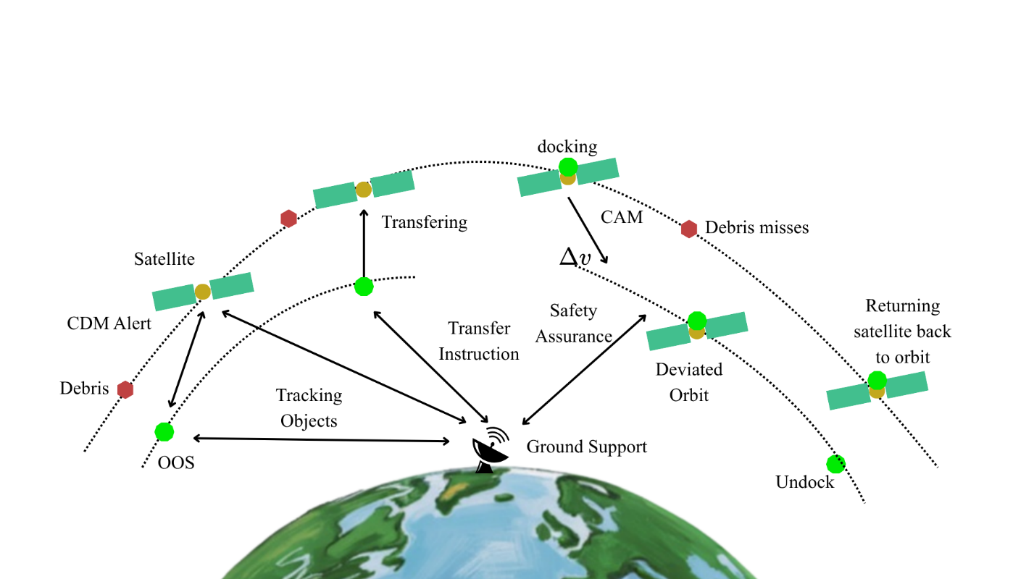
A distributed multi-agent On-Orbit Servicing (OOS) swarm framework is conceptualized and implemented in the software-level for enabling autonomous satellite collision avoidance in Low Earth Orbit. The system consists of multiple servicing spacecraft that collaboratively detect potential conjunction events and execute collision avoidance manoeuvres on behalf of satellites. A baseline approach to such operations is a centralized architecture, as shown in Figure 1, where conjunction detection and decision-making are performed on the ground, and commands are transmitted to spacecraft (S. Patnala, 2025). While this allows coordinated control, it introduces dependency on ground communication, resulting in delays because signals have to travel from OOS to Earth control centre and during that time the OOS has to wait.
Figure 1 Centralized Ground-Controlled OOS Collision Avoidance
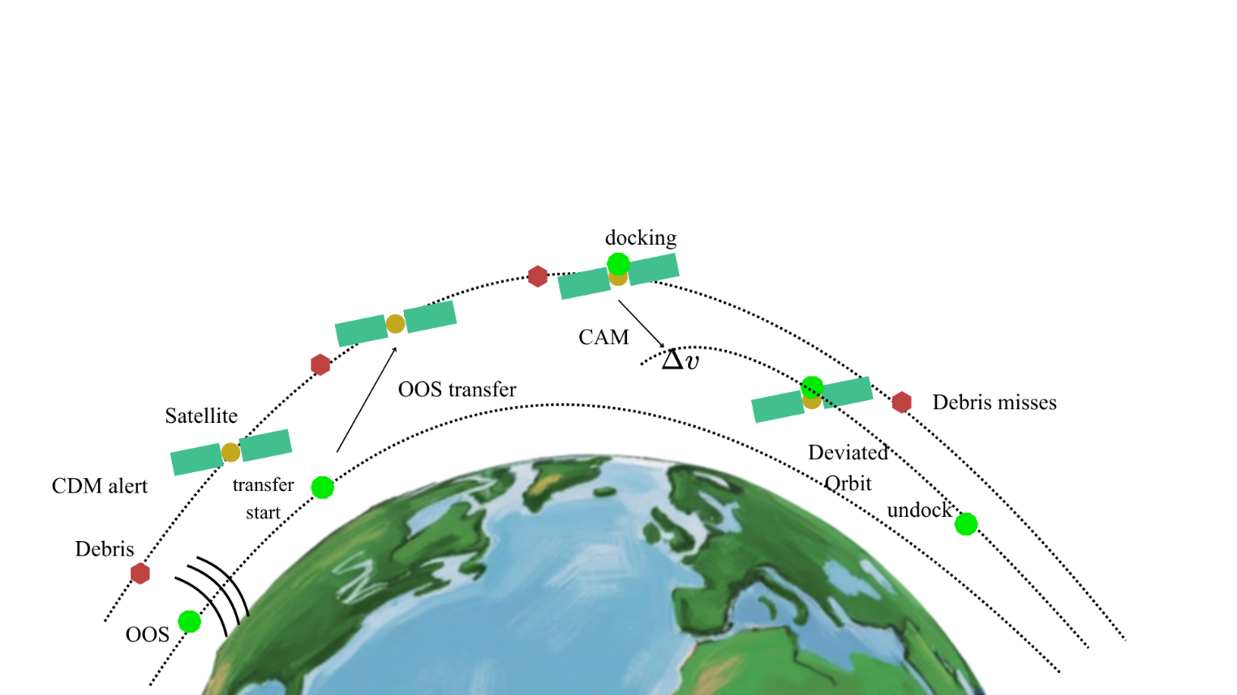
An alternative approach involves a single autonomous OOS spacecraft, shown in Figure 2, which independently monitors its surrounding environment, performs rendezvous with target satellites, and executes avoidance manoeuvres. This removes reliance on ground-based coordination and improves response time. However, the system remains constrained by the capabilities of a single agent, making it unsuitable for handling multiple concurrent collision risks in dense orbital regions.
Figure 2 Autonomous OOS-Based Collision Avoidance Process Showing Single OOS Vehicle
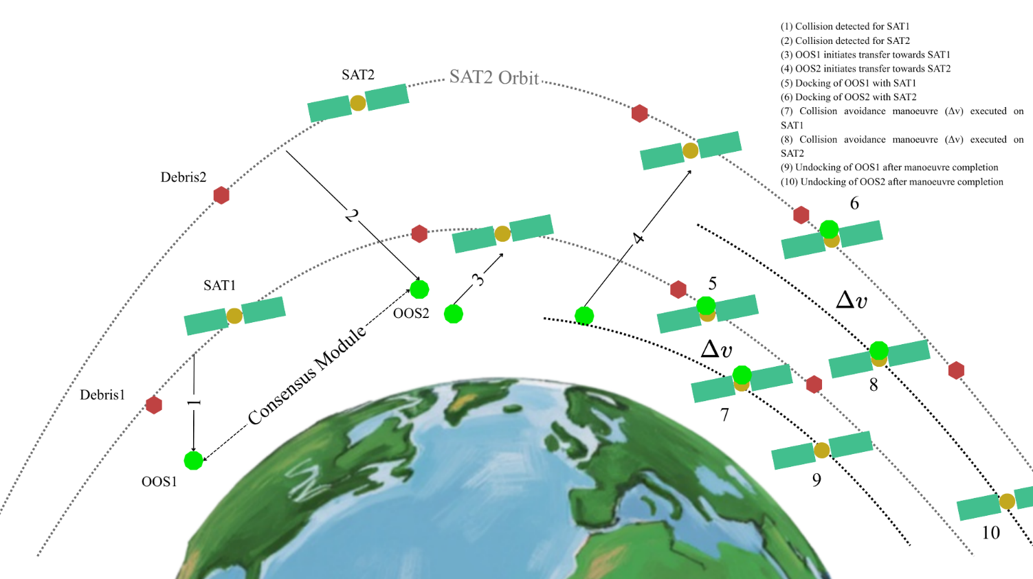
To address these limitations, the proposed system adopts a distributed multi-agent architecture, as illustrated in Figure 3. In this framework, multiple OOS agents operate concurrently, each responsible for monitoring and servicing a subset of the environment. The agents coordinate with one another through a consensus-based communication mechanism through a lightweight network model to allocate mission responsibilities and avoid conflicts, enabling parallel handling of multiple collision events.
Figure 3 Autonomous OOS based collision avoidance using multiple OOS vehicles
Each OOS agent operates based on a state-driven sensing model, where it observes nearby objects within a predefined sensing radius. The agent receives positional and velocity information of these objects and uses this data to evaluate potential collision risks. Object classification, such as distinguishing operational satellites from debris, is assumed to be available through onboard tracking information or databases.
Detection of collision risk is performed by evaluating the relative motion of objects within the sensing region. For each relevant object pair, the agent computes the probability of collision using established formulation of Chan’s method (Chan, 1997). A conjunction event is identified when the computed probability exceeds a predefined threshold, triggering the decision-making process for collision avoidance.
The monitoring and decision-making process is carried out continuously at discrete time intervals. Since orbital states may change due to perturbations or prior manoeuvres, the system does not rely on long-term prediction. Instead, each OOS agent performs repeated short-horizon evaluations based on updated state information. Any variations in position or velocity are naturally accounted for in subsequent evaluation cycles, allowing the system to adapt dynamically to changes in the environment.
The system operates under realistic constraints, including limited sensing radius, partial communication between agents, and Earth occlusion effects that restrict line-of-sight communication. These constraints necessitate localized perception and decentralized coordination, forming the basis of the proposed distributed framework.

3.2 System Architecture
The proposed system is designed as a distributed multi-agent architecture consisting of multiple On-Orbit Servicing (OOS) agents operating within a simulated Low Earth Orbit environment. The system includes three primary entities: servicing agents, satellites, and debris objects, all of which interact within a dynamically evolving orbital space.

3.2.1 On-Orbit Servicing Agent Model
Each OOS agent is an independent vehicle. It is characterised by state variables, position, velocity and available fuel. Each of them has a fixed sensing radius, this is, a radius of sphere within which all the objects are tracked by that particular OOS. This is required because handling the calculation of the entire Low Earth Orbit will require expensive hardware and will significantly increase cost of operation as well as increase the delay in the system. Thus, each OOS is given a possible sensing radius so that it only needs to handle the condition and situation of objects within only that sphere radius. Besides, each OOS has a storage inbox for all the messages it receives from other OOS through the network for consensus decisions. Further it is assumed that the vehicle is provided with thrust rockets. The physical properties of the OOS such as mass and size are not explicitly modelled. Their effects are implicitly captured through parameters such as fuel constraints and manoeuvre capabilities, which are sufficient for the scope of this system-level study.
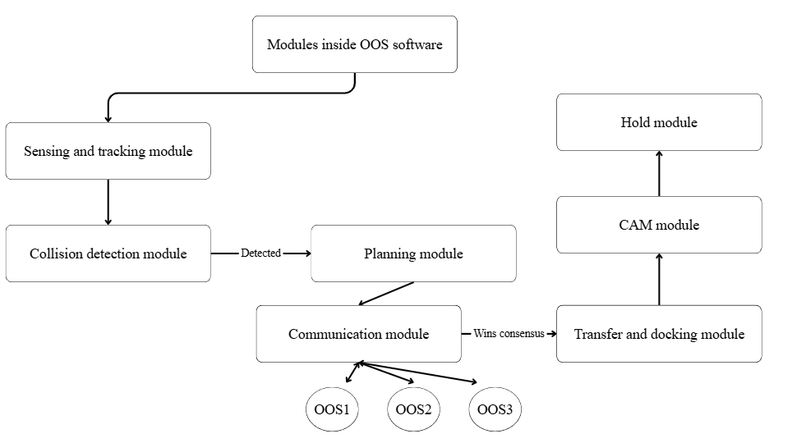
Communication between OOS agents is modelled as a constrained network, where agents can exchange information only within a limited range and subject to line-of-sight restrictions because of Earth occlusion. This ensures that coordination occurs in a distributed and realistic manner.
Figure 4 Architecture Diagram showing modules inside OOS

3.2.2 Satellite and Debris Model
Satellites represent the primary targets for servicing and collision avoidance operations. These objects may be manoeuvrable or non-manoeuvrable and rely on OOS agents for executing avoidance manoeuvres. Debris objects are modelled as passive entities that follow orbital dynamics and contribute to collision risk but do not actively participate in decision-making. Satellites too do not participate in any decision making and are assumed to have easy docking facilities available.

3.3.3 The Environment Model
The simulation environment developed for this study represents the Low Earth Orbit (LEO) space in which all objects evolve over time. It is responsible for updating the states of all entities based on orbital motion and their interactions. Although the simulation maintains a global state of the system, each OOS agent operates solely using locally available information provided to it.

3.3 Problem Formulation
The problem addressed in this work is the autonomous allocation and execution of collision avoidance manoeuvres for satellites in a congested Low Earth Orbit environment using a distributed multi-agent On-Orbit Servicing (OOS) framework.
Let $S=s_{1},s_{2},…,s_{n}$ denote the set of satellites, $O=o_{1},o_{2},…,o_{m}$ the set of servicing agents, and $D=d_{1},d_{2},…,d_{k}$the set of debris objects. Each object in the environment is characterized by its state, defined by position $r∈R^{3}$and velocity $v∈R^{3}$. Additionally, each OOS agent maintains internal state variables such as available fuel $F_{I }$ for OOS $i$
The probability of collision between satellite $S_{i}$and debris object $D_{k}$, denoted as $P_{c}^{\left(i , k\right)}$, is computed using Chan’s formulation (Chan, 1997) and is a function of their relative state and associated uncertainties. It can be expressed as:
$$\begin{aligned}P_{c}^{\left(i , k\right)}=f\left(r_{rel}^{\left(i , k\right)} , v_{rel}^{\left(i , k\right)} , C^{\left(i , k\right)} , R^{\left(i , k\right)}\right)\#\end{aligned} SEQ Equation \backslash * ARABIC 1$$where:
- $r_{rel}^{\left(i , k\right)}=r_{i}-r_{k}$ is the relative position vector,
- $v_{rel}^{\left(i , k\right)}=v_{i}-v_{k}$ is the relative velocity vector,
- $C^{\left(i , k\right)}$ represents the combined covariance matrix capturing uncertainty in position estimation,
- $R^{\left(i , k\right)}$ is the combined collision radius of the two objects.
For a servicing agent $O_{j}$, the time required to transfer from its current state to satellite $S_{i}$is denoted as $T_{\text{transfer}}^{\left(j , i\right)}$.
The total servicing time associated with a collision avoidance mission can be decomposed into multiple sequential components as follows:
$\begin{aligned}T_{\text{service}}^{\left(j , i\right)}=T_{\text{decision}}^{\left(j\right)}+T_{\text{transfer}}^{\left(j , i\right)}+T_{\text{dock}}^{\left(j , i\right)}+T_{\text{CAM}}^{\left(j , i\right)}+T_{\text{hold}}^{\left(j , i\right)}+T_{\text{undock}}^{\left(j , i\right)}\#\end{aligned}$$SEQ Equation \backslash * ARABIC$$2$
where:
- $T_{\text{decision}}^{\left(j\right)}$is the time required by OOS agent $O_{j}$to evaluate the environment and select a target after executing consensus protocol with other OOS agents,
- $T_{\text{transfer}}^{\left(j , i\right)}$is the time required to rendezvous with satellite $S_{i}$,
- $T_{\text{dock}}^{\left(j , i\right)}$is the docking time,
- $T_{\text{CAM}}^{\left(j , i\right)}$is the time required to execute the collision avoidance manoeuvre,
- $T_{\text{hold}}^{\left(j , i\right)}$is the stabilization or verification time after the manoeuvre,
- $T_{\text{undock}}^{\left(j , i\right)}$is the time required to disengage and return to nominal operation.
The objective of the system can be formulated as a multi-objective optimization problem, where the goal is to minimize collision risk while ensuring efficient use of resources. This can be expressed as:
$$\begin{aligned}J=\sum_{i ϵ S}{\sum_{k ∈ D}{P_{c}^{\left(i,k\right)}}}+λ_{1}\sum_{j ∈ O}{F_{j}}+λ_{2}\sum_{j ϵ O}{\sum_{i ∈ S}{{x_{j,i}T}_{service }^{\left(j,i\right)}}}\#\end{aligned} SEQ Equation \backslash * ARABIC 3$$
where:
- $P_{c}^{\left(i , k\right)}$represents the probability of collision between satellite $S_{i}$and debris object $D_{k}$,
- $F_{j}$denotes the fuel consumed by OOS agent $O_{j}$,
- $T_{\text{service}}^{\left(j , i\right)}$represents the total servicing time for OOS agent $O_{j}$assigned to satellite $S_{i}$,
- $λ_{1}$and $λ_{2}$are weighting coefficients that balance the trade-off between collision risk, fuel consumption, and response time.
Therefore, the problem statement can be formulated as
$$\min{J}$$
$$\text{subject to}\text{:} \\ ∥r_{o}-r_{x}∥≤R_{s} where x∈S∪D$$ $F_{j}≤F_{j}^{max}$
$$\sum_{j∈O}{x_{j,i}}≤1$$where:
- $r_{o}$and $r_{x}$denote the position vectors of an OOS agent and a generic object (satellite or debris), respectively,
- $R_{s}$is the sensing radius of an OOS agent,
- $F_{j}$is the fuel available with OOS agent $O_{j}$,
- $F_{j}^{max}$is the maximum fuel capacity of agent $O_{j}$,
- $x_{j,i}∈\{0,1\}$is a binary assignment variable indicating whether OOS agent $O_{j}$is assigned to satellite $S_{i}$.

3.4 Assumptions and Constraints
To ensure computational tractability while preserving the essential characteristics of the problem, several assumptions and operational constraints are considered in the proposed system.
- The OOS agents are assumed to be equipped with sufficient onboard computational capabilities to execute tracking, communication, and decision-making algorithms in real time.
- All orbital objects are assumed to be in near-circular orbits within the Low Earth Orbit (LEO) region.
- Satellites are assumed to possess compatible docking interfaces, enabling seamless interaction with OOS agents.
- The environment is assumed to be static in terms of object population during each simulation run; no new satellites or debris objects are introduced.
- State information of nearby objects, within the sensing range of each OOS agent, is assumed to be available with reasonable accuracy.
To ensure real-world implantability, certain constraints are considered and the algorithms are built around them.
- Each OOS agent operates with a limited sensing radius, restricting its perception to nearby objects only.
- Communication between OOS agents is modelled through a network that introduces propagation delays dependent on the distance between the sender and receiver. Messages are assumed to be transmitted via electromagnetic signals, and broadcast communication is subject to both range limitations and line-of-sight constraints.
- Each OOS agent has a finite fuel capacity, which limits the extent and number of manoeuvres it can perform.
- Decision-making is decentralized, and each agent operates based only on locally available information and received messages from neighbouring agents.
- Collision avoidance decisions must be executed within a limited time window prior to the predicted conjunction event.
- The implemented Network system, that caters inter-OOS communication, has a delay in sending messages based on distance between sender and receiver and delivers broadcasting messages using electromagnetic waves.

3.5 LEO Environment Modelling

3.6 OOS Agent Model

3.7 Communication Model

3.8 Mission Planning and Decision Framework

3.9 Motion and Control Model

3.10 System Workflow

Chapter IV

4.1 Overview of Implementation

4.2 Simulation Framework

4.3 Algorithmic Design

4.3.1 Target Selection Algorithm

4.3.2 Communication Protocol

4.3.3 Conflict Resolution Strategy

4.3.4 Agent Behaviour

4.4 Motion and Control Implementation

4.5 Scenario Design

4.6 Performance Metrics

4.7 Validation Strategy

