**RDBMS, SQL, PLSQL Lab Exercises**

**1. Create three relations- sailors, boats and reserves. Sid, Bid and (Sid, Bid) are the primary keys of sailors, boats and reserves respectively. Sid and Bid are also the foreign keys of reserves which references Sid and Bid of sailors and boats relation respectively. No two sailors have same rating. [ 3X3=9]**

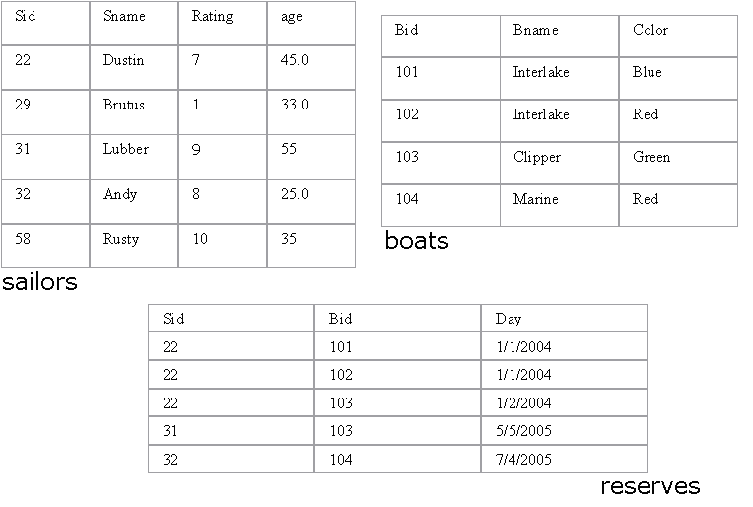

**2. Write SQL queries for the following: [ 4 X 2= 8]**

a. Find the names of sailors who have reserved a red boat.

b. Find the names of the Sailors who have reserved at least one boat

c. Find the ages of sailors whose name begins and ends with B and has at least 3 characters.

d. Find the names of sailors who have reserved a red and a green boat.

**3. Create a trigger to restrict any DML on RESERVES table on MON and WEDNESDAY. [3]**