**COMSATS University Islamabad,   
Park Road, Chak Shahzad, Islamabad Pakistan**

Project Proposal  
(SCOPE DOCUMENT)

for

**<PROJECT NAME>**  
Version 1.0

***By***

**Student Name 1 CIIT/SP09-BCS-xxx/ISB**

**Student Name 2 CIIT/SP09-BCS-xxx/ISB**

***Supervisor*Supervisor Name**

*Bachelor of Science in Computer Science (20xx-20xx)*

|  |  |  |
| --- | --- | --- |
| **No.** | **Comment** | **Action** |
|  |  |  |
|  |  |  |
|  |  |  |
|  |  |  |
|  |  |  |
|  |  |  |

**SCOPE DOCUMENT REVSION HISTORY**

**Supervisor Signature**

**Date:**

**Table of Contents**

Abstract 3

1. Introduction 4

2. Problem Statement 4

3. Problem Solution for Proposed System 4

4. Related System Analysis/Literature Review 4

5. Advantages/Benefits of Proposed System 5

6. Scope 5

7. Modules 6

7.1 Module 1: Image Processing 6

7.2 Module 2: Machine Learning 6

7.3 Module 3: Workout Routine 6

7.4 Module 4: Professional Assistance 7

7.5 Module 5: User Profile 7

8. System Limitations/Constraints 7

9. Software Process Methodology 7

10. Tools and Technologies 7

11. Project Stakeholders and Roles 8

12. Team Members Individual Tasks/Work Division 8

13. Data Gathering Approach 9

14. Concepts 9

15. Gantt chart 9

16. Mockups 10

17. Conclusion 12

18. References 12

19. Plagiarism Report 12

**Project Category: (**Select all the major domains of proposed project**)**

* **A-**Desktop Application/Information System **B-**Web Application/Web Application based Information System **C-** Problem Solving and Artificial Intelligence ** D-**Simulation and Modeling ** E-** Smartphone Application ** F-** Smartphone Game ** G-** Networks ** H-** Image Processing****Other (specify category) _____________________

# Abstract

Projectname is an application for the common people. It provides a solution to the general public to be able to exercise at home without the risk of obtaining any serious injury.

This is achieved by having the user perform the desired exercises in front of the smartphone camera. The live streaming video will be processed and compared to the ideal positions defined by experts. The Projectname will incur the fault in the user’s posture and help in improving it by vocal guidance.

Additionally, Projectname gives professionals a platform to promote themselves and develop a name for themselves. This also allows the user to ask professionals for guidance in their plan, hence allows them to add exercises to their personal routines to make them perfect.

# Introduction

Specify the purpose of this project proposal document along with description detailed background

of the system***.*** (Usually in 10-12 sentences).

This document introduces the idea of a new smartphone application, Projectname. It will inform

you about the need of the people for such a system and its applicable solution.

# Problem Statement

**What** problem does your software solve? **Why** you are developing this system? **Does** the same

system already exists? **If yes**, how will a re-implementation aid your learning? **What** skills do you

expect to learn from this project?(Usually in 14-16 sentences)

The world has evolved into a self-serve basis. This means that everyone does everything on their

own, even exercise. Many of the world population has neither the time nor the expenses to go to

expensive gyms and hire professionals to help them. This results in them using the numerous

applications that provide exercise guidebooks or help. These applications provide an already set

plan regardless of the body type, age and weight of the user. Some applications that provide

exclusive plans for the user, fail to correct the user’s posture. Some of the exercises are hardcore,

that if done improperly and without professional guidance would result in severe injuries. Even the

exercises that are not hardcore, if not done with the proper posture are useless, and would result in a

wastage of time. Currently there are no such applications available that would provide the user with

an ideal exercise plan and help them exercise with the correct posture.

# Problem Solution for Proposed System

Briefly explain how your system solves the problems mentioned in the problem statement.(Usually in 14-16 sentences)

Our application, Projectname, provides actual real time guidance for a user trying to exercise from home. The posture included in the system will be approved by the professionals hence will make sure that no severe injury is endured by the user. Moreover, the application includes the feature of custom planning for each user according to their body type, age and weight. The user will have a professional (if needed) to guide them through their daily exercise routines and accommodate to their schedule. This all is achieved from an application inside their phone without having the user go to a gym, allowing them to save time and money. The professionals can also join the applications to promote their name by helping the users in guidance of the correct exercise. A human advice would only add to motivation of the user.

# Related System Analysis/Literature Review

Table 1Related System Analysis with proposed project solution

|  |  |  |
| --- | --- | --- |
| **Application Name** | **Weakness** | **Proposed Project Solution** |
| PEAR Personal Fitness Coach | -does not have exercises that user can add on their own, have to follow trainer plans.  -has no interaction with professionals other than the premade plans.  -does not guide user about their posture | -our application allows the user to add exercises of their choice to their routines and the programs maintained by professionals.  -user can contact and ask for advice from professionals.  -has exclusive feature to help guide the user correct their posture |
| Map My Fitness | -only for running  -virtual coach for money  -security risk as tracks location  -does not guide user about posture | -Projectname will include all categories of exercises  -the Professionals will offer guidance free of cost  -helps correct the user posture  -does not need location |
| Workout Trainer | -does not guide user about posture | -has exclusive feature to help guide the user correct their posture. |

# Advantages/Benefits of Proposed System

Write down the advantages and benefits of the system you are developing. In other words, you have

to mention here advantage of your proposed solution to the existing problem.

* 1. It makes sure that the user is not subjected to any major injury due to incorrect posture. This is done by using the smartphone’s camera to monitor the user while exercising.
  2. It allows a platform for the professionals to offer advice to users and help promote themselves.
  3. It allows users to have personalized exercise plans.
  4. It allows users to add exercises of their choice to their routines.

(Usually in 5-7 advantages)

# Scope

Write down the scope of your project in a paragraph. Briefly define the main functionalities of the proposed project.Scope defines the boundaries and range of the proposed solution, that what would be the part of your project and what will be not. Write down in logical flow with consistency.

(Usually in 14-18sentences)

The scope of the project is to help the user achieve a healthy lifestyle without the chance of injury occuring as follows:

* The user will register in the system using their email and enter details such as their weight, date of birth etc.
* The user will be able to choose what category of exercise they would have preference of.
* The user will be able to search for professionals that the would like to keep in contact with.
* The user will be able to view, select and add exercises to their manual.
* The user will be able to select premade plans to add to their list.
* The application supports the user in performing every exercise precisely, with the help of the inbuilt camera inside the phone. The live feed of the user exercising will be analyzed to guide and help the user to correct the posture.
* The user will receive vocal guidance from the application regarding their posture while exercising.
* The exercise plans will be executed with timers and details for best user experience.
* The progress of the user will be kept up-to-date and the user will be able to return where they left off.
* The application will provide motivation to the user using pop-ups of selected times and give progress charts to keep them encouraged.
* Additionally, the professionals can also register into the system.
* The application will contain plans that have been made by the professionals for the users to accept and add into their routines.
* The professionals will provide an extra option for the users to get human advice on their exercise plan. This will provide an eerie sense of surety to the users that their plan has been approved by professionals.
* The professionals will be able to promote their own selves on the application to attract customers to their studios/gyms.

# Modules

## Module 1: Image Processing

In this module, the system will detect the form while exercising. This will be done by detecting the keypoint locations in human body. There are several datasets which will help achieving our task. Some of these datasets are COCO Keypoint Detection, MPII Human Pose Dataset and VGG Pose Dataset.

## Module 2: Machine Learning

The system will be provided a number of datasets to train the detection of keypoints of human skeleton. We will provide images of people having different body structures. The images will be from different angles, as our initial dataset.

## Module 3: Workout Routine

The user will be provided different workout plans. Each workout plan will be according to user data. The workout plans fall into four basic categories which are Strength, Endurance, Flexibility and Balance. User will be free to select either one specific category or combination to suit his needs.

## Module 4: Professional Assistance

In this module, the user will be provided an option of professional assistance. The professional (Trainer) will guide the user on his queries and help him solve any issues related to exercise.

## Module 5: User Profile

User will provide required details to the system before enrolling to workout plans. User Profile will include details like age, weight, etc.

# System Limitations/Constraints

Write down the limitations and constraints of the proposed project.

(Usually 2-4 constraints)

* Phone has to be kept in such an angle that it captures the whole body of the user.
* May have difficulty detecting overlapping focal points in the user’s posture.
* Camera has to support the software versions that is used.
* Mobile has to support the technology that the software has been built on.

# Software Process Methodology

This project will be made using Object Oriented (OO) Methodology. It is a smartphone-based application with complex structures. The OO Methodology will allow us to use libraries that will make the project easier to develop. Additionally, OO provides exceptional features for smartphone applications.

This project will be made using an Incremental Software Process Approach.

The core product will be delivered as our Final Year Project, which can be further enhanced in future increments according to customer needs.

Write down your software methodology/ software process that will be used for project development. Also mention why you have chosen this methodology. (Usually 3-5 sentences)

1. You can use Object oriented Methodology, or Procedural methodology.
2. Choice of methodology will affect choice of tools and technologies
3. Choice of methodology will affect nature of design (SDS)
4. Choice should be made depending on your expertise and your needs e.g. most simulation and device level software can only be programmed in procedural languages.

# Tools and Technologies

Mention all the hardware/software tools and technologies with version number which will be used in implementation of the project. Write about the APIs, language(s), SDK(s) etc. which you will use for implementation.

Example:

Table 2Tools and Technologies for Proposed Project

|  |  |  |  |
| --- | --- | --- | --- |
| **Tools**  **And**  **Technologies** | **Tools** | **Version** | **Rationale** |
| Android Studio | 3.2 | IDE |
| MS SQL Server | 14.0 | DBMS |
| Pycharm | 2019.1.1 | IDE |
| MS Word | 2015 | Documentation |
| MS Power Point | 2015 | Presentation |
| Pencil | 2.0.5 | Mockups Creation |
| **Technology** | **Version** | **Rationale** |
| Python | 3 | Programming language |
| SQL | 2017 | Query Language |
| Java | 8 | Android Development |

# Project Stakeholders and Roles

Write down the project stakeholders and their roles.

Table 3Project Stakeholders for Proposed Project

|  |  |
| --- | --- |
| **Project Sponsor** | COMSATS University, Islamabad |
| **Stakeholder** | Mention your stake holders with their roles and responsibilities.  Default option will be   * Maarooshaa Asim Maalik * Ikram-ul-Qureshi * Miss Behjat Zuhaira * Final Year Project Committee: Evaluation of project |

# Team Members Individual Tasks/Work Division

Table 4Team Member Work Division for Proposed Project

|  |  |  |
| --- | --- | --- |
| **Student Name** | **Student Registration Number** | **Responsibility/ Modules** |
| Maarooshaa Asim Maalik | FA16-BSE-067 | Describe the work division of each  student along with modules  E.g.  Mr. Ali (Module1-Module3)  Augmented reality and Databasestasks. |
| Ikram-ul-Haq Qureshi | FA16-BSE-054 |  |

# Data Gathering Approach

Write down information and requirement gathering approaches for proposed project e.g. Interview, Questionnaire etc. (Usually 3-5 sentences)

# Concepts

Mention the concepts that you will learn while doing the proposed project.

For example: Augmented Reality, Virtual Reality, Algorithms, API’’s Code injection, Closures, VI technique etc.

Not more than 4 sentences for one concept.(Usually 3-5 concepts are briefly mentioned)

Example:

Concept-1: Concept Name E.g. Augmented Reality (Briefly give the overview of concept with respect to your project)

Concept-1: Artificial Intelligence

To detect the posture of the user the tensorflow library will be used.

Concept-2: API’s Code Injection

To guide the user about their posture Text-to-Speech API.

Concept-3: Image Processing

OpenCV will be used to gather image data.

Concept-4: Database Management

Manage Data of; Exerciser, Professional, Exercise Plans.

# Gantt chart

Create the Grant Chart and provide estimated start and end dates of all proposed modules/tasks for each team member. Also identify the dependencies (which tasks cannot be started/completed, until the dependent task is completed). Gantt chart can be created using MS Project.

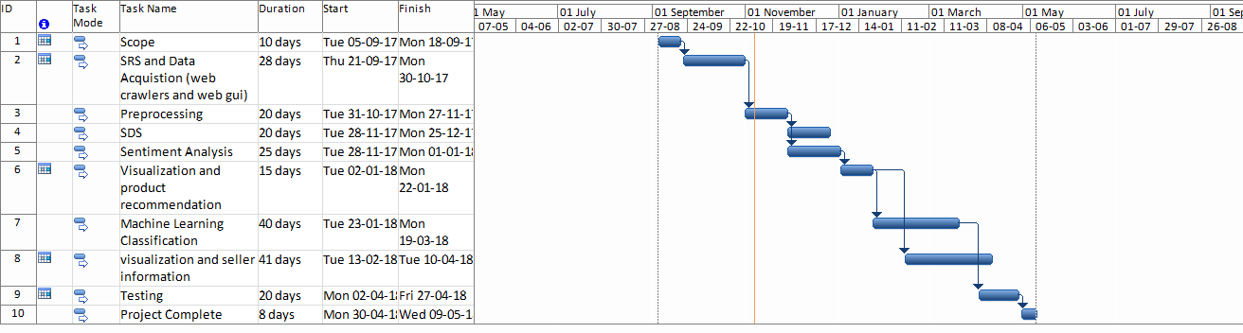

Figure Sample Gantt chart

# Mockups

Insert minimum mockups (Usually 4-6 mockups) which show the major modules mentioned in the scope section of the document. Do not include mockups for Login, Signup, Forgot Password, Contact Us, About Us etc. If the project is a Web or a Smartphone Application, then include at-least three mockups from each part of the project. You can design mockup in any design tool for example pencil tool (<https://pencil.evolus.vn/>) or Balsamiq (<https://balsamiq.com/>)

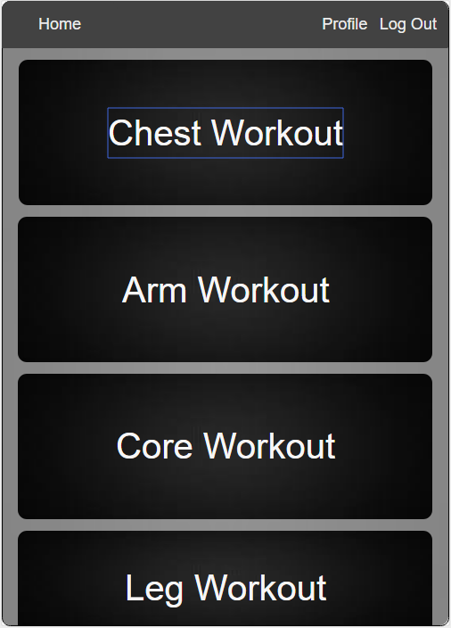

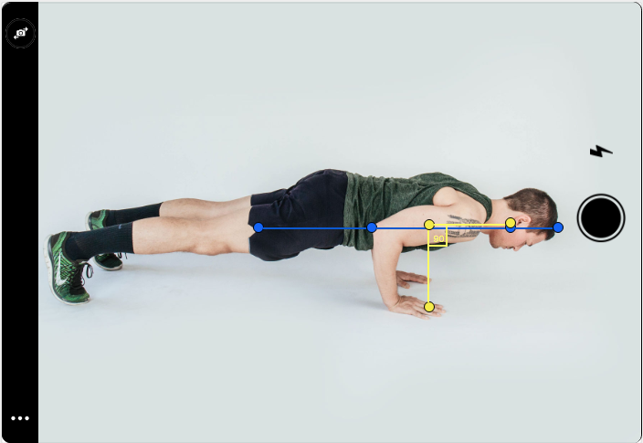

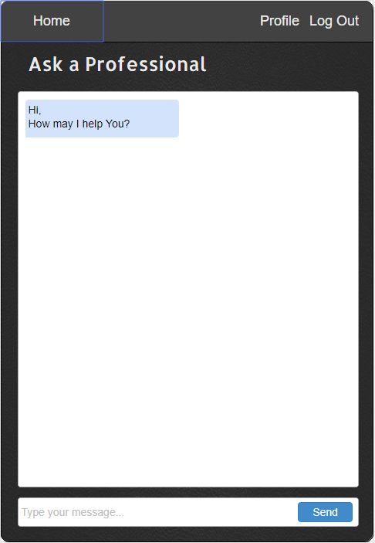

# Conclusion

Conclude this document.(Usually 4-5 sentences)

# References

Mention the books, research papers, web links etc.

https://www.tomsguide.com/us/pictures-story/702-best-workout-apps.html#s4

# Plagiarism Report

Attach the Plagiarism report of your project scope document from library staff of turnitin tool (<http://turnitin.com>)