**MainClient.java**

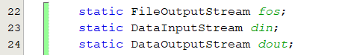Declaring as class variables so we can use them in methods

Main method is performing 2 functions, i.e. connection setup and file receiving.

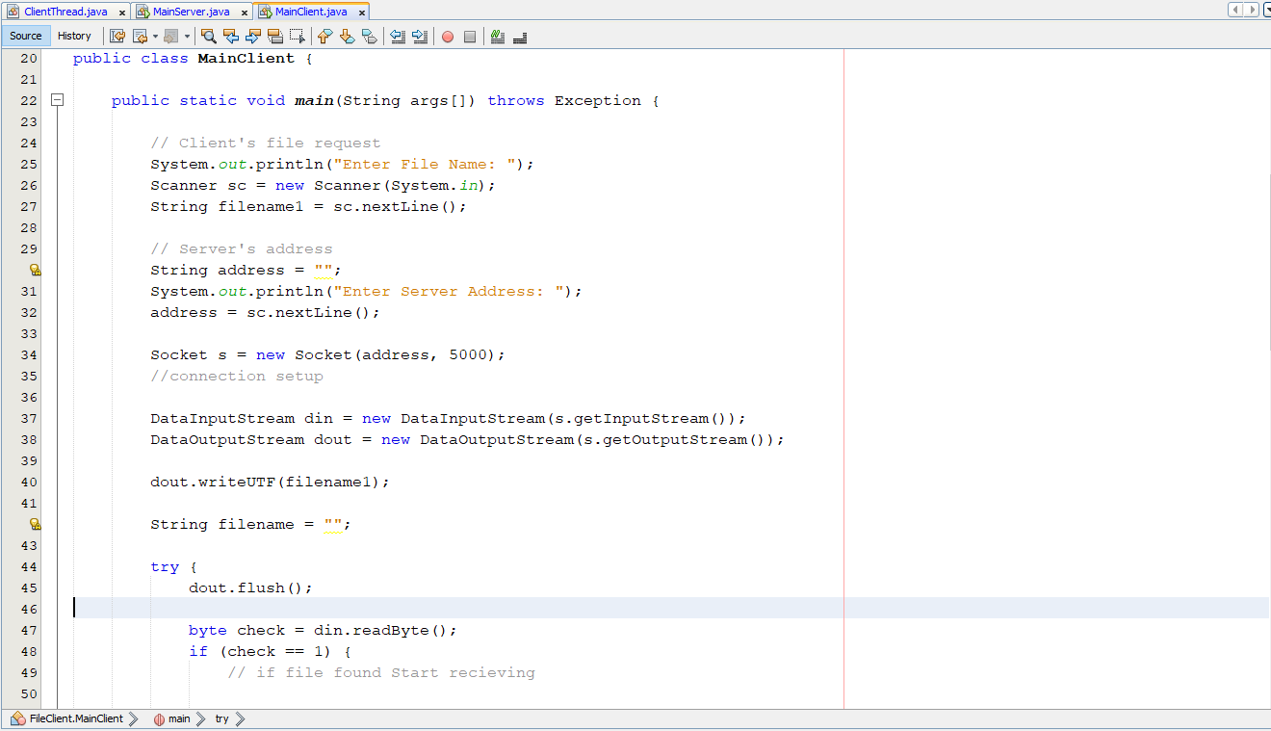

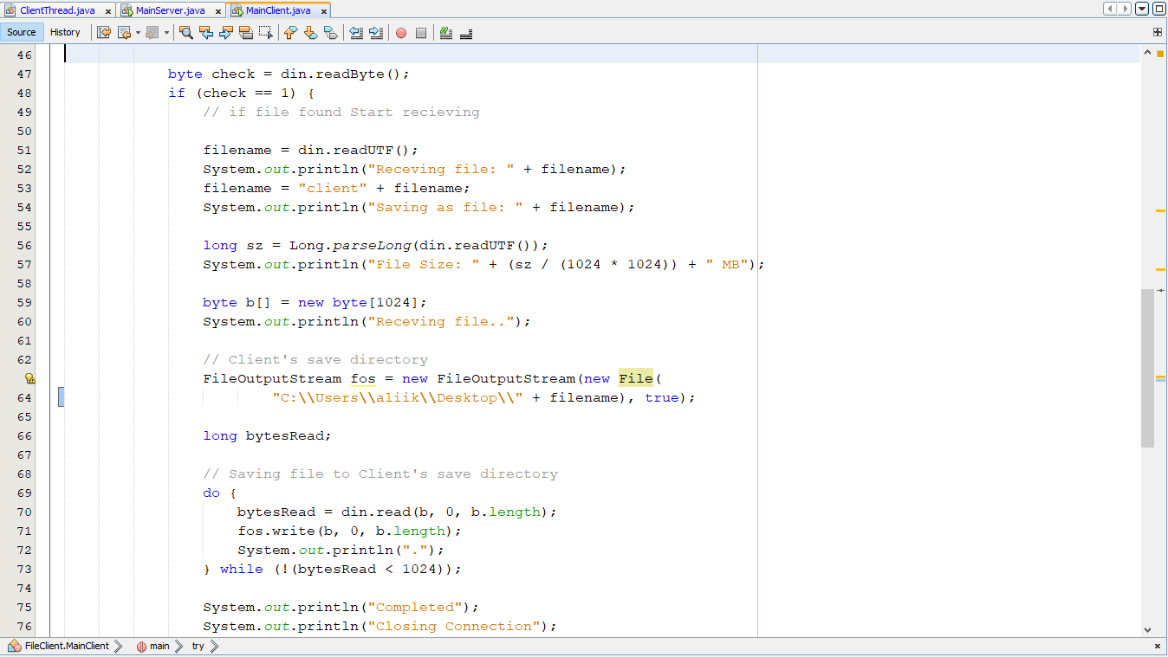

A method ‘startRecieving’ is created to perform the file receiving and is called from main

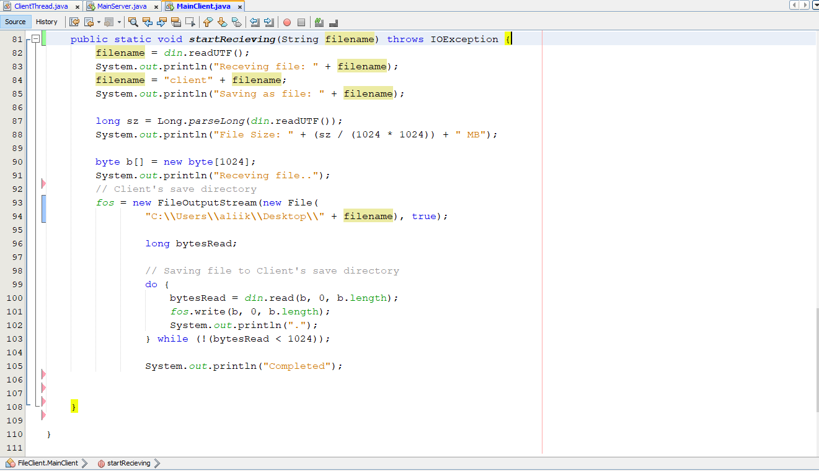

After creating method for receiving the try-catch in main method is not needed

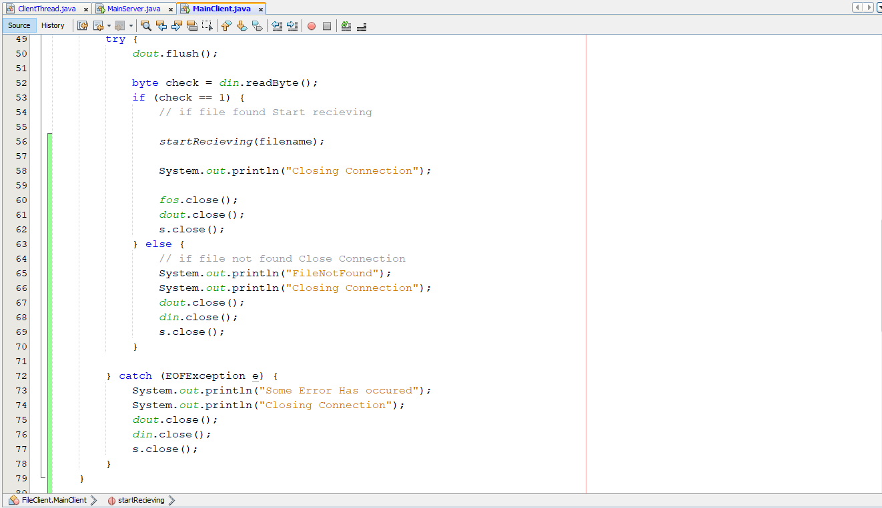

**ClientThread.java**

Variables declared as static to increase scope

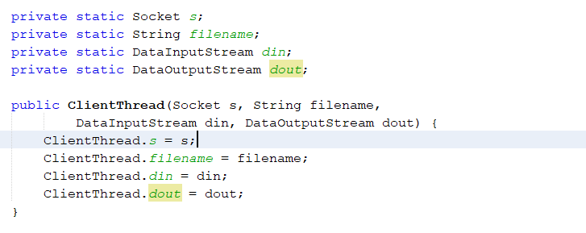

Created a ‘sendFile’ method that would be called from main

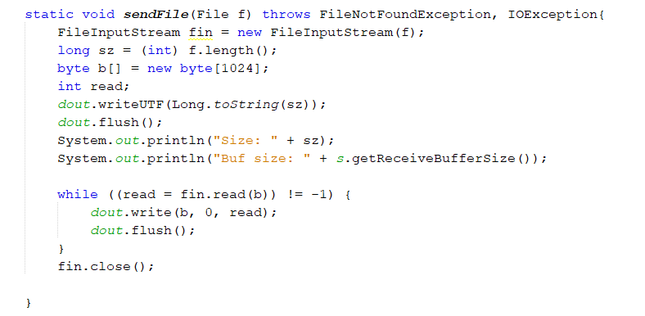

Extra flush statements removed

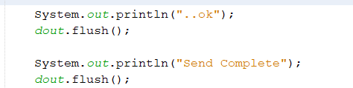

**Variables to be renamed:**

1. **ClientThread.java**

private static Socket s;

private static DataInputStream din;

private static DataOutputStream dout;

File f = new File(filename);

FileInputStream fin = new FileInputStream(f);

long sz = (int) f.length();

byte b[] = new byte[1024];

1. **MainServer.java**

ServerSocket ss = new ServerSocket(5000);

Socket s = null;

DataInputStream din = new DataInputStream(s.getInputStream());

DataOutputStream dout = new DataOutputStream(s.getOutputStream());

Thread ct;

1. **MainClient.java**

static FileOutputStream fos;

static DataInputStream din;

static DataOutputStream dout;

Scanner sc = new Scanner(System.in);

Socket s = new Socket(address, 5000);

long sz = Long.parseLong(din.readUTF());

byte b[] = new byte[1024];

**Variables after rename:**

1. **ClientThread.java**

private static Socket clientSocket;

private static DataInputStream dataIn;

private static DataOutputStream dataOut;

File file = new File(filename);

FileInputStream fileIn = new FileInputStream(file);

long size = (int) file.length();

byte bytes[] = new byte[1024];

1. **MainServer.java**

ServerSocket socket_Server = new ServerSocket(5000);

Socket serverSocket = null;

DataInputStream dataIn = new DataInputStream(serverSocket.getInputStream());

DataOutputStream dataOut = new DataOutputStream(serverSocket.getOutputStream());

Thread clientThread;

1. **MainClient.java**

static FileOutputStream fileOut;

static DataInputStream dataIn;

static DataOutputStream dataOut;

Scanner input = new Scanner(System.in);

Socket clientSocket = new Socket(address, 5000);

long size = Long.parseLong(dataIn.readUTF());

byte bytes[] = new byte[1024];