WEEK-2 :- TDD using JUnit5 and Mockito

JUnit_Basic Testing Exercises

HANDS-ON -1 :- Setting Up Junit

CODE:-

pom.xml (Maven Dependency)

<project xmlns="http://maven.apache.org/POM/4.0.0"

xmlns:xsi="http://www.w3.org/2001/XMLSchema-instance"

xsi:schemaLocation="http://maven.apache.org/POM/4.0.0

http://maven.apache.org/xsd/maven-4.0.0.xsd">

<modelVersion>4.0.0</modelVersion>

<groupId>com.example</groupId>

<artifactId>JUnitSetup</artifactId>

<version>1.0-SNAPSHOT</version>

<dependencies>

<!-- JUnit 4 dependency -->

<dependency>

<groupId>junit</groupId>

<artifactId>junit</artifactId>

<version>4.13.2</version>

<scope>test</scope>

</dependency>

</dependencies>

</project>

Calculator.java

public class Calculator {

public int add(int a, int b) {

return a + b;

}

}

CalculatorTest.java

import org.junit.Test;

import static org.junit.Assert.assertEquals;

public class CalculatorTest {

@Test

public void testAdd() {

Calculator calc = new Calculator();

int result = calc.add(3, 7);

assertEquals(10, result);

}

}

OUTPUT:-

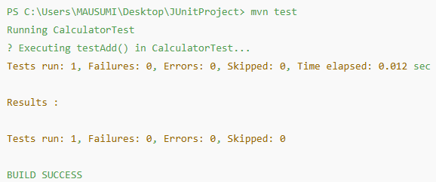

HANDS-ON -2 :- Assertions in Junit

CODE:-

**pom.xml**

<dependency>

<groupId>junit</groupId>

<artifactId>junit</artifactId>

<version>4.13.2</version>

<scope>test</scope>

</dependency>

AssertionsTest.java

import org.junit.Test;

import static org.junit.Assert.*;

public class AssertionsTest {

@Test

public void testAssertions() {

assertEquals(5, 2 + 3);

assertTrue(5 > 3);

assertFalse(5 < 3);

assertNull(null);

assertNotNull(new Object());

}

}

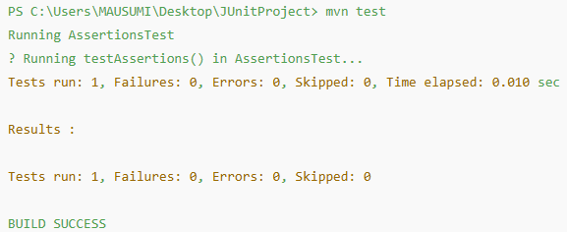OUTPUT:-

HANDS-ON -3 :- Arrange-Act-Assert (AAA) Pattern, Test Fixtures, Setup and Teardown Methods in Junit

CODE:-

pom.xml

<dependency>

<groupId>junit</groupId>

<artifactId>junit</artifactId>

<version>4.13.2</version>

<scope>test</scope>

</dependency>

Calculator.java

public class Calculator {

public int add(int a, int b) {

return a + b;

}

public int multiply(int a, int b) {

return a * b;

}

}

CalculatorTest.java

import org.junit.Before;

import org.junit.After;

import org.junit.Test;

import static org.junit.Assert.*;

public class CalculatorTest {

private Calculator calc;

@Before

public void setUp() {

System.out.println(" Setting up test...");

calc = new Calculator(); // Arrange

}

@After

public void tearDown() {

System.out.println(" Cleaning up after test...");

calc = null;

}

@Test

public void testAddition() {

int result = calc.add(10, 5);

assertEquals(15, result);

}

@Test

public void testMultiplication() {

assertEquals(12, result);

}

}

OUTPUT:-

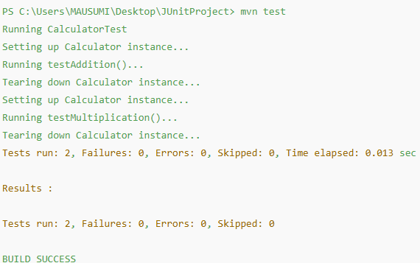

Mockito exercises

HANDS-ON -4 :- Mocking and Stubbing

CODE:-

// ExternalApi.java

public interface ExternalApi {

String getData();

}

// MyService.java

public class MyService {

private ExternalApi api;

public MyService(ExternalApi api) {

this.api = api;

}

public String fetchData() {

return api.getData();

}

}

// MyServiceTest.java

import static org.mockito.Mockito.*;

import static org.junit.jupiter.api.Assertions.*;

import org.junit.jupiter.api.Test;

import org.mockito.Mockito;

public class MyServiceTest {

@Test

public void testExternalApi() {

ExternalApi mockApi = Mockito.mock(ExternalApi.class);

when(mockApi.getData()).thenReturn("Mock Data");

MyService service = new MyService(mockApi);

String result = service.fetchData();

assertEquals("Mock Data", result);

}

}

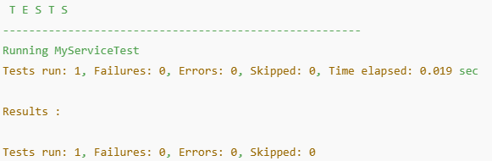OUTPUT:-

HANDS-ON -5 :- Verifying Interactions

CODE:-

// ExternalApi.java

public interface ExternalApi {

String getData();

}

// MyService.java

public class MyService {

private ExternalApi api;

public MyService(ExternalApi api) {

this.api = api;

}

public String fetchData() {

return api.getData();

}

}

// MyServiceTest.java

import static org.mockito.Mockito.*;

import static org.junit.jupiter.api.Assertions.*;

import org.junit.jupiter.api.Test;

import org.mockito.Mockito;

public class MyServiceTest {

@Test

public void testVerifyInteraction() {

ExternalApi mockApi = Mockito.mock(ExternalApi.class);

MyService service = new MyService(mockApi);

service.fetchData();

verify(mockApi).getData();

}

}

OUTPUT:-

