**WEEK–6 :- REACT**

**HANDS-ON- 1 :- Create a React App to Display a Welcome Message**

**CODE:-**

App.js

import React from 'react';

function App() {

return (

<div>

<h1>Welcome to the first session of React</h1>

</div>

);

}

export default App;

Terminal Commands to Run

npm install -g create-react-app

npx create-react-app myfirstreact

cd myfirstreact

code .

npm start

**OUTPUT:-**

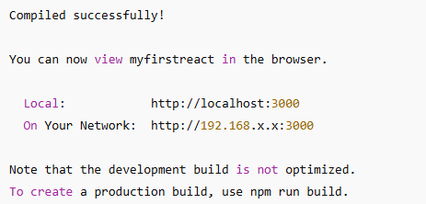

**HANDS-ON- 2:- Creating and Rendering React Class Components**

**CODE:-**

Home.js

import React, { Component } from 'react';

class Home extends Component {

render() {

return (

<div>

<h3>Welcome to the Home Page of Student Management Portal</h3>

</div>

);

}

}

export default Home;

About.js

import React, { Component } from 'react';

class About extends Component {

render() {

return (

<div>

<h3>Welcome to the About Page of Student Management Portal</h3>

</div>

);

}

}

export default About;

Contact.js

import React, { Component } from 'react';

class Contact extends Component {

render() {

return (

<div>

<h3>Welcome to the Contact Page of Student Management Portal</h3>

</div>

);

}

}

export default Contact;

App.js

import logo from './logo.svg';

import './App.css';

import { Home } from './Components/Home';

import { About } from './Components/About';

import { Contact } from './Components/Contact';

function App() {

return (

<div className="container">

<Home />

<About />

<Contact />

</div>

);

}

export default App;

**BROWSER OUTPUT:-**

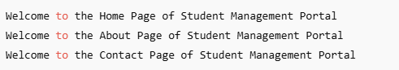

**HANDS-ON- 3:- Create and Render a Functional Component with Styling in React**

**CODE:-**

CalculateScore.js

import '../Stylesheets/mystyle.css';

const percentToDecimal = (decimal) => {

return (decimal.toFixed(2) * 1);

};

const calcScore = (total, goal) => {

return percentToDecimal(total / goal);

};

export const CalculateScore = ({ Name, School, total, goal }) => {

return (

<div className="formatstyle">

<div className="Name">

<b>Name: </b>

<span>{Name}</span>

</div>

<div className="School">

<b>School: </b>

<span>{School}</span>

</div>

<div className="Total">

<b>Total: </b>

<span>{total}</span>

</div>

<div className="Score">

<b>Score: </b>

<span>{calcScore(total, goal)}</span>

</div>

</div>

);

};

App.js

import { CalculateScore } from './Components/CalculateScore';

function App() {

return (

<div>

<CalculateScore

Name={"Stevee"}

School={"DAV Public School"}

total={284}

goal={3}

/>

</div>

);

}

export default App;

**BROWSER OUTPUT:-**

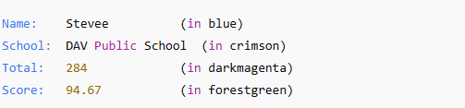

**HANDS-ON- 4:- Implement Component Lifecycle Methods in React using Class Components**

**CODE:-**

Post.js

class Post {

constructor(id, title, body) {

this.id = id;

this.title = title;

this.body = body;

}

}

export default Post;

Posts.js

import React from 'react';

import Post from './Post';

class Posts extends React.Component {

constructor(props) {

super(props);

this.state = {

posts: [],

error: null

};

}

loadPosts() {

fetch('https://jsonplaceholder.typicode.com/posts')

.then(response => response.json())

.then(data => {

const postList = data.slice(0, 5).map(

post => new Post(post.id, post.title, post.body)

);

this.setState({ posts: postList });

})

.catch(err => this.setState({ error: err.message }));

}

componentDidMount() {

this.loadPosts();

}

componentDidCatch(error, info) {

alert('An error occurred: ' + error);

console.error("Error info:", info);

}

render() {

const { posts, error } = this.state;

return (

<div>

<h2>Blog Posts</h2>

{error ? (

<p style={{ color: 'red' }}>{error}</p>

) : (

posts.map(post => (

<div key={post.id}>

<h3>{post.title}</h3>

<p>{post.body}</p>

<hr />

</div>

))

)}

</div>

);

}

}

export default Posts;

App.js

import React from 'react';

import Posts from './Posts';

function App() {

return (

<div>

<Posts />

</div>

);

}

export default App;

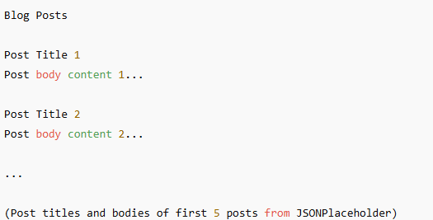**OUTPUT:-**

**HANDS-ON- 5:- Display Cohort Details**

**CODE:-**

CohortDetails.js

import React from "react";

import styles from "./CohortDetails.module.css";

const cohorts = [

{ id: 1, name: "INTADMF10 - .NET FSD", startedOn: "22-Feb-2022", status: "Scheduled", coach: "Aashma", trainer: "Jojo Jose" },

{ id: 2, name: "ADM21JF014 - Java FSD", startedOn: "10-Sep-2021", status: "Ongoing", coach: "Apoorv", trainer: "Elisa Smith" },

{ id: 3, name: "CDBJFI2025 - Java FSD", startedOn: "24-Dec-2021", status: "Completed", coach: "Aashma", trainer: "John Doe" },

];

const CohortDetails = () => (

<div>

<h2>Cohorts Details</h2>

<div style={{ display: "flex", gap: "20px" }}>

{cohorts.map(({ id, name, startedOn, status, coach, trainer }) => (

<div key={id} className={styles.box}>

<h3 style={{ color: status === "Ongoing" ? "green" : "blue" }}>{name}</h3>

<table>

<tbody>

<tr><td>Started On</td><td>{startedOn}</td></tr>

<tr><td>Current Status</td><td>{status}</td></tr>

<tr><td>Coach</td><td>{coach}</td></tr>

<tr><td>Trainer</td><td>{trainer}</td></tr>

</tbody>

</table>

</div>

))}

</div>

</div>

);

export default CohortDetails;

App.js

import React from "react";

import CohortDetails from "./components/CohortDetails";

function App() {

return (

<div className="App">

<CohortDetails />

</div>

);

}

export default App;

index.js

import React from 'react';

import ReactDOM from 'react-dom/client';

import App from './App';

const root = ReactDOM.createRoot(document.getElementById('root'));

root.render(

<React.StrictMode>

<App />

</React.StrictMode>

);

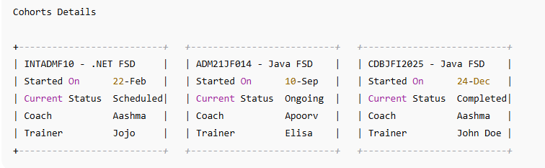**OUTPUT:-**