**WEEK-7 :- REACT**

**HANDS-ON – 1 :- ES6 Features with ReactJS - "cricket app"**

**CODE:-**

ListofPlayers.js

import React from 'react';

const ListofPlayers = () => {

const players = [

{ name: 'Virat Kohli', score: 95 },

{ name: 'Rohit Sharma', score: 88 },

{ name: 'MS Dhoni', score: 72 },

{ name: 'Hardik Pandya', score: 65 },

{ name: 'Rishabh Pant', score: 78 },

{ name: 'KL Rahul', score: 55 },

{ name: 'Shubman Gill', score: 85 },

{ name: 'Jadeja', score: 45 },

{ name: 'Ashwin', score: 76 },

{ name: 'Shami', score: 69 },

{ name: 'Bumrah', score: 91 },

];

const filteredPlayers = players.filter(player => player.score < 70);

return (

<div>

<h2>All Players</h2>

<ul>

{players.map((player, index) => (

<li key={index}>

{player.name} - Score: {player.score}

</li>

))}

</ul>

<h3>Players with Score &lt; 70</h3>

<ul>

{filteredPlayers.map((player, index) => (

<li key={index}>

{player.name} - Score: {player.score}

</li>

))}

</ul>

</div>

);

};

export default ListofPlayers;

IndianPlayers.js

import React from 'react';

const IndianPlayers = () => {

const oddTeam = ['Virat', 'Rohit', 'Dhoni', 'Hardik', 'Pant'];

const evenTeam = ['Gill', 'Jadeja', 'Ashwin', 'Shami', 'Bumrah'];

const [p1, p2, p3, ...restOdd] = oddTeam;

const [e1, e2, e3, ...restEven] = evenTeam;

const T20players = ['Virat', 'Rohit', 'Gill'];

const RanjiTrophy = ['Pujara', 'Rahane', 'Jadeja'];

const mergedPlayers = [...T20players, ...RanjiTrophy];

return (

<div>

<h2>Odd Team Players</h2>

<ul>

<li>{p1}</li>

<li>{p2}</li>

<li>{p3}</li>

{restOdd.map((player, idx) => <li key={idx}>{player}</li>)}

</ul>

<h2>Even Team Players</h2>

<ul>

<li>{e1}</li>

<li>{e2}</li>

<li>{e3}</li>

{restEven.map((player, idx) => <li key={idx}>{player}</li>)}

</ul>

<h2>Merged Players (T20 + Ranji)</h2>

<ul>

{mergedPlayers.map((player, idx) => <li key={idx}>{player}</li>)}

</ul>

</div>

);

};

export default IndianPlayers;

App.js

import React from 'react';

import ListofPlayers from './ListofPlayers';

import IndianPlayers from './IndianPlayers';

const App = () => {

const flag = true; // toggle this to false to change component

return (

<div>

<h1>🏏 Cricket App</h1>

{flag ? <ListofPlayers /> : <IndianPlayers />}

</div>

);

};

export default App;

index.js

import React from 'react';

import ReactDOM from 'react-dom/client';

import App from './App';

const root = ReactDOM.createRoot(document.getElementById('root'));

root.render(<App />);

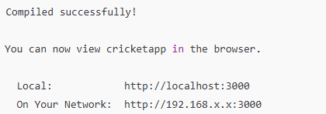**Terminal Output :-**

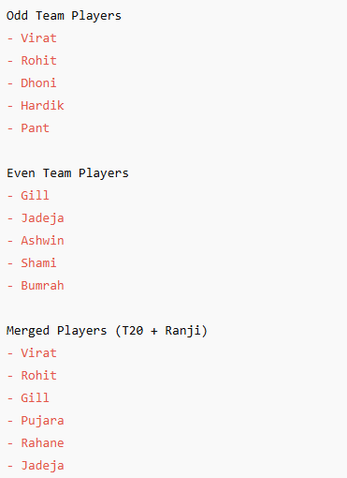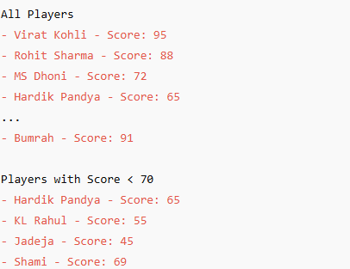**Browser Output (Flag = true)** **Browser Output (Flag = false)**

**HANDS-ON – 2 :- JSX and Inline CSS in Office Rental App**

**CODE:-**

App.js

import React from 'react';

const offices = [

{

name: 'Regus Tower',

rent: 55000,

address: 'MG Road, Bengaluru',

image: 'https://via.placeholder.com/150'

},

{

name: 'WeWork Center',

rent: 75000,

address: 'Koramangala, Bengaluru',

image: 'https://via.placeholder.com/150'

},

{

name: 'IndiQube Vista',

rent: 62000,

address: 'HSR Layout, Bengaluru',

image: 'https://via.placeholder.com/150'

}

];

const App = () => {

return (

<div>

<h1>Office Space Rental</h1>

{offices.map((office, index) => (

<div key={index} style={{ marginBottom: '20px' }}>

<img src={office.image} alt={office.name} width="150" />

<h2>{office.name}</h2>

<p>{office.address}</p>

<p style={{ color: office.rent < 60000 ? 'red' : 'green' }}>

Rent: ₹{office.rent}

</p>

</div>

))}

</div>

);

};

export default App;

index.js

import React from 'react';

import ReactDOM from 'react-dom/client';

import App from './App';

const root = ReactDOM.createRoot(document.getElementById('root'));

root.render(<App />);

**Output :-**

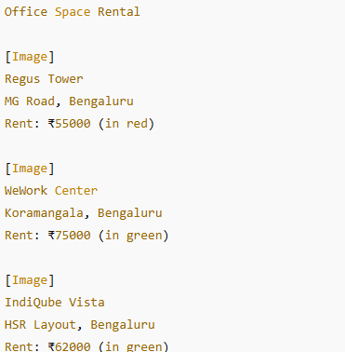

**HANDS-ON – 3 :- React Event Handling and Currency Converter App**

**CODE:-**

App.js

import React, { useState } from 'react';

import CurrencyConvertor from './CurrencyConvertor';

const App = () => {

const [count, setCount] = useState(0);

const increment = () => {

setCount(prev => prev + 1);

sayHello();

};

const decrement = () => {

setCount(prev => prev - 1);

};

const sayHello = () => {

console.log('Hello! You clicked Increment.');

};

const sayWelcome = (msg) => {

alert(msg);

};

const handleClick = (e) => {

alert('I was clicked');

console.log(e); // SyntheticEvent object

};

return (

<div>

<h1>React Event Examples</h1>

<h2>Counter: {count}</h2>

<button onClick={increment}>Increment</button>

<button onClick={decrement}>Decrement</button>

<br /><br />

<button onClick={() => sayWelcome("Welcome to the Event App!")}>Say Welcome</button>

<br /><br />

<button onClick={handleClick}>OnPress</button>

<br /><br />

<CurrencyConvertor />

</div>

);

};

export default App;

CurrencyConvertor.js

import React, { useState } from 'react';

const CurrencyConvertor = () => {

const [rupees, setRupees] = useState('');

const [euros, setEuros] = useState('');

const handleSubmit = () => {

const euro = parseFloat(rupees) / 90;

setEuros(euro.toFixed(2));

};

return (

<div>

<h2>Currency Convertor</h2>

<input

type="number"

placeholder="Enter Rupees"

value={rupees}

onChange={(e) => setRupees(e.target.value)}

<button onClick={handleSubmit}>Convert</button>

{euros && <p>Euros: €{euros}</p>}

</div>

);

};

export default CurrencyConvertor;

index.js

import React from 'react';

import ReactDOM from 'react-dom/client';

import App from './App';

const root = ReactDOM.createRoot(document.getElementById('root'));

root.render(<App />);

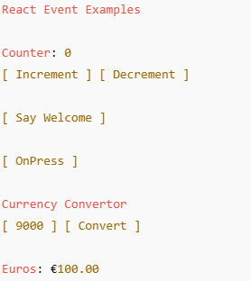**OUTPUT :-**

**HANDS-ON – 4 :- Conditional Rendering in Ticket Booking App**

**CODE:-**

App.js

import React, { useState } from 'react';

const GuestPage = () => (

<div>

<h2>Welcome Guest</h2>

<p>Browse Flights</p>

<ul>

<li>✈️ Delhi → Mumbai</li>

<li>✈️ Bengaluru → Kolkata</li>

<li>✈️ Chennai → Goa</li>

</ul>

</div>

);

const UserPage = () => (

<div>

<h2>Welcome User</h2>

<p>You can now book tickets!</p>

<ul>

<li>Booking: Delhi → Mumbai</li>

<li>Booking: Bengaluru → Kolkata</li>

<li>Booking: Chennai → Goa</li>

</ul>

</div>

);

const App = () => {

const [loggedIn, setLoggedIn] = useState(false);

const toggleLogin = () => setLoggedIn(!loggedIn);

return (

<div>

<h1>Ticket Booking App</h1>

<button onClick={toggleLogin}>

{loggedIn ? 'Logout' : 'Login'}

</button>

{loggedIn ? <UserPage /> : <GuestPage />}

</div>

);

};

export default App;

index.js

import React from 'react';

import ReactDOM from 'react-dom/client';

import App from './App';

const root = ReactDOM.createRoot(document.getElementById('root'));

root.render(<App />);

**OUTPUT :-**

**BEFORE LOGIN**

**AFTER LOGIN**

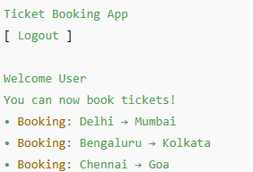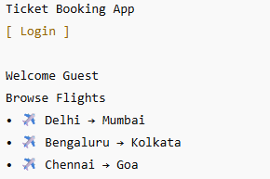

**HANDS-ON – 5 :- Conditional Rendering in Ticket Booking App**

**CODE:-**

App.js

import React, { useState } from 'react';

import BookDetails from './BookDetails';

import BlogDetails from './BlogDetails';

import CourseDetails from './CourseDetails';

const App = () => {

const [section, setSection] = useState('book');

let content;

if (section === 'book') {

content = <BookDetails />;

} else if (section === 'blog') {

content = <BlogDetails />;

} else {

content = <CourseDetails />;

}

return (

<div>

<h1>Blogger App</h1>

<button onClick={() => setSection('book')}>Book</button>

<button onClick={() => setSection('blog')}>Blog</button>

<button onClick={() => setSection('course')}>Course</button>

<hr />

{content}

</div>

);

};

export default App;

BookDetails.js

import React from 'react';

const books = [

{ id: 1, title: 'Atomic Habits', author: 'James Clear' },

{ id: 2, title: 'Deep Work', author: 'Cal Newport' }

];

const BookDetails = () => (

<div>

<h2>Book Details</h2>

<ul>

{books.map(book => (

<li key={book.id}>{book.title} - {book.author}</li>

))}

</ul>

</div>

);

export default BookDetails;

BlogDetails.js

import React from 'react';

const blogs = [

{ id: 1, title: 'React Basics', author: 'John Doe' },

{ id: 2, title: 'JSX Deep Dive', author: 'Jane Smith' }

];

const BlogDetails = () => (

<div>

<h2>Blog Details</h2>

<ul>

{blogs.map(blog => (

<li key={blog.id}>{blog.title} - {blog.author}</li>

))}

</ul>

</div>

);

export default BlogDetails;

CourseDetails.js

import React from 'react';

const courses = [

{ id: 1, title: 'ReactJS', duration: '6 weeks' },

{ id: 2, title: 'Node.js', duration: '4 weeks' }

];

const CourseDetails = () => (

<div>

<h2>Course Details</h2>

<ul>

{courses.map(course => (

<li key={course.id}>{course.title} - {course.duration}</li>

))}

</ul>

</div>

);

export default CourseDetails;

**OUTPUT :-**

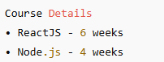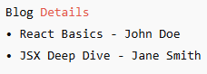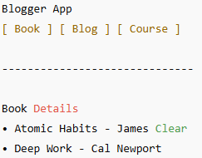

After clicking [Course]

After clicking [Blog]

Book section