PENETRATION TESTING REPORT
FOOTPRINTING & NETWORK SCANNING PHASES
W2-PM-FINAL | CYBERSECURITY | NETWORKWALKS

Pentester Name  (Cybersecurity Professional) | Mavani Dharm
Program/Batch | B084-Networkwalks
Date | 09 November 2026
Modules completed | W2-PM1 (Multiple Kali Tools)  W2-PM5 (Zenmap Scanning)
Client/Target | 1. Networkwalks (secured written permission already)  2. My own local network (VirtualBox Host-Only subnet on my Windows PC)
Permission secured from client? | Yes
Phases covered | Phase 1: Reconnaissance & Footprinting  Phase 2: Scanning & Network Discovery  Phase 3-5: In Progress

1. Liability Disclaimer
I have performed these activities only on the systems & devices where I had secured written permission or the devices/systems that I own myself. All these materials are for education and research purpose only. Do not use anything from here to break the law. The instructor, the authors and Networkwalks are not responsible for what you do with this knowledge. Every action you take is your own responsibility. Misuse can lead to criminal charges, heavy fines, loss of your job and a permanent record. In most countries unauthorised access is a crime even when nothing is damaged.

2. Introduction
This report covers footprinting the networkwalks.com domain using multiple Kali Linux tools (W2-PM1) and scanning my own local network with Zenmap (W2-PM5). One module covers the footprinting phase and the other covers the scanning phase, so together they show how an attacker moves from gathering public information to mapping live hosts on a network. It is the Week 2 part of my Cybersecurity program at Networkwalks.
All footprinting commands were run in a Kali Linux virtual machine (Oracle VirtualBox), and the scan was run on my Windows PC with Zenmap installed. Every step below includes the exact command used, the result I observed, a screenshot as evidence, and a short note on why the finding matters from an attacker's point of view.

3. Tools Used
The table below lists each tool used in this report and its purpose.
Tool | Purpose
Kali Linux & Windows | Operating systems used for reconnaissance activities
WHOIS | Find domain registration details (owner, dates, name servers).
whatweb | Fingerprint web technologies (server, CMS, plugins, IP).
nslookup | Resolve the domain name to its IP address using DNS.
curl -I | Read the HTTP response headers of the website.
wafw00f | Detect whether a Web Application Firewall protects the site.
dnsrecon | Enumerate all DNS records (NS, MX, SPF, TXT, SRV).
Zenmap (Nmap GUI) | Scan the local subnet to find live hosts, IPs and MAC addresses.
Windows CMD | Local IP and MAC address identification

4. Activities Performed

4.1 Footprinting & Reconnaissance

I performed reconnaissance against the networkwalks.com domain on 9 November 2026 using six Kali Linux tools: WHOIS, WhatWeb, Nslookup, Curl, Wafw00f and DNSRecon. Each tool collects a different type of information about the target, and none of them attempts to exploit anything.
First, I ran whois networkwalks.com to get the public WHOIS record. The domain is registered with GoDaddy.com, LLC, was created on 6 November 2019 and is registered until 6 November 2027. The name servers are NS6135.HOSTGATOR.COM and NS6136.HOSTGATOR.COM, which shows that the website is hosted with HostGator. DNSSEC is shown as unsigned, and the four client lock statuses (delete, renew, transfer and update prohibited) are set, which protects the domain against accidental or unauthorised changes. No personal registrant details were visible in the output.
I then ran whatweb networkwalks.com. The HTTP address redirected (301 Moved Permanently) to HTTPS, and the HTTPS site answered 200 OK. WhatWeb identified Apache as the web server, WordPress 7.1.4 as the CMS and the WordPress Download Manager 3.3.76 plugin, together with jQuery 3.7.1, HTML5 and Google Tag Manager. It also exposed the e-mail address info@networkwalks.com, the page title “Networkwalks Academy”, a cookie named __wpdm_client and the server IP address 192.232.216.135.
Using nslookup networkwalks.com, I resolved the domain through my network’s DNS server (10.49.34.151). The answer was non-authoritative and returned the IPv4 address 192.232.216.135. A second address, 64:ff9b::c0e8:d887, was also returned. It belongs to the 64:ff9b::/96 NAT64 range and simply encodes the same IPv4 address, so it was most likely created by my network’s DNS64 and is not a real IPv6 record of the website.
I used Curl with the -I option (curl -I https://networkwalks.com) to read only the HTTP response headers. The site answered HTTP/2 200 and identified itself as Apache. The Link header publicly points to the WordPress REST API (/wp-json/) and to a page endpoint (/wp-json/wp/v2/pages/53). The response also showed a __wpdm_client cookie (with the Secure and HttpOnly flags), the headers x-nginx-cache and x-endurance-cache-level, which reveal the caching layer, and a Referrer-Policy header. I did not see Strict-Transport-Security, X-Frame-Options, X-Content-Type-Options or Content-Security-Policy headers in this output.
Next, I ran wafw00f networkwalks.com to check whether a Web Application Firewall protects the website. After 2 requests, the tool reported that the site is behind the ModSecurity (SpiderLabs) WAF. I ran it twice and got the same result both times.
Finally, I ran dnsrecon -d networkwalks.com to enumerate DNS records. Two errors appeared first (no answer to the DNSSEC query, and a timeout while resolving the SOA record through my resolver), but the enumeration continued and returned: the name servers ns6135.hostgator.com and ns6136.hostgator.com, which both disclosed their BIND version 9.16.23-RH; the mail server mail.networkwalks.com (192.232.216.135); the A and AAAA records of the domain; a Google site-verification TXT record; an SPF record (v=spf1 +a +mx +ip4:50.87.144.87 +include:websitewelcome.com ~all); and several _autodiscover SRV records pointing to cpanelemaildiscovery.cpanel.net.

4.2 Network Scanning with Zenmap
For the second activity, I used Zenmap to perform network discovery on my local network. The practical required me to identify my local IP address and subnet, discover live hosts, identify their IP and MAC addresses, and generate a network topology.
I first ran ipconfig in the Windows Command Prompt to check my network adapters. The VirtualBox host-only Ethernet adapter has the IPv4 address 192.168.56.1 with subnet mask 255.255.255.0, so its subnet is 192.168.56.0/24. My Wi-Fi adapter has the address 10.49.34.210 and uses 10.49.34.151 as its gateway. I entered 192.168.56.0/24 as the target in Zenmap and selected the Ping scan profile, which runs nmap -sn 192.168.56.0/24.
The scan (Nmap 7.993, run on 9 November 2026 at 13:25) checked 256 IP addresses in 11.56 seconds and found 1 live host and 255 hosts down. The live host is:
- 192.168.56.1
This live host is my own Windows PC (its VirtualBox host-only adapter), so Nmap does not list a MAC address for it, because MAC addresses are only shown for other devices on the same local network. No other device responded in this subnet, so there are no additional IP or MAC addresses to report.
After the scan, I opened the Topology tab in Zenmap and enabled the legend. The topology shows the single host 192.168.56.1 connected to localhost as a green node (the legend’s colour for hosts with fewer than 3 open ports; no port scan was run).
Note: This was a ping scan (-sn) only. It checks which hosts are alive and does not scan ports or detect services.

5. Risk Analysis / Impact
Based on the information collected during the footprinting and network scanning activities, I identified the following potential risks.
# | Risk / Finding | Evidence / Observation | Potential Impact | Risk Level
1 | Web technology information exposed | WhatWeb identified WordPress 7.1.4 and WP Download Manager 3.3.76 | Attackers may use exposed technology/version information to identify software requiring further security review | ● Medium
2 | Server IP address identifiable | Nslookup resolved the domain to 192.232.216.135 | Provides information about the network location of the web service | ● Low
3 | HTTP technical information exposed | Curl returned headers exposing /wp-json/ and caching details; HSTS, CSP and X-Frame-Options were not seen | May assist technology fingerprinting; missing security headers reduce browser-side protection | ● Low
4 | WAF technology identifiable | Wafw00f identified ModSecurity (SpiderLabs) | Reveals information about the web application’s security architecture | ● Low
5 | DNS infrastructure information exposed | DNSRecon found DNS, mail, SPF and SRV records and the BIND version 9.16.23-RH | DNS software versions and records help build a broader infrastructure profile | ● Medium
6 | Live host visible on local (host-only) network | Zenmap found only 192.168.56.1 (my own PC) alive in 192.168.56.0/24 | No unknown devices were found, but a ping scan quickly shows any device that joins the network | ● Low

Risk level key: ● Critical ● Medium ● Low
The risks above are observations from the footprinting and scanning exercises, not confirmed vulnerabilities.
The practical exercises primarily involved information gathering and host discovery. No exploitation or vulnerability validation was performed as part of these two modules.
Therefore, the presence of information such as a software version, IP address or DNS record does not by itself mean that the system is vulnerable. Further authorized security testing would be required to confirm any actual vulnerability.

6. Recommendations
Based on the observations from these activities, I recommend the following security improvements:
- Review publicly exposed technology information
Organizations should regularly review what information about their web technologies, CMS and plugins is publicly visible.
- Keep software updated
CMS platforms, plugins and other web technologies should be regularly updated and reviewed against current security advisories.
- Review HTTP headers
HTTP response headers should be reviewed to determine whether unnecessary technical information is being exposed, and security headers such as HSTS, X-Frame-Options, X-Content-Type-Options and Content-Security-Policy should be considered.
- Review DNS records regularly
DNS records should be checked periodically to ensure that only required information and services are publicly exposed. DNS software version details (such as the BIND version) should not be disclosed.
- Properly configure and monitor the WAF
Keep the WAF (ModSecurity) enabled and tuned, since it already blocks naive attacks.
- Perform regular internal network discovery
Organizations should periodically scan their own networks to identify active devices.
- Investigate unknown devices
Any unexpected device discovered during network scanning should be investigated and verified.
- Maintain network documentation
Network topology and device information should be documented and updated regularly.
- Perform security testing with authorization
Reconnaissance and scanning should only be performed against systems and networks where appropriate authorization has been provided.

7. Conclusion
During Week 2 of my Cybersecurity & Ethical Hacking program at Networkwalks, I completed practical activities covering footprinting, reconnaissance and network scanning.
In the footprinting activity, I used six Kali Linux tools to collect information about the target domain. I learned how WHOIS can provide domain information, WhatWeb can identify web technologies, Nslookup can resolve domain names, Curl can inspect HTTP headers, Wafw00f can identify a WAF, and DNSRecon can provide additional DNS information.
In the network scanning activity, I used Zenmap to identify my local subnet (192.168.56.0/24), run a ping scan, find the one live host on it and view it in the network topology.
The exercises showed me that information gathering is an important part of cybersecurity. Even before attempting to exploit a system, a security professional can learn a significant amount about an environment by carefully analyzing publicly available information and network responses.
I also learned that technical findings should be documented clearly. A good cybersecurity report should explain what was performed, what was discovered, what the observation means, what risk it may create, and what can be done to reduce that risk.
Finally, I learned that reconnaissance and scanning must always be performed within an authorized scope. These activities were completed as part of the assigned educational cybersecurity lab.

8. Evidences Collected

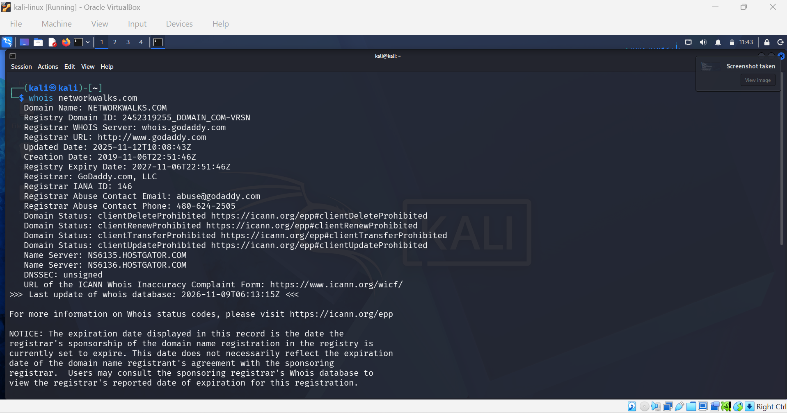
Figure 1: WHOIS lookup of networkwalks.com

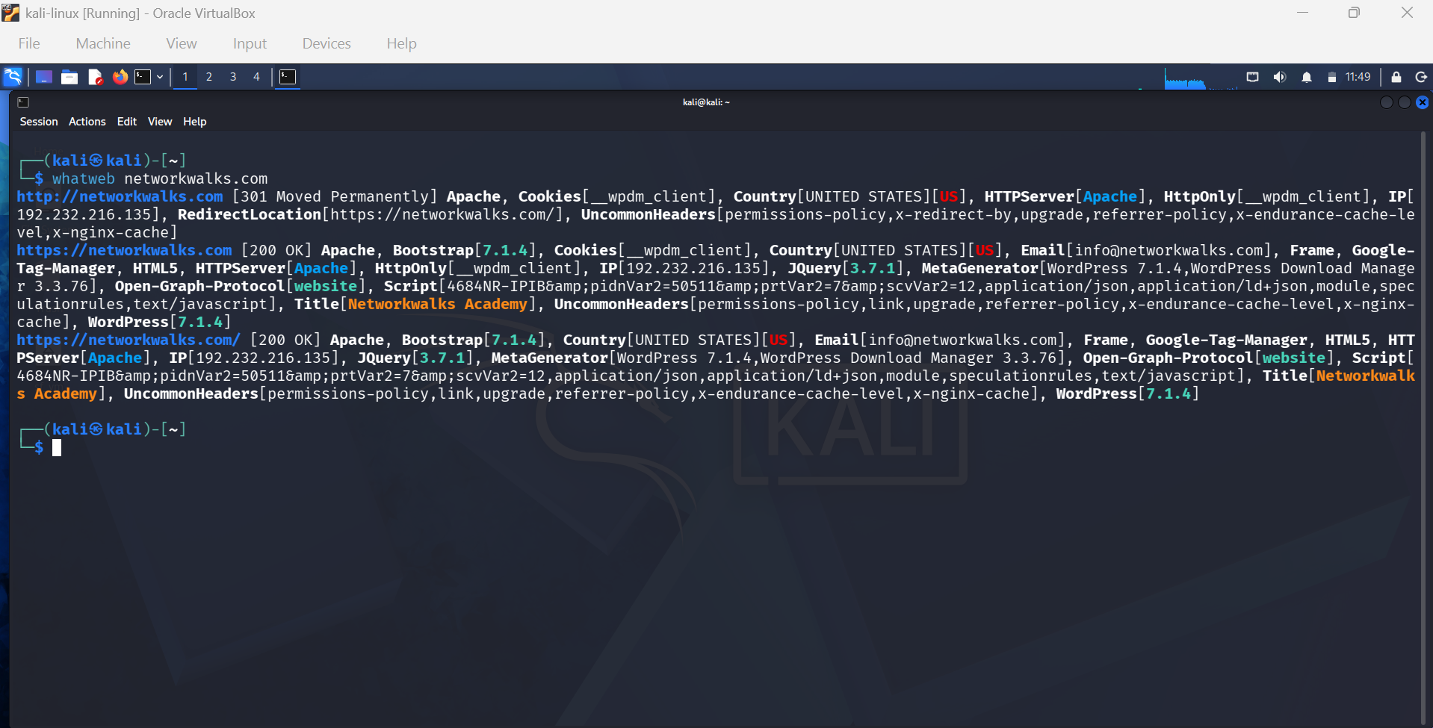
Figure 2: WhatWeb fingerprint of networkwalks.com

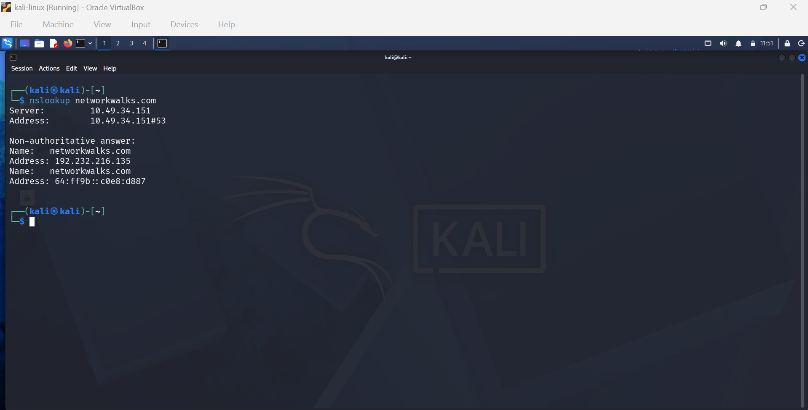
Figure 3: Nslookup DNS resolution of networkwalks.com

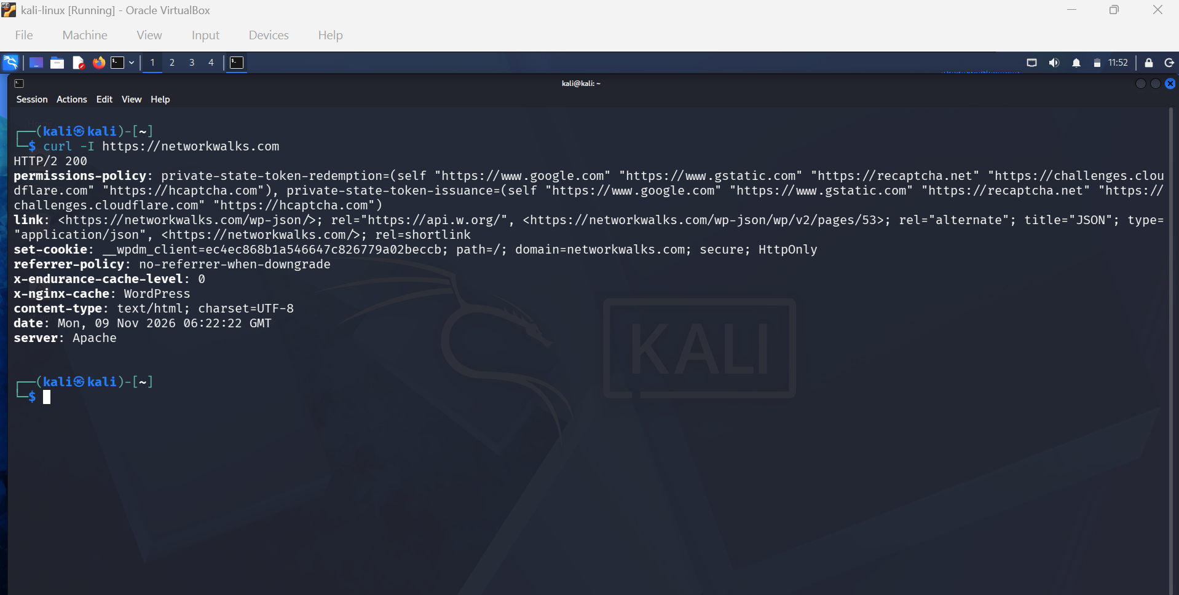
Figure 4: HTTP response headers (curl -I)
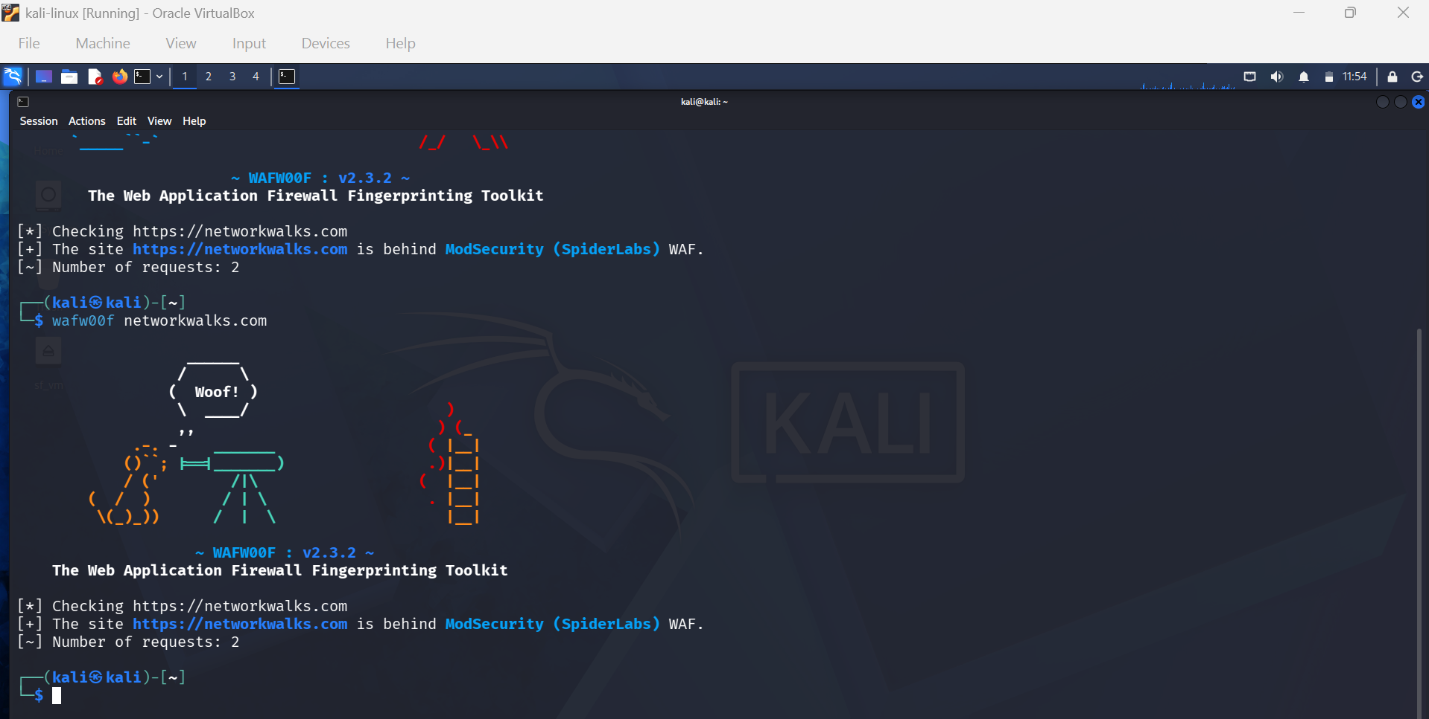
Figure 5: Wafw00f Web Application Firewall detection

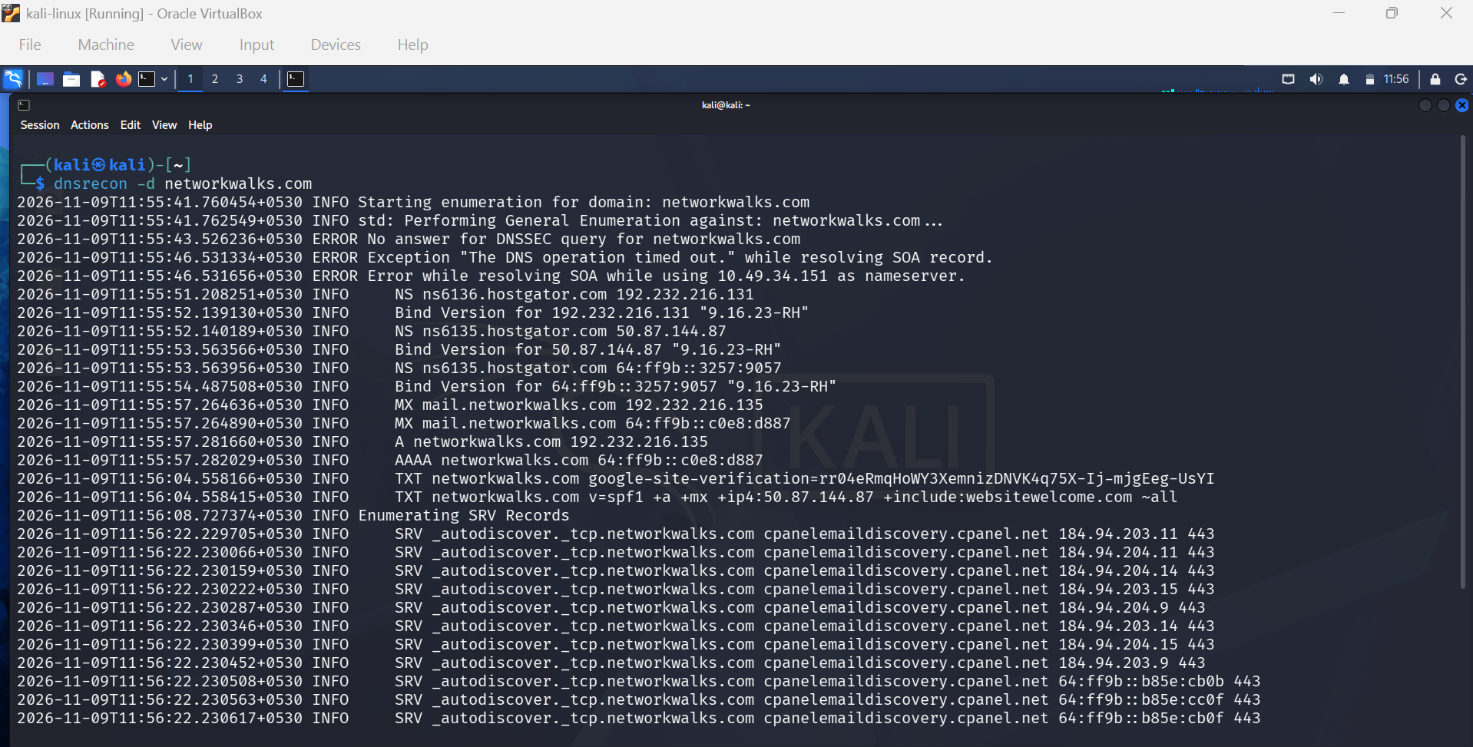
Figure 6: DNSRecon DNS enumeration
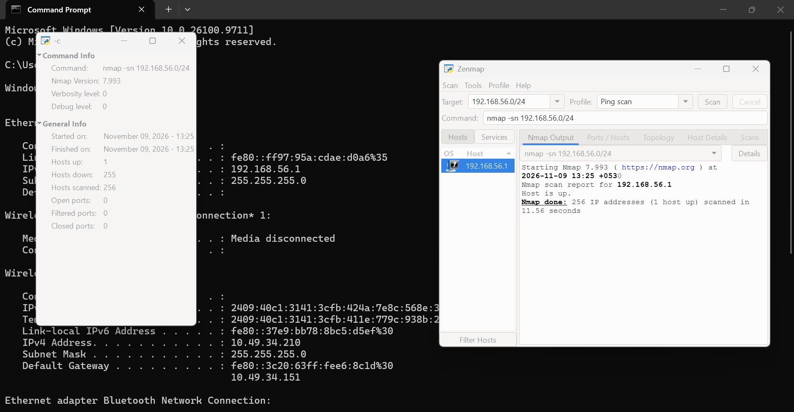
Figure 7: Windows ipconfig and Zenmap ping scan of 192.168.56.0/24
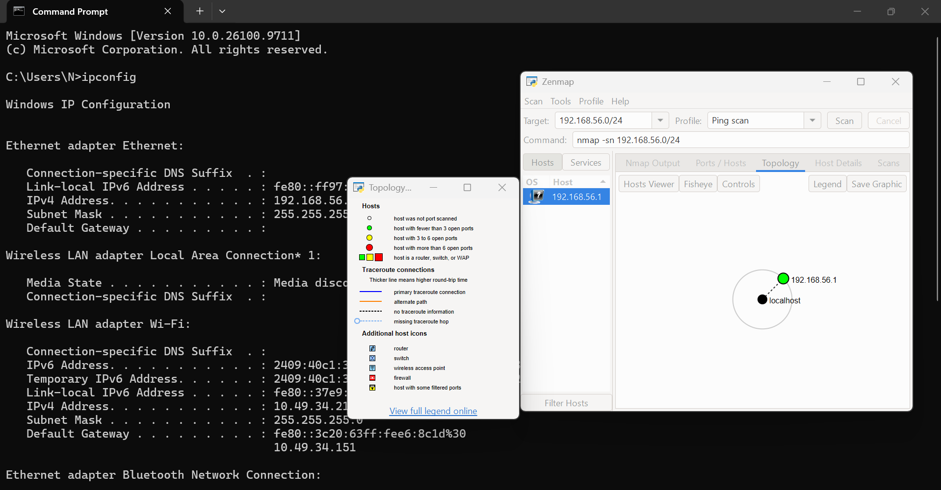
Figure 8: Zenmap Topology tab with the legend
-End-

👤 Author
Mavani Dharm
Cybersecurity Student B084
LinkedIn: https://www.linkedin.com/in/dharm-mavani-075525344

📌 Project Information
Program Name: Cybersecurity program at Networkwalks | Week: 02 | Repository: GitHub

