**The British College**

**KATHMANDU**

**Coursework Submission Coversheet**(individual coursework only)

**Faculty of Arts, Environment and Technology LBU Student Id:**

77261075

**For checking by the student:**

Please ensure all information is complete and correct and attach this form securely to the front of your work before posting it in a coursework collection box.

Award name: Bsc Hons in Computing

Module code: [15781 - AUT - 202210](https://my.leedsbeckett.ac.uk/webapps/blackboard/execute/courseMain?course_id=_157454_1)

Module name: Advance Database System (ADS)

Module run: 2022

Coursework title: Data warehouse Design and Development

Due Date:

Module leader: (In LBU): Jackie Campbell, Sanela Lazarevski

Module tutor: (In TBC): Dibya Tara Shakya

**TURNITIN** Checked: YES NO ***(please circle)***

Submission date& time: Date: Time: Before noon

**Total Word Count: Total Number of Pages (including this front sheet):**

**In submitting this form with your assignment, you make the following declaration:**  
I declare, that the coursework submitted is my own work and has not (either in whole or part) been submitted towards the award of any other qualification either at LBU or elsewhere. I have fully attributed/referenced all sources of information used during the completion of my assignment, and I am aware that failure to do so constitutes an assessment offence.

Signed: Mavira Bhattarai Date: <Submitted Date>

**You are strongly advised to retain a second copy of your work in case of any query about the assignment.**

**For completion by the faculty:**

**This mark is provisional and subject to moderation and approval by the relevant examining board**

**Teacher's Feedback**

**Teacher's Signature: __________________________________ Date: _________________**

Contents

Task 2: Take your design and code further by using PL/SQL techniques 3

Identify, code, test a function, procedure and package to support the ETL task. 3

1. Overview of PL/SQL 3

2. Aspects of PL/SQL: 3

1. Creating Packages for PL/SQL 3

For Staging Tables 4

For Bad Stage Tables 6

For Recleaning Data 10

For transform table 13

FOR DIM_TIME 15

2. Inserting from data source PRCS 17

a) Insert into stage table 17

# Task 2: Take your design and code further by using PL/SQL techniques

## Identify, code, test a function, procedure and package to support the ETL task.

### Overview of PL/SQL

Programmers can combine the features of SQL with procedural statements by using PL/SQL, a block structured language. All of a block's assertions are submitted at once to the Oracle engine, which speeds up processing and lowers bandwidth. By using SQL and PL/procedural SQL's approach, you may instruct the compiler on both "what to do" and "how to do it." Similar to other database languages, it makes use of loops, conditions, and object-oriented concepts to provide programmers more control. The full name of PL/SQL is "Procedural Language extensions to SQL".

### Aspects of PL/SQL:

1. PL/SQL, in general, is a procedural language that provides decision-making, iteration, and many other features typical of procedural programming languages.
2. Multiple queries can be run in a block using a single PL/SQL query.
3. PL/SQL units like as procedures, functions, packages, triggers, and types can be developed and saved in the database for later usage by applications.
4. The PL/SQL feature known as the exception handling block enables you to handle exceptions that occur inside PL/SQL blocks.
5. PL/SQL applications can run on any piece of hardware or operating system that supports Oracle.
6. PL/SQL has comprehensive error checking.

# 1. Creating Packages for PL/SQL

All the procedures are kept inside packages

## For Staging Tables

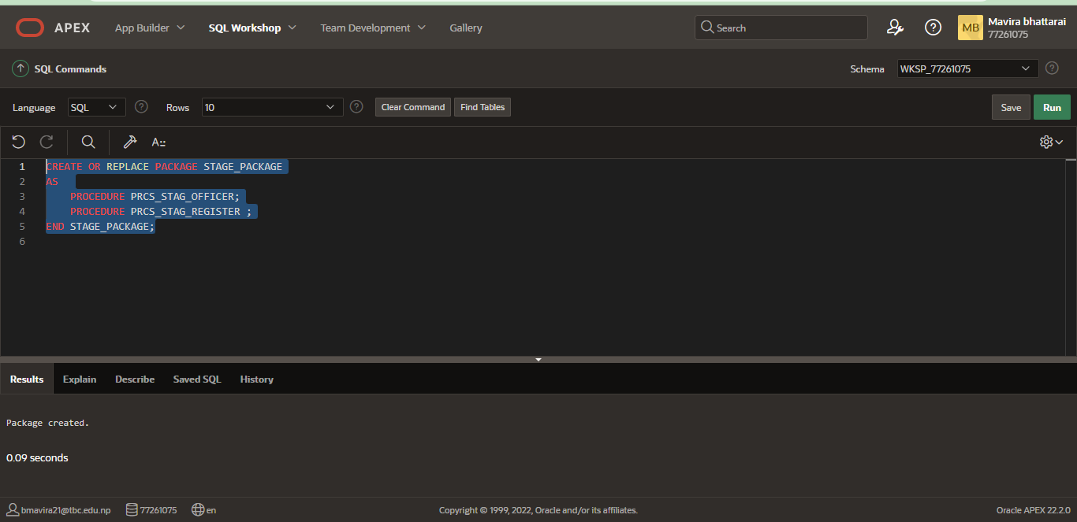

Figure: Creating Package

A Package is created for procedures used for staging Table.

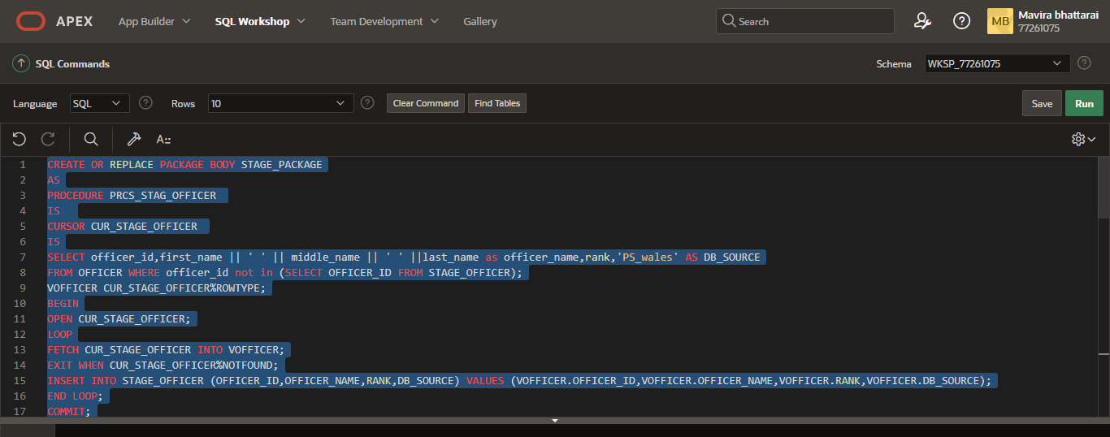

Figure: Making Procedure for STAGE_OFFICER

A procedure PRCS_STAG_OFFICER is created to insert all the data of officer from OFFICER table of PS_wales Data Source

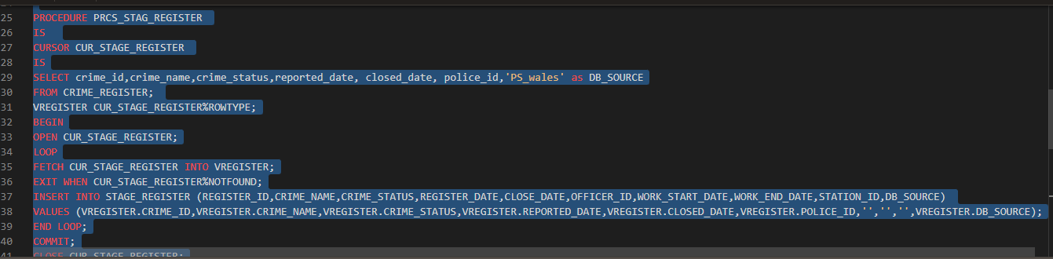

Figure: Making Procedure for STAGE_REGISTER

A procedure PRCS_STAG_REGISTER is created to insert all the data of officer from CRIME_REGISTER of PS_wales Data Source

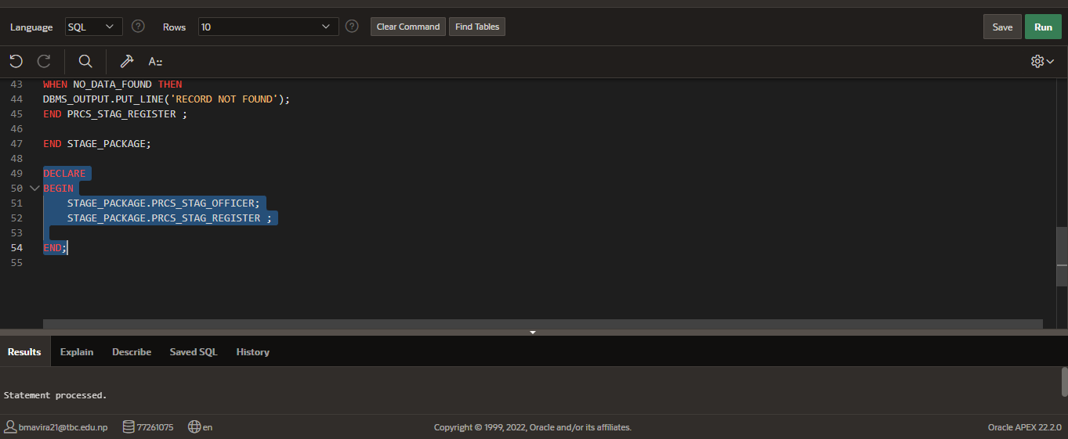

Figure: DECLARING AND RUNNING PACKAGE

The package is declared and run.

## For Bad Stage Tables

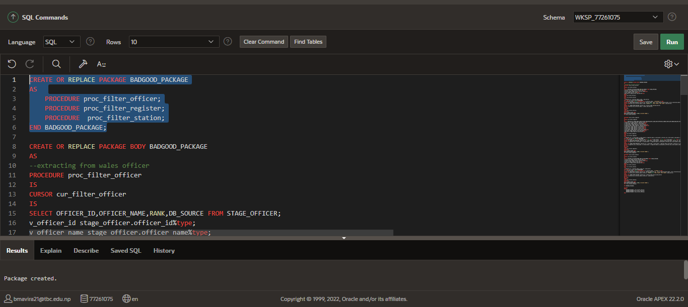

Figure: CREATING PACKAGE FOR BAD GOOD TABLE

A package is created where att the procedures made for inserting data into bad and good tables are kept.

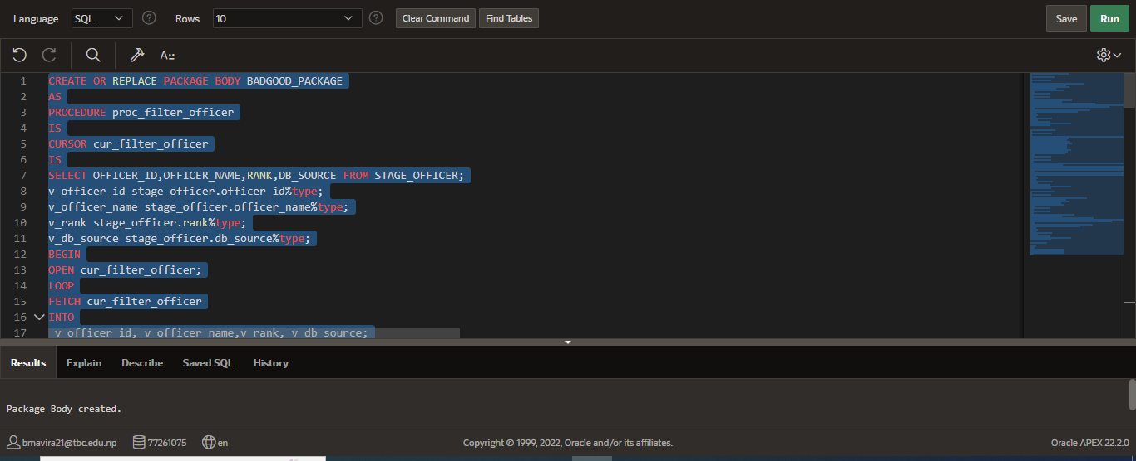Figure: Making Procedure for GOOD_STAGE_OFFICER AND BAD_STAGE_OFFICER

A Procedure proc_filter_officer is made for inserting all the data of officer from STAGE_OFFICER. The bulk insert is done using cursor cur_filter_officer.

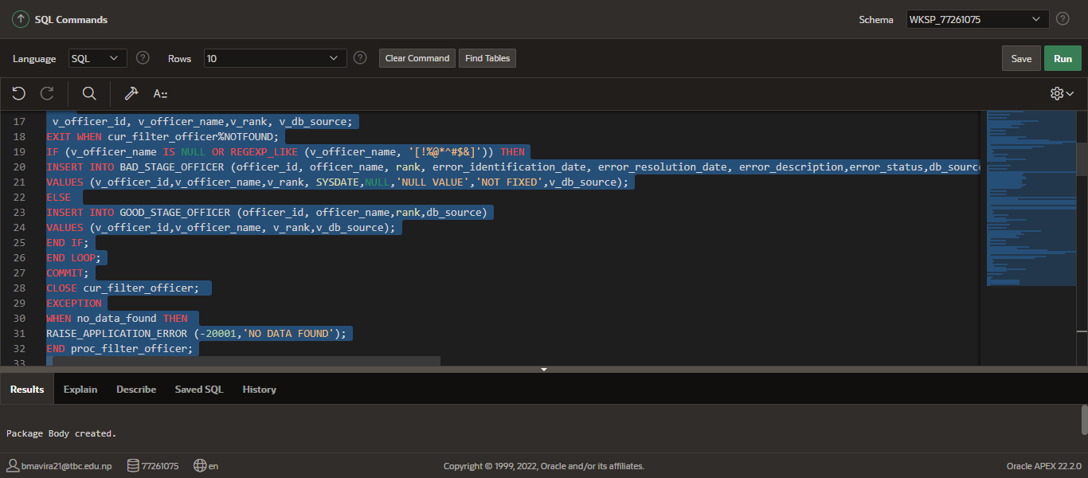

If the data is good it goes to the GOOD_STAGE_REGISTER. However, if the data is null or missing or invalid, it goes the BAD_STAGE_REGISTER.

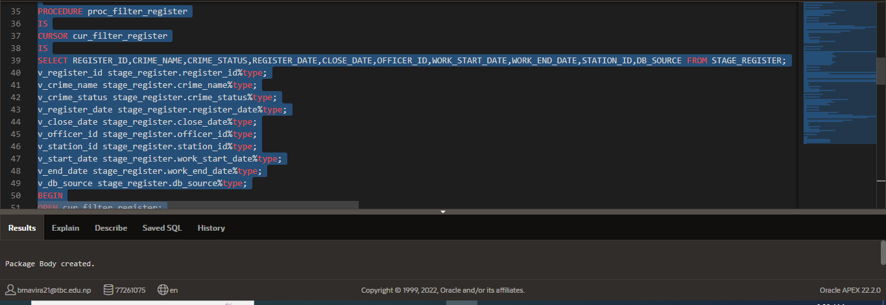

Figure: Making Procedure for GOOD_STAGE_REGISTER AND BAD_STAGE_REGISTER

A Procedure proc_filter_register is made for inserting all the data of officer from STAGE_REGISTER. The bulk insert is done using cursor cur_filter_register.

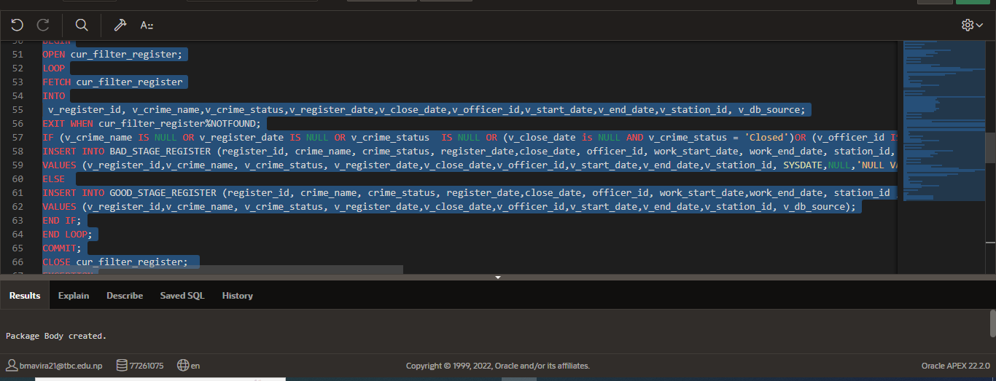

If the data is good it goes to the GOOD_STAGE_REGISTER. However, if the data is null or missing or invalid, it goes the BAD_STAGE_REGISTER.

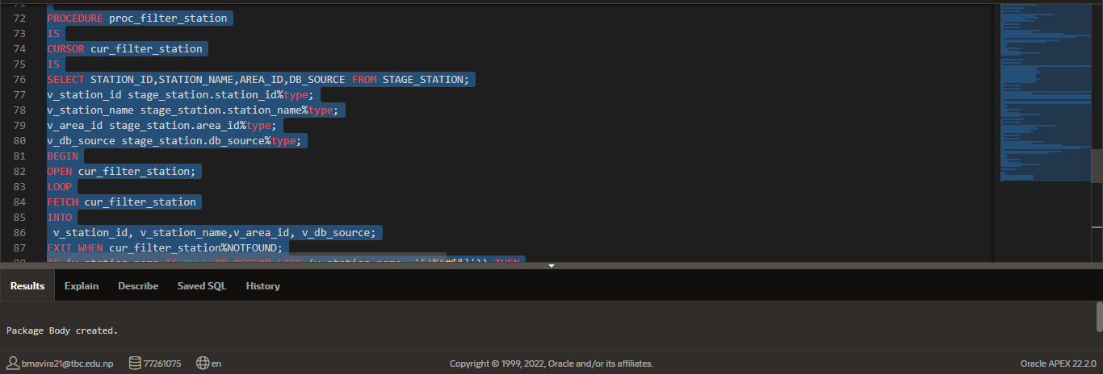

Figure: Making Procedure for GOOD_STAGE_STATION AND BAD_STAGE_STATION

A Procedure proc_filter_station is made for inserting all the data of officer from STAGE_STATION. The bulk insert is done using cursor cur_filter_station.

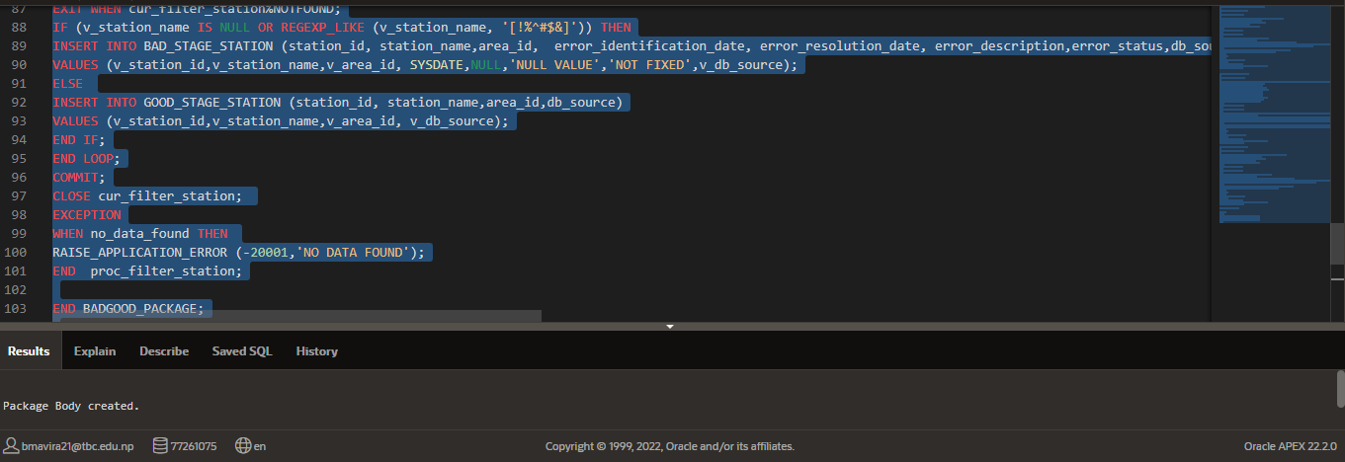

If the data is good it goes to the GOOD_STAGE_STATION. However, if the data is null or missing or invalid, it goes the BAD_STAGE_STATION.

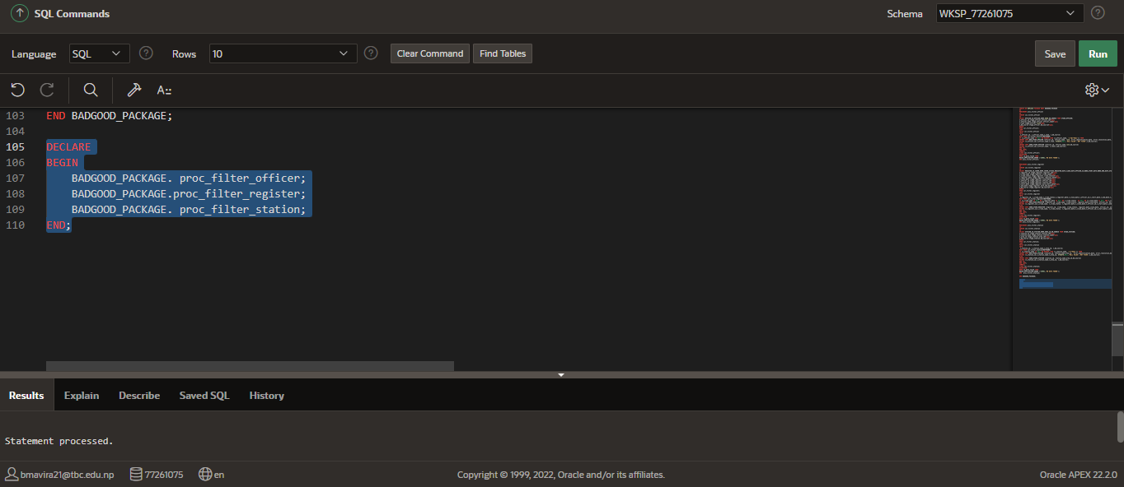

Figure: DECLARING AND RUNNING PACKAGE

Calling the procedure using the package name. It inserts data into the tables after calling the procedures.

## For Recleaning Data

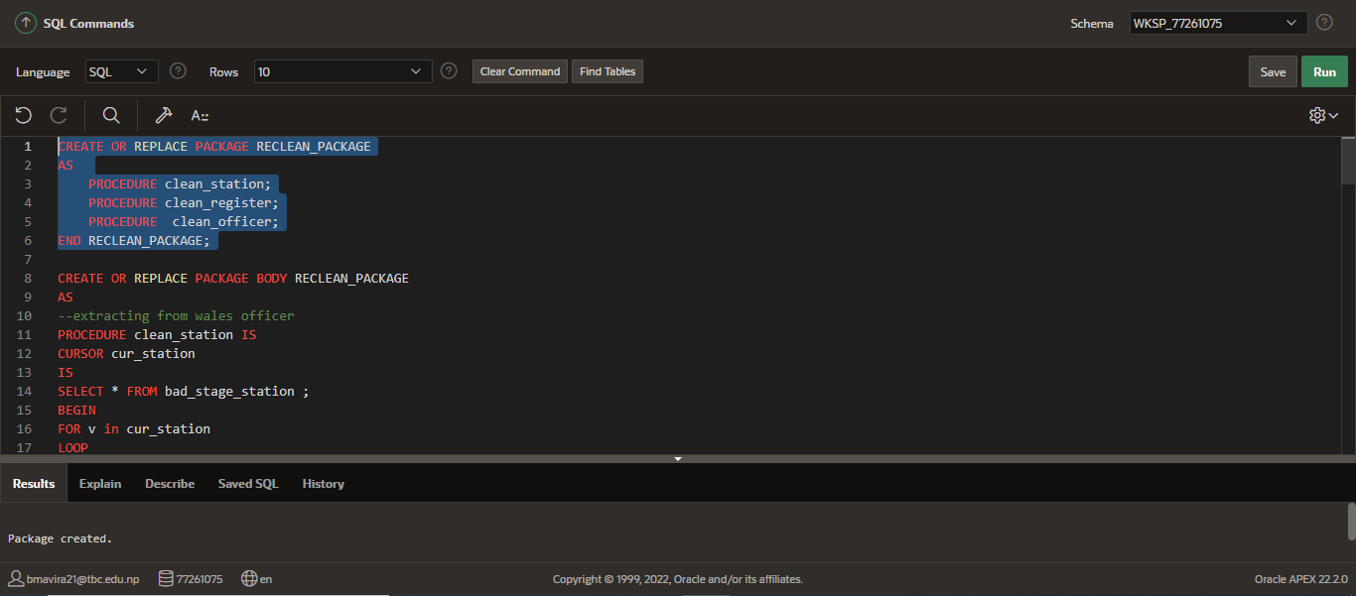

Figure: Creating Package for recleaning process

Package declared to reclean data.

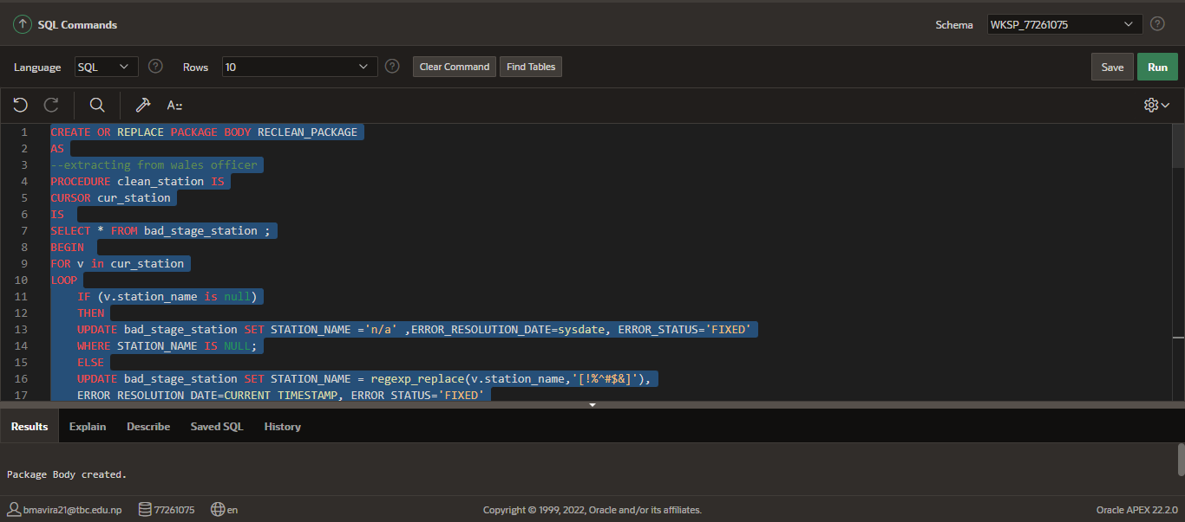

Figure: Making Procedure to clean data from BAD_STAGE_STATION

Package body declared for recleaning the bad data of station. This package recleans the bad data and merges into the good data table of station.

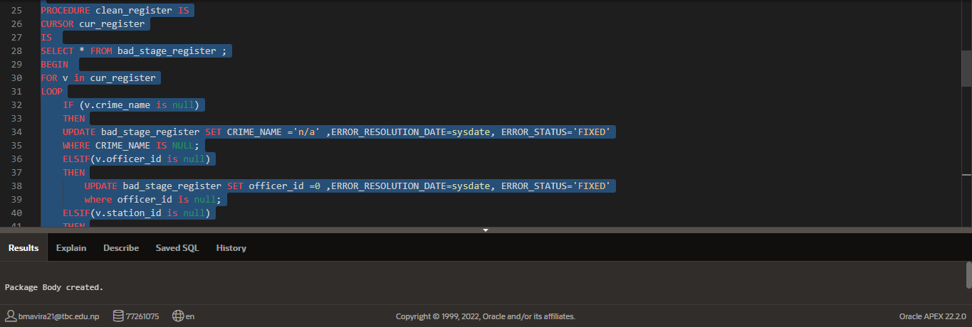

Figure: Making Procedure to clean data from BAD_STAGE_REGISTER

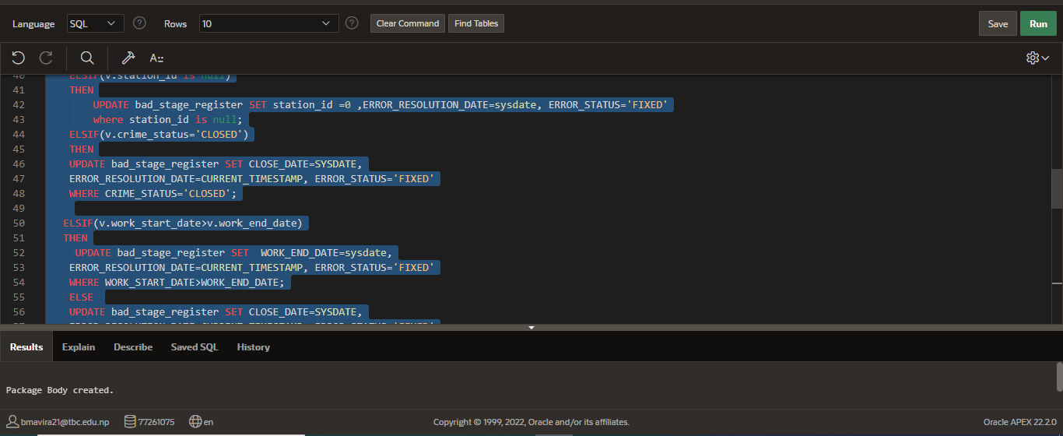

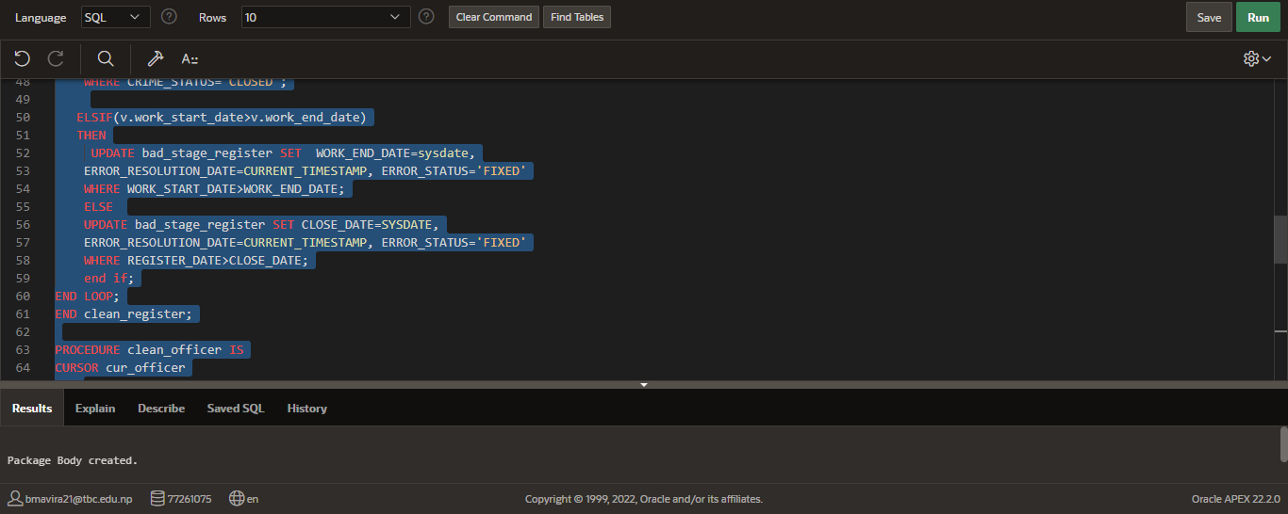

Package body declared for recleaning the bad data of crime. This package recleans the bad data and merges into the good data table of crime into good_stage_register.

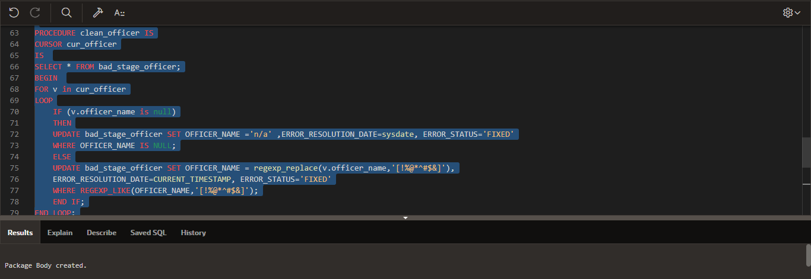

Figure: Making Procedure to clean data from BAD_STAGE_OFFICER

Package body declared for recleaning the bad data of officer. This package recleans the bad data and merges into the good data table of officer.

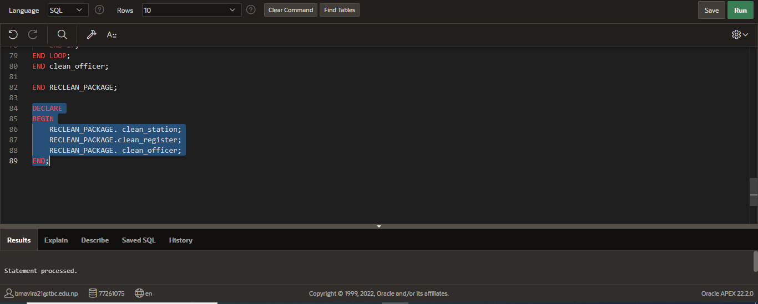

Figure: DECLARING AND RUNNING PACKAGE

Calling the procedure using package name.

## For transform table

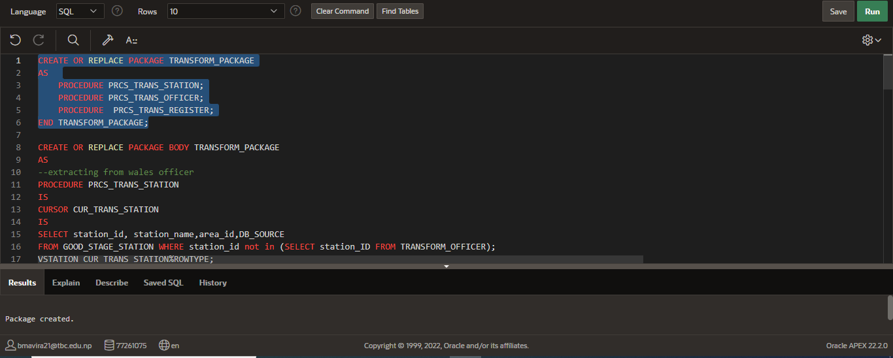

Figure: CREATING A PACKAGE FOR TRANSFORM TABLE

Package name declaration for transform table.

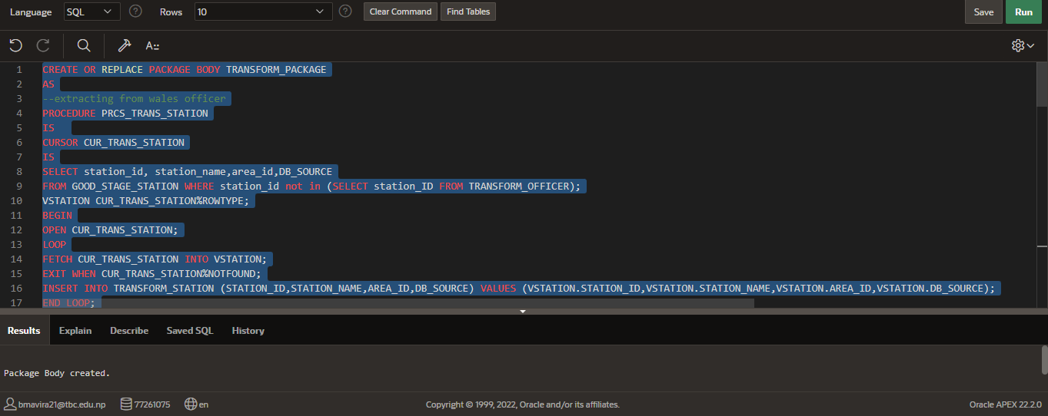

Figure: Making Procedure to transform data from BAD_STAGE_STATION AND GOOD_STAGE_STATION

Package body declaration for transformation table. Declaring package body for transformation table of station to insert data into the transformation table of station.

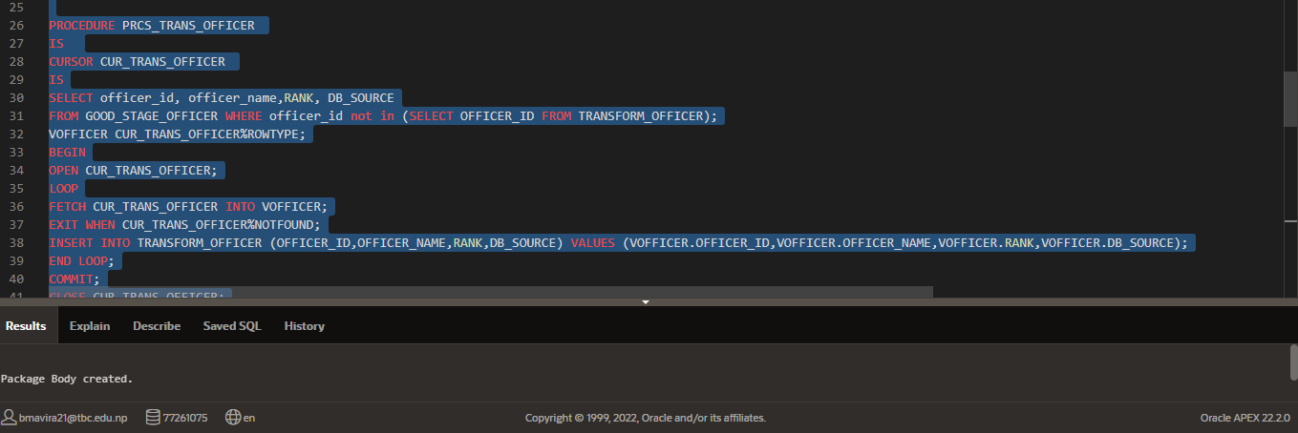

Figure: Making Procedure to transform data from BAD_STAGE_OFFICER AND GOOD_STAGE_OFFICER

Package body declaration for transformation table. Declaring package body for transformation table of officer to insert data into the transformation table of officer.

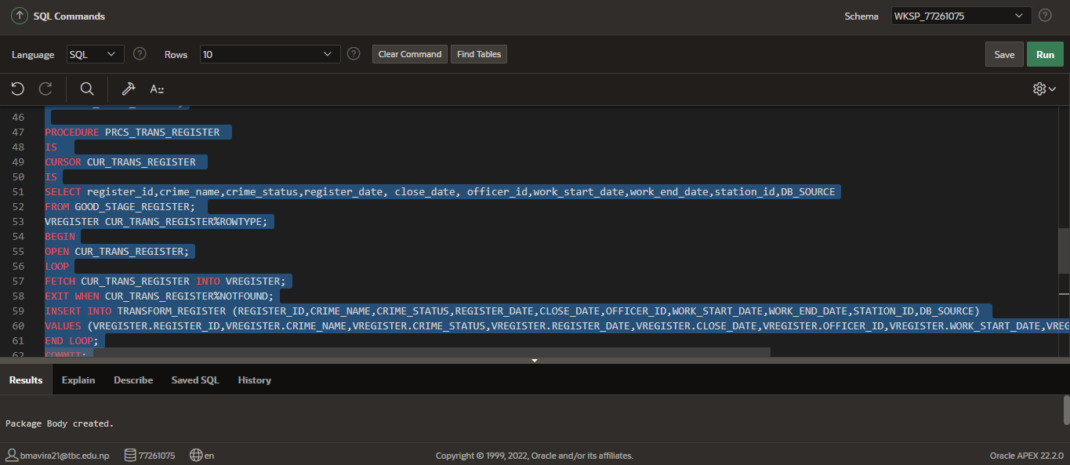

Figure: Making Procedure to transform data from BAD_STAGE_REGISTER AND GOOD_STAGE_REGISTER

Package body declaration for transformation table. Declaring package body for transformation table of crime to insert data into the transformation table of crime.

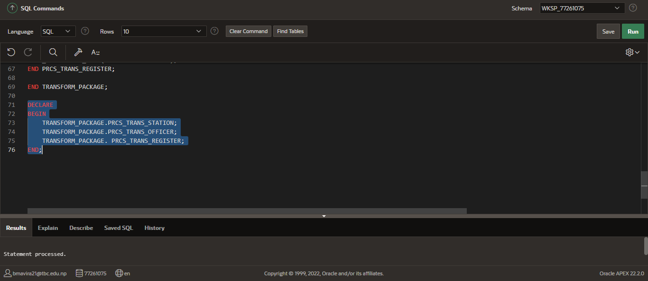

Figure: Declaring and Running package for transform tables

Calling the package for transformation table. This inserts data into the transformation tables.

## FOR DIM_TIME

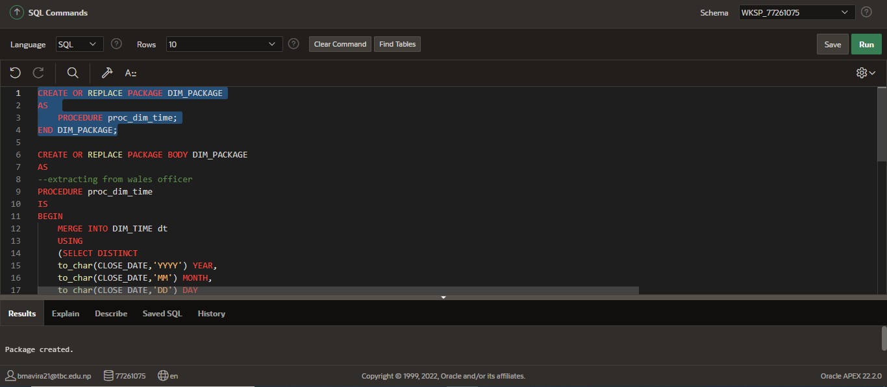

Figure: Creating Package for dim table Time

Package declaration for dim time table.

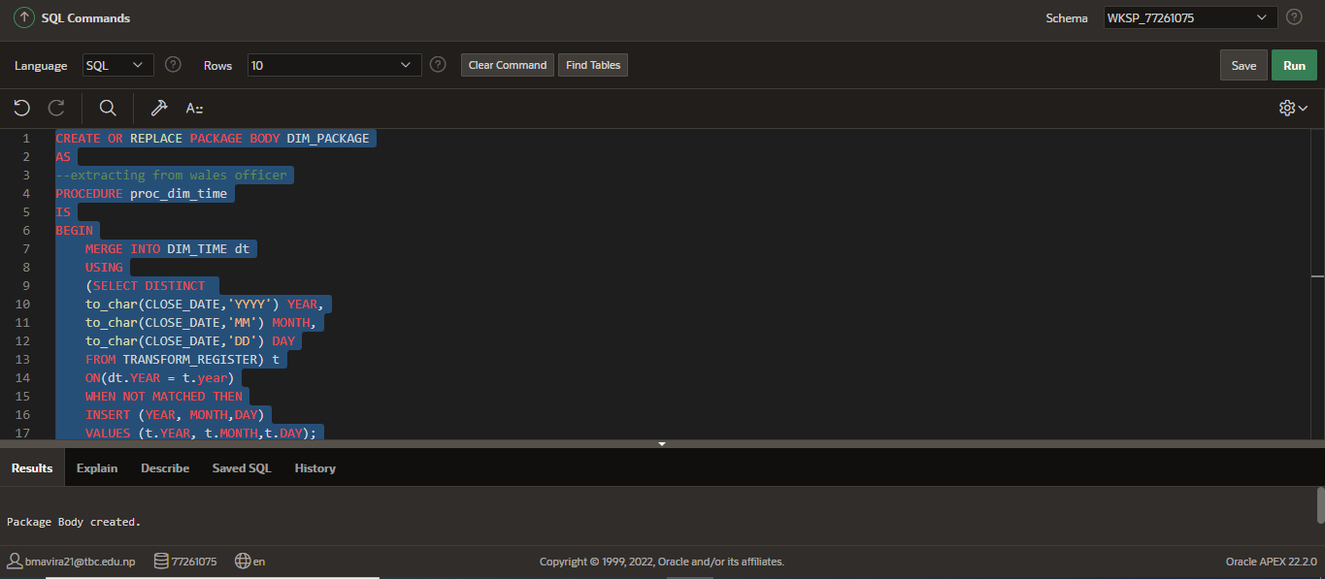

Figure: Making Procedure for DIM_TIME

Package body declaration for dim time table.

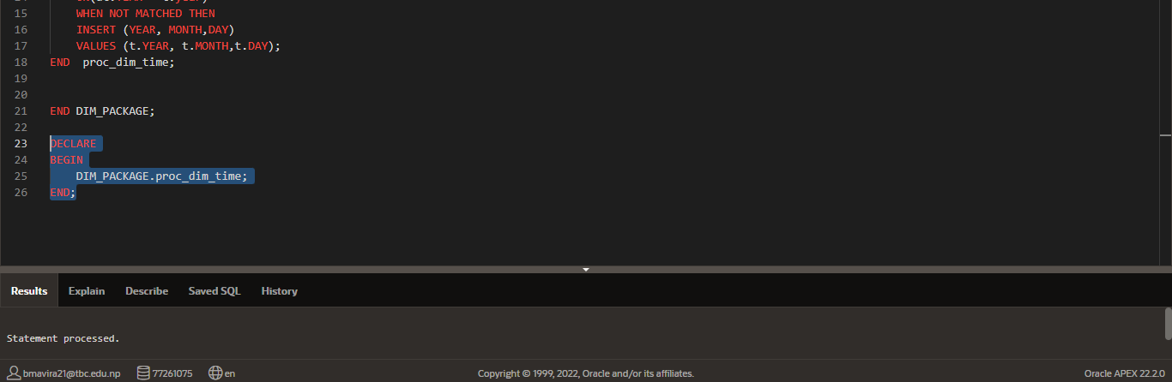

Figure: Declaring and running package

Calling the package for dim time table.

# 2. Inserting from data source PRCS

## a) Insert into stage table

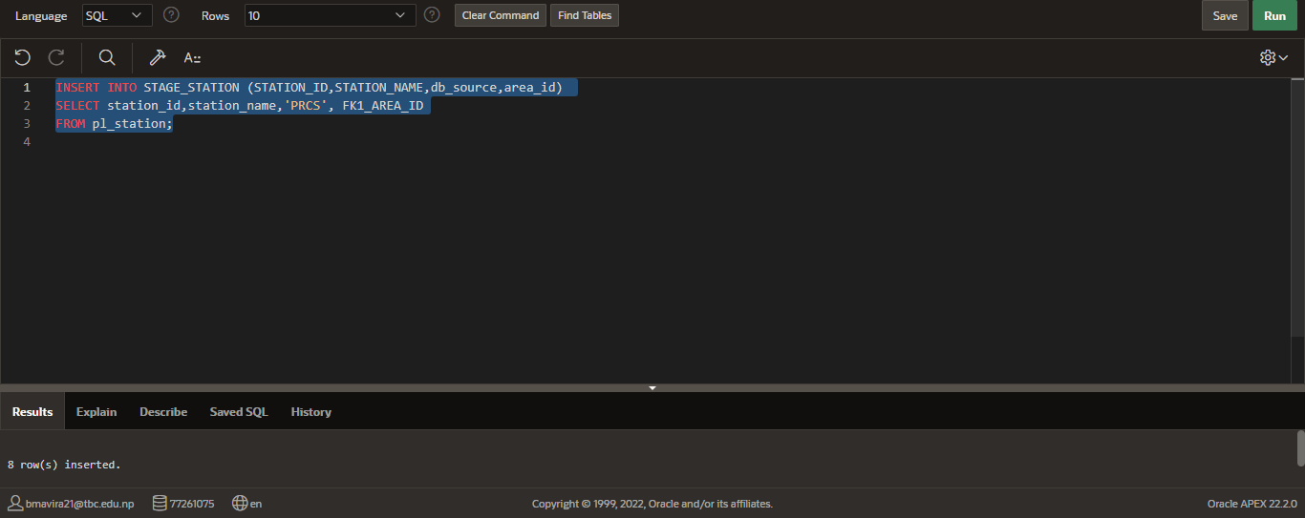

Figure: Inserting data from station table of prcs into staging table of station.

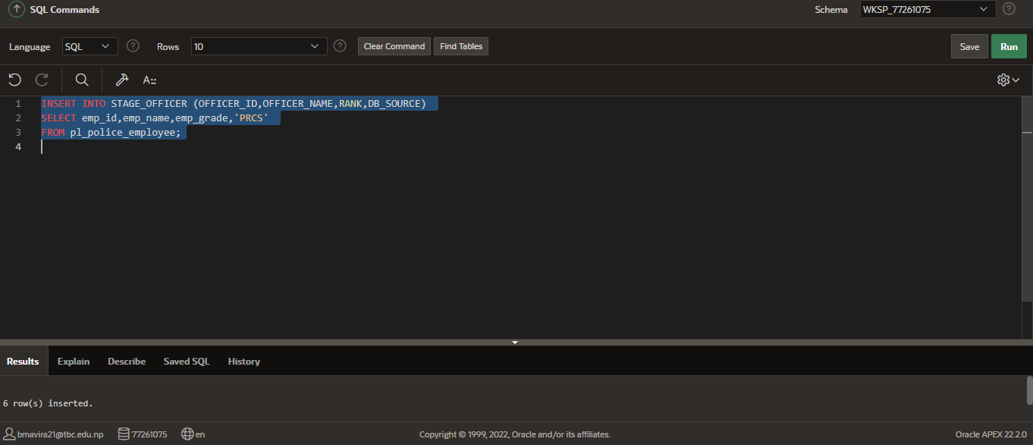

Figure: Inserting data from officer table of prcs into staging table of officer.

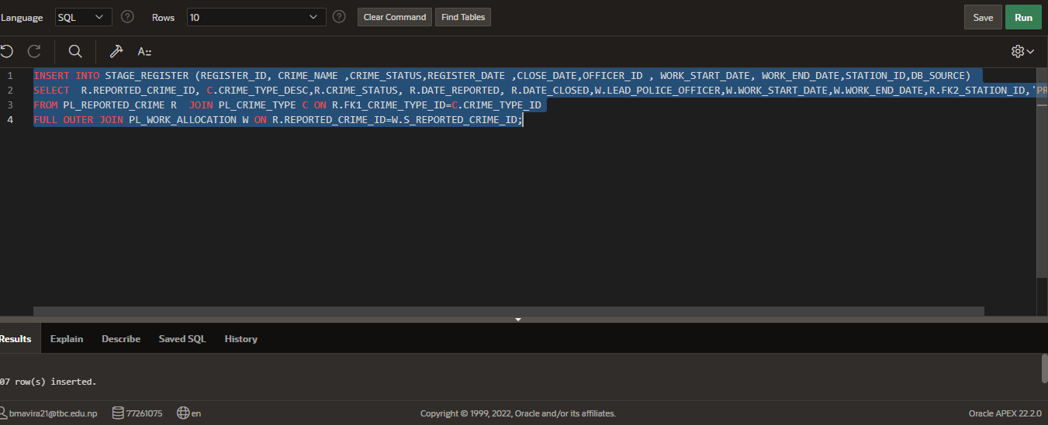

Figure: Inserting data from crime table of prcs into staging table of register.

b) Update in stage table

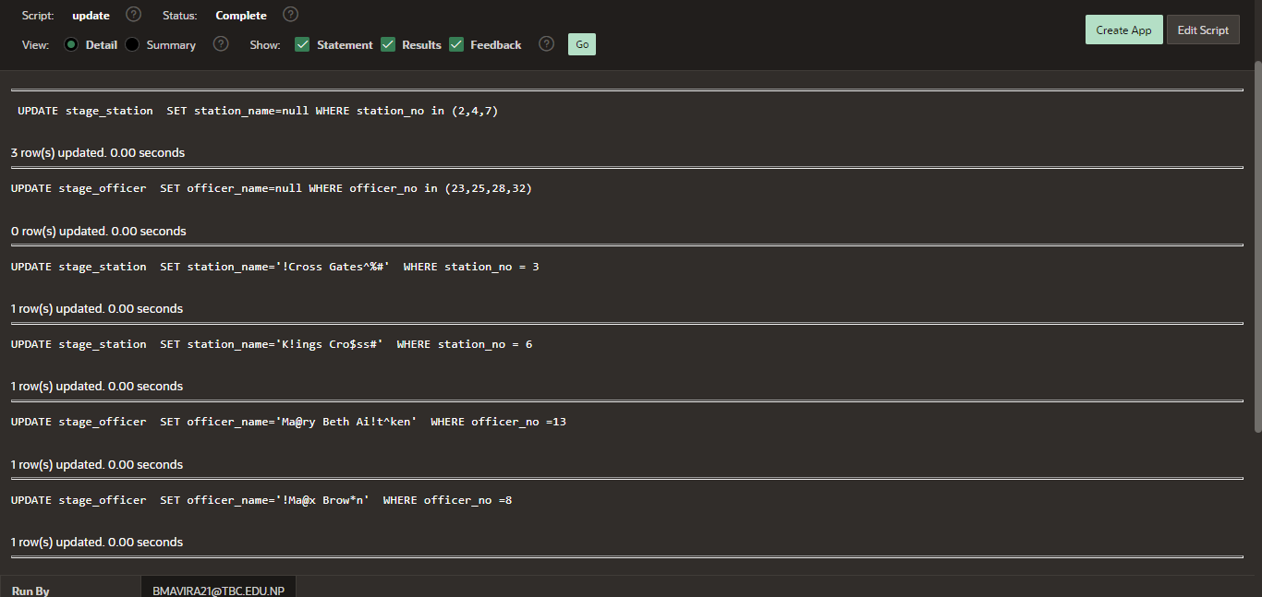

Figure: Updating data in Staging tables

Some datas are updated in stage_register, stage_station, stage_officer respectively to make some bad data in order to insert into bad tables.

c) Inserting into dim tables

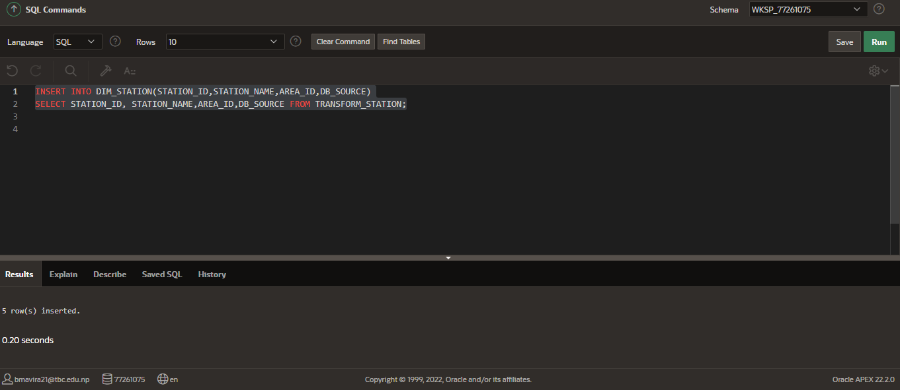

Figure: Inserting data into DIM_STATION from TRANFORM_STATION

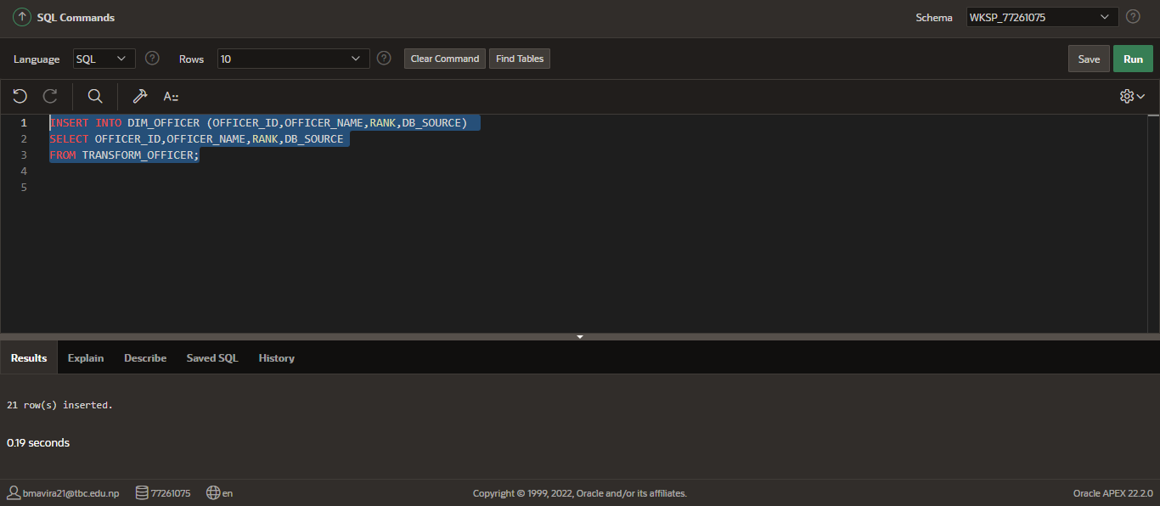

Figure: Inserting data into DIM_OFFICER from TRANFORM_OFFICER

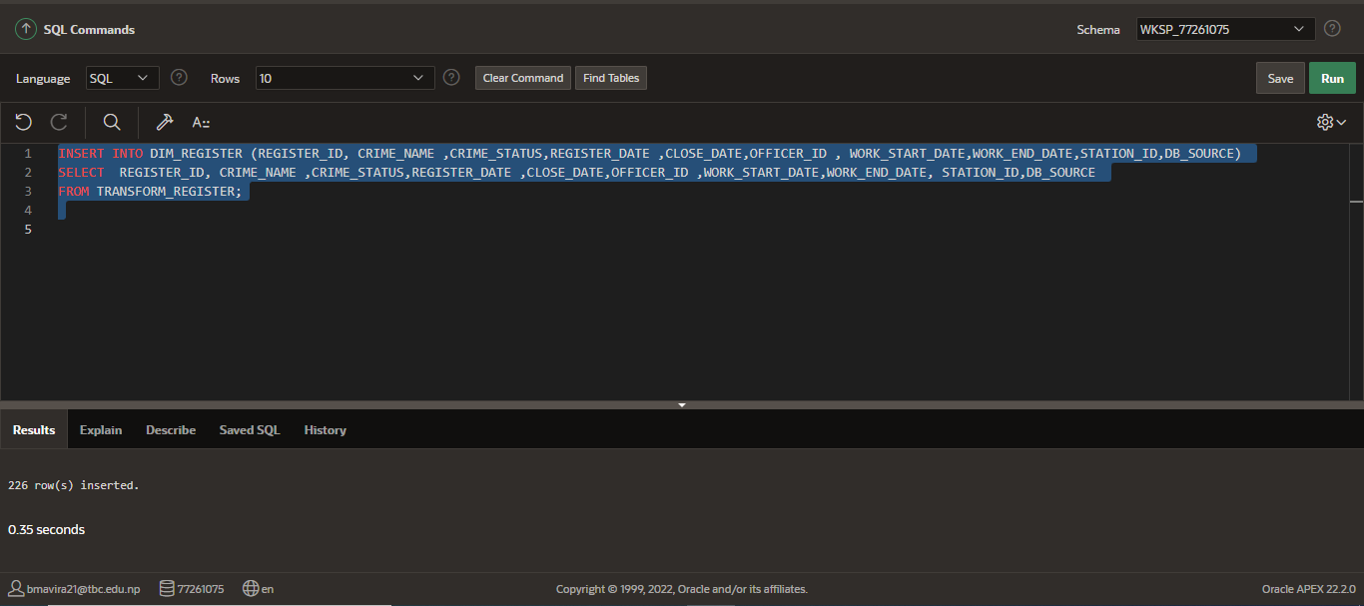

Figure: Inserting data into DIM_REGISTER from TRANFORM_REGISTER

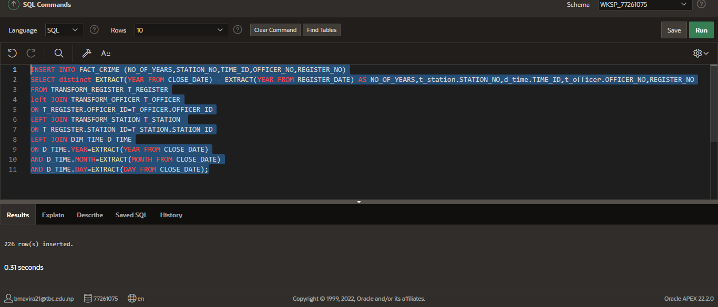

Figure: Inserting data into FACR_CRIME

**SQL QUERIES**

**Packages**

1.

FOR STAGING TABLE

-----------------------------------------------

CREATE OR REPLACE PACKAGE STAGE_PACKAGE

AS

PROCEDURE PRCS_STAG_OFFICER;

PROCEDURE PRCS_STAG_REGISTER ;

END STAGE_PACKAGE;

CREATE OR REPLACE PACKAGE BODY STAGE_PACKAGE

AS

--extracting from wales officer

PROCEDURE PRCS_STAG_OFFICER

IS

CURSOR CUR_STAGE_OFFICER

IS

SELECT officer_id,first_name || ' ' || middle_name || ' ' ||last_name as officer_name,rank,'PS_wales' AS DB_SOURCE

FROM OFFICER WHERE officer_id not in (SELECT OFFICER_ID FROM STAGE_OFFICER);

VOFFICER CUR_STAGE_OFFICER%ROWTYPE;

BEGIN

OPEN CUR_STAGE_OFFICER;

LOOP

FETCH CUR_STAGE_OFFICER INTO VOFFICER;

EXIT WHEN CUR_STAGE_OFFICER%NOTFOUND;

INSERT INTO STAGE_OFFICER (OFFICER_ID,OFFICER_NAME,RANK,DB_SOURCE) VALUES (VOFFICER.OFFICER_ID,VOFFICER.OFFICER_NAME,VOFFICER.RANK,VOFFICER.DB_SOURCE);

END LOOP;

COMMIT;

CLOSE CUR_STAGE_OFFICER;

EXCEPTION

WHEN NO_DATA_FOUND THEN

DBMS_OUTPUT.PUT_LINE('RECORD NOT FOUND');

END PRCS_STAG_OFFICER;

PROCEDURE PRCS_STAG_REGISTER

IS

CURSOR CUR_STAGE_REGISTER

IS

SELECT crime_id,crime_name,crime_status,reported_date, closed_date, police_id,'PS_wales' as DB_SOURCE

FROM CRIME_REGISTER;

VREGISTER CUR_STAGE_REGISTER%ROWTYPE;

BEGIN

OPEN CUR_STAGE_REGISTER;

LOOP

FETCH CUR_STAGE_REGISTER INTO VREGISTER;

EXIT WHEN CUR_STAGE_REGISTER%NOTFOUND;

INSERT INTO STAGE_REGISTER (REGISTER_ID,CRIME_NAME,CRIME_STATUS,REGISTER_DATE,CLOSE_DATE,OFFICER_ID,WORK_START_DATE,WORK_END_DATE,STATION_ID,DB_SOURCE)

VALUES (VREGISTER.CRIME_ID,VREGISTER.CRIME_NAME,VREGISTER.CRIME_STATUS,VREGISTER.REPORTED_DATE,VREGISTER.CLOSED_DATE,VREGISTER.POLICE_ID,'','','',VREGISTER.DB_SOURCE);

END LOOP;

COMMIT;

CLOSE CUR_STAGE_REGISTER;

EXCEPTION

WHEN NO_DATA_FOUND THEN

DBMS_OUTPUT.PUT_LINE('RECORD NOT FOUND');

END PRCS_STAG_REGISTER ;

END STAGE_PACKAGE;

DECLARE

BEGIN

STAGE_PACKAGE.PRCS_STAG_OFFICER;

STAGE_PACKAGE.PRCS_STAG_REGISTER ;

END;

2.

BAD GOOD TABLE

CREATE OR REPLACE PACKAGE BADGOOD_PACKAGE

AS

PROCEDURE proc_filter_officer;

PROCEDURE proc_filter_register;

PROCEDURE proc_filter_station;

END BADGOOD_PACKAGE;

CREATE OR REPLACE PACKAGE BODY BADGOOD_PACKAGE

AS

--extracting from wales officer

PROCEDURE proc_filter_officer

IS

CURSOR cur_filter_officer

IS

SELECT OFFICER_ID,OFFICER_NAME,RANK,DB_SOURCE FROM STAGE_OFFICER;

v_officer_id stage_officer.officer_id%type;

v_officer_name stage_officer.officer_name%type;

v_rank stage_officer.rank%type;

v_db_source stage_officer.db_source%type;

BEGIN

OPEN cur_filter_officer;

LOOP

FETCH cur_filter_officer

INTO

v_officer_id, v_officer_name,v_rank, v_db_source;

EXIT WHEN cur_filter_officer%NOTFOUND;

IF (v_officer_name IS NULL OR REGEXP_LIKE (v_officer_name, '[!%@*^#$&]')) THEN

INSERT INTO BAD_STAGE_OFFICER (officer_id, officer_name, rank, error_identification_date, error_resolution_date, error_description,error_status,db_source)

VALUES (v_officer_id,v_officer_name,v_rank, SYSDATE,NULL,'NULL VALUE','NOT FIXED',v_db_source);

ELSE

INSERT INTO GOOD_STAGE_OFFICER (officer_id, officer_name,rank,db_source)

VALUES (v_officer_id,v_officer_name, v_rank,v_db_source);

END IF;

END LOOP;

COMMIT;

CLOSE cur_filter_officer;

EXCEPTION

WHEN no_data_found THEN

RAISE_APPLICATION_ERROR (-20001,'NO DATA FOUND');

END proc_filter_officer;

PROCEDURE proc_filter_register

IS

CURSOR cur_filter_register

IS

SELECT REGISTER_ID,CRIME_NAME,CRIME_STATUS,REGISTER_DATE,CLOSE_DATE,OFFICER_ID,WORK_START_DATE,WORK_END_DATE,STATION_ID,DB_SOURCE FROM STAGE_REGISTER;

v_register_id stage_register.register_id%type;

v_crime_name stage_register.crime_name%type;

v_crime_status stage_register.crime_status%type;

v_register_date stage_register.register_date%type;

v_close_date stage_register.close_date%type;

v_officer_id stage_register.officer_id%type;

v_station_id stage_register.station_id%type;

v_start_date stage_register.work_start_date%type;

v_end_date stage_register.work_end_date%type;

v_db_source stage_register.db_source%type;

BEGIN

OPEN cur_filter_register;

LOOP

FETCH cur_filter_register

INTO

v_register_id, v_crime_name,v_crime_status,v_register_date,v_close_date,v_officer_id,v_start_date,v_end_date,v_station_id, v_db_source;

EXIT WHEN cur_filter_register%NOTFOUND;

IF (v_crime_name IS NULL OR v_register_date IS NULL OR v_crime_status IS NULL OR (v_close_date is NULL AND v_crime_status = 'Closed')OR (v_officer_id IS NOT NULL AND v_crime_status = 'Closed') OR (v_officer_id IS NOT NULL AND v_start_date IS NULL)OR v_officer_id IS NULL OR v_station_id IS NULL OR v_register_date>v_close_date OR v_start_date>v_end_date) THEN

INSERT INTO BAD_STAGE_REGISTER (register_id, crime_name, crime_status, register_date,close_date, officer_id, work_start_date, work_end_date, station_id, error_identification_date, error_resolution_date, error_description,error_status,db_source)

VALUES (v_register_id,v_crime_name, v_crime_status, v_register_date,v_close_date,v_officer_id,v_start_date,v_end_date,v_station_id, SYSDATE,NULL,'NULL VALUE','NOT FIXED',v_db_source);

ELSE

INSERT INTO GOOD_STAGE_REGISTER (register_id, crime_name, crime_status, register_date,close_date, officer_id, work_start_date,work_end_date, station_id ,db_source)

VALUES (v_register_id,v_crime_name, v_crime_status, v_register_date,v_close_date,v_officer_id,v_start_date,v_end_date,v_station_id, v_db_source);

END IF;

END LOOP;

COMMIT;

CLOSE cur_filter_register;

EXCEPTION

WHEN no_data_found THEN

RAISE_APPLICATION_ERROR (-20001,'NO DATA FOUND');

END proc_filter_register;

PROCEDURE proc_filter_station

IS

CURSOR cur_filter_station

IS

SELECT STATION_ID,STATION_NAME,AREA_ID,DB_SOURCE FROM STAGE_STATION;

v_station_id stage_station.station_id%type;

v_station_name stage_station.station_name%type;

v_area_id stage_station.area_id%type;

v_db_source stage_station.db_source%type;

BEGIN

OPEN cur_filter_station;

LOOP

FETCH cur_filter_station

INTO

v_station_id, v_station_name,v_area_id, v_db_source;

EXIT WHEN cur_filter_station%NOTFOUND;

IF (v_station_name IS NULL OR REGEXP_LIKE (v_station_name, '[!%^#$&]')) THEN

INSERT INTO BAD_STAGE_STATION (station_id, station_name,area_id, error_identification_date, error_resolution_date, error_description,error_status,db_source)

VALUES (v_station_id,v_station_name,v_area_id, SYSDATE,NULL,'NULL VALUE','NOT FIXED',v_db_source);

ELSE

INSERT INTO GOOD_STAGE_STATION (station_id, station_name,area_id,db_source)

VALUES (v_station_id,v_station_name,v_area_id, v_db_source);

END IF;

END LOOP;

COMMIT;

CLOSE cur_filter_station;

EXCEPTION

WHEN no_data_found THEN

RAISE_APPLICATION_ERROR (-20001,'NO DATA FOUND');

END proc_filter_station;

END BADGOOD_PACKAGE;

DECLARE

BEGIN

BADGOOD_PACKAGE. proc_filter_officer;

BADGOOD_PACKAGE.proc_filter_register;

BADGOOD_PACKAGE. proc_filter_station;

END;

3.

RECLEAN

CREATE OR REPLACE PACKAGE RECLEAN_PACKAGE

AS

PROCEDURE clean_station;

PROCEDURE clean_register;

PROCEDURE clean_officer;

END RECLEAN_PACKAGE;

CREATE OR REPLACE PACKAGE BODY RECLEAN_PACKAGE

AS

--extracting from wales officer

PROCEDURE clean_station IS

CURSOR cur_station

IS

SELECT * FROM bad_stage_station ;

BEGIN

FOR v in cur_station

LOOP

IF (v.station_name is null)

THEN

UPDATE bad_stage_station SET STATION_NAME ='n/a' ,ERROR_RESOLUTION_DATE=sysdate, ERROR_STATUS='FIXED'

WHERE STATION_NAME IS NULL;

ELSE

UPDATE bad_stage_station SET STATION_NAME = regexp_replace(v.station_name,'[!%^#$&]'),

ERROR_RESOLUTION_DATE=CURRENT_TIMESTAMP, ERROR_STATUS='FIXED'

WHERE REGEXP_LIKE(STATION_NAME,'[!%^#$&]');

END IF;

END LOOP;

END clean_station;

PROCEDURE clean_register IS

CURSOR cur_register

IS

SELECT * FROM bad_stage_register ;

BEGIN

FOR v in cur_register

LOOP

IF (v.crime_name is null)

THEN

UPDATE bad_stage_register SET CRIME_NAME ='n/a' ,ERROR_RESOLUTION_DATE=sysdate, ERROR_STATUS='FIXED'

WHERE CRIME_NAME IS NULL;

ELSIF(v.officer_id is null)

THEN

UPDATE bad_stage_register SET officer_id =0 ,ERROR_RESOLUTION_DATE=sysdate, ERROR_STATUS='FIXED'

where officer_id is null;

ELSIF(v.station_id is null)

THEN

UPDATE bad_stage_register SET station_id =0 ,ERROR_RESOLUTION_DATE=sysdate, ERROR_STATUS='FIXED'

where station_id is null;

ELSIF(v.crime_status='CLOSED')

THEN

UPDATE bad_stage_register SET CLOSE_DATE=SYSDATE,

ERROR_RESOLUTION_DATE=CURRENT_TIMESTAMP, ERROR_STATUS='FIXED'

WHERE CRIME_STATUS='CLOSED';

ELSIF(v.work_start_date>v.work_end_date)

THEN

UPDATE bad_stage_register SET WORK_END_DATE=sysdate,

ERROR_RESOLUTION_DATE=CURRENT_TIMESTAMP, ERROR_STATUS='FIXED'

WHERE WORK_START_DATE>WORK_END_DATE;

ELSE

UPDATE bad_stage_register SET CLOSE_DATE=SYSDATE,

ERROR_RESOLUTION_DATE=CURRENT_TIMESTAMP, ERROR_STATUS='FIXED'

WHERE REGISTER_DATE>CLOSE_DATE;

end if;

END LOOP;

END clean_register;

PROCEDURE clean_officer IS

CURSOR cur_officer

IS

SELECT * FROM bad_stage_officer;

BEGIN

FOR v in cur_officer

LOOP

IF (v.officer_name is null)

THEN

UPDATE bad_stage_officer SET OFFICER_NAME ='n/a' ,ERROR_RESOLUTION_DATE=sysdate, ERROR_STATUS='FIXED'

WHERE OFFICER_NAME IS NULL;

ELSE

UPDATE bad_stage_officer SET OFFICER_NAME = regexp_replace(v.officer_name,'[!%@*^#$&]'),

ERROR_RESOLUTION_DATE=CURRENT_TIMESTAMP, ERROR_STATUS='FIXED'

WHERE REGEXP_LIKE(OFFICER_NAME,'[!%@*^#$&]');

END IF;

END LOOP;

END clean_officer;

END RECLEAN_PACKAGE;

DECLARE

BEGIN

RECLEAN_PACKAGE. clean_station;

RECLEAN_PACKAGE.clean_register;

RECLEAN_PACKAGE. clean_officer;

END;

4.

TRANSFORM

------------------------

CREATE OR REPLACE PACKAGE TRANSFORM_PACKAGE

AS

PROCEDURE PRCS_TRANS_STATION;

PROCEDURE PRCS_TRANS_OFFICER;

PROCEDURE PRCS_TRANS_REGISTER;

END TRANSFORM_PACKAGE;

CREATE OR REPLACE PACKAGE BODY TRANSFORM_PACKAGE

AS

--extracting from wales officer

PROCEDURE PRCS_TRANS_STATION

IS

CURSOR CUR_TRANS_STATION

IS

SELECT station_id, station_name,area_id,DB_SOURCE

FROM GOOD_STAGE_STATION WHERE station_id not in (SELECT station_ID FROM TRANSFORM_OFFICER);

VSTATION CUR_TRANS_STATION%ROWTYPE;

BEGIN

OPEN CUR_TRANS_STATION;

LOOP

FETCH CUR_TRANS_STATION INTO VSTATION;

EXIT WHEN CUR_TRANS_STATION%NOTFOUND;

INSERT INTO TRANSFORM_STATION (STATION_ID,STATION_NAME,AREA_ID,DB_SOURCE) VALUES (VSTATION.STATION_ID,VSTATION.STATION_NAME,VSTATION.AREA_ID,VSTATION.DB_SOURCE);

END LOOP;

COMMIT;

CLOSE CUR_TRANS_STATION;

EXCEPTION

WHEN NO_DATA_FOUND THEN

DBMS_OUTPUT.PUT_LINE('RECORD NOT FOUND');

END PRCS_TRANS_STATION;

PROCEDURE PRCS_TRANS_OFFICER

IS

CURSOR CUR_TRANS_OFFICER

IS

SELECT officer_id, officer_name,RANK, DB_SOURCE

FROM GOOD_STAGE_OFFICER WHERE officer_id not in (SELECT OFFICER_ID FROM TRANSFORM_OFFICER);

VOFFICER CUR_TRANS_OFFICER%ROWTYPE;

BEGIN

OPEN CUR_TRANS_OFFICER;

LOOP

FETCH CUR_TRANS_OFFICER INTO VOFFICER;

EXIT WHEN CUR_TRANS_OFFICER%NOTFOUND;

INSERT INTO TRANSFORM_OFFICER (OFFICER_ID,OFFICER_NAME,RANK,DB_SOURCE) VALUES (VOFFICER.OFFICER_ID,VOFFICER.OFFICER_NAME,VOFFICER.RANK,VOFFICER.DB_SOURCE);

END LOOP;

COMMIT;

CLOSE CUR_TRANS_OFFICER;

EXCEPTION

WHEN NO_DATA_FOUND THEN

DBMS_OUTPUT.PUT_LINE('RECORD NOT FOUND');

END PRCS_TRANS_OFFICER;

PROCEDURE PRCS_TRANS_REGISTER

IS

CURSOR CUR_TRANS_REGISTER

IS

SELECT register_id,crime_name,crime_status,register_date, close_date, officer_id,work_start_date,work_end_date,station_id,DB_SOURCE

FROM GOOD_STAGE_REGISTER;

VREGISTER CUR_TRANS_REGISTER%ROWTYPE;

BEGIN

OPEN CUR_TRANS_REGISTER;

LOOP

FETCH CUR_TRANS_REGISTER INTO VREGISTER;

EXIT WHEN CUR_TRANS_REGISTER%NOTFOUND;

INSERT INTO TRANSFORM_REGISTER (REGISTER_ID,CRIME_NAME,CRIME_STATUS,REGISTER_DATE,CLOSE_DATE,OFFICER_ID,WORK_START_DATE,WORK_END_DATE,STATION_ID,DB_SOURCE)

VALUES (VREGISTER.REGISTER_ID,VREGISTER.CRIME_NAME,VREGISTER.CRIME_STATUS,VREGISTER.REGISTER_DATE,VREGISTER.CLOSE_DATE,VREGISTER.OFFICER_ID,VREGISTER.WORK_START_DATE,VREGISTER.WORK_END_DATE,VREGISTER.STATION_ID,VREGISTER.DB_SOURCE);

END LOOP;

COMMIT;

CLOSE CUR_TRANS_REGISTER;

EXCEPTION

WHEN NO_DATA_FOUND THEN

DBMS_OUTPUT.PUT_LINE('RECORD NOT FOUND');

END PRCS_TRANS_REGISTER;

END TRANSFORM_PACKAGE;

DECLARE

BEGIN

TRANSFORM_PACKAGE.PRCS_TRANS_STATION;

TRANSFORM_PACKAGE.PRCS_TRANS_OFFICER;

TRANSFORM_PACKAGE. PRCS_TRANS_REGISTER;

END;

-----------------

Fact

CREATE OR REPLACE PACKAGE DIM_PACKAGE

AS

PROCEDURE proc_dim_time;

END DIM_PACKAGE;

CREATE OR REPLACE PACKAGE BODY DIM_PACKAGE

AS

--extracting from wales officer

PROCEDURE proc_dim_time

IS

BEGIN

MERGE INTO DIM_TIME dt

USING

(SELECT DISTINCT

to_char(CLOSE_DATE,'YYYY') YEAR,

to_char(CLOSE_DATE,'MM') MONTH,

to_char(CLOSE_DATE,'DD') DAY

FROM TRANSFORM_REGISTER) t

ON(dt.YEAR = t.year)

WHEN NOT MATCHED THEN

INSERT (YEAR, MONTH,DAY)

VALUES (t.YEAR, t.MONTH,t.DAY);

END proc_dim_time;

END DIM_PACKAGE;

DECLARE

BEGIN

DIM_PACKAGE.proc_dim_time;

END;

**Insert Queries**

1ST STAGE INSERTING

INSERT INTO STAGE_STATION (STATION_ID,STATION_NAME,db_source,area_id)

SELECT station_id,station_name,'PRCS', FK1_AREA_ID

FROM pl_station;

INSERT INTO STAGE_OFFICER (OFFICER_ID,OFFICER_NAME,RANK,DB_SOURCE)

SELECT emp_id,emp_name,emp_grade,'PRCS'

FROM pl_police_employee;

INSERT INTO STAGE_REGISTER (REGISTER_ID, CRIME_NAME ,CRIME_STATUS,REGISTER_DATE ,CLOSE_DATE,OFFICER_ID , WORK_START_DATE, WORK_END_DATE,STATION_ID,DB_SOURCE)

SELECT R.REPORTED_CRIME_ID, C.CRIME_TYPE_DESC,R.CRIME_STATUS, R.DATE_REPORTED, R.DATE_CLOSED,W.LEAD_POLICE_OFFICER,W.WORK_START_DATE,W.WORK_END_DATE,R.FK2_STATION_ID,'PRCS'

FROM PL_REPORTED_CRIME R JOIN PL_CRIME_TYPE C ON R.FK1_CRIME_TYPE_ID=C.CRIME_TYPE_ID

FULL OUTER JOIN PL_WORK_ALLOCATION W ON R.REPORTED_CRIME_ID=W.S_REPORTED_CRIME_ID;

**Inserting into dim table and fact table**

INSERT INTO DIM_STATION(STATION_ID,STATION_NAME,AREA_ID,DB_SOURCE)

SELECT STATION_ID, STATION_NAME,AREA_ID,DB_SOURCE FROM TRANSFORM_STATION;

3.

INSERT INTO DIM_OFFICER (OFFICER_ID,OFFICER_NAME,RANK,DB_SOURCE)

SELECT OFFICER_ID,OFFICER_NAME,RANK,DB_SOURCE

FROM TRANSFORM_OFFICER;

4.

INSERT INTO DIM_REGISTER (REGISTER_ID, CRIME_NAME ,CRIME_STATUS,REGISTER_DATE ,CLOSE_DATE,OFFICER_ID , WORK_START_DATE,WORK_END_DATE,STATION_ID,DB_SOURCE)

SELECT REGISTER_ID, CRIME_NAME ,CRIME_STATUS,REGISTER_DATE ,CLOSE_DATE,OFFICER_ID ,WORK_START_DATE,WORK_END_DATE, STATION_ID,DB_SOURCE

FROM TRANSFORM_REGISTER;

5.

INSERT INTO FACT_CRIME (NO_OF_YEARS,STATION_NO,TIME_ID,OFFICER_NO,REGISTER_NO)

SELECT distinct EXTRACT(YEAR FROM CLOSE_DATE) - EXTRACT(YEAR FROM REGISTER_DATE) AS NO_OF_YEARS,t_station.STATION_NO,d_time.TIME_ID,t_officer.OFFICER_NO,REGISTER_NO

FROM TRANSFORM_REGISTER T_REGISTER

left JOIN TRANSFORM_OFFICER T_OFFICER

ON T_REGISTER.OFFICER_ID=T_OFFICER.OFFICER_ID

LEFT JOIN TRANSFORM_STATION T_STATION

ON T_REGISTER.STATION_ID=T_STATION.STATION_ID

LEFT JOIN DIM_TIME D_TIME

ON D_TIME.YEAR=EXTRACT(YEAR FROM CLOSE_DATE)

AND D_TIME.MONTH=EXTRACT(MONTH FROM CLOSE_DATE)

AND D_TIME.DAY=EXTRACT(DAY FROM CLOSE_DATE)