nf_report_6/5/24

Miguel Velasquez

2024-05-30

# Pooled effect sizes

## Last vs. First training session

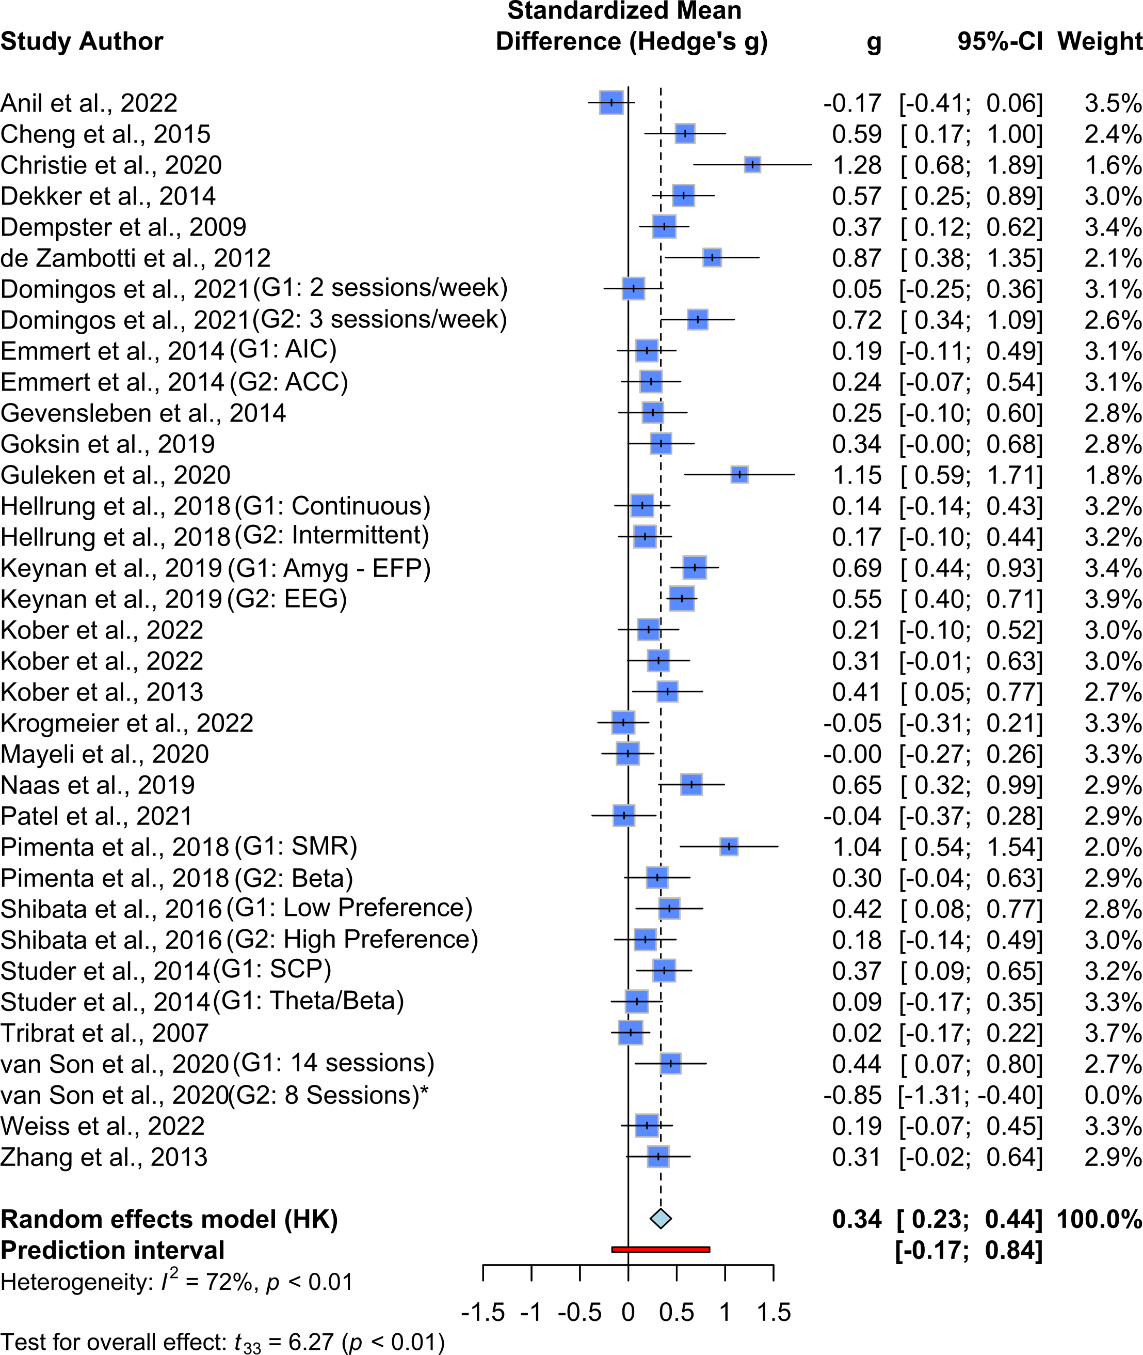

Last vs. First training session. Random effects model: Hedge’s g = 0.3358, CI = [ 0.2269; 0.4447], t = 6.27, p < 0.0001

## Post-training vs. Pre-training Baseline

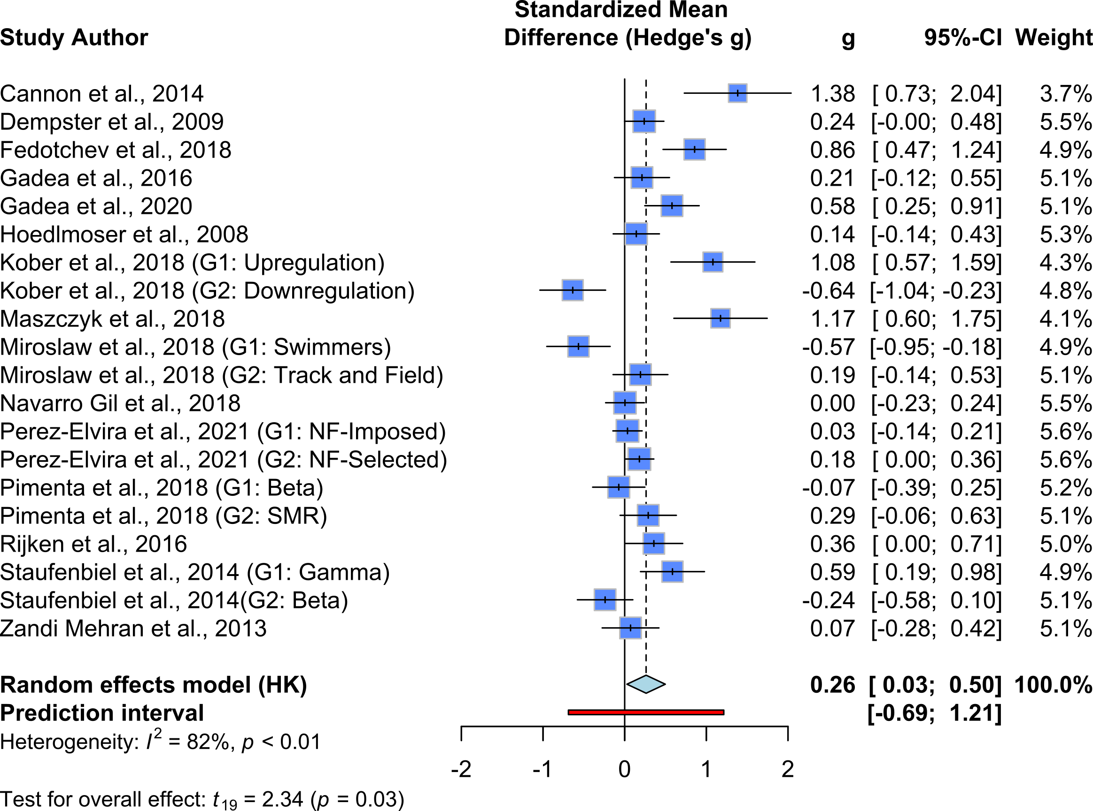

Post-training vs. Pre-training Baseline. Random effects model: Hedge’s g = 0.2624, CI = [0.028; 0.497], t = 2.34, p = 0.031

## Transfer Trial vs First Training

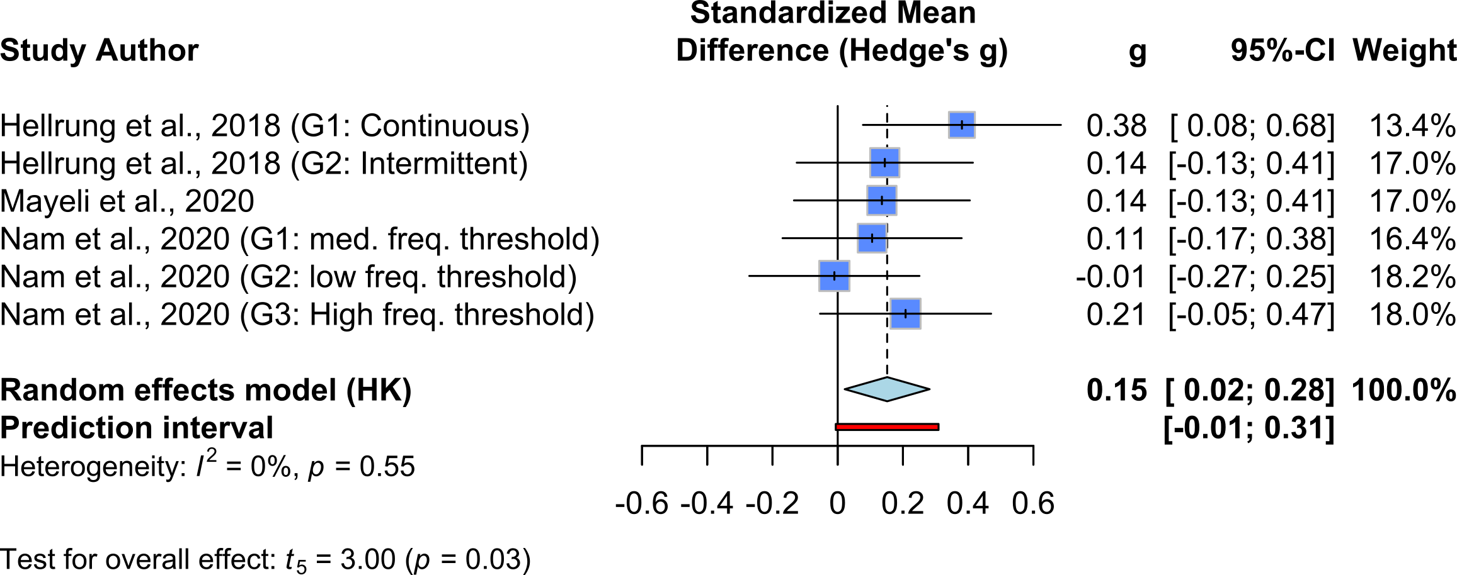

## Transfer Trial vs Baseline

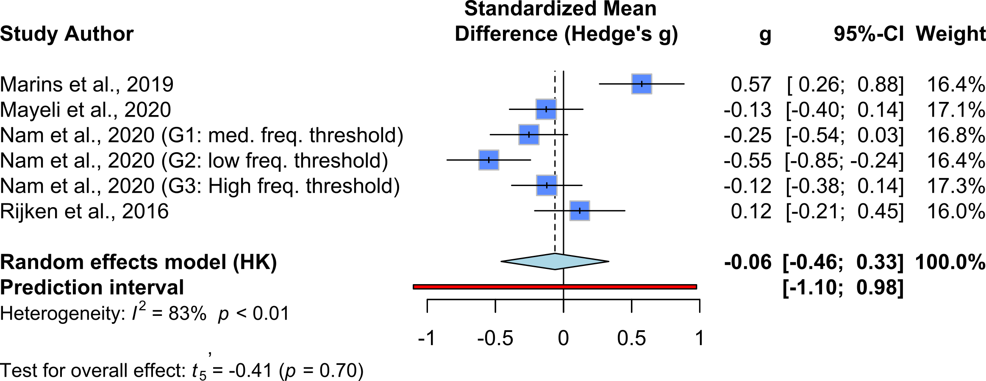 # Meta Regression Total Training Duration ## Total Training since First Training Trial 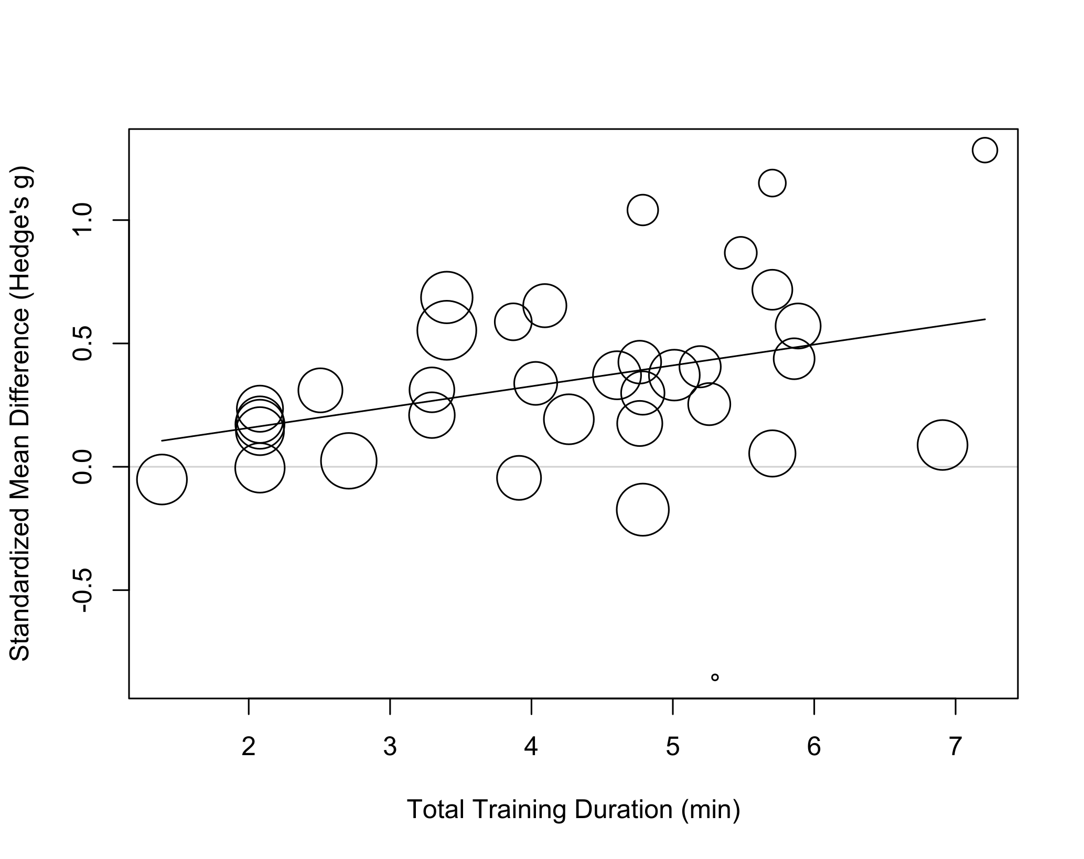

summary(m.gen.reg)

##   
## Mixed-Effects Model (k = 34; tau^2 estimator: REML)  
##   
## logLik deviance AIC BIC AICc   
## -5.9218 11.8435 17.8435 22.2407 18.7007   
##   
## tau^2 (estimated amount of residual heterogeneity): 0.0509 (SE = 0.0192)  
## tau (square root of estimated tau^2 value): 0.2255  
## I^2 (residual heterogeneity / unaccounted variability): 68.99%  
## H^2 (unaccounted variability / sampling variability): 3.22  
## R^2 (amount of heterogeneity accounted for): 13.19%  
##   
## Test for Residual Heterogeneity:  
## QE(df = 32) = 107.1422, p-val < .0001  
##   
## Test of Moderators (coefficient 2):  
## F(df1 = 1, df2 = 32) = 6.1869, p-val = 0.0183  
##   
## Model Results:  
##   
## estimate se tval df pval ci.lb ci.ub   
## intrcpt -0.0115 0.1470 -0.0784 32 0.9380 -0.3110 0.2880   
## training.dur.min.log 0.0845 0.0340 2.4873 32 0.0183 0.0153 0.1537 *   
##   
## ---  
## Signif. codes: 0 '***' 0.001 '**' 0.01 '*' 0.05 '.' 0.1 ' ' 1

## Total Training since Baseline

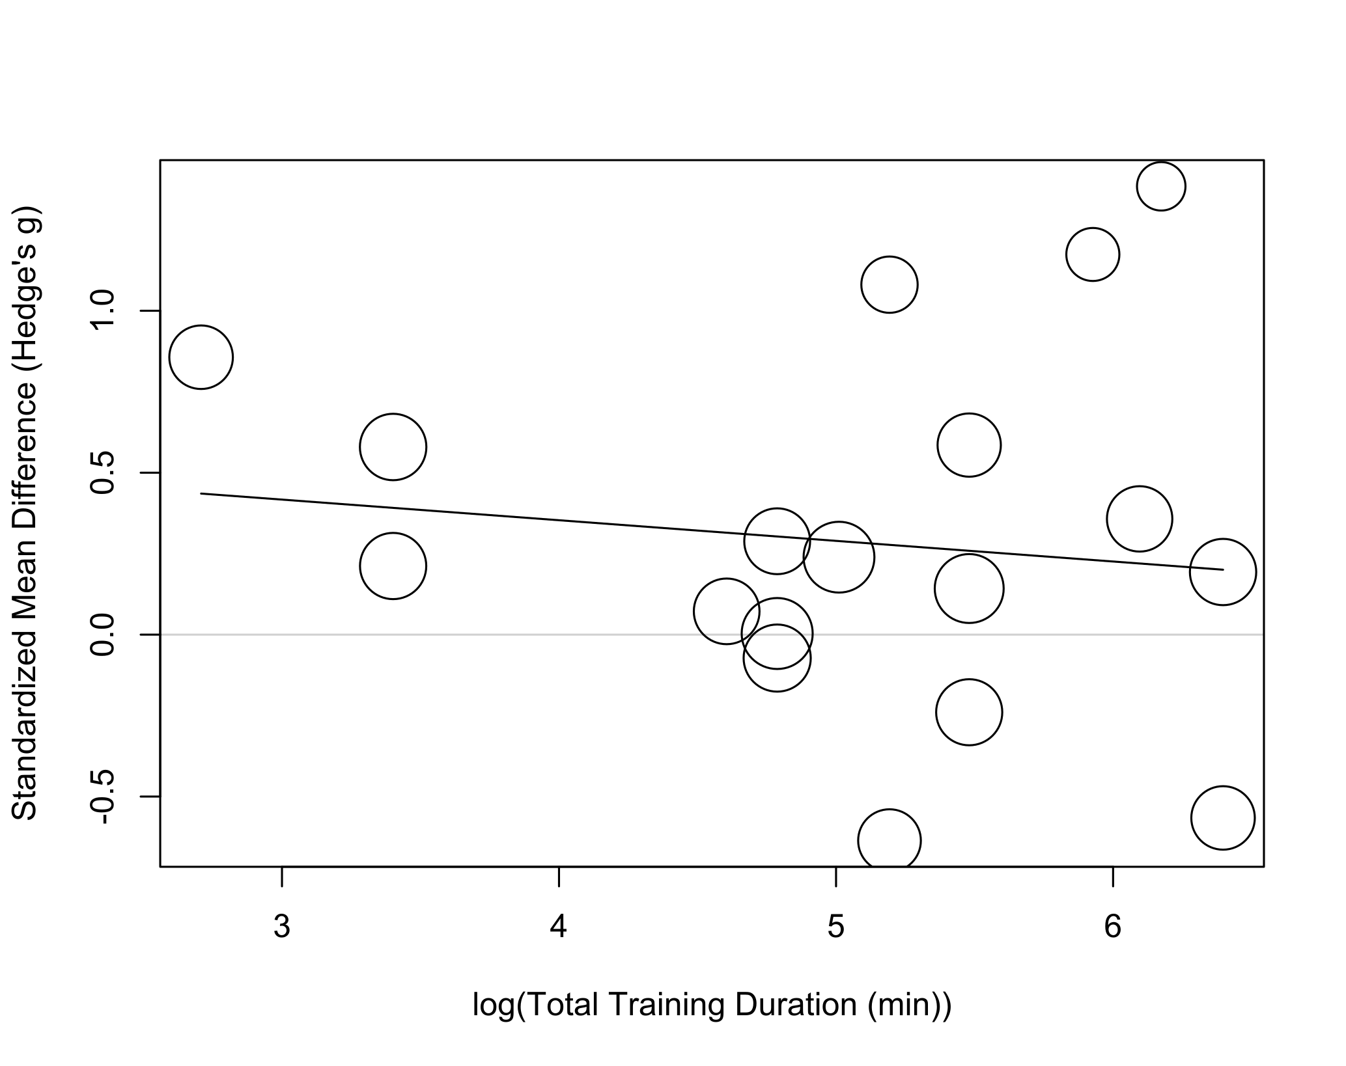

summary(m.gen.reg_base)

##   
## Mixed-Effects Model (k = 18; tau^2 estimator: REML)  
##   
## logLik deviance AIC BIC AICc   
## -13.0848 26.1695 32.1695 34.4873 34.1695   
##   
## tau^2 (estimated amount of residual heterogeneity): 0.2365 (SE = 0.0968)  
## tau (square root of estimated tau^2 value): 0.4863  
## I^2 (residual heterogeneity / unaccounted variability): 88.43%  
## H^2 (unaccounted variability / sampling variability): 8.65  
## R^2 (amount of heterogeneity accounted for): 0.00%  
##   
## Test for Residual Heterogeneity:  
## QE(df = 16) = 93.5799, p-val < .0001  
##   
## Test of Moderators (coefficient 2):  
## F(df1 = 1, df2 = 16) = 0.2525, p-val = 0.6222  
##   
## Model Results:  
##   
## estimate se tval df pval ci.lb ci.ub   
## intrcpt 0.6081 0.6530 0.9312 16 0.3656 -0.7762 1.9923   
## training.dur.min.log -0.0637 0.1268 -0.5025 16 0.6222 -0.3326 0.2051   
##   
## ---  
## Signif. codes: 0 '***' 0.001 '**' 0.01 '*' 0.05 '.' 0.1 ' ' 1

# Meta Regression For Multiple Trials

## SMD since First training session

### Interaction Between Amount of time and training since the first training trial

summary(reg.train_since_first_int)

##   
## Multivariate Meta-Analysis Model (k = 131; method: REML)  
##   
## logLik Deviance AIC BIC AICc   
## 17.7812 -35.5625 -23.5625 -6.4973 -22.8625   
##   
## Variance Components:  
##   
## estim sqrt nlvls fixed factor   
## sigma^2.1 0.0402 0.2005 34 no .id   
## sigma^2.2 0.0083 0.0912 131 no .id/.idx   
##   
## Test for Residual Heterogeneity:  
## QE(df = 127) = 319.1415, p-val < .0001  
##   
## Test of Moderators (coefficients 2:4):  
## F(df1 = 3, df2 = 127) = 11.4469, p-val < .0001  
##   
## Model Results:  
##   
## estimate se tval   
## intrcpt -0.2186 0.1570 -1.3920   
## log.train_amount_since_first 0.1029 0.0439 2.3439   
## log.time_since_first -0.0520 0.0244 -2.1321   
## log.train_amount_since_first:log.time_since_first 0.0173 0.0063 2.7373   
## df pval ci.lb   
## intrcpt 127 0.1664 -0.5294   
## log.train_amount_since_first 127 0.0206 0.0160   
## log.time_since_first 127 0.0349 -0.1002   
## log.train_amount_since_first:log.time_since_first 127 0.0071 0.0048   
## ci.ub   
## intrcpt 0.0922   
## log.train_amount_since_first 0.1898 *   
## log.time_since_first -0.0037 *   
## log.train_amount_since_first:log.time_since_first 0.0299 **   
##   
## ---  
## Signif. codes: 0 '***' 0.001 '**' 0.01 '*' 0.05 '.' 0.1 ' ' 1

### Amount of Training since First Training Session

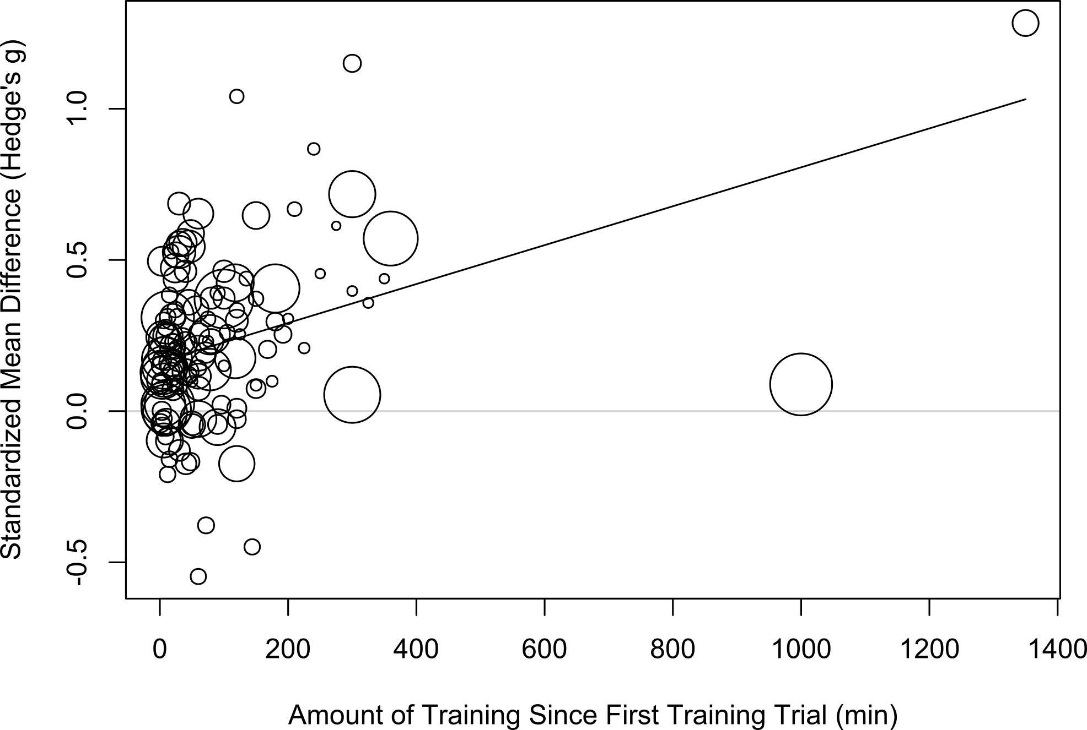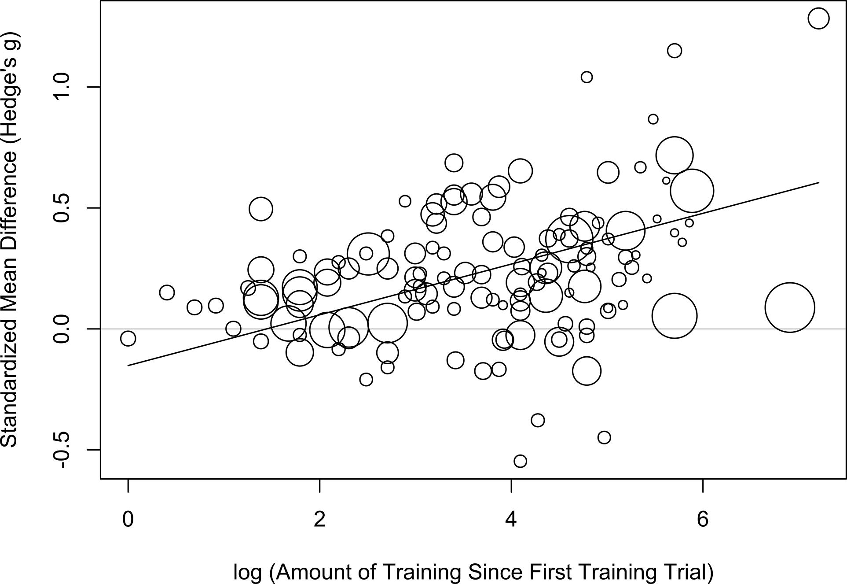

### Amount of Time since First Training Session

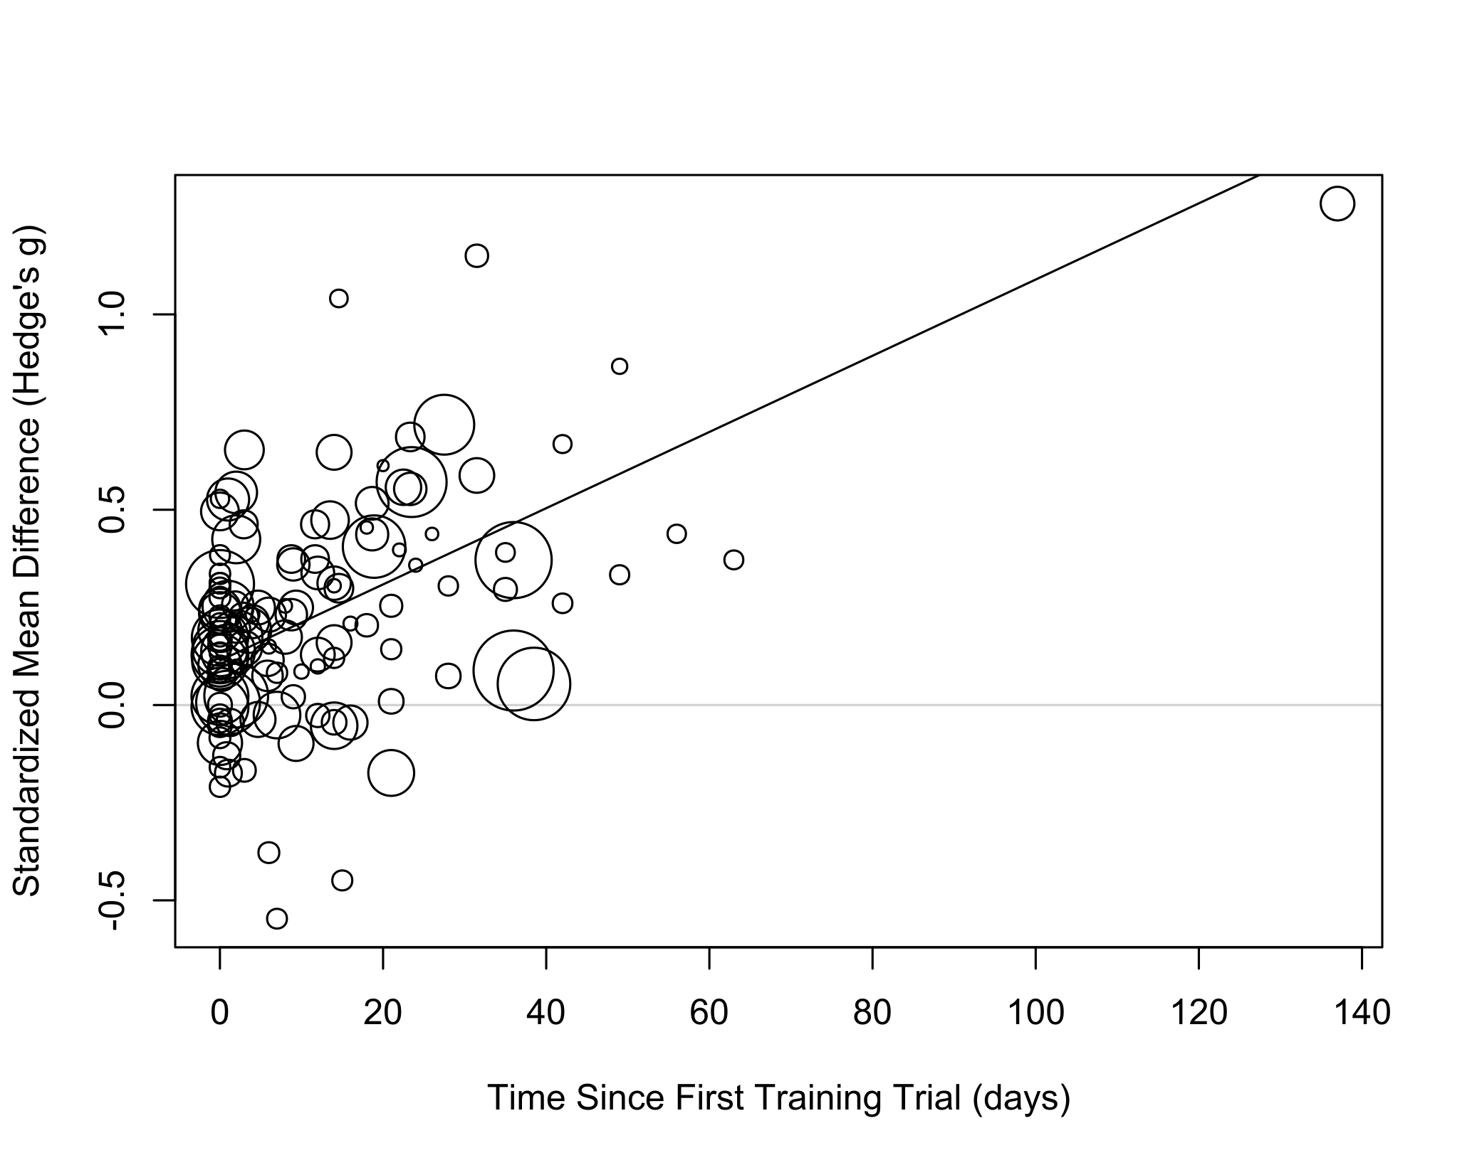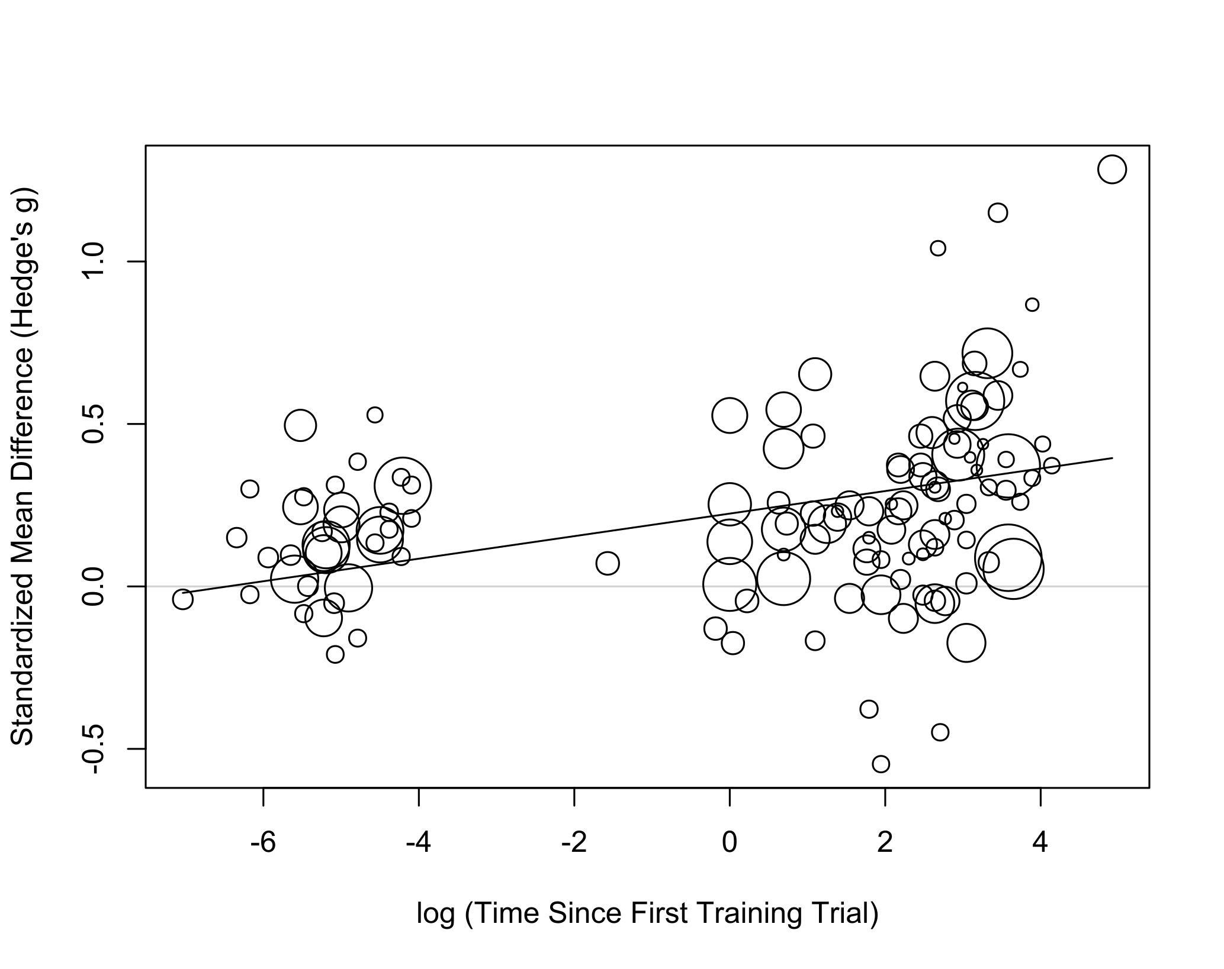

## SMD since Pre-training Baseline

### Interaction Between Amount of time and training since the first training trial

summary(reg.train_since_base_int)

##   
## Multivariate Meta-Analysis Model (k = 60; method: REML)  
##   
## logLik Deviance AIC BIC AICc   
## 8.9010 -17.8019 -5.8019 6.3502 -4.0876   
##   
## Variance Components:  
##   
## estim sqrt nlvls fixed factor   
## sigma^2.1 0.1772 0.4209 18 no .id   
## sigma^2.2 0.0000 0.0000 60 no .id/.idx   
##   
## Test for Residual Heterogeneity:  
## QE(df = 56) = 148.4588, p-val < .0001  
##   
## Test of Moderators (coefficients 2:4):  
## F(df1 = 3, df2 = 56) = 7.7856, p-val = 0.0002  
##   
## Model Results:  
##   
## estimate se tval   
## intrcpt -0.2658 0.2807 -0.9469   
## log.train_amount_since_first 0.0979 0.0635 1.5423   
## log.time_since_first 0.0013 0.0411 0.0323   
## log.train_amount_since_first:log.time_since_first 0.0071 0.0087 0.8198   
## df pval ci.lb ci.ub   
## intrcpt 56 0.3477 -0.8281 0.2965   
## log.train_amount_since_first 56 0.1286 -0.0293 0.2251   
## log.time_since_first 56 0.9744 -0.0810 0.0837   
## log.train_amount_since_first:log.time_since_first 56 0.4158 -0.0103 0.0245   
##   
## intrcpt   
## log.train_amount_since_first   
## log.time_since_first   
## log.train_amount_since_first:log.time_since_first   
##   
## ---  
## Signif. codes: 0 '***' 0.001 '**' 0.01 '*' 0.05 '.' 0.1 ' ' 1

### Amount of Training since Baseline

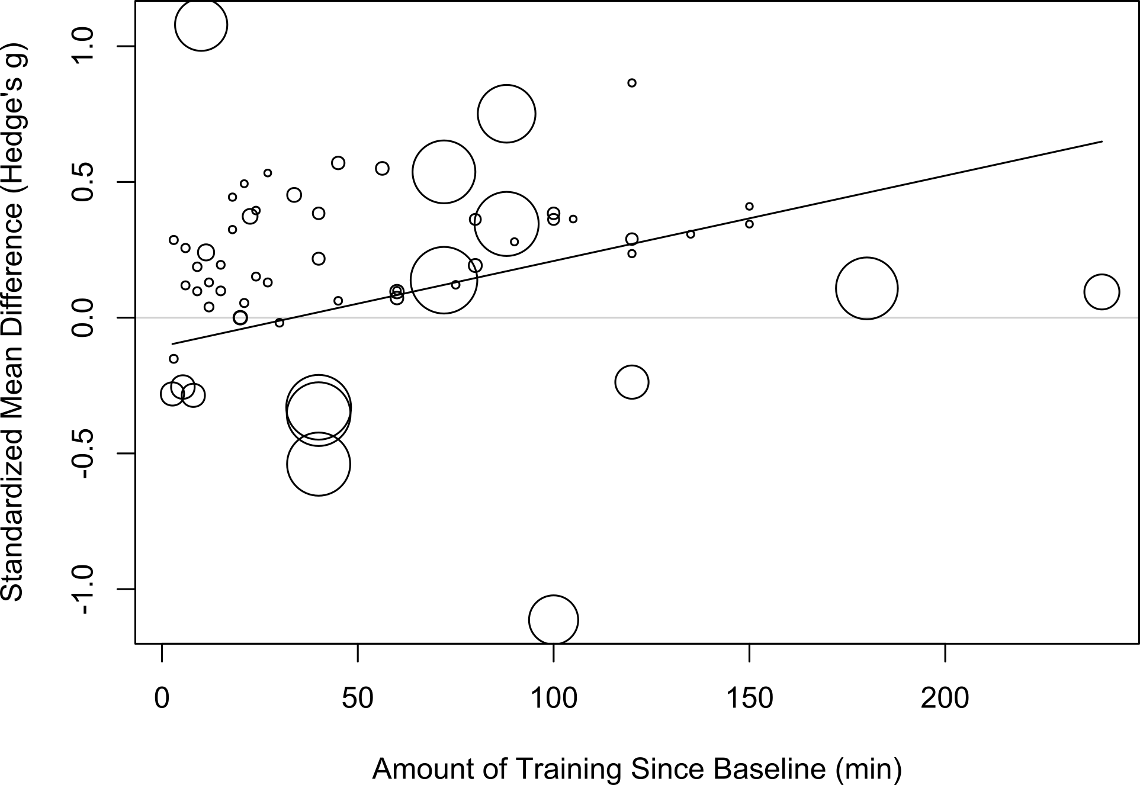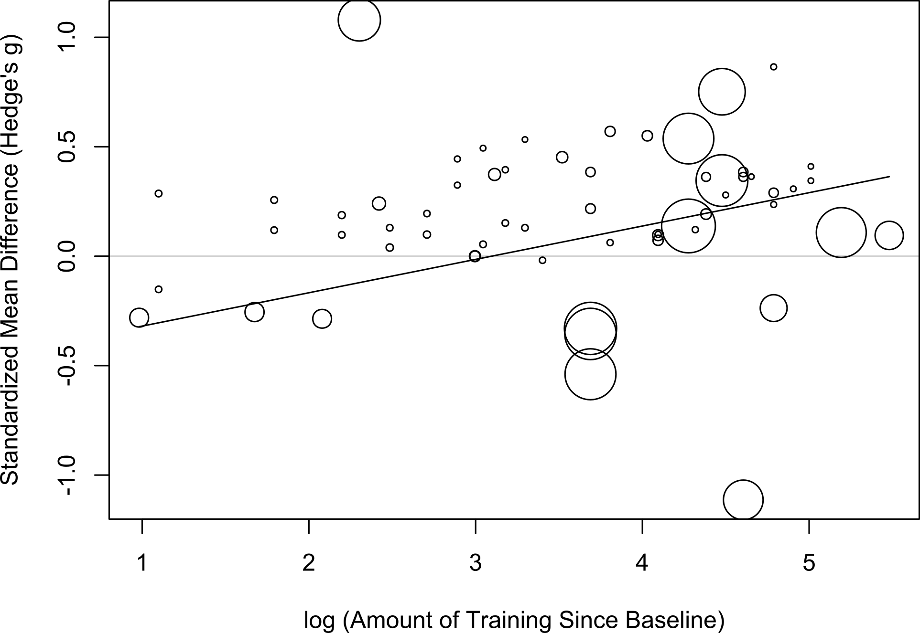

### Amount of Training since Baseline

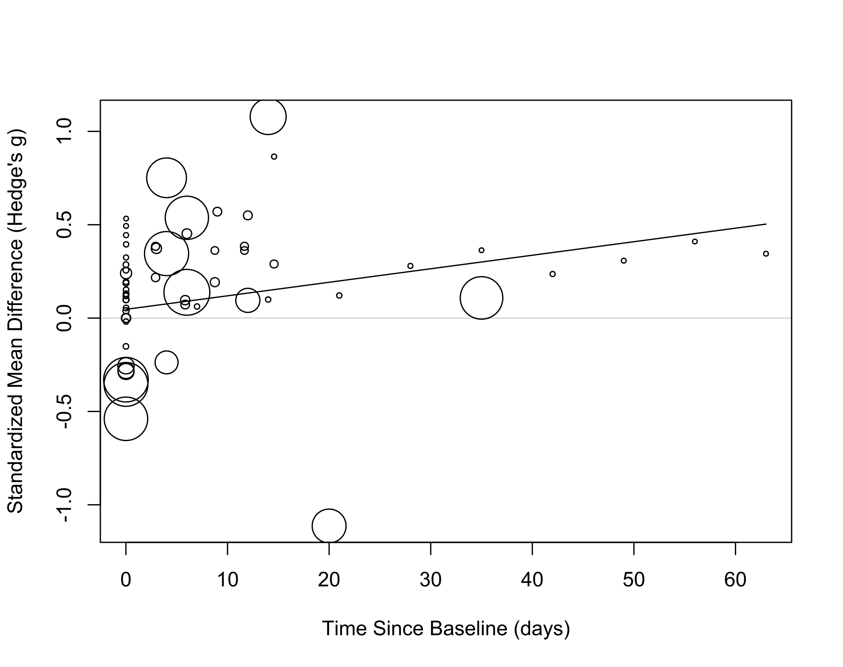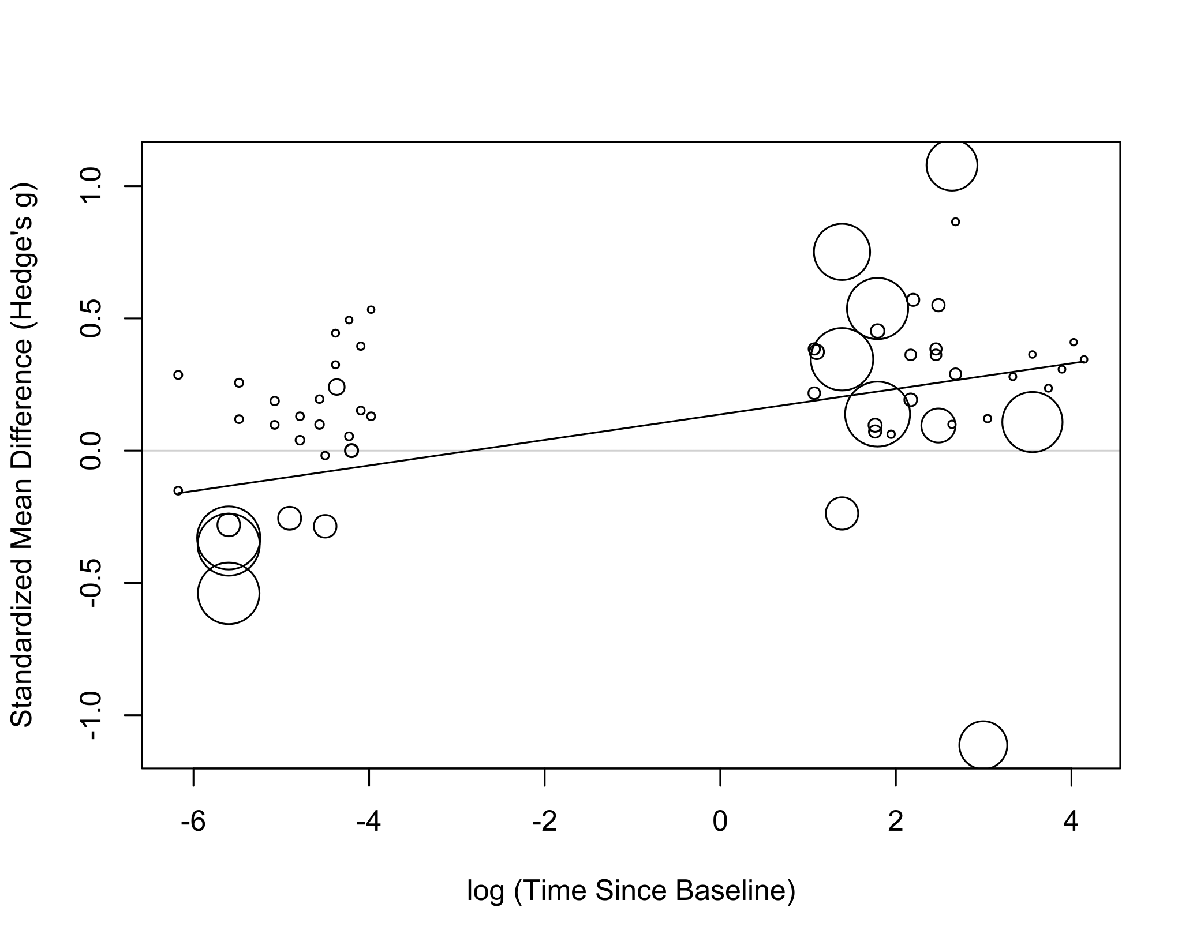

# Egger’s Test

summary(eggers)

## Eggers' test of the intercept   
## =============================   
##   
## intercept 95% CI t p  
## 2.527 0.76 - 4.3 2.797 0.0068  
##   
## Eggers' test indicates the presence of funnel plot asymmetry.

