Neurofeedback Parameters Meta-Analysis

2024-05-22

# Summary

A meta-analysis was conducted testing the influence of different neurofeedback (NF) training parameters on changes in neural activity from (1) first NF training session to last training session (k = 35) and (2) pre-training baseline to post-training rest (k = 20). Analyses were conducted on the following predictors: training duration, presence of pretraining rehearsal, imaging device, quality assessment score, presence of additional training instruction, blinding, functinal localizer, year and age. Predictors with too few cases per level (<10) were excluded from the analysis.

## Methods

* **Convert SE to SD**: All pre and post variability measures were converted to standard deviation in order to calculate the standardized mean difference (SMD)
* The **standardized mean difference (SMD)** was calculated using Hedge’s g, as this is appropriate for studies with small sample sizes (Mean N = 16.23, SD = 12.67) (Hedge, 1981). This was done separately for last vs. first training session and post-training vs. baseline.
* **Adjust for Direction of Effect**: In studies where the task was to decrease activity, the SMD was multiplied by -1 to ensure that a positive SMD indicates a change in the predicted direction.
* **Pooled effect size**: Random effects model was used to calculate the pooled effect size. The Restricted Maximum Likelihood (REML) method was used for estimating the between-study variance (tau²). REML was used since it produces results with reduced bias (Veroniki et al., 2016). The R package meta was used to calculate the pooled effect sizes (Balduzzi, 2019).
* **Outlier detection**: Graphic Display of Heterogeneity (GOSH) plot analysis (Olkin, 2012) was performed in order to identify influential cases which had a significant contrbution to heterogeneity.

### Meta-regression and Sub-Group Analyses:

* **Check for Multicollinearity**: Correlations between predictor variables were assessed to check for multicollinearity. Variables with correlations ≥ 0.8 were considered for removal. No significant multicollinearity was detected.
* **Multi-model inference**: was used to identify the best-fitting model and the most influential predictors (Harrer et al., 2009).
* **Meta-Regression Analysis**: Meta-regression was performed to investigate the effect of potential moderators on the effect sizes.
* The following **sub-group analyses** were performed: blinding, imaging device, instruction provided, presence of pre-training rehearsal, functional localizer.

## Results

* When testing the overall difference between the first and last training sessions there was a significant effect of training (*g* = 0.34, *t* = 6.31, *p* < 0.001).
* There was no significant effect when testing the difference between pre-training baseline and post-training activity (*g* = 0.2, *t* = 2.05, *p* = 0.056).
* The effect size for studies that used EEG was significantly higher (g = .40) than those that used fMRI (g = .19) (p = .01)
* The effect size for studies that included a pre-training rehearsal trial was significantly lower (g = 0.20) than those that did not include one (g = 0.40) (p = .04)
* Although multimodel inference analysis classified training duration as the most important predictor, there was no significant relationship between standardized mean differences and training duration( $I^{2}$ = 71.51%, $R^{2}$ = .77%, $F\left(1,32\right)$ = 3.32, *p* = 0.078)

## Next Steps and Questions

* Go back to the papers that reported more than one type of feedback and maybe try to find a way to further aggregate studies or reduce categories.
  + Multimodal vs non
  + Number vs non
* Regions of interest might need to be aggregated into categories. Discuss with group on how to do this.
  + Cortical vs sub cortical
  + Systems (functional connectitivity)
  + How many fit into each category
  + Left and right
* Need to make a comparison between different targeted frequency bands. Some frequency bands have too few studies and might need to be excluded. Another option is to treat frequency as a continous variable.
* Plot risk of bias
* How can we include data from multiple sessions? One option could be to run a regression between SMD and time since first session with amount of training up to that point as a covariate. Open to suggestions.
  + Intersession interval also issue
  + Compare slopes
* How do we apply correction for multiple comparisons here?
* Need to clean methods and results for the manuscript. Also not sure what are all the values that need to be included with each result.
* NOTES

# Matrix of papers with SMD

* Clean spreadsheet
* Smd and variables

Thursday at 1

# Overall Effect of Training

A random effects model was used to test the overall effect of training on neural activity.

## Last vs. First training session

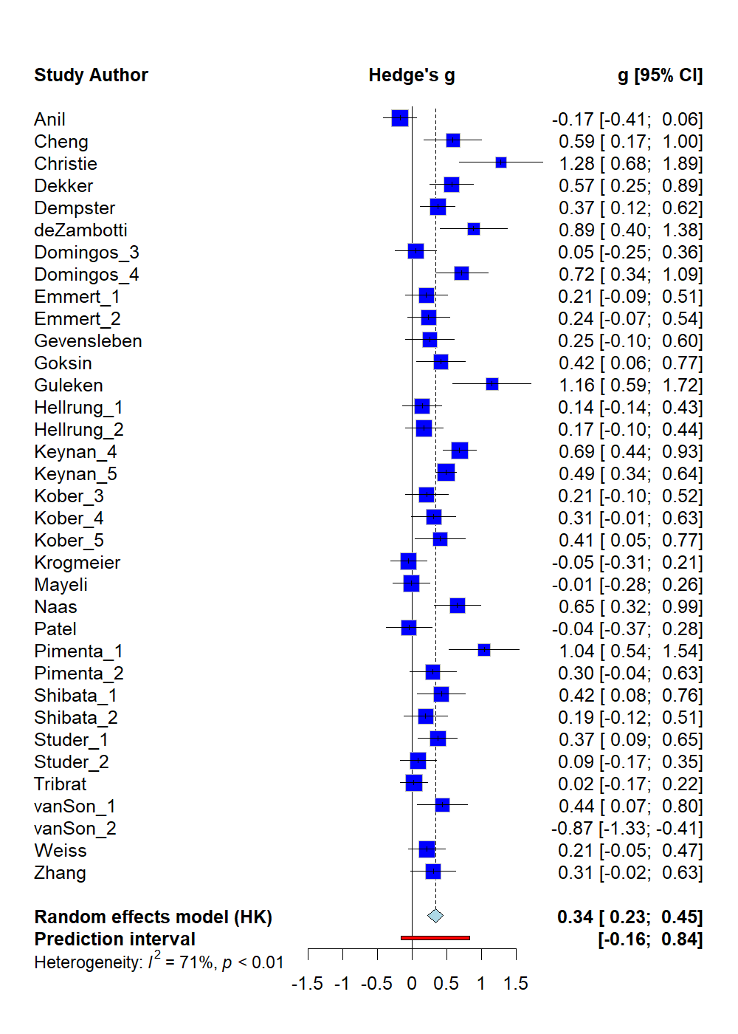

*When testing the overall difference between the first and last training sessions there was a significant effect of training (Hedge’s g = 0.3369, CI = [ 0.2284; 0.4455], t = 6.31, p < 0.001)*

## Post-training vs. Pre-training Baseline

## Post-training vs. Pre-training Baseline. Random effects model: Hedge’s g = 0.1999, CI = [-0.0054; 0.4053], t = 2.05, p = 0.0557

*There was no significant effect of training when testing the difference between pre-training baseline and post-training activity (g = 0.2, t = 2.05, p = 0.056).*

## Sensitivity Analyses on Outlier Influence

Outliers were detected using the *graphic display of heterogeneity (GOSH)* plot analysis. Sensitivity analyses comparing the results before and after removing the outliers are reported below.

### Last vs. First training session

| ***Analysis*** | ***g*** | ***95%CI*** | ***p*** | ***95%PI*** | ***I2*** | ***95%CI*** |
| --- | --- | --- | --- | --- | --- | --- |
| Main Analysis | 0.32 | 0.19-0.44 | <0.001 | -0.29-.93 | 75.4% | 65.9-82.2 |
| Infl. Cases Removed1 | 0.37 | 0.23-0.45 | <0.001 | -0.16-0.84 | 70.9% | 58.8-79.4 |

*1 Removed as outliers: Van Son (group B).*

### Post-training vs. Pre-training Baseline

| ***Analysis*** | ***g*** | ***95%CI*** | ***p*** | ***95%PI*** | ***I2*** | ***95%CI*** |
| --- | --- | --- | --- | --- | --- | --- |
| Main Analysis | 0.15 | -0.08-0.38 | 0.19 | -0.78-1.08 | 81.2% | 71.8%-87.4%] |
| Infl. Cases Removed2 | 0.2 | 0.005-0.40 | 0.056 | -0.58-0.98 | 77.9% | 66.0%-85.7% |

*2 Removed as outliers: Maszczyk.*

# Meta-Regression

## Multimodel Inference

Multimodel inference was used to identify the best-fitting model and the most influential predictors

### Last vs. First training session

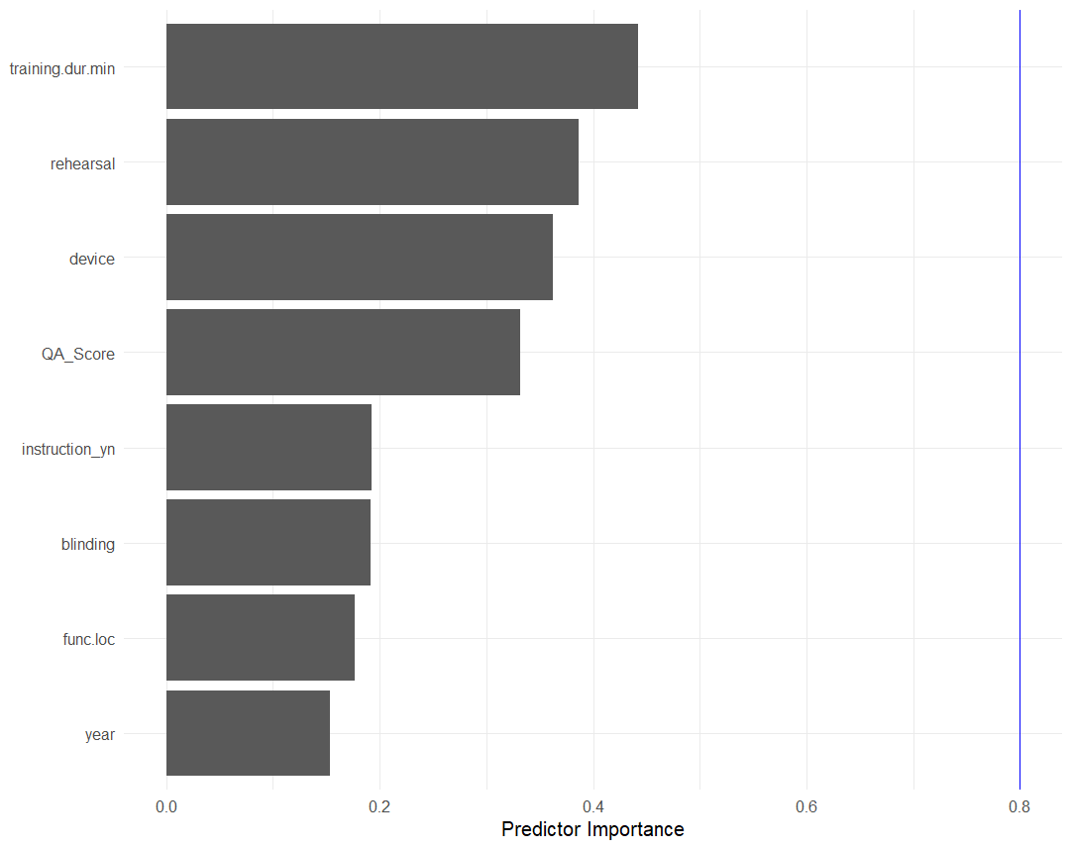

Predictors in Last vs. First training session ranked by importance. Results from the analysis indicated that best fit occurs when predictors are looked at separetely

### Post-training vs. Pre-training Baseline

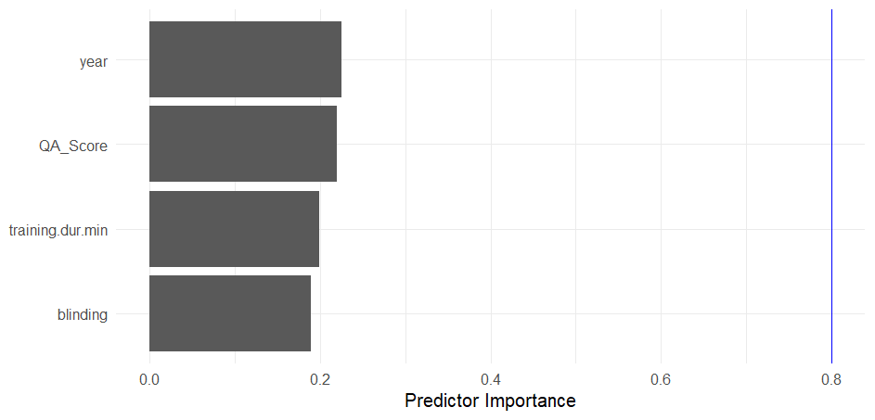

Predictors in Post-training vs. Pre-training Baseline ranked by importance. Results from the analysis indicate that best fit occurs when predictors are looked at separetely

## Mixed-Effects Model Regression

### Training Duration

#### Last vs. First training session

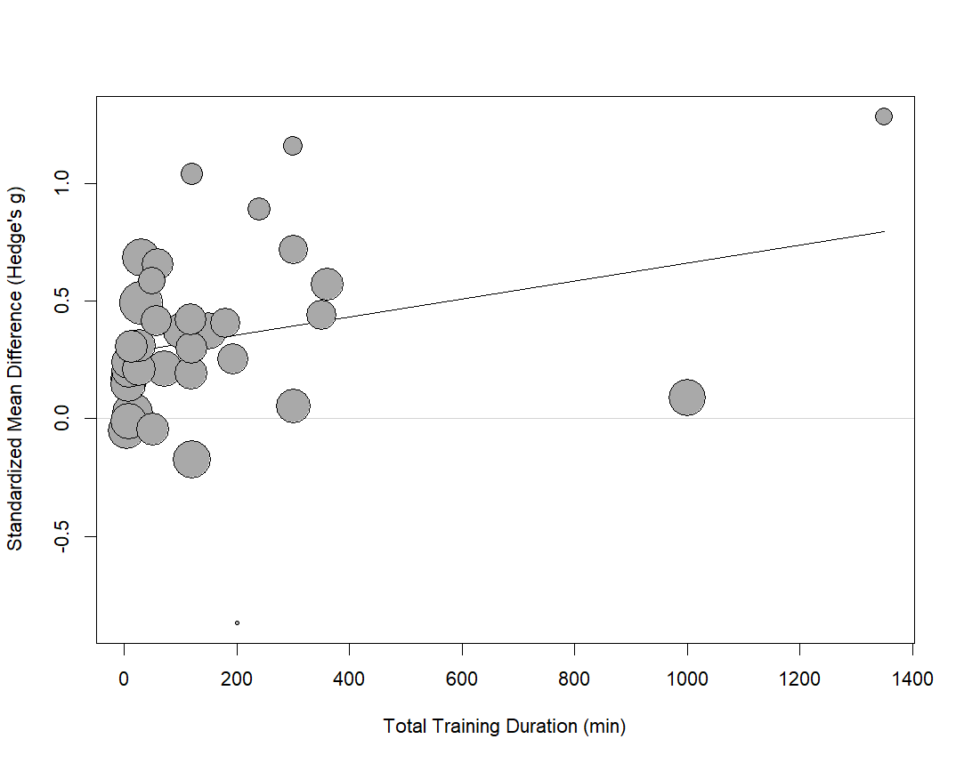

There was no significant relationship between Standardized Mean Difference (Hedge’s g) and total training duration. (k = 34, $I^{2}$ = 71.51%, $R^{2}$ = .77%, $F_{\left(1,32\right)}$ = 3.32, p = 0.078)

#### Post-training vs. Pre-training Baseline

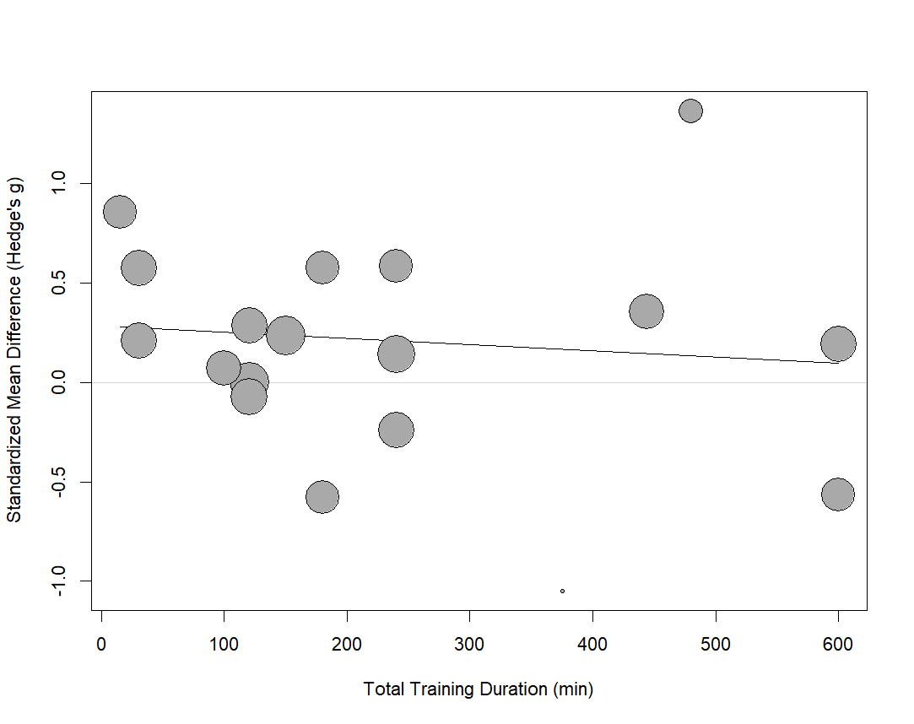

There was no significant relationship between Standardized Mean Difference (Hedge’s g) and total training duration. (k = 17, $I^{2}$ = 84.98%, $R^{2}$ = 0.0%, $F_{\left(1,15\right)}$ = 0.24, p = 0.63)

### Quality Score

#### Last vs. First training session

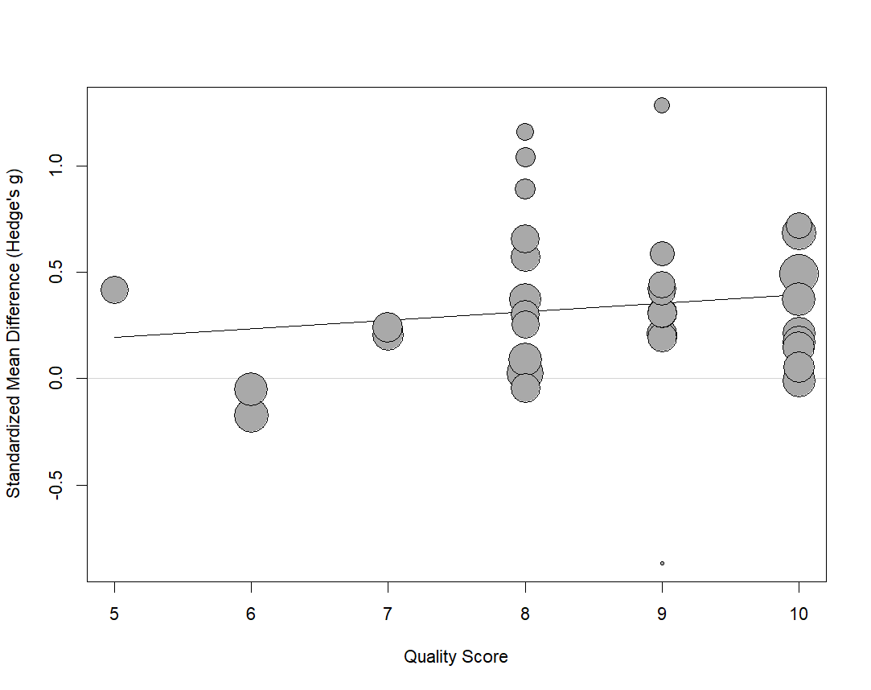

There was no significant relationship between Standardized Mean Difference (Hedge’s g) and Study Quality Score. (k = 34, $I^{2}$ = 70.77%, $R^{2}$ = 3.0%, $F_{\left(1,32\right)}$ = .96, p = 0.34)

#### Post-training vs. Pre-training Baseline

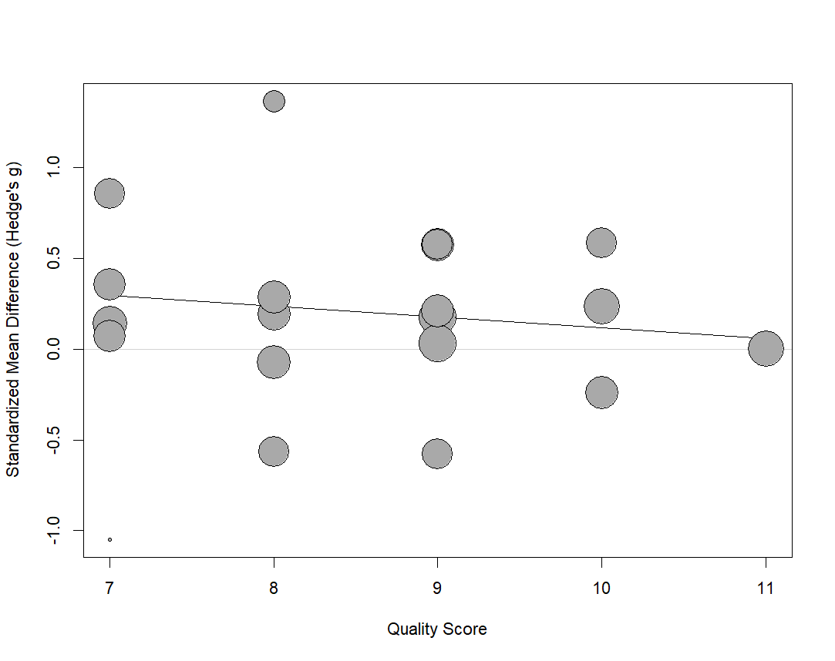

There was no significant relationship between Standardized Mean Difference (Hedge’s g) and Study Quality Score. (k = 19, $I^{2}$ = 85.24%, $R^{2}$ = 0.0%, $F_{\left(1,17\right)}$ = 0.48, p = 0.50)

### Age

#### Last vs. First training session

There was no relationship between age and SMD (*k* = 23, $I^{2}$ = 64.9%, $R^{2}$ = 5.13%, $F_{\left(1,21\right)}$ = 1.45, *p* = 0.24)

#### Post-training vs. Pre-training Baseline

There was no relationship between age and SMD (*k* = 13, $I^{2}$ = 87.01%, $R^{2}$ = 0.0%, $F_{\left(1,11\right)}$ = 0.42, *p* = 0.53)

## Subgroup Analyses

### Imaging Device Used

#### Last vs. First training session

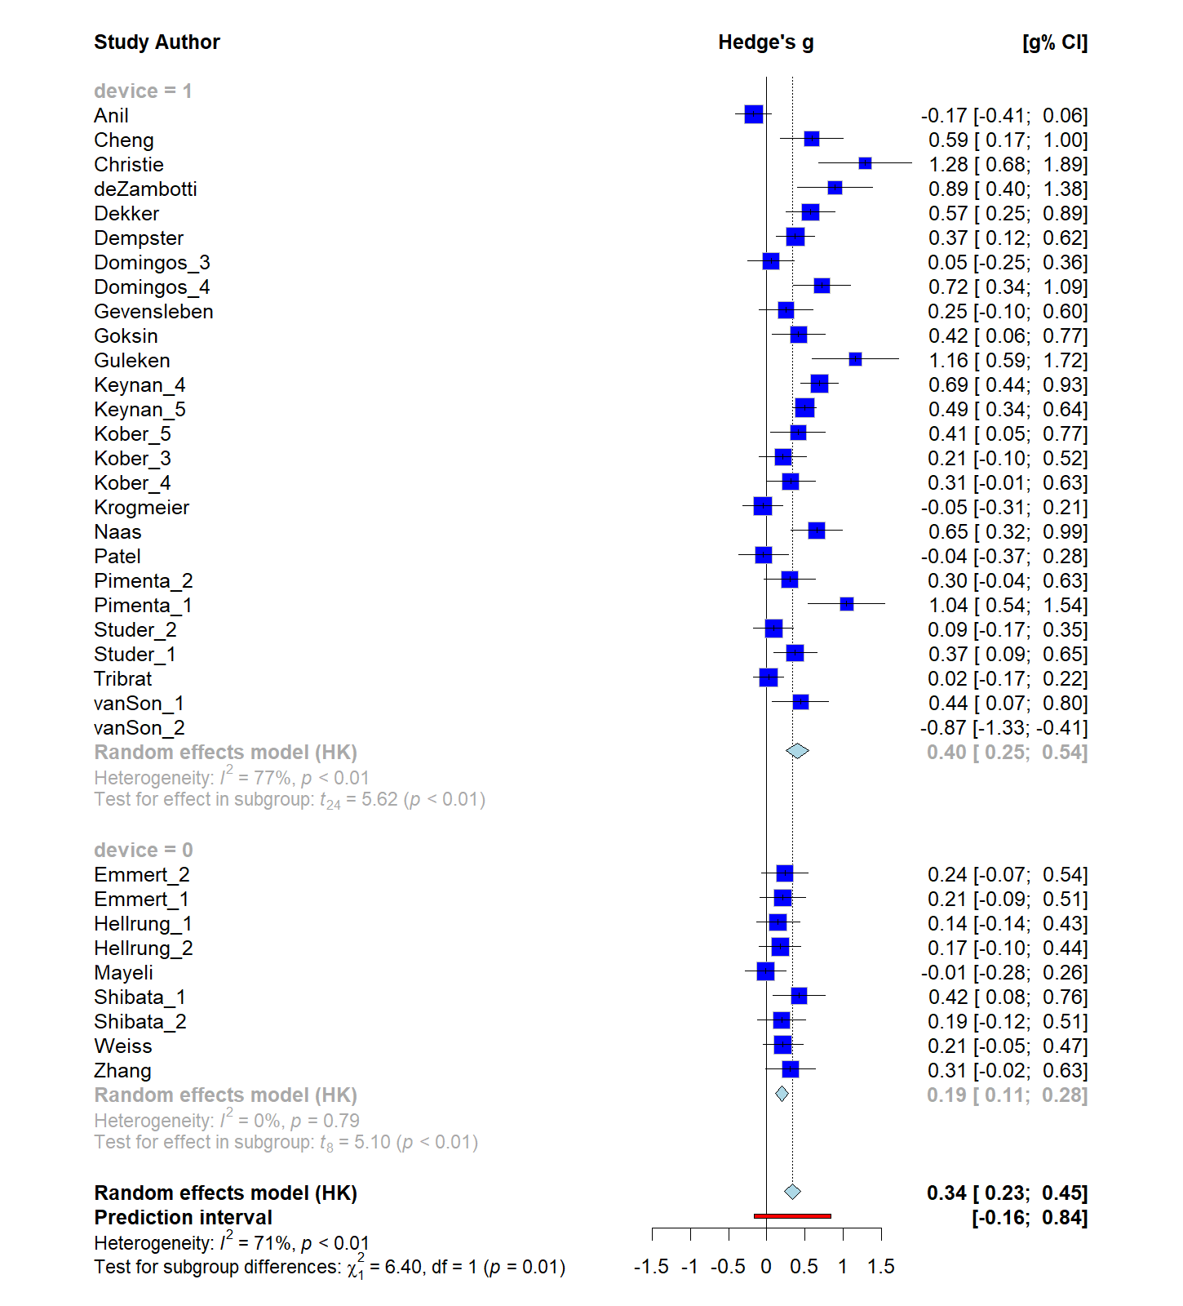

*Subgroup analysis comparing EEG (device = 1) and fMRI (device = 0) studies’ effect sizes. The effect size for studies that used EEG (g = .40) was significantly higher than those that used fMRI (g = .19) (p = .01)*

### Pre-training Rehearsal Present

#### Last vs. First training session

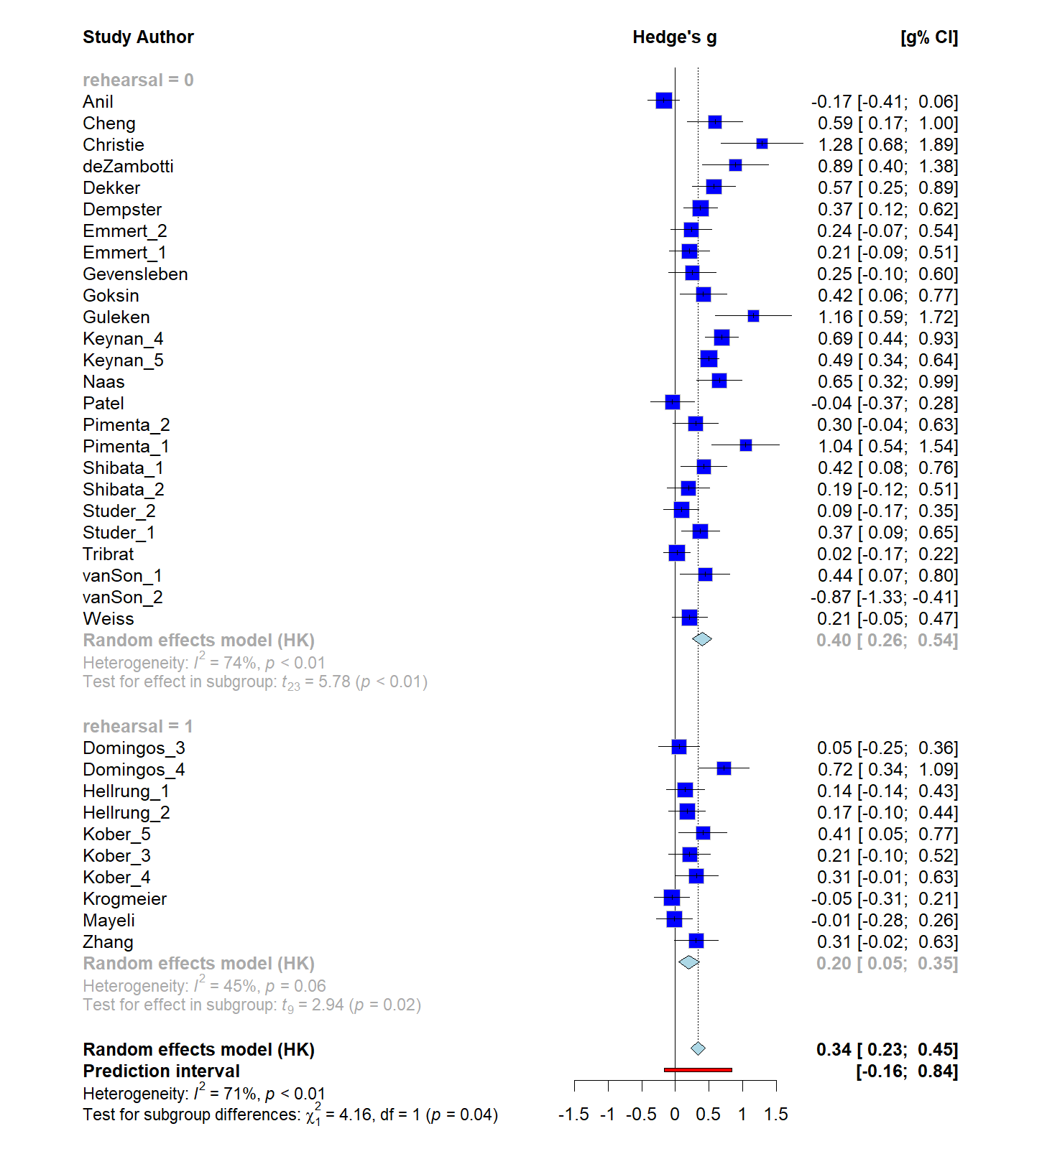

*Subgroup analysis comparing studies with pre-training rehearsal (1) and no rehearsal (0). The effect size for studies that included a pre-training rehearsal trial was significantly lower (g = 0.20) than those that did not include one (g = 0.40) (p = .04)*

### Blinding

#### Last vs. First training session

There was no difference between blinding (*k* = 15, *g* = 0.35) and no blinding (*k* = 19, *g* = 0.33) (*Q* = 0.05, *p* = .82)

#### Post-training vs. Pre-training Baseline

There was no difference between blinding (*k* = 9, *g* = 0.25) and no blinding (*k* = 10, *g* = 0.16) (*Q* = 0.15, *p* = .70)

### Functional Localizer Used

#### Last vs. First training session

There was no difference between the presence of a functional localizer (*k* = 10, *g* = 0.29) vs non (*k* = 24, *g* = .36) (*Q* = 0.53, *p* = .47).

### Presence of Instruction for Feedback Training

#### Last vs. First training session

There was no difference between the presence of a additional instruction (*k* = 12, *g* = 0.26) vs non (*k* = 22, *g* = .37) (*Q* = 1.15, *p* = .28).