Hospital Readmission & Resource Utilization Analytics

Executive Summary
This project analyzes hospital admission data to identify operational inefficiencies related to patient readmissions, bed utilization, and length of stay. Using Python, PostgreSQL, and Power BI, key performance indicators were derived to support hospital leadership in reducing readmissions, optimizing capacity, and improving discharge efficiency. The analysis highlights high-risk departments such as Neurology and provides data-driven recommendations for operational improvement.

1. Business Context & Problem Statement

Business Problem
Hospitals face continuous operational and financial challenges due to:
- High patient readmission rates
- Inefficient bed utilization
- Extended average length of stay (ALOS)
- Delays in patient discharge
These issues lead to increased operational costs, reduced patient satisfaction, and capacity constraints, especially during peak admission periods.

Project Goal
The objective of this project is to use data analytics to:
- Monitor and analyze hospital readmission patterns
- Optimize bed occupancy and resource utilization
- Identify departments contributing to long patient stays
- Enable data-driven decision-making for hospital management

2. Data Source & Data Gathering

Data Source
The dataset is modeled on publicly available hospital admission datasets and structured to reflect real-world healthcare operations. The raw data contains 1,000+ patient admission-level information including department, admission dates, discharge dates, and resource utilization metrics.
The structure aligns with commonly available open healthcare datasets such as:
- Government hospital admission records
- Public healthcare performance datasets
- Admission and discharge data

Key Fields
- patient_id
- admission_id
- department
- admission_date
- discharge_date
- readmitted
- total_beds
- occupied_beds
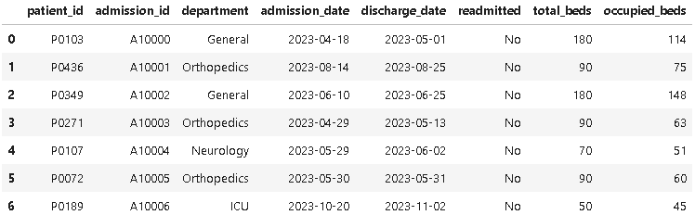
3. Data Cleaning & Preparation (Python – Jupyter Notebook)

Tools Used
- Python
- Pandas
- NumPy
- Jupyter Notebook

Cleaning Steps Performed
- Removed duplicate admission records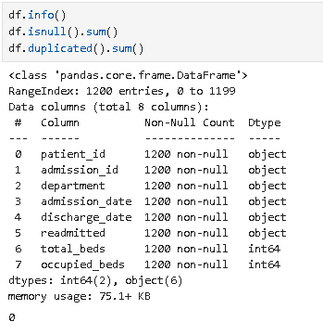

- Standardized department names
- Converted date fields to proper datetime format
- Validated discharge dates against admission dates
- Created derived fields:
  - Length of Stay (LOS)
  - Readmission flag
  - Bed Occupancy Rate
  - Long Stay Indicator
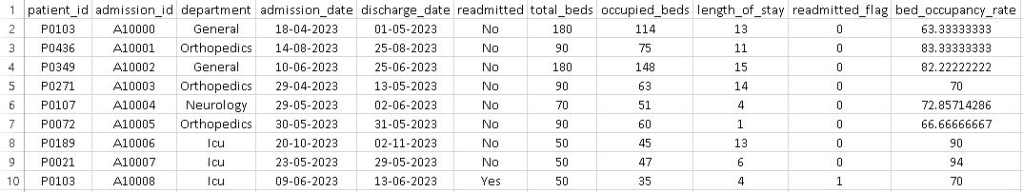

Outcome
The cleaned dataset ensures:
- Consistent data types
- Accurate date calculations
- Reliable KPIs for downstream analysis
The final cleaned data was exported as:
hospital_admissions_cleaned.csv

4. Data Storage & KPI Derivation (PostgreSQL)

Database Used
- PostgreSQL (pgAdmin 4)

Process
- Imported the cleaned CSV into PostgreSQL
- Created structured tables for admissions
- Used SQL queries to derive KPIs

Key KPIs Derived
- Total Admissions
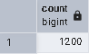
- Readmission Rate
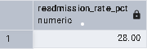
- Average Length of Stay (ALOS)
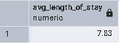
- Bed Occupancy Rate
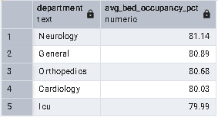
- Discharge Efficiency
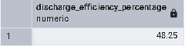
- Readmitted Patients by Department
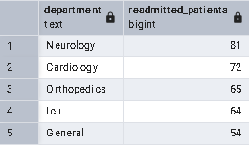
- Long Stay Patients by Department
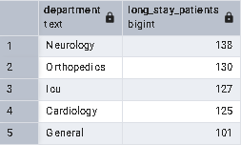

KPI Definitions
- Readmission Rate: Percentage of admissions where the patient was readmitted within the observation period.
- Average Length of Stay (ALOS): Average number of days between admission and discharge.
- Bed Occupancy Rate: Percentage of occupied beds relative to total available beds.
- Discharge Efficiency: Percentage of patients discharged within the defined acceptable length of stay threshold.
SQL enables:
- Accurate aggregation logic
- Validation of Power BI calculations
- Scalable backend analytics

5. Data Visualization (Power BI)

Tool Used
- Microsoft Power BI

Dashboard Title
Hospital Readmission & Resource Utilization Dashboard
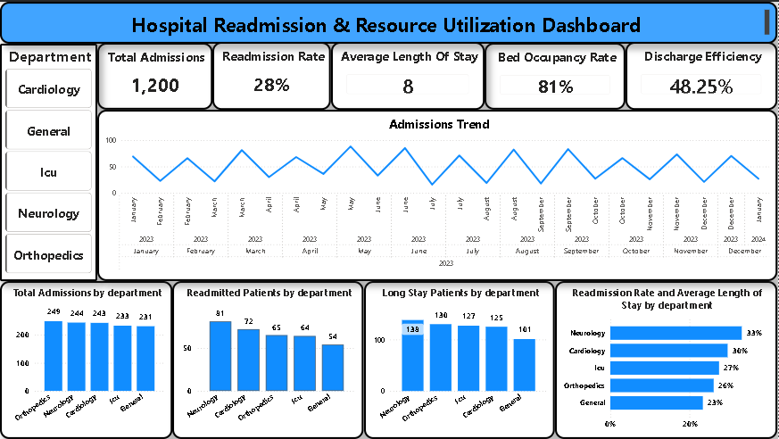

Dashboard Objectives
- Provide leadership with a real-time operational overview
- Identify high-risk departments
- Monitor capacity utilization trends
- Support data-driven healthcare decisions

Key Dashboard Sections
- KPI Summary
  - Total Admissions
  - Readmission Rate
  - Average Length of Stay
  - Bed Occupancy Rate
  - Discharge Efficiency
- Trend Analysis
  - Admissions trend over time
- Department-Level Insights
  - Total admissions by department
  - Readmitted patients by department
  - Long-stay patients by department
  - Readmission rate comparison across departments
- Interactive Controls
  - Department slicer
  - Time-based filtering

6. Key Insights
- The overall readmission rate is 28%, indicating potential gaps in post-discharge care.
- Neurology shows the highest readmission rate (33%) and the highest number of long-stay patients, suggesting complex case handling and discharge challenges.
- General Medicine handles high admission volumes while maintaining the lowest readmission rate (23%), indicating effective discharge practices.
- Average Length of Stay is 8 days, contributing to sustained bed occupancy.
- Bed occupancy at 81% reflects controlled utilization but signals risk during peak admission periods.
- Discharge efficiency of 48.25% indicates scope for improving patient turnover.

7. Action Plan & Recommendations

Operational Improvements
- Implement structured post-discharge follow-up programs for high-risk departments.
- Introduce early discharge planning for patients with extended stays.
- Apply best practices from General Medicine across other departments.

Capacity Management
- Monitor occupancy trends proactively to avoid congestion.
- Optimize bed allocation during seasonal admission spikes.

Data-Driven Governance
- Track KPIs monthly using the Power BI dashboard.
- Set department-level benchmarks for readmission reduction.

8. Conclusion
This solution demonstrates how data analytics can directly support hospital operational strategy by reducing inefficiencies, improving patient flow, and enabling proactive decision-making. Raw hospital admission data was transformed into actionable insights through a structured end-to-end analytics approach.
By integrating Python for data cleaning, PostgreSQL for KPI derivation, and Power BI for interactive visualization, the solution provides hospital leadership with a reliable decision-support system.
As a result, stakeholders are empowered to reduce avoidable readmissions, optimize bed utilization, improve discharge efficiency, and enhance overall operational performance.

