Radiant Rovers Football Academy — Player Performance Analysis
Prepared by: Muddassir Mushtaq Mulla
Tools: Python (Pandas, NumPy), PostgreSQL, Power BI
Dataset: 48 Players | 20 Matches | Player-level performance data

1. Project Overview
This project focuses on analysing on-field performance data for Radiant Rovers Football Academy using player-level match data collected across 20 competitive matches. The objective of this analysis is to evaluate individual and team performance, identify top performers, understand fitness and technical trends, and support data-driven coaching and player development decisions.
The complete analytics pipeline follows an end-to-end workflow:
CSV → Python (Jupyter Notebook) → PostgreSQL (SQL KPIs) → Power BI Dashboard

2. Dataset Summary
The dataset represents match-wise performance records of academy players.
Dataset characteristics:
- Total rows (player–match records): 960
- Total players: 48
- Total matches: 20
Key features include:
Player Information
- Player ID
- Player Name
- Age
- Playing Position
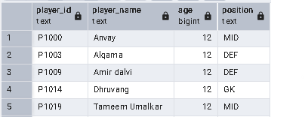
Match Details
- Match ID
- Match Date
- Minutes Played
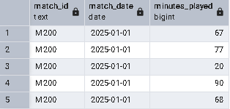
Performance Metrics
- Goals
- Assists
- Shots on Target
- Tackles
- Passing Accuracy
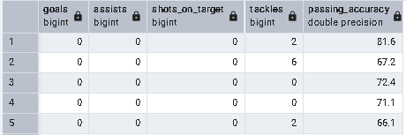
Fitness Metrics
- Fitness Score
- Stamina
- Speed
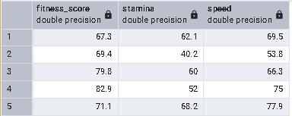

Training Indicator
- Attendance
Data Quality Notes:
- Player goal and assist values were complete after cleaning
- Missing performance metrics were handled logically during preprocessing
- Dataset is suitable for player-level and match-level analysis

3. Exploratory Data Analysis using Python
Python (Pandas & NumPy) was used inside a Jupyter Notebook to clean, transform, and prepare the dataset for analysis.
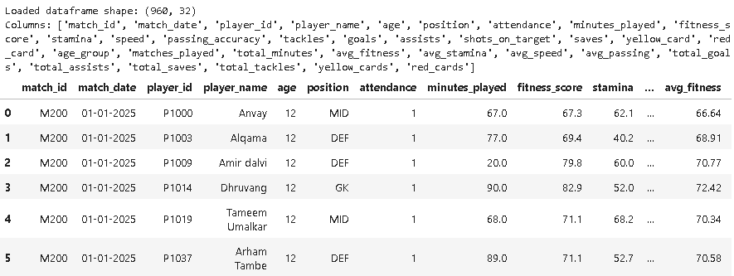
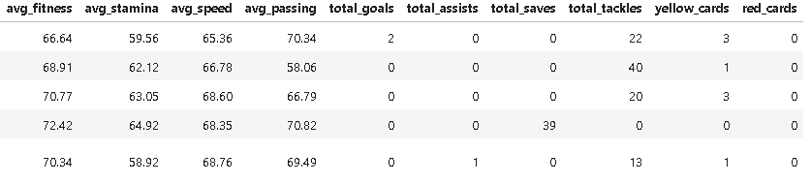

3.1 Data Loading and Initial Inspection
- Loaded CSV data using - pandas.read_csv()
- Reviewed structure using - df.info()
- Generated descriptive statistics using - df.describe()
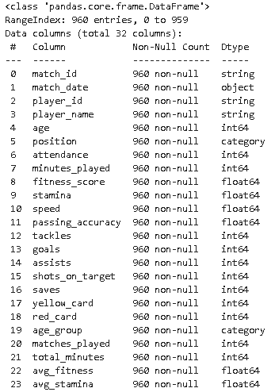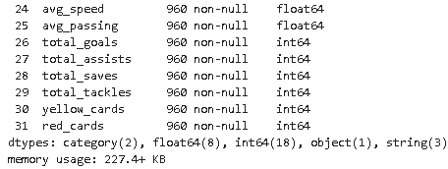

3.2 Handling Missing Values
- Converted numeric columns such as goals, assists, minutes played, fitness scores, and attendance into appropriate data types
- Replaced missing goal- and assist-related values with 0 (logical for match performance)
- Retained NaN values where metrics were not applicable (e.g., passing accuracy when no passes were attempted)
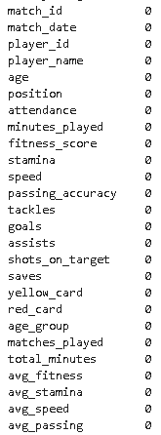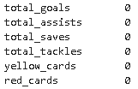
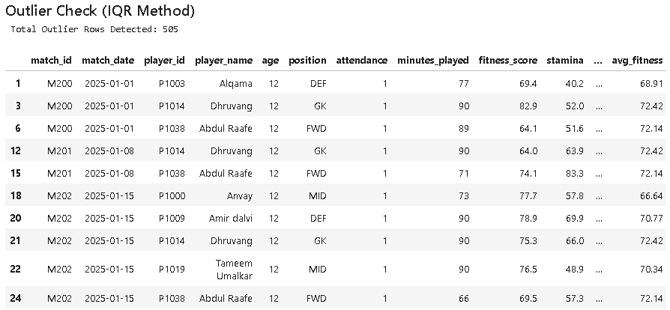

3.3 Data Standardization
- Standardized column names for consistency
- Ensured categorical values such as position were consistently formatted
- Parsed match dates into datetime format

3.4 Feature Engineering
To improve analytical depth, the following derived metrics were created:
- Goals per 90 minutes – to normalize scoring across different playing times
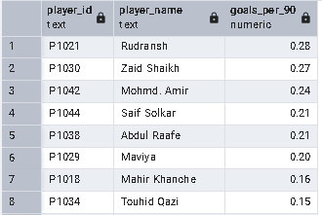
- Aggregated player performance metrics
These features enabled fair comparison between players with varying match minutes.
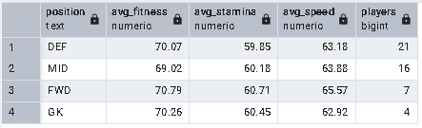

3.5 Database Loading
The cleaned dataset was exported to PostgreSQL using SQLAlchemy. A structured table ("FA_P&E_TAB")was created to support KPI calculation and Power BI connectivity.

4. Performance Analysis using SQL (PostgreSQL)
SQL queries were used to compute key performance indicators and answer important analytical questions.
Key KPIs and Insights derived:
- Total matches played: 20
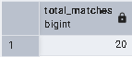
- Total players analyzed: 48
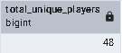
- Average goals per match (player-sum): 1.6
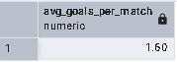

- Identification of top goal scorers
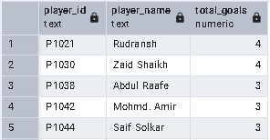

- Goals-per-90 efficiency rankings
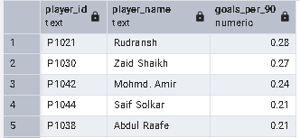
- Average passing accuracy by playing position
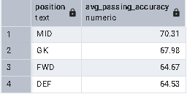

- Fitness score trends by age
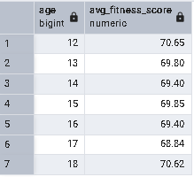

- Attendance-based consistency indicators
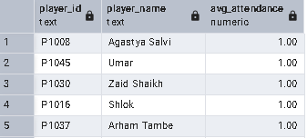

5. Power BI Dashboard
An interactive Power BI dashboard was developed using the cleaned dataset and SQL-derived KPIs.
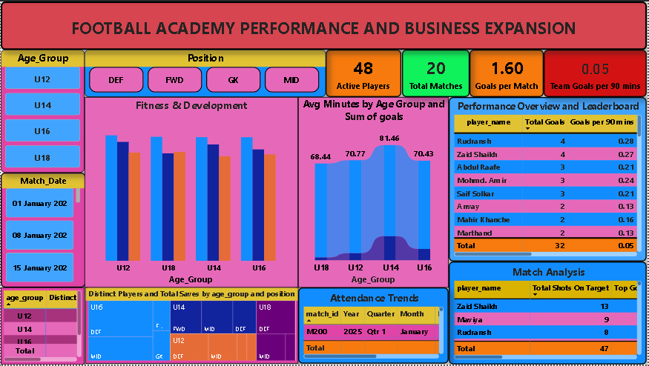

Dashboard pages include:
- Performance Overview – Total goals, Assists, minutes played, and goals per match
- Player Leaderboard – Top scorers, goals per 90, and players conversion percentage
- Fitness & Development – Fitness score trend by age
- Match Analysis – Shots On Target, Match day Attendance and match contribution metrics
- Attendance Trends – Training Consistency Indicators
Slicers were implemented for position, age, and player selection to enable drill-down analysis.

6. Coaching & Player Development Recommendations
- Improve Finishing Efficiency
Players with high shots but lower goals should undergo targeted finishing drills.
- Optimize Playing Time
Players with high goals-per-90 efficiency should be considered for increased match minutes.
- Position-Specific Training
Passing accuracy analysis suggests the need for tailored passing drills, especially for defenders.
- Fitness Conditioning Programs
Lower fitness-score age groups should receive focused conditioning sessions.
- Attendance Monitoring
Use attendance trends as an early indicator of player engagement and consistency.

7. Conclusion
The project demonstrates the practical application of sports analytics in a real academy environment using real match data collected and analyzed by the coach. By integrating Python-based data preparation, SQL-driven KPI analysis, and Power BI visualization, the analysis provides actionable insights for coaching decisions, player development, and performance tracking.

End of Report

