End-to-End MLOps Pipeline for Heart Disease Risk Prediction
  - Machine Learning Operations (MLOps) — AIMLCZG523 — Assignment 01
Abhishek Singh
October 2026

Introduction and Problem Statement
This report documents an end-to-end Machine Learning Operations (MLOps) solution for predicting the presence of heart disease from clinical attributes in the UCI Heart Disease dataset. The work follows a production-style workflow: reproducible data acquisition, exploratory analysis, model development with cross-validation, experiment tracking, automated testing, containerized serving, Kubernetes deployment, and API monitoring.
The modelling problem is binary classification. The raw UCI target uses values 0 through 4, where 0 denotes absence of disease and 1–4 denote presence at increasing angiographic severity. For this assignment the target is binarized to 0 = absent and 1 = present. The served model is an educational demonstration only and is not intended for medical diagnosis or treatment.
Code repository: https://github.com/Maverick2509/AI-Projects
Local API (Docker Compose): http://127.0.0.1:8000
Kubernetes (Minikube NodePort tunnel): http://127.0.0.1:51430
MLflow UI: http://127.0.0.1:5001
Prometheus: http://127.0.0.1:9090
Grafana: http://127.0.0.1:3000 (default login admin / admin)

Architecture Overview
The system is organized as a linear MLOps pipeline. Source code lives in GitHub. Every push runs GitHub Actions, which lints the code, executes unit tests, downloads and prepares data, trains models, and uploads training artifacts. Training writes parameters, metrics, and sklearn pipelines to MLflow. The selected preprocessing-plus-estimator pipeline is packaged as a Joblib artifact and loaded by a FastAPI service. That service is containerized with Docker, deployed to Minikube, and scraped by Prometheus; Grafana is provisioned with a dashboard for request rate, server errors, and latency.
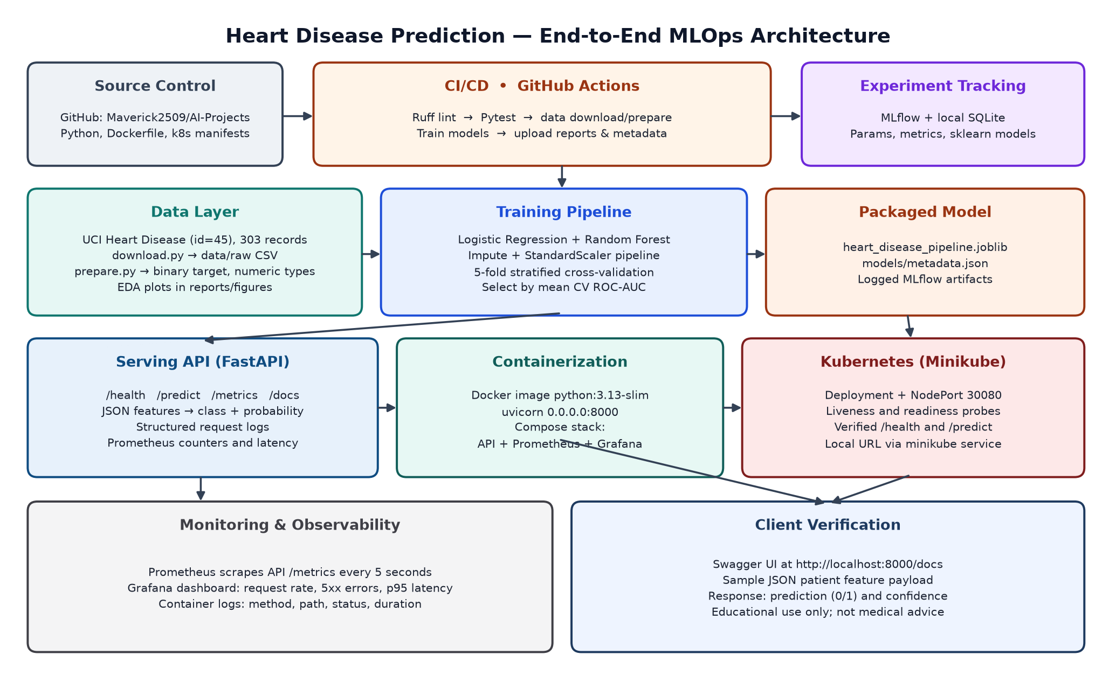
Figure 1. Architecture spanning source control, CI/CD, data and training, packaging, serving, Kubernetes, and monitoring.

Technology stack
Layer | Choice | Role in this project
Language | Python 3.13 | Training, tests, and API
Data | pandas, ucimlrepo | Download and cleaning
Models | scikit-learn | Logistic Regression and Random Forest
Tracking | MLflow + SQLite | Parameters, metrics, model artifacts
API | FastAPI + uvicorn | /health, /predict, /metrics
Quality | Pytest, Ruff | Unit tests and lint in CI
CI/CD | GitHub Actions | Lint, test, train, upload artifacts
Containers | Docker Compose | API + Prometheus + Grafana
Orchestration | Kubernetes / Minikube | Deployment, Service, probes
Monitoring | Prometheus, Grafana | Request rate, errors, p95 latency

Setup and Reproducible Execution
The project is designed to run from a clean checkout using requirements.txt.
git clone https://github.com/Maverick2509/AI-Projects.git && cd AI-Projects
python3 -m venv .venv && source .venv/bin/activate
pip install -r requirements.txt
python -m src.data.download && python -m src.data.prepare && python -m src.eda && python -m src.train
python -m pytest -q
# API locally: uvicorn api.main:app --host 127.0.0.1 --port 8000
# Docker: docker compose -f deployment/k8s/docker-compose.yml up -d --build
# Kubernetes: kubectl apply -f deployment/k8s/ && minikube service heart-disease-api
A sample prediction payload accepted by POST /predict is:
{
"features": {
"age": 62, "sex": 0, "cp": 4, "trestbps": 160, "chol": 164,
"fbs": 0, "restecg": 2, "thalach": 145, "exang": 0,
"oldpeak": 6.2, "slope": 3, "ca": 3, "thal": 7
}
}

Data Acquisition and Exploratory Data Analysis

Dataset and download
The dataset is obtained programmatically from the UCI Machine Learning Repository (id 45) in src/data/download.py using ucimlrepo.fetch_ucirepo. Features and the target are concatenated into data/raw/heart_disease.csv. This avoids hand-copied CSVs and keeps the acquisition step reproducible in CI.
The downloaded table contains 303 records and 14 columns: age, sex, cp, trestbps, chol, fbs, restecg, thalach, exang, oldpeak, slope, ca, thal, and target. The raw target distribution is 164 / 55 / 36 / 35 / 13 for values 0, 1, 2, 3, and 4 respectively. Missingness is limited to ca (4 values) and thal (2 values). There are no duplicate rows in the downloaded file.

Cleaning and preprocessing
src/data/prepare.py performs the following steps:
- Replace common missing-value markers (?, NA, N/A, empty string) with NaN.
- Drop duplicate rows.
- Coerce the target to numeric, drop rows without a target, and binarize (target > 0).
- Coerce remaining feature columns to numeric, leaving true missing values in place so that the training pipeline can impute them.
The cleaned file is written to data/processed/heart_disease_clean.csv. After binarization the class counts are 164 absent (0) and 139 present (1) — moderately balanced, so accuracy remains a useful metric, but class-weighted estimators were still used.
Median imputation and standard scaling are not applied in the CSV cleaning step. They live inside a scikit-learn Pipeline so that the same transformations are fitted on training folds and applied at inference time.

Exploratory visualizations
EDA is implemented in src/eda.py and writes figures to reports/figures/.
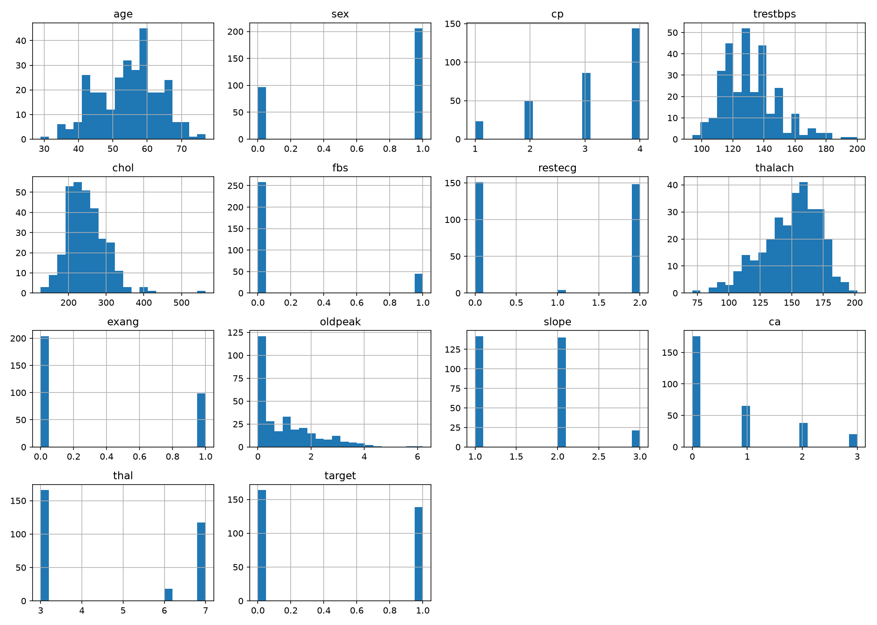
Figure 2. Feature histograms. Age is concentrated between 40 and 70. Resting blood pressure and cholesterol are right-skewed. Several clinical attributes (sex, fbs, exang, cp, slope, thal) are discrete.
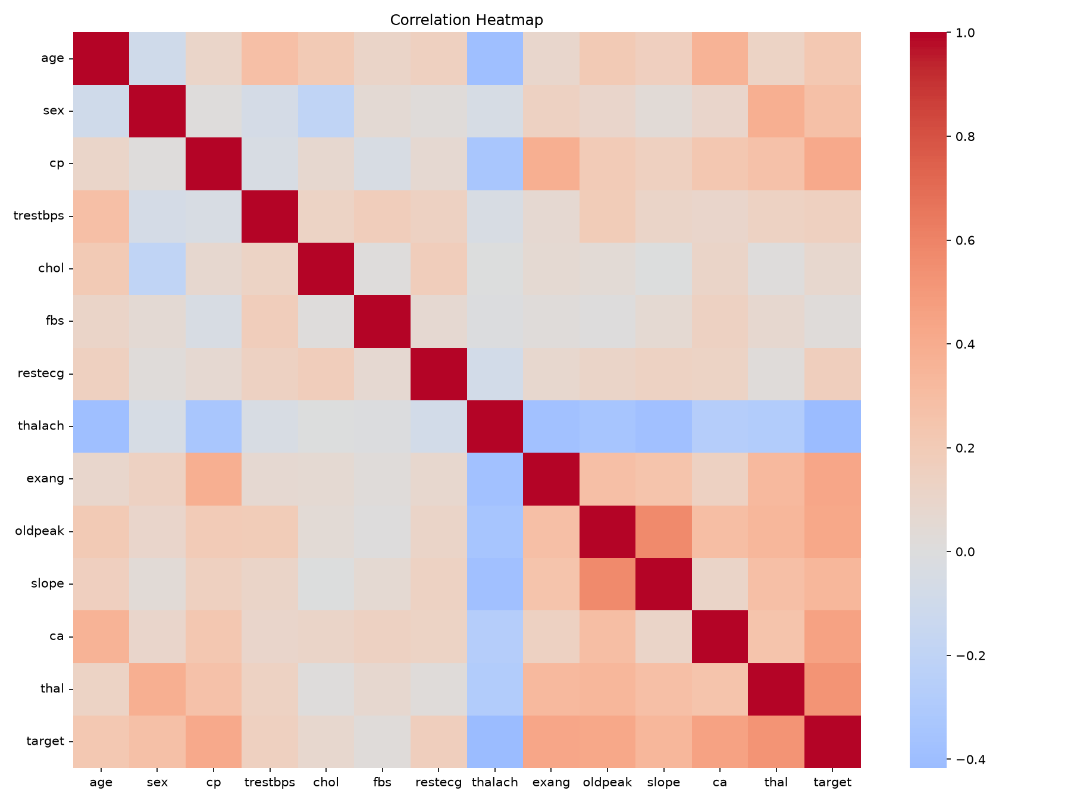
Figure 3. Correlation heatmap. The target is positively associated with chest-pain type (cp), exercise-induced angina (exang), ST depression (oldpeak), number of vessels (ca), and thalassemia (thal). Maximum heart rate (thalach) is negatively associated with the target.
The class-balance plot (164 absent vs 139 present) is stored in reports/figures/class_balance.png. These plots informed two modelling choices. First, mixed continuous and coded-categorical features are all treated as numeric inputs and standardized; one-hot encoding was not required because UCI already encodes the categoricals as numbers. Second, class_weight="balanced" was enabled because the positive class is slightly smaller and missed disease cases are more costly in this domain.

Feature Engineering and Model Development

Feature pipeline
All 13 clinical attributes are retained. The training script builds a ColumnTransformer that applies median imputation and StandardScaler to every feature, then attaches a classifier. The full object is a scikit-learn Pipeline, so serialization stores preprocessing and the estimator together.
A stratified 80/20 train-test split (random_state=42) holds out a test set. Model selection uses 5-fold stratified cross-validation on the training split only. The selection metric is mean CV ROC-AUC, which is threshold-independent and appropriate for a slightly imbalanced medical classification task. Held-out test metrics are reported for honesty but are not used to pick the winner.

Models and hyperparameters
Two classifiers were trained:
- Logistic Regression — linear, interpretable baseline; max_iter=2000, class_weight="balanced", default C=1.0.
- Random Forest — non-linear ensemble; n_estimators=300, min_samples_leaf=2, class_weight="balanced".
These are complementary: logistic regression tests whether a linear decision surface is sufficient after scaling; random forest tests whether interactions and non-linear splits improve discrimination. Limited tree depth growth was controlled via min_samples_leaf=2 rather than an aggressive grid search, which is more appropriate for a 242-row training split.

Evaluation results
Model | CV Acc. | CV Prec. | CV Rec. | CV ROC-AUC | Test Acc. | Test Prec. | Test Rec. | Test ROC-AUC
Logistic Regression | 0.814 | 0.815 | 0.774 | 0.896 | 0.869 | 0.813 | 0.929 | 0.950
Random Forest | 0.802 | 0.800 | 0.765 | 0.887 | 0.885 | 0.839 | 0.929 | 0.962
Logistic Regression is selected because of the higher mean CV ROC-AUC (0.896 vs 0.887), even though Random Forest is slightly stronger on the 61-row test set. Recall on the test set is 0.929 for both models, which is desirable: false negatives (missed disease) are more serious than false positives in a screening-style API. Test ROC-AUC values above 0.95 should be read cautiously because the test split is small; the CV estimates around 0.89 are the more trustworthy generalization numbers.
The selected pipeline is saved to models/heart_disease_pipeline.joblib, with metadata in models/metadata.json recording the selected model name, feature column order, and selection score.

Experiment Tracking
MLflow is configured against a local SQLite store (mlflow.db) under the experiment name heart-disease-classification. Each estimator is a named run. The training script logs:
- parameters (model_name, random_state, cv_folds, and the estimator’s get_params());
- metrics (CV and test accuracy, precision, recall, ROC-AUC);
- a scikit-learn model artifact for each run.
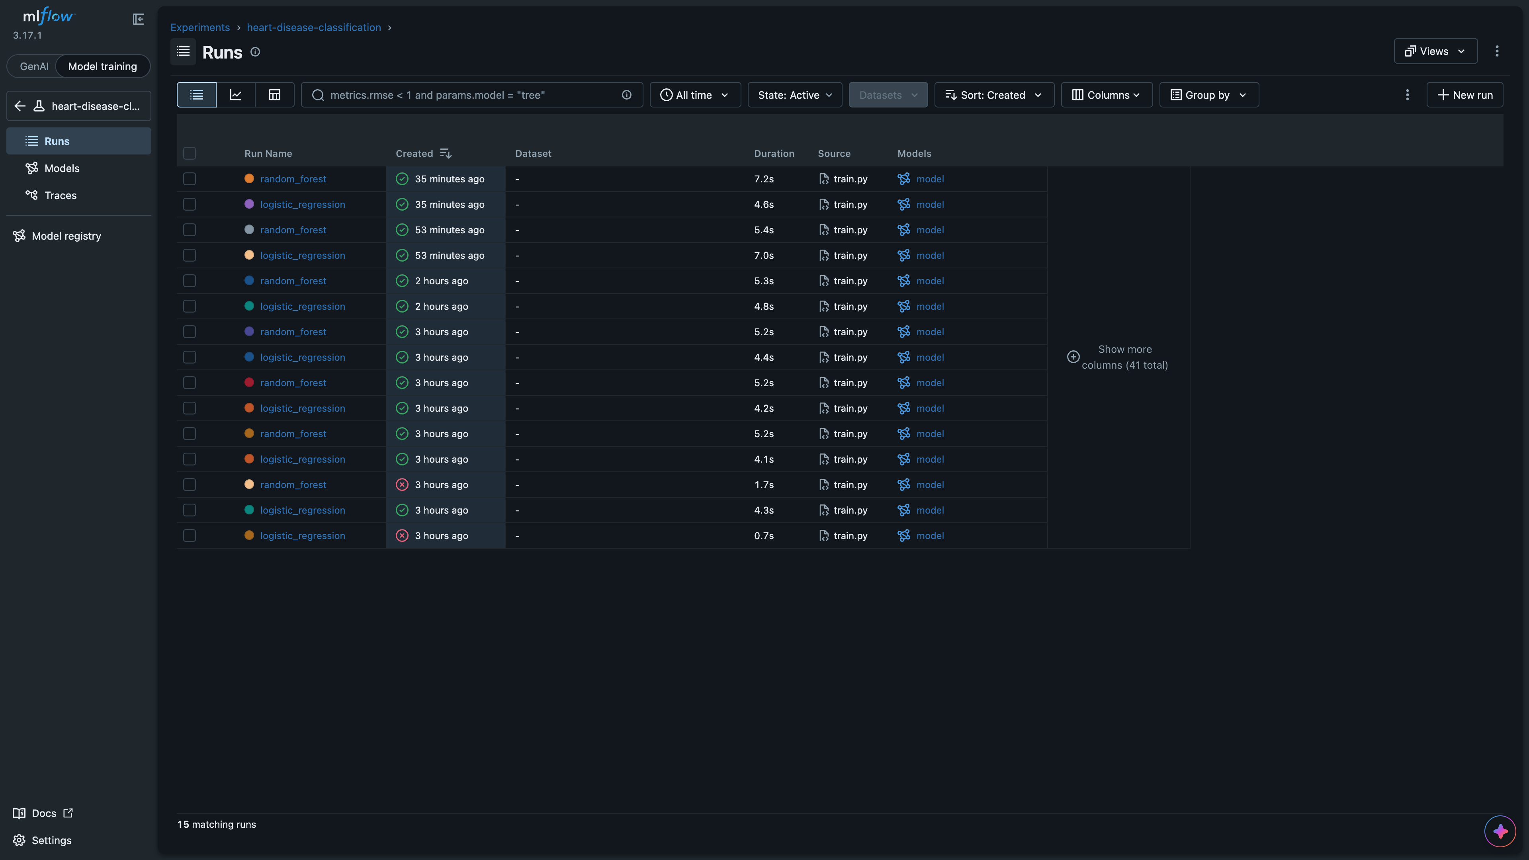
Figure 4. Repeated training runs for logistic_regression and random_forest, each logging a model artifact from train.py.
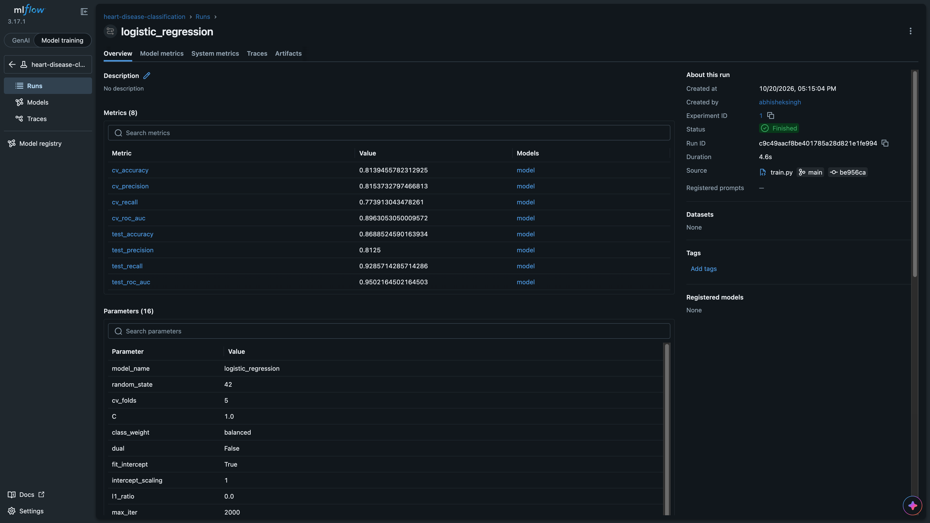
Figure 5. Detail view of the selected Logistic Regression run: CV ROC-AUC 0.896, test recall 0.929, class_weight=balanced, max_iter=2000, 5 CV folds.
The UI is started with:
mlflow ui --backend-store-uri sqlite:///mlflow.db --host 127.0.0.1 --port 5001
Port 5001 is used because macOS AirPlay occupies port 5000.

Model Packaging and Reproducibility
Reproducibility is enforced at three layers:
- Pinned dependencies. requirements.txt records the exact environment used for training and serving (notably scikit-learn==1.9.1, mlflow==3.17.1, fastapi==0.151.0).
- Single inference artifact. joblib.dump stores the entire Pipeline (imputer, scaler, classifier). The API never reimplements preprocessing.
- Feature contract. models/metadata.json lists the 13 feature names in training order. The API rejects requests with missing or unexpected keys and returns HTTP 422, which prevents silent column misalignment.
MLflow additionally stores sklearn model artifacts per run, providing a second packaging path if a run needs to be reloaded later.

CI/CD Pipeline and Automated Testing

Unit tests
tests/test_data.py covers the cleaning contract:
- multi-valued UCI targets become binary {0, 1};
- duplicate rows are removed;
- "?" in a feature becomes NaN so that the imputer can handle it;
- a missing target column raises ValueError.
Pytest runs locally and in CI (python -m pytest -q). Ruff is the linter (ruff check .). The GitHub Actions job is configured to fail the workflow when lint or tests fail, which was observed on early commits before the pipeline turned green.

GitHub Actions
Workflow file: .github/workflows/ci.yml. Trigger: push, pull request, and workflow_dispatch. Job test-and-train on ubuntu-latest:
- Checkout and set up Python 3.13 with pip caching.
- Install requirements.txt.
- Lint with Ruff.
- Run Pytest.
- Download and prepare the dataset.
- Train models (python -m src.train).
- Upload reports/, models/metadata.json, and mlruns/ as the training-results artifact (retained 14 days), including on failure (if: always()).
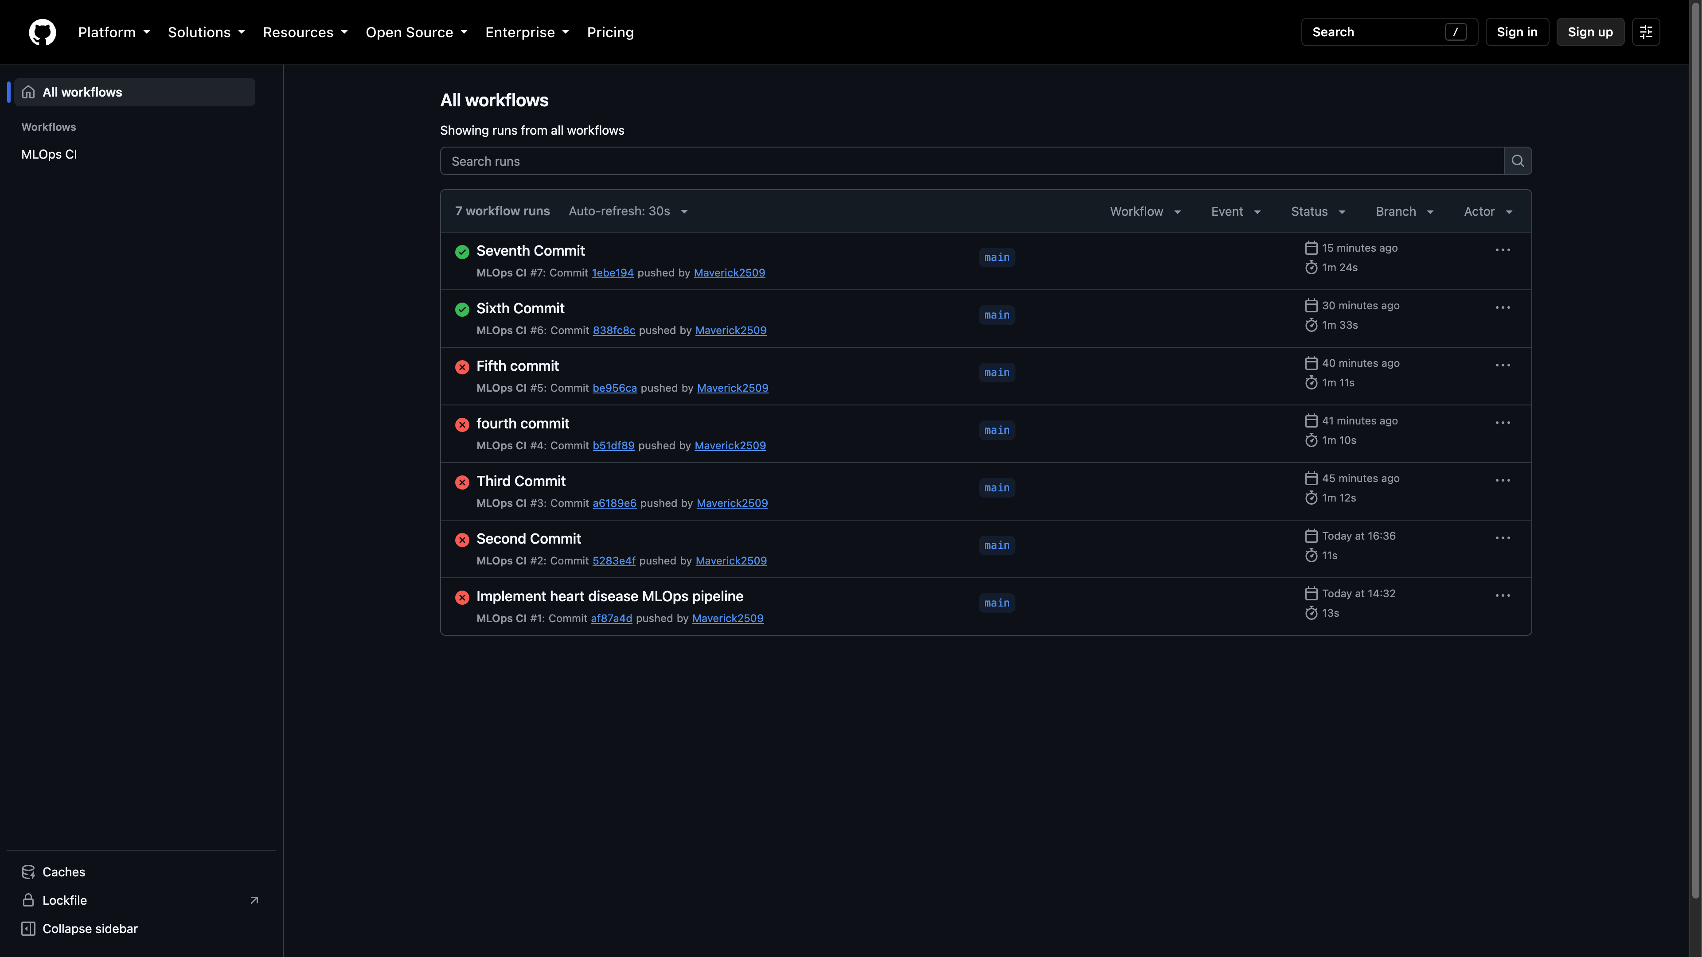
Figure 6. Workflow history. Early commits failed (the pipeline correctly stopped on errors). The latest two runs, including Seventh Commit, succeeded.
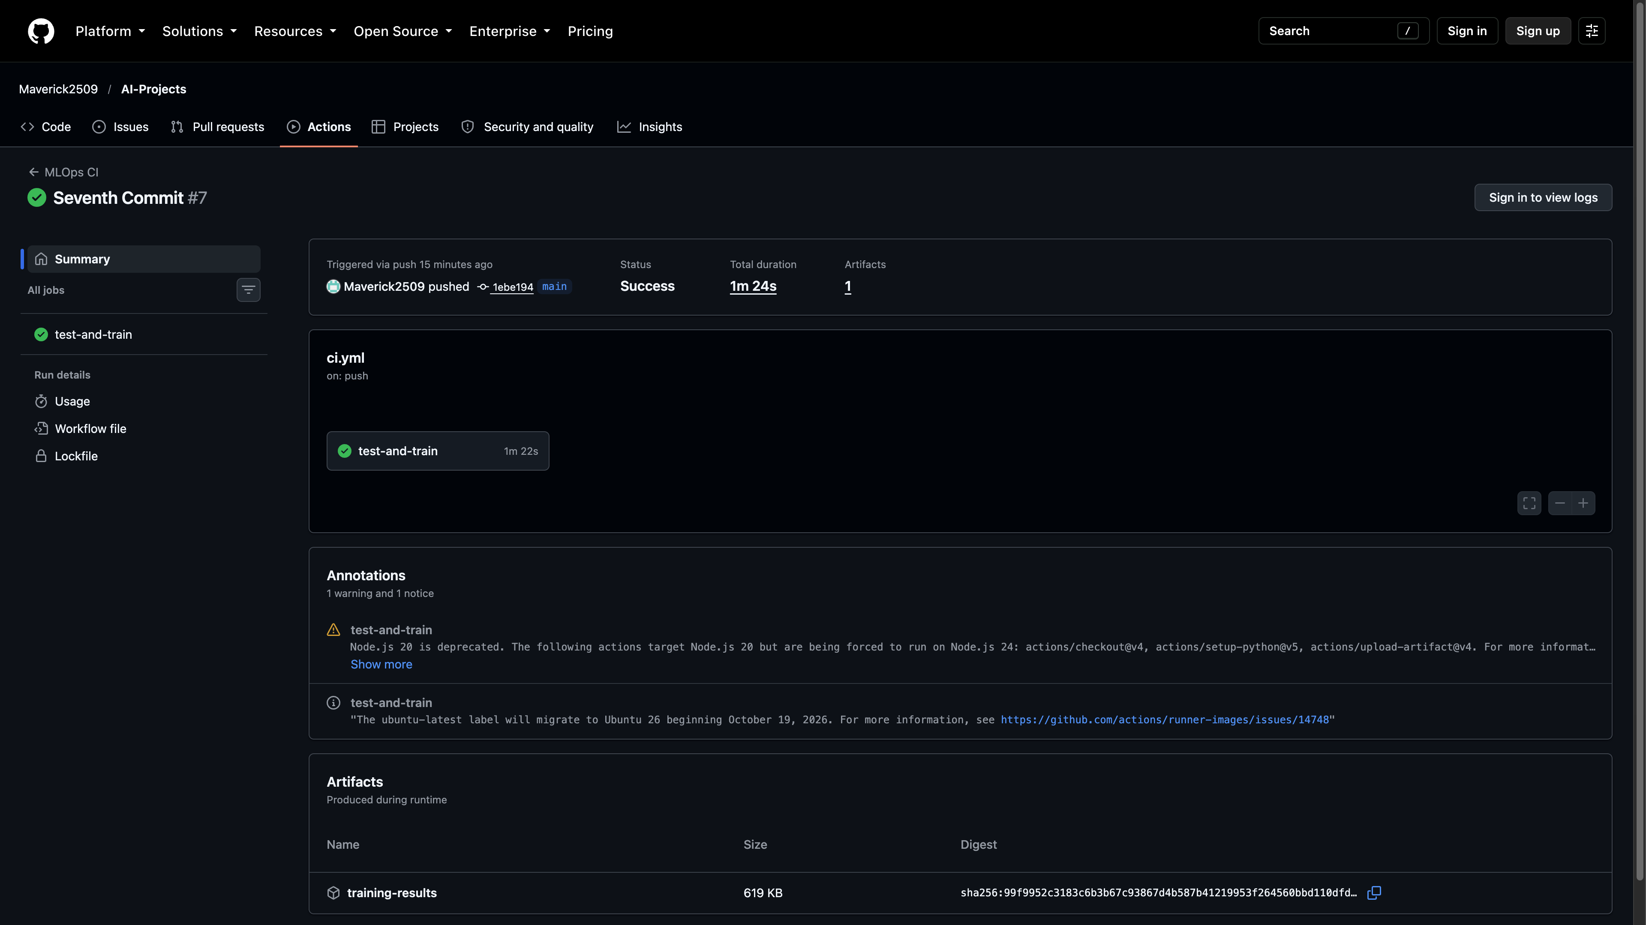
Figure 7. Seventh Commit (#7) completed successfully in 1 m 24 s. The test-and-train job ran 1 m 22 s and published the training-results artifact (619 KB).
Successful run URL: https://github.com/Maverick2509/AI-Projects/actions/runs/39419677107
The red-then-green history is evidence that the pipeline does not report success when code or tests break.

Model Containerization
The Dockerfile uses python:3.13-slim, installs pinned requirements, copies src/, api/, and models/, exposes port 8000, and starts uvicorn api.main:app. Docker Compose (deployment/k8s/docker-compose.yml) builds this image and runs it beside Prometheus and Grafana; docker ps showed heart-disease-api on host port 8000, Prometheus on 9090, and Grafana on 3000.
The API exposes:
- GET /health — liveness/readiness style status and model_loaded;
- POST /predict — JSON feature map, returning prediction, probability (positive-class confidence), model_name, and a medical-use disclaimer;
- GET /metrics — Prometheus metrics;
- GET /docs — Swagger UI.
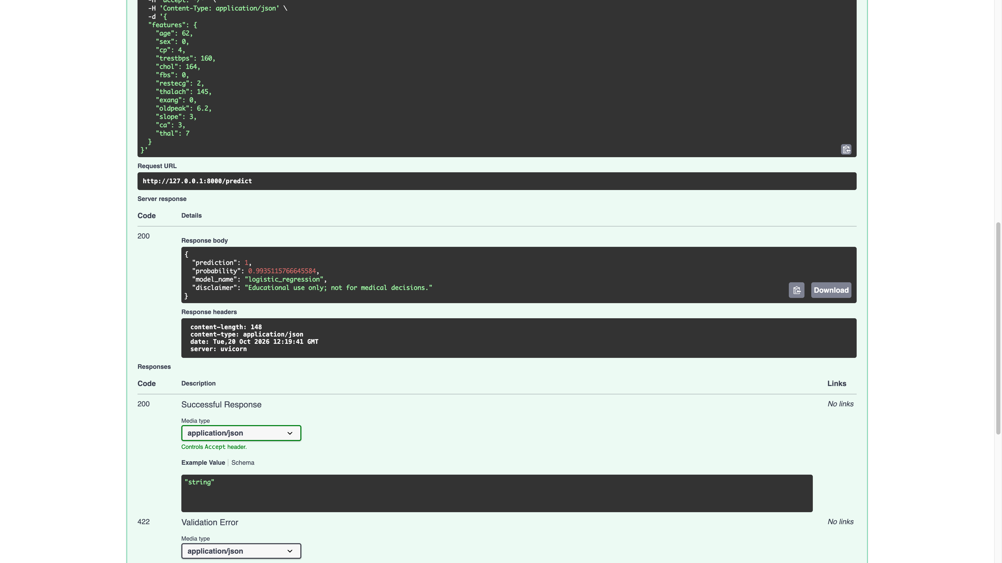
Figure 8. Sample inference through Swagger. Request URL http://127.0.0.1:8000/predict returned HTTP 200 with prediction: 1, probability: 0.9935, and model_name: logistic_regression.
Structured request logs are emitted for every call (method, path, status, duration_seconds) and are visible in docker logs heart-disease-api.

Production Deployment on Kubernetes
The API is deployed to a local Kubernetes cluster using Minikube. Manifests:
- deployment/k8s/deployment.yml — one replica, image heart-disease-api:latest, imagePullPolicy: IfNotPresent, container port 8000, HTTP liveness and readiness probes on /health, CPU/memory requests and limits.
- deployment/k8s/service.yml — NodePort service mapping port 8000 to node port 30080.
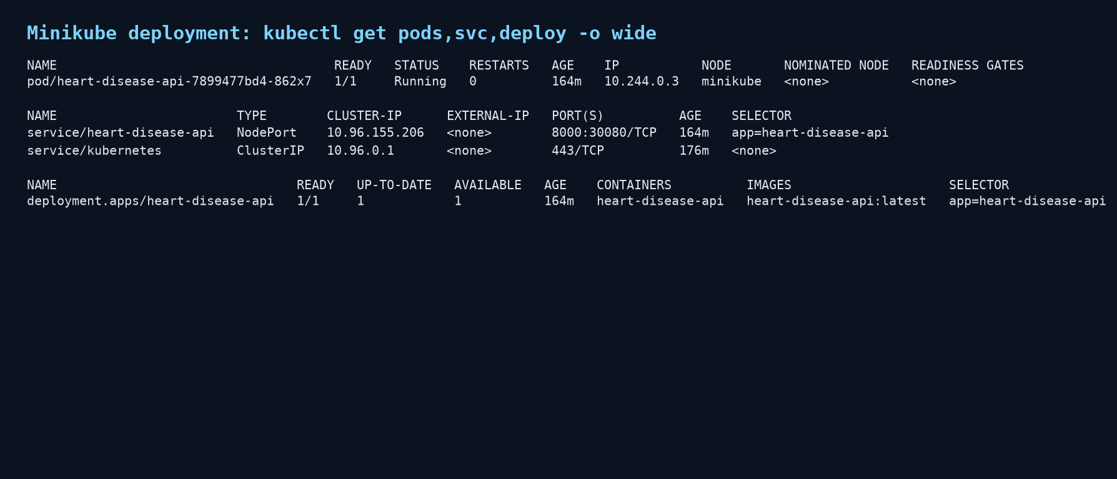
Figure 9. kubectl get output. Pod heart-disease-api-... is Ready 1/1. Service type is NodePort 8000:30080.
After minikube service heart-disease-api, the API was verified at http://127.0.0.1:51430. GET /health returned {"status":"ok","model_loaded":true} and POST /predict returned the same class and probability as the Docker service. Swagger for the Kubernetes endpoint is available at http://127.0.0.1:51430/docs.

Monitoring and Logging
Three observability mechanisms are in place.
Application logs. FastAPI middleware records method, path, status, and duration. Prediction handlers log the predicted class. Unhandled exceptions are logged with stack traces.
Prometheus metrics. Counters api_requests_total and api_server_errors_total, plus histogram api_request_duration_seconds, are exposed on /metrics. Prometheus scrapes api:8000 every 5 seconds (deployment/k8s/prometheus.yml).
Grafana dashboard. Provisioned datasource points at Prometheus. Dashboard Heart Disease API Monitoring (uid heart-disease-api) plots request rate by status, 5xx error rate, and p95 latency, with a 5-second refresh.
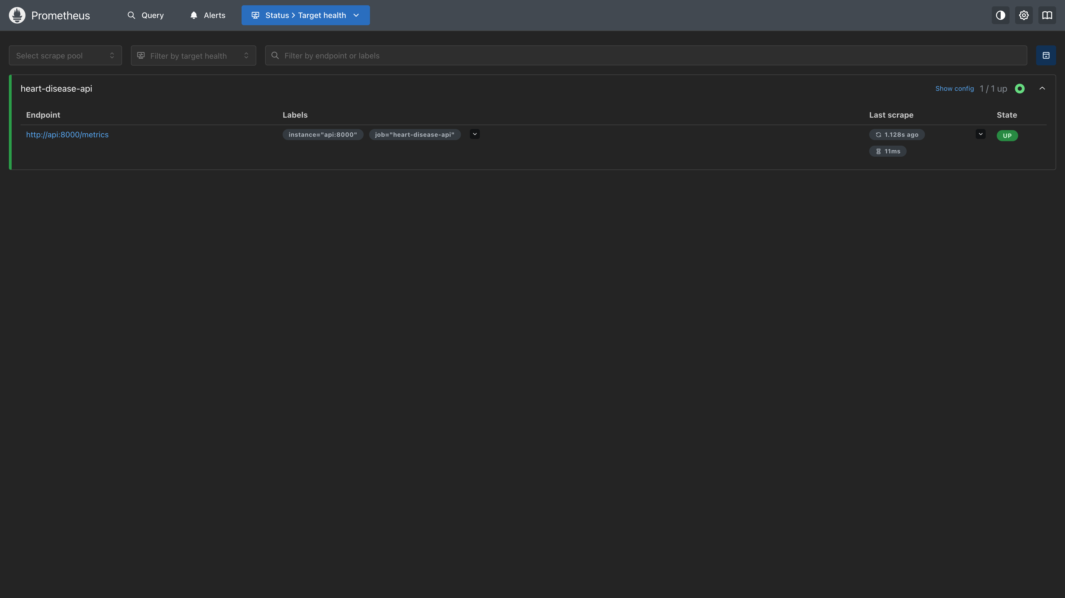
Figure 10. Prometheus target health: job heart-disease-api, endpoint http://api:8000/metrics, state UP.
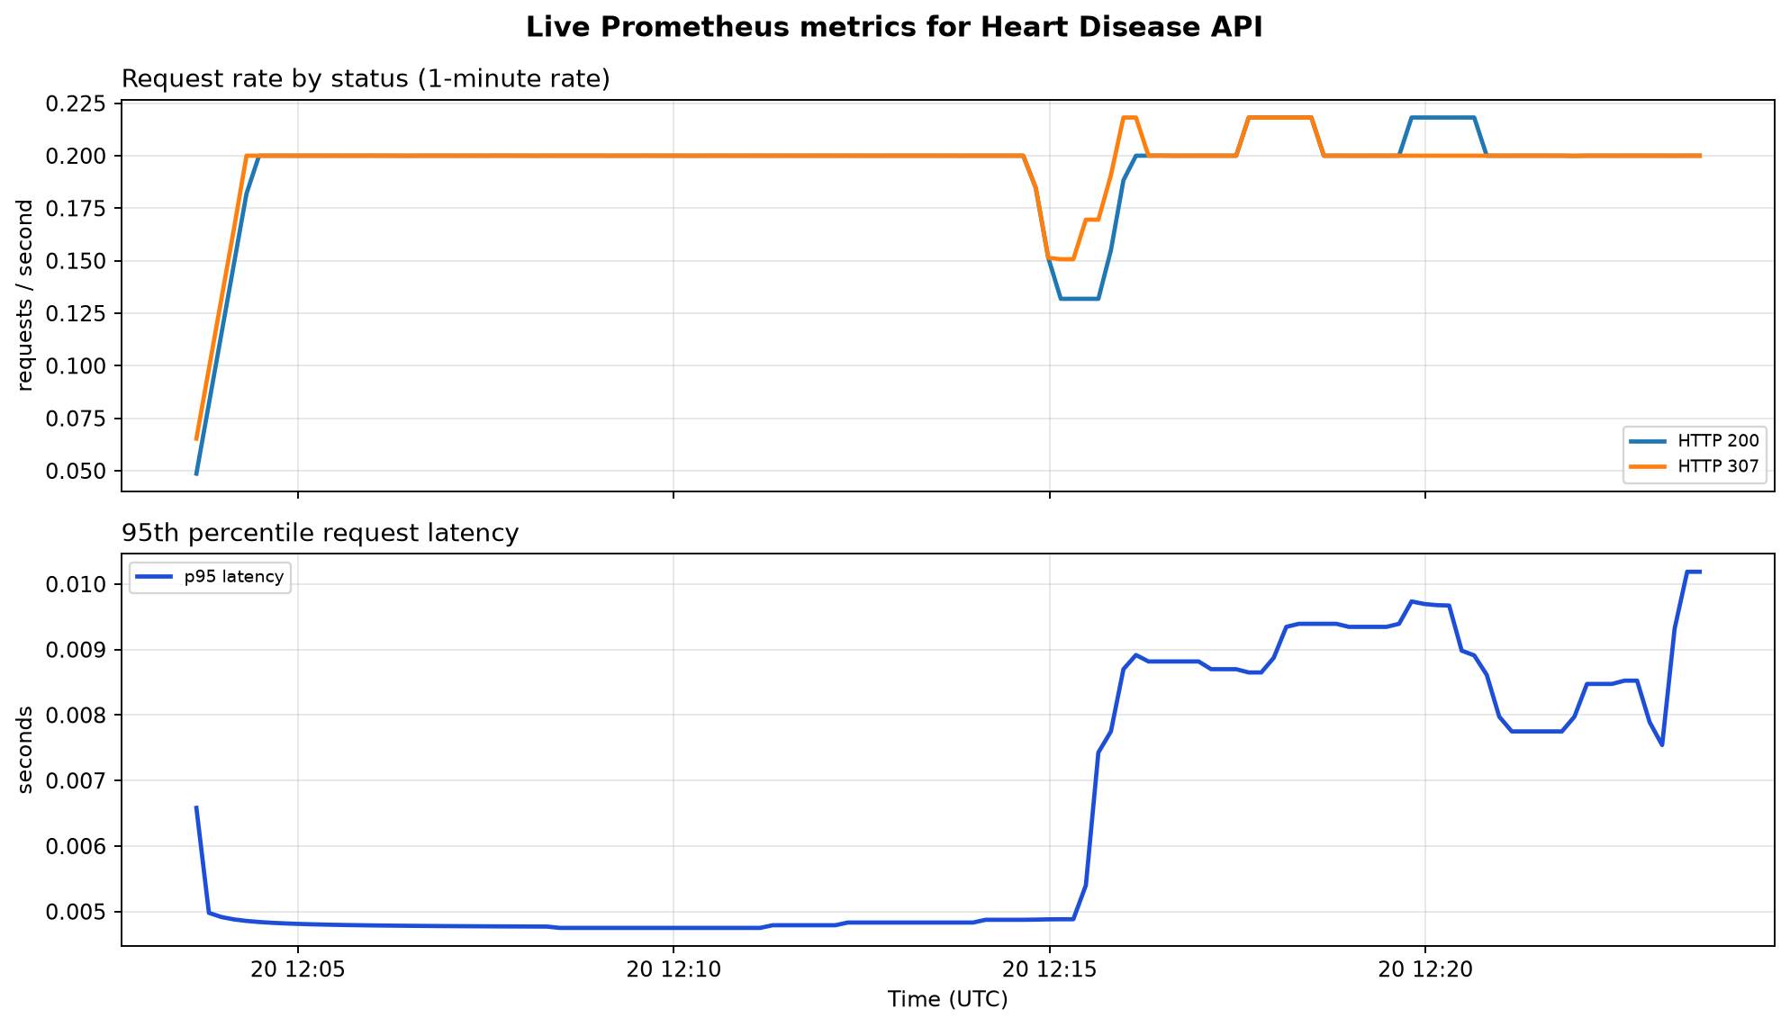
Figure 11. Live Prometheus queries over a 20-minute window after exercising /health, /predict, and /docs. Request traffic is visible; p95 latency remains well below 50 ms. No 5xx series was recorded in this window.
Grafana is available at http://127.0.0.1:3000 (anonymous first login admin/admin; Grafana will prompt to change the password). The provisioned dashboard lives under folder MLOps Assignment.

Production-Readiness Checklist
Requirement | Evidence
Scripts run from a clean requirements.txt setup | Documented in Section 3; CI installs the same file
Model serves in an isolated Docker environment | Figure 8; /predict HTTP 200 from the container
Pipeline fails on code or test errors | Figures 6–7: failed early commits, green latest run
/predict returns class and confidence | Figure 8
Deployment manifest and live endpoint | Figure 9; Minikube Service 8000:30080
Request logging and metrics | Figures 10–11

Conclusions
This assignment implemented a complete MLOps path from UCI data download to a monitored, containerized API. Logistic Regression was selected on cross-validated ROC-AUC (0.896) and packaged with its preprocessing pipeline so that training and serving cannot drift apart. GitHub Actions enforces linting, tests, and retraining on every push. The same image runs under Docker Compose and Minikube, with Prometheus confirming a healthy scrape target and sub-50 ms p95 latency under sample traffic.
Remaining operational notes: the current Kubernetes Service is NodePort rather than a cloud LoadBalancer, which is appropriate for Minikube but would be replaced by an Ingress or cloud LB in a public deployment. The held-out test set is small (61 rows), so CV metrics should remain the promotion criterion. The API is an academic prototype and must not be used for clinical decisions.
Repository: https://github.com/Maverick2509/AI-Projects
Local testing: docker compose -f deployment/k8s/docker-compose.yml up -d --build, then curl http://127.0.0.1:8000/health and Swagger at /docs. Prometheus: http://127.0.0.1:9090/targets. Grafana: http://127.0.0.1:3000 (admin/admin). Kubernetes: kubectl apply -f deployment/k8s/ and minikube service heart-disease-api. Attach a short screen recording of this walkthrough as required by the assignment deliverables.

