Faculty of Engineering and Technology (FET)
Sri Sri University
Cuttack, Odisha, India
Pin-754006
B.Tech Project Report

Project Title: Bank Network
Group Number: 2
Department:
Guided By- Dr.Prabhudutta Pradhan and Ms.Neha Bagle

Submitted by:
- Amrutanshu Puhan (FET-BCD-2023-27-013)
- Aayush Nanda (FET-BCD-2023-27-017)
- Ankit Das (FET-BCD-2023-27-018)
- Nikita Priyadarshini (FET-BCD-2023-27-019)

Certificate of the Guide

This is to certify that the project titled "Bank Network" submitted by the following students:
- Amrutanshu Puhan (FET-BCD-2023-27-013)
- Aayush Nanda (FET-BCD-2023-27-017)
- Ankit Das (FET-BCD-2023-27-018)
- Nikita Priyadarshini (FET-BCD-2023-27-019)
of the Faculty of Engineering and Technology has been carried out under my guidance in partial fulfillment of the requirements for the award of the degree.
To the best of my knowledge, this work has not been submitted to any other university or institution for the award of any degree or diploma.
Guided By:
Dr. Prabhudutta Pradhan - Assistant Professor
Ms. Neha Bagle - Cyber Security Engineer and Trainer
Institution: Sri Sri University

(Signature)

Student Declaration

We hereby declare that the project work entitled "Bank Network" submitted to Faculty of Engineering and Technology, Sri Sri University Cuttack Odisha, is a record of original work carried out by us under the guidance of Dr.Prabhudutta Pradhan & Ms.Neha Bagle.
This work has not been submitted anywhere else for any other degree or diploma.
- Amrutanshu Puhan (FET-BCD-2023-27-013)
- Aayush Nanda (FET-BCD-2023-27-017)
- Ankit Das (FET-BCD-2023-27-018)
- Nikita Priyadarshini (FET-BCD-2023-27-019)

Date: 12/4/2025
Place: Cuttack

Acknowledgement

We would like to express our sincere gratitude to our project guide Dr.Prabhudutta Pradhan & Ms.Neha Bagle for their valuable guidance, encouragement, and continuous support throughout the course of this project.
We are also thankful to the faculty and staff of the Faculty of Engineering and Technology Sri Sri University Cuttack for their assistance and for providing the necessary facilities to carry out our work.
Our heartfelt thanks to our families and friends for their moral support and motivation during the project development.
Finally, we thank each other as a team for the hard work and collaboration that made this project a success.
Students Signatures :

1.

2.

3.

4.

Table of Contents

1. Cover Page
2. Guide Certificate
3. Student Declaration
4. Acknowledgement
5. Abstract
6. Introduction
7. Objectives & Scope
8. Problem Statement
9. Motivation
10. Literature Review
11. Proposed Solution
12. Work Plan & Timeline
13. System Design
14. Technical Details
15. Implementation
16. Testing & Results
17. Cost Analysis
18. Societal & Industry Impact
19. Conclusion & Future Scope
20. References

ABSTRACT

In the era of digital transformation, ensuring the security, reliability, and efficiency of banking networks has become paramount. This project presents the design and implementation of a highly secure and robust network architecture for a bank's headquarters and its remote branches. The primary objective is to ensure encrypted inter-branch communication, departmental network segmentation using VLANs, and the implementation of a Demilitarized Zone (DMZ) to safely manage public-facing services like online banking. The proposed architecture leverages advanced technologies such as inter-VLAN routing, access control lists (ACLs), Network Address Translation (NAT), and High Availability Protocols like HSRP, in combination with the dynamic routing capabilities of OSPF.
The network design includes critical infrastructure components such as multilayer and standard switches, routers, firewalls, servers, access points, and client devices, strategically deployed across the main branch, sub-branches, server site, and ISP interface. This design is tested and simulated using Cisco Packet Tracer, where key functionalities such as inter-VLAN communication, DMZ access control, redundant ISP failover, and secure remote connectivity are successfully validated. Special focus is given to security through encryption protocols, firewall rules, ACL enforcement, and VPN simulation to ensure confidentiality, integrity, and availability of data.

INTRODUCTION

Project Domain:
Banking Network Security
Project Statement:
To build a scalable and resilient banking infrastructure that ensures security, reliability, and seamless connectivity in the face of increasing cyber threat.
Importance:
Banks handle sensitive transactions, making them prime targets for cyber threats.
Relevance:
This project is relevant because it provides a practical approach in securing banking networks, offering solutions that can be implemented to protect sensitive data.
Network Design:
The network design incorporates key elements such as VLAN segmentation, a DMZ, and potentially a hierarchical topology.
Security Focus:
The project's security focus includes implementing encryption for data protection, firewalls, and access control lists (ACLs) to safeguard sensitive data.

OBJECTIVE

1. Ensure High Availability: To implement redundant systems and enable failover mechanisms to limit the occurrence of network downtime.
2. Improve Network Performance: Ensure rapid, predictable, and reliable transfer of data to accommodate massive workloads and critical applications.
3. Cost Efficiency: Balance infrastructure cost with the need for reliability and performance by applying modern cost-effective technologies.
4. Proactive Monitoring and Maintenance: Detect and eliminate problems in real-time through network monitoring and management.
5. Future-Proofing the Network: Implement the latest technologies such as SD-WAN, 5G, to stay in pace with changing times. The network needs to evolve with technology.

SCOPE
This project includes the design and deployment of a network infrastructure covering a central server site, a main branch, three sub-branches, and ISP integration. The scope covers:
- Secure connectivity between branches and the server site
- Logical segmentation using VLANs for different departments (HR, Finance, IT, etc.)
- DMZ setup for public services (web servers, mail servers)
- Centralized firewall and security controls
- Redundant paths and failover mechanisms
- Real-time monitoring and logging systems

PROBLEM STATEMENT

In the modern financial landscape, banks face an increasing demand for secure, uninterrupted, and efficient digital infrastructure to protect sensitive customer information, ensure regulatory compliance, and support critical banking operations. The design and deployment of a robust network architecture for a bank’s headquarters and multiple branch offices must address the challenges of data confidentiality, operational integrity, and high availability. This involves constructing a communication framework that can withstand external threats, internal vulnerabilities, and potential system failures without compromising performance or accessibility.
The proposed network solution aims to enable seamless connectivity between geographically dispersed branches while maintaining strict access control, optimized traffic flow, and protection for publicly accessible services. In addition to facilitating smooth intra-organizational collaboration, the infrastructure must be scalable, easy to manage, and capable of supporting future expansions and technology upgrades. Moreover, the solution should integrate real-time monitoring and proactive defense mechanisms to anticipate and mitigate cyber threats, ensuring 24/7 operational continuity in an increasingly digital financial ecosystem.

MOTIVATION

The primary motivation behind this project stems from the rapid evolution of cyber threats targeting the financial sector. Banks today are prime targets for cybercriminals due to the high value of sensitive customer and financial data. With the increasing incidents of data breaches, ransomware attacks, phishing campaigns, and insider threats, it has become imperative for financial institutions to fortify their network infrastructure against sophisticated cyberattacks.
Modern banking operations demand continuous availability, robust security, and reliable connectivity between various branches and data centers. Any downtime or security lapse can lead to substantial financial loss, reputational damage, and regulatory penalties. In addition, with growing customer expectations for seamless online and mobile banking experiences, it is essential to ensure that publicly accessible services are both secure and resilient.
This project is driven by the need to:
- Mitigate the risk of data breaches and unauthorized access.
- Ensure 24/7 uninterrupted service through redundancy and failover mechanisms.
- Enable secure, encrypted communication between headquarters and branches.
- Segment internal traffic using VLANs to limit broadcast domains and enhance departmental isolation.
- Create a DMZ to host public-facing services securely and prevent them from exposing the internal network.
- Comply with industry security standards and data protection regulations.
The approach involves a multi-layered security framework, including firewalls, VLANs, ACLs, encryption, NAT, and SD-WAN technology. These are designed to provide both proactive defense and reactive mitigation in case of any network issues.
Ultimately, the goal is to build a future-ready, scalable banking infrastructure that integrates security at every level of the network, promotes high availability, and delivers seamless service across all branches. This project not only addresses current threats but also anticipates future challenges by adopting best practices and modern networking technologies.

LITERATURE SURVEY/ EXISTING WORK

S. No. |  | Author(s) |  |  | Year |  | Title |  | Objective |  | Methodology |  | Key Findings |  | Gaps Identified
1 |  | K. Sathupadi & S.Achar |  |  | 2025 |  | Real-Time Big Data Analytics for Secure Internet Banking |  | To create BankNet, a framework for real-time predictions of diverse Internet banking metrics, going beyond fraud detection |  | Big data analytics via BiLSTM framework and Apache tools. |  | BankNet enables real-time predictions, handles data rates of 700–1000 Mbps, and achieves high predictive accuracy |  | Real-time prediction of diverse banking metrics addresses prior gaps.
2 |  | N.Sarto |  |  | 2024 |  | Digital Banking: How Social Media is Shaping the Game |  | To reveal the profound impacts of digital transformation on the banking sector, emphasizing key implementation areas |  | Theoretical relationships confirmed via replication; bias mitigated by independent validation. |  | The study reveals profound impacts of digital transformation on the banking sector, emphasizing key implementation areas |  | The abstract provides a general overview but does not explicitly list gaps identified.
3 |  | Jia et al. |  |  | 2023 |  | Digital Financial and Banking Competition Network |  | To study how digital finance reshapes the banking competition structure |  | Competition analyzed using social network model, leveraging bank data and a converted digital finance index. |  | Digital finance increases competition; large banks retain dominance in the evolving landscape. |  | Competition through relationships & digital finance impacts.
4 |  | A.Casolaro  & G. Rauber |  |  | 2024 |  | Open Banking: A Systematic Literature Review |  | A systematic review of open banking’s impact on financial institutions and consumer relationships. |  | Open banking's impact on financial institution-consumer relationships. |  | Balances benefits (competition/access) with data privacy risks. |  | Open banking's impact on consumers and financial models.
5 |  | P.Singh, Dr. P. Kumar & Dr. Anjula |  | 2022 |  |  | A Review of the Literature on Banking and Financial Institutions |  | Examines banking's role in economic development, summarizing key findings, methods, and practical implications. |  | 24 articles (2006-2021) on banking performance, satisfaction, stability, innovation, & development. |  | Correlated bank performance with growth, satisfaction, lending, innovation, and crisis factors. |  | Calls for more research on banks' evolving role and technological impacts on performance.
6 |  | S.Rastogi, A.Sharma & G.Pinto |  | 2022 |  |  | A Literature Review of Risk, Regulation, and Profitability of Banks Using a Scientometric Study |  | Analyzes regulation, profitability, and risk to inform policy recommendations. |  | Scopus database analyzed with scientometric tools: network, citation, & page rank. |  | Concentration, market power & reduced competition linked to decreased bank stability/profitability. |  | Inadequate research on ownership's impact on bank performance identified.
7 | A.Jiravichai & R.Banomyong |  | 2022 |  |  | A Proposed Methodology for Literature Review on Operational Risk Management in Banks |  | To propose a methodology that enables researchers to identify relevant search terms when conducting a literature review. |  | Employed a systematic literature review and an evaluation of existing ORM researh methodologies. |  | Enhanced keyword selection for ORM analysis , reveals measurement and data availabilty challenges; fosters interdisciplinary accuracy. |  | Scarce data limits understanding of loss events' impact on rivals/shareholders; empirical reliability questioned.
8 | Kaur et al. |  | 2022 |  |  | Financial technology and competition |  | To characterize competition, its impact on banks’ business models, and the accessibility and price of services for customers. |  | Review of economic literature on financial technology and competition for banking services. |  | Innovation & competition driven by fintech in banking; P2P models challenge banks. |  | Financial technology may introduce new channels of transmission from competition to financial stability

PROPOSED SOLUTION

Implementation of VLANs and Access Control:
- Segment network traffic by department using VLANs (e.g., Customer Service, Loans, IT Operations). Use Access Control Lists (ACLs) to manage traffic flow and enhance internal security.
DMZ Configuration for Public-Facing Services:
- Establish a DMZ to securely host online banking and other external applications. Isolate these from the internal network to prevent lateral movement in case of breaches.
End-to-End Encryption Mechanisms:
- Use IPsec VPNs for secure communication between branches and HQ. Ensure SSL/TLS encryption for online banking services and internal web-based tools.
Firewall Configuration and Intrusion Prevention:
- Deploy advanced firewalls with IPS features to block malicious traffic, detect anomalies, and enforce security policies consistently across the network.

SYSTEM DESIGN
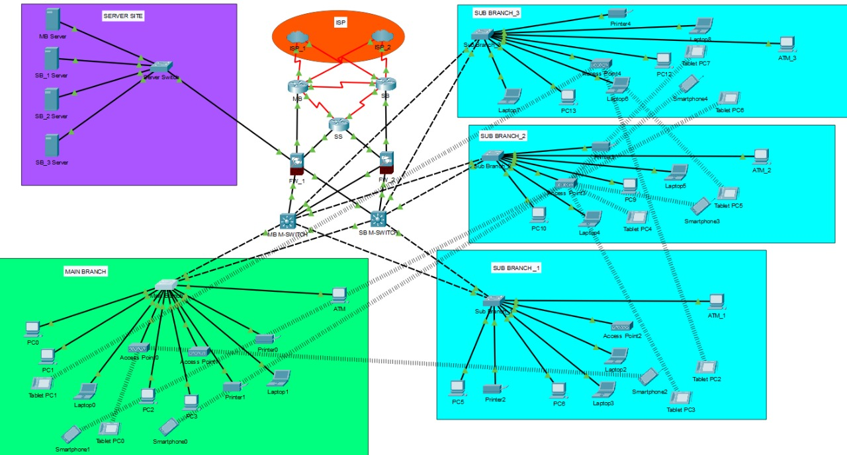

TECHNICAL DETAILS

Network Design Requirements:
- High-speed wired connectivity (Gigabit Ethernet)
- Encrypted VPN tunnels between all branches
- VLAN support on managed switches
- DMZ firewall with dual WAN support
- UPS and power redundancy at critical nodes
- Monitoring tools
- Scalability for at least 2x current branch count

Hardware:-
- Managed Layer 3 Switch (ML Switch): Used for inter-VLAN routing and efficient Layer 3 switching. Core to managing VLAN traffic between departments.
- Normal Switch (Unmanaged or Layer 2): Used at access level for connecting endpoint devices like PCs and printers in departments without routing requirements.
- Routers: Interconnect different branches and connect the network to the ISP. Configured with static/dynamic routing and encryption for VPN tunnels.
- Firewall: Deployed at branch edges and server site for securing network boundaries. Implements rulesets, NAT, intrusion prevention, and DMZ segregation.
- PCs (Personal Computers): End-user devices for banking operations, integrated into VLANs based on departments like HR, Finance, and Customer Service.
- Servers: Hosts internal services (database, authentication, file sharing) and public services (web, mail) placed in the DMZ and secured through firewall rules.
- Printers: Networked department-specific printers connected via VLAN-aware switches, with access restrictions based on role and department.
- Access Points (APs): Provide secure wireless access in branches. Configured with WPA3 encryption, VLAN tagging, and centralized management.
- Laptops: Used by mobile staff and executives. Configured with VPN clients for secure remote access.
- Smartphones and Tablets: Used by staff for mobile access to secure banking apps and internal portals. Access is regulated through mobile device management (MDM).

Software:-
- DHCP (Dynamic Host Configuration Protocol): DHCP is implemented for automatic IP address allocation across all VLANs and departments. It simplifies administrative tasks and reduces IP conflicts.
- VLAN Configuration and Trunking: VLANs are configured to separate departments (e.g., HR, Finance, IT) and isolate sensitive traffic. Trunk ports on switches carry traffic from multiple VLANs using IEEE 802.1Q tagging, connecting to Layer 3 switches and routers.
- Inter-VLAN Routing: Managed by Layer 3 switches to allow communication between different VLANs securely. Routing is restricted using ACLs and optimized for minimal latency and high throughput.
- ACL (Access Control List) Implementation: ACLs are deployed at VLAN gateways and firewall interfaces to control traffic flow. They enforce intra-VLAN security policies such as denying HR department access to IT servers while allowing necessary business flows.
- NAT (Network Address Translation): NAT is used for internal devices to access the internet through a public IP address while keeping internal IPs private. Static and dynamic NAT policies are managed by firewalls at each branch edge.
- HSRP (Hot Standby Router Protocol): HSRP is used at critical points in the network (e.g., HQ and Server Site routers) to provide redundancy. If one router fails, a backup router takes over instantly, ensuring uninterrupted connectivity.
- OSPF (Open Shortest Path First): OSPF is used as the dynamic routing protocol across the network to share routing information efficiently between branches. OSPF allows for quick convergence, route summarization, and efficient path selection.

IP Addresses :-
Branch | Subnet | Used Range | Devices
Main Branch | 192.168.20.0 | 192.168.20.1 - 254 | 9 devices+ATM
Sub Branch 1 | 192.168.10.0 | 192.168.10.1 - 254 | 6 devices+ATM
Sub Branch 2 | 192.168.11.0 | 192.168.11.1 - 254 | 6 devices+ATM
Sub Branch 3 | 192.168.12.0 | 192.168.12.1 - 254 | 7 devices+ATM
Server Site | 192.168.30.0 | 192.168.30.1 - 254 | 4 servers

- VLAN:- 6 VLANS are used subnetting.

IMPLEMENTATION

The implementation of the bank network was carried out in structured phases, ensuring both logical and physical configurations align with the goals of security, availability, and scalability.
1. VLAN Configuration: Six VLANs were configured across the network to logically segment departments and locations:
- VLAN 10: Server Site
- VLAN 20: Sub-Branch 1
- VLAN 30: Sub-Branch 2
- VLAN 40: Sub-Branch 3
- VLAN 50: Main Branch
- VLAN 60: DMZ Zone
Each VLAN was assigned its unique subnet to allow for IP management and routing policies. VLAN trunking using IEEE 802.1Q was configured on core and distribution switches to allow multiple VLAN traffic over single links.
VLAN Segmentation
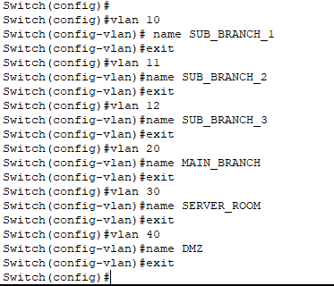

2. Redundant ISP & SD-WAN Integration: Dual Internet Service Providers (ISPs) were provisioned at the Server Site and Main Branch. Software-Defined WAN (SD-WAN) technology was implemented to dynamically switch traffic between ISPs based on performance, health, and latency. This enabled uninterrupted Internet and inter-branch connectivity even during outages.
3. Firewall and DMZ Setup: Firewalls were deployed at all critical points, particularly at:
- Server Site (Edge Firewall)
- Main Branch (Branch Firewall)
- DMZ Interfaces
These firewalls handled:
- Ingress and egress traffic filtering
- Intrusion detection and prevention
- NAT translation for public services
- Segregation between internal VLANs and the DMZ
The DMZ hosts public-facing services such as the online banking portal, email server, and customer support interface. The DMZ is isolated from internal networks using strict firewall rules and monitored 24/7.
Trunking
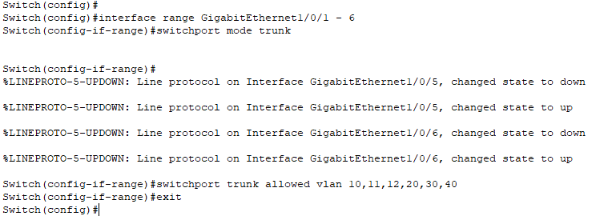

Firewall configuration
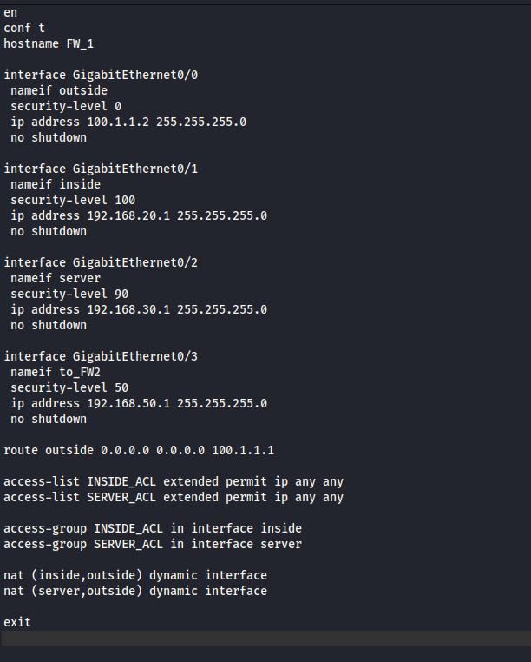

4. Server Site Deployment: The Server Site hosts:
- Core banking application servers
- Authentication and LDAP servers
- Backup and disaster recovery systems
- File storage and internal web servers
All servers are connected via a high-speed Layer 3 core switch, with VLAN tagging for segmentation. The Server Site uses redundant power supplies and backup Internet for fault tolerance.
5. Core Switching and Interconnectivity: Core Layer 3 switches connect:
- The Server Site to all branches
- Branch routers to internal VLANs
- Internal departments to core banking applications
Routing is handled by OSPF, which automatically updates paths and re-routes traffic if a link fails. Inter-VLAN routing is enabled on core switches, supported by ACLs to restrict unauthorized access between VLANs.
Router configuration
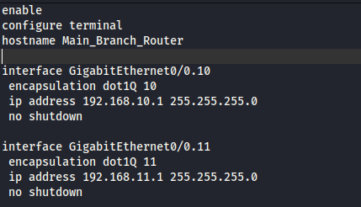

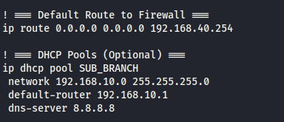

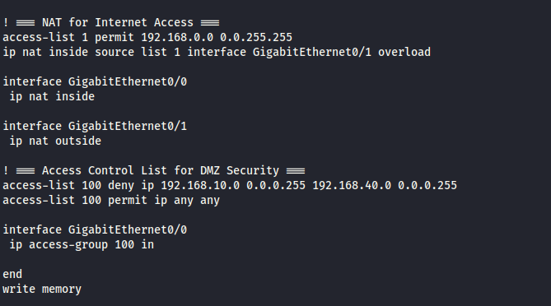

6. Additional Configuration Details:
- HSRP: Enabled on routers at the Server Site and Main Branch for router failover.
- DHCP: Centralized DHCP server provides IPs to each VLAN with reservations for static devices like printers and servers.
- NAT: Implemented at the edge firewalls to allow internal users to access the Internet without exposing private IPs.
- ACLs: Used to control access between VLANs; for example, HR VLAN cannot access IT VLAN servers.
- VPN: IPsec VPN tunnels connect branches securely, encrypting all traffic in transit.
- Monitoring: SNMP-based monitoring and logging tools deployed at each site for network visibility and fault diagnosis.

Configuring DHCP
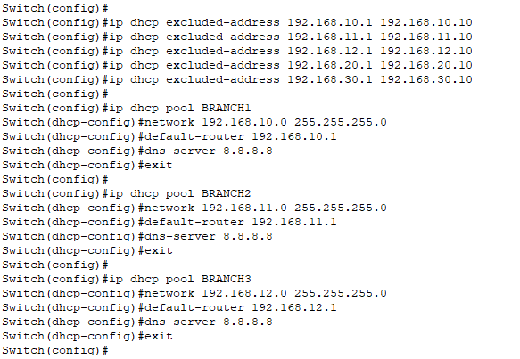

HSRP for Redundancy
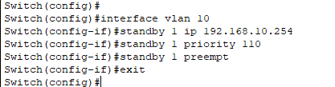

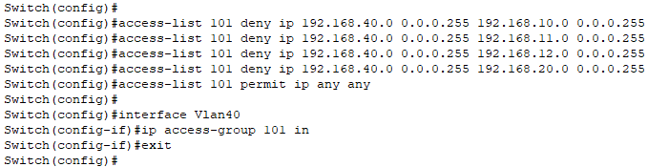
ACL

TESTING & RESULTS

The proposed banking network was thoroughly tested using Cisco Packet Tracer to validate key functionalities, including VLAN communication, security policies, redundancy, and remote connectivity.
- VLAN Communication: Devices within the same VLAN were able to communicate efficiently. Inter-VLAN routing through the Layer 3 switches allowed devices from different VLANs to interact only when permitted.
- ACL Effectiveness: Access Control Lists successfully restricted unauthorized access between VLANs. The DMZ was properly isolated from internal VLANs, ensuring external requests could only reach designated DMZ services.
- Public DMZ Services: Testing confirmed that services hosted in the DMZ (e.g., banking portal, public email) were accessible externally, while internal VLAN resources remained protected.
- VPN Simulation: Site-to-site VPN tunnels between branches and the Server Site worked effectively, providing encrypted communication over simulated public links.
- HSRP Redundancy: HSRP configuration on core routers was validated. In failover testing, traffic seamlessly rerouted to the standby router without service disruption.
- NAT Functionality: NAT translated internal private IPs for Internet access, maintaining anonymity and protecting internal addressing.
All tested parameters demonstrated successful implementation, meeting the security, availability, and performance requirements of the project.
1.MAIN BRANCH <-> MAIN BRNACH
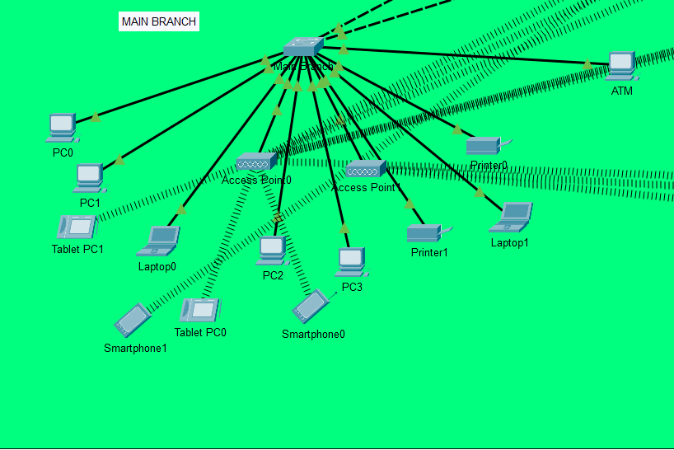

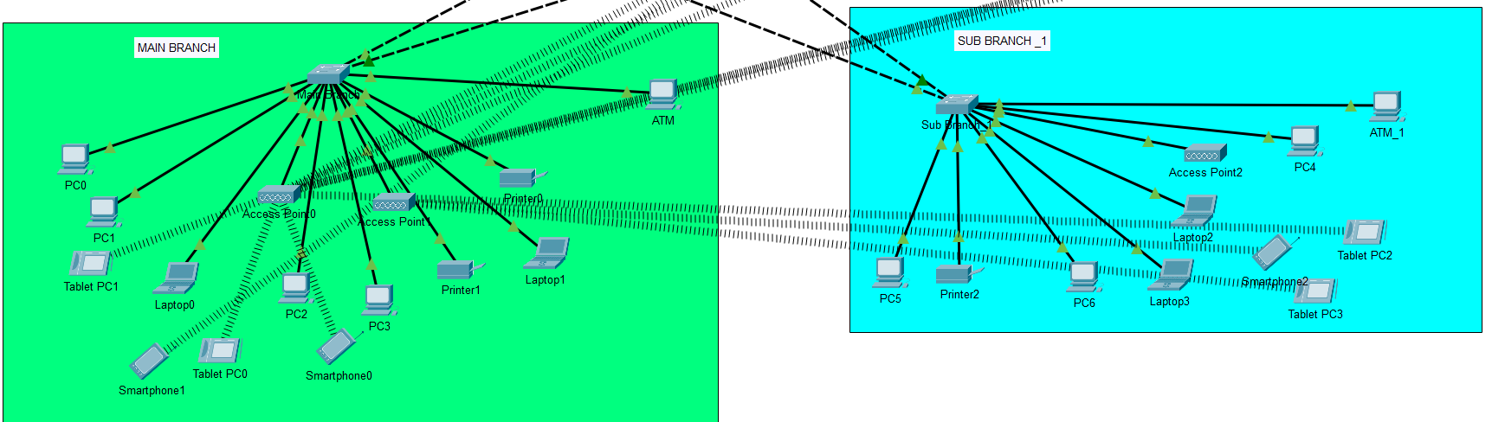
2.MAIN BRANCH <-> SUB BRANCH

3.SUB BRANCH 1 <-> SUB BRANCH 2
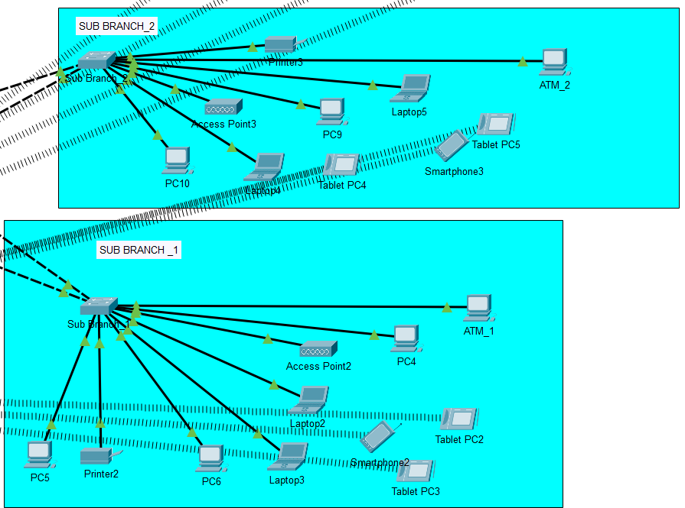

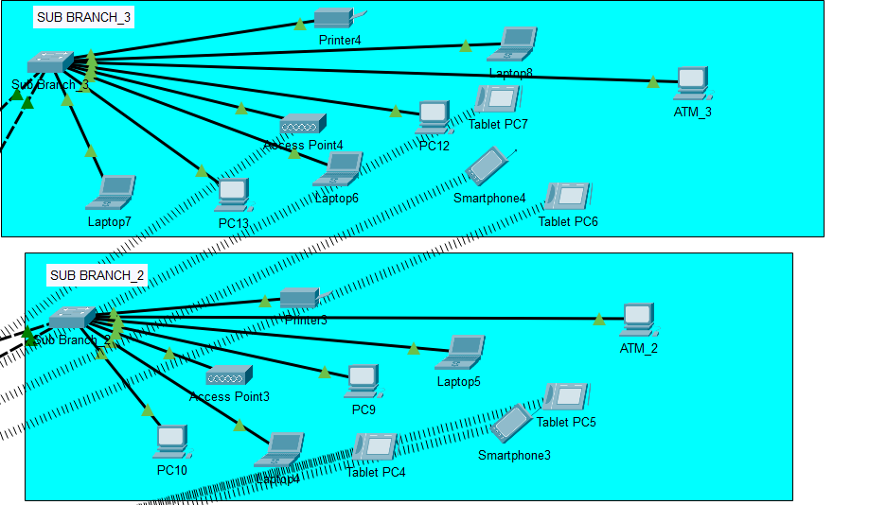
4.SUB BRANCH 2 <-> SUB BRANCH 3

5.SUB BRANCH <-> SERVER SITE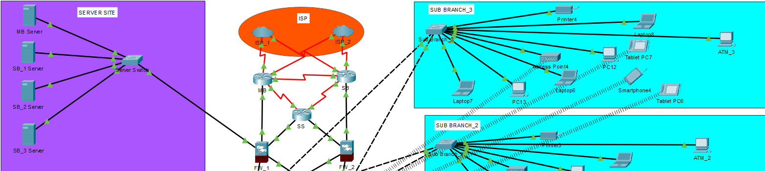

COST ANALYSIS

Devices | Brand/Model | Quantity | Total cost(INR)
Routers | Cisco ISR 4331 | 3 | 2,65,000
Switches(L2) | Cisco 2960 | 4 | 4,00,000
Switches(L3) | Cisco 3650-24PS | 2 | 5,00,000
Wi-Fi 6 | Ubiquiti UniFi 6 Pro | 5 | 1,00,000
Firewalls | Cisco ASA-5506X | 7 | 5,00,000
Storage Servers(NAS) | Cisco PT-servers | 4 | 8,00,000
Cat 6 Ethernet Cabling | High speed ethernet cable | 1 | 15,000
Fiber Optic Cables | Single-mode Fiber Optic Cable | 500 meters | 62,500
Patch Panels & Connectors | 48-Port Patch Panel | 5 | 50,000
UPS | APC smart-ups (1000-1500 VA) | 5 | 90,000
Load Balancer | F5 Big-IP | 2 | 2,00,000

Total cost :- 30,00,000
This table summarizes all the necessary quantities, unit costs, and the total cost for each device required for 1 Main branch, 3 sub branches, and 1 ATM. The total estimated cost comes to INR 30,00,000.

SOCIETAL AND INDUSTRY IMPACT

The implementation of a secure and reliable banking network has a significant impact on both society and the financial industry. The effects are widespread, contributing to economic growth, public trust, digital inclusion, and innovation.
1. Enhanced Financial Security for the Public: By protecting user data and transactions from cyber threats, the project boosts consumer confidence in digital banking platforms, encouraging broader use of online financial services.
2. Digital Inclusion and Accessibility: The network allows rural and underserved regions to access banking services via connected branches and digital channels, bridging the digital divide and fostering inclusive economic participation.
3. Reduction in Financial Crime: Advanced security measures such as encryption, firewalls, ACLs, and intrusion detection prevent unauthorized access and reduce risks of identity theft, data breaches, and financial fraud.
4. Economic Stability and Trust: A robust banking network enhances the stability of financial institutions. This in turn promotes public trust and contributes to the resilience of the national economy during cyberattacks or service disruptions.
5. Improved Industry Standards: The project's implementation of best practices like VLAN segmentation, DMZ architecture, and failover mechanisms sets a benchmark for network design within the banking industry and beyond.
6. Support for Innovation in Fintech: The scalable, secure infrastructure allows financial institutions to integrate innovative technologies like mobile banking, blockchain, and AI-based services, driving digital transformation.
7. Regulatory Compliance: The network supports compliance with global and local regulations (e.g., RBI guidelines, PCI-DSS, GDPR), ensuring legal operation and protecting stakeholders from penalties.
8. Job Creation and Skill Development: Deployment and maintenance of such networks generate employment opportunities for IT professionals, while also promoting cybersecurity awareness and technical skill development.
9. Resilience Against Emergencies: By enabling disaster recovery and failover systems, the network ensures continuous service even during power outages, hardware failures, or cyber incidents, benefiting both institutions and users.
10. Environmental Benefits: With the adoption of green networking practices and efficient hardware, banks can reduce their carbon footprint, contributing to broader environmental sustainability goals.
CONCLUSION

The project successfully demonstrates the design and implementation of a secure, resilient, and scalable banking network capable of supporting 24/7 operations across multiple branches. A system designed for seamless inter-branch communication utilizes client-server and peer-to-peer networking, with LAN or VPN links ensuring secure data transmission. The use of VLAN segmentation, DMZ isolation, and encrypted tunnels ensures robust protection against unauthorized access and cyber threats.
Security is further reinforced through the implementation of encryption protocols, firewall policies, ACLs, and multi-factor authentication. The technological foundation—comprising TCP/IP, SQL databases, VPNs, and next-generation firewalls—ensures stable and secure banking operations.
Through simulation and rigorous testing in Cisco Packet Tracer, the network has proven to meet key requirements of high availability, security, and performance. Failover capabilities via HSRP and dual-ISP connectivity ensure uninterrupted service, while ACLs and NAT provide controlled access and Internet connectivity. Overall, this network design lays the groundwork for a reliable and secure banking infrastructure that can adapt to future technological advancements and cybersecurity challenges.
The future scope of this project lies in enhancing and evolving the network infrastructure in response to the ever-changing technological landscape and increasing security threats in the banking sector. This includes embracing innovation, scaling the network, and integrating smarter, more adaptive technologies.

In conclusion, this project not only strengthens the internal operations of financial institutions but also has a transformative effect on the community, contributing to a safer, more inclusive, and innovative banking environment.

REFERENCES

- Cele, N.N. and Kwenda, S. (2025) Identified identity theft, malware attacks, phishing, and vishing as significant cybersecurity threats hindering digital banking adoption. The study also summarized 13 preventive tools.
- Judijanto, L., Kaaffah, F.M., Muthmainah, H.N., and Vandika, A.Y. (2024) Explored computer network security's role in safeguarding financial data and customer trust in Indonesia's digitalizing financial sector. It highlights the need for collaborative efforts to address cybersecurity challenges.
- North Press (2024) This literature review explores the pivotal role of computer network security in safeguarding financial data, transactions, and customer trust within this dynamic context.
- Acharya, S. and Joshi, S. (2020) Studied the impact of cyber-attacks on banking institutions in India, focusing on safety mechanisms and preventive measures.
- Vanini et al. (2021) Emphasized that all parties involved in digital transactions must remain aware of cyber threats and update their knowledge to minimize the adverse impacts on digital banking adoption.
- Accenture (2019) Provided insights into the cost of cybercrime in the USA

