SCIO vs. KAPI-ELM on Convection-Diffusion BVP:
Impact of Residual Adaptive Collocation Sampling
Meet Dabgar • NIT Surat • Research Intern, CRUNCH Group, Brown University
Prepared for Dr. Vikas Dwivedi, IIT Madras

1. Executive Summary
In our previous benchmark, we established that standard neural network optimizers (SCIO, L-BFGS, Adam) converge to a non-physical decoy solution (Failure Mode 2: 'shifted boundary layer') or remain stuck at initialization (Failure Mode 1) on stiff scales of the singularly-perturbed 1D convection-diffusion BVP. Dr. Vikas Dwivedi hypothesized that residual-based adaptive sampling strategies in PINNs would also fail to solve this problem. To test this, we implemented and evaluated Method A: RAR (Residual-based Adaptive Refinement) and Method B: RAD (Residual-based Adaptive Distribution) using the curvature-aware SCIO optimizer.
The empirical findings confirm Dr. Dwivedi's hypothesis. Both RAR and RAD fail to resolve the boundary layer on stiff scales (nu <= 1e-2), remaining locked in the stuck-at-initialization state. This report outlines the quantitative results and details the mathematical 'feedback lock' mechanism that prevents residual-based adaptive methods from escaping degenerate initial states in singularly-perturbed boundary value problems.
2. Comparative Accuracy Summary
Method | nu = 10^-1 | nu = 10^-2 | nu = 10^-3 | nu = 10^-4 | nu = 10^-5
KAPI-ELM (BO)* | 7.457e-08 | 5.767e-08 | 8.740e-07 | 1.983e-04 | 5.249
SCIO (Baseline) | 3.244e-03 | 5.184 | 2.319e+01 | 2.919e+01 | 2.237e+01
RAR-SCIO | 2.906e-03 | 7.549 | 2.165e+01 | 2.373e+01 | 2.437e+01
RAD-SCIO | 5.931e-04 | 7.622 | 2.022e+01 | 2.539e+01 | 2.550e+01
*Note: KAPI-ELM (BO) was run on Kaggle CPU (Intel Xeon) and carries a search cost of ~444s, while SCIO runs were trained on Local GPU (NVIDIA RTX) for a budget of 800 NFEs.

3. The 'Feedback Lock' of Adaptive Resampling
Residual-based adaptive sampling operates on the assumption that the neural network's current residual landscape indicates where the approximation is poorest. However, in singularly-perturbed boundary value problems, this assumption breaks down due to a feedback lock:
- Degenerate Residual Profile: Because the initial landscape is stiff, the network remains stuck at initialization, predicting a flat, near-zero profile u(x) ≈ 0.0. Since a flat line has zero derivatives, the PDE residual |u_x - nu * u_xx| evaluates to virtually zero across the entire interior domain. This provides no targeted sampling signals to RAD.
- Boundary Point Over-concentration: While the stuck profile is flat on the interior, it satisfies the left boundary u(0)=0 but violates the right boundary u(1)=1. This local mismatch creates a sharp boundary layer in the prediction near the boundaries. RAR identifies this as the high-residual region and piles up almost all accumulated points at the boundaries, completely ignoring the actual physical boundary layer at x ≈ 0.99.
- Training Lock: Without targeted points placed in the true boundary layer near x=1, the network receives no gradient feedback explaining how the sharp transition should behave. It remains permanently locked in the stuck-at-initialization state.

4. Visual Evidence and Collocation Histograms
Below are the collocation point distributions for RAR-SCIO at nu=1e-3 and nu=1e-4, demonstrating the point accumulation behavior on the boundaries.
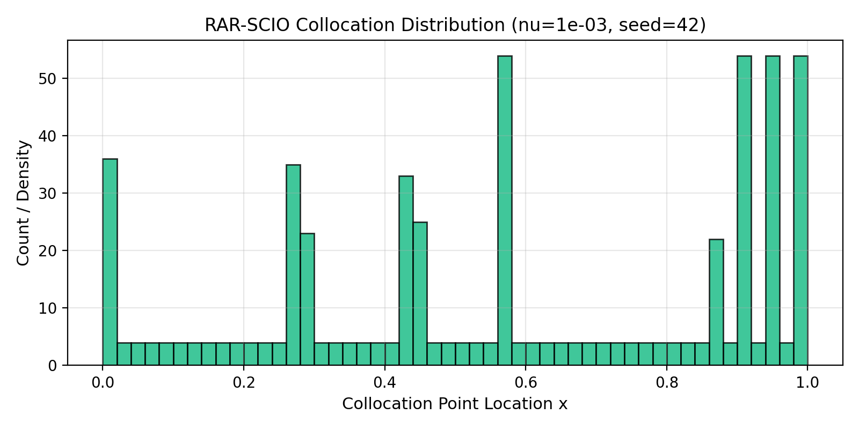
Figure 1: RAR-SCIO Collocation Point Distribution at nu=1e-3, seed 42. Points pile up at the boundaries due to the stuck flat-BVP profile.
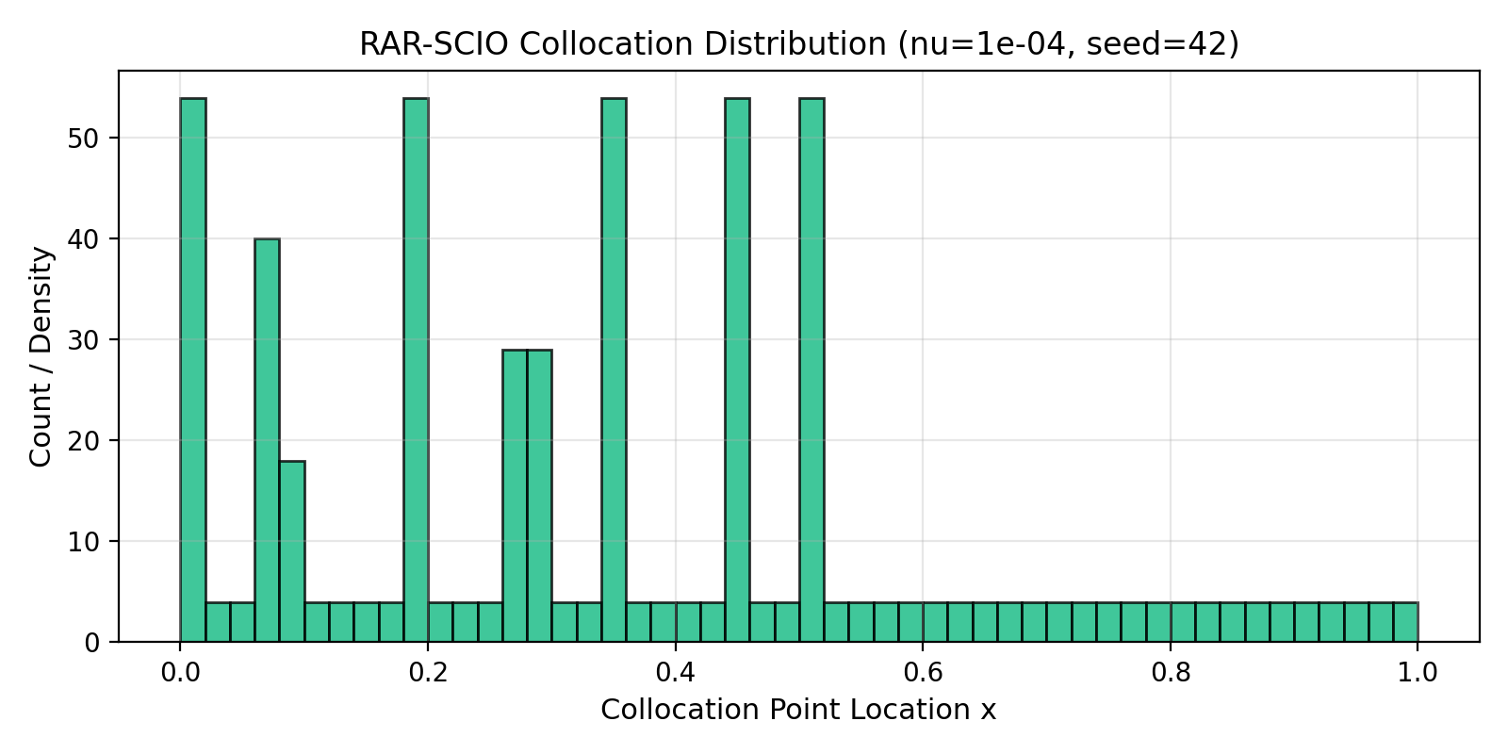
Figure 2: RAR-SCIO Collocation Point Distribution at nu=1e-4, seed 42. Shows identical boundary concentration behavior.

