**Abstract:** Silicon Dictionary Final Project - User Story, Prototype, ER Diagram

**Class:** Professor Jason Henderson, Spring 2017 Internet Programming CST 336

**Author:** Mavey Ma

**Date:** 8 May 2017

1. **User Story**

Silicon Dictionary is inspired by a [post](https://www.facebook.com/groups/LadiesStormHackathons/permalink/1762952227293184/) on Ladies Storm Hackathons (a Facebook group of 8,300 members). The post crowdsourced for a compilation of “tech lingo” that people new to computer science might not know. The goal is to keep the definitions as simple as possible. To further promote accessibility, Silicon Dictionary will be a one-shop-stop for people around the world who can translate the definitions into their own languages, considering that programming is primarily taught in English.

1. **Prototype**
   1. [**Google doc**](https://docs.google.com/document/d/1YTvW5FuRR1PjXG5rx4PPNvw4Iwx_wHYZnrNrnxWeu3Q/edit#) **Inspiration for a website that scrolls in ABC order based on category (Types of Jobs, Specific Roles, Areas of Research, and Miscellaneous Terminology)**
   2. **Home Page Preface message**

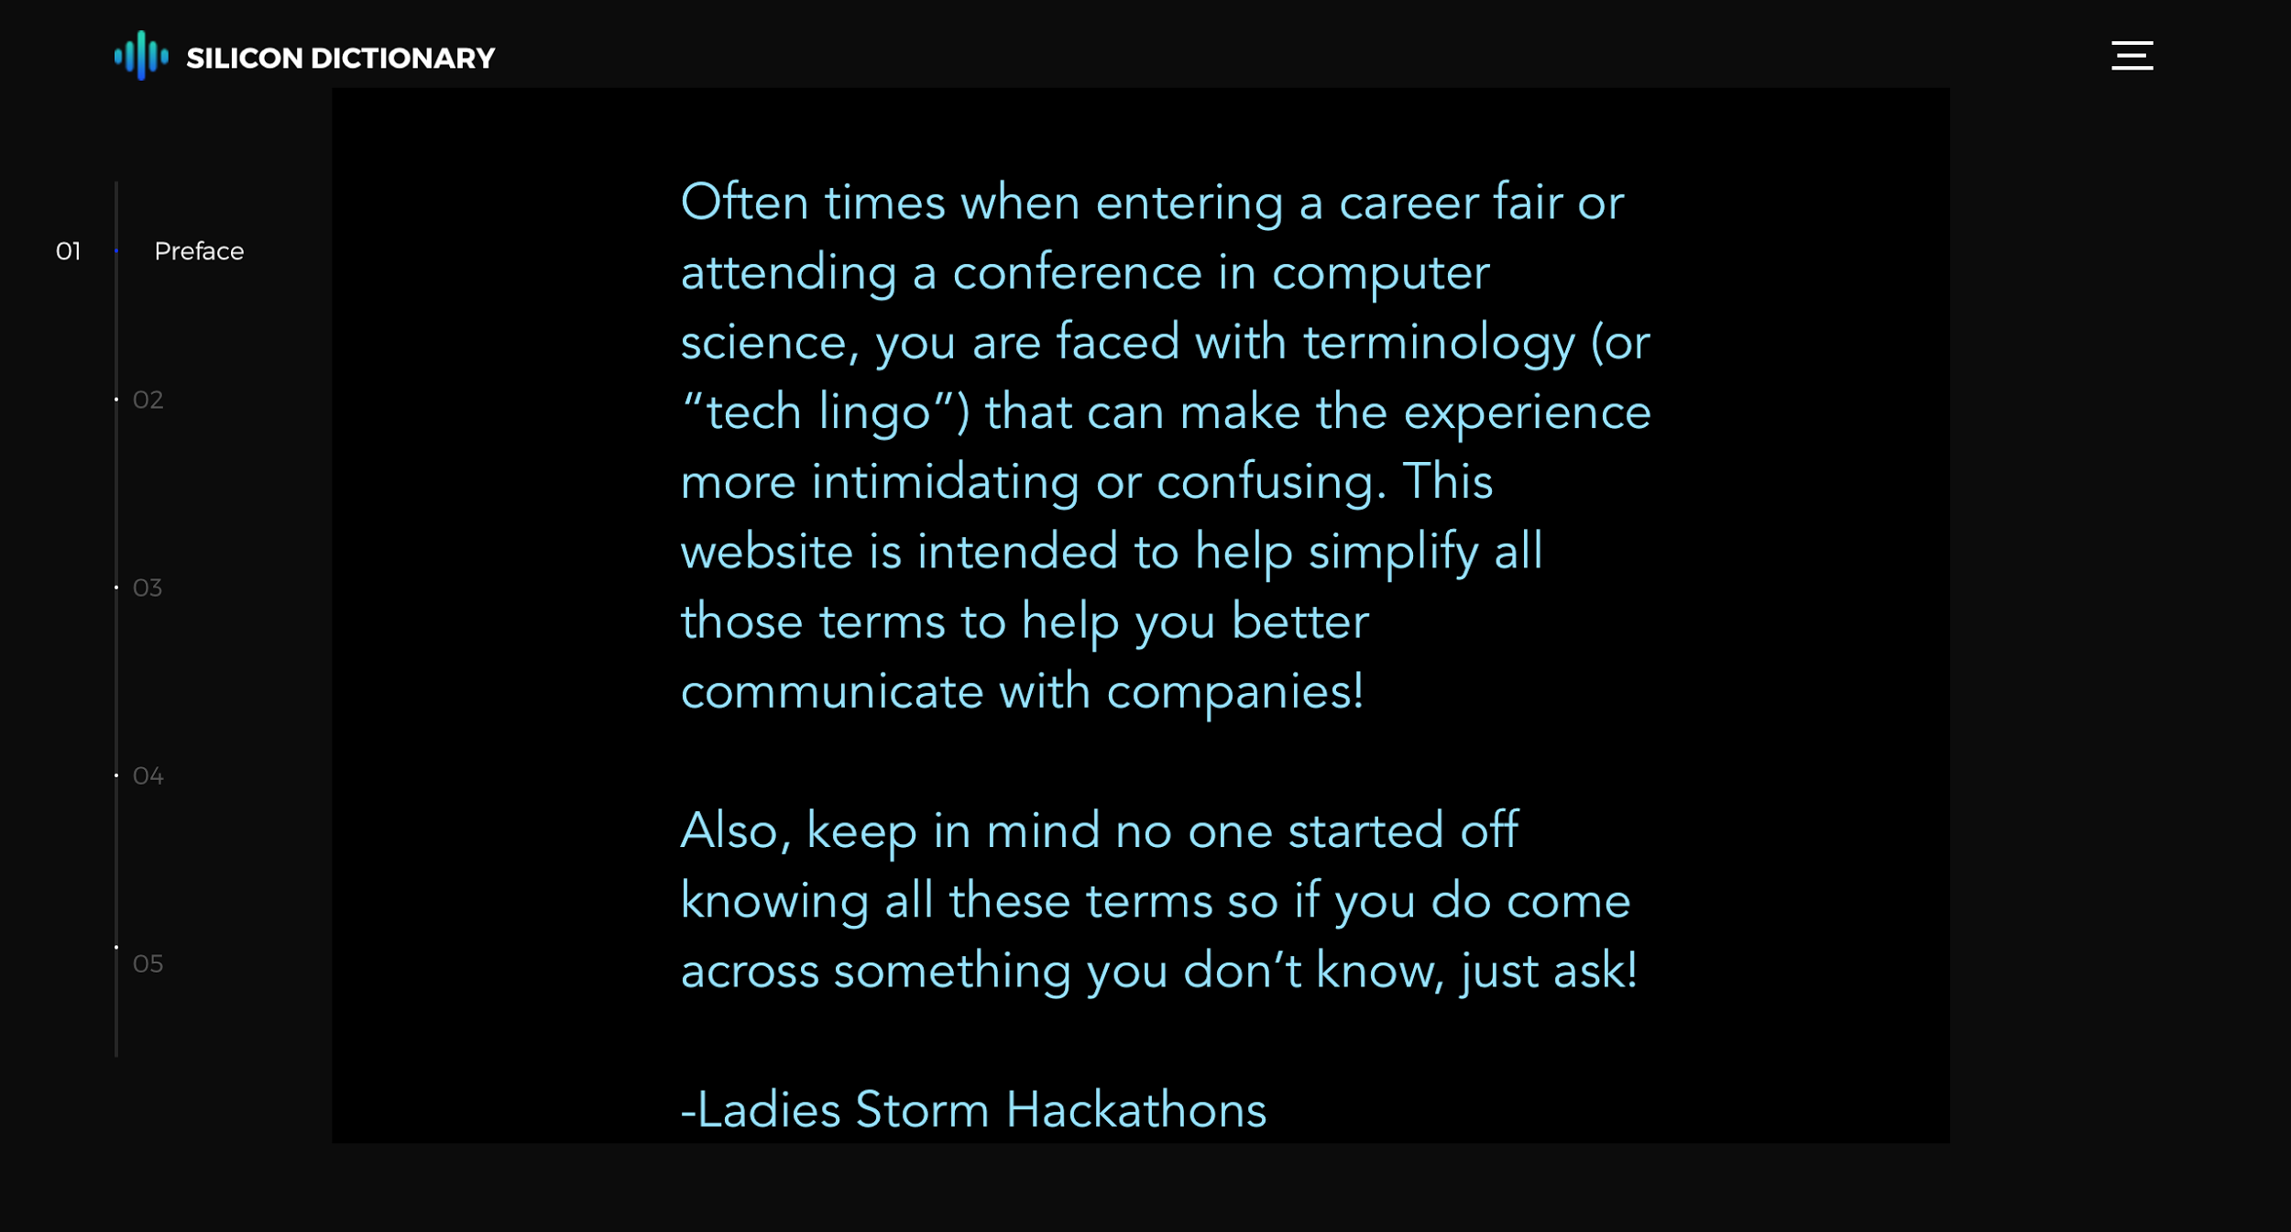

* 1. **Admin page**

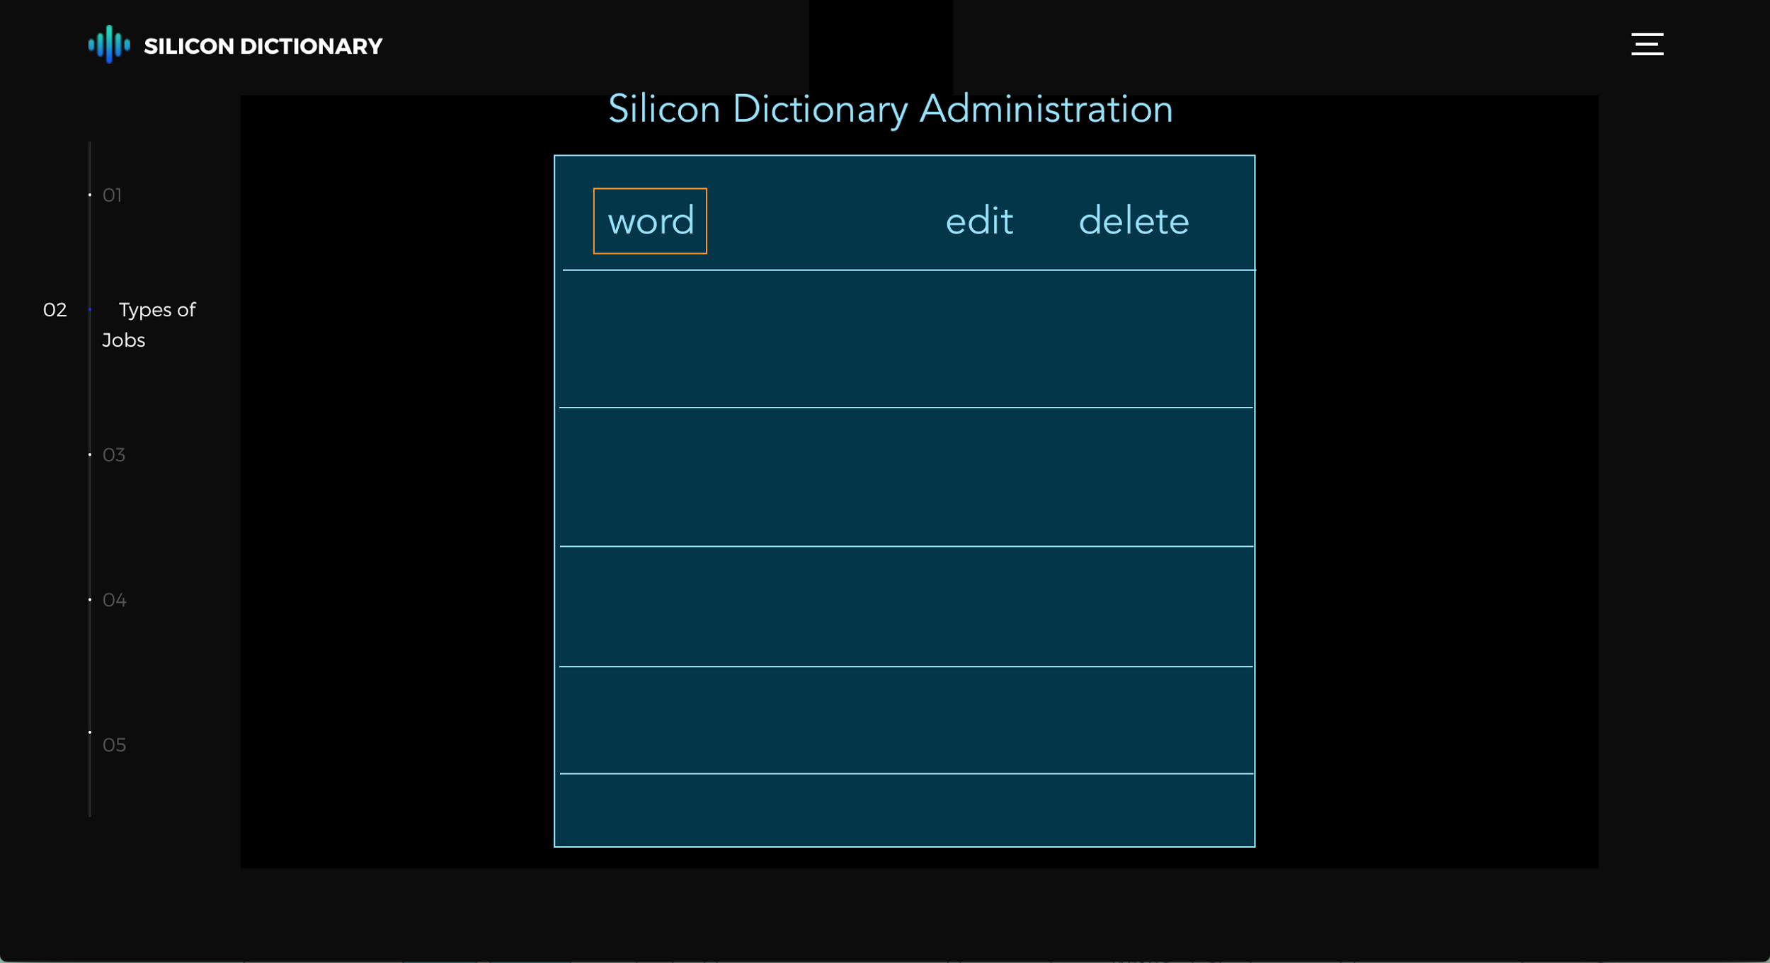

* 1. **User page**

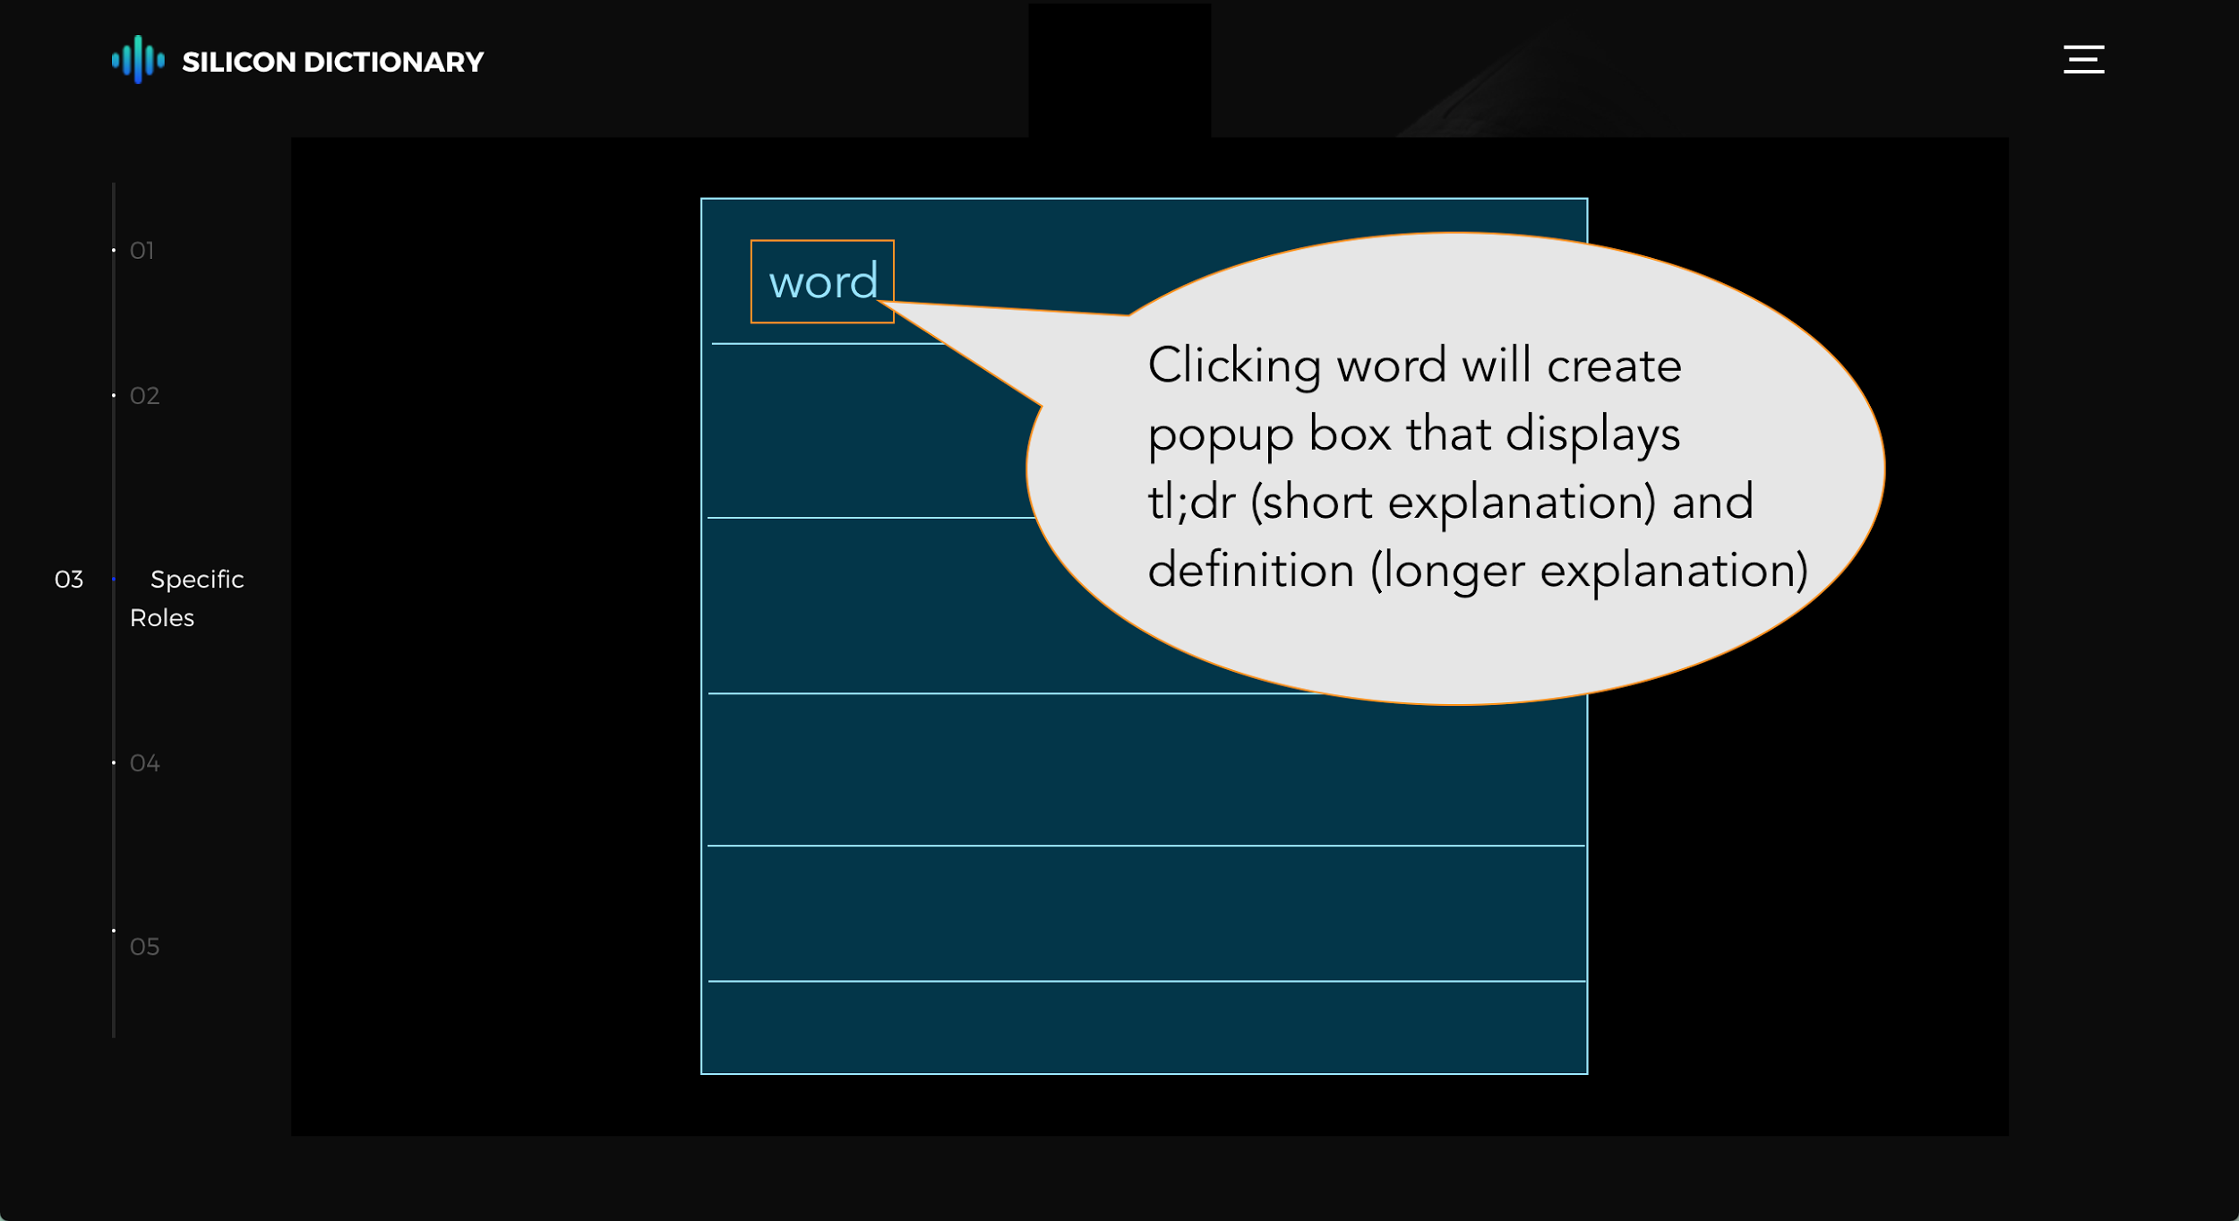

1. **E/R Diagram**

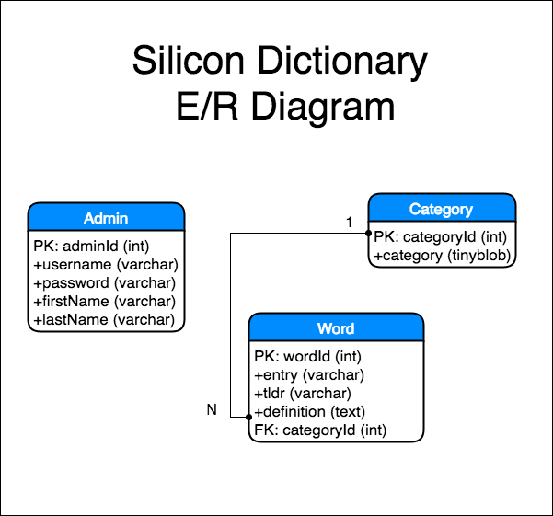

1. **Database Schema**

