System Design Document (SDD)

Title Page
System Design Document
Project Title: Time Table Creation System
Version: 1.0
Date: 15/11/2025
Prepared by: Aditya Sukhadeo Jagadale , Pratik Dhanaji Kawade , Punyam Santosh Shah.
Reviewed by: [Reviewer]
Approved by: [Supervisor / Department]

System Overview
- System Description - The Smart Timetable Creation System is a web-based application designed to automatically generate efficient and error-free college timetables. The system collects inputs such as departments, subjects, classrooms, teachers, time slots, and workloads, and uses a scheduling algorithm to create a conflict-free timetable for each class and faculty member.
- It eliminates manual work by ensuring that:
- No two classes use the same room at the same time
- No teacher is assigned to multiple classes simultaneously
- Subject hours match weekly requirements
- Timings are optimized based on constraints
The system provides an easy interface for administrators to enter data and instantly generate timetables. Once created, the timetable can be viewed, edited, downloaded, or shared.

- System Objectives -
- Automate Timetable Generation
Automatically create accurate and conflict-free timetables for all departments and classes.
- Avoid Scheduling Conflicts
Ensure no teacher, room, or class is double-booked at the same time.
- Optimize Resource Usage
Efficiently allocate classrooms, teachers, and time slots based on availability.
- Reduce Manual Work
Minimize the time and effort required compared to traditional manual timetable creation.
- Provide Easy Editing & Updates
Allow administrators to modify or regenerate timetables quickly whenever changes occur.
- Improve Accuracy & Consistency
Maintain correct subject hours per week and ensure all rules and constraints are followed.
- Generate Department-wise Timetables
Create separate timetables for each class, faculty, and room.
- Support Export & Sharing
Enable downloading or printing the timetable in PDF/Excel formats.

- System Environment –
  - Hardware Environment
  - A computer or server with minimum:
  - Processor: Dual-Core or higher
  - RAM: 4GB or higher
  - Storage: 20GB free space
  - Users can access the system from laptops, desktops, or mobile devices.
  - Software Environment
  - Frontend: Next.js (React)
  - Backend: Node.js (Express)
  - Database: MongoDB / MySQL (depending on your choice)
  - OS Support: Windows, Linux, or macOS
  - Package Manager: npm or yarn
  - Browser Support: Chrome, Edge, Firefox, Safari
  - Network Environment
  - Runs on a local server or cloud server (AWS, Render, Vercel, etc.)
  - Requires internet connection for online access, or LAN for local deployment.
  - Supports multi-user access via web browser.

System Architecture Design

1. High-level architecture (layered view)
The system follows a three-layered architecture:
- Presentation Layer (Frontend)
  - Next.js (React) web app — Admin UI, Faculty view, Student view, Timetable viewer/editor, Export UI.
  - Responsibilities: data entry forms, timetable display, edit operations, authentication UI, real-time updates (WebSocket).
- Application Layer (Backend / Services)
  - Node.js + Express (REST / GraphQL) API
  - Scheduler Service (timetable solver) — standalone module or microservice that runs the constraint/optimisation algorithm.
  - Authentication & Authorization Service — JWT + role-based access control.
  - Notification Service — email / SMS / push notifications.
  - File Service — PDF/Excel export generator.
- Data Layer (Persistence & Storage)
  - Primary DB: MongoDB (document) or MySQL/Postgres (relational) depending on normalization needs.
  - Object storage: S3-compatible storage (for exported files, backups).
  - Cache (optional): Redis for session store, caching availability and recent results.
2. Core components and responsibilities
- Client (Next.js)
  - Inputs: department data, courses, faculty availability, room list, constraints.
  - Displays: generated timetables, conflict reports, edit UI.
  - Real-time: receives scheduling progress/notifications via WebSocket.
- API Gateway / Backend (Node.js / Express)
  - Exposes REST endpoints (or GraphQL) for CRUD operations: /departments, /courses, /rooms, /teachers, /timetables, /scheduler.
  - Handles validation, authentication, request throttling, logging.
- Scheduler Service
  - Accepts constraint definitions and inputs; runs the solver to produce timetables.
  - Implementation options:
    - Rule-based heuristic (greedy + backtracking) — simpler, faster for small colleges.
    - Constraint Programming (CP-SAT) via OR-Tools — robust, handles complex constraints.
    - Genetic algorithm or simulated annealing — for optimization objectives (minimize idle times, teacher gaps).
  - Runs as:
    - In-process job (for small scale) or
    - Separate worker microservice (recommended) using a job queue (e.g., Bull with Redis or RabbitMQ).
- Job Queue & Worker
  - Queues scheduler jobs to avoid blocking API. Workers process jobs, update results in DB, emit progress events.
- Database
  - Stores master data and generated timetables.
  - Schema highlights: Departments, Courses, Batches/Classes, Teachers, Rooms, Timeslots, Constraints, TimetableRuns (metadata, versioning), Users/Roles.
- File / Export Service
  - Converts timetable data to PDF or Excel for download—uses headless browser (Puppeteer) or server-side libraries (xlsx, pdfkit).
- Notification Service
  - Sends completion emails, change alerts, or calendar invites. Integrates with SMTP, Twilio, or push service.
- Monitoring & Logging
  - Logs (structured) to ELK or hosted logging. Health checks and metrics exported to Prometheus/Grafana.
3. Interactions & Sequence (high-level flows)
A. Generate timetable flow
- Admin/Dept → Frontend: fills forms and clicks Generate.
- Frontend → API: POST /api/scheduler/run with input snapshot (department, semester, constraints).
- API → Validation: quick schema & business-rule validation. Persist TimetableRun(status=queued) with snapshot ID.
- API → Queue: push job to Redis/Bull (job includes snapshot ID and run metadata). Return runId to client.
- Worker picks job → loads snapshot from DB → builds solver model → runs solver.
- Worker publishes progress to Redis pub/sub (or emits via message broker).
- Frontend subscribes to WebSocket → receives progress updates and final completion event.
- Worker persists results (allocations) and marks TimetableRun(status=done); optionally store a PDF/Excel in object storage.
- Frontend fetches result and displays; user may accept or request repair.
B. Manual edit (repair)
- User edits a cell → Frontend calls PATCH /api/timetables/:runId/allocations/:allocId.
- API validates edit (locks, conflicts). If repair requested, enqueue a repair job containing locked assignments.
- Worker runs incremental solver (respect locks) and updates TimetableRun with new result version.
4. Recommended data model (conceptual / simplified ER)
I recommend relational (Postgres) for strong constraints and easy joins; document DB (MongoDB) can work if you prefer flexible snapshots. Below is a compact relational model (table names + key fields):
- users (id, name, email, role)
- departments (id, name)
- courses (id, code, title, department_id, lecture_slots_per_week, lab_slots_per_week)
- batches (id, dept_id, year, size) — grouping of students (section)
- sections (id, course_id, batch_id, section_code)
- teachers (id, name, email, max_load, preferred_slots JSON, unavailable_slots JSON)
- rooms (id, name, capacity, type)
- timeslots (id, day_of_week, start_time, end_time, slot_index)
- constraints (id, timetable_run_id, type, params JSON, hard_flag)
- timetable_runs (id, snapshot_json, status, created_by, created_at, completed_at, metrics JSON)
- allocations (id, timetable_run_id, section_id, teacher_id, room_id, timeslot_id, locked_by_edit boolean, version)
- audit_logs (id, entity_type, entity_id, user_id, action, details JSON, timestamp)
Notes:
- Keep snapshot_json for immutability of runs.
- constraints.params can store flexible constraint definitions (e.g., no-two-lectures-on-friday for a teacher).
- Index timeslots and allocations on timeslot_id and teacher_id for conflict checks.
5. Example API surface (essential endpoints)
Group by responsibility — auth omitted for brevity.
Metadata
- GET /api/meta/departments
- GET /api/meta/teachers
- GET /api/meta/rooms
- GET /api/meta/timeslots
Scheduler & Runs
- POST /api/scheduler/run — start run (body: snapshot + constraints) → returns { runId }
- GET /api/scheduler/run/:runId — status + summary
- GET /api/scheduler/run/:runId/result — full allocations JSON
- POST /api/scheduler/run/:runId/repair — request repair with locked cells (body: locks)
Timetable CRUD / Edits
- GET /api/timetables/:runId/allocations
- PATCH /api/timetables/:runId/allocations/:allocId — edit single cell (lock/unlock)
- POST /api/timetables/:runId/allocations/bulk — bulk updates
Exports
- GET /api/scheduler/run/:runId/export?format=pdf|xlsx|csv
Admin
- POST /api/admin/import — bulk import metadata (rooms/teachers/courses)
- GET /api/admin/audit/:entity — audit logs
6. Scheduler job lifecycle & worker responsibilities
- Enqueue: Backend serializes a snapshot and enqueues job with runId and solver params (time_limit, seed, objective_weights).
- Worker startup: claims job, loads immutable snapshot, prepares in-memory matrices (teacher_availability, room_availability).
- Model construction: translate domain into solver variables (binary or integer). Apply hard constraints as invariants and soft constraints as weighted penalties.
- Solve: run solver with time limit; periodically checkpoint best solution to DB (for recovery). Stream progress messages (percent, objective, violations).
- Finalize: save final allocations, metrics (solve_time, nodes_explored, objective_value), generate export files (async) and publish completion.
- Retry policy: configure job retries for transient errors; permanent failures -> dead-letter queue and alert.
7. Deployment & Infrastructure (practical choices)
- Containers: Docker images per service (frontend, backend, worker, scheduler microservice).
- Orchestration: Kubernetes (EKS/GKE/AKS) or Docker Compose for small deployments.
- Managed services: Postgres (RDS / Cloud SQL), Redis (Elasticache), S3 (AWS) or MinIO for on-prem.
- CI/CD: GitHub Actions or GitLab CI → build images, run tests, deploy to k8s.
- Storage: Use S3 buckets for exported artifacts; store presigned URLs in timetable_runs.
- Secrets: Vault / K8s secrets for DB/SMTP/Twilio credentials.
8. Security & Compliance
- Enforce HTTPS + HSTS.
- JWT with short TTL and refresh tokens. Role-based access checks server-side.
- Input validation & sanitization on all endpoints (prevent injection in constraint JSON).
- Least-privilege IAM for cloud resources.
- Audit trails for manual edits and exports.
- Data retention policy: purge old runs or archive to cold storage.
- If PHI or sensitive data present, enable encryption at rest & in transit and apply relevant compliance controls.
9. Scalability & performance strategies
- Horizontal workers: scale workers independently from API.
- Sharding jobs: split large runs by department or day-ranges to create subproblems and merge results.
- Seeding & warm starts: use previous accepted timetables as seeds to accelerate convergence.
- Time-limited solves: return best-found solution after time limit; show trade-off UI to user.
- Caching: keep availability matrices and frequently read metadata in Redis.
- Bulk conflict checks: use indexed DB queries and in-memory bitsets during solve for speed.
10. Monitoring, logging & backups
- Metrics: expose Prometheus metrics: queue_length, job_rate, avg_solve_time, last_success_timestamp.
- Logging: structured logs (JSON) to ELK or hosted log provider; include runId in logs.
- Tracing: distributed tracing (Jaeger) across API and workers.
- Alerts: on long queue backlog, repeated job failures, or DB errors.
- Backups: automated DB snapshots daily; retain exports in object store for configured period.
- Disaster recovery: documented RTO/RPO; ability to replay jobs from snapshots.

11. Testing & QA
- Unit tests: for validators, API endpoints, and small solver modules.
- Integration tests: end-to-end run with a tiny dataset to ensure no hard constraint violations.
- Property-based tests: randomly generate small problem instances and assert invariants (no double booking, capacity respected).
- Performance tests: run solver at scale with representative data; measure solve time and memory.
- User acceptance: recruit faculty to validate outputs and editing workflow.
- Canary releases: use feature flags for solver changes and roll out gradually.
12. Implementation roadmap (phased)
Phase 0 — Preparation (1 week)
- Finalize data model, choose stack (Postgres vs Mongo). Create seed data.
Phase 1 — MVP (2–4 weeks)
- Frontend skeleton (forms + grid with mock results).
- Backend CRUD + job enqueue endpoint.
- Worker stub returns deterministic mock timetable.
- Expose WebSocket progress.
Phase 2 — Basic solver (3–6 weeks)
- Implement simple greedy/heuristic solver (in Python) that respects hard constraints.
- Persist real allocations; allow manual edits with locks.
Phase 3 — CP Solver & Repair (4–8 weeks)
- Integrate OR-Tools CP-SAT solver (soft constraints with weights).
- Implement repair job logic, versioning, and export generation.
Phase 4 — Scale & Harden (ongoing)
- Add monitoring, horizontal scaling, backups, and security hardening.
- Improve UI/UX, analytics, and calendar integrations.

Architectural Design Overview
1. Overview
The system uses a layered architecture with a microservice-friendly decomposition. That means we organize functionality into Presentation, Application, and Data layers, while keeping heavy/independently-scalable responsibilities (scheduler/solver, export, notifications) as separate services/workers. This gives fast development for an MVP and lets you extract microservices without a major rewrite.
Primary goals:
- Enforce hard constraints (no double-booking, room capacity, teacher availability).
- Optimize soft constraints (teacher preferences, minimize gaps).
- Support manual edits and repair runs while preserving reproducibility via immutable run snapshots.
- Be observable, scalable, and resilient.
2. Major components & responsibilities
Presentation Layer
- Next.js (React) Web App
  - Admin UI: metadata management, run control, audit view.
  - Faculty UI: view/confirm assignments, set preferences.
  - Student UI: personal timetable (read-only).
  - Timetable editor: visual weekly grid, drag-and-drop, lock/unlock, diff view.
  - Real-time: subscribes to progress/events via WebSocket or SSE.
Application Layer (Backend / Services)
- API Gateway / Backend (Node.js / FastAPI)
  - CRUD for departments/courses/rooms/teachers/timeslots.
  - Snapshot creation for scheduler runs.
  - Job enqueueing, status endpoints, edit endpoints.
  - Enforces RBAC and request validation.
- Auth Service
  - JWT issuance/validation, role checks (admin, registrar, teacher, student).
- Scheduler Controller
  - Accepts user run requests, validates inputs, persists run metadata, calls queue.
- Notification Service
  - Handles emails/push/SMS for run completion / alerts.
- Export Service
  - Generates PDF/Excel/ICS exports (Puppeteer/pdfkit/xlsx); runs offline as worker if heavy.
- Monitoring & Logging
  - Metrics (Prometheus), logging (ELK or hosted), error tracking (Sentry).
Worker / Scheduler Layer
- Job Queue (Redis + Bull/BullMQ or RabbitMQ/Celery)
  - Durable queue for scheduling jobs, retries, dead-letter handling.
- Worker(s) / Solver Service (recommended Python + OR-Tools)
  - Loads immutable snapshot, constructs solver model, enforces hard constraints, optimizes soft constraints.
  - Checkpoints best partial solutions periodically and persists final allocations.
  - Honors locked manual edits in repair runs.
  - Emits progress events.
Data Layer (Persistence & Storage)
- Primary DB — PostgreSQL (recommended) for relational integrity; MongoDB is an option if you prefer flexible documents.
- Cache / Pub-Sub — Redis for caching availability, distributed locks, and pub/sub for progress.
- Object Storage — S3 or S3-compatible (exports, archived snapshots, backups).

3. Interactions & data flow (high-level)
- User -> Frontend: user completes metadata (courses, teachers, rooms) and clicks Generate.
- Frontend -> API: POST /api/scheduler/run with input snapshot and constraint overrides.
- API -> DB: validate and persist TimetableRun(status=queued) with immutable snapshot JSON.
- API -> Queue: enqueue job (runId, solver params).
- Worker -> Queue: worker claims job, loads snapshot from DB.
- Worker -> Solver: build model (variables & constraints) and run solver (time-limited).
- Worker -> DB: checkpoint best solution periodically; on completion persist final allocations and metrics; update TimetableRun(status=done).
- Worker -> PubSub/WS: publish progress and completion events.
- Frontend: receives progress, fetches final result, displays timetable and conflict highlights.
- Manual Edit / Repair: user locks cells and calls POST /api/scheduler/run/:runId/repair → enqueue repair job with locks → worker honors locks and re-solves subproblem.

4. Constraint model (summary)
- Variables: e.g., x[section, timeslot, room] ∈ {0,1} (assignment indicator).
- Hard constraints (must hold):
  - Section coverage (required lecture/lab slots assigned).
  - Teacher not double-booked at same timeslot.
  - Room occupancy ≤ capacity and type matches.
  - Locked assignments are immutable in repair runs.
- Soft constraints (minimize penalties):
  - Teacher preferred times.
  - Minimize teacher gaps / student gaps.
  - Balance teacher load.
  - Avoid undesired times (early/late slots).
- Objective: minimize weighted sum of soft penalties while satisfying all hard constraints.

5. Non-functional requirements & strategies
- Scalability: workers scale horizontally; shard by department/semester for very large datasets; enforce solver timeouts and return best-found solution.
- Reliability: checkpoint partial solutions; retry jobs with backoff; dead-letter for manual inspection.
- Performance: cache static metadata in Redis; seed solver with previously accepted solutions to speed convergence.
- Security: TLS, JWT + RBAC, server-side input validation, audit logs, encryption at rest/in transit.
- Observability: metrics (queue length, avg solve time), structured logs with runId, alerting on backlog/failure spikes.
- Reproducibility: immutable run snapshots preserved for auditing and reruns.

6. Sample API surface (essential endpoints)
- POST /api/scheduler/run — start run (body: snapshot + constraints) → { runId }
- GET /api/scheduler/run/:runId — status and metadata
- GET /api/scheduler/run/:runId/result — allocations JSON
- POST /api/scheduler/run/:runId/repair — repair with locked assignments
- PATCH /api/timetables/:runId/allocations/:allocId — manual edit (lock/unlock)
- GET /api/meta/{departments|teachers|rooms|timeslots} — metadata for UI
- GET /api/scheduler/run/:runId/export?format=pdf|xlsx|csv — export retrieval

7. Deployment & infra considerations
- Containerization: Docker for all services (frontend, API, workers).
- Orchestration: Kubernetes for production (or Docker Compose for dev).
- Managed services: Managed Postgres, managed Redis, S3 for object storage to reduce ops burden.
System Architecture Diagram
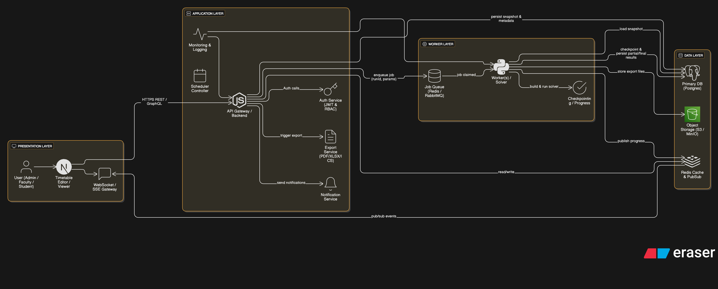

Component Description

1.Component Name | 2.Description | 3.Technologies Used
Frontend (Presentation Layer) | User interface for Admin, Faculty, and Students. Handles forms, timetable viewer/editor, drag-and-drop scheduling, real-time UI updates. | Next.js (React), HTML/CSS, Tailwind CSS, WebSocket
API Gateway / Backend | Provides REST/GraphQL APIs, handles validation, business logic, authentication, run management, and metadata operations. | Node.js (Express/NestJS) or FastAPI, JWT
Auth Service | Manages authentication, generates & validates JWT tokens, enforces user roles and permissions. | JWT, bcrypt, RBAC
Scheduler Controller | Validates constraints, creates immutable snapshots, and submits scheduling jobs to the queue. | Node.js/Python, Redis Client
Job Queue | Stores scheduling tasks and enables reliable background processing with retries and dead-letter handling. | Redis + Bull/BullMQ or RabbitMQ
Scheduler Worker / Solver | Runs the scheduling algorithm, enforces constraints, runs solver, checkpoints progress, and writes final timetable. | Python, OR-Tools (CP-SAT), Celery/RQ
Export Service | Generates downloadable timetable files in PDF, Excel, CSV, or ICS formats. | Puppeteer, pdfkit, xlsx
Notification Service | Sends alerts (email/SMS/push) for timetable completion, errors, and updates. | SMTP, Twilio, Firebase Cloud Messaging
WebSocket / Real-time Gateway | Streams real-time progress updates from workers to the frontend. | WebSocket, Socket.IO, Redis Pub/Sub
Primary Database | Stores teachers, rooms, courses, timetable snapshots, allocations, user data, logs, and history. | PostgreSQL, MySQL, MongoDB
Cache Layer | Caches metadata and supports real-time pub/sub event distribution. | Redis

Detailed Design
1. Module Overview - Provide an overview of each subsystem and its role.
1. Frontend (Next.js)
- Role: UI for Admin/Faculty/Student, timetable editor, drag-and-drop, run control, shows progress/events.
- Key responsibilities: input validation (client), submit run snapshot, subscribe to WebSocket events, present results and edit UI.
2. API Gateway / Backend
- Role: central business logic, REST/GraphQL endpoints, auth enforcement, snapshot creation, job enqueueing.
- Key responsibilities: validate inputs, persist immutable run snapshots, create TimetableRun records, expose metadata endpoints, accept manual edits.
3. Auth Service
- Role: authentication & authorization.
- Key responsibilities: issue/validate JWTs, RBAC checks for endpoints.
4. Scheduler Controller
- Role: orchestrates scheduler runs and repair jobs.
- Key responsibilities: prepare job payloads, set solver params (time_limit, weights), enqueue to job queue.
5. Job Queue
- Role: durable job broker between API and workers.
- Tech: Redis + Bull/BullMQ (or RabbitMQ).
- Key responsibilities: store jobs, retries, dead-lettering.
6. Scheduler Worker / Solver
- Role: heavy compute service that runs solver over immutable snapshot.
- Key responsibilities: translate domain → solver vars, enforce hard constraints, minimize soft penalties, checkpoint best solution, persist final allocations.
7. Export Service (Worker)
- Role: generate PDF/XLS/ICS exports from timetable results.
- Key responsibilities: generate files and upload to object storage; return presigned download URLs.
8. WebSocket / Real-time Gateway
- Role: stream worker progress (via Redis pub/sub) to frontend.
- Key responsibilities: push events (percent, messages, partial solution).
9.Primary Database (Postgres)
- Role: master data store: users, departments, courses, rooms, snapshots, runs, allocations, audit logs.
- Key responsibilities: transactional integrity, queries for UI.
10.Cache/Redis
- Role: store ephemeral data (availability matrices), message pub/sub for realtime, distributed locks.
11.Monitoring & Logging
- Role: metrics & observability (Prometheus/Grafana), centralized logs (ELK/Sentry), alerts.

2. Data Flow Diagrams (DFDs) - Include DFDs to represent data movement across modules.
Level 0
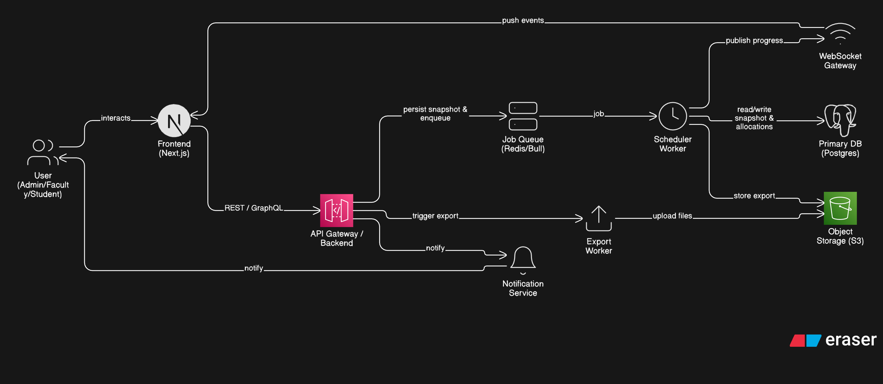
Level-1 DFD — Scheduler Run
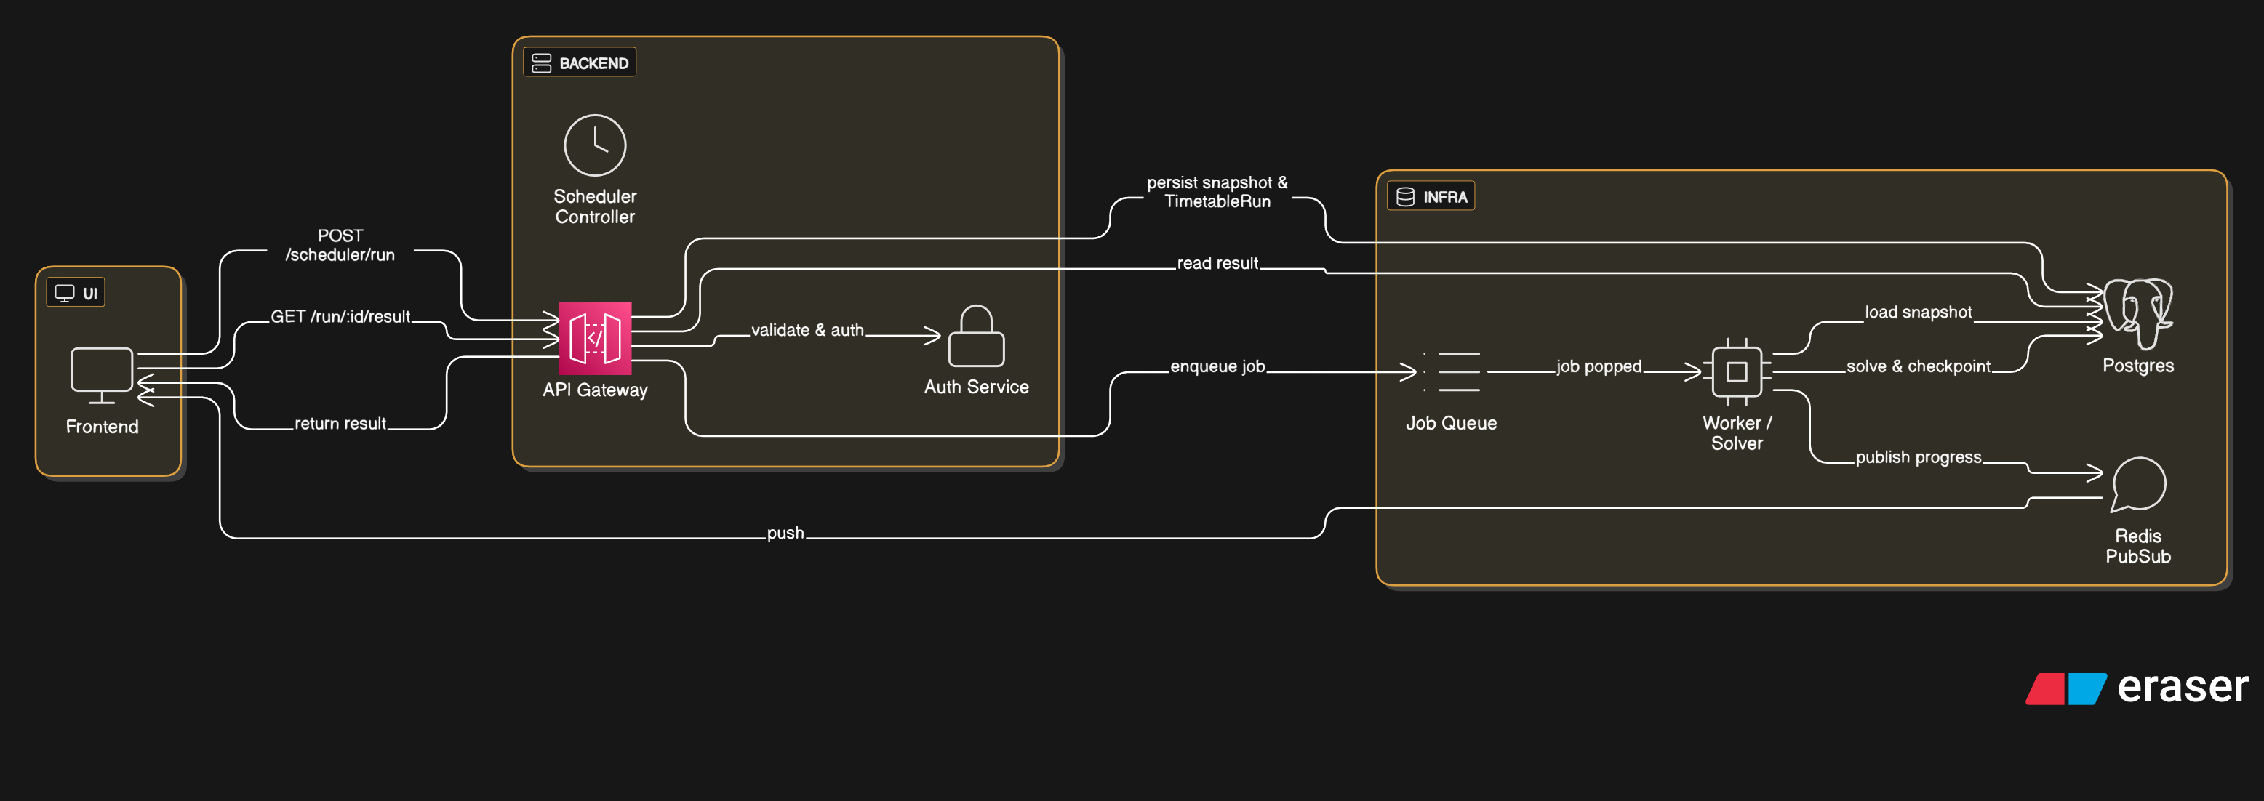

3.Class Diagram - Describe class relationships and dependencies.
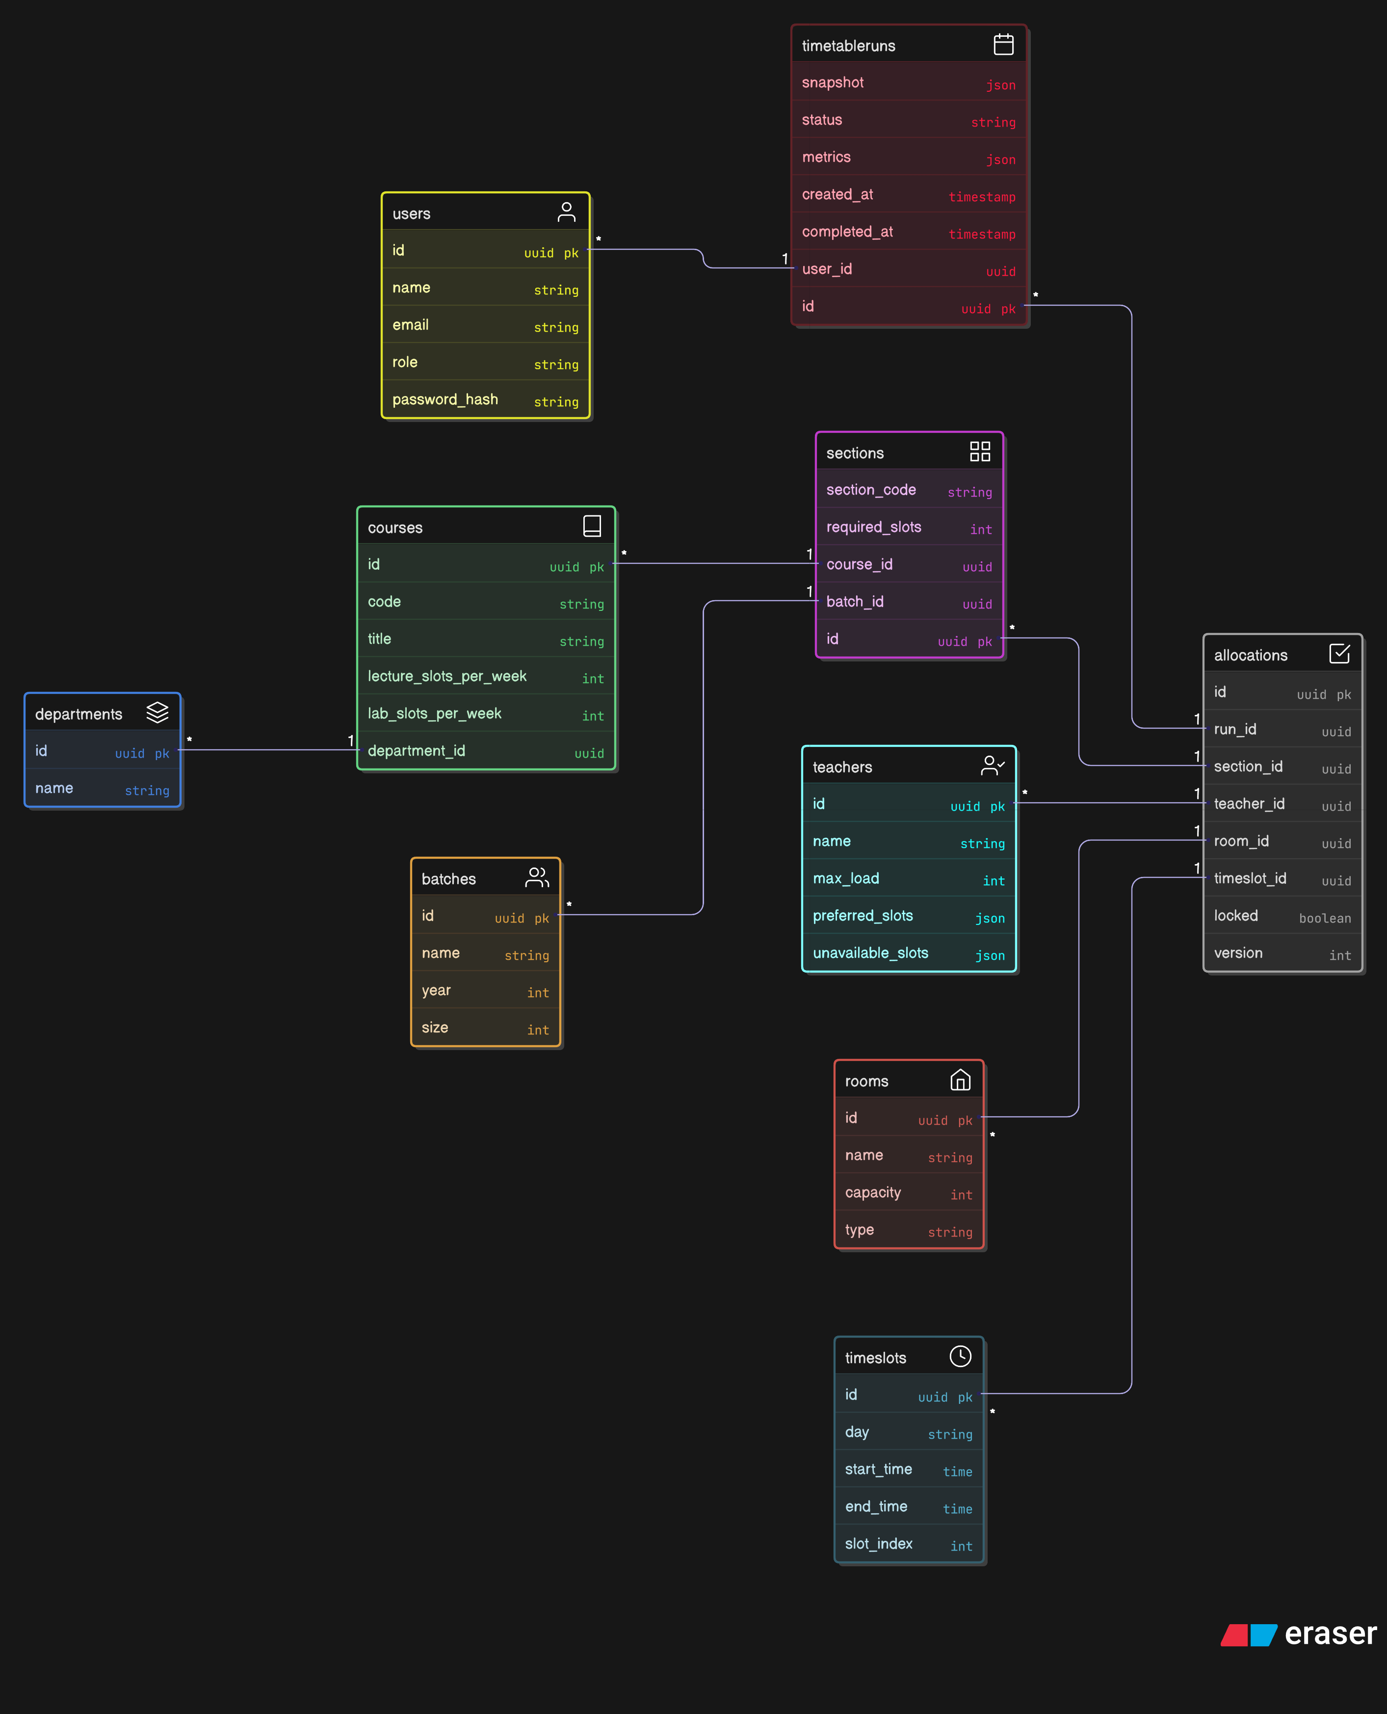
- Sequence Diagrams - Illustrate key process sequences.

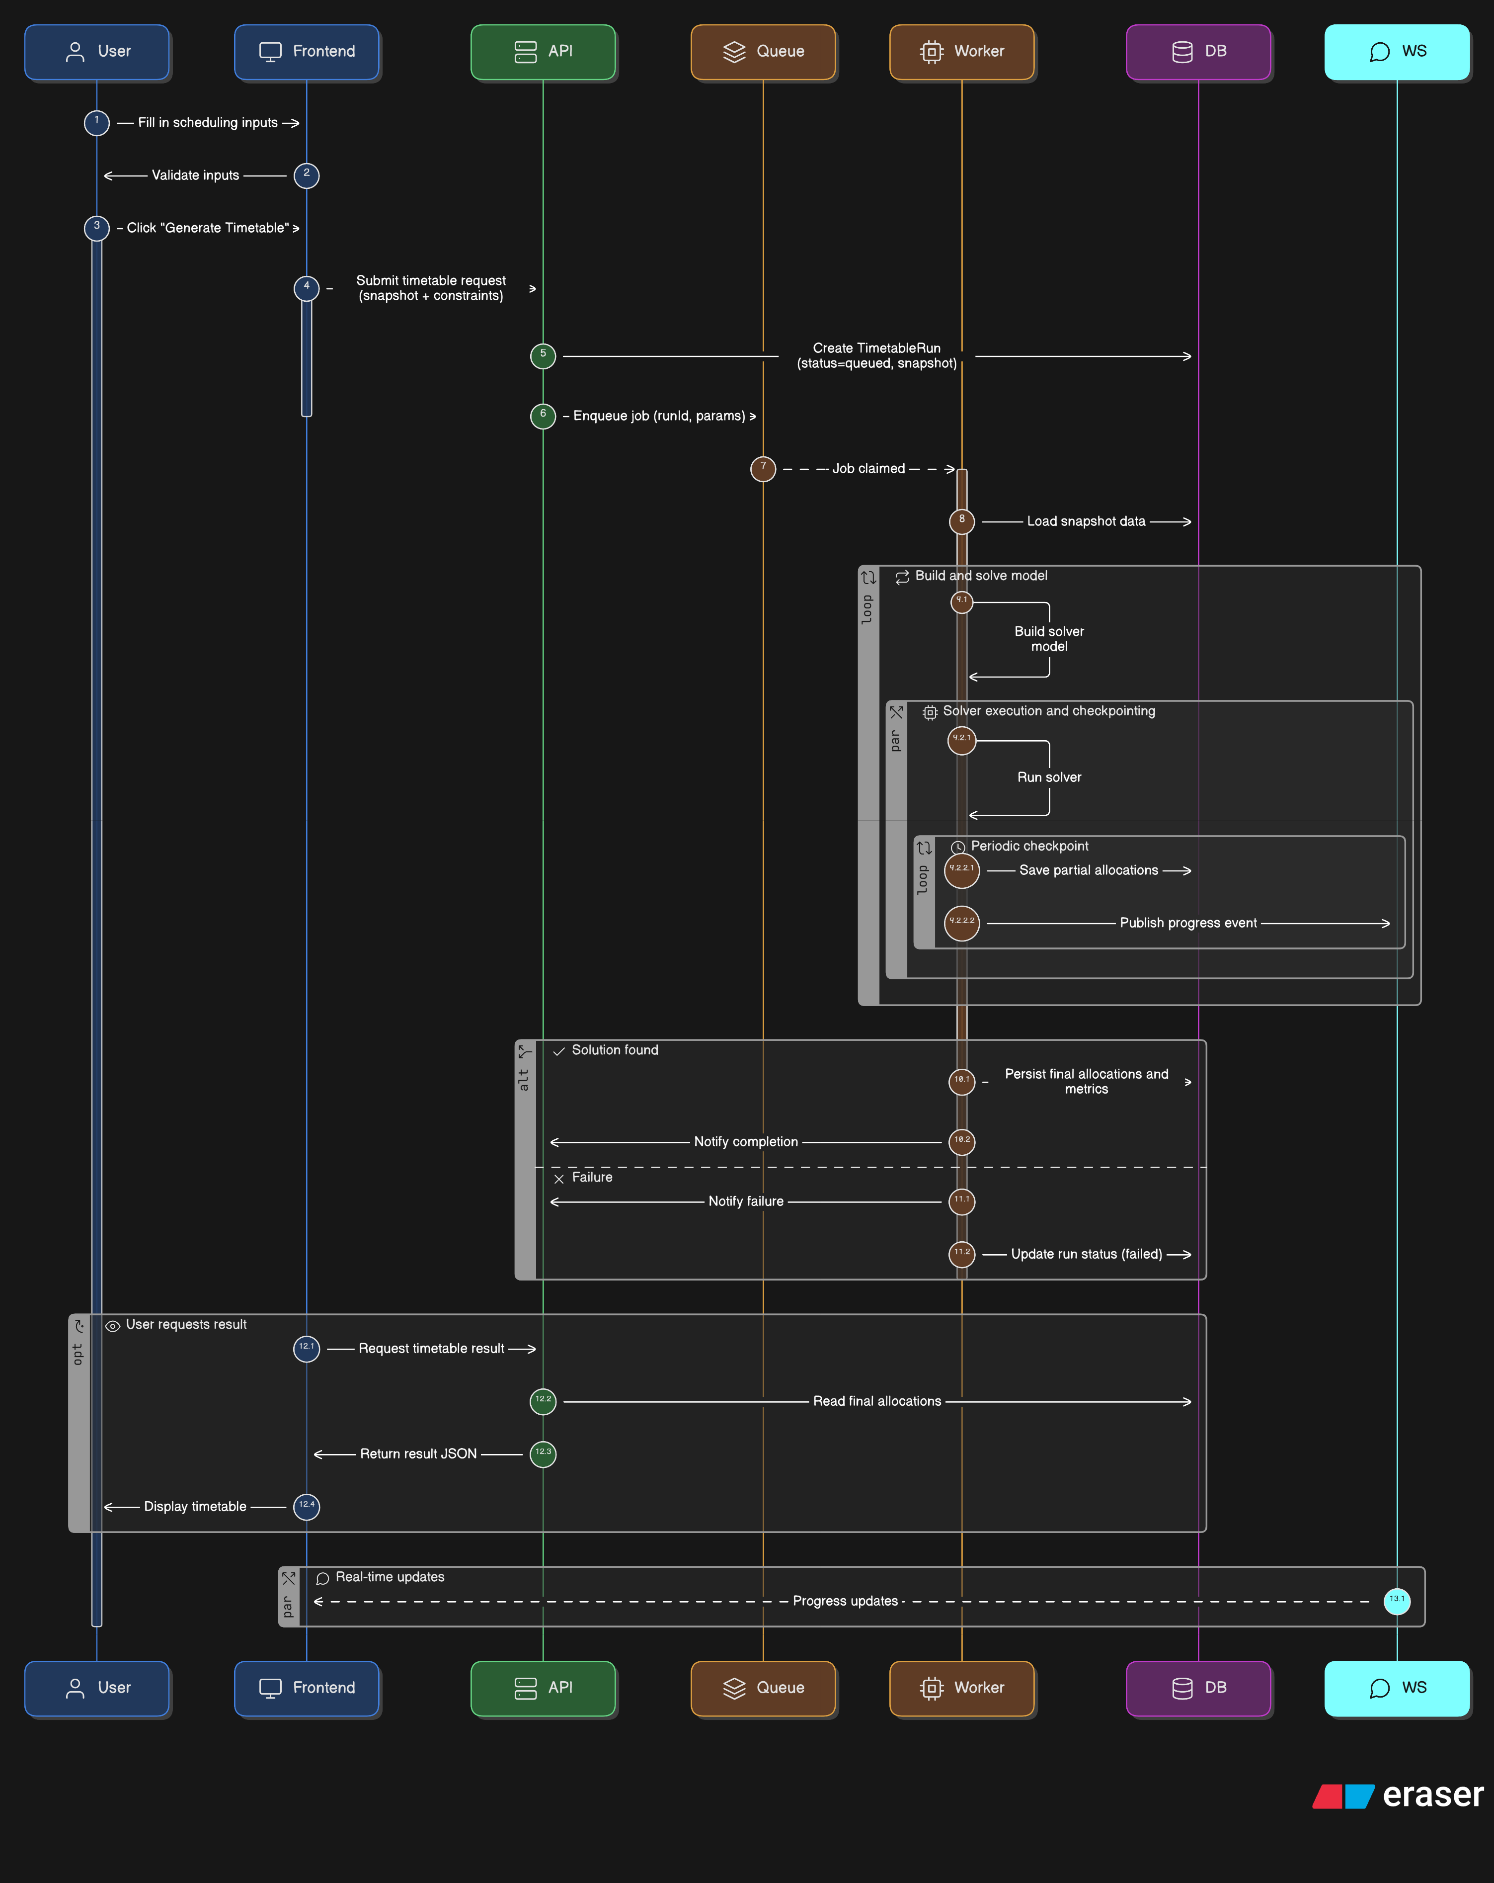
- Database Design - Present ER diagrams and table schemas.

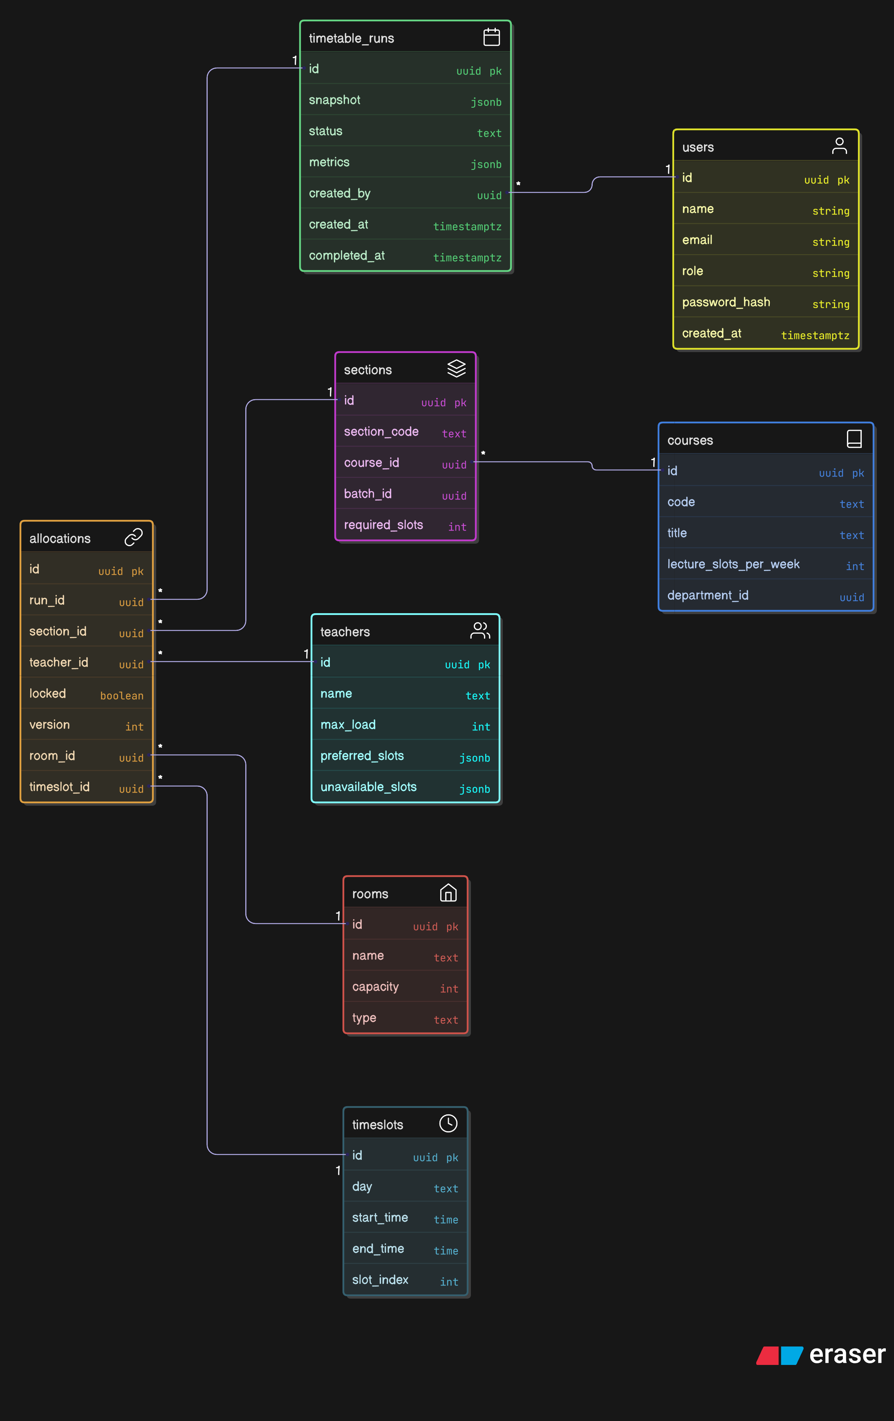

Interface Design
Describe user interfaces, API endpoints, and interactions with external systems.
Include wireframes, screenshots, or mockups if applicable.

