**Analysis on Disaster Loan Program**

**Superstorm Sandy**

One of the most destructive and strongest hurricanes developed in Caribbean Sea in 2012, affected people across eight countries was named ‘Hurricane Sandy’ but often referred to as ‘Superstorm Sandy’. This data is from U.S. Small Business Administration (SBA) disaster loan program for Superstorm Sandy. The SBA provides disaster assistance by lending low interest long-term loans for damages not covered by insurance. The dataset contains information on total verified loss and total approved loan amount for every damage along with the split of each amount into real estate and property damage. Below are few graphs to explore the numbers and analyze on the loan amount.

Figure

The above graph depicts the total verified loss amount with respect to each state that is affected by the storm. As we can see, only 9 states along the east coast of North America. Among all the states listed, New York and New Jersey seem to have exponentially higher damages compared to other states. The total amount of verified loss for New York is around $3061M and for New Jersey it is around $1638M. Other states like Connecticut, Maryland, Rhode Island, Virginia, Delaware, North Carolina and West Virginia have incurred damages below $83M and with the low of $0.1M. Total verified loss amount for each state is also split into content loss(yellow) and real estate loss(grey).

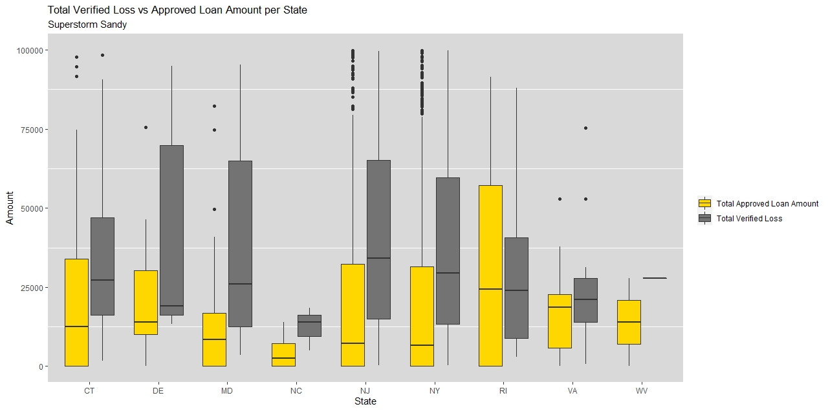Figure 2 is a similar to previous graph, but only difference is depicting the total approved loan amount including both content and real estate loss, in each state. Highest amount of loan approved for New York(~$1288M) and New Jesey (~$639M). It is also understood that West Virginia and North Carolina are allocated very negligible amount of loan, when referred in millions.

Figure 3

Figure

Above graph is a comparison of total verified loss amount and the approved loan amount for each of the state. For most of the state, SBA provided lower loan amount against each of the verified loss. We can see that the highest amount of verified loss (without outliers) in most state is way higher than the highest amount of approved loan. In fact the highest value of approved loan only math upto the median value of verified losses. Except for Rhode Island and West Virginia, more loan amount is allocated against the verified loss.

The map graph shows the percentage difference of total verifies loss amount and total approved loan amount in each state. All of the state cumulatively were provided lesser amount than the verified damages. But the amount of difference is shown with variation in color. The highest percentage difference for the state North Carolina is shown in grey. Loan approved is about 90% less than the amount verified. The most compensated among these states is Connecticut, as about 46% (54% less) of the damage is covered by loan.

**Why these graph types?**

In Figure 1 & 2, the range of values needs to be visualized were very far away. So in order to get clear picture of all ranges of values, a facet_zoom function is used to zoom in small values. Figure3 is show the comparison of both loss and loan amounts with respect to states. Figure 4 to plotted to visualize the difference in the values in a geographical format. From the color pattern, the user can get idea of most affected (along shore) and less affected (covered by land) states.

Figure 4

**Data Source:** <https://data.sba.gov/dataset/superstorm-sandy>