Department of Computer Science and Engineering
Lab Report
Lab Report No | : | 08
Lab Report Name | : | Gauss Elimination Method.
Course Title | : | Numerical Methods Sessional
Course Code | : | CSE 226
Name | : | Gazi Rishad Kaiser
ID | : | 1120047
Level | : | 2 | Term | : | 2 | Section | : | A | Group | : | 2
Date of Submission | : | -2026 | Semester | : | Spring | Year | : | 2026
Problem: Find the solution using Gauss Elimination Method:
x+y+z=9
2x+5y+7z=52
2x+y-z=0
Key Learnings:
- Learned how to enter and organize a system of linear equations as an augmented matrix.
- Performed forward elimination step by step to simplify the matrix into an upper triangular form.
Source Code:
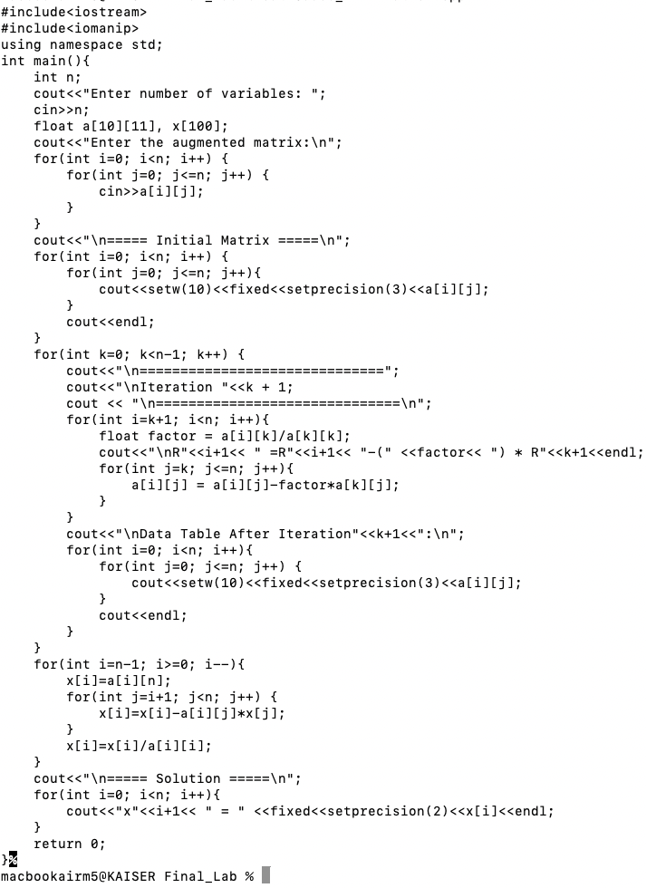

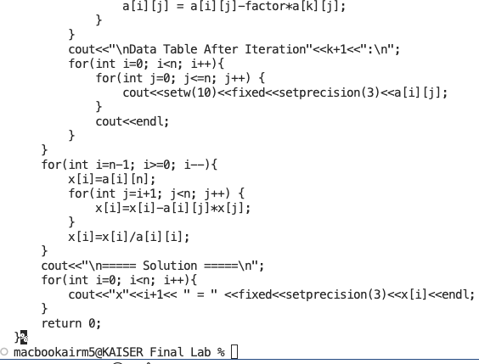

Input & Output:
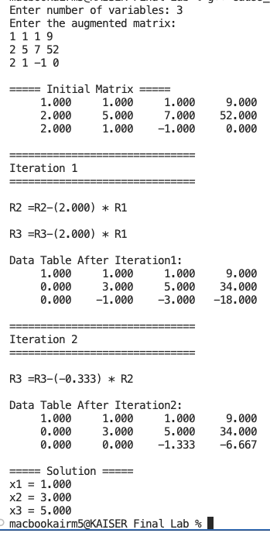

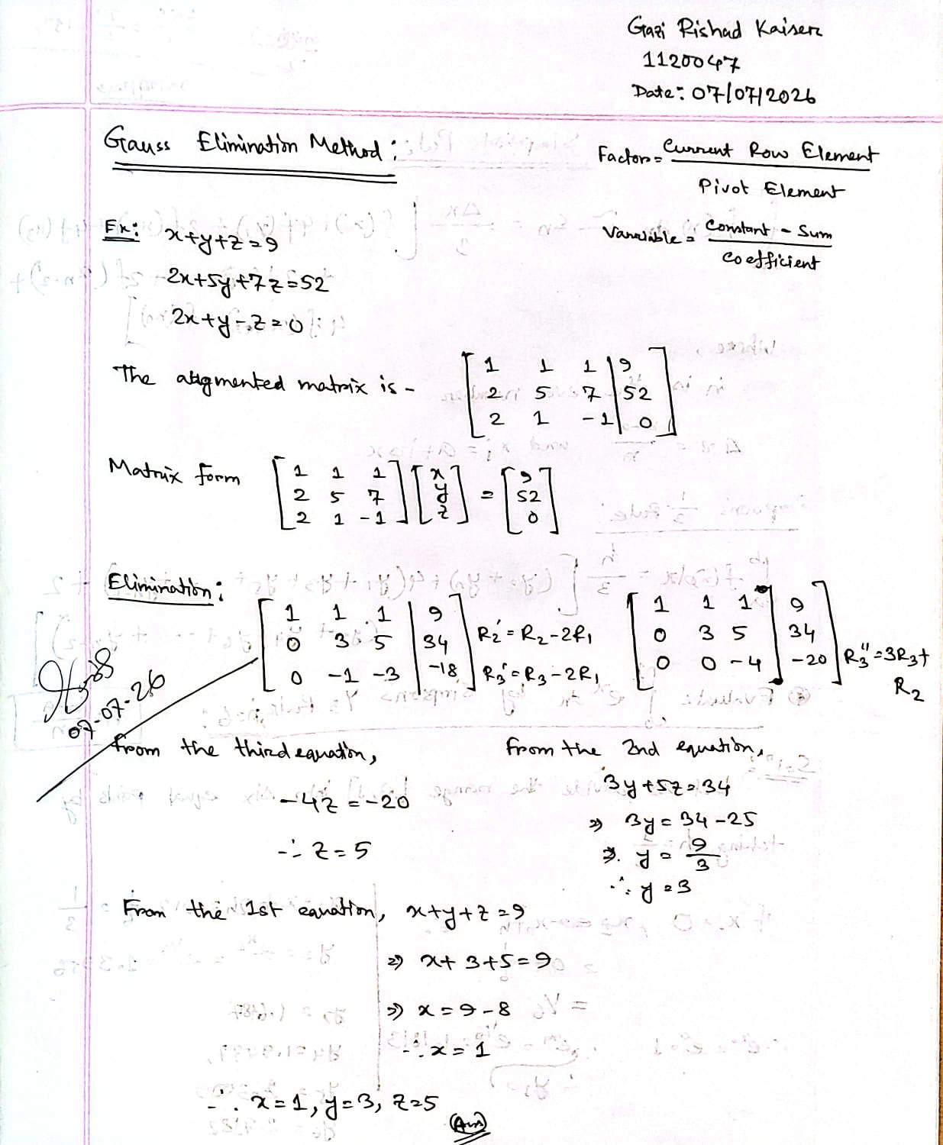

Result Analysis: The Gauss Elimination Method was successfully applied to solve the given system of linear equations. The augmented matrix was transformed into an upper triangular form using forward elimination, and the unknown variables were determined through back substitution. The obtained solutions satisfied the given equations, demonstrating the accuracy and effectiveness of the method for solving systems of linear equations.

