4.

$${\left|P\right|}^{2}=perimeter squared of a polygon= s^{2}.N^{2}$$

$$A=area of a polygon having N sides= \frac{s^{2}.N}{4.tan⁡(\frac{180}{N})}$$

$$\frac{{\left|P\right|}^{2}}{A}=\frac{s^{2}.N^{2}}{\frac{s^{2}.N}{4.tan⁡(\frac{180}{N})}}=4.N.tan⁡(\frac{180}{N})$$

For circle:

$$\frac{{\left|P\right|}^{2}}{A}=4π≅12,5664$$

|  |  |
| --- | --- |
| Polygon Side Number (N) | |P|²/A |
| 3 | 20,7846 |
| 4 | 16 |
| 5 | 14,5309 |
| 6 | 13,8564 |
| 7 | 13,4841 |
| 8 | 13,2548 |
| 10 | 12,9968 |
| 100 | 12,5705 |
| 1000 | 12,5664 |

As the side number increases, polygons become similar to a circle. We can see that|P|²/A of any polygon is greater than the value of |P|²/A for a circle.

3.

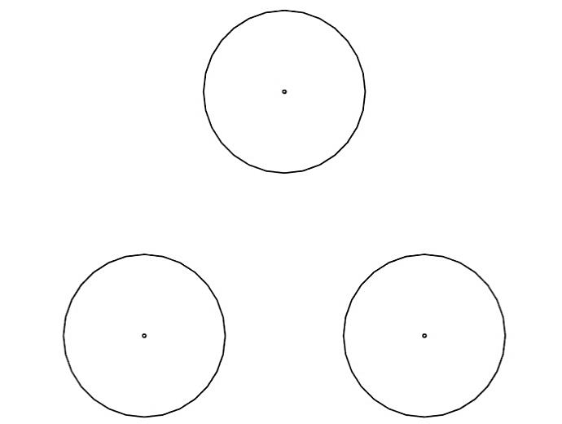

Figure 1: Structing Element - Circular Disc with Radius “r”

r

r < d

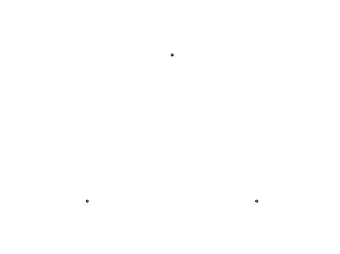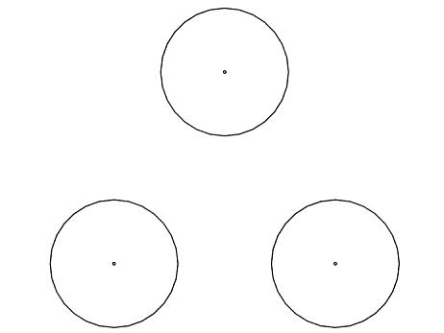

Figure 2: Set - After Dilation - After Closing Operation (Dilation + Erosion)

r >= d

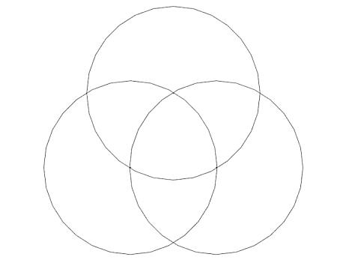 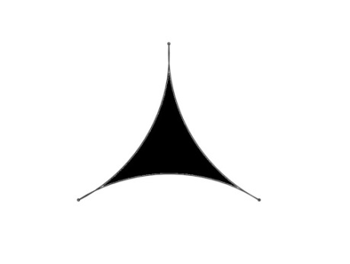

Figure 3: Set - After Dilation - After Closing Operation (Dilation + Erosion)

It follows that as the radius of the structing element increases, the intersection set occurs and becomes greater. When the radius “r” reaches the side length “d” of the triangle, the closing operation results with a shape in which the three dots are connected as shown in Figure 3.

5.  
Rotate 30 degree clockwise and change radio of image.

**\***  **=**

6.  
#include "img_pro.h"

#include "my_header.h"

int main(int argc, char * * argv){

unsigned char * * img;

char * pgm_file, * new_pgm_file;

int i, j, NR, NC, number;

if (argc != 4) {

printf("\n Usage: HW1 [OLD Image file (*.pgm)] [NEW Image file (*.pgm)] [Value]\n");

printf("\n E.g. HW1 cathedral.pgm new.pgm 15 \n");

exit(-1);

}

pgm_file = argv[1];

new_pgm_file = argv[2];

number = atoi(argv[3]);

img = pgm_file_to_img(pgm_file, &NC, &NR);

for (i = 0; i < NR; i++) {

for (j = 0; j < NC; j++) {

if (img[i][j] + number > 255){

img[i][j] = 255;

}

else if (img[i][j] + number < 0){

img[i][j] = 0;

}

else{

img[i][j] += number;

}

}

}

img_to_pgm_file(img, new_pgm_file, NC, NR);

free_img(img);

show_pgm_file(new_pgm_file);

return (1);

}