EE443 - Embedded Systems
Experiment 2 Laboratory Report
Input Port Pins and Execution Timing

Name: M. Serdar Karaman
Number: 190206038
Date: 09 - November - 2016

Objective

Taking input from button and understanding effect of if-else statement on execution time.
Experimental Work

Preliminary code
#include <avr/io.h>
#include <util/delay.h>

int main(void)
{

DDRB = 0b11111111;//output for LEDs on Port B
DDRD = 0b11111100; //Pin 0,1 are input for PortD
PORTD = 0b00000011;//Pull up resistors are enabled for pin 0,1 at PortD

while(1){

if(( PIND & _BV(PIND0) ) == 0x00){
PORTB |= 0b00001111;
}
else{
PORTB &= 0b11110000;
}

if(( PIND & _BV(PIND1) ) == 0x00){
PORTB |= 0b11110000;
}
else{
PORTB &= 0b00001111;
}

}
return 0;
}
When SW0 pressed LED0-3 are ON. When SW1 pressed LED4-7 are ON. When both pressed all LED are ON.

Experiment code
#include <avr/io.h>
#include <util/delay.h>
#define _NOP() do { __asm__ __volatile__ ("nop"); } while (0)

int main(void){

DDRB = 0b11111111;//output for LEDs on Port B
DDRD = 0b11111100; //Pin 0,1 are input for PortD
PORTD = 0b00000011;//Pull up resistors are enabled for pin 0,1 at PortD
PORTB = 0b00000001; //Starting from right

while(1){
if(( PIND & _BV(PIND0) ) == 0x00){ //SW0 pressed
if (( PIND & _BV(PIND1) ) == 0x00){ //SW1 and SW0 pressed (1 clock)
_NOP(); // to make right and left shift time equal.
if(PORTB == 0b00000001){ //(1 clock)
_NOP(); // (1 clock)
PORTB = 0b10000000;//Turn to start (1 clock)
}
else{// + jump (1 clock)
PORTB= PORTB >> 1;;//shift right (1 clock))
}

}
else{ //SW1 not pressed, SW0 pressed + jump (1 clock)

if(PORTB == 0b10000000){ //(1 clock)
_NOP();// (1 clock)
PORTB = 0b00000001; //Turn to end (1 clock)
}
else{// + jump (1 clock)
PORTB= PORTB << 1; //shift left (1 clock)
}
}
}
}

return 0;
}

to left | ON time | OFF time |  | Duration |  | Clock
LED6 | 14,13 | 15,75 |  | 1,62 |  | 13
LED7 | 15,75 | 17,38 |  | 1,63 |  | 13
LED0 | 17,38 | 19,01 |  | 1,63 |  | 13
LED1 | 19,01 | 20,63 |  | 1,62 |  | 13
LED2 | 20,63 | 22,26 |  | 1,63 |  | 13

to right | ON time | OFF time |  | Duration |  | Clock
LED2 | 14,13 | 15,76 |  | 1,63 |  | 13
LED1 | 15,76 | 17,38 |  | 1,62 |  | 13
LED0 | 17,38 | 19 |  | 1,62 |  | 13
LED7 | 19 | 20,63 |  | 1,63 |  | 13
LED6 | 20,63 | 22,26 |  | 1,63 |  | 13
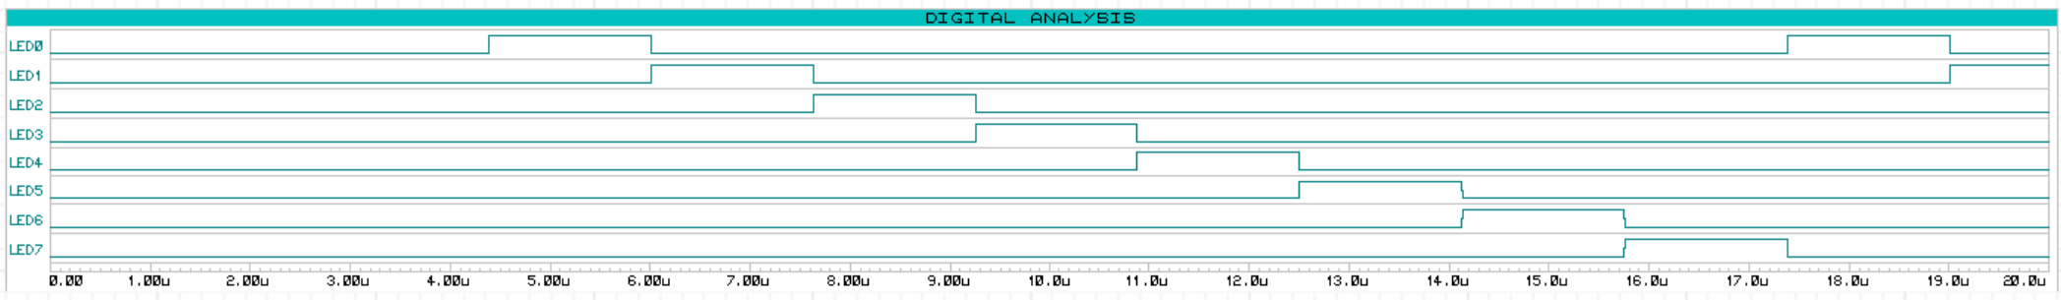

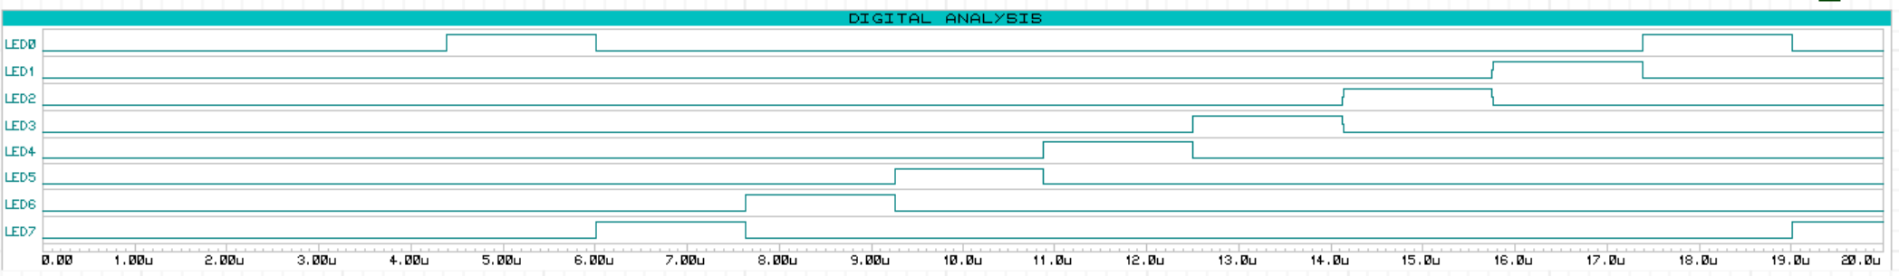

Results and Conclusion
There is no gap between LED7->LED0 operation and LED0->LED7
Else statement take more clock to execute because there is a jump operation before starting to execute. That’s why I added _NOP() operation for every else operation.
ON and OFF time of leds can be seen above. Durations are same for every led and both direction. Its 13 clock.
Everything is done according to lab paper.

Answers to the Questions
Question 1: How can you remove the two pull-up resistors connected to the
switches without changing the circuit functionality? Find a solution by using the
programmable port features described in the ATmega328 datasheet.
Answer 1: If we enable the internal pull-up resistors of the port-D pin-0 and pin-1, the external pull-up resistors can be removed.
When the bits in DDRx set to be inputs, corresponding bits in PORTx register are used to enable/disable pull-up resistors associated with that pin. To enable pull-up resistor, the corresponding bit in PORTx is set to 1, and to disable the pull-up resistor, it is set to 0.
According to the description above, adding the following line to the code would be sufficient for removing the two pull-up resistors:
PORTD = 0b00000011;
With this additional code line, the initial values of two input pins (pin-0 and pin-1) are set to 1. So, even nothing is connected to those input pins they will always be 1 and when the switch is closed (button is pressed), they will be grounded.

