EE443 - Embedded Systems
Experiment 5 Laboratory Report
Analog Input Output

Name: M. Serdar Karaman
Number: 190206038
Date: 05 - December - 2016

Objective

Turning analog signal to digital with ADC and showing result on LCD, reconstruct signal with DAC.

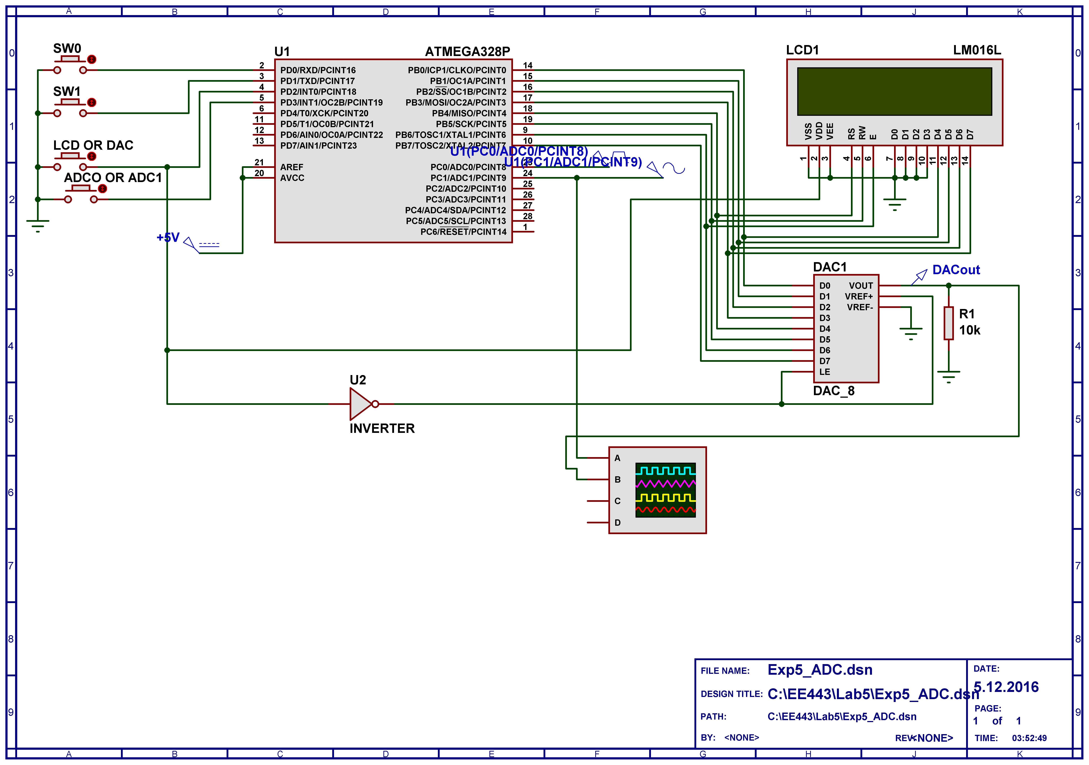

Experimental Work

Experiment code
#include <avr/io.h>
#include <stdio.h>
#include <util/delay.h>
#include "LCDmodule.h"

int main(void){

PRR &=~_BV(PRADC); //Turn on ADC peripheral module
//REFS1 REFS0 ADLAR MUX3 MUX2 MUX1 MUX0
ADMUX = 0b00100000; // ADLAR=1, 8bit high
/* MUX[3:0] Single Ended Input
0000 ADC0
0001 ADC1
0010 ADC2
0011 ADC3
0100 ADC4
0101 ADC5
0110 ADC6
0111 ADC7
1000 Temperature sensor
1001 Reserved
1010 Reserved
1011 Reserved
1100 Reserved
1101 Reserved
1110 1.1V (VBG)
1111 0V (GND) */

ADCSRA = 0x10000110; // ADEN ADSC ADATE ADIF ADIE ADPS2 ADPS1 ADPS0
/* ADPS[2:0] Division Factor
000 2
001 2
010 4
011 8
100 16
101 32
110 64
111 128 */
//8M/64=125k <200k(max ADC frequency)

ADCSRB = 0x00; //ADC B is disabled.

DDRD |= 0b11110000; // pin-0 and pin-1 set as input, others are output
PORTD |= 0b00001111; //Pull-up resistor for inputs

DIDR0 |= 0b00000011; //Disabled buffer for ADC0 and ADC1

DDRB |=0b11111111; // all Port B pins are output

LCD_Init(); //initialize the LCD display
LCD_Clear(); //clear the LCD display

char LCDtext[16];
unsigned char Atten=1;
unsigned char PDsave = 0x00;
unsigned char PDsave_1 = 0x00;

while(1){

if((PIND & 0b00001000) == 0b00000000){// input selection
ADMUX = 0b00100001;//ADC1
}
else{
ADMUX = 0b00100000;//ADC0
}

ADCSRA = 0b11000110; // set ADSC, start converting
while(ADCSRA==0b11000110) {
;//wait until ADC complete
}

if((PIND & 0b00000100) == 0b00000000){//SW2=0 DAC active LCD inactive

PDsave_1=PDsave;
PDsave = PIND;

if(((PIND & 0x01) == 0x00) && ((PDsave_1&0x01) == 0x01)){//SW0 pressed
if(Atten > 1){
Atten--;
}
else{
;
}

}
else if(((PIND & 0x02) == 0x00) && ((PDsave_1&0x02) == 0x02)){//SW1 pressed
if(Atten < 6){
Atten++;
}
else{
;
}
}
else{//Both pressed or not pressed
;//Do nothing
}

PORTB=(ADCH>>(Atten-1));
}
else{
int ADCout=ADCH;
PrintByte(LCDtext, "", ADCout);

LCD_MoveCursor(1, 1); // Place LCD cursor at column-1 of line-1
LCD_WriteString(LCDtext); // Send LCDtext to the LCD module

_delay_us(1000);
}

};

return 0;
}

Answers to the Questions
Question 1: Explain the changes in the DAC output waveform that occur at high
attenuation factors. How can you implement an attenuator that does not cause
distortion at high attenuation factors by using two DACs?
Answer 1: Low resolution at high attenuation is a foult of wrong refence voltage if attenuation was analog.
We need a voltage controlled resistor to attentuate input voltage and to control this voltage from MCU we need second DAC. Also output of this DAC needs to be connectod to reference voltage.
Question 2: As a home exercise, modify the program to obtain the attenuation steps
given below by using shift and addition operations only.
Atten = 1=>1/1, 2=>3/4, 3=>1/2, 4=>3/8, 5=>1/4, 6=>3/16,
7=>1/8, 8=>3/32, 9=>1/16, 10=>3/64, 11=>1/32

Answer 2: Only the PORTB calculations were changed. Rest of the code remains same.
if(Atten%2 == 0){
PORTB = ADCH>>(Atten-1);
}
else{
PORTB = ADCH>>((Atten+3)>>1) + ADCH>>((Atten+3)>>1) + ADCH>>((Atten+3)>>1);
}

Question 3: Suggest a method to send data to two external devices by using two
more MCU pins. Port-B data should be directed to the target device without causing
any unwanted data transfers (i.e. DAC will not receive LCD data, LCD will not
receive DAC data).

Answer 3: Solution is alredy implemented on my code.

