EE443 - Embedded Systems
Experiment 6 Laboratory Report
Timers and Interrupts

Name: M. Serdar Karaman
Number: 190206038
Date: 21 - December - 2016

Objective

Generating PWM signal and using ISRs to run tasks.

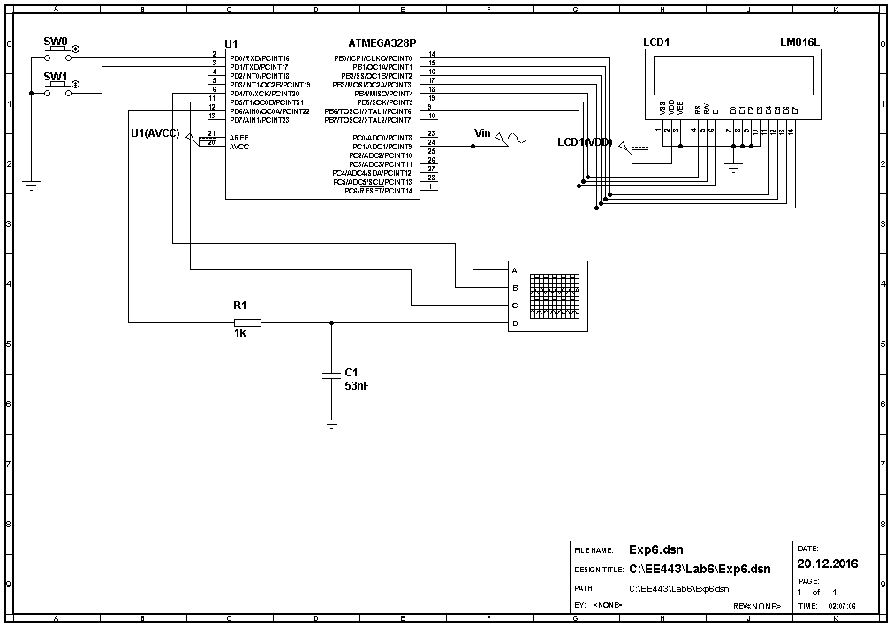
Experimental Work

Experiment code
#include <avr/io.h>
#include <stdio.h>
#include <util/delay.h>
#include "LCDmodule.h"
#include <avr/interrupt.h>

int main(void)
{ DDRB |= 0b11111111; // set all pins of PORTB output
DDRD |= 0b11111100; //input SW0 SW1, 456 output
PORTD|= 0b00000011; //Pull-up resistor for inputs
DDRC |= 0b11111100;

PRR &= ~_BV(PRADC); //Enable power for ADC module

ADMUX = 0b00100001; // ADLAR=1, 8bit high
/* MUX[3:0] Single Ended Input
0000 ADC0
0001 ADC1
0010 ADC2
0011 ADC3
0100 ADC4
0101 ADC5
0110 ADC6
0111 ADC7
1000 Temperature sensor
1001 Reserved
1010 Reserved
1011 Reserved
1100 Reserved
1101 Reserved
1110 1.1V (VBG)
1111 0V (GND) */

ADCSRA = 0b10000110; // ADEN ADSC ADATE ADIF ADIE ADPS2 ADPS1 ADPS0
/* ADPS[2:0] Division Factor
000 2
001 2
010 4
011 8
100 16
101 32
110 64
111 128 */
//8M/64=125k <200k(max ADC frequency)

ADCSRB = 0x00; //ADC B is disabled.
DIDR0 |= 0b00000011; //Disabled buffer for ADC0 and ADC1

PRR &= ~_BV(PRTIM0); //Enable Timer0
PRR &= ~_BV(PRTIM1); //Enable Timer1

TCNT0= 0x00; // Reset timer0 Counter
TCNT1= 0x0000; // Reset timer1 Counter

OCR0A = 0x00;// PWM duty cycle at OC0A=0

OCR1A = 1000; // 1000*1us = 1ms

TCCR0A = 0b10000011;//COM0A=10 (regular PWM output), WGM0=011(fast PWM mode);
/*Mode WGM02 WGM01 WGM00 Timer/Counter Mode of Operation TOP Update of OCR0x at TOV Flag Set on(1)(2)
0 0 0 0 Normal 0xFF Immediate MAX
1 0 0 1 PWM, Phase Correct 0xFF TOP BOTTOM
2 0 1 0 CTC OCRA Immediate MAX
3 0 1 1 Fast PWM 0xFF BOTTOM MAX
4 1 0 0 Reserved - - -
5 1 0 1 PWM, Phase Correct OCRA TOP BOTTOM
6 1 1 0 Reserved - - -
7 1 1 1 Fast PWM OCRA BOTTOM TOP */

TCCR0B = 0b00000001; // no prescaling for timer 0
/*CA02 CA01 CS00 Description
0 0 0 No clock source (Timer/Counter stopped).
** 0 0 1 clkI/O/1 (No prescaling)
0 1 0 clkI/O/8 (From prescaler)
0 1 1 clkI/O/64 (From prescaler)
1 0 0 clkI/O/256 (From prescaler)
1 0 1 clkI/O/1024 (From prescaler)
1 1 0 External clock source on T0 pin. Clock on falling edge.
1 1 1 External clock source on T0 pin. Clock on rising edge. */
TCCR1A = 0x00; //no PWM
TCCR1B = 0b00001010; // 1/8 clock scale counter clock of timer1 ; WGM1[3:0]=0100, clear timer on compare match
TIMSK0 = 0x00; //no interrupt
TIMSK1 = 0b00000010;//OCIE1A =1 , create interrupt when timer reach OCR1A

LCD_Init();
LCD_Clear();

sei(); // Enable Interrupt
while(1){;}//wait interrupt
return 0;
}

ISR(TIMER1_COMPA_vect){
static unsigned char LCDtext[16];
static unsigned char Atten=1;
static unsigned char PDsave = 0x00;
static unsigned char PDsave_1 = 0x00;

ADCSRA |= 0b01000000;//start ADC convert
PORTD |= _BV(PORTD4); // Set ADC time marker 105us
while((ADCSRA & 0b01000000) == 0b01000000){;} // wait ADC convert
PORTD &= ~_BV(PORTD4); // Clear ADC time marker

PDsave_1=PDsave;
PDsave = PIND;

if(((PIND & 0x01) == 0x00) && ((PDsave_1&0x01) == 0x01)){//SW0 pressed
if(Atten > 1){
Atten--;
}
else{
;
}

}
else if(((PIND & 0x02) == 0x00) && ((PDsave_1&0x02) == 0x02)){//SW1 pressed
if(Atten < 6){
Atten++;
}
else{
;
}
}
else{//Both pressed or not pressed
;//Do nothing
}

OCR0A=(ADCH>>(Atten-1)); // PWM duty-cycle adjustment

PrintByte(LCDtext,"",ADCH);
PORTD |= _BV(PORTD5); // Set LCD time marker 210us
LCD_MoveCursor(1, 1); // Place LCD cursor
LCD_WriteString(LCDtext); // Send LCDtext on screen
PORTD &= ~_BV(PORTD5); // Clear LCD time marker
} // end of ISR

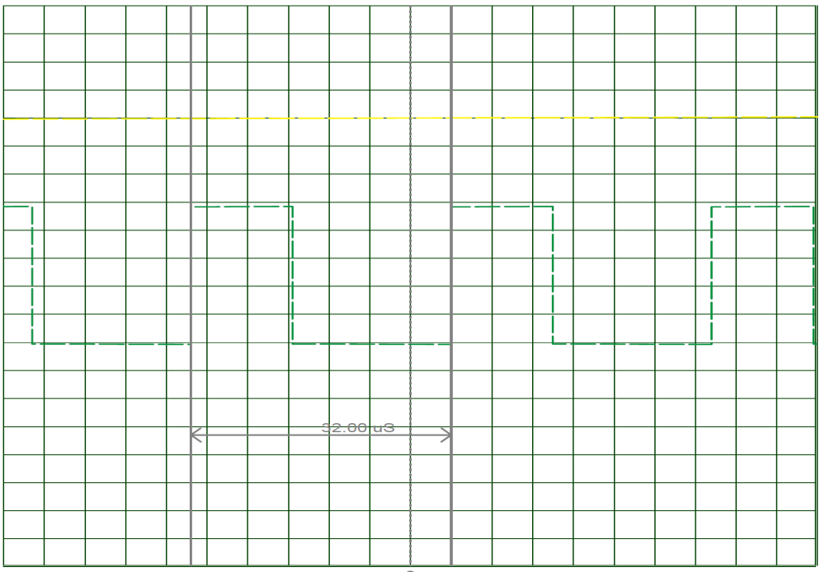

Measure PWM period is 32us = 31250Hz
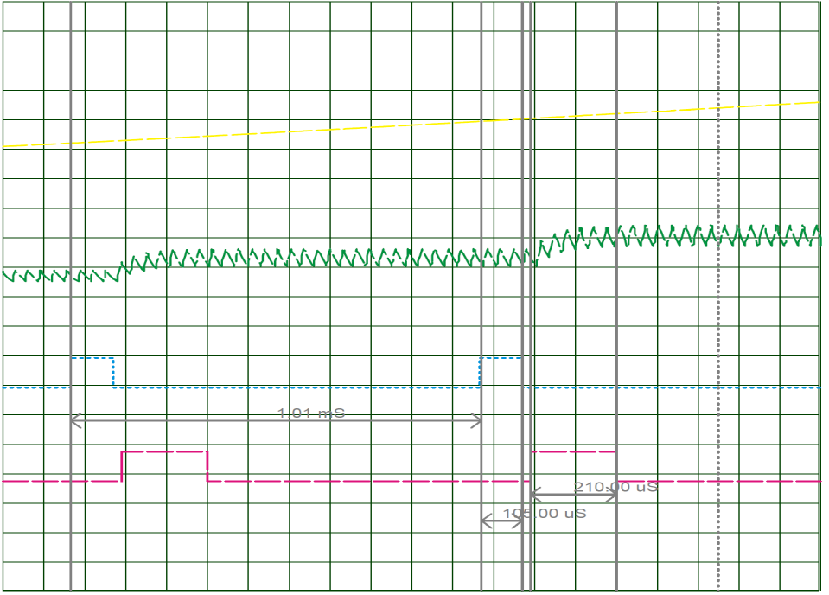

Repetition time of ISR is 1.01ms . ADC convertion time is 105us. LCD write time is 210us.

Answers to the Questions

Question 1: Calculate these timing parameters based on the information provided in
the ATmega328 datasheet and in LCDmodule.h and compare with the measured
values.
Answer 1: ADC clock frequncy is 125kHZ
ADC convertion time is 13 ADC clock cycle.
so ADC convertion time = 13/125kHz= 104us
Measured value is 105us.

Acoording to LCDmodule.h; LCD_MoveCursor took 40us and LCD_WriteString for 3 digit 150us. So it must be 190us but we found it 210 us.

Question 2: What is the other function call that takes significant time in the ISR?
How much CPU time does it take?
Answer 2: PrintByte function takes 18us to exceute.

Question 3: Suggest some solutions to prevent wasting of CPU time on idle tasks,
such as waiting for ADC conversions and LCD operations.

Answer 3: We can write interrupt for ADC so until convertion finish CPU can do other works.

