Mawethu Phakathi
Aspiring Cybersecurity & DevOps Engineer with a strong software engineering foundation.
Johannesburg, South Africa
Phone: 076 796 7460
Email: mawethu.p@yahoo.com
GitHub: github.com/Mawethu1

Profile Summary
Motivated and disciplined IT student pursuing a career in Cybersecurity, Cloud (DevOps), and Software Development. Skilled in web development, database systems, cloud fundamentals and building working applications. Strong teamwork and discipline developed through rugby, combined with hands-on problem solving and commitment to continuous learning.

Technical Skills
- Programming & Web: HTML, CSS, JavaScript, PHP, C#, SQL
- Frameworks / Platforms: ASP.NET MVC
- Cloud & DevOps: Microsoft Azure (fundamentals), Git & GitHub
- Databases: MySQL, Oracle SQL

Projects
- EventEase – Cloud Venue Booking System
ASP.NET MVC, SQL, Azure — Built a secure booking platform with cloud storage and event management.
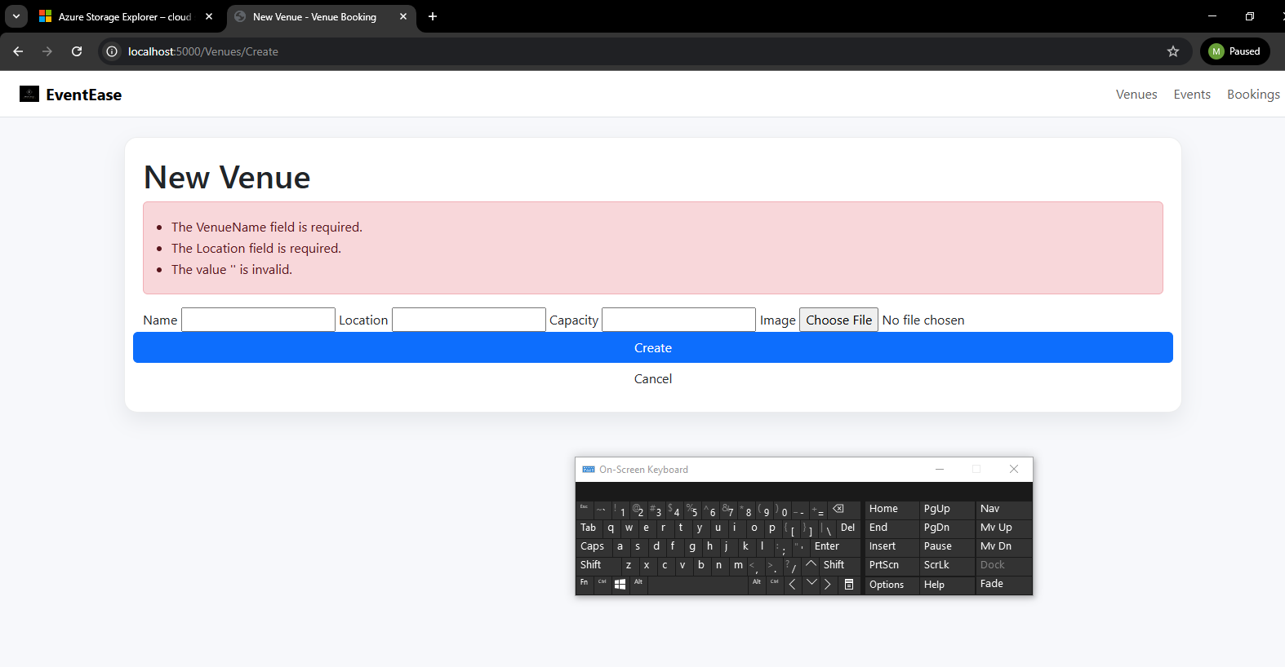
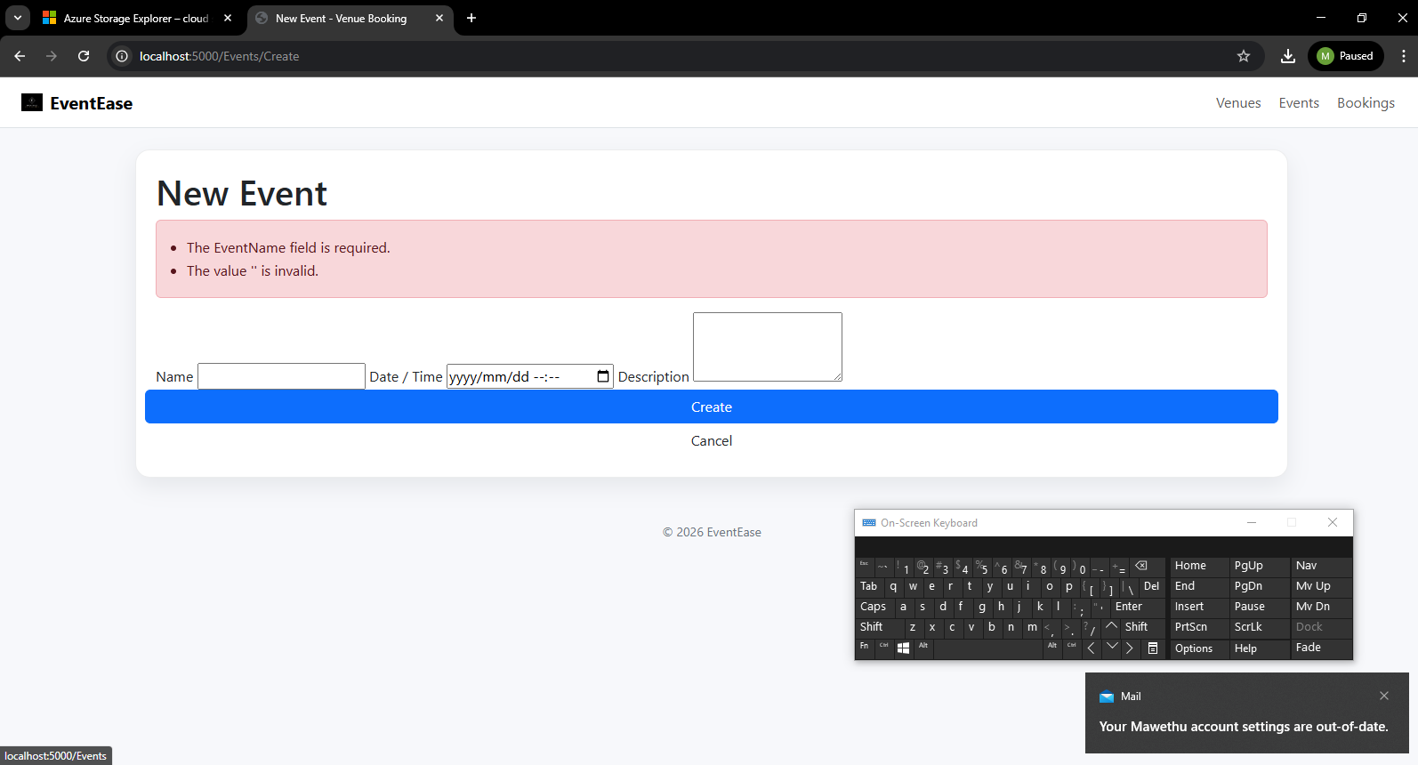
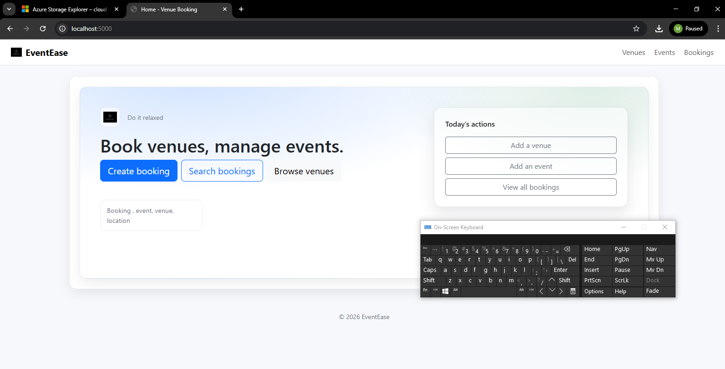
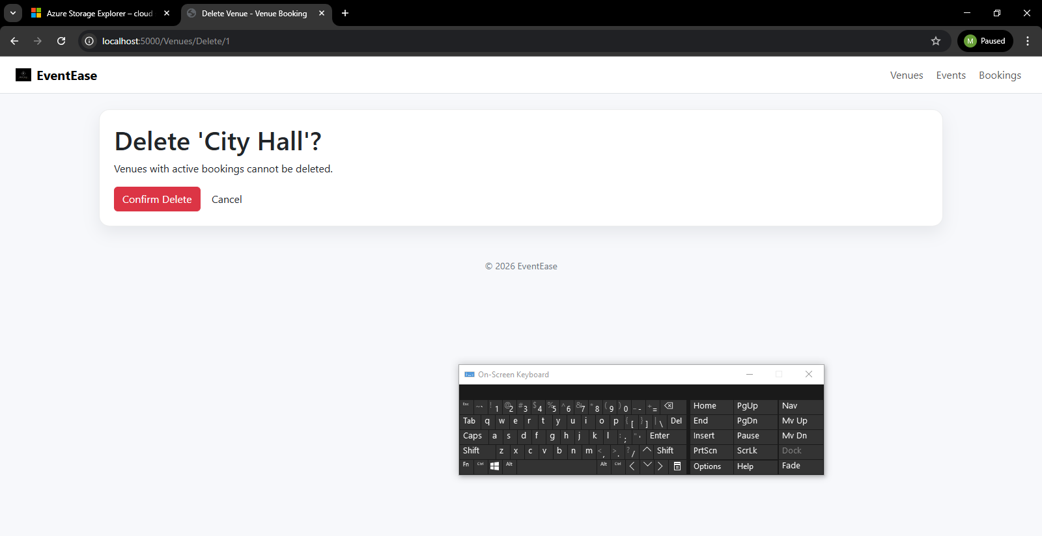
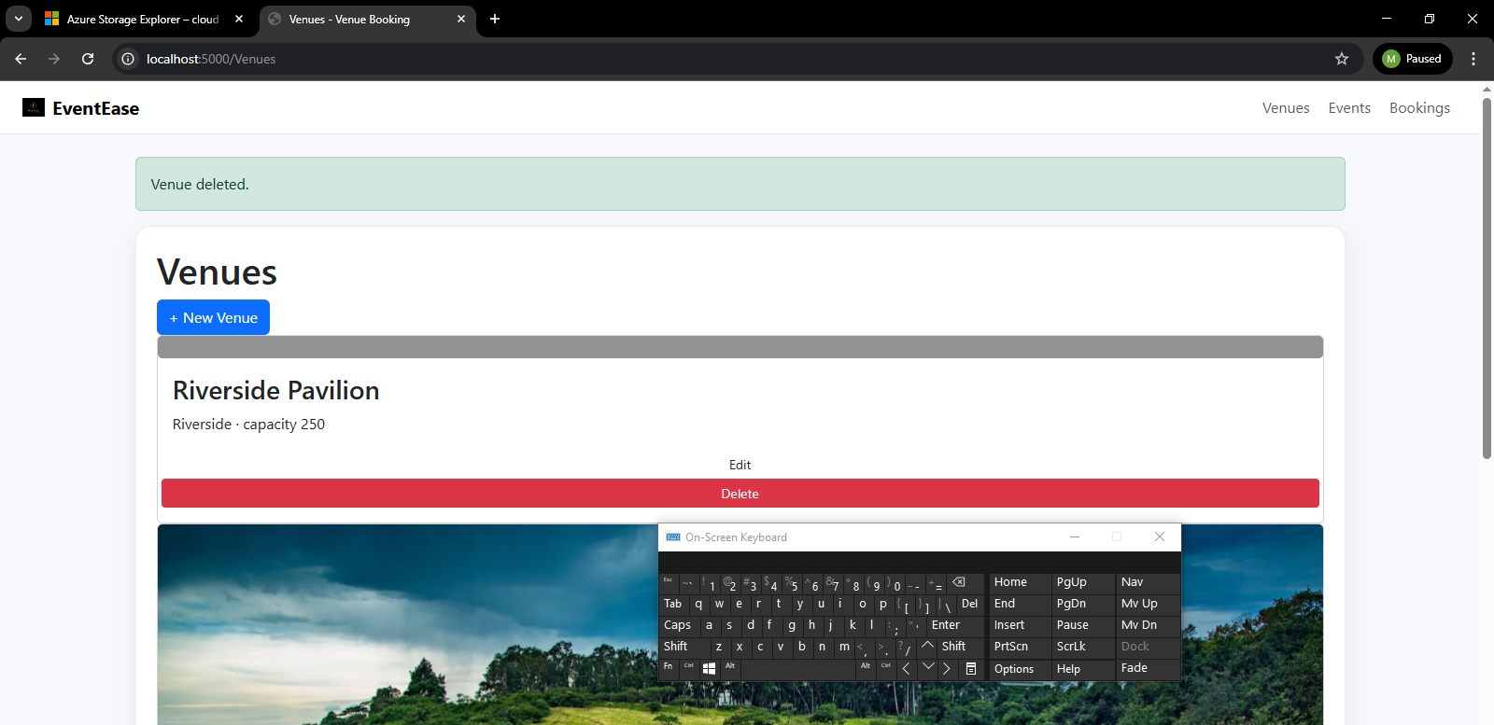
With the information above, we can see that a user is able to add or delete information from the database with ease. This is done without the use of AI. With a AI model incorporated this will be done efficiently, but will need to use a model directly created for the organization.

- Dew Of Africa Website
HTML, CSS, JS — Built a functional startup website with product display and contact integration.
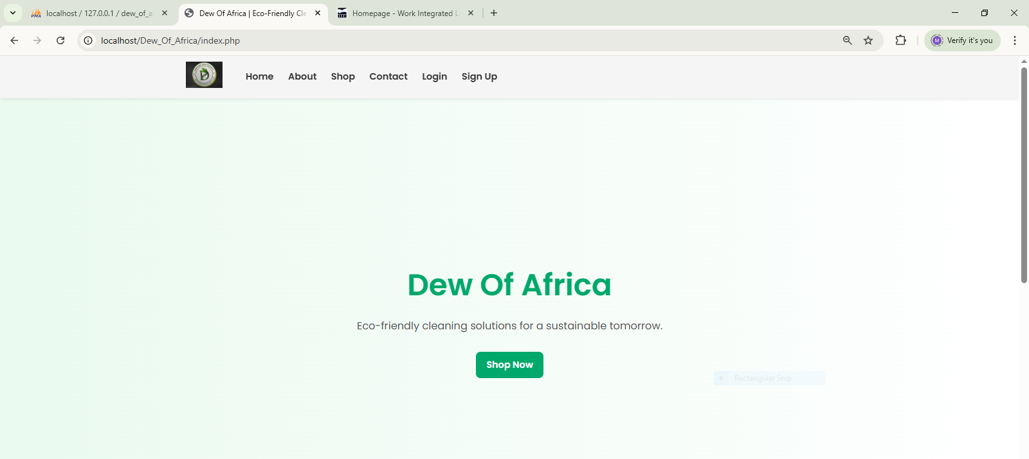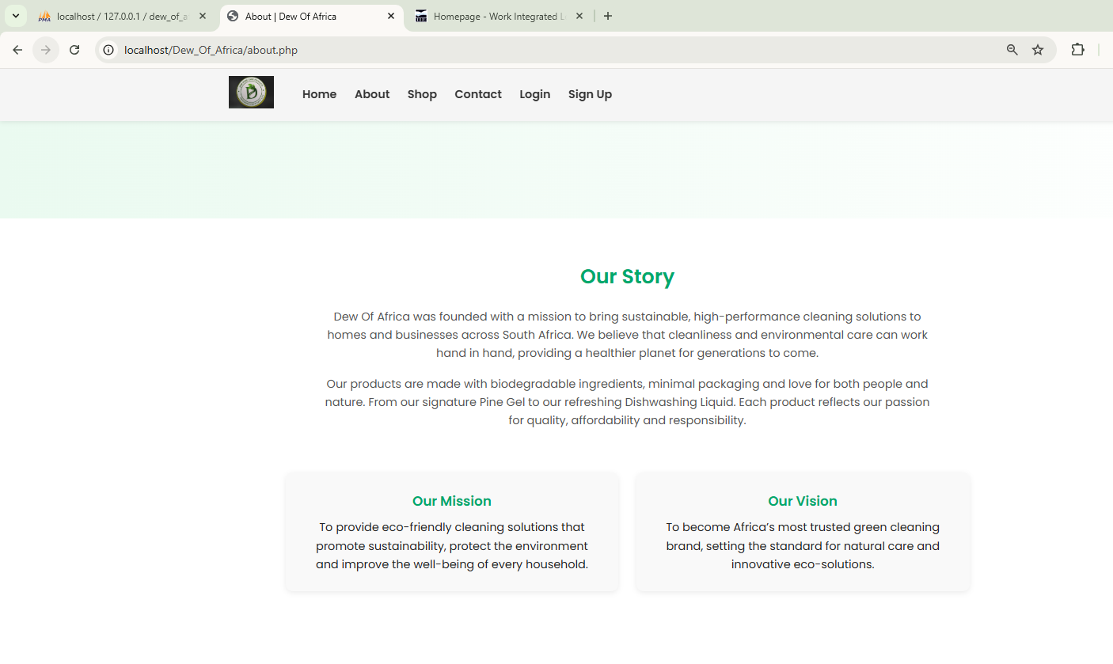
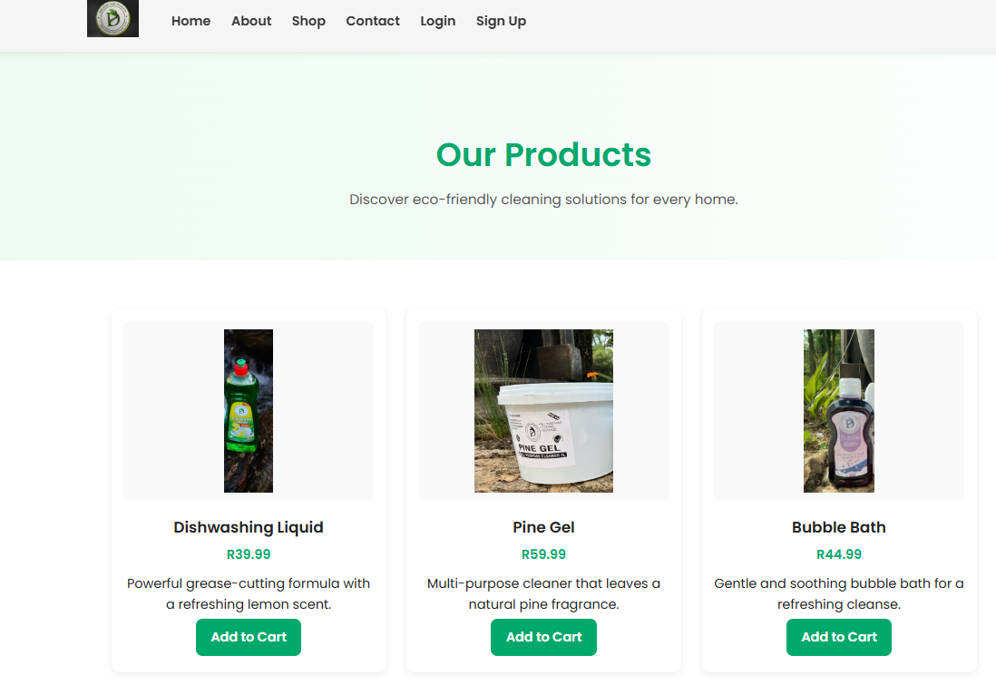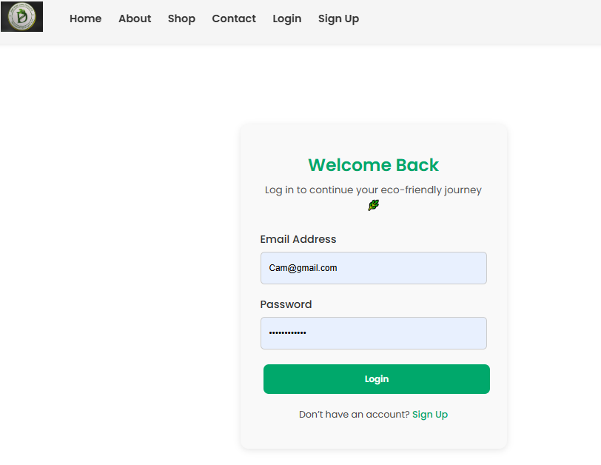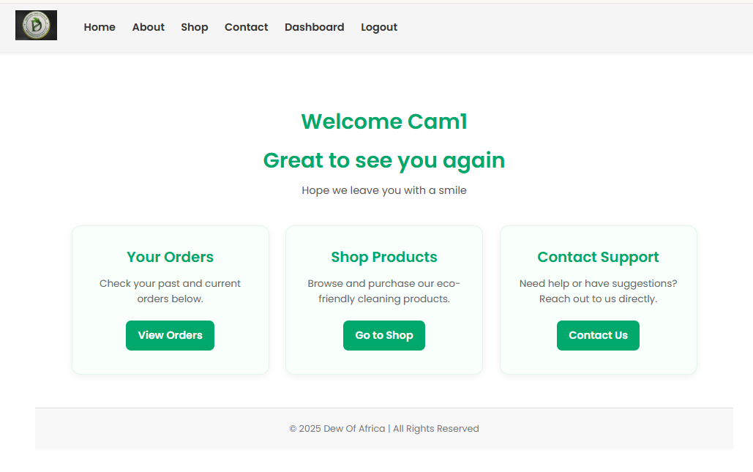
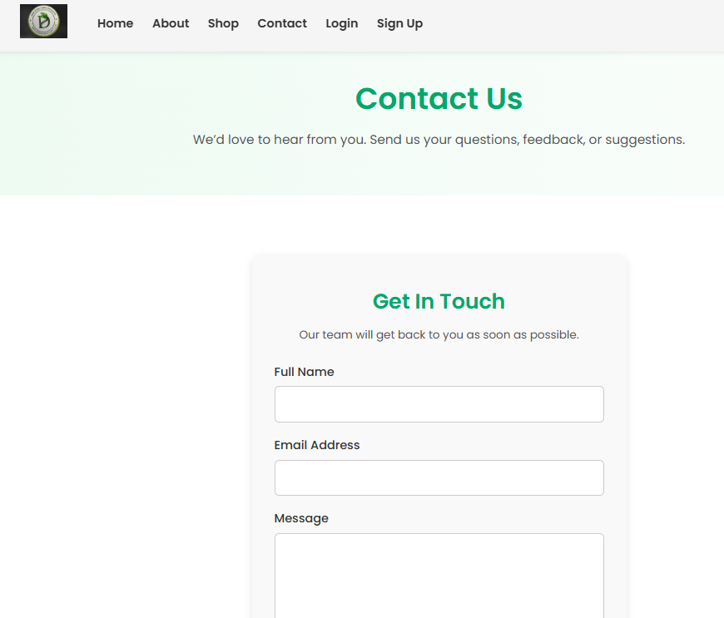
- Pastimes Clothing Store System
PHP, MySQL — User roles, database insert functions, and cart validation logic.
- Phakathi Surveillance System
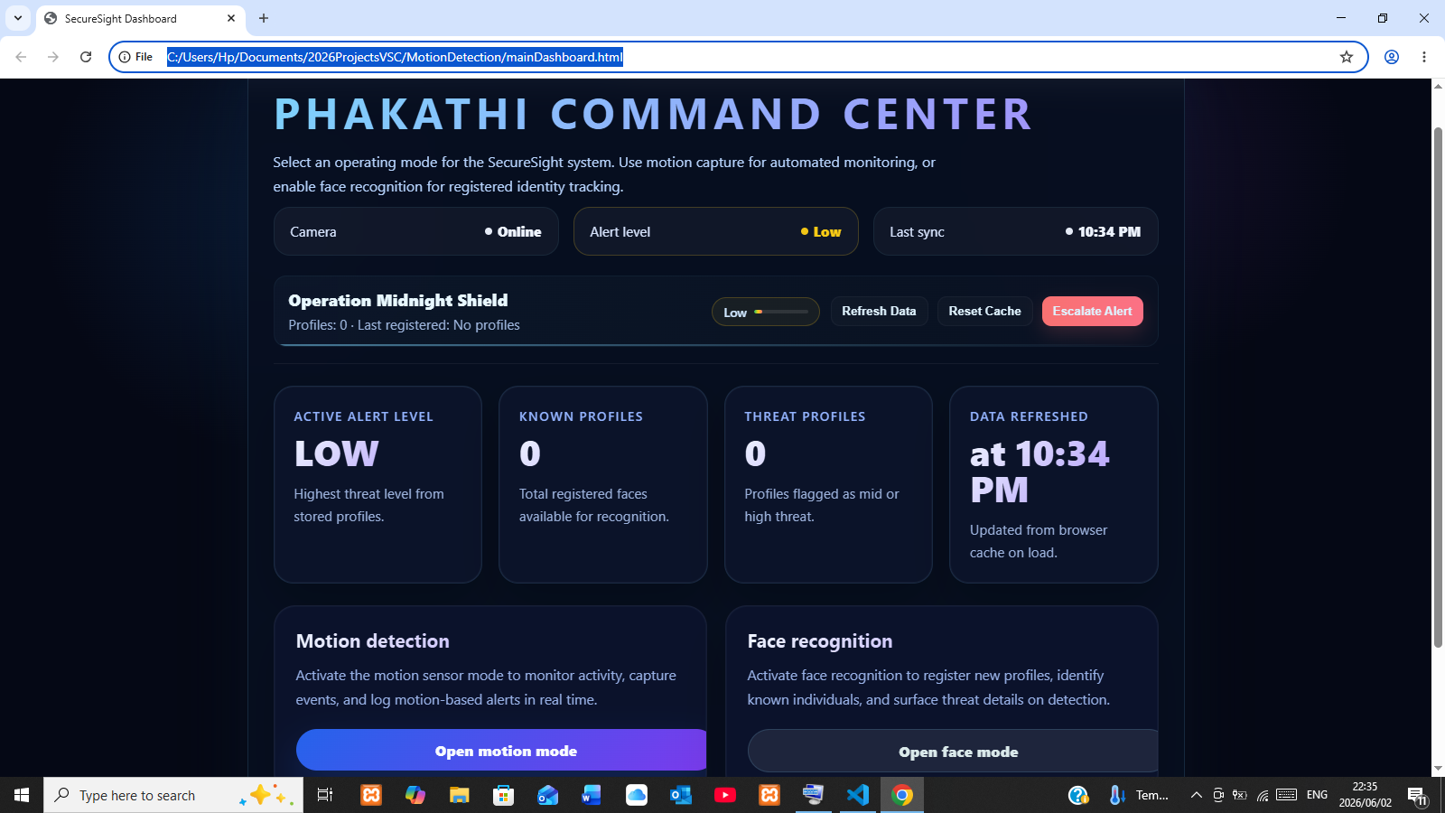Within this frame we are able to see all effect tools, which are facial recognition and motion detection which are operated without the use of AI. This allows for a robust system using key principles.
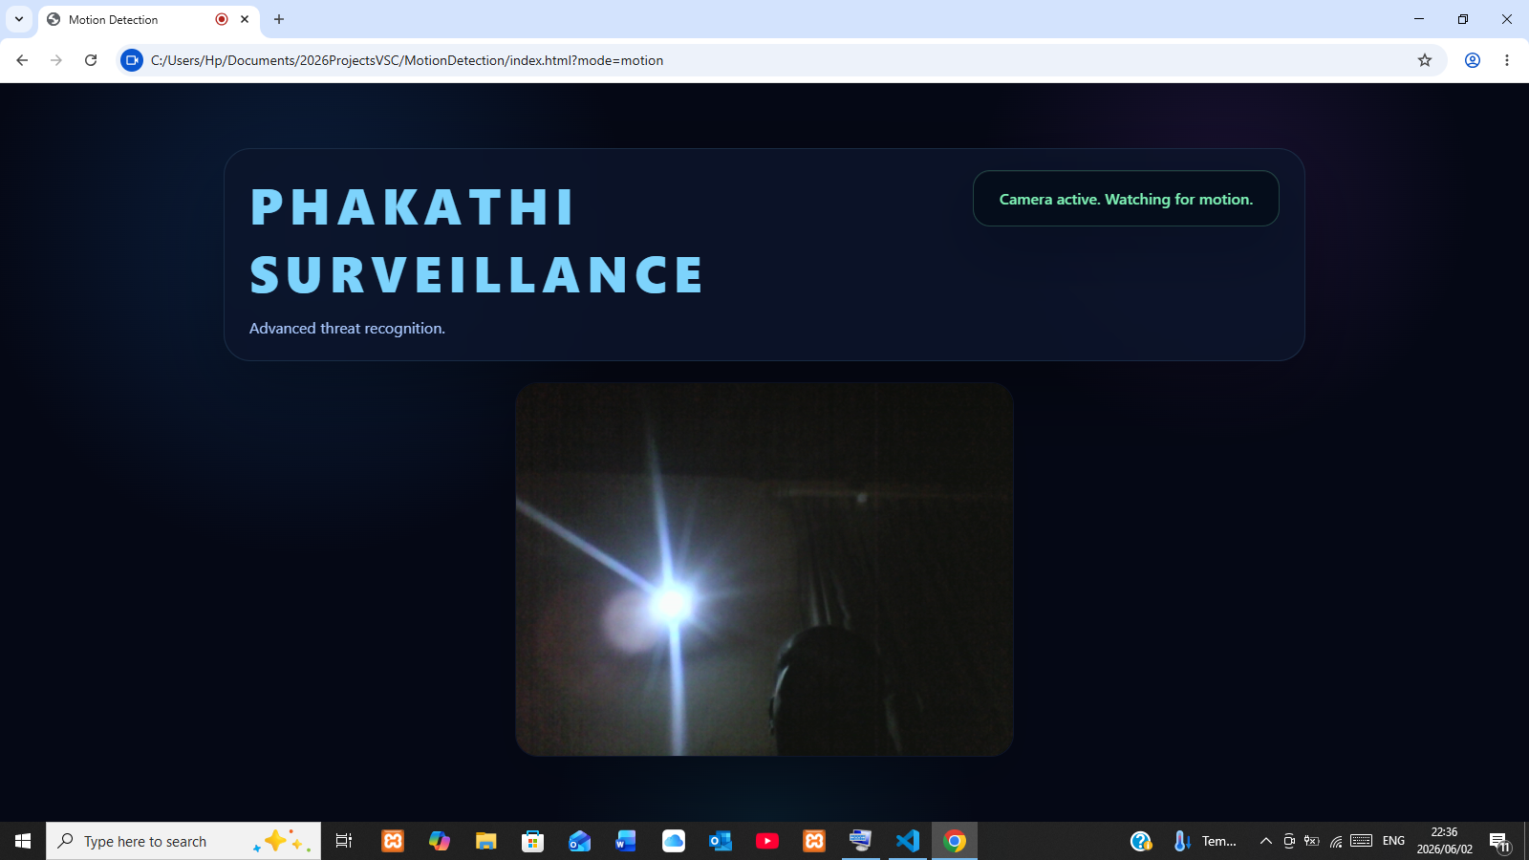

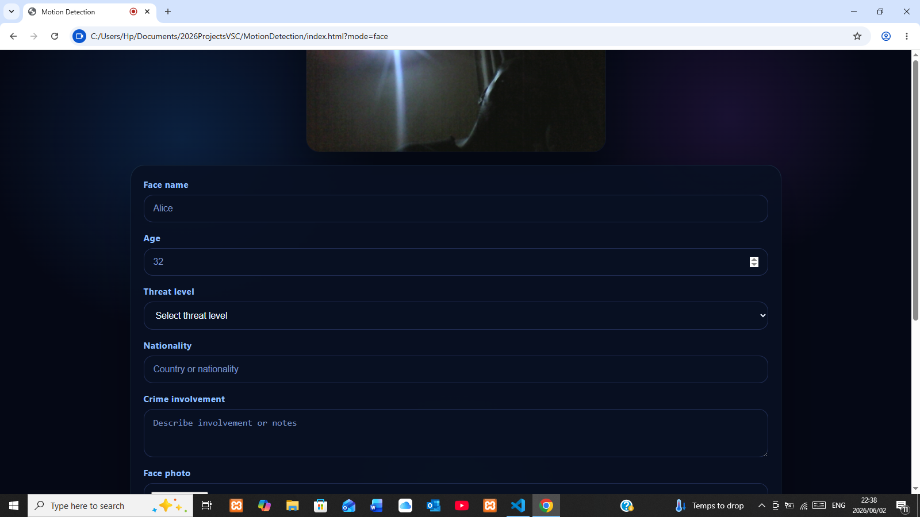
Both frames do not use Public AI models so they can not be exploited easily and allows for them to be robust.

Work Experience
- Product Manager (Full Time) Dew Of Africa — 2023-2024
Assisted in product planning, user insights and delivery cycles.
- Merchandiser (Part time) Blue Lyne - 2021
Supported customer service, stock handling and store preparation.
- Community Service — Bothongo Rhino & Lion Nature Reserve
Assisted in teamwork-based conservation activities.

Education
IIE MSA — Bachelor of Computer & Information Sciences (Studying 3rd Year — 2025)
HeronBridge College — Grade 12 (Matric)
Certificates: Body Lotion & Cream Manufacturing, Detergents & Soap Manufacturing, Rugby Program

Strengths
- Strong discipline & work ethic
- Team communication and leadership
- Problem-solving and fast learning
- Time management & resilience

References
Available on request

