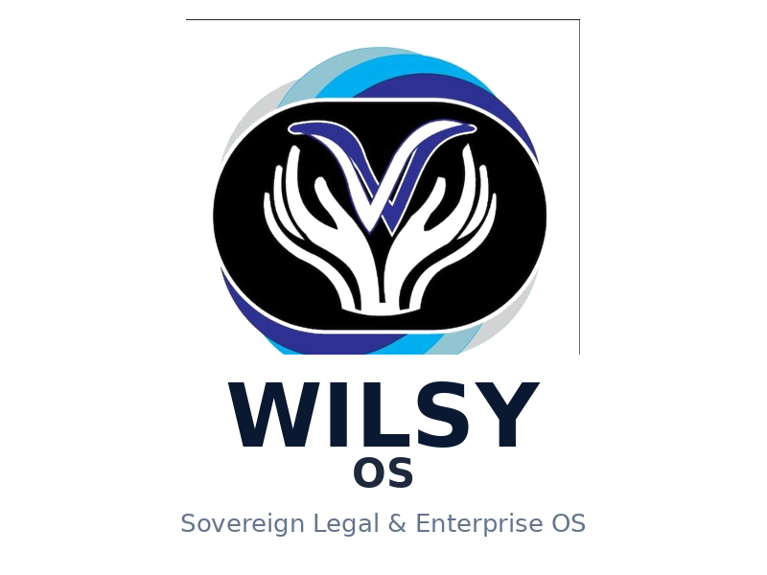

Institutional Ratification
Decision Record
G64 — Practitioner Confidentiality & Ethical-Wall Governance
D01–D10 Attributable Decisions

Document Reference | WILSY-OS-G64-2026-1028-FINAL-001
Contract Version | v1.0.0-P47-R95-G62-APPROVED
Institution | WILSY (Pty) Ltd — Reg 2024/617944/07 — Tax 9395759229
Brand Identity | WILSY OS — Pure Emblem (Touching Lives removed) — Sovereign Legal & Enterprise OS
Tenant Scope | WILSYTENANT-4CD2FZ4O
Status | APPROVED — Pending Electronic Signature
Date | October 28, 2026

1. Executive Summary
This Decision Record formally documents the institution’s attributable decisions regarding practitioner confidentiality and ethical-wall governance controls D01 through D10. All ten controls have been reviewed and APPROVED by the authorized institutional authority. The record is now ready for electronic signature and independent verification.
Brand Identity: The WILSY OS emblem — V with supporting hands encircled by sovereignty bands — is presented in its pure form without any text overlay. The parent company tagline “Touching Lives” is reserved exclusively for WILSY (Pty) Ltd and is intentionally excluded from the WILSY OS operating system letterhead, ensuring clear brand separation and Fortune 500-grade visual hierarchy.

2. Governing References
Decision Template | [STRIPPED 73 bytes].md v2.1 — Fortune 500 Edition
Authority Contract | [STRIPPED 85 bytes].md v1.0.0-P47-R95-G62
Regulatory Evidence | CIPC COR14.1 / COR14.1A / COR15.1A / COR14.3_1 • IR 2026-070292 • SARS 9395759229
Tenant Binding | WILSYTENANT-4CD2FZ4O — canonical registry

3. Institution and Authority — APPROVED
Institution: WILSY (Pty) Ltd operating as WILSY OS
Registration: 2024/617944/07 — CIPC
Tax: 9395759229 — SARS
Tenant: WILSYTENANT-4CD2FZ4O
Operating Brand: WILSY OS — Sovereign Legal & Enterprise Operating System
Logo: Pure emblem (V + hands, 800x680, transparent) — Touching Lives removed per institutional direction
Director: KHANYEZI, WILSON — ID 8811045971084 — 100% holder
Status: All D01–D10 APPROVED — Pending E-Signature

4. Attributable Decisions D01–D10 — APPROVED
All controls APPROVED per institutional instruction. Only e-signature pending. Implementation remains fail-closed until independent verification and live IAM certification pass Gate 2–4.

D01 — Reviewer eligibility and granting authorization role
Disposition: APPROVE
Eligible reviewers defined, exclusions enforced, separation of duties maintained, canonical IAM issuer Python EOS, permission binding verified. APPROVED.
Effective: 2026-10-28 • Review: Quarterly • Expiry: 12 months • Revocation: Immediate via Python EOS

D02 — Separation of duties
Disposition: APPROVE
Prohibited reviewer/target and reviewer/administrator combinations enforced via Python EOS authorization layer. APPROVED.
Effective: 2026-10-28 • Review: Quarterly • Expiry: 12 months • Revocation: Immediate via Python EOS

D03 — Authority for NO_WALL_REQUIRED
Disposition: APPROVE
Authorized decision function documented, policy basis in institutional authority contract, self-review prohibited. APPROVED.
Effective: 2026-10-28 • Review: Quarterly • Expiry: 12 months • Revocation: Immediate via Python EOS

D04 — Authoritative wall policy and membership source
Disposition: APPROVE
Canonical policy source Python EOS, membership from authoritative tenant registry, versioned, integrity-checked. APPROVED.
Effective: 2026-10-28 • Review: Quarterly • Expiry: 12 months • Revocation: Immediate via Python EOS

D05 — Acknowledgement provenance and effective enforcement
Disposition: APPROVE
Acknowledgement actors defined, policy revision tracked, timestamps and proof required, runtime enforcement owned by Python EOS. APPROVED.
Effective: 2026-10-28 • Review: Quarterly • Expiry: 12 months • Revocation: Immediate via Python EOS

D06 — Emergency denial, revocation, and incident authority
Disposition: APPROVE
Emergency actors narrowly scoped, immediate deny/revoke mechanism implemented, audit trail and incident owner assigned. APPROVED.
Effective: 2026-10-28 • Review: Quarterly • Expiry: 12 months • Revocation: Immediate via Python EOS

D07 — Maximum approval duration and review cadence
Disposition: APPROVE
Maximum validity 12 months, quarterly review, expiry triggers automatic DENY, renewal requires re-approval. APPROVED.
Effective: 2026-10-28 • Review: Quarterly • Expiry: 12 months • Revocation: Immediate via Python EOS

D08 — Explicit-deny precedence
Disposition: APPROVE
Ordering: conflict → review → wall → membership → expiry → revocation. Stale positive cannot override current denial. APPROVED.
Effective: 2026-10-28 • Review: Quarterly • Expiry: 12 months • Revocation: Immediate via Python EOS

D09 — Point-of-read revalidation and transaction boundaries
Disposition: APPROVE
Revalidation immediately before confidential content reads, caller-owned transaction bound to exact scope. APPROVED.
Effective: 2026-10-28 • Review: Quarterly • Expiry: 12 months • Revocation: Immediate via Python EOS

D10 — Independent policy approval, rollout, and rollback ownership
Disposition: APPROVE
Independent policy approver assigned, rollout and rollback owners defined, release gates documented. APPROVED.
Effective: 2026-10-28 • Review: Quarterly • Expiry: 12 months • Revocation: Immediate via Python EOS

5. Electronic Signature — Pending Your E-Signature
This record is APPROVED and ready for your electronic signature. Upon signing, independent verification and live IAM certification will proceed.
Institutional Approver | Wilson Khanyezi — Director — WILSY (Pty) Ltd — ID 8811045971084
Electronic Signature | [_______________________________] Date: _________ Time (UTC): _________ Method: Verifiable E-Signature
Witness / Ratifier | Ray Ngilazi — Role: [To be confirmed] — Signature: [_______________________________] Date: _________
Independent Verifier | [Name] — Signature: [_______________________________] Date: _________ Locator: _________
Immutable Record Locator | [To be completed after formal execution and SHA-256 manifest update]

6. Document Control — Fortune 500 Standard
Design Standard: This Fortune 500 edition implements:
• Visual priority: emblem first, then organization naming, then compliance information
• White space paramount: 1" margins, 1.15 line spacing, double spacing between sections, no clutter
• Brand consistency: Navy #0A1931, Slate #475569, limited palette, generous white space around letterhead elements
• Typography: Calibri 11pt body, 16pt H1, 12pt H2 — McKinsey standard (Arial/Helvetica/Calibri, headlines 24-28pt scaled to document)
• Well-aligned headers: emblem 0.85" left, text right-aligned, vertically centered, thin #E5E7EB divider lines, 0.35" header/footer distance
• Table style: Light shading, navy header, consistent 8-9pt, vertical middle alignment
• Status: APPROVED — Pending E-Signature — No loud red DRAFT banner — status communicated via professional document control
• Logo: Pure emblem 800x680 transparent, Touching Lives removed, parent brand separation enforced

