WSEI University in Lublin

Faculty of Transportation and Information

Virtualization techniques, containerization

Laboratory
VirtualBox Installation, VM Cloning, and Network Interface
Management

Name: Winston Huruva
Student ID: 43614

Introduction
This laboratory exercise centers on establishing and configuring a virtualized environment optimized for containerization workflows. Conducted within a virtual machine, the session encompasses Docker installation, repository configuration, and foundational container operations. The objective is to build proficiency in Docker deployment, image retrieval, and container execution. Command-line screenshots are provided throughout to document each procedural step.
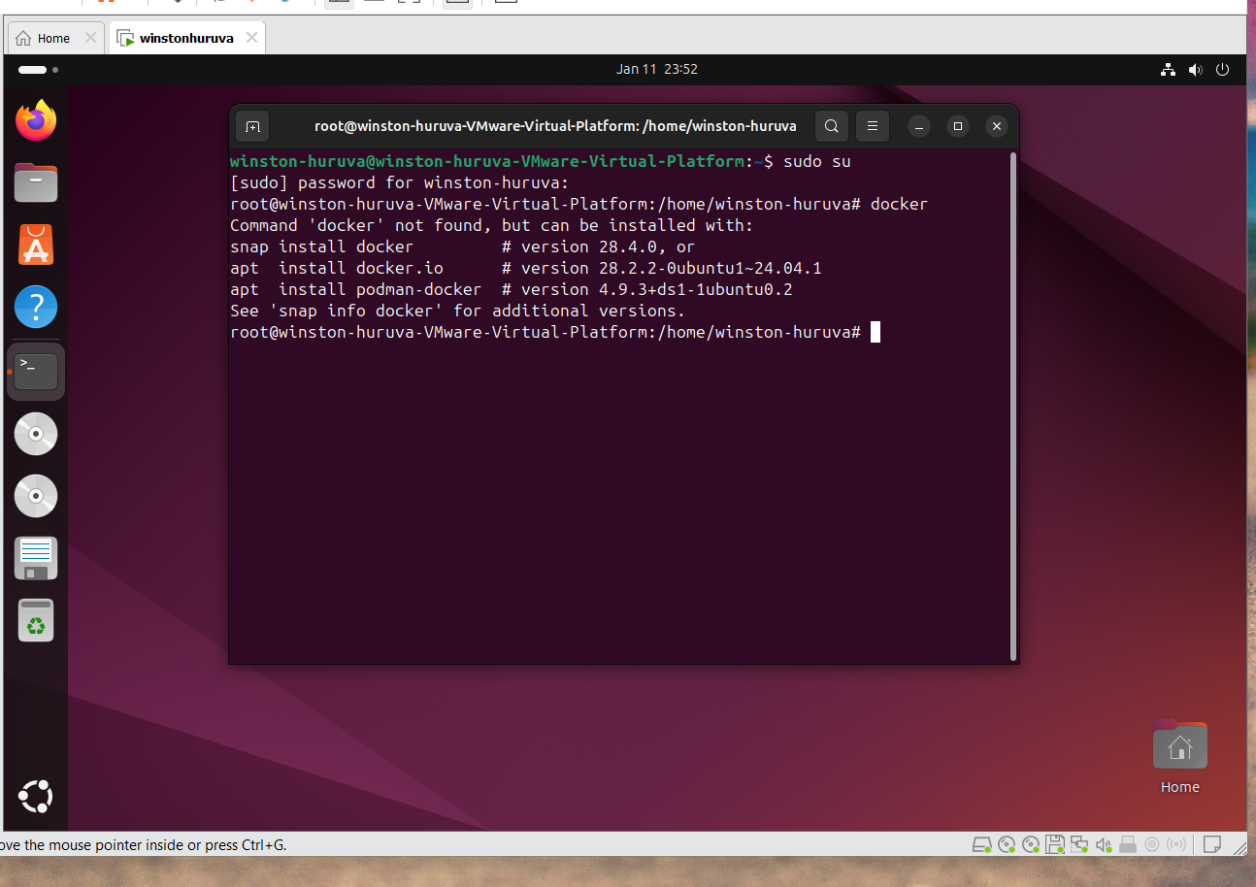
The sudo su command switches from a standard user to the root account, granting administrative privileges necessary for installing packages and configuring repositories—foundational steps for Docker installation.

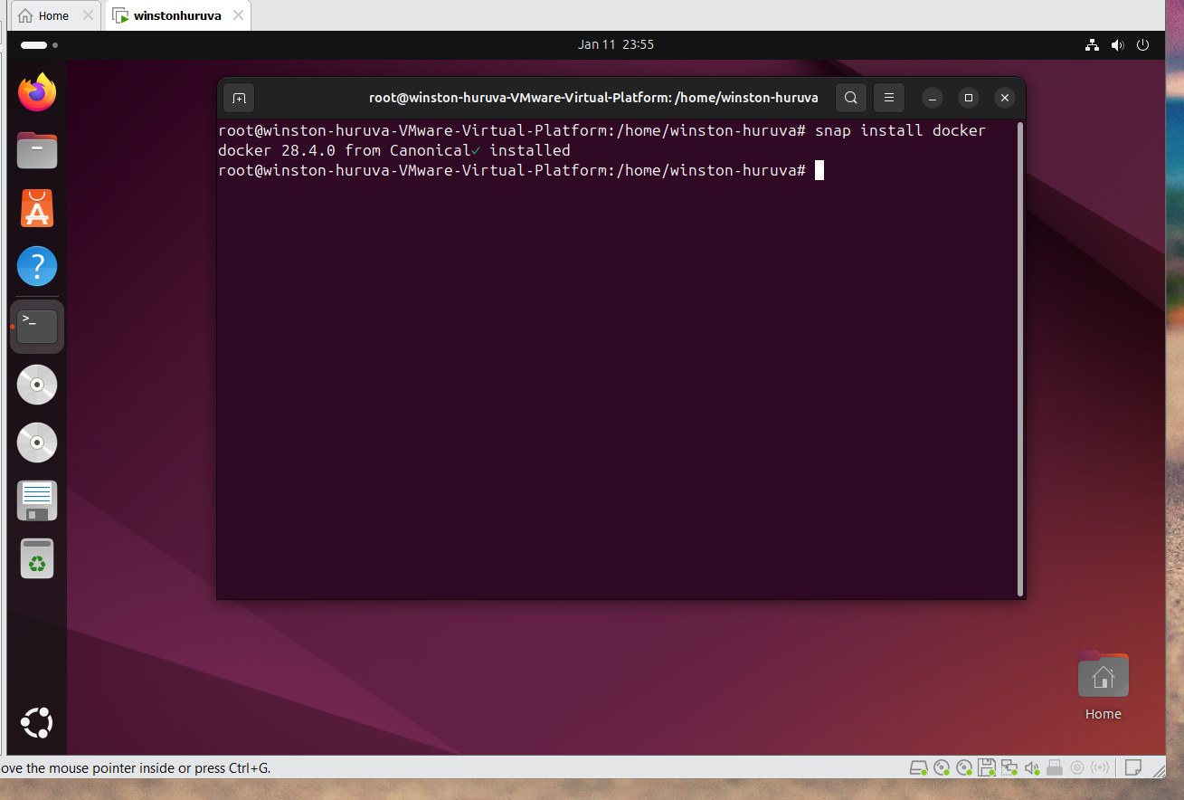
The screenshot above shows the installation of docker using snap install docker.
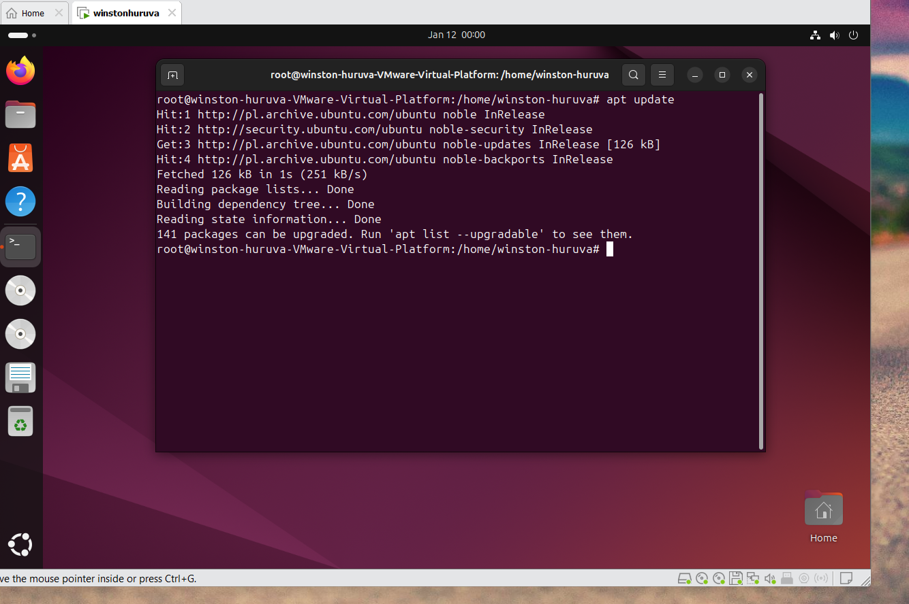
This screenshot captures the apt update command execution following repository configuration. The command refreshes the local package database, ensuring Docker packages become visible to the package manager. The system response—listing several upgradable packages—verifies that the update completed successfully.
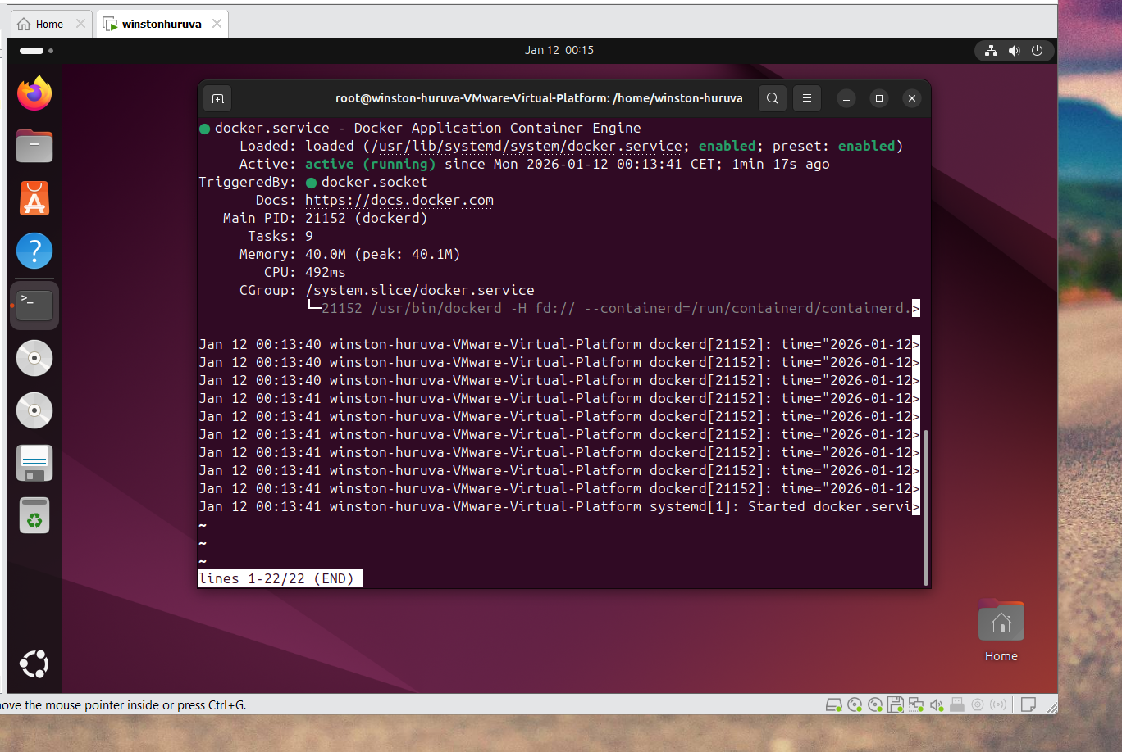
The screenshot demonstrates Docker service status verification. The output contains service logs with container engine initialization events, confirming Docker is operational.
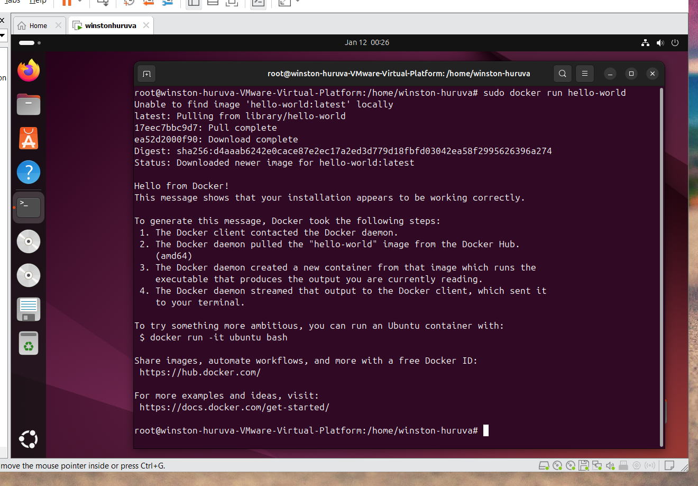

The screenshot shows execution of docker run hello-world, which downloads the official hello-world image (if not cached locally) and runs it as a container. The output confirms Docker's operational status, demonstrating successful image retrieval from Docker Hub and container execution.
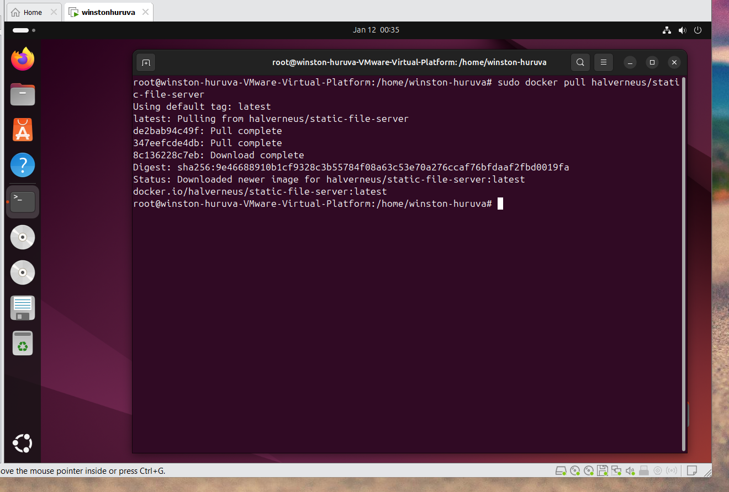
The screenshot shows execution of sudo docker pull halverneus/static-file-server. This command downloads the static-file-server Docker image from the halverneus repository on Docker Hub. The output displays the image layers being downloaded, verifying successful retrieval and preparation for container execution.
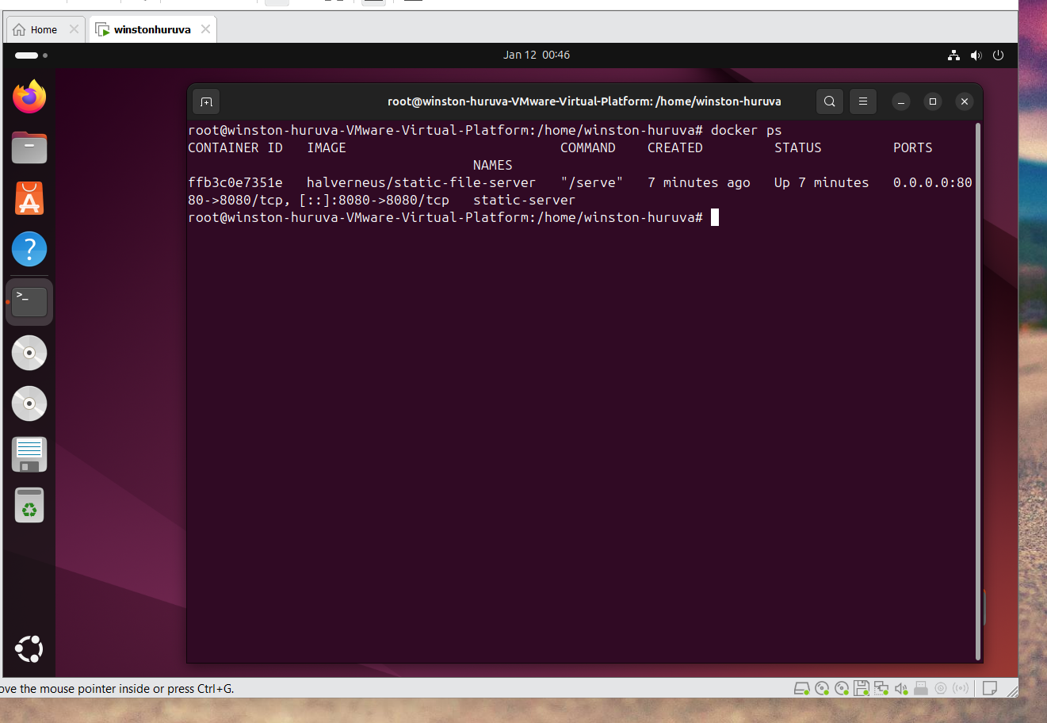
This command displays a list of currently running containers on the system.

Summary

This laboratory exercise established a foundation for container-based workflows by configuring a Docker environment within a virtual machine. Key activities included privilege escalation, repository configuration, package management, and service validation. The session progressed to foundational container operations, including test container execution and web server image retrieval. Screenshots documented each procedural stage, confirming successful Docker deployment and providing a basis for advanced containerization studies within virtualized infrastructures.

