WSEI University in Lublin

Faculty of Transportation and Information

Virtualization techniques, containerization

Laboratory

VirtualBox Installation, VM Cloning, and Network Interface Management

Name: Winston Huruva
Student ID: 43614

Lublin 2025

Introduction to VirtualBox
VirtualBox is an open-source virtualization platform used to run multiple operating systems on a single physical computer. It enables the creation of virtual machines (VMs), each functioning as an independent system with its own virtual hardware.
It allows different operating systems to be installed and tested without affecting the host system, which makes it useful for experiments, software testing, and educational purposes.
The platform provides features such as snapshots, shared folders, and virtual networking, offering flexibility and control for various technical applications.

VirtualBox Interface

The main interface displays a list of available virtual machines on the left and detailed information about the selected machine on the right. The top menu provides access to functions such as creating, starting, and managing virtual machines.
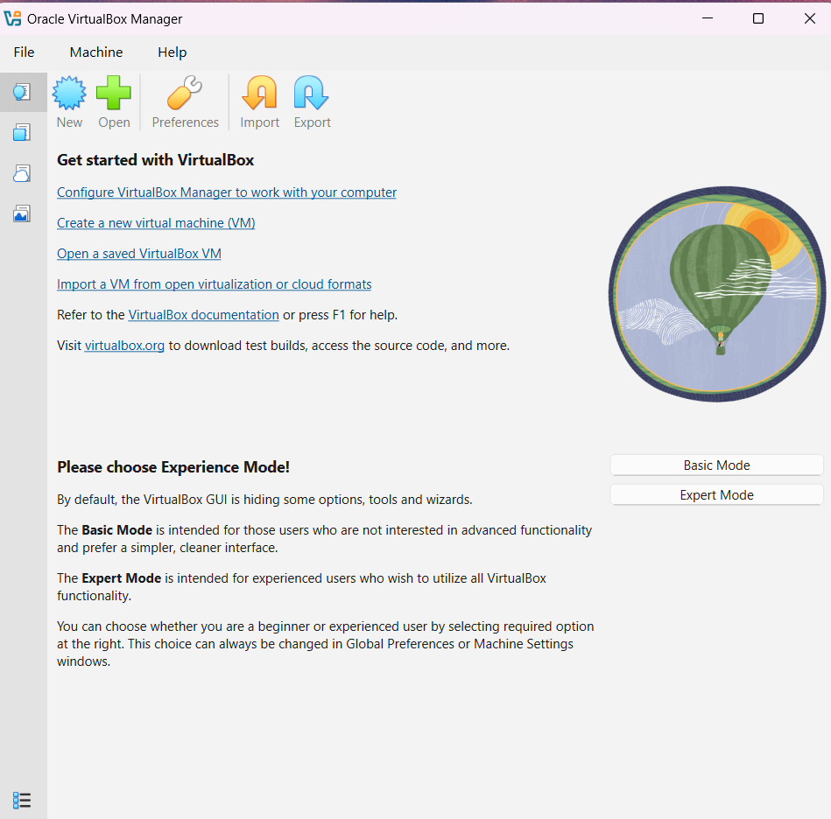
Rysunek 1VirtualBox Interface

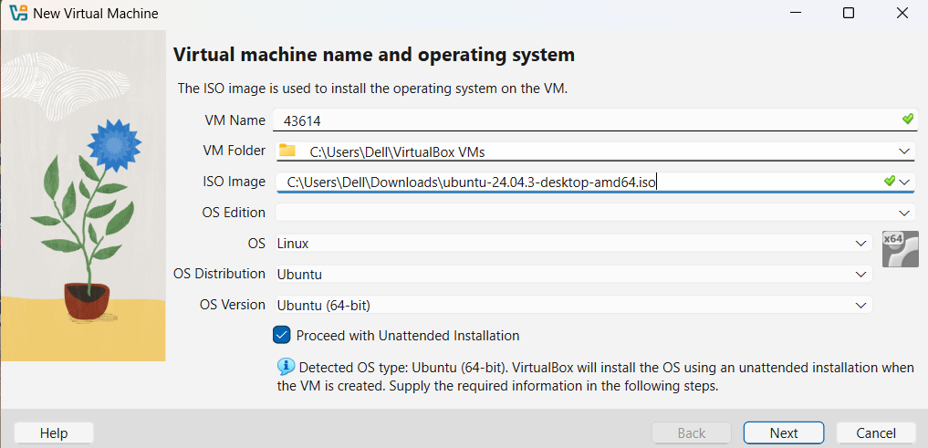
Rysunek 2Creating a virtual machine

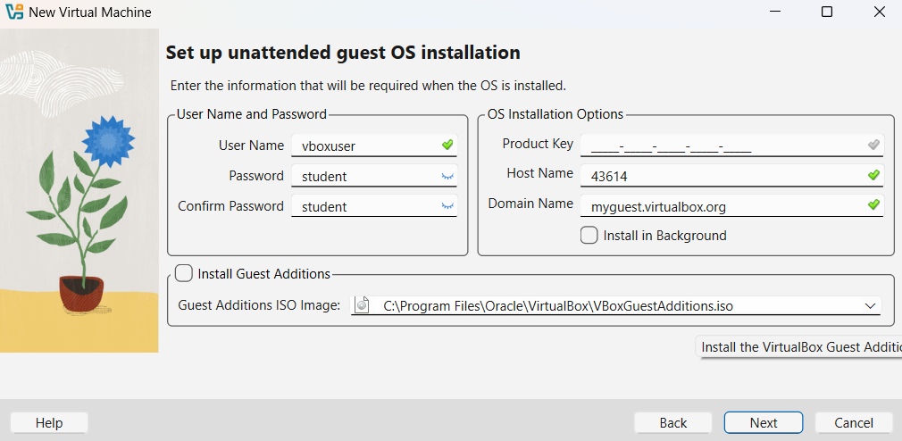
Rysunek 3Creating username and password of the virtual machine

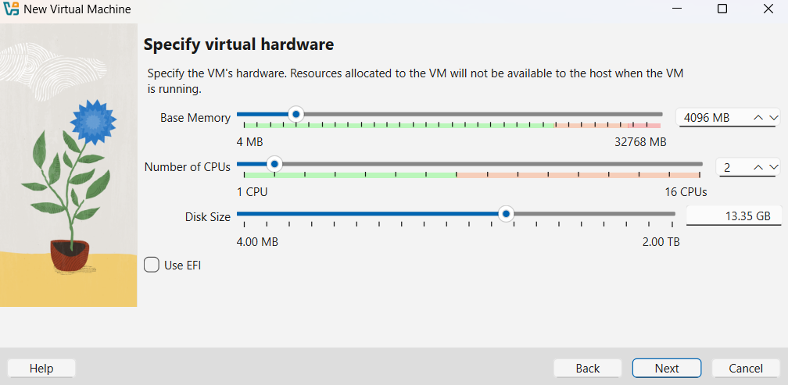
Rysunek 4The diagram above shows the ram size of 4gb,2 proccessors,disk size of 13,35gb

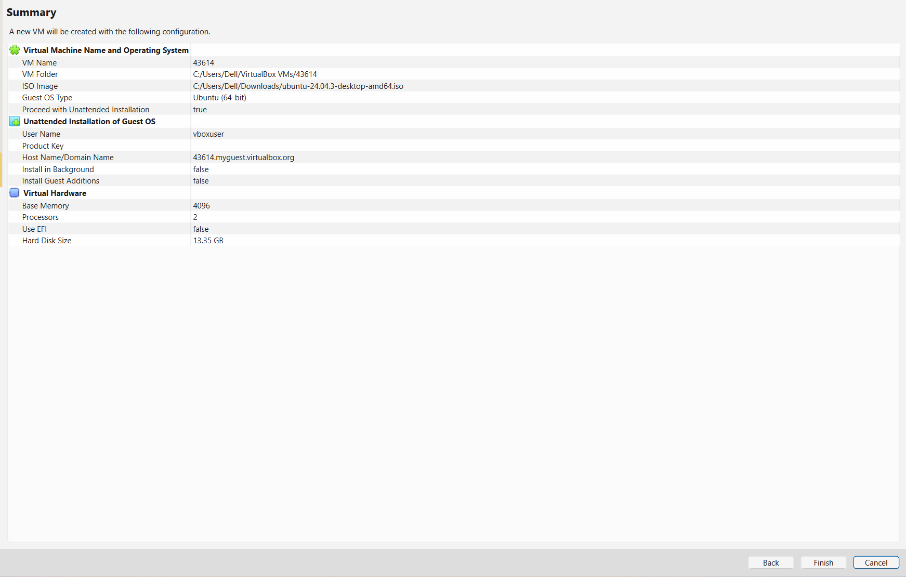
Rysunek 5The diagram above shows the full components of the operating system.
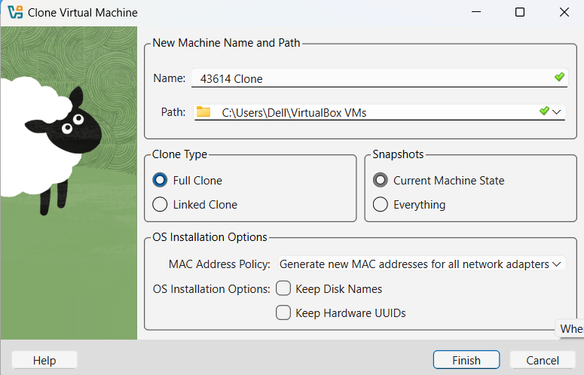
Rysunek 6Creating a clone virtual machine , also the type of clone machine is shown on the diagram above .

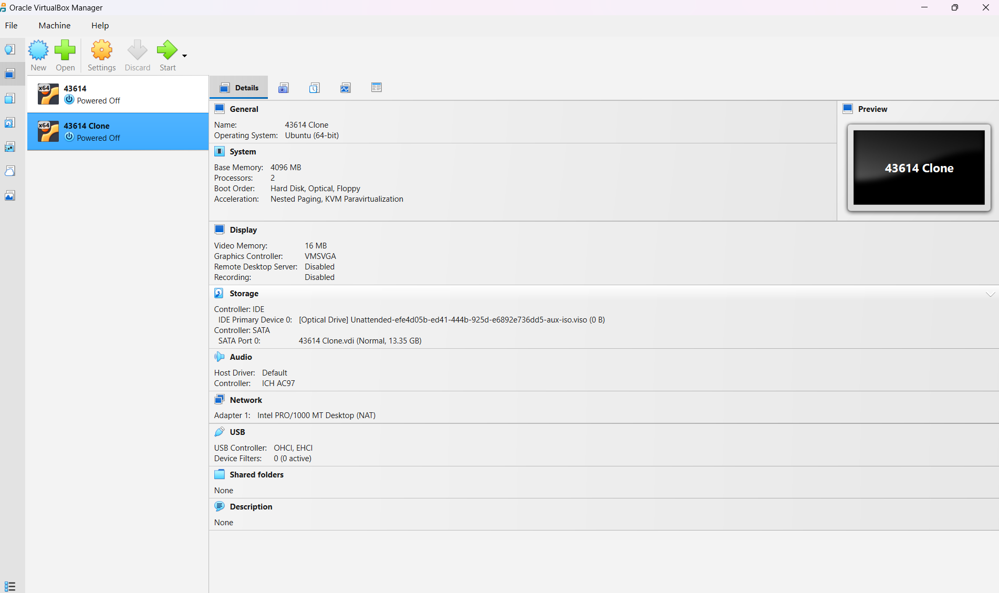
Rysunek 7The diagram above shows both the clone and the actual virtual machine also it shows the specifications of the virtual machine

Network Interfaces in VirtualBox

VirtualBox provides several types of network interfaces that determine how a virtual machine
connects to other systems. The most common modes include NAT, Bridged Adapter, Internal
Network, and Host-Only Adapter. Each mode defines a different way of accessing and sharing network resources between the host and virtual machines.

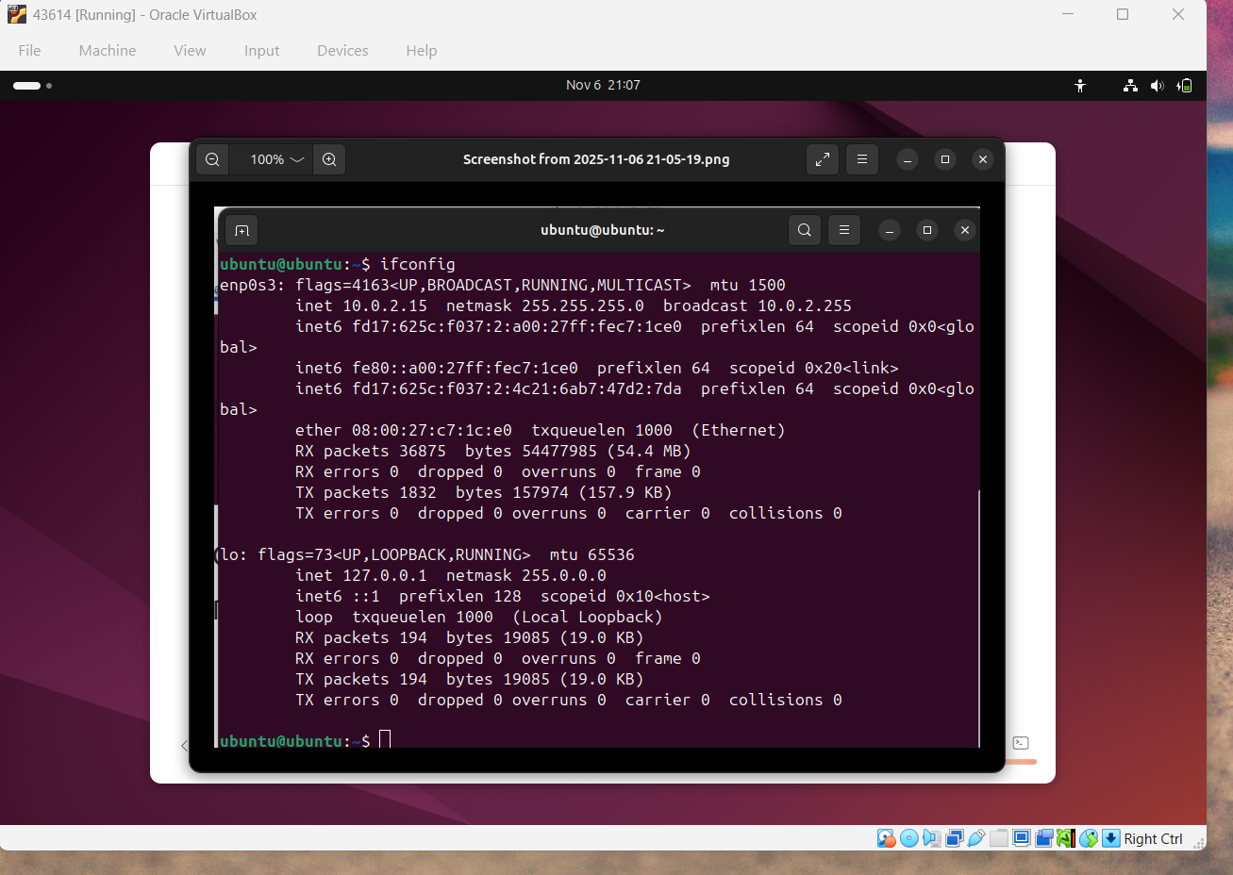
Rysunek 8Network interface of virtual machine

Summary
During the lab, the basic functions of VirtualBox were explored, including creating and configuring virtual machines, adjusting system resources, and setting up network interfaces. The exercise demonstrated how virtualization can be used to safely test different operating systems and network configurations without affecting the host system.

