WSEI University in Lublin

Faculty of Transportation and Information

Virtualization techniques, containerization

Laboratory
VirtualBox Installation, VM Cloning, and Network Interface
Management

Name: Winston Huruva
Student ID: 43614

1. Creating the first virtual machine in the VMware Player environment
In this exercise, a new virtual machine will be created for which the Ubuntu operating system will be installed. This machine will have 1 processor and 1 GB of RAM allocated. The size of the virtual disk will be set to 10 GB. When launched, this machine will have access to the external network through one native network interface.
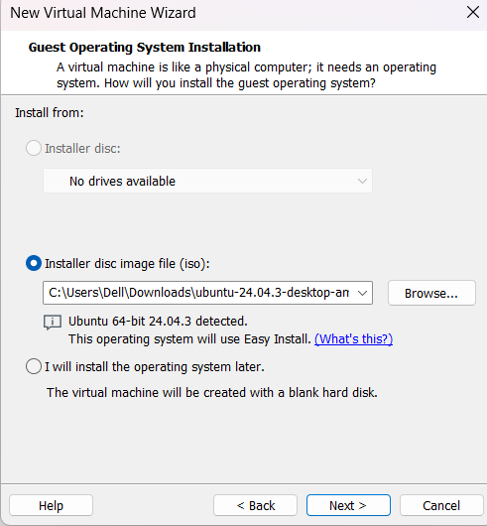
Figure 1Virtual Machine

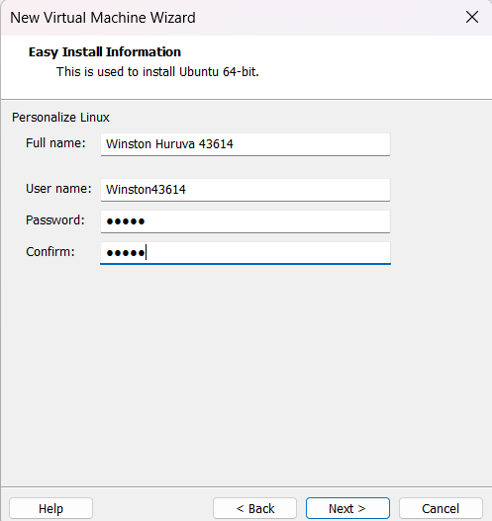
Figure 2Virtual Machine Name Configuration

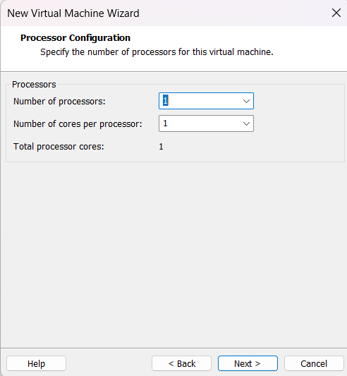
Figure 3Select number of processors
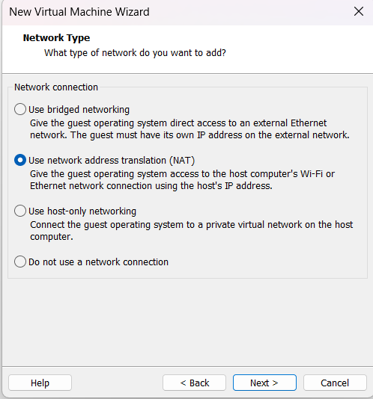
Figure 4type of network chosen

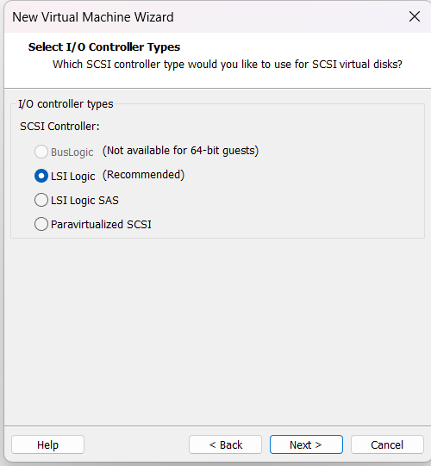
Figure 5Type of controllers
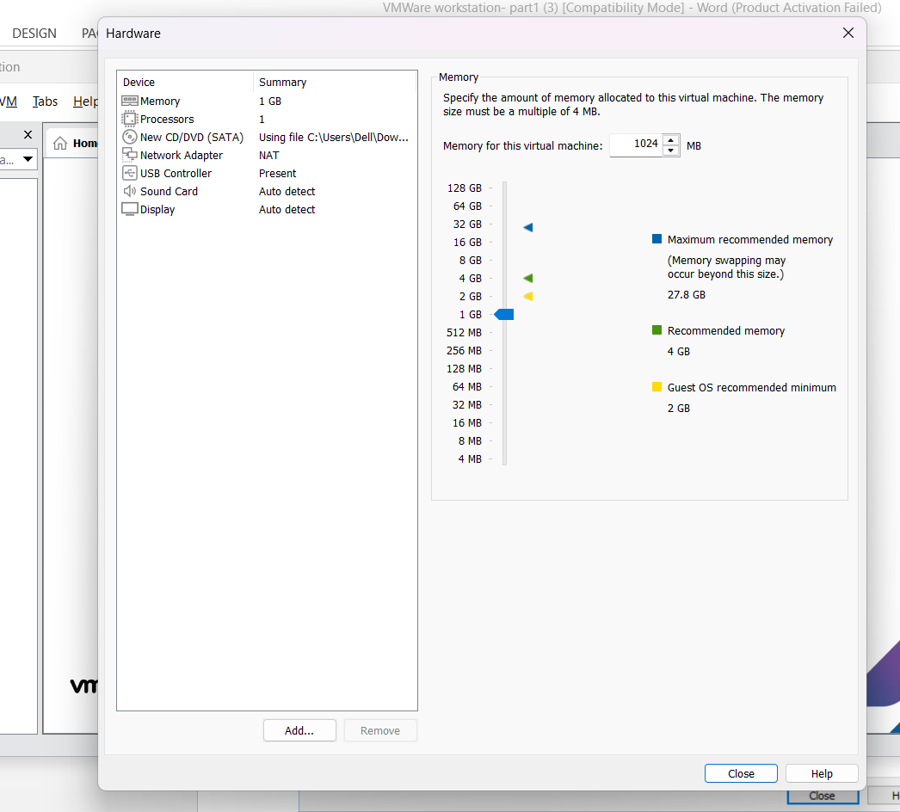
Figure 6Selecting and configuring virtual hardware

Task 5: Please check if the created machine has access to the Internet (browser, ping).

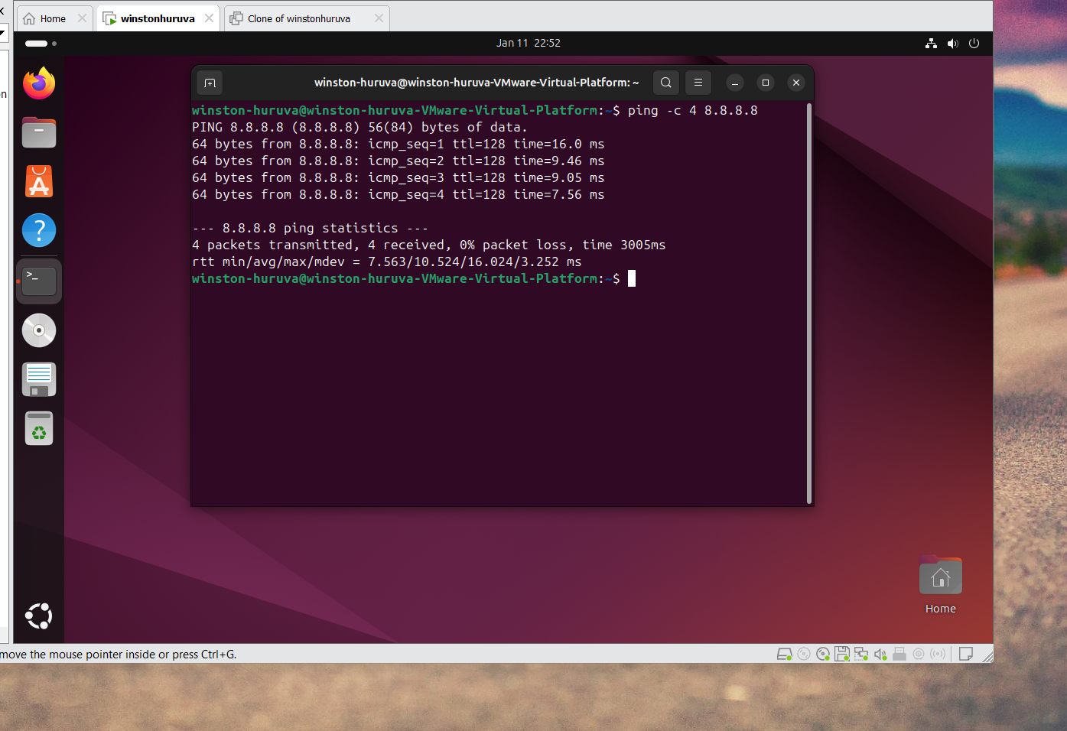
Figure 7Shows connection to the internet
Task 6: Is it possible to effectively use ping to the neighbor's (colleague's) virtual machine?
Yes, you can use ping effectively to test connectivity to a colleague's virtual machine, provided certain conditions are met. Here's what you need:
Prerequisites for Successful Ping:
1. Network Configuration:
- Both VMs must be on the same network segment (same subnet/VLAN)
- Or there must be proper routing between different networks
2. Firewall Settings:
- Your colleague's VM must allow ICMP traffic (ping uses ICMP protocol)

Task 7: How to display the routing table in the host system?
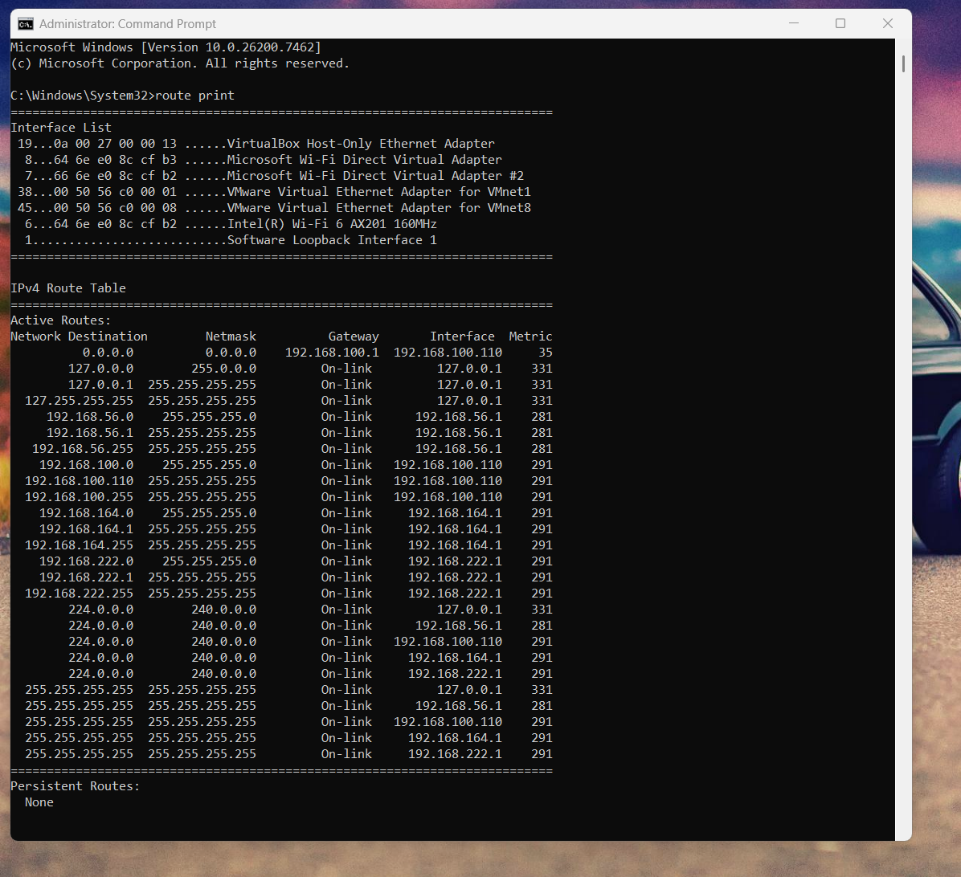
Figure 8routing table in the host sytem

Task 8: How to display the routing table in the guest system?

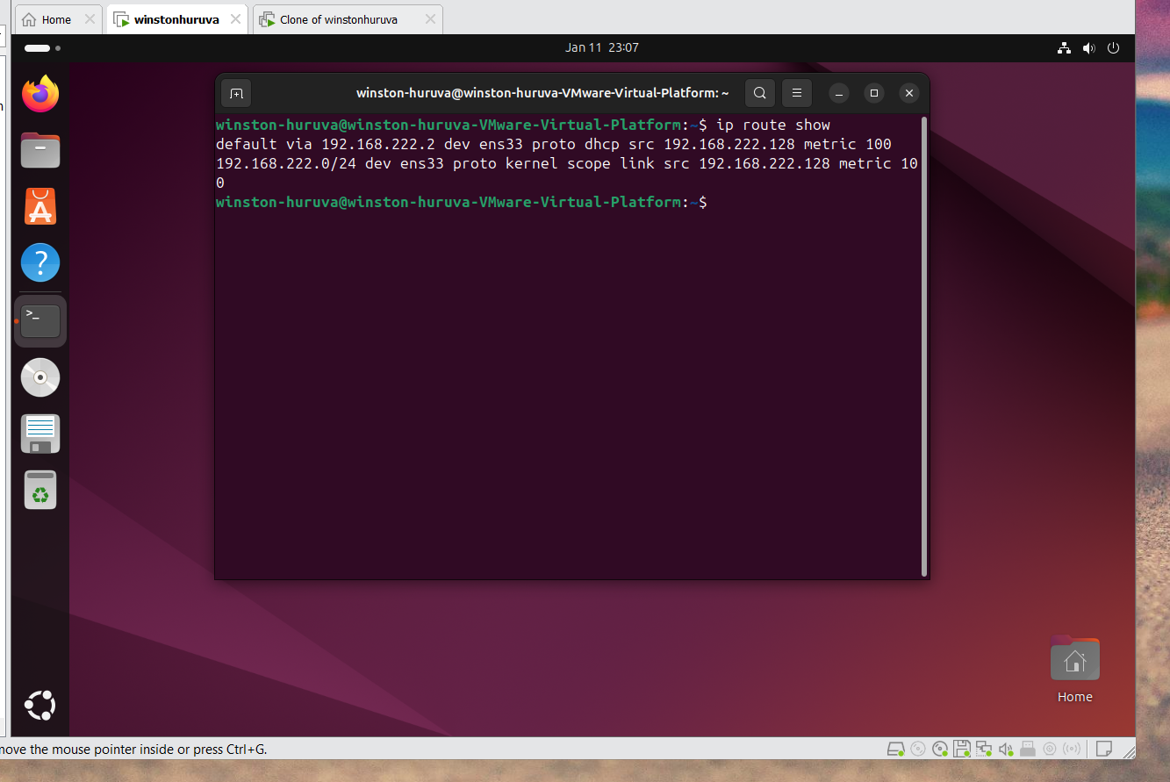

Task 9
Attach a screenshot of the machine configuration to the report
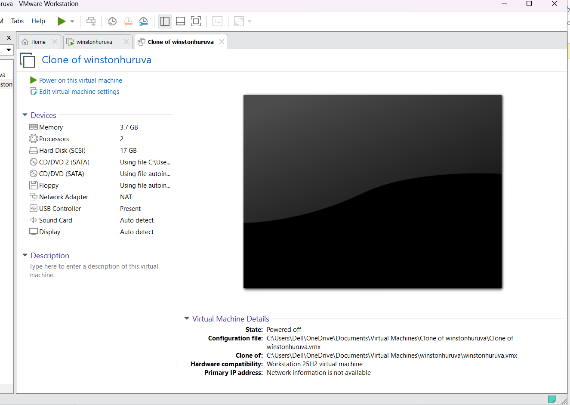
Figure 9configuration report of the machines

