Implementing a Targeted Pharmacogenomic NGS Panel in an NHS Hospital – Genomics
Author: - 23038420
This report recommends a 12‑month pilot of a targeted pharmacogenomic NGS panel for high‑risk prescribing in cardiology, oncology and psychiatry within NHS hospital, subjected by clinical governance, informatics support and staff training.

Introduction
In NHS Hospitals, it is usual for the average medical ward to be full of patients taking several different drugs. This poses a significant risk. In a UK study 6.5% of admissions were directly due to adverse drug reactions (ADRs) and over 70% of those were at least avoidable (Pirmohamed et al., 2004). In more recent work at a large teaching hospital in the UK, it emerged that one in every ten medical admissions is because of ADRs, particularly in those patients who have multimorbidity and are taking several different drugs (Osanlou et al., 2022). Each such admission uses beds, staff and investigations that might be avoidable.
Although many causes of ADRs have been identified, it has recently been acknowledged that genetic variation also has an important role to play. An analysis of the UK Yellow Card scheme, it was estimated that approximately 9% of reported ADRs were associated with medications that had obvious pharmacogenomic associations (Magavern et al., 2025). Pharmacogenomics may well hold potential to mitigate medication-related harm, rather than accepting it as the inevitable consequence of modern medical practice.

Pharmacogenomics and the case for change
Pharmacogenomics is focused on understanding the effect of variation in genes that regulate drug metabolism, transport and drug target proteins. Some of the gene-drug associations have been reinforced with solid evidence. For instance, CYP2D6 and CYP2C19 genotypes influence both exposure and response to many different antidepressants. The Clinical Pharmacogenetics Implementation Consortium (CPIC) aggregates this evidence and publishes graded dosing recommendations on the use of some of these gene-drug and are continually updated when new data emerge (Bousman et al., 2023).
The trial‑and‑error approach remains standard in NHS prescribing. Pharmacogenomic testing is usually reactive and single‑gene, requested only after a patient experiences a severe adverse reaction or repeated treatment failure. This reactive strategy is inefficient and benefits only the small proportion of patients who are tested, despite evidence that many patients carry multiple actionable variants (Mosch et al., 2025).

The proposed test: a targeted pharmacogenomic NGS panel
“Omics” integration in pharmacogenetics can be better achieved in relation to pharmacogenomics next-generation sequencing (NGS). Within one reaction, the panel can sequence specified genes of pharmacogenetics, including genes that code for the following: “CYP2D6, CYP2C19, CYP2C9, CYP3A5, SLCO1B1, DPYD, TPMT, and others implicated in the pharmacogenetics of drug treatment in psychiatry, cardiology and oncology” (Cavallari and Johnson, 2023; Mosch et al., 2025). In practical terms, one blood or saliva sample can generate a pharmacogenomic profile that is relevant for many prescribing decisions over a patient’s lifetime.
Targeted NGS allows capture or amplicon enrichment in order to achieve high depth coverage of the exons and crucial regulatory areas. In contrast to fixed SNP arrays, this increases the sensitivity for rare variation and complicated haplotypes, which is of especial note for genes such as CYP2D6 that demonstrate copy number and structural variation (Kee et al., 2023). Direct variant results are then encoded into 'star' alleles and metaboliser phenotypes employing curated translation tables and tools such as PharmGKB and CPIC. Direct sequencing results are not accessible to the clinician. Instead, results are communicated within a brief, focused report detailing each gene (e.g., CYP2D6 poor metaboliser), and targeted guidance for drug products affected. Within an average NHS lab, his would be another routine molecular test. The main point of departure is that it is pre-emptive and reusable, instead of requested towards the end of the patient care process for a one-off use.

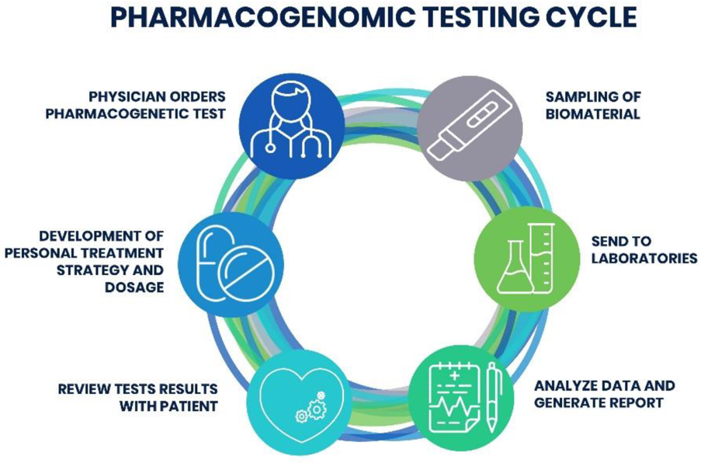
Figure 1 Pharmacogenomic Testing Cycle

Evidence for impact
Evidence that multi-gene pharmacogenomic panels can reduce harm comes from the PREPARE study, an open-label, multicentre, cluster-randomised crossover implementation trial conducted in seven European countries. Patients in the intervention arm received a 12-gene pharmacogenetic panel test, and prescribers were given gene-based dosing and prescribing guidance for selected medications. The study reported a 30% relative reduction in clinically relevant ADRs compared with usual care, suggesting that pre-emptive panel testing can meaningfully reduce medication-related harm in routine practice (Swen et al., 2023). For an under-pressure NHS hospital, even a modest reduction in ADR-related admissions would be clinically and operationally significant.
A good demonstration of this potential is around psychiatry. Pharmacogenomic tests for depressed patients evaluate CYP2D6, CYP2C19 and other genes. In major depressive disorder pharmacogenomics-based care can lead to better symptoms and lower total cost of care relative to usual care (Groessl et al., 2018; Ghanbarian et al., 2023). These findings are consistent with CPIC guidance, which predicts higher side effect burden and treatment failure when standard doses are used in poor and ultra-rapid metabolizers (Bousman et al., 2023).
Firstly, it should be made clear that not all reported gene-drug links are associated with large effect sizes or robust evidence. Clinical trials and cost-effectiveness analysis are generally concentrated on a subset of genes and drugs that are thoroughly validated for each other. In the case of any local initiative, it is advised to start with such gene-drug pairs of high confidence and avoid over interpreting less well-founded links (Mosch et al., 2025). Pharmacogenomics must be represented in such a way that it is not thought of as the solution that can preclude all occurrences of ADRs. A more accurate claim is that well selected panels can reduce the rate of clinically important ADRs in specific, clearly defined patient groups.

Implementation in an NHS context
Results of some cost-effectiveness analyses reveal that pre-emptive panel testing can be cost-effective, especially in cardiovascular diseases. In the systematic review of pharmacogenomics for cardiovascular medication, it was indicated that about two-thirds of reports concluded that pharmacogenomics-based care is cost-effective (Zhu et al., 2020). Results of cost-effectiveness analysis that included pre-emptive panel testing, testing in reaction to suspected poor metabolism and non-testing indicated that pre-emptive panel testing was the dominant approach in terms of cost-effectiveness in a lifetime perspective (Zhu et al., 2021). In the comprehensive reviews that have included several CPIC-guided medications, similar results were observed, with most evaluations favouring testing (Verbelen et al., 2017; Morris et al., 2022). This implies shifting some costs upfront to testing and informatics in favour of lower rates of admission for potential drug-related ADRs of any kind, lower rates of failed treatments and higher clinic efficiency.
A pilot is preferable to large‑scale implementation and should focus on cardiology and oncology, where higher‑risk drugs and stronger gene–drug evidence exist. Patients on antiplatelets, statins and fluoropyridines would be given panel testing and the outcome would be directly uploaded to the electronic prescription system based on required messages. Data on ADRs, admission rates and prescribing rates for both groups can be compared after 6-12 months in the trial group.
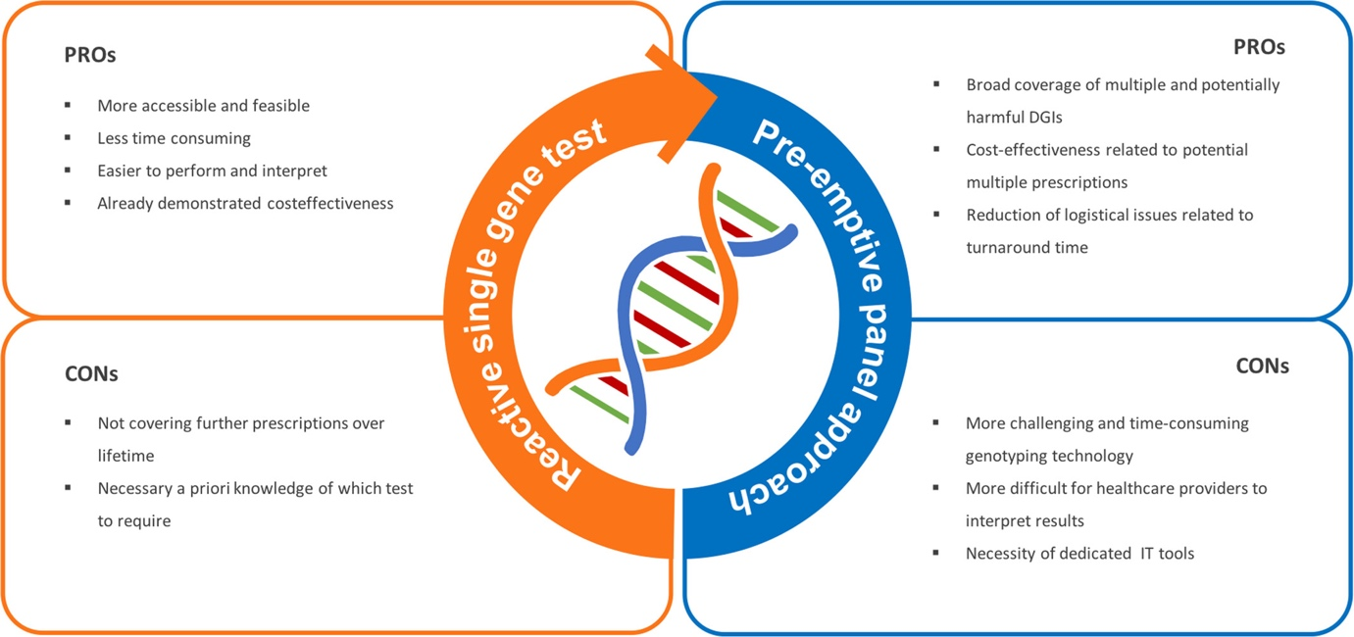
Figure 2 Advantages and disadvantages of applying a pre-emptive pharmacogenetic panel approach compared to a reactive single gene-drug approach.
There will be a need for training of the clinicians and the development of reports for them. Additionally, the lab and informatics departments will need some time to develop decision support tools and validate the test. The panels created in other countries may work less well in the UK due to the difference in ancestry and allele frequencies (Kee et al., 2023). However, this doesn’t affect the need for pharmacogenomics testing.

Conclusion
The evidence supports implementing targeted NGS pharmacogenomic panels in a carefully controlled, case-specific way rather than as universal testing, with validated multi-gene panels reducing clinically important ADRs and failed treatments in high-risk groups and showing favourable long-term cost-effectiveness. For this NHS hospital, the most appropriate next step is a 12-month pilot of pre-emptive panel testing in cardiology, oncology and psychiatry, embedded within existing laboratory and electronic prescribing systems and supported by robust governance, decision-support tools and formal evaluation of clinical and economic outcomes.
“I acknowledge the use of Perplexity.ai (GPT‑4–class generative AI tool, https://www.perplexity.ai/) to edit sentence structure, phrasing, grammar and spelling in this report.”
References
Bousman, C.A., Stevenson, J.M., Ramsey, L.B., Sangkuhl, K., Hicks, J.K., Strawn, J.R., Singh, A.B., Ruaño, G., Mueller, D.J., Tsermpini, E.E., Brown, J.T., Bell, G.C., Leeder, J.S., Gaedigk, A., Scott, S.A., Klein, T.E., Caudle, K.E. and Bishop, J.R. (2023). Clinical Pharmacogenetics Implementation Consortium (CPIC) Guideline for CYP2D6, CYP2C19, CYP2B6, SLC6A4, and HTR2A Genotypes and Serotonin Reuptake Inhibitor Antidepressants. Clinical Pharmacology and Therapeutics, [online] 114(1). doi:https://doi.org/10.1002/cpt.2903.

Cavallari, L.H. and Johnson, J.A. (2023). Use of a multi-gene pharmacogenetic panel reduces adverse drug effects. Cell Reports Medicine, p.101021. doi:https://doi.org/10.1016/j.xcrm.2023.101021.

Ghanbarian, S., Wong, G.W.K., Bunka, M., Edwards, L., Cressman, S., Conte, T., Price, M., Schuetz, C., Riches, L., Landry, G., Erickson, D., McGrail, K., Peterson, S., Vijh, R., Hoens, A.M., Austin, J. and Bryan, S. (2023). Cost-effectiveness of pharmacogenomic-guided treatment for major depression. CMAJ, [online] 195(44), pp.E1499–E1508. doi:https://doi.org/10.1503/cmaj.221785.
‌Groessl, E.J., Tally, S.R., Hillery, N., Maciel, A. and Garces, J.A. (2018). Cost-Effectiveness of a Pharmacogenetic Test to Guide Treatment for Major Depressive Disorder. Journal of Managed Care & Specialty Pharmacy, 24(8), pp.726–734. doi:https://doi.org/10.18553/jmcp.2018.24.8.726.
‌Kee, P.S., Maggo, S.D.S., Kennedy, M.A. and Chin, P.K.L. (2023). The pharmacogenetics of CYP2D6 and CYP2C19 in a case series of antidepressant responses. Frontiers in Pharmacology, 14. doi:https://doi.org/10.3389/fphar.2023.1080117.
Magavern, E.F., Megase, M., Thompson, J., Marengo, G., Jacobsen, J., Smedley, D. and Caulfield, M.J. (2025). Pharmacogenetics and adverse drug reports: Insights from a United Kingdom national pharmacovigilance database. PLoS Medicine, 22(3), pp.e1004565–e1004565. doi:https://doi.org/10.1371/journal.pmed.1004565.

Morris, S.A., Alsaidi, A.T., Verbyla, A., Cruz, A., Macfarlane, C., Bauer, J. and Patel, J.N. (2022). Cost Effectiveness of Pharmacogenetic Testing for Drugs with Clinical Pharmacogenetics Implementation Consortium ( CPIC ) Guidelines: A Systematic
Review. Clinical Pharmacology & Therapeutics, 112(6). doi:https://doi.org/10.1002/cpt.2754.
‌Mosch, R., van, H.J. Guchelaar and Swen, J.J. (2024). Pharmacogenetic Panel Testing: A Review of Current Practice and Potential for Clinical Implementation. The Annual Review of Pharmacology and Toxicology. doi:https://doi.org/10.1146/annurev-pharmtox-061724-080935.
‌Osanlou, R., Walker, L., Hughes, D.A., Burnside, G. and Pirmohamed, M. (2022). Adverse drug reactions, multimorbidity and polypharmacy: a prospective analysis of 1 month of medical admissions. BMJ Open, [online] 12(7), p.e055551. doi:https://doi.org/10.1136/bmjopen-2021-055551.
‌Pirmohamed, M., James, S., Meakin, S., Green, C., Scott, A.K., Walley, T.J., Farrar, K., Park, B.K. and Breckenridge, A.M. (2004). Adverse Drug Reactions as Cause of Admission to hospital: Prospective Analysis of 18 820 Patients. BMJ, [online] 329(7456), pp.15–19. doi:https://doi.org/10.1136/bmj.329.7456.15.‌
Swen, J.J., van der Wouden, C.H., Manson, L.E., Abdullah-Koolmees, H., Blagec, K., Blagus, T., Böhringer, S., Cambon-Thomsen, A., Cecchin, E., Cheung, K.-C., Deneer, V.H., Dupui, M., Ingelman-Sundberg, M., Jonsson, S., Joefield-Roka, C., Just, K.S., Karlsson, M.O., Konta, L., Koopmann, R. and Kriek, M. (2023). A 12-gene pharmacogenetic panel to prevent adverse drug reactions: an open-label, multicentre, controlled, cluster-randomised crossover implementation study. Lancet (London, England), [online] 401(10374), pp.347–356. doi:https://doi.org/10.1016/S0140-6736(22)01841-4.
‌Verbelen, M., Weale, M.E. and Lewis, C.M. (2017). Cost-effectiveness of pharmacogenetic-guided treatment: are we there yet? The pharmacogenomics journal, [online] 17(5), pp.395–402. doi:https://doi.org/10.1038/tpj.2017.21.
‌Zhu, Y., Swanson, K.M., Rojas, R.L., Wang, Z., St. Sauver, J.L., Visscher, S.L., Prokop, L.J., Bielinski, S.J., Wang, L., Weinshilboum, R. and Borah, B.J. (2019). Systematic review of the evidence on the cost-effectiveness of pharmacogenomics-guided treatment for cardiovascular diseases. Genetics in Medicine. [online] doi:https://doi.org/10.1038/s41436-019-0667-y.
Zhu, Y., Moriarty, J.P., Swanson, K.M., Takahashi, P.Y., Bielinski, S.J., Weinshilboum, R., Wang, L. and Borah, B.J. (2020). A model-based cost-effectiveness analysis of pharmacogenomic panel testing in cardiovascular disease management: preemptive, reactive, or none? Genetics in Medicine. doi:https://doi.org/10.1038/s41436-020-00995-w.
Figure 1:- https://www.mdpi.com/pharmaceutics/pharmaceutics-12-01240/article_deploy/html/images/pharmaceutics-12-01240-g002.png
Figure 2 :- https://bpspubs.onlinelibrary.wiley.com/cms/asset/ddeffa8c-78ab-4412-9fdf-60bc79114405/bcp15956-fig-0001-m.jpg

