Differential Gene Expression Analysis of Human Lung and Liver Tissue Using RNA Sequencing
Author: - 23038420

Introduction
Although the cells in the human body contain very similar genetic information, the liver and lungs have very distinct functions. There is a very significant specialization of the liver and lungs, which is due to the differential expression of genes. The liver expresses genes that encode enzymes for metabolism, detoxification, and the production of plasma proteins, while the lungs express surfactant proteins, which help lower the surface tension of the alveoli. A comparison of the expression of genes in the tissues provides information regarding the physiological function and the basis of the specificity of diseases that target specific tissues.
RNA sequencing has revolutionized the field of transcriptomics by allowing for the unbiased assessment of gene expression levels (Wang et al., 2009). The method involves the generation of cDNA from mRNA and the simultaneous analysis of millions of sequence tags. The genes that are differentially expressed based on the condition are determined by the use of two parameters: the log₂ fold change, which is an indicator of the level and nature of gene expression difference, and the adjusted p-value, calculated using the Benjamini–Hochberg method
This paper applied RNA-seq in analysing gene expression differences between human lung and liver tissue from healthy individuals. The objectives were to evaluate data quality and alignment performance, detect differentially expressed genes with significant differences, and interpret biological relevance in the most differentially expressed gene.

Methods

Data Acquisition
Publicly accessible RNA-seq data were collected from the Suntsova et al. (2019) atlas of normal human tissues, which provides a comprehensive resource with expression data from different organ types. The dataset included six liver samples (SRR7961207-SRR7961212) and five lung samples (SRR7961219-SRR7961223), all from healthy adults. The sequencing was carried out on the Illumina HiSeq 3000 platform, producing single end reads that were 35-50 base pairs in length. The entire bioinformatics workflow was conducted on the Galaxy platform.
The bioinformatics workflow is summarised in Figure 1.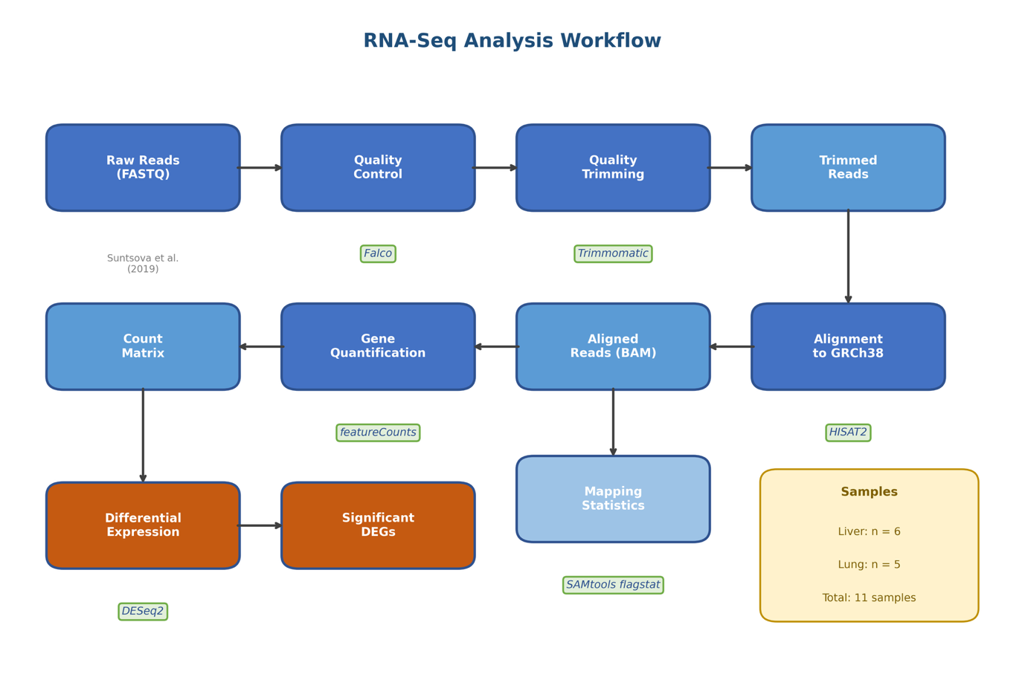
Figure 1. RNA-seq analysis workflow showing the complete pipeline from raw reads to differential expression results, with bioinformatics tools indicated at each step.

Quality Control and Trimming
Quality of raw reads was also analysed using Falco, a fast and efficient alternative to FastQC that considers quality scores per nucleotide base, read length distribution, GC content, and adapter contamination. The quality scores represented by Phred scaling values above 30 are a strong indicator of confident nucleotide bases. Trimming of reads based on quality was done using Trimmomatic (Bolger et al., 2014) options SLIDINGWINDOW:4:20 and MINLEN:20 (removes reads below 20 bases).

Alignment and Quantification
Trimmed reads were aligned to the human reference genome (GRCh38) using HISAT2 (Kim, Langmead and Salzberg, 2019), a graph-based splice-aware aligner that efficiently handles reads spanning exon-exon junctions. Alignment statistics were generated using SAMtools flagstat to assess mapping efficiency and identify potential quality issues. Gene-level counts were obtained using featureCounts (Liao, Smyth and Shi, 2014) with GENCODE annotation, assigning reads to genomic features using the union counting mode.

Differential Expression Analysis
For count data, the analysis was conducted by the software package DESeq2 (Love et al., 2014). This software assumes that read counts follow a negative binomial distribution and uses a method of shrinkage estimation for dispersions. The design formula for the analysis was ~tissue, with the liver as the reference condition. Genes that have less than ten counts across the entire data were filtered before analysis. The significance of the data was tested using Benjamini-Hochberg (BH) adjustment (Benjamini and Hochberg, 1995) with a significance level of 0.05 for the adjusted p-value. A positive log₂ fold change represents enrichment in the lung, while a negative value represents enrichment in the liver.

Results

Quality Assessment
Quality assessment with Falco showed that high-quality data had been obtained in all eleven samples (Table 1). Of 194,881,401 raw reads, no reads were classified as low quality. The percentage of GC content varied between 46% and 56% in different samples, as expected in human RNA-seq data (45-55%). Adapter contamination assessment showed that in all samples, Illumina Universal Adapter reads were below 0.05% (threshold in Falco: <5%). After Trimmomatic trimming, 194,578,614 reads were retained (99.84%).
Table 1. Quality control metrics for all samples.
Sample | Tissue | Raw Reads | Poor Quality | %GC | Adapter | Post-trim Reads
SRR7961207 | Liver | 24,351,701 | 0 | 53 | PASS | 24,304,383
SRR7961208 | Liver | 14,940,927 | 0 | 53 | PASS | 14,933,504
SRR7961209 | Liver | 13,824,967 | 0 | 54 | PASS | 13,781,664
SRR7961210 | Liver | 15,602,576 | 0 | 50 | PASS | 15,590,559
SRR7961211 | Liver | 16,653,751 | 0 | 56 | PASS | 16,643,565
SRR7961212 | Liver | 16,118,343 | 0 | 52 | PASS | 15,997,830
SRR7961219 | Lung | 19,280,524 | 0 | 46 | PASS | 19,279,212
SRR7961220 | Lung | 14,400,054 | 0 | 56 | PASS | 14,360,565
SRR7961221 | Lung | 18,115,698 | 0 | 50 | PASS | 18,107,577
SRR7961222 | Lung | 23,885,940 | 0 | 54 | PASS | 23,874,622
SRR7961223 | Lung | 17,706,920 | 0 | 50 | PASS | 17,705,133
Total |  | 194,881,401 | 0 |  |  | 194,578,614

%GC = percentage of guanine and cytosine bases (expected: 45-55% for human RNA-seq). Adapter = Falco assessment of Illumina adapter contamination (PASS = <5% detected).

Alignment Statistics
The overall mapping efficiency of HISAT2 was 70.09%, with 136,383,179 reads mapped to the reference genome (Figure 2). It is pertinent to mention here that the lung tissues showed a significantly higher mapping efficiency of 83.02% than liver tissues, which showed a mapping efficiency of 58.18%. It is likely that the liver tissue has a very complex transcriptome, with a large number of tissue-specific transcripts, uncanonical splicing, and genes that are perhaps not fully represented in the reference genome. Sample SRR7961207 showed a remarkably low mapping efficiency of 9.80%, which may impact the downstream analysis of liver samples. Despite this variability, the overall mapping rate remained sufficient for robust differential expression analysis, and retaining all samples preserved statistical power.
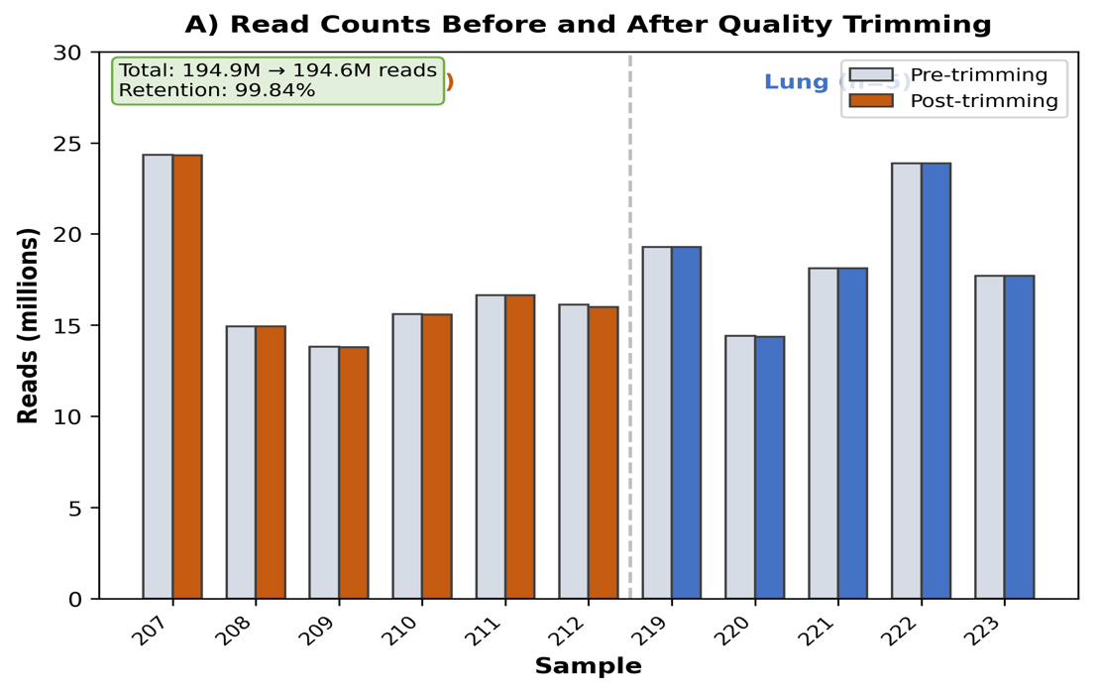
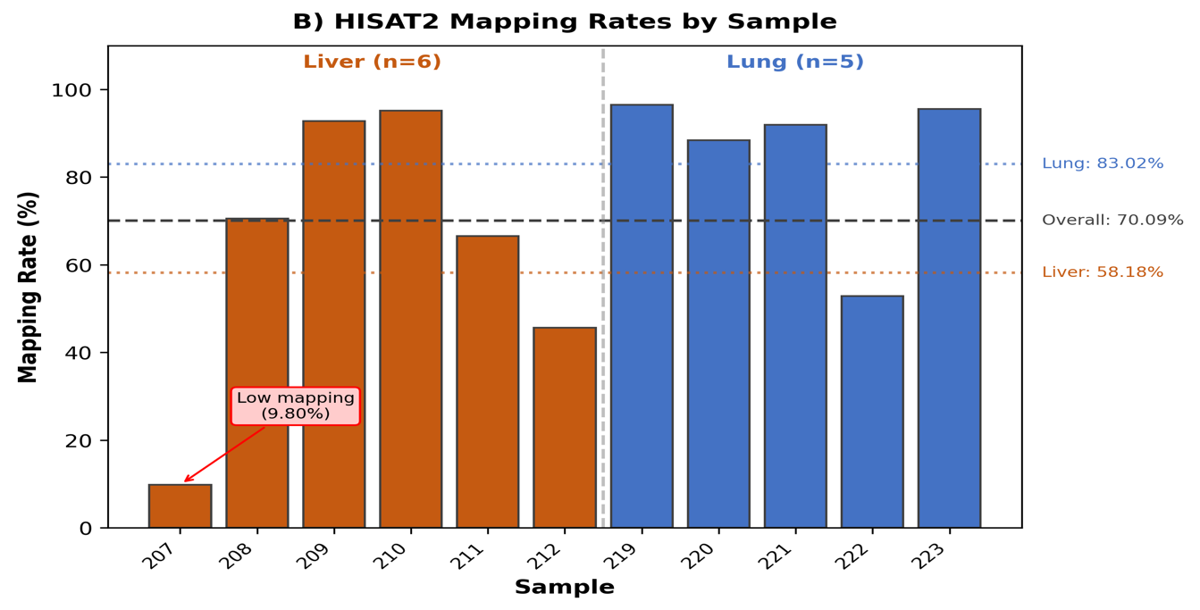Figure 2. Quality control and alignment statistics. (A) Read counts before and after quality trimming for each sample. (B) HISAT2 mapping rates showing tissue-dependent differences, with horizontal lines indicating mean rates.

Differential Expression
Differential Expression Principal Component Analysis showed a distinct separation among tissues (Fig. 4), thus validating their unique expression profiles. Of 78,691 genes assessed, DESeq2 identified 3,871 genes that showed significant differential expression (adjusted p-value < 0.05). Of these, 2,013 showed enrichment in the liver and 1,858 in the lungs (Fig. 3). 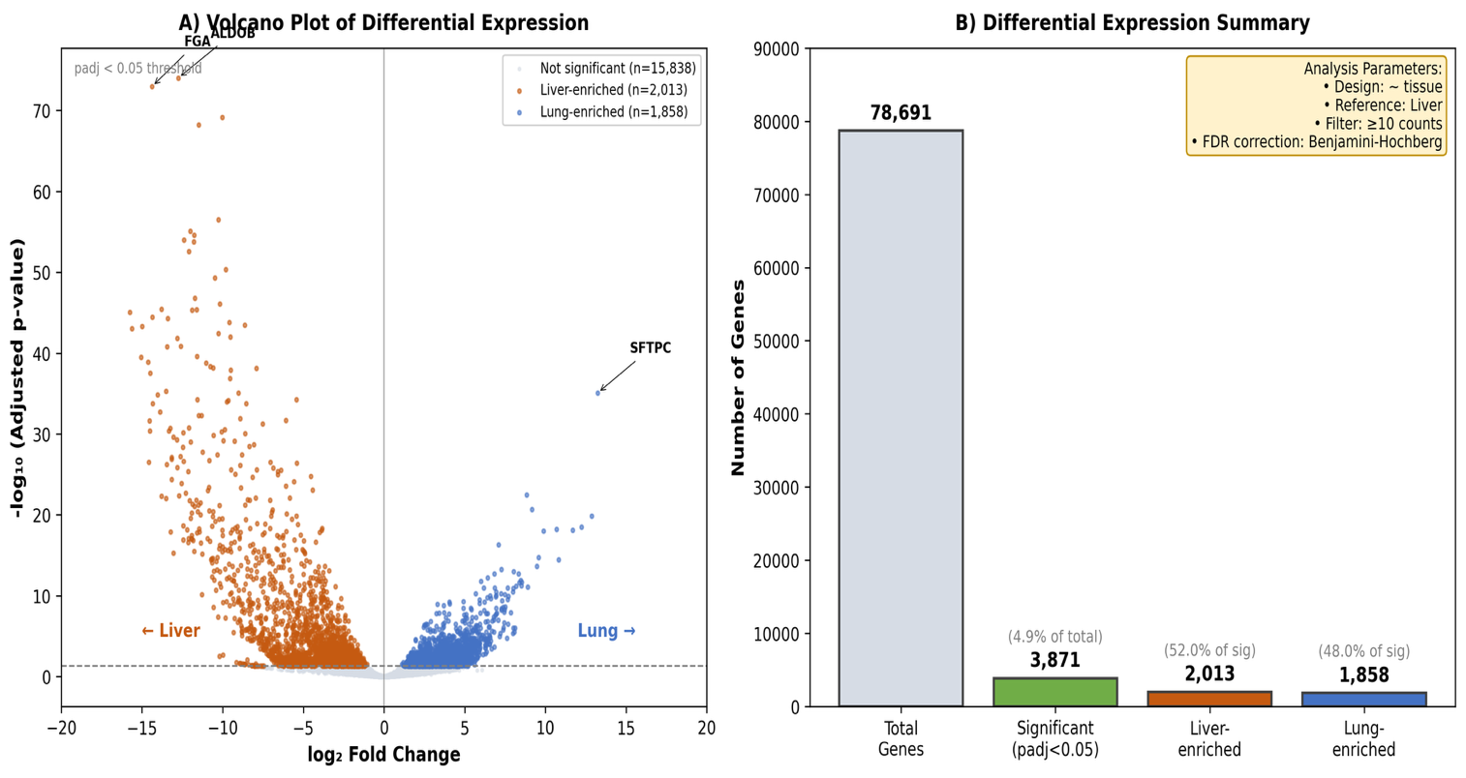
Figure 3. Differential expression analysis results. (A) Volcano plot showing log₂ fold change versus statistical significance, with liver-enriched genes (orange) and lung-enriched genes (blue) highlighted. (B) Summary of gene counts showing total analysed, significant, and tissue-enriched genes.
Table 2. Top ten differentially expressed genes (five per tissue, ranked by adjusted p-value).
Ensembl ID | Gene | baseMean | log₂FC | Adjusted p-value | Tissue
ENSG00000136872.22 | ALDOB | 10,615.8 | −12.75 | 9.34 × 10⁻⁷⁵ | Liver
ENSG00000171560.19 | FGA | 25,061.0 | −14.38 | 1.07 × 10⁻⁷³ | Liver
ENSG00000109072.15 | VTN | 4,959.1 | −10.03 | 6.94 × 10⁻⁷⁰ | Liver
ENSG00000110169.13 | HPX | 5,071.0 | −11.47 | 5.87 × 10⁻⁶⁹ | Liver
ENSG00000160862.14 | AZGP1 | 2,131.7 | −10.26 | 3.09 × 10⁻⁵⁷ | Liver
ENSG00000168878.20 | SFTPC | 2,571.1 | +13.24 | 8.31 × 10⁻³⁶ | Lung
ENSG00000066405.14 | CLDN18 | 347.9 | +8.85 | 3.16 × 10⁻²³ | Lung
ENSG00000086548.10 | CEACAM6 | 245.4 | +9.17 | 2.00 × 10⁻²¹ | Lung
ENSG00000185303.18 | SFTPA2 | 1,441.6 | +12.87 | 1.45 × 10⁻²⁰ | Lung
ENSG00000168484.14 | SFTPA1 | 949.1 | +12.24 | 3.03 × 10⁻¹⁹ | Lung
Negative log₂FC indicates liver enrichment; positive indicates lung enrichment.
Table 2 presents the top ten differentially expressed genes, comprising the five most significant from each tissue. The extremely low adjusted p-values (ranging from 10⁻⁷⁵ to 10⁻¹⁹) indicate very high statistical confidence, while the large log₂ fold changes (8.85 to 14.38) demonstrate substantial expression differences between tissues.
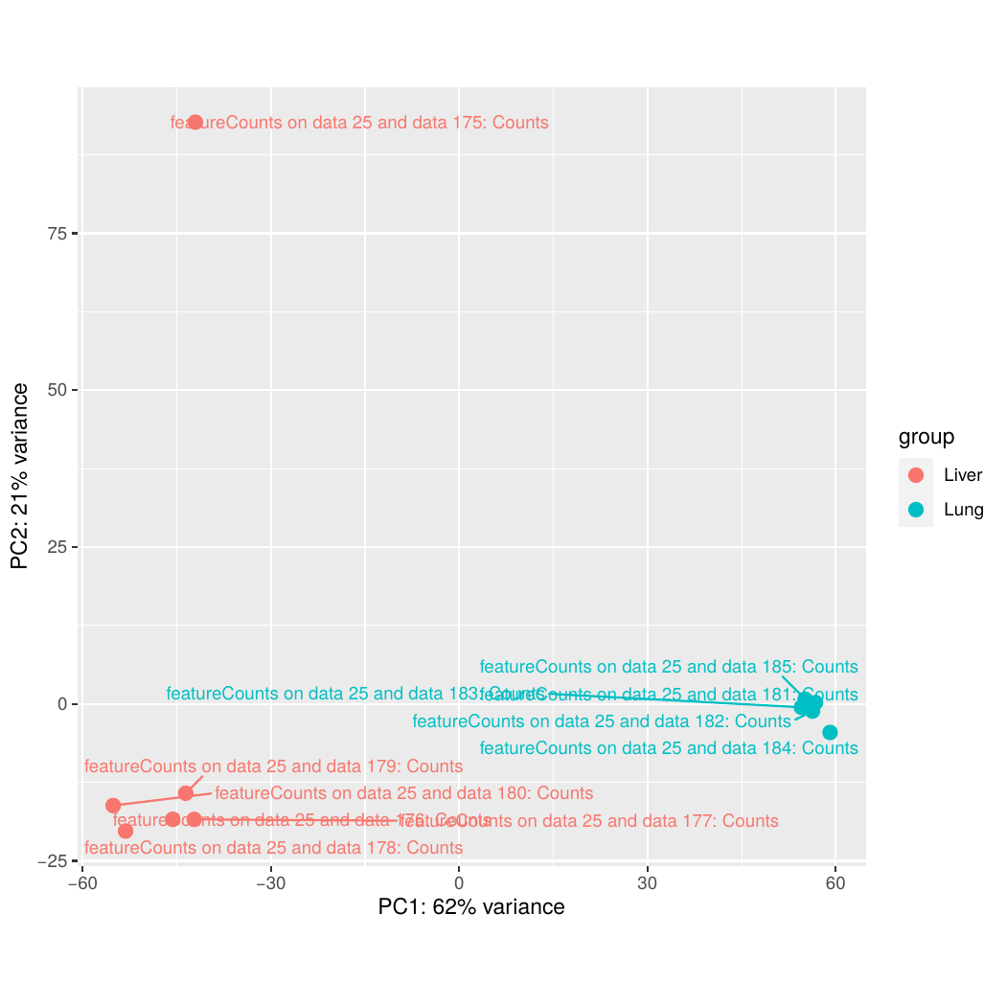
Figure 4. Principal component analysis of normalised expression data showing complete separation of lung and liver samples along PC1.
Liver-expressed genes code for proteins that are involved in carbohydrate metabolism (ALDOB), initiation of the coagulation pathway (FGA), or lipid transport (AZGP1). Lung-expressed genes code for proteins that are involved in reducing alveolar surface tension (SFTPC, SFTPA1, SFTPA2), a tight junction protein (CLDN18) that maintains the integrity of the epithelial barrier, or a cell adhesion molecule (CEACAM6). These results are as expected based on the biological functions of these organs.

Discussion

Overview of Findings
The gene expression profiles were strongly separated for liver and lung samples, as evident from the clear-cut clustering in the PCA analysis. The liver-enriched genes were predominantly composed of metabolic enzymes and secreted plasma proteins, such as genes involved in carbohydrate metabolism (ALDOB), lipid transport (APOA1, APOA2, APOB), blood coagulation (FGA), and xenobiotic metabolism (CYP2C8). The lung-enriched genes, in contrast, were defined by surfactant proteins (SFTPC, SFTPA1, and SFTPA2) and markers for epithelial cells (CLDN18 and CEACAM6), in accordance with the specialized function of the lung in gas exchange. The significantly greater statistical significance for the liver genes than for lung genes (p-values 10⁻⁷⁵ vs 10⁻³⁶) is probably a reflection of the uniquely high level of metabolic activity in the liver and its main function as the main producer of plasma proteins.
This study also has a number of limitations, some of which need to be discussed. The small sample size (six for the liver and five for the lungs) is a limitation in terms of power and generalizability. Bulk RNA sequencing also does not allow for the estimation of gene expression profiles in a cell-specific manner in a tissue with multiple cell types. The low rate of reads mapping to the genome for sample SRR7961207 (9.80%) may also result in bias in the estimation of gene expression in the liver.

Gene Focus: ALDOB (Aldolase B)

Structure
The ALDOB gene is found on chromosome 9q31.1 and consists of 14.5 kilobases of DNA divided into nine exons. The gene codes for a 364 amino acid protein that weighs 40 kDa and exists as a homotetramer (Tolan, 1995). Each subunit of the protein has a TIM barrel catalytic domain with a key lysine residue at position 229, which participates in the formation of the Schiff base intermediate.

Biological Function
Aldolase B catalyses the reversible breakdown of fructose-1,6-bisphosphate in glycolysis and gluconeogenesis. In contrast to the widely distributed aldolase A, aldolase B not only catalyses the breakdown of fructose-1,6-bisphosphate, but it also catalyses effectively the breakdown of fructose-1-phosphate, thus playing a crucial role in fructose metabolism (Esposito et al., 2002). Upon fructose intake, it is phosphorylated to fructose-1-phosphate by fructokinase, which is subsequently split to glyceraldehyde and dihydroxyacetone phosphate by aldolase B to produce energy (Ali et al., 1998). The enzyme's tissue distribution, highest in liver with lower expression in kidney and intestine, precisely matches sites of fructose processing.

Disease Associations
ALDOB gene mutations lead to hereditary fructose intolerance (HFI), an autosomal recessive condition seen in 1:20,000 births. The A149P mutation accounts for approximately 65% of Central European cases (Santer et al., 2005).The accumulation of fructose-1-phosphate leads to hepatotoxicity, phosphate depletion, and profound hypoglycaemia due to the absence of the enzyme. Symptoms of the disease include vomiting and abdominal pain due to the ingestion of fructose. A controlled diet helps the patient lead a healthy life.

Conclusion
In this RNA-seq analysis, tissue-specific molecular signatures were successfully detected to distinguish human lung and liver tissues. This is evident in the over-representation of metabolic genes in liver-specific genes and lung-specific genes such as surfactant proteins, which indicate a high degree of specialization in both tissues. Both log2 fold change and adjusted p-value were critical in defining significant differences in gene expression. ALDOB turned out as the gene showing the highest degree of differential expression, illustrating the relevance of analysing differential expression data to link transcriptomic data with biological functions as well as disease. Although there are limitations, such as the small number of samples as well as the varying rates of mapping, the present study clearly illustrates the strength of transcriptomics as a technique for identifying tissue-specific gene expression patterns.

Supplementary Information
Supplementary Table S1. Data sources for reported statistics.
Statistic | Value | Galaxy Source File | Extraction Method
Total raw reads | 194,881,401 | Falco on collection 12 (RawData) | Sum of "Total Sequences" from all 11 .txt files
Poor quality reads | 0 (0.00%) | Falco on collection 12 (RawData) | "Sequences flagged as poor quality" field
Post-trimming reads | 194,578,614 | Falco on collection 114 (RawData) | Sum of "Total Sequences" after trimming
Retention rate | 99.84% | Calculated | (194,578,614 ÷ 194,881,401) × 100
Overall mapping rate | 70.09% | SAMtools flagstat on collection | 136,383,179 mapped ÷ 194,578,614 total
Liver mapping rate | 58.18% | SAMtools flagstat | 58,907,334 mapped ÷ 101,251,505 total (n=6)
Lung mapping rate | 83.02% | SAMtools flagstat | 77,475,845 mapped ÷ 93,327,109 total (n=5)
Total genes analysed | 78,691 | DESeq2 output | Total row count
Significant DEGs | 3,871 | DESeq2 output | Filter: adjusted p-value < 0.05
Liver-enriched genes | 2,013 | DESeq2 output | Filter: padj < 0.05 AND log₂FC < 0
Lung-enriched genes | 1,858 | DESeq2 output | Filter: padj < 0.05 AND log₂FC > 0

References
Ali, M, et al. “Hereditary Fructose Intolerance.” Journal of Medical Genetics, vol. 35, no. 5, 1 May 1998, pp. 353–365, https://doi.org/10.1136/jmg.35.5.353.
Benjamini, Yoav, and Yosef Hochberg. “Controlling the False Discovery Rate: A Practical and Powerful Approach to Multiple Testing.” Journal of the Royal Statistical Society: Series B (Methodological), vol. 57, no. 1, Jan. 1995, pp. 289–300.
Bolger, Anthony M., et al. “Trimmomatic: A Flexible Trimmer for Illumina Sequence Data.” Bioinformatics, vol. 30, no. 15, 1 Apr. 2014, pp. 2114–2120.
Esposito, Gabriella, et al. “Structural and Functional Analysis of Aldolase B Mutants Related to Hereditary Fructose Intolerance.” FEBS Letters, vol. 531, no. 2, 5 Oct. 2002, pp. 152–156, https://doi.org/10.1016/s0014-5793(02)03451-8.
Kim, Daehwan, et al. “Graph-Based Genome Alignment and Genotyping with HISAT2 and HISAT-Genotype.” Nature Biotechnology, vol. 37, no. 8, Aug. 2019, pp. 907–915, https://doi.org/10.1038/s41587-019-0201-4.
Liao, Y., et al. “FeatureCounts: An Efficient General Purpose Program for Assigning Sequence Reads to Genomic Features.” Bioinformatics, vol. 30, no. 7, 13 Nov. 2013, pp. 923–930, https://doi.org/10.1093/bioinformatics/btt656.
Love, Michael I, et al. “Moderated Estimation of Fold Change and Dispersion for RNA-Seq Data with DESeq2.” Genome Biology, vol. 15, no. 12, Dec. 2014, p. 550, https://doi.org/10.1186/s13059-014-0550-8.
Santer, René, et al. “The Spectrum of Aldolase B (ALDOB) Mutations and the Prevalence of Hereditary Fructose Intolerance in Central Europe.” Human Mutation, vol. 25, no. 6, 2005, pp. 594–594, https://doi.org/10.1002/humu.9343.
Suntsova, Maria, et al. “Atlas of RNA Sequencing Profiles for Normal Human Tissues.” Scientific Data, vol. 6, no. 1, 23 Apr. 2019, https://doi.org/10.1038/s41597-019-0043-4.
Tolan, Dean R. “Molecular Basis of Hereditary Fructose Intolerance: Mutations and Polymorphisms in the Human Aldolase B Gene.” Human Mutation, vol. 6, no. 3, 1995, pp. 210–218, https://doi.org/10.1002/humu.1380060303.
Suntsova, Maria, et al. “Atlas of RNA Sequencing Profiles for Normal Human Tissues.” Scientific Data, vol. 6, no. 1, 23 Apr. 2019, https://doi.org/10.1038/s41597-019-0043-4.
Wang, Z., Gerstein, M. and Snyder, M. (2009). RNA-Seq: a revolutionary tool for transcriptomics. Nature Reviews Genetics, 10(1), pp.57–63. doi:https://doi.org/10.1038/nrg2484.

GenAI Acknowledgement
I acknowledge the use of Claude (Anthropic, https://claude.ai/) to edit sentence structure and phrasing.

