Part 1:
1.
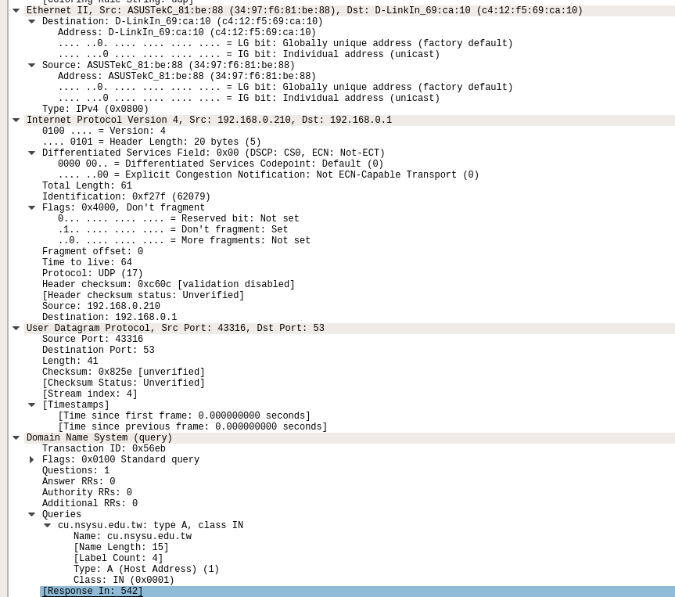

(1)Ethernet
a. Destination : D-LinkIn_69:ca:10(c4:12:f5:69:ca:10)
Source : ASUSTekC_81:be:88(34:97:f6:81:be:88)
b. content : IPv4 (0x0800)

(2)IP
a. Destination : 192.168.0.1
Source : 192.168.0.210
b. Header Length : 20 bytes
total Length : 61
c. type : 17 -> Protocol : UDP
(3)UDP
a. client : 43316 server : 53
b. DNS
(4)DNS
a. Flags : 0x0100 -> query
b. Transaction ID : 0x56eb
c. type A , class IN

2.
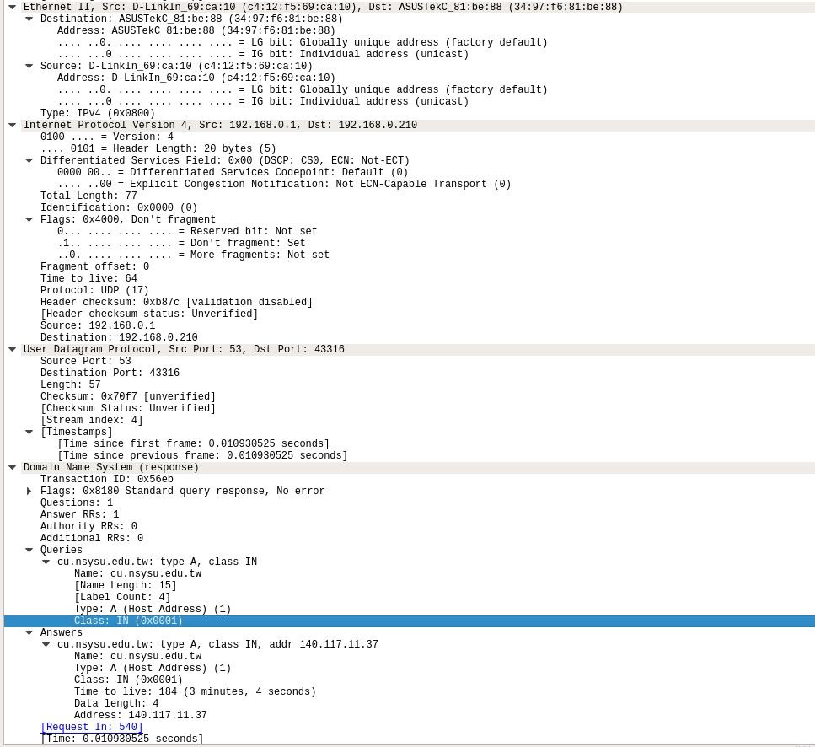

(1)Ethernet
a. Destination : ASUSTekC_81:be:88(34:97:f6:81:be:88)
Source : D-LinkIn_69:ca:10(c4:12:f5:69:ca:10)
b. content : IPv4 (0x0800)
(2)IP
a. Destination : 192.168.0.210
Source : 192.168.0.1
b. Header Length : 20 bytes
total Length : 77 bytes
Yes
c. Only 1 Answer Time to live : 184

3.
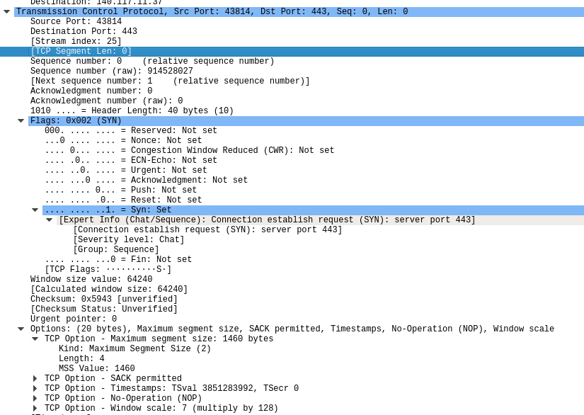
a. client : 43814 server : 443
b. 0
c. 914528027(raw)
d. 64240
e. 1460 bytes
f. 0x002

Part 2
1.
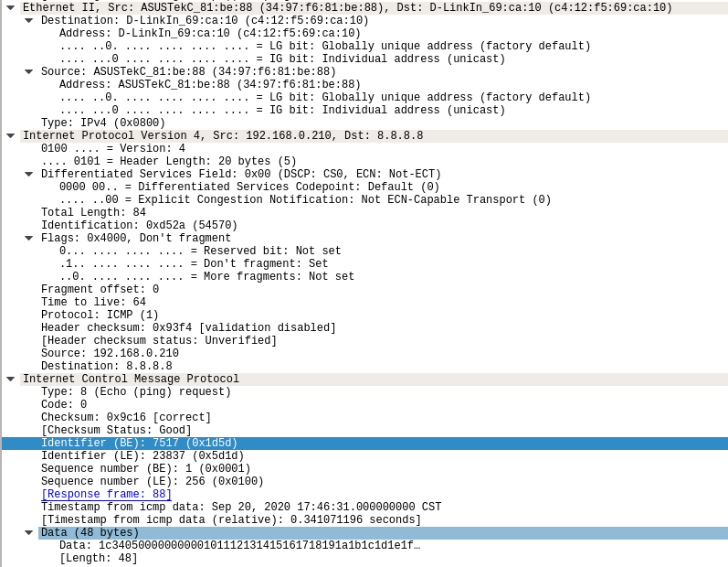

(1)ICMP request
a. 64
b. 8 (Echo (ping) request)
c. Message Identifier : 7517(Big endian)
Sequence Number : 1(Big endian)
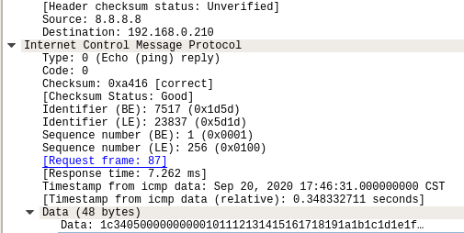

(2)ICMP reply
a. 0 (Echo (ping) reply)

2.
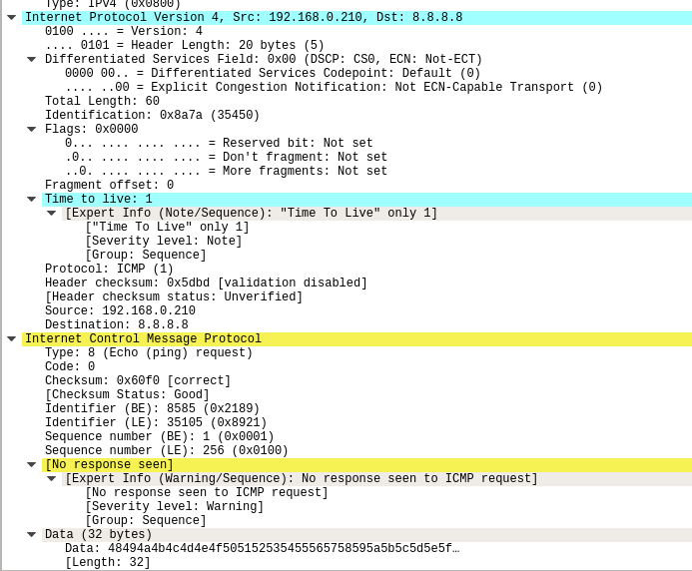

(1)ICMP request
a. Destination : 8.8.8.8
Source : 192.168.0.210
b. type : ICMP
time-to-live : 1
c. type : 8 (Echo (ping) request)
Message Identifier : 8585(Big endian)
Sequence Number : 1(Big endian)
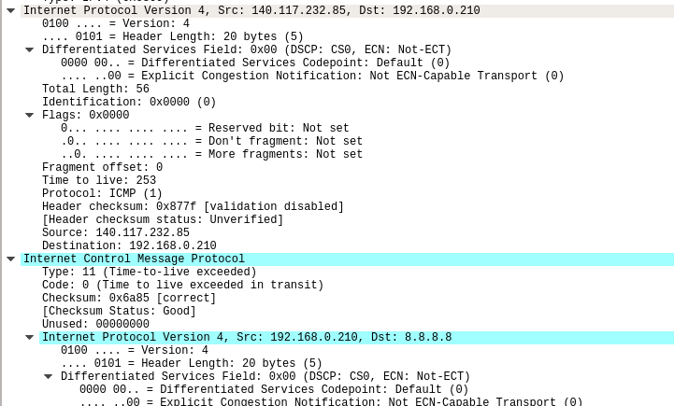

(2)Time-to-live exceed
a. Destination : 192.168.0.210
Source : 140.117.232.85
b. type : 11(Time-to-live exceeded)

Part3
1. 874 Mbits/sec
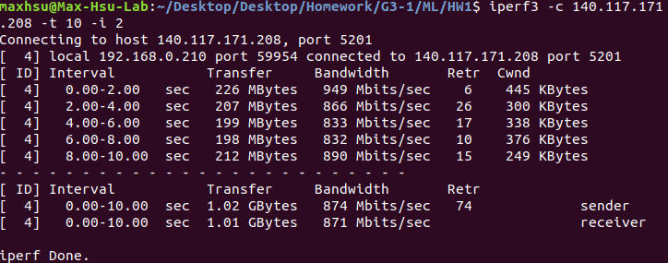

2. window size = 2000
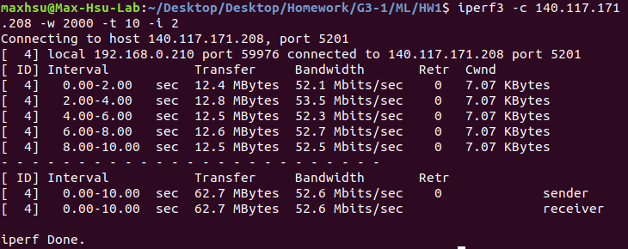

window size = 10000
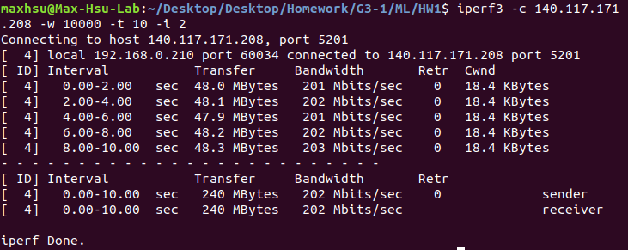

Result : Bandwidth increase with Window size

3. 1.05 Mbits/sec
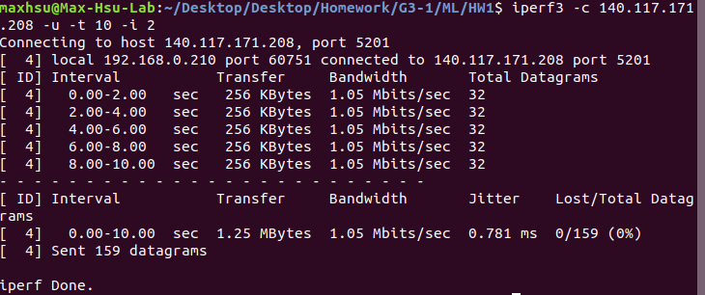
4. bandwidth = 512G
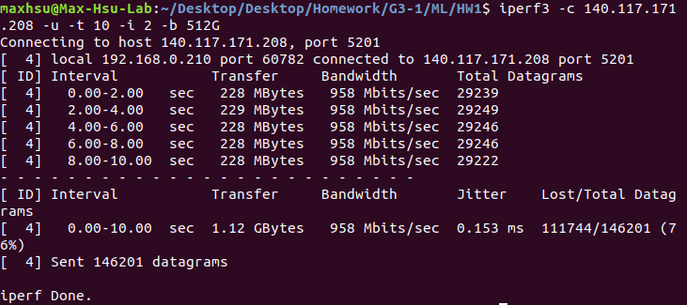

bandwidth = 10M
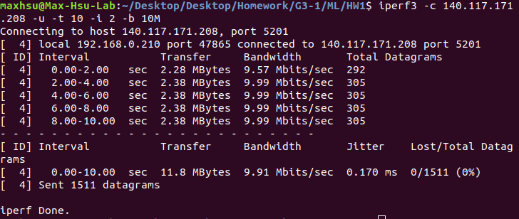

Result : error packet decrease with bandwidth

