|  |  |  |  |  |  |
| --- | --- | --- | --- | --- | --- |
| 資料量 | Insertion | Merge | Quick | C qsort | C++ sort |
| 100 | 0.0 | 0.0 | 0.0 | 0.0 | 0.0 |
| 500 | 0.0 | 0.001 | 0.001 | 0.001 | 0.0 |
| 1000 | 0.002 | 0.003 | 0.001 | 0.0 | 0.0 |
| 5000 | 0.045 | 0.011 | 0.011 | 0.0 | 0.002 |
| 10000 | 0.177 | 0.021 | 0.021 | 0.001 | 0.003 |
| 50000 | 4.517 | 0.108 | 0.119 | 0.008 | 0.013 |
| 100000 | 19.197 | 0.110 | 0.259 | 0.015 | 0.025 |
| 500000 | 467.291(TLE) | 1.085 | 1.606 | 0.078 | 0.136 |

CPU:Intel Xeon CPU E5-2690 V3

Memory:95GB

OS:CentOS7

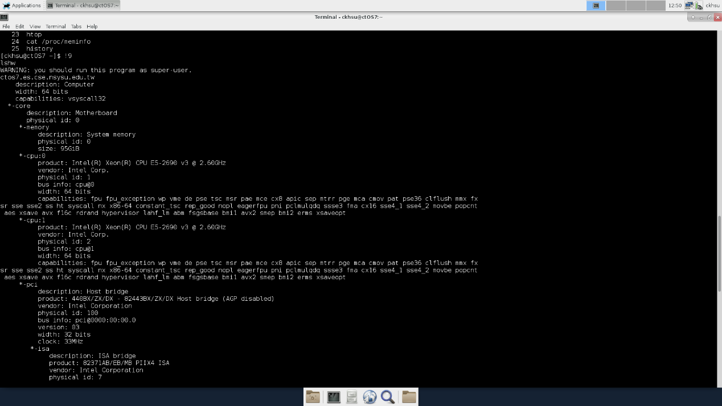Compiler: g++ 4.8.5

